**ASTROSWAB**

Blast Asteroids, Eat Cakes – and Save the Day!

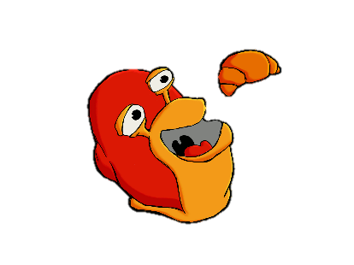The objective of the game is to score as many points as possible. You guide Swabby the snail through different areas of increasing difficulty, while shooting down asteroids, missiles and even the occasional UFO. Be sure to grab the juice, cakes and other bakery goodies – they will boost your score and make Swabby shoot even faster. Don’t let the flaming asteroids (the so-called spinners) reach the ground!

Scoring overview:

You have got two different score meters: 1) Your score can go up or down during the game, depending on the events described in the table below; 2) your peak score can only go up, and it is the basis for your progression and possible position on the high score table.

|  |  |  |  |
| --- | --- | --- | --- |
| Object | Destroyed | Hits ground | Hits Swabby |
| Asteroid | 100 | - 50 | - 100 |
| Shard | 200 | - 100 | - 100 |
| Spinner | 400 | - 100* | - 200 |
| Booster | - 500 | 0 | 1.000** |
| Missile | 800 | 0 | - 200 |
| UFO | 1.000 | - | - |

* You lose one life.  
** Swabby’s firing rate improves.

Progression overview:

As your peak score increases, the difficulty ramps up and you travel through different scenes. The scenes are selected randomly within each difficulty, creating 54 unique playthrough experiences.

|  |  |  |
| --- | --- | --- |
| Difficulty | Peak Score Range | Scenes |
| 1 | 0 – 4.999 | - Mushroom Valley  - Beach  - Countryside |
| 2 | 5.000- 14.999 | - Desert  - Mountains  - Cloudy day |
| 3 | 15.000- 34.999 | - Night  - Old tree  - Field |
| 4 | 35.000 – 59.999 | - Graveyard 1  - Graveyard 2 |
| 5 | 60.000 – 90.000 | - The Moon |

High score system:

The high score table has 10 positions. When you run out of lives, your peak score is compared to the entries in the high score table. Enter characters with Button 1 and backspace with Button 2.

Battery-backed RAM saves the scores between gaming sessions. If you ever want to wipe the high score table and start over, do the following: At the title screen, press UP + Button 1 + Button 2. You will be taken to a confirmation screen where you can press DOWN + Button 1 + Button 2 to clear the high score table and reset Astroswab to the default settings.

HELPFUL HINTS:

Most asteroids explode into two shards. Time your shot carefully so that you can mop up at least one of the shards before it hits the ground.

Don’t just shoot wildly up in the sky. You risk accidentally hitting one of the bakery goods, which will cost you 500 points and a missed chance for powering up Swabby’s gun.

The homing missile is fast. While it is possible to shoot it, it is often better to outrun it.

You can’t possibly blast all the incoming asteroids and shards. When you are out of position, it is better to stay safe at the cost of a few points.

Destroy the UFO and the spinner as soon as they appear on the screen. The UFO will quickly fill the screen with bullets that Swabby cannot destroy, and the spinner will eventually touch the ground causing you to lose a life.

Astroswab (c) 2018, Hang-On Entertainment

Astroswab is an unlicensed Sega Master System homebrew created for the SMS-Power coding competition in 2018. It is based on the Astroblast game for the Atari 2600, fused together with homebrew hero Swabby the Snail.

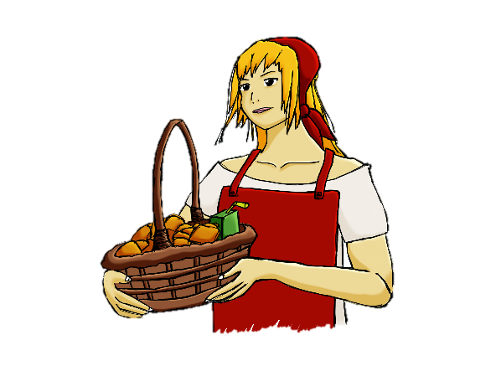

Astroswab gameplay and musical assets are created for PAL (50 Hz) systems. The game can fully run on NTSC (60 Hz) systems, but a PAL setup is recommended for the best gameplay experience. The game will display a warning the first time it is booted, if it is on an NTSC system.

Credits:

Anders - Concept, code, music, graphics

Lasse - Graphics, playtesting

Greetings:

Maxim - BMP2Tile tool

sverx - PSGLib sound library and vgm2psg tool

Calindro - Emulicious emulator

Bock - Meka emulator

Kagesan - Screen fading routines

SMS-Power - Community, resources and support