**Milestone 1 Gameplay Abstract**

**A note on long term goals and complexity**

Management games tend to attract players that enjoy efficient progress. To put it another way, they like to be offered many small choices; choices that add up over time to a large difference between doing well and doing badly. The first system we are going to implement is the primary engine for these little decisions over time. Below are some guiding principles that lead us to our first choice on the matter.

* A player that plays more should progress faster, but one that is less active should still progress
* Complexity should ramp up slowly over time
* The barrier to entry should be low in terms of required skill
* There should be some sense of individuality for each simulated citizen

**Milestone 1: Citizen Attributes and Task Allocation**

The first set of mechanics we want to implement is that which will govern the basic decision loop of the player, moment to moment. It should be somewhat obvious to the player that one choice is better than another in the immediate sense, even if the overall strategy is unclear.

Each citizen may be assigned a task at any given time. The player will want to assign the right task to the right person, in order for things to work as efficiently as possible. In order to make that decision a gameplay element, there need to be rules that suggest which task is best for which citizen. To this end, we have developed a set of attributes that governs how well certain tasks are performed. For the purposes of this milestone, the attributes will be fixed. This will allow us to test the systems affected by the attributes more closely.

Efficiency Attributes

Each citizen has three attributes associated with efficiency. Higher levels of the attribute mean that the task will be performed at a faster rate. These attributes are strength, dexterity, and endurance, which are fairly common attributes in games.

Quality Attributes

Each citizen has three attributes associated with quality. Higher levels of the attribute mean that the outcome of the task will be better. The implications for quality on all tasks are not yet clear, and may be different for different tasks. There should be some cases in which quality is more important, and some in which efficiency is more important. These attributes are perception, focus, and acumen.

Task Attributes

Each task will involve all six attributes in some way. In respect to a given task:

* One primary (draining) attribute - Primary attributes for a given task will affect efficiency (time to complete) the most. While the task is being performed by a citizen, that attribute will slowly drain, making them worse over time. This works as a percentage of the citizen’s maximum.
* One secondary (locked) attribute – Secondary attributes will affect the efficiency less than primary attributes, but will not naturally recover either.
* One unused (recovering) attribute – The third attribute does not affect the task at hand at all, but will recover back to the citizen’s natural maximum over time.

Quality attributes will work the same way.

The purpose behind this system is to create a way for players to optimize the village through micromanagement. With no other influence, the best way to play would be to rotate tasks by attribute, in order to prevent the loss of efficiency through fatigue. Idle citizens would recover all three attributes, so there could be some utility in allowing idle time as well.

Global Attributes

Three additional attributes exist which influence the task-centric attributes. The management of these would be more gradual and overarching. These are:

* Health – A representation of the overall health of the citizen. This would usually change due to things like disease, poor sanitation, poor water quality, etc. The health attribute affects how quickly all efficiency attributes drain. A low health citizen will lose strength much faster than a high health citizen when performing a strength oriented task.
* Happiness – This functions very similarly to health, but instead affects quality attributes. Like health, it is inversely correlated with quality attribute drain.
* Recovery – This represents the citizen’s level of hunger (it could also be called satiation). This attribute affects the rate of recovery of all task attributes. A well-fed citizen will recover from fatigue much more quickly.

Food and its Effects on Attributes

One of the major intended features of the game is nutrition and cooking. The many crops that are available as the village progresses could be used in recipes. Recipes and their assembled meals would afford specific, timed benefits that make certain things go more smoothly in the village. For this milestone, recipes are not going to be implemented. Instead, the benefits of the food will be more direct. A given food, if eaten raw, will simply increase the recovery attribute by an amount. This is useful for recovering from fatigue, but the real goal of the food system is to use cooking to improve food quality. A cooked food item will also generate one of the timed benefits mentioned earlier. These timed benefits will be unique to each food type in this milestone, and will be affected by the quality attributes of the chef.

**An Example Scenario**

For this milestone, only cultivation, cooking, selling, eating, and idling will be possible actions for citizens to pursue. To better test the attribute system, each crop will have a different combination of attribute scores. The goal will be to grow and sell as many crops as possible to advance to level 9. Some health/happiness modifiers may be introduced, or may be postponed to milestone 2.

Below is an example citizen, followed by a possible set of tasks and food interaction.

This citizen is healthy, happy and strong. He would be best used in a task that requires strength and focus as primary attributes.

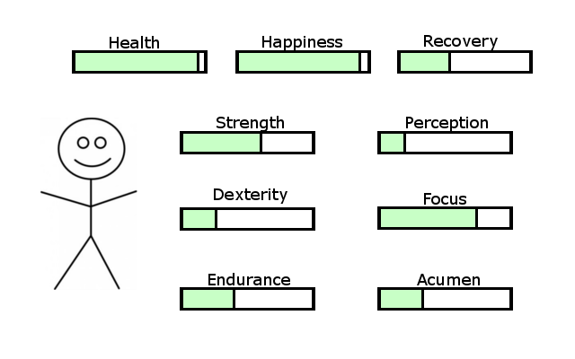

In this case, we don’t have a good option for both, but we can cultivate sweet potato quickly with our high strength attribute. Our citizen needs to eat soon. The primary attributes for sweet potato cultivation are strength and perception, which will drain as the farm plot is worked.

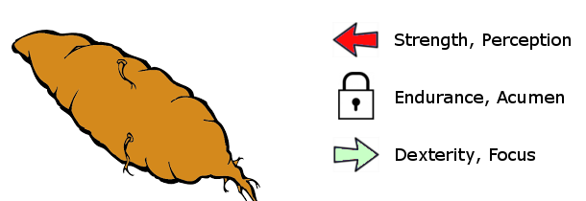

After awhile, our citizen’s attributes have been modified by working the sweet potato plot. Our citizen is even hungrier now as well.

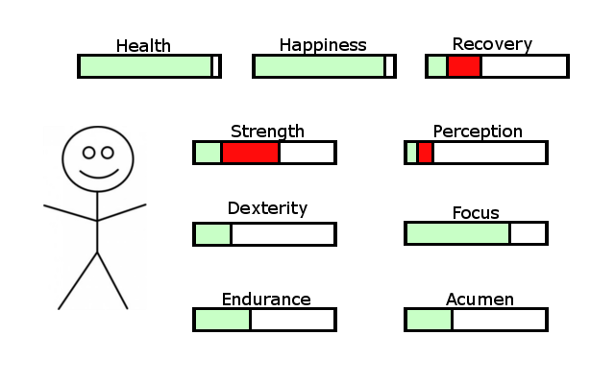

We could eat the potato and gain recovery, but there is a better solution available. Cooking the potato will produce a buff effect which increases strength recovery by 50% for 20 minutes. This task also benefits highly from focus, which will improve the quality of the food.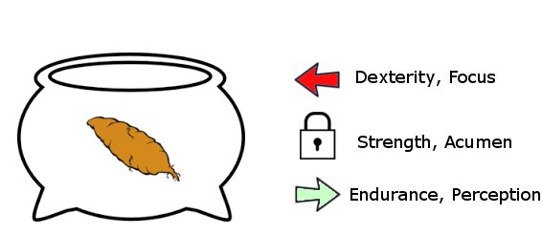

The cooking was a success, though at some cost to our citizen’s dexterity and focus. Focus and acumen have increased the quality of the result as well!

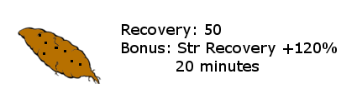

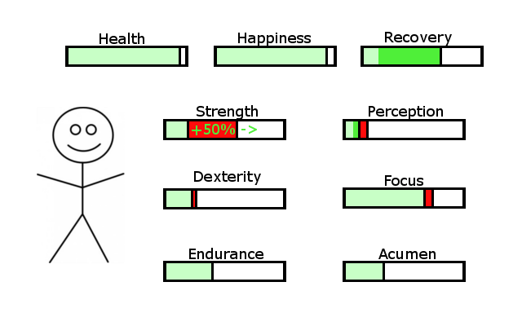

The player would most benefit from letting this citizen rest idle a bit, or assign it a task that does not use strength. If assigned a task which drains or locks strength, the special bonus of the cooked sweet potato will not be utilized.