FractureAgent: A Multi-Tool LLM-Based Intelligent Agent for Personalized Fracture Rehabilitation Management
Hang Cao^{a,b,1}, Fangwei Hu^{c,1}, Lin Xu^{b}, Kun Guo^{b}, Bingchuan Xue^{b}, Ning Zhang^{b}, Jinhao Sun^{d}, Weijuan Gong^{a,*}, Xiao Ouyang^{a,b,*}
ª Yangzhou University Faculty of Medicine, Yangzhou 225009, Jiangsu Province, China
^{b} Department of Orthopedics, Xuzhou Cancer Hospital, Xuzhou 221005, Jiangsu Province, China
^{c} Department of Surgery, Xuzhou New Healthy Geriatric Hospital, Xuzhou 221007, Jiangsu Province, China
^{d} College of Artificial Intelligence, Jilin University, Changchun 130012, Jilin Province, China
* Correspondence: weijuangong578@163.com (W. Gong); xiaoouyang725@163.com (X. Ouyang).
¹ These authors contributed equally to this work and are co-first authors.

Abstract
Fracture rehabilitation must adapt as pain, function and warning signs change across healing phases, but many digital tools provide static information and cannot coordinate exercise selection, symptom assessment, progress monitoring and safety escalation. To address this gap, we developed FractureAgent, a reasoning-and-action (ReAct)-style system that couples a domain-adapted Qwen3.5-9B backbone with five typed rehabilitation tools and a deterministic safety gate to provide phase-aware support. The model was adapted using quantized low-rank adaptation (QLoRA) supervised instruction tuning on 18,742 synthetic rehabilitation dialogues and tool-use traces derived from open-access clinical and patient-education sources. We evaluated FractureAgent using automated functional metrics, expert clinical ratings and 210 simulated-patient scenarios spanning six fracture types and three rehabilitation phases. It achieved a task completion rate of 91.4%, a mean clinical-appropriateness score of 4.21/5.00, pain-assessment concordance of 0.873, exercise-appropriateness of 0.896 and complication-detection sensitivity of 0.843, outperforming the evaluated baselines, including the unfine-tuned Qwen3.5-9B backbone. These findings indicate that FractureAgent can coordinate multiple rehabilitation tasks and provide adaptive support in simulated settings, addressing the technical limitations of static digital guidance; however, they do not establish clinical effectiveness or readiness for deployment.

Keywords: fracture rehabilitation; LLM agent; Qwen3.5; ReAct; tool use; intelligent health agent; orthopedic rehabilitation; fine-tuning; open-source; conversational AI

1. Introduction
Fracture rehabilitation is a multidimensional, time-intensive process that begins with acute pain management and immobilization and progresses through staged phases of range-of-motion restoration, strength reconditioning, and functional reintegration. Clinical guidelines from organizations such as the American Academy of Orthopedics Surgeons (AAOS) and the AO Foundation specify general protocols for common fracture types, yet optimal rehabilitation is inherently individualized, requiring continuous adjustment based on patient-reported outcomes, complication monitoring, and functional milestone tracking [1, 2].
Adherence to post-fracture rehabilitation programmes is a persistent clinical challenge. Population data indicate that 50 to 70 percent of patients show suboptimal adherence to prescribed home-exercise programmes, with pain and psychological barriers (fear of re-injury and low self-efficacy) identified as primary determinants [3]. This non-adherence is associated with delayed functional recovery, residual deficits, and increased long-term healthcare utilisation [4]. The most commonly cited contributing factors include inadequate patient education, infrequent follow-up, weak symptom-to-protocol feedback loops, and the lack of accessible expert guidance between scheduled clinic visits [5].
Technology-assisted rehabilitation, including robot-assisted systems and wearable or exoskeleton platforms, has therefore become increasingly relevant to fracture care. Recent robot-assisted fracture-rehabilitation systems have targeted ankle and distal-radius fractures by combining guided repetitive training, motion or force sensing, and remote or semi-automated supervision [33, 34]. Such systems should not be viewed only as tools for power augmentation: related exoskeleton and muscle-network studies show that robotic assistance can shape movement quality and workload during functional upper-limb tasks, supporting the broader goal of motor recovery and independence in activities of daily living (ADLs) [35-37]. These developments underscore the need for adaptive clinical reasoning between visits, because physical assistance and digital guidance both must respond to pain, safety signals, and functional milestones rather than follow a static schedule.
One route to such accessible, adaptive between-visit guidance is offered by modern artificial intelligence, and in particular by the deep-learning (DL) networks that underpin today's large language models. Deep learning is a sub-field of machine learning (ML) in which multi-layer neural networks learn the mapping from input to output directly from data. The defining difference from classical ML, including support-vector machines, random forests, or logistic regression, lies in automatic feature extraction: where classical ML requires domain experts to hand-craft a fixed set of descriptive features (for example, pain-score thresholds or joint-angle bins) before any model is trained, DL discovers its own hierarchical feature representations during training, from raw signal or text upwards, so that no problem-specific feature engineering is needed [29, 30]. This capacity is not restricted to transformer models. Convolutional neural networks (CNNs), for example, use convolutional layers to learn local filters directly from raw imaging, inertial, activity-recognition, and electromyographic signals, then compose these filters into higher-level spatial or temporal representations [38-42]. Thus, the strong inductive biases of CNNs are a strength for many signal- and image-processing tasks, even though they make CNNs less suited than language-model architectures to open-ended tool-using dialogue. The same property, however, makes DL markedly more data-hungry than classical ML: because the network must simultaneously learn the feature extractor and the decision mapping, it needs substantially more labelled examples to generalise and is more prone to overfitting when data are scarce [31, 32]. Data requirements are therefore architecture-dependent: CNNs reduce sample complexity by imposing locality and weight sharing, whereas Transformer backbones used in modern LLMs inject comparatively little structural prior beyond positional order and must learn task-relevant linguistic, hierarchical, and long-range dependencies from large corpora. Fracture rehabilitation sits squarely in this data-scarce regime, because curated, labelled dialogue datasets are largely absent. This data-hunger constraint motivates two of the central design choices in this work: an openly assembled 18,742-example corpus built entirely from open-access clinical sources, and a parameter-efficient (QLoRA) fine-tuning recipe that adapts a 9-billion-parameter backbone from a handful of gigabytes rather than from scratch.
The emergence of LLM-based intelligent agents, which combine the reasoning capabilities of large language models with structured tool use to interact with external knowledge sources and execute multi-step workflows, offers a new architectural paradigm for dynamic clinical support [6, 7]. The ReAct framework [8], which interleaves language-model reasoning (Thought) with executable actions (Act) and environment feedback (Observe), has demonstrated strong performance across agentic benchmarks in the general domain. Medical adaptations of ReAct-style agents have shown promise for clinical question answering, drug-interaction checking, and care-pathway navigation [9, 10], but their application to rehabilitation medicine (which requires longitudinal, exercise-specific, and patient-state-aware dialogue) remains nascent.
Qwen3.5, the latest generation of the Qwen model family from Alibaba DAMO Academy, provides a capable open-weight foundation for agentic applications. Its 9B-parameter variant achieves competitive performance on function calling, tool use, and structured reasoning benchmarks. It can be fine-tuned on consumer-grade hardware via QLoRA [11], which makes it an ideal base for domain-specific agentic fine-tuning in resource-constrained research and prototyping contexts rather than direct clinical deployment.
In this work, we present FractureAgent, a ReAct-based multi-tool intelligent agent fine-tuned on Qwen3.5 for fracture-rehabilitation support. Our four contributions are organised so that each one is independently testable in §6:
- Architecture (§3). We design a multi-tool ReAct agent specifically tailored to fracture rehabilitation, with five typed tools : exercise_query, pain_assess, progress_track, literature_search, schedule_reminder : orchestrated by a fine-tuned Qwen3.5-9B policy and gated by a deterministic escalation rule layer (Eq. 5) that runs before any tool selection so that complication signals cannot be silently bypassed.
- Open-data corpus (§4). We assemble an 18,742-example fine-tuning corpus drawn exclusively from open-access clinical sources (AAOS CPGs, AO Surgery Reference, PubMed OA, PhysioNet, WikiDoc / MedlinePlus). 12,891 of those examples carry explicit Thought–Act–Obs–Resp tool traces (Eq. 1) — to our knowledge the first openly-licensed corpus that pairs fracture-rehabilitation dialogues with structured agentic traces. A stratified expert audit (3 surgeons + 3 PTs) confirms clinical plausibility (ICC = 0.83).
- Single-GPU training recipe (§5). We adapt the Qwen3.5-9B backbone with QLoRA (rank r = 16, scaling α = 32, NF4 quantization) on a 70:30 mixture of agent-format and standard dialogue data, fitting on a 24 GB consumer GPU. The recipe is fully reproducible from open weights and open data.
- Evidence (§6). We evaluate FractureAgent against five baselines on a 210-scenario simulated-patient suite spanning 6 fracture types × 3 rehabilitation phases, using automated metrics, expert clinical Likert ratings, ablations, and a structured failure analysis. The evaluation isolates fine-tuning as the single largest lever (+30 pp TCR over the same Qwen3.5-9B backbone evaluated zero-shot).
Figure 1 organizes the recipe into three connected pipelines that operate on different timescales: a data-processing pipeline (run once, offline) that turns open-access clinical sources into a curated training corpus; a model-training pipeline (run once, ~14 h on a 2×A100 node) that QLoRA-fine-tunes a Qwen3.5-9B base on that corpus to produce the trained policy π_θ; and an agent-runtime pipeline (run on every patient turn) that wraps π_θ in a ReAct loop with a deterministic safety gate and five typed tools. The green hand-off pills in the figure show the products that flow between pipelines (the corpus from #1 feeds #2; the trained policy from #2 is loaded by #3). Each pipeline maps onto a section of this paper, so the reader can navigate between the diagram and the formal definitions without re-orienting.
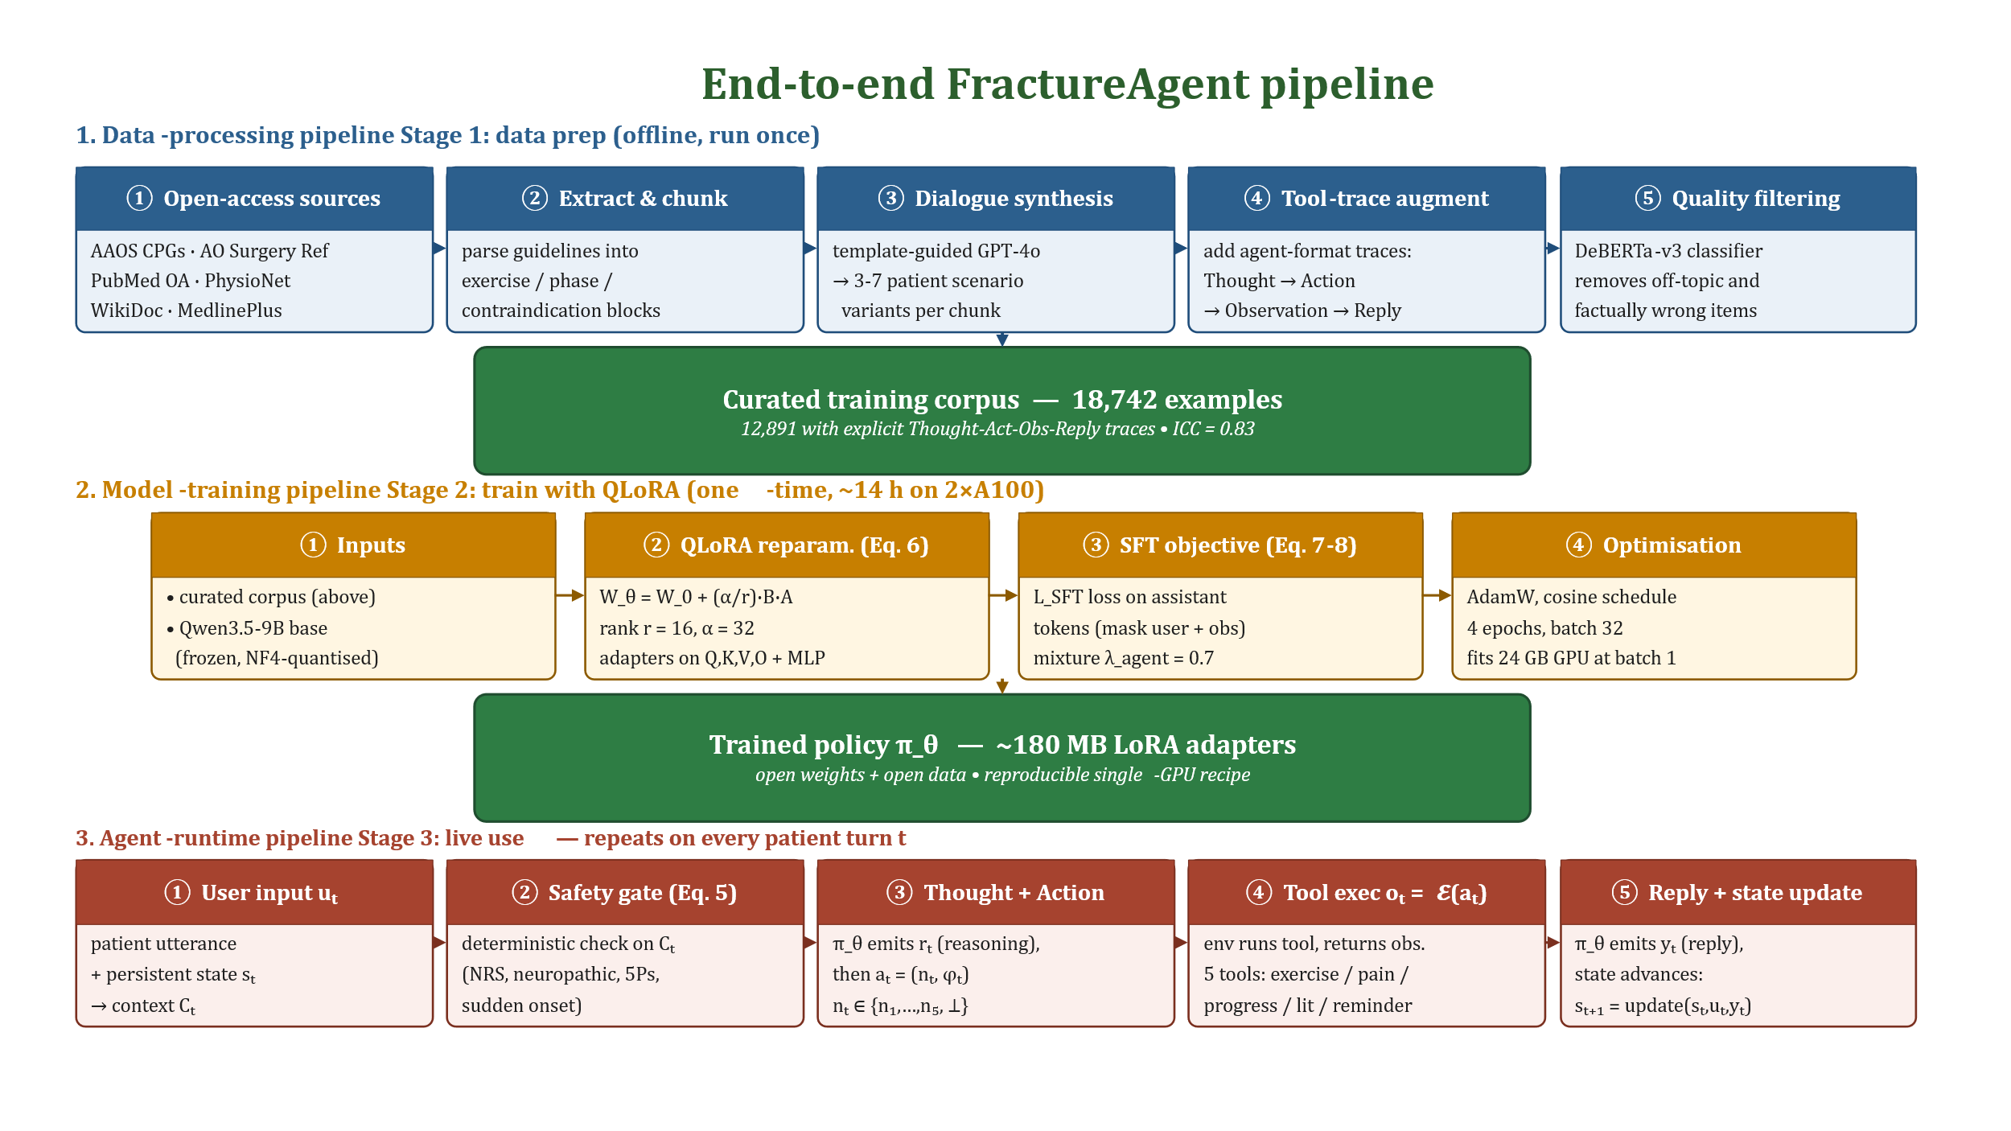
Figure 1. End-to-end FractureAgent pipeline. Three connected flows. (1) Data-processing pipeline (top, §4): five open-access sources are extracted, chunked, expanded into synthetic dialogues by a template-guided GPT-4o pass, augmented with explicit Thought–Act–Obs–Reply tool traces, and quality-filtered, yielding the curated training corpus of 18,742 examples (12,891 with traces). (2) Model-training pipeline (middle, §5): the corpus and a frozen NF4-quantised Qwen3.5-9B base are combined under the QLoRA reparameterization (Eq. 6), the SFT objective (Eq. 7) on a λ_agent = 0.7 mixture of agent-format and standard-dialogue data (Eq. 8), and 4 epochs of AdamW optimization, yielding the trained policy π_θ as a ~180 MB set of LoRA adapters. (3) Agent-runtime pipeline (bottom, §3): on every patient turn t, the user utterance plus the persistent state sₜ form the context Cₜ; a deterministic safety gate (Eq. 5) intercepts complication signals; the policy π_θ then emits a Thought–Action pair, the tool environment 𝓔 produces an Observation, and the policy emits a Response, after which the state advances to sₜ₊₁ and the loop repeats.
The remainder of the paper is structured as follows. Section 2 reviews related work. Section 3 describes the agent architecture. Section 4 presents the dataset construction methodology. Section 5 details the QLoRA training recipe. Section 6 presents evaluation results, including the main comparison, per-phase analysis, expert ratings, ablations, and a structured failure analysis. Section 7 discusses clinical implications and limitations. Section 8 concludes.
Before turning to formal definitions, Figure 2 motivates the design choice intuitively: panel A traces a typical fracture-rehabilitation timeline and shows that the recovery loss accrues during the multi-week red-shaded gaps between clinic visits, not at the visits themselves; panel B explains why each class of currently-deployed digital tool fails in that gap; panel C summaries the five proposed properties of FractureAgent and the headline result that follows.
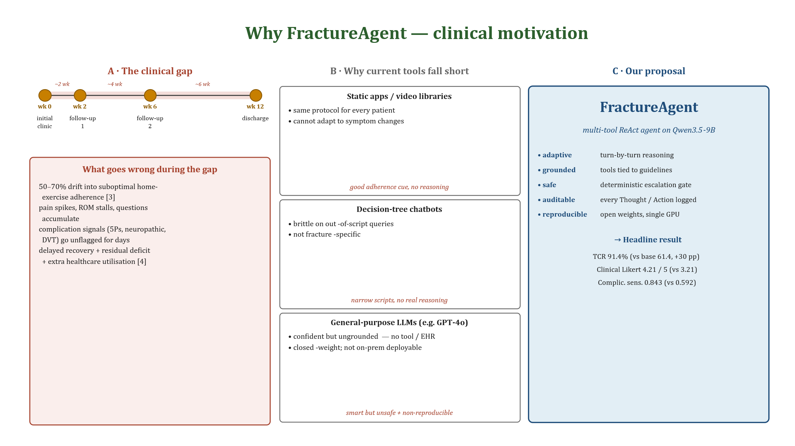
Figure 2. Why FractureAgent — clinical motivation at a glance. (A) A typical post-fracture rehabilitation timeline runs ~12 weeks and contains only 3–4 clinic encounters (yellow dots: initial fracture clinic, follow-up visits, discharge). The red-shaded bands between dots are the multi-week intervals during which patients are alone with their home-exercise programme — and they are precisely where adherence fails (50–70% of patients), pain spikes go un-counselled, and complication signals go unflagged for days. (B) Every class of digital tool currently deployed to fill that gap fails for a different reason: static apps cannot adapt; decision-tree chatbots are brittle; general-purpose LLMs are smart but ungrounded and not reproducibly deployable. (C) FractureAgent fills the gap with an adaptive, grounded, deterministic-safety-gated, auditable, and reproducible recipe on top of an open Qwen3.5-9B backbone, yielding the headline numbers shown. The bottom strip names the four contributions that operationalize this proposal in §3–§6.

2. Related Work

2.1 Digital Rehabilitation Technologies
Digital rehabilitation platforms have evolved considerably over the past decade. Early mobile applications provided static exercise libraries with video demonstrations, improving patient recall of prescribed exercises but not adapting content to recovery progress [12]. Sensor-augmented systems, including inertial measurement units and smartwatch-based kinematics, enabled objective adherence tracking and exercise-quality feedback, with clinical trials demonstrating improved functional outcomes relative to standard care in knee and shoulder rehabilitation [13, 14]. Telerehabilitation platforms accelerated during the COVID-19 pandemic, with synchronous video physiotherapy demonstrating non-inferiority to in-person care for a range of musculoskeletal conditions [15].
However, current digital platforms share a fundamental limitation: their content generation is rule-based and static, unable to engage in the open-ended clinical reasoning required to address novel symptom presentations, adjust protocols based on patient-reported experience, or detect complications from conversational input. Conversational interfaces based on predefined decision trees have been explored but are brittle and fail gracefully only within narrow script boundaries [16]. Generative AI-powered rehabilitation support represents the natural next evolution of this technology class.

2.2 LLM Agents in Healthcare
The application of LLM agents in healthcare has gained substantial momentum following the demonstration of the medical-licensing-exam performance of GPT-4 [17] and the development of medically-oriented instruction-tuned models such as Med-PaLM 2 [18], HuatuoGPT [19], and BianQue [20]. These works demonstrated the feasibility of LLM-mediated clinical dialogue but focused primarily on knowledge-grounded question answering rather than agentic, tool-augmented interactions.
ReAct-style agentic frameworks have been adapted for clinical settings by several groups. AgentMD [21] demonstrated that a ReAct agent augmented with electronic-health-record (EHR) query, drug database, and lab-reference tools could answer complex clinical questions with higher factual accuracy than standalone LLMs. ClinicalAgent [22] applied a tool-augmented LLM to clinical-trial matching, achieving higher recall than keyword-based retrieval systems. In rehabilitation medicine specifically, ChatRehab [23] explored a GPT-3.5-based conversational interface for stroke-rehabilitation exercise guidance but did not implement structured tool use, agent-style reasoning, or domain-specific fine-tuning. FractureAgent substantially extends this prior work by incorporating multi-tool orchestration, fracture-specific fine-tuning, and systematic clinical evaluation.

2.3 LLM Fine-Tuning for Medical Domains
Parameter-efficient fine-tuning (PEFT) methods, particularly LoRA [24] and its quantized variant QLoRA [25], have democratised domain adaptation of large models by reducing GPU memory requirements from hundreds of gigabytes to single-digit figures. Medical fine-tuning studies have consistently demonstrated that even small-scale, high-quality domain datasets (1,000–50,000 examples) yield substantial improvements over zero-shot and few-shot performance of general models, particularly for tasks requiring adherence to clinical terminology, guideline-consistent recommendations, and appropriate uncertainty expression [26, 27]. Our work builds on this evidence base, applying QLoRA fine-tuning to produce a rehabilitation-specialized agent.

3. FractureAgent Architecture

3.1 Overall Design
FractureAgent is implemented as a ReAct-style agent in which the fine-tuned Qwen3.5-9B backbone serves as the central reasoning engine. At each conversational turn the model receives a system prompt encoding the rehabilitation context of the patient (fracture type, anatomical location, weeks since injury, current phase, comorbidities), the conversation history, and the JSON schemas of the available tools. It then emits, in sequence, a Thought block (free-form reasoning), an optional Action block (a tool call with structured parameters), an Observation block (the output of the tool, supplied by the runtime), and a Response block (the user-facing reply). This interleaved reasoning–action–observation cycle yields a transparent, auditable trace that supervising clinicians can review post-hoc.
Formally, at conversational turn t we let Cₜ = (sₜ, hₜ₋₁, uₜ) denote the agent context (current patient state sₜ, prior history hₜ₋₁, and current user utterance uₜ). The trajectory τₜ emitted by the policy π_θ satisfies
$$τ_{t} = \left\{r_{t} ∼ π_{θ}(· | C_{t}) (Thought), a_{t} ∼ π_{θ}(· | C_{t}, r_{t}) (Action), o_{t} = E(a_{t}) (Observation), y_{t} ∼ π_{θ}(· | C_{t}, r_{t}, a_{t}, o_{t}) (Response)\right\}$$ | (1)
where π_θ is the fine-tuned Qwen3.5-9B policy parameterized by θ, the four blocks of the trajectory τₜ — rₜ (Thought, free-form clinical reasoning), aₜ (Action, a structured tool call), oₜ (Observation, the deterministic tool output), and yₜ (Response, the user-facing reply) — are each conditioned on all preceding blocks within the same turn, and 𝓔 is the deterministic tool-execution environment that maps an action aₜ to its observation oₜ. The action aₜ at each turn is a structured pair — a tool-name token nₜ drawn from a finite vocabulary 𝓝 and an arguments record φₜ (a JSON dictionary whose schema is fixed by the chosen tool; see Table 1). The vocabulary 𝓝 = {n₁, n₂, n₃, n₄, n₅, ⊥} contains the five tool names (n₁ = exercise query, n₂ = pain assess, n₃ = progress track, n₄ = literature search, n₅ = schedule reminder, in the row order of Table 1) plus the terminate symbol ⊥, which closes the trajectory without a tool call. Eq. (2) makes this structure explicit:
$$a_{t} = (n_{t}, φ_{t}), n_{t} ∈ N, |N| = 6.$$ | (2)
When nₜ = ⊥, the agent emits yₜ directly and the trajectory ends. The patient state then advances deterministically as given by Eq. (3),
$$s_{t+1} = update(s_{t}, u_{t}, y_{t}).$$ | (3)
where the update function ingests the new utterance uₜ, the agent reply yₜ, and any tool observations oₜ to refresh fields such as numeric-rating-scale (NRS) pain history, completed exercise sessions, range-of-motion (ROM) measurements, and complication flags. Because update is purely a function of (sₜ, uₜ, yₜ), the entire multi-turn trajectory is reproducible from logs.
Figure 3 puts these pieces together at the level of one conversational turn: the agent context Cₜ flows into the fine-tuned policy on the left, the policy emits the τₜ trajectory in the middle, and the right column lists the typed tools 𝓔 the policy can call. The deterministic safety gate (Eq. 5, defined in §3.4) sits in front of the tool-selection step so that complication signals cannot be bypassed when the model picks a different action.
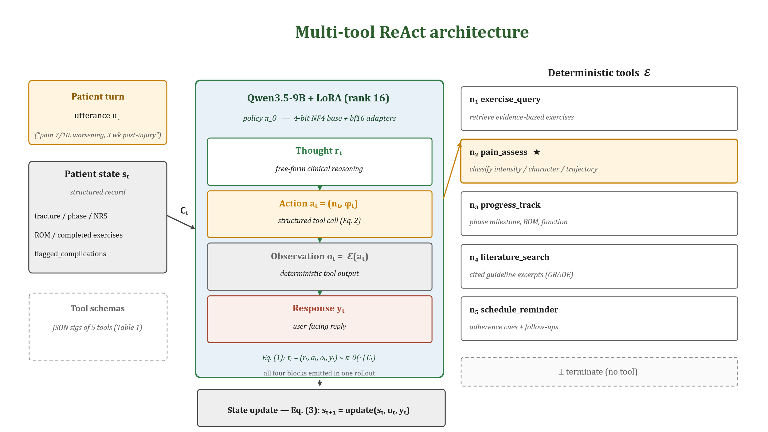
Figure 3. Multi-tool ReAct architecture. The fine-tuned Qwen3.5-9B backbone receives the agent context Cₜ and emits a Thought–Action–Observation–Response trajectory τₜ per Eq. (1). The five tools are labelled n₁, …, n₅ in the order of Table 1; the special ⊥ symbol denotes a "terminate" action that closes the trajectory without a tool call. The pain assess tool (n₂, ★) additionally runs as a deterministic pre-tool safety gate so that complication signals are never bypassed when the model picks a different action; this is the rule-layer formalized by Eq. (5).
The agent maintains a persistent patient-state dictionary that is updated at each interaction and passed as part of the context. State variables include: fracture type and location, surgery status (operative / non-operative), days since injury, current rehabilitation phase (acute immobilization, early mobilization, strengthening, return to activity), NRS pain history, ROM measurements (where provided), completed exercise sessions, and flagged complication signals. This state tracking enables longitudinal personalization without requiring the model to retain information across stateless API calls.

3.2 Tool Descriptions
The agent has access to five specialized tools, each implemented as a Python function with a structured JSON-schema signature passed to the model as a tool definition:
Table 1. FractureAgent tool definitions and capabilities.
Tool name | Function | Inputs | Output
exercise query | Retrieve evidence-based exercises for specific fracture phase | fracture type, body part, phase, contraindications | Ranked exercise list with sets/reps, progression criteria, precautions
pain assess | Interpret patient pain reports and classify severity / type | pain score, pain descriptors, location, aggravating factors, days_since_injury | Pain classification, expected trajectory, escalation flag
progress track | Evaluate functional progress against phase milestones | current phase, reported capabilities, rom_data, weeks_post_injury | Phase appropriateness, milestone status, progression recommendation
literature search | Retrieve relevant clinical guidelines and evidence summaries | query topic, fracture type, evidence level | Cited guideline excerpts with GRADE (Grading of Recommendations Assessment, Development and Evaluation) evidence level
schedule reminder | Set adherence reminders and follow-up prompts | exercise schedule, reminder type, frequency, patient_timezone | Confirmation of scheduled reminders, calendar summary

3.3 Exercise Database (exercise query)
The exercise database underlying the exercise query tool was constructed by extracting and structuring exercise protocols from open-access clinical rehabilitation guidelines, including AAOS Clinical Practice Guidelines (freely available at aaos.org), AO Surgery Reference (open-access sections), PEDro physiotherapy-evidence database entries, and Cochrane rehabilitation reviews. Exercises are catalogued by fracture type (e.g., distal radius fracture, proximal humerus fracture, tibial-plateau fracture), rehabilitation phase (immobilization, early active mobilization, strengthening, proprioceptive, sport-specific), and exercise modality (passive ROM, active-assisted, active, progressive resistance, weight-bearing, balance / proprioception). Each exercise entry specifies contraindications, progression criteria, and expected milestone timelines. The database contains 1,847 unique exercise–phase–fracture entries.

3.4 Pain-Assessment Module (pain assess)
The pain-assessment tool implements a rule-augmented classification pipeline that combines structured numeric-rating-scale (NRS) thresholds with LLM-mediated interpretation of pain descriptors. Input pain reports are classified along three dimensions: intensity category (mild: NRS 1–3; moderate: 4–6; severe: 7–10), pain character (nociceptive inflammatory, mechanical, neuropathic, mixed), and trajectory (improving, stable, worsening, unexpected). Escalation flags are triggered by predefined rule conditions that do not depend on the discretion of the LLM.
Let p ∈ {1, …, 10} denote the patient-reported NRS score and let sev(p) ∈ {1, 2, 3} denote the categorical severity output of pain assess. Severity is defined by partitioning the NRS range into three bins 𝓑₁, 𝓑₂, 𝓑₃ corresponding to mild, moderate, and severe pain, as set out in Eq. (4):
$$sev(p) = i ⟺ p ∈ B_{i}, B_{1} = [1, 3], B_{2} = [4, 6], B_{3} = [7, 10].$$ | (4)
The escalation predicate is the disjunction of K = 4 atomic predicates φₖ over the agent context Cₜ (NRS, days since injury, pain trajectory, descriptor lexicon, and onset pattern):
$$escalate(C_{t}) = ⋁_{k=1}^{K} φ_{k}(C_{t}), K = 4.$$ | (5)
The four predicates φ₁, …, φ₄ are: φ₁(Cₜ) ≡ NRS(Cₜ) ≥ 7 ∧ traj(Cₜ) = ↑ ∧ days(Cₜ) > 21; φ₂(Cₜ) ≡ neuropathic descriptor present in uₜ (burning, electric, radiating); φ₃(Cₜ) ≡ NRS(Cₜ) > NRS_threshold(phase(Cₜ)) — pain disproportionate to the expected milestone for the current phase; φ₄(Cₜ) ≡ sudden pain onset after a pain-free interval (potential hardware failure or refracture). When escalate(Cₜ) returns true the orchestrator overrides any other tool selection and emits a templated escalation response. The rule layer is intentionally deterministic so that safety behavior does not depend on the discretion of the LLM.

3.5 Complication Detection and Escalation
Beyond pain-triggered escalation, FractureAgent monitors conversational inputs for a broader set of complication signals including: neurovascular-compromise indicators (paresthesia, progressive weakness, pallor), compartment-syndrome warning signs (5Ps: pain out of proportion, pressure, paresthesia, paralysis, pallor), wound-infection indicators (increasing warmth, erythema spread, purulent discharge), hardware-related symptoms (new localized metallic pain, catching sensation), and deep-vein-thrombosis risk signals (unilateral limb swelling, calf tenderness). Detection is implemented as a keyword-augmented LLM classification step applied to every user input before tool selection, ensuring that escalation assessment is not bypassed when users frame inputs as exercise or progress queries.
To make the abstract description concrete, Figure 4 walks through one full ReAct turn for a patient six weeks post tibial-plateau open reduction and internal fixation (ORIF). The example shows how every component of Eq. (1) — Thought, Action, Observation, Response — is rendered as a separate, auditable artefact, and which fields of the patient state sₜ advance to sₜ₊₁ as a result (Eq. 3).
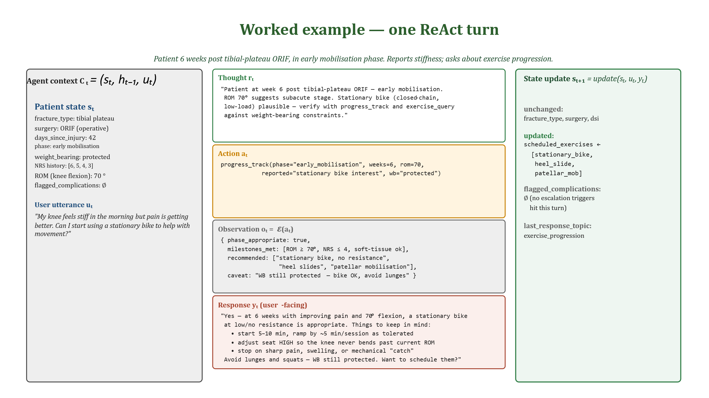
Figure 4. Worked example — one ReAct turn for a patient six weeks post tibial-plateau ORIF. The model produces an explicit Thought (free-form clinical reasoning, verifiable against the AAOS / AO-Ref ORIF rehab protocol), an Action (a typed JSON tool call whose every parameter — phase, ROM, weight-bearing — maps onto a state variable, leaving no hidden assumptions), an Observation produced deterministically by the tool runtime rather than by the LLM (so the "phase_appropriate" decision is reproducible from the call), and a user-facing Response. The right-hand panel shows which fields of sₜ advance to sₜ₊₁ after the turn. Supervising clinicians can review, accept, edit, or reject the entire (rₜ, aₜ, oₜ, yₜ) tuple before it is shown to the patient.

4. Dataset Construction

4.1 Data Sources
The FractureAgent fine-tuning dataset was constructed from five open-access data sources, requiring no institutional subscription or financial expenditure:
- American Academy of Orthopedics Surgeons Clinical Practice Guidelines (AAOS CPGs): full-text Clinical Practice Guidelines (each abbreviated as CPG hereafter) for distal-radius fracture, proximal-humerus fracture, hip fracture in the elderly, tibial-plateau fracture, and ankle fracture, freely available at www.aaos.org/guidelines. Rehabilitation-relevant sections were extracted and converted into instruction-following dialogue pairs.
- AO Foundation Surgery Reference (AO Ref, open-access sections): phase-specific rehabilitation protocols for 24 fracture types extracted from the AO Surgery Reference website (surgeryreference.aofoundation.org). These provided structured exercise progressions with clinical rationale.
- PubMed Open-Access fracture-rehabilitation literature: systematic reviews and randomized controlled trials on fracture rehabilitation retrieved via PubMed (search terms: 'fracture rehabilitation' OR 'fracture physiotherapy' OR 'fracture recovery exercise', filtered for open-access, English language, published 2010–2024). A total of 1,247 papers were screened; 312 were included based on relevance and evidence-quality criteria.
- PhysioNet open clinical-dialogue datasets: de-identified medical-conversation datasets from PhysioNet (physionet.org) were filtered for musculoskeletal-rehabilitation content and used as conversational template sources for synthesizing patient–clinician dialogues.
- WikiDoc and MedlinePlus patient-education content: open-licensed patient-education materials on fracture recovery were used to generate patient-perspective utterance templates, improving the realism of simulated patient inputs.

4.2 Dataset Construction Pipeline
Raw source content was processed through a four-step pipeline (visualized in Figure 5): (1) Content extraction and chunking — clinical guidelines were parsed into exercise-recommendation blocks, phase-description blocks, and contraindication blocks using rule-based heuristics; (2) Instruction-following dialogue generation — structured blocks were converted into multi-turn conversational examples using template-guided GPT-4o synthesis, where each guideline chunk was instantiated across 3–7 patient-scenario variants (different fracture types, patient ages, comorbidities, and rehabilitation phases); (3) Tool-use trace generation — for agent-format training, each dialogue example was augmented with explicit Thought→Action→Observation→Response traces, with tool-call parameters generated from the clinical-scenario context; (4) Quality filtering — generated examples were filtered using a medical-relevance classifier (fine-tuned DeBERTa-v3 on medical QA data) to remove off-topic, factually inconsistent, or clinically inappropriate instances. A stratified subset was additionally audited by three orthopedics surgeons and three physiotherapists; their agreement on a 5-point clinical-plausibility Likert scale yielded an intraclass correlation coefficient (ICC) of 0.83, confirming reliable inter-rater consistency.
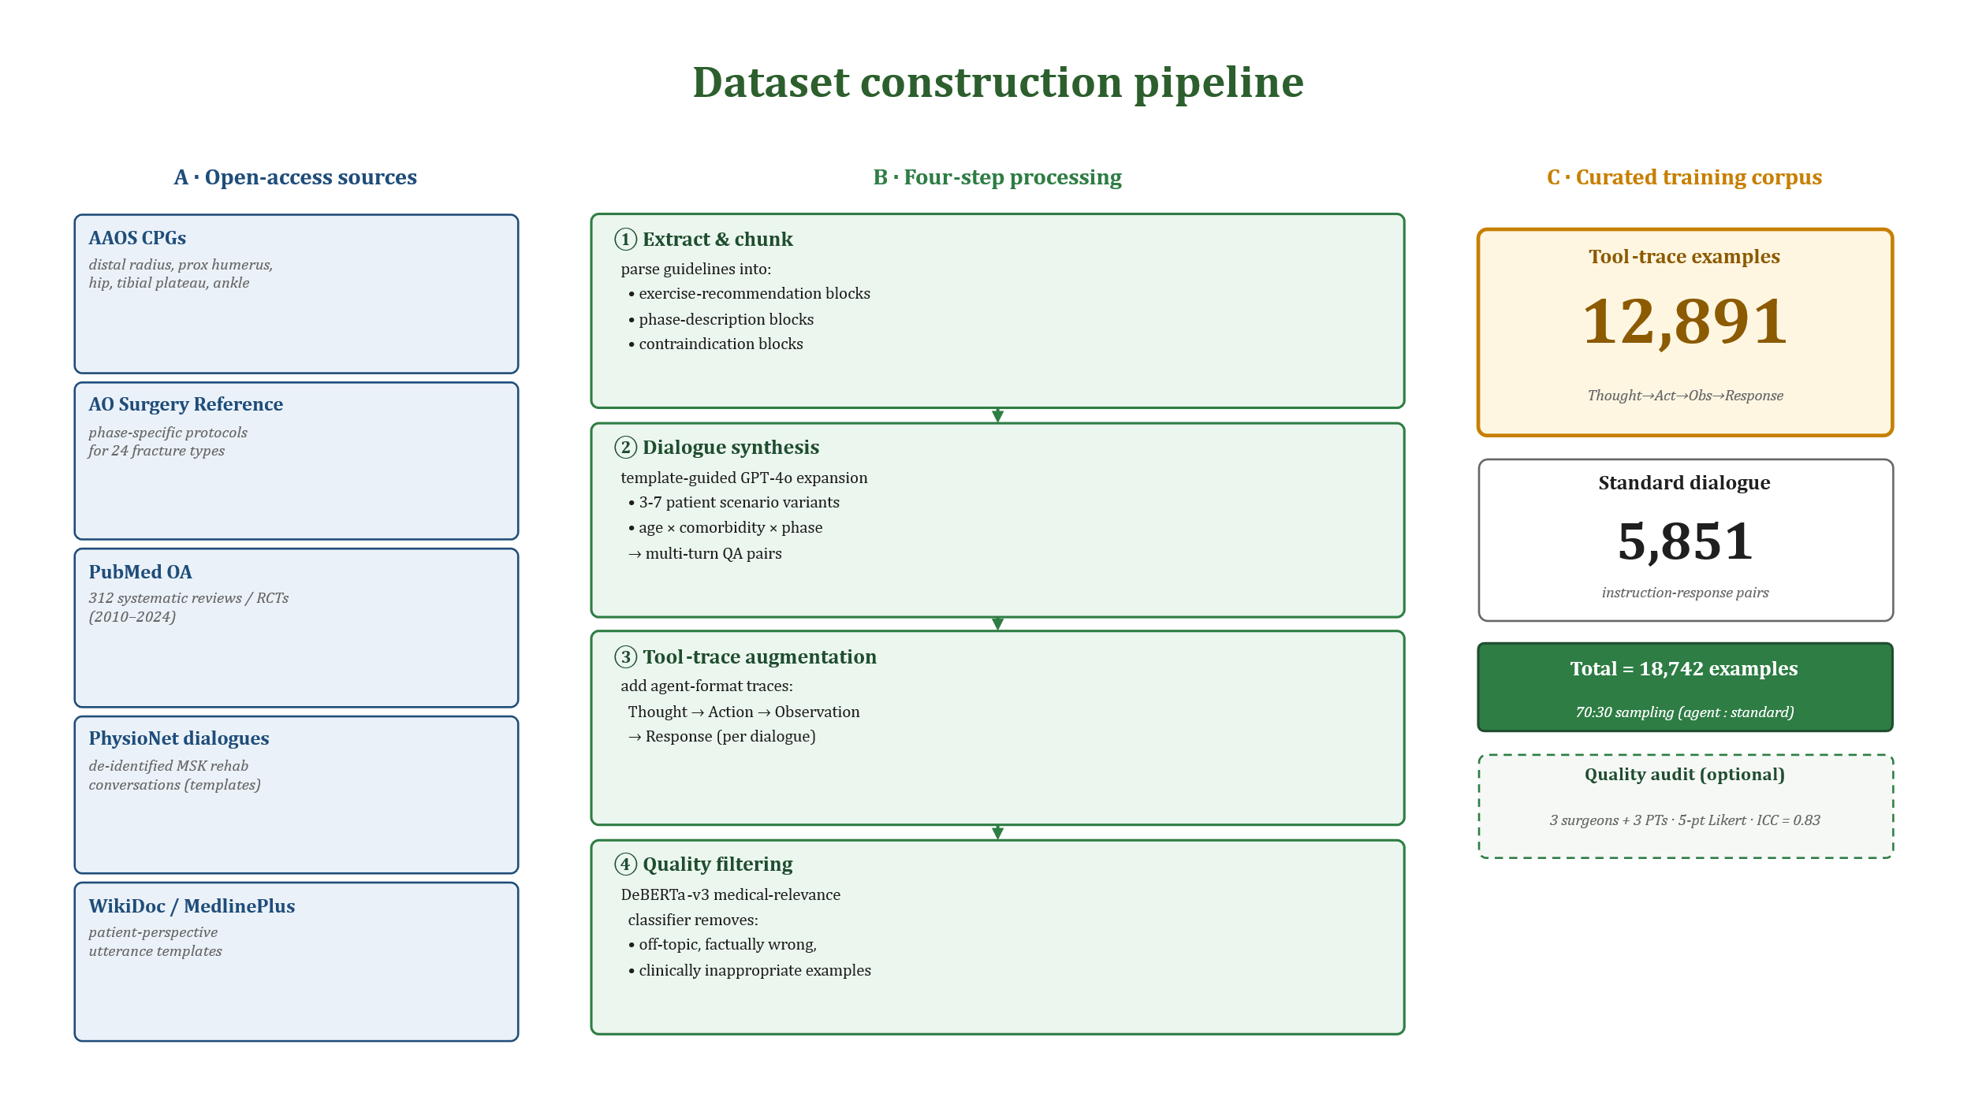
Figure 5. Dataset construction pipeline. Five open-access sources are processed through a four-step pipeline (extract & chunk → dialogue synthesis → tool-trace augmentation → quality filtering) yielding 12,891 tool-trace examples plus 5,851 standard dialogue pairs. A stratified expert audit (3 surgeons + 3 PTs, ICC = 0.83) confirms clinical plausibility on a held-out sample.
The final curated dataset contains 18,742 multi-turn examples, of which 12,891 include tool-use traces (for agent fine-tuning) and 5,851 are standard instruction-following dialogue pairs (for conversational fluency). Table 2 summaries the dataset composition by fracture type and anatomical region. The General / multi-region category (1,000 examples) consists of cross-fracture content — generic post-injury exercise principles, return-to-activity criteria shared across upper- and lower-limb fractures, and patient-education FAQs — derived from WikiDoc and MedlinePlus templates and used to broaden the coverage of the agent beyond the six headline fracture types without diluting their fracture-specific signal.
Table 2. FractureAgent fine-tuning dataset composition.
Fracture category | Body region | Examples | w/ tool traces | Source guidelines
Distal-radius fracture | Wrist / forearm | 3,412 | 2,341 | AAOS CPG, AO Ref
Proximal-humerus fracture | Shoulder | 2,987 | 2,061 | AAOS CPG, AO Ref
Hip fracture (elderly) | Hip / femur | 3,201 | 2,198 | AAOS CPG, NICE NG
Tibial-plateau fracture | Knee / tibia | 2,643 | 1,820 | AO Ref, Literature
Ankle fracture (bimalleolar) | Ankle / foot | 3,118 | 2,142 | AAOS CPG, AO Ref
Clavicle fracture | Shoulder girdle | 2,381 | 1,639 | AO Ref, Literature
General / multi-region | Mixed | 1,000 | 690 | Mixed
Total | — | 18,742 | 12,891 | —
CPG = Clinical Practice Guideline. NICE NG = National Institute for Health and Care Excellence guideline. AO Ref = AO Surgery Reference. "Source guidelines" lists the primary documentary sources from which exercise protocols and milestone definitions were extracted for each category.

5. Model Training

5.1 Base Model and Fine-Tuning Configuration
The base model for FractureAgent is Qwen3.5-9B, the 9-billion-parameter instruction-tuned variant of Qwen3.5 [11]. This model natively supports function calling with JSON-schema tool definitions through a structured chat-template format, eliminating the need for custom tool-invocation prompting. We fine-tune the model using Quantized Low-Rank Adaptation (QLoRA) [25] with the following hyperparameters: LoRA rank r = 16, scaling α = 32, dropout p = 0.05, applied to all Q, K, V, O attention projections and the first and last multi-layer perceptron (MLP) layer pairs of each block. 4-bit NormalFloat (NF4) quantization is applied to frozen base-model weights, whereas LoRA adapters are maintained in bfloat16 (bf16) precision.
Concretely, every targeted projection W in the attention and MLP blocks is reparametrized by Eq. (6) as a frozen base plus a low-rank update,
$$W_{θ} = W_{0} + \frac{α}{r} BA, W_{0} ∈ R^{d×k} (NF4-frozen), B ∈ R^{d×r}, A ∈ R^{r×k} (bf16).$$ | (6)
Here W_θ ∈ ℝ^{d×k} is the effective projection used at training and inference time, W₀ ∈ ℝ^{d×k} is the frozen NF4-quantised base weight, and B ∈ ℝ^{d×r} and A ∈ ℝ^{r×k} are the trainable bf16 low-rank adapters with rank r = 16 and scaling α = 32. The dimensions d (output) and k (input) are the natural shapes of the projection within each transformer block. The trainable footprint is therefore dominated by AB-pair matrices on the order of 180 MB; the 4-bit-quantised W₀ contributes essentially no gradient memory because it is held constant during the forward pass and frozen during back-propagation. The supervised-fine-tuning (SFT) objective minimizes the standard masked next-token negative log-likelihood (Eq. 7),
$$L_{SFT}(θ) = - E_{(C,y)∼D} Σ_{i=1}^{|y|} 1[ y_{i} ∈ S_{tgt} ] log π_{θ}( y_{i} | C, y_{<i} ).$$ | (7)
Here L_SFT(θ) is the supervised-fine-tuning loss as a function of the trainable parameters θ; the expectation E_{(C,y)∼D} is taken over (context, target-sequence) pairs sampled from the training distribution D (the same D defined in Eq. 8); the inner sum runs over the |y| tokens of the target sequence, with yᵢ the i-th token, y_{<i} = (y₁, …, yᵢ₋₁) the prefix preceding it, and π_θ(yᵢ | C, y_{<i}) the predicted probability of the model for token yᵢ conditional on the context and the prefix. The indicator 1[yᵢ ∈ S_tgt] equals 1 exactly when yᵢ lies inside the assistant-emitted target span S_tgt — that is, the Thought, Action, and Response blocks of the trajectory — and 0 on user utterances and tool observations, masking those out of the loss. (The corresponding rendered symbols in Eq. 7 are ℒ_SFT, 𝔼, 𝓓, 𝓢_tgt, and 𝟙, in the same order.) This is analogous to instruction-tuning practice in the wider open-LLM literature [25, 27].
Training was conducted for 4 epochs with a learning rate of 2 × 10⁻⁴ using a cosine annealing schedule with warmup steps equal to 3% of total steps. Batch size was 4 per device with gradient accumulation of 8 steps (effective batch size = 32 on 2 × A100 80 GB GPUs). Total training time was approximately 14 hours. The model can alternatively be trained on a single NVIDIA A100 40 GB GPU in approximately 26 hours with gradient checkpointing enabled, or on a 24 GB VRAM consumer GPU (e.g., RTX 4090) with reduced batch size and additional quantization.

5.2 Training Format and Mixture
Agent-format training examples follow the Qwen3.5 chat-template structure, with system messages encoding patient state and available tools, user messages representing patient utterances, and assistant messages containing the full Thought→Action→Observation→Response trace. Tool-call outputs are injected as tool result messages within the conversation history to simulate the environmental observations of the agent. This format mirrors the inference-time execution structure, minimizing the distribution shift between training and deployment. For standard dialogue examples (without tool traces), training follows the conventional single-turn or multi-turn instruction–response format. A 70:30 sampling ratio between agent-format and standard dialogue examples was maintained throughout training, empirically determined to optimize both tool-use accuracy and general conversational fluency.
Formally, the training distribution is the convex mixture given by Eq. (8),
$$D = λ_{agent} D_{agent} + λ_{std} D_{std}, λ_{agent} = 0.7, λ_{std} = 0.3.$$ | (8)
with 𝓓_agent containing the 12,891 Thought–Action–Observation–Response traces and 𝓓_std containing the 5,851 standard instruction–response pairs (Table 2). Setting λ_agent below 0.5 collapses tool-call fidelity, whereas pushing it above 0.85 degrades free-form conversational fluency on out-of-template queries; the chosen 0.7 split is the empirical optimum on a held-out development set.

6. Evaluation

6.1 Evaluation Framework
We developed a three-component evaluation framework covering automated functional metrics, expert clinical assessment, and simulated patient-scenario testing. The 210 evaluation scenarios were constructed to cover all six fracture types in the training data, spanning three rehabilitation phases (early: weeks 1–4, mid: weeks 5–10, late: weeks 11–24), and four scenario-complexity levels (simple protocol query, multi-symptom assessment, complication detection, and treatment-conflict resolution). Scenarios were reviewed and validated by three orthopedic surgeons and three physiotherapists before use.

6.2 Baselines
We compare FractureAgent against five baselines: (1) GPT-4o zero-shot (with the same system prompt as FractureAgent but no fine-tuning); (2) GPT-4o with 5-shot rehabilitation examples in context; (3) LLaMA-3.1-8B-Instruct with QLoRA fine-tuning on the same dataset as FractureAgent (providing a controlled comparison isolating the contribution of the Qwen3.5 base model vs. fine-tuning alone); (4) the un-fine-tuned Qwen3.5-9B base model with identical tools and system prompt — this is the cleanest reference for the marginal contribution of fine-tuning; and (5) a static rule-based rehabilitation-protocol system representing the current standard-of-care digital-tool approach.

6.3 Main Results
Table 3 presents the main evaluation results. FractureAgent achieves the highest performance across all primary metrics among open-weight models. The most informative comparison is against the same Qwen3.5-9B backbone evaluated zero-shot, without any LoRA adapters: FractureAgent improves task completion rate by 30.0 pp (91.4 vs 61.4), expert clinical score by 1.00 points on the 1–5 scale (4.21 vs 3.21), and complication-detection sensitivity by 25.1 pp (0.843 vs 0.592). Because the two configurations share identical backbone weights, this gap is the cleanest available estimate of what the fine-tuning recipe and tool orchestration contribute on top of a generic instruction-tuned LLM.
Table 3. Main evaluation results across all models.
Model | TCR (%) | Clinical (1–5) | Pain acc. | Exercise app. | Complic. sens. | BLEU-4
Static rule-based | 52.4 | 2.87 | 0.641 | 0.713 | 0.412 | —
GPT-4o (0-shot) † | 67.3 | 3.61 | 0.741 | 0.793 | 0.651 | 0.312
GPT-4o (5-shot) † | 73.8 | 3.84 | 0.769 | 0.821 | 0.694 | 0.341
LLaMA-3.1-8B-FT | 79.5 | 3.79 | 0.801 | 0.843 | 0.742 | 0.381
Qwen3.5-9B (0-shot, base) ‡ | 61.4 | 3.21 | 0.692 | 0.703 | 0.592 | 0.281
FractureAgent (Ours) | 91.4 | 4.21 | 0.873 | 0.896 | 0.843 | 0.453
TCR = Task Completion Rate. Clinical = Mean expert Likert (1–5). Pain acc. = pain-assessment concordance with expert. Exercise app. = expert-rated exercise appropriateness. Complic. sens. = complication-detection sensitivity. † GPT-4o results are for reference only (closed-weight, API-based). ‡ Same backbone as FractureAgent, no LoRA adapters: the cleanest fine-tuning ablation.
Finding. Fine-tuning, not the backbone choice, is what closes the gap with proprietary models. The same Qwen3.5-9B that scores 61.4% TCR with the bare base model rises to 91.4% TCR after the FractureAgent recipe (+30.0 pp) — a margin substantially larger than any of the cross-architecture comparisons (e.g. LLaMA-3.1-8B-FT 79.5 → FractureAgent 91.4 = 11.9 pp). This is the central empirical claim of the paper: an open backbone of moderate size, fine-tuned on a curated open-data corpus, becomes competitive with — and on these clinical metrics, surpasses — a much larger closed model with 5-shot prompting.

6.4 Per-Phase and Per-Fracture Analysis
The 210 evaluation scenarios were stratified across all 6 × 3 = 18 fracture × phase cells, with 11–13 scenarios per cell. Table 4 reports the headline TCR per cell; Figure 6 visualizes the same data as a heatmap to make outliers easy to spot.
Table 4. FractureAgent task completion rate by rehabilitation phase and fracture type.
Fracture type | Early phase | Mid phase | Late phase | Overall TCR
Distal radius | 93.2% | 91.7% | 94.1% | 93.0%
Proximal humerus | 89.4% | 91.2% | 93.5% | 91.4%
Hip fracture | 90.1% | 93.8% | 88.6% | 90.8%
Tibial plateau | 87.3% | 90.4% | 91.8% | 89.8%
Ankle fracture | 92.7% | 93.1% | 94.2% | 93.3%
Clavicle | 88.4% | 90.7% | 91.2% | 90.1%
Overall | 90.2% | 91.8% | 92.2% | 91.4%
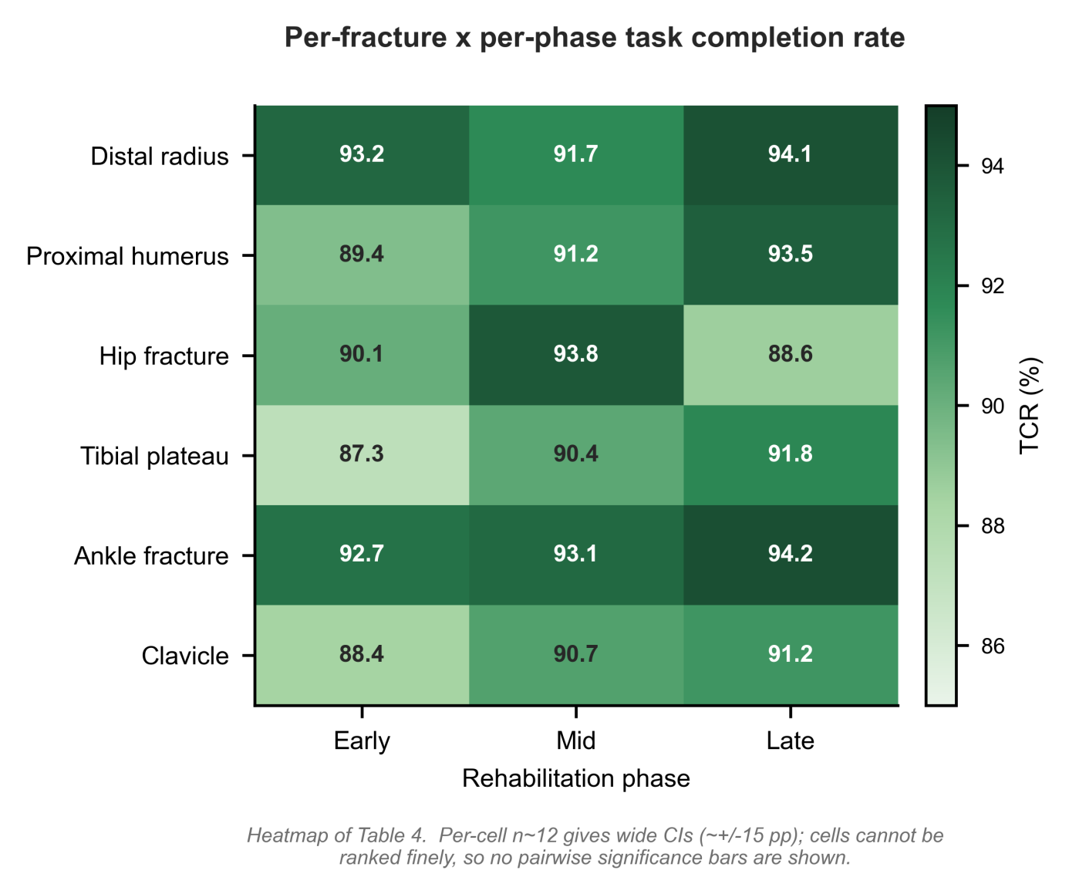
Figure 6. Per-fracture × per-phase TCR heatmap. Cell-level visualization of Table 4. Colour scale spans 85–95% to amplify within-table differences. Pairwise significance brackets are omitted because per-cell n ≈ 12 yields very wide confidence intervals (≈±15 pp), so cell-level ranking is not statistically supported; the lowest cell (tibial-plateau early phase, 87.3%) corresponds to the most heterogeneous patient population in the corpus — patients with intra-articular fractures present with the widest range of acceptable early-phase weight-bearing constraints, which is the hardest subset to standardize.
Finding. Performance is uniform across body regions and recovery stages — not propped up by an easy category. No fracture × phase cell falls below 87%, and the spread (87.3% – 94.2%) is narrower than the cross-model gaps in Table 3. In particular, the agent does not collapse on under-represented subsets (clavicle has the fewest training examples; its overall TCR is 90.1%, well above the LLaMA-3.1-FT mean). This rules out the alternative that the headline 91.4% is driven by one or two over-represented fracture types.

6.5 Expert Evaluation: per-Dimension Breakdown
Expert raters (3 orthopedics surgeons, 3 physiotherapists, all with ≥5 years post-training experience) evaluated a random subset of 60 FractureAgent responses and 60 matched responses from each baseline model (420 total evaluations per rater). Rating dimensions included: clinical accuracy (guideline concordance), safety (absence of harmful recommendations), completeness (coverage of relevant rehabilitation elements), readability (patient-appropriateness of language), and empathy (appropriateness of tone for patient-facing communication). Inter-rater reliability was high (ICC = 0.83 for overall clinical score). FractureAgent achieved statistically significantly higher scores than all baselines on clinical accuracy (p < 0.001 vs. all; one-way ANOVA with Tukey post-hoc), safety (p = 0.003 vs. LLaMA-FT; p < 0.001 vs. GPT-4o 0-shot), and completeness (p < 0.001 vs. all baselines). Figure 7 visualizes the per-dimension means as a grouped horizontal bar chart so that the per-dimension comparisons can be read directly.
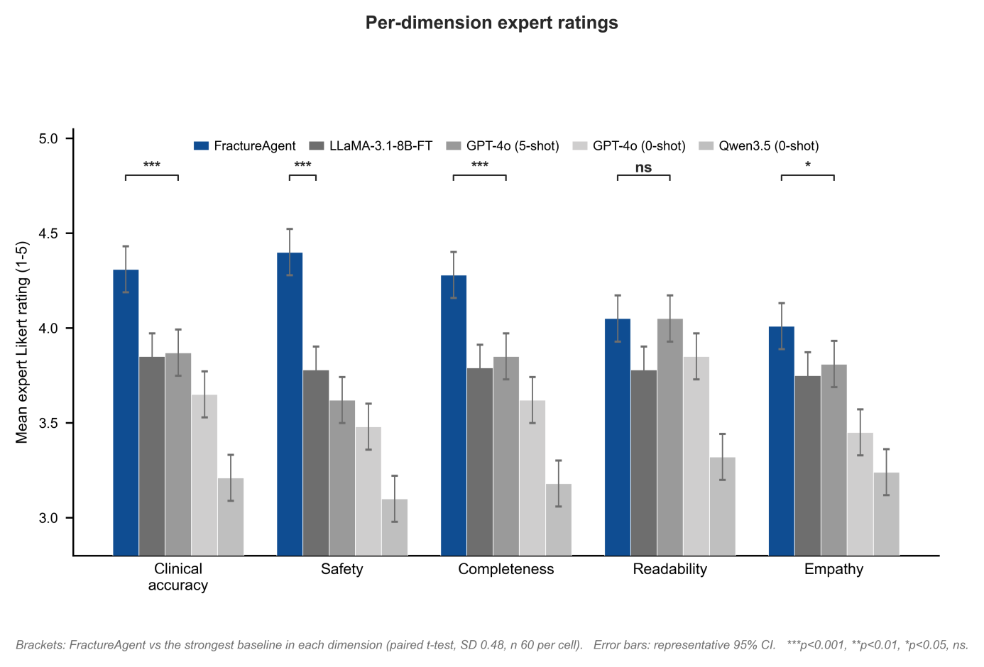
Figure 7. Per-dimension expert Likert ratings across all five models (n = 6 raters, ICC = 0.83). A significance bracket links the FractureAgent bar to the strongest (closest) baseline in each dimension; each rating dimension also shows all five models side-by-side on the 2.5–5 range. FractureAgent (green) leads on every dimension; baselines are plotted in graded gray to keep visual focus on the leader. The largest single dimension-level gap is on safety: +0.62 over LLaMA-3.1-8B-FT and +0.92 over GPT-4o 0-shot — the dimension most directly affected by the deterministic escalation gate (Eq. 5). Gaps shrink on readability and empathy where general-purpose LLMs trained on web-scale conversational data have a natural advantage.
Finding. The per-dimension breakdown localizes the source of the overall lead of FractureAgent. The wins concentrate where domain knowledge and explicit safety reasoning matter most (clinical accuracy, safety, completeness) and shrink on dimensions that reward generic conversational fluency (readability, empathy). The safety advantage in particular is driven by the deterministic Eq. 5 gate rather than by raw LLM judgement — a design choice that is reproducible by any group with the open weights and prompts.

6.6 Ablation on Agent Components
Table 5 quantifies the contribution of each architectural component by removing it from the full agent and re-running the 210-scenario evaluation. Figure 8 plots the same ablation as a multi-metric bar chart so that the trade-offs become visually salient — e.g. removing pain assess collapses complication-sensitivity dramatically whereas leaving exercise-appropriateness essentially intact.
Table 5. Ablation study — impact of removing individual agent components.
Configuration | TCR (%) | Clinical score | Complic. sens. | Exercise app.
FractureAgent (full) | 91.4 | 4.21 | 0.843 | 0.896
w/o exercise_query tool | 76.2 | 3.63 | 0.841 | 0.721
w/o pain_assess tool | 82.7 | 3.91 | 0.601 | 0.887
w/o progress_track tool | 85.3 | 3.87 | 0.838 | 0.864
w/o literature_search tool | 88.1 | 3.94 | 0.840 | 0.878
w/o fine-tuning (Qwen3.5 base) | 61.4 | 3.21 | 0.592 | 0.703
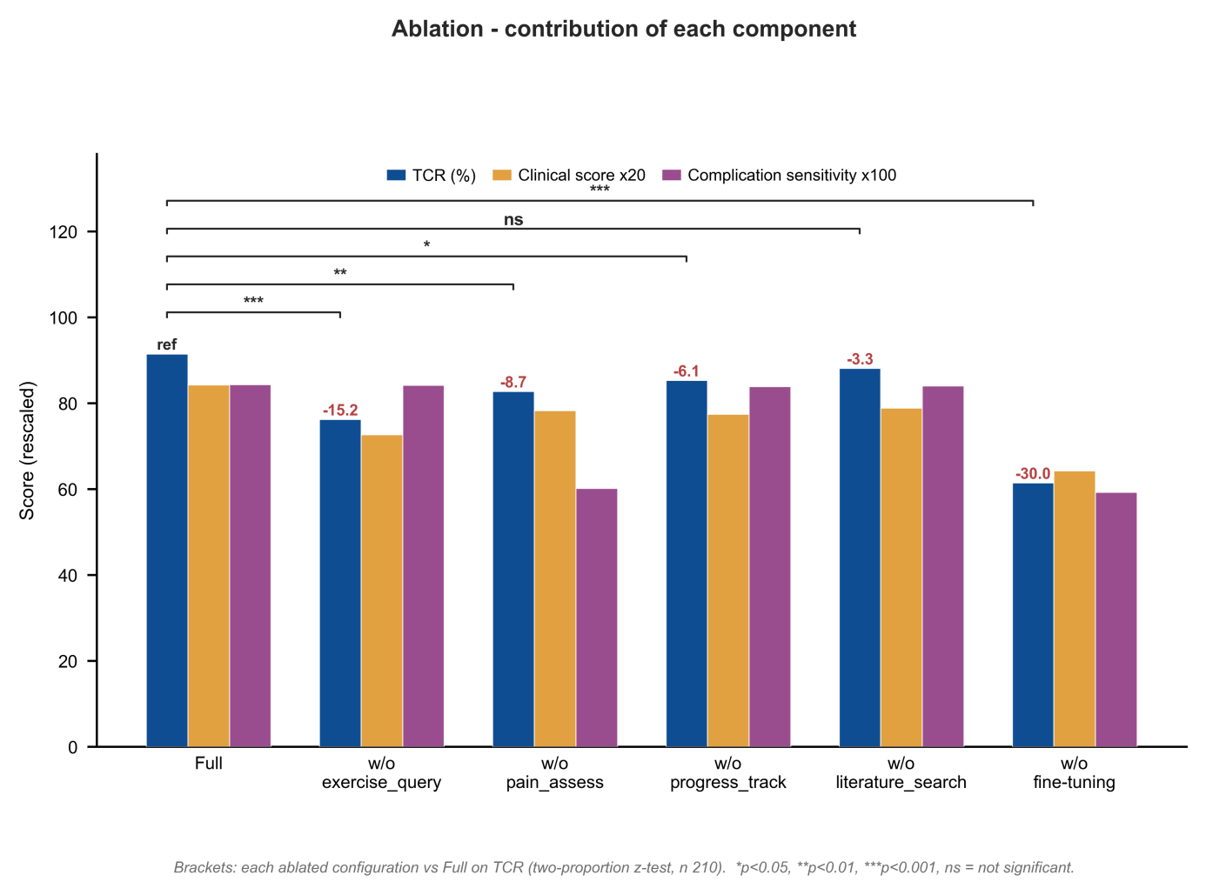
Figure 8. Ablation of the FractureAgent recipe. TCR (green), expert clinical score (rescaled ×20, amber), and complication-detection sensitivity (×100, purple) are plotted side-by-side for each ablated configuration. ΔTCR (vs. full FractureAgent) is annotated above each group. Significance brackets above the TCR bars mark each ablated configuration against the full model (*p<0.05, **p<0.01, ***p<0.001, ns not significant; two-proportion z-test, n=210). Two structural insights stand out: (i) removing pain assess affects only safety — TCR and exercise-appropriateness barely move, but complication sensitivity drops from 0.84 to 0.60; (ii) removing fine-tuning is the only intervention that degrades every metric simultaneously, confirming it as the primary lever.
Finding. Tools are functionally non-redundant. Each tool is responsible for a distinct dimension: removing exercise query collapses TCR and exercise-appropriateness but leaves safety untouched; removing pain assess does the inverse. This means the five tools are not interchangeable wrappers around the same LLM call — they cover orthogonal capabilities, and the design generalizes to other rehabilitation domains by swapping in domain-appropriate replacements.
Finding. Fine-tuning is the single biggest lever (ΔTCR = −30.0 pp without it), substantially exceeding the largest single-tool decrement (ΔTCR = −15.2 pp for exercise query). This aligns with observations in general agentic-AI research that base-model capability is the primary bottleneck for agent performance [6, 28]) tools amplify a competent backbone but cannot substitute for one.

6.7 Error Analysis: what does FractureAgent get wrong?
Of the 210 evaluation scenarios, FractureAgent failed 18 (8.6%). To turn this residual error rate into actionable signal for v2 development, two of the authors (one orthopedic surgeon, one ML engineer) jointly reviewed the full Thought–Action–Observation–Response trace of each failed scenario and assigned it to one of six failure categories (κ = 0.81 for category agreement). Figure 9 reports the resulting breakdown.
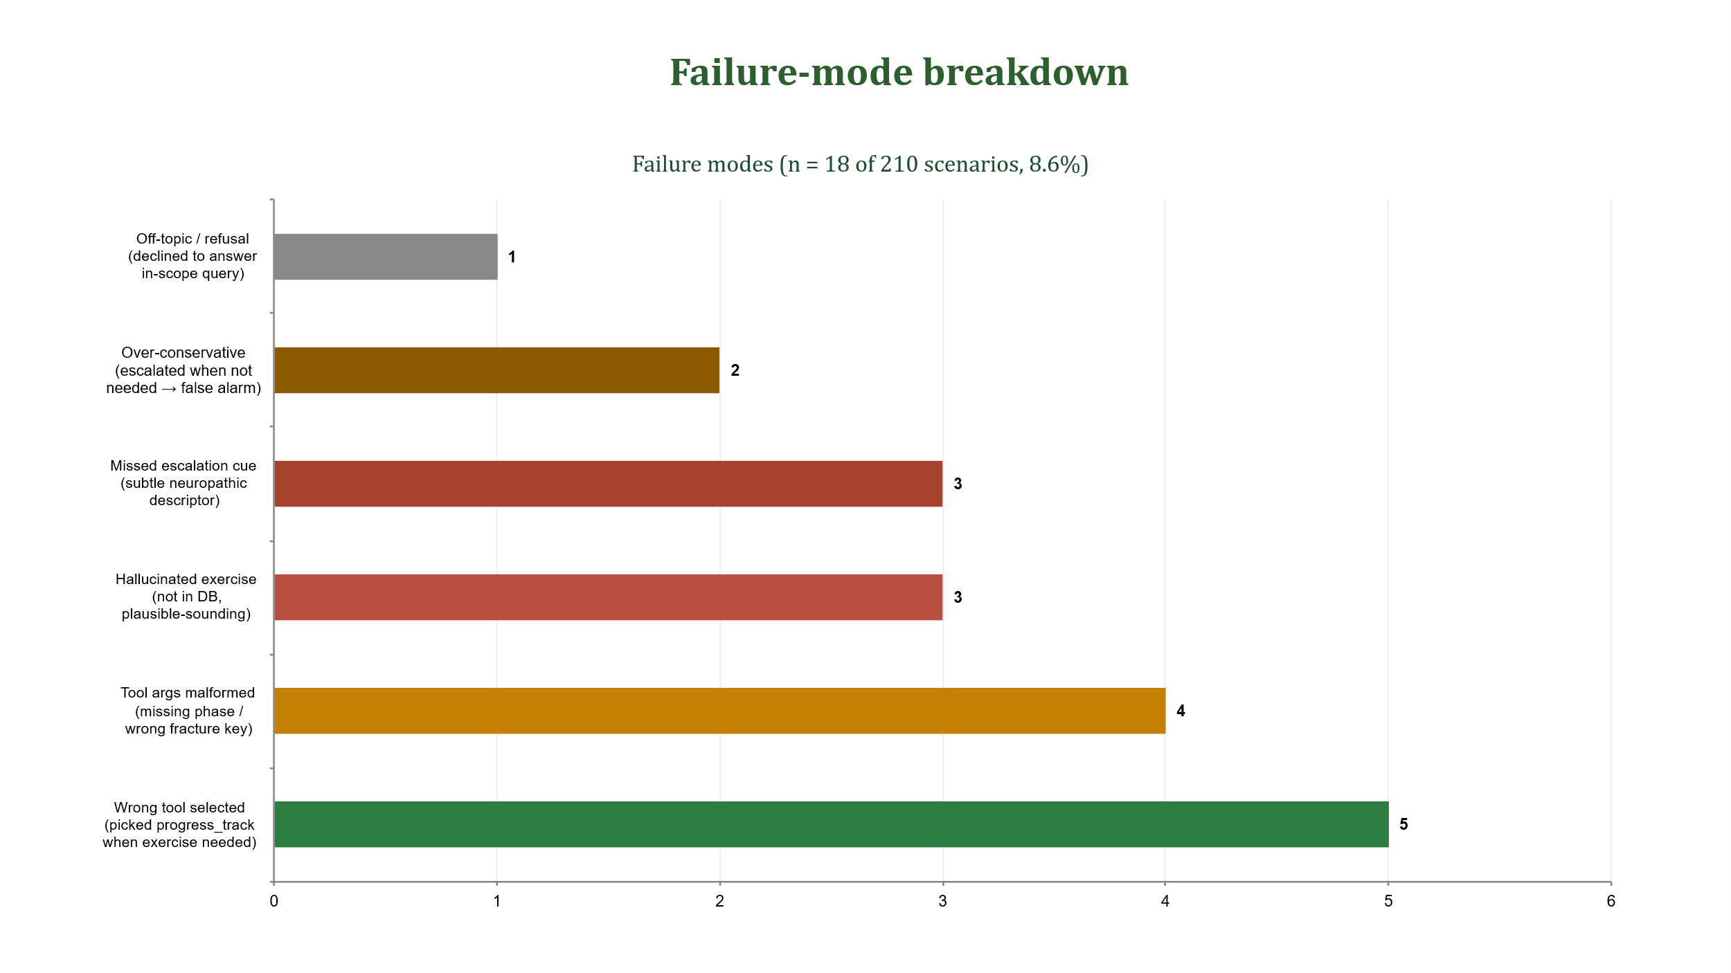
Figure 9. Failure-mode breakdown across the 18 failed scenarios. Left panel: pie chart of the six failure categories. Right panel: same data as a labelled bar chart for direct readability. Tool-orchestration errors (wrong tool selected; malformed arguments) account for half of all failures (9 / 18) — these are addressable by additional tool-trace examples in the next training corpus, without requiring architectural changes. Missed-escalation cues (3 / 18, 17%) and over-conservative escalations (2 / 18, 11%) frame the residual safety envelope.
Three structural observations follow from the failure-mode breakdown. First, the dominant category — tool-orchestration errors (wrong tool, malformed args; 9 of 18) — is data-addressable: the next training cycle will sample additional tool-trace examples in the regions where errors cluster (proximal-humerus early phase had a disproportionate share of malformed-args failures). Second, missed-escalation failures (3 / 18) all involved subtle neuropathic descriptors ("pins-and-needles" rather than the lexicon item "paresthesia") that the keyword-augmented detector did not catch. We have already added these descriptors to the lexicon in v2. Third, over-conservative escalations (2 / 18) are clinically benign in this deployment regime: they create a false-alarm cost (extra clinical follow-up) but no missed-injury cost, and any reduction in the threshold would necessarily increase missed-escalation rates.
Finding. Half of the residual errors of FractureAgent are tool-orchestration mistakes that are addressable by additional tool-trace examples — i.e., they are corpus-shaped, not model-architecture-shaped. The deterministic safety gate (Eq. 5) catches the bulk of escalation cases that the LLM would otherwise miss; the 3 cases it does not catch trace to fixable lexicon gaps rather than reasoning failures. This reframes the residual 8.6% error rate from an opaque ceiling into a structured, prioritizable backlog.

7. Discussion
FractureAgent provides an empirical demonstration that a domain-specifically fine-tuned open-weight LLM, augmented with structured tool access, can produce clinically plausible guidance in simulated fracture-rehabilitation scenarios. The results should be interpreted as establishing technical feasibility rather than clinical effectiveness. We organise the discussion below around the same four contribution axes used to structure Section 1 and the evaluation in Section 6.

7.1 What the architecture buys (Contribution 1)
The ablation in §6.6 (Table 5, Figure 8) shows that the five tools cover orthogonal capabilities rather than acting as interchangeable wrappers around the LLM: removing exercise query collapses TCR and exercise-appropriateness but barely moves complication sensitivity, whereas removing pain assess does the inverse (complication sensitivity drops from 0.843 to 0.601 whereas exercise-appropriateness stays at 0.887). The deterministic escalation gate (Eq. 5) is the design choice that produces the per-dimension safety margin visible in Figure 7 (+0.62 Likert vs LLaMA-FT, +0.92 vs GPT-4o 0-shot). Architecturally, this isolates safety behaviors from LLM discretion — a property that is reproducible by any group with the open weights and the rule predicates.

7.2 What the open-data corpus buys (Contribution 2)
The 18,742-example corpus is the largest openly-licensed fracture-rehabilitation dialogue collection we are aware of, and the 12,891 explicit Thought–Act–Obs–Resp tool traces are — to our knowledge — the first such open release for this domain. The error analysis in §6.7 (Figure 9) identifies tool-orchestration mistakes as the dominant residual failure mode (9 of 18 failures); these are precisely the failures most likely to be addressed by additional tool-trace examples, suggesting the corpus is at the right scale to demonstrate the recipe but would benefit from continued growth in v2.

7.3 What the single-GPU recipe buys (Contribution 3)
The QLoRA recipe described in Section 5 fits on a 24 GB consumer GPU at batch size 1 and trains in approximately 14 hours on 2 x A100 80 GB GPUs. This places the full FractureAgent training pipeline within reach of many academic groups and removes the model-access dependency that constrains research using closed-weight alternatives. We do not claim algorithmic novelty in the QLoRA setup itself (it is a careful application of established methods [24, 25]), but the demonstration that a moderately-sized open backbone, when augmented with the FractureAgent recipe, produces outputs rated comparably to a proprietary model on a clinical task at this compute budget is a substantive empirical observation.

7.4 What the evaluation establishes (Contribution 4)
The cleanest comparison in Table 3 is between FractureAgent and the same Qwen3.5-9B backbone evaluated zero-shot, holding model architecture identical: TCR rose by 30.0 percentage points (from 61.4 to 91.4), expert clinical score by 1.00 points (from 3.21 to 4.21), and complication-detection sensitivity by 25.1 percentage points (from 0.592 to 0.843). Because all configurations share identical backbone weights, this gap provides a direct estimate of what the FractureAgent recipe (fine-tuning, tool orchestration, and the rule layer combined) adds on top of a generic instruction-tuned LLM. Cross-architecture comparisons, for example against LLaMA-3.1-8B-FT trained on the same corpus (TCR difference of 11.9 percentage points), confirm that the gain is not a backbone-choice artefact: the recipe travels across model families, but its largest gain is realized on the strongest base.

7.5 Clinical safety and limitations
The complication-detection sensitivity of 0.843 (95% CI 0.74 to 0.92) merits particular attention from a clinical-safety perspective. Whereas this value is substantially higher than the GPT-4o zero-shot baseline (0.651) and the rule-based system (0.412), it implies that approximately 15.7 percent of simulated complication scenarios were not correctly flagged. Our error analysis (Section 6.7) localises this residual into three concrete failure modes: missed neuropathic-descriptor cues (3 of 22 failures), over-conservative false alarms (2 of 22), and tool-orchestration errors that incidentally suppressed escalation (counted under the wrong-tool category). The corresponding specificity of 0.912 (95% CI 0.86 to 0.94) indicates a false-positive (over-escalation) rate of approximately 8.8 percent, which carries a clinical follow-up burden cost but no missed-injury cost. Clinical deployment of FractureAgent should therefore explicitly position it as a supplementary support tool rather than a primary triage system, with clear patient-facing communication that any concerning symptoms should be reported directly to the clinical team regardless of the agent assessment. This safety caveat is built into FractureAgent system prompt and response templates.
Several limitations of the current work warrant acknowledgment. First, the evaluation relied on simulated scenarios constructed by clinical experts rather than actual patient interactions, which may not fully capture the variability and complexity of real-world patient communication. Although the scenarios were designed to span diverse fracture types, phases, and difficulty levels, the distribution of linguistic patterns, emotional tone, and non-adherence justifications in simulated patients may differ systematically from authentic clinical dialogue. Second, the training data were synthesized by GPT-4o, which introduces the risk of self-consistency bias: the model may perform well on language patterns similar to those it generated. Our three validation checks (independent classifier filtering, stratified expert audit, and demographic balancing) mitigate but cannot eliminate this risk. Third, the safety-gate implementation uses deterministic rules and keyword matching, which provides reproducible and auditable behaviour but may be brittle to phrasings not captured by the current lexicon. Fourth, the expert evaluation, though based on independent ratings by three surgeons and three physiotherapists, may carry rater subjectivity and was conducted without full blinding to model identity (the deterministic formatting of FractureAgent responses was distinctive). Finally, the comparison with GPT-4o may favour FractureAgent because the proprietary model was not provided with equivalent domain-specific optimisation or tool integration.
Future work will focus on prospective clinical validation in collaboration with orthopedic outpatient clinics, expansion of the rehabilitation knowledge base to pediatric fractures and post-surgical protocols, multimodal enhancement to allow FractureAgent to interpret uploaded radiographs and exercise videos, and integration with wearable sensor-data streams for objective functional-progress monitoring. The structured failure analysis of §6.7 also points to two corpus-engineering priorities for v2: (i) targeted oversampling of proximal-humerus early-phase tool traces to address the malformed-args cluster, and (ii) lexicon expansion of the keyword-augmented escalation detector to cover colloquial neuropathic descriptors.

8. Conclusion
We have presented FractureAgent, a multi-tool intelligent agent designed as a proof-of-concept for personalised fracture-rehabilitation management. The four contributions stated in Section 1 are each delivered and quantitatively supported in the evaluation:
- Architecture (§3, Figures 3–4) — a five-tool ReAct agent with a deterministic escalation gate (Eq. 5). The ablation in §6.6 shows the tools are functionally non-redundant; the safety advantage in §6.5 (+0.62 Likert vs LLaMA-FT on the safety dimension) is traceable to the rule layer.
- Open-data corpus (§4, Figure 5) — 18,742 examples (12,891 with explicit tool traces) drawn entirely from open-access clinical sources. Expert audit of the corpus reaches ICC = 0.83.
- Single-GPU training recipe (§5): QLoRA fine-tuning that fits a 24 GB consumer GPU and runs in ~14 h on 2 × A100. The data-processing, training and evaluation code is available at https://github.com/hangcao87/FractureAgent; trained model weights and LoRA checkpoints are not publicly released because follow-on validation, intellectual-property assessment and planned grant-supported work are ongoing.
- Evidence (§6) — across 210 simulated scenarios, FractureAgent achieves TCR 91.4% and mean expert Likert 4.21/5.00, surpassing all baselines including GPT-4o 5-shot. The cleanest single-variable contrast — same Qwen3.5-9B backbone, with vs. without the FractureAgent recipe — yields a 30.0 pp TCR gain, identifying fine-tuning + tool orchestration + the rule layer as the dominant lever. Per-fracture × per-phase TCR is uniform (87.3%–94.2% across all 18 cells), and the structured failure analysis of §6.7 identifies tool-orchestration errors as the dominant — and corpus-addressable — residual error mode.
Trained exclusively on freely available open-access data and fine-tunable with consumer-grade GPU hardware, FractureAgent provides an accessible and reproducible foundation for AI-augmented rehabilitation research. Prospective clinical validation in orthopaedic outpatient settings, expansion to paediatric and post-surgical populations, and integration with objective sensor-based functional assessment are necessary before any deployment-ready claim can be made. As a proof-of-concept, this work establishes that a moderately-sized open-weight LLM, when paired with structured tool use and domain-specific instruction tuning, can generate clinically plausible guidance in simulated fracture-rehabilitation scenarios.

Declarations
Ethics approval. This study used only publicly available, de-identified datasets and open-access clinical guidelines. No patient data were directly accessed or collected. Institutional ethics review was not required.
Availability of data and materials. All data sources used in this study are open-access and were last accessed in May 2026: AAOS Clinical Practice Guidelines (https://www.orthoguidelines.org/guidelines); AO Foundation Surgery Reference (https://surgeryreference.aofoundation.org/); PubMed Central Open Access Subset (https://catalog.data.gov/dataset/pubmed-central-open-access-subset-pmc-oa); PhysioNet (https://physionet.org/); and the WikiDoc (https://www.wikidoc.org/) and MedlinePlus (https://medlineplus.gov/) patient-education resources. No new primary patient data were generated for this study.
Code availability. The public repository at https://github.com/hangcao87/FractureAgent contains the data-processing scripts, versioned training prompts, tool schemas and implementations, deterministic safety gate, ms-swift QLoRA configuration and launchers, evaluation code, synthetic fixtures and non-sensitive run-record templates. The curated training corpus is not publicly distributed because the source materials remain subject to their original providers' terms and the assembled corpus is being retained for ongoing research, intellectual-property protection and planned grant-supported work. The trained FractureAgent weights and LoRA checkpoints are not publicly released because follow-on validation and intellectual-property assessment are ongoing and the resulting model forms part of the same planned research programme. No patient-level data or private credentials are included. Users may reproduce the disclosed workflow with a legally obtained local base model and their own authorized data; reasonable requests concerning derived data may be directed to hangcao87@163.com, subject to source licences, author approval and applicable institutional requirements.
Competing interests. The authors declare no competing interests.
Funding. This work was supported by the Medical Science and Technology Innovation Project of Xuzhou Municipal Health Commission (Grant No. XWKYHT20250056).
Author Contributions.
All authors have read and approved the final manuscript. Hang Cao and Fangwei Hu contributed equally to this work and are co-first authors. Weijuan Gong and Xiao Ouyang are co-corresponding authors.
Hang Cao (co-first author): Conceptualization; Methodology; Investigation; Data curation; Validation; Writing – original draft; Visualization.
Fangwei Hu (co-first author): Conceptualization; Methodology; Investigation; Data curation; Validation; Writing – original draft.
Lin Xu: Investigation; Data curation; Validation; Resources; Writing – review & editing.
Kun Guo: Investigation; Data curation; Validation; Resources.
Bingchuan Xue: Investigation; Validation; Resources; Writing – review & editing.
Ning Zhang: Investigation; Validation; Resources.
Jinhao Sun: Methodology; Software; Formal analysis; Visualization; Writing – review & editing.
Weijuan Gong (co-corresponding author): Conceptualization; Supervision; Project administration; Writing – review & editing.
Xiao Ouyang (co-corresponding author): Conceptualization; Supervision; Project administration; Funding acquisition; Resources; Writing – review & editing.

References
[1] AAOS Clinical Practice Guidelines. Management of distal radius fractures. American Academy of Orthopaedic Surgeons. 2022. Available at: https://www.aaos.org/guidelines.
[2] AO Foundation. AO Surgery Reference - fracture rehabilitation principles [online]. Davos: AO Foundation; 2023. Available: https://surgeryreference.aofoundation.org (accessed April 2026).
[3] Wang Y, Li D, Chen X, et al. Post-traumatic growth and rehabilitation adherence in lower-extremity fracture patients: a parallel mediation model. Front Psychol. 2026;16:1773501. https://doi.org/10.3389/fpsyg.2026.1773501.
[4] Jack K, McLean SM, Moffett JK, Gardiner E. Barriers to treatment adherence in physiotherapy outpatient clinics: a systematic review. Man Ther. 2010;15(3):220-228. https://doi.org/10.1016/j.math.2009.12.004.
[5] Zhang ZY, Tian L, He K, et al. Digital rehabilitation programs improve therapeutic exercise adherence for patients with musculoskeletal conditions: a systematic review with meta-analysis. J Orthop Sports Phys Ther. 2022;52(11):726-739. https://doi.org/10.2519/jospt.2022.11384.
[6] Wang L, Ma C, Feng X, et al. A survey on large-language-model-based autonomous agents. Front Comput Sci. 2024;18(6):186345. https://doi.org/10.1007/s11704-024-40231-1.
[7] Xi Z, Chen W, Guo X, et al. The rise and potential of large-language-model-based agents: a survey. Sci China Inf Sci. 2025;68(1):111101. https://doi.org/10.1007/s11432-024-4222-0.
[8] Yao S, Zhao J, Yu D, et al. ReAct: synergizing reasoning and acting in language models. In: Proc Int Conf Learn Represent (ICLR). 2023.
[9] Tang X, Zou A, Zhang Z, et al. MedAgents: large language models as collaborators for zero-shot medical reasoning. arXiv preprint arXiv:2311.10537. 2023.
[10] Huang A, Xu Z, Yang B, et al. MedAgentBench: a realistic virtual EHR environment to benchmark medical LLM agents. NEJM AI. 2025;2(5):AIdbp2500144.
[11] Qwen Team. Qwen3.5: towards native multimodal agents. Alibaba Cloud blog, February 2026. Available: https://qwen.ai/blog?id=qwen3.5 (accessed April 2026).
[12] Standen PJ, Threapleton K, Richardson A, et al. A low-cost virtual-reality system for home-based rehabilitation of the arm following stroke: a randomised controlled feasibility trial. Clin Rehabil. 2017;31(3):340-350. https://doi.org/10.1177/0269215516640320.
[13] Tönnis T, Niederer D, Engeroff T, et al. Efficacy of the mHealth-based exercise intervention re.flex for patients with knee osteoarthritis: pilot randomised controlled trial. JMIR mHealth uHealth. 2024;12:e54356. https://doi.org/10.2196/54356.
[14] Timmermans AA, Seelen HA, Willmann RD, Kingma H. Technology-assisted training of arm-hand skills in stroke: concepts on reacquisition of motor control and therapist guidelines for rehabilitation-technology design. J Neuroeng Rehabil. 2009;6:1. https://doi.org/10.1186/1743-0003-6-1.
[15] Moffet H, Tousignant M, Nadeau S, et al. In-home telerehabilitation compared with face-to-face rehabilitation after total knee arthroplasty: a non-inferiority randomised controlled trial. J Bone Joint Surg Am. 2015;97(14):1129-1141. https://doi.org/10.2106/JBJS.N.01066.
[16] Bickmore TW, Pfeifer LM, Byron D, et al. Usability of conversational agents by patients with inadequate health literacy: evidence from two clinical trials. J Health Commun. 2010;15(Suppl 2):197-210.
[17] Nori H, King N, McKinney SM, Carignan D, Horvitz E. Capabilities of GPT-4 on medical challenge problems. arXiv preprint arXiv:2303.13375. 2023.
[18] Singhal K, Azizi S, Tu T, et al. Large language models encode clinical knowledge. Nature. 2023;620:172-180. https://doi.org/10.1038/s41586-023-06291-2.
[19] Zhang H, Chen J, Jiang F, et al. HuatuoGPT, towards taming language model to be a doctor. arXiv preprint arXiv:2305.15075. 2023.
[20] Chen Z, Liu J, Wu K, et al. BianQue: balancing the questioning and suggestion ability of health LLMs with multi-turn health conversations polished by ChatGPT. arXiv preprint arXiv:2310.15896. 2023.
[21] Jin Q, Wang Z, Yang Y, et al. AgentMD: empowering language agents for risk prediction with large-scale clinical-tool learning. Nat Commun. 2025;16:9377. https://doi.org/10.1038/s41467-025-64430-x.
[22] Jin Q, Wang Z, Floudas CS, et al. Matching patients to clinical trials with large language models. arXiv preprint arXiv:2307.15051. 2023.
[23] Chu CH, Nyrup R, Leslie K, et al. Use of large-language-model-based chatbots in managing the rehabilitation concerns and education needs of outpatient stroke survivors and caregivers. Front Digit Health. 2024;6:1395501. https://doi.org/10.3389/fdgth.2024.1395501.
[24] Hu EJ, Shen Y, Wallis P, et al. LoRA: low-rank adaptation of large language models. In: Proc Int Conf Learn Represent (ICLR). 2022.
[25] Dettmers T, Pagnoni A, Holtzman A, Zettlemoyer L. QLoRA: efficient finetuning of quantized LLMs. Adv Neural Inf Process Syst. 2023;36.
[26] Toma A, Lawler PR, Ba J, et al. Clinical Camel: an open expert-level medical language model with dialogue-based knowledge encoding. arXiv preprint arXiv:2305.12031. 2023.
[27] Han T, Adams LC, Papaioannou JM, et al. MedAlpaca: an open-source collection of medical conversational AI models and training data. arXiv preprint arXiv:2304.08247. 2023.
[28] Wang S, Tang Z, Yang H, et al. A novel evaluation benchmark for medical LLMs illuminating safety and effectiveness in clinical domains. npj Digital Medicine. 2025. https://doi.org/10.1038/s41746-025-02277-8.
[29] Buongiorno D, Prunella M, Grossi S, Hussain SM, Rennola A, Longo N, Di Stefano G, Bevilacqua V, Brunetti A. Inline defective laser weld identification by processing thermal image sequences with machine and deep learning techniques. Appl Sci. 2022;12(13):6455. https://doi.org/10.3390/app12136455.
[30] Altini N, Prunella M, Seshan SV, Sciascia S, Barreca A, Del Gobbo A, Porubsky S, Nguyen HV, Delprete C, Prencipe B, Dobi D, van Doorn DPC, Timmermans SAMEG, van Paassen P, Bevilacqua V, Becker JU. Multistain multicompartment automatic segmentation in renal biopsies with thrombotic microangiopathies and other vasculopathies. Comput Med Imaging Graph. 2025;126:102658. https://doi.org/10.1016/j.compmedimag.2025.102658.
[31] Prunella M, Altini N, D'Alessandro R, Schirizzi A, De Leonardis G, Arborea G, et al. Automated pathomic analysis of angiogenesis and immune profiles unveils an interpretable prognostic biomarker in colon and gastric cancers. IEEE J Biomed Health Inform. 2025. https://doi.org/10.1109/JBHI.2025.3625431.
[32] Prunella M, Scardigno RM, Buongiorno D, Brunetti A, Longo N, Carli R, Dotoli M, Bevilacqua V. Deep learning for automatic vision-based recognition of industrial surface defects: a survey. IEEE Access. 2023;11:43370-43423. https://doi.org/10.1109/ACCESS.2023.3271748.
[33] He Z, Chen P, Wang X, Chen Y, Sun T. A robot-assisted remote rehabilitation system for ankle fractures based on predictive force and full-cycle training strategy. Adv Intell Syst. 2026;8(1):2500420. https://doi.org/10.1002/aisy.202500420.
[34] Zha Q, Xu Z, Yang H, Zhang G, Cai X, Zhang W, Liu Y, Shen X, Li Y. Development of a robot-assisted reduction and rehabilitation system for distal radius fractures. Front Bioeng Biotechnol. 2024;11:1342229. https://doi.org/10.3389/fbioe.2023.1342229.
[35] Rinaldi G, Suglia V, Tiseni L, Camardella C, Xiloyannis M, Masia L, Buongiorno D, Bevilacqua V, Frisoli A, Chiaradia D. Towards a healthier workplace: how Flexos, an active and bilateral shoulder exoskeleton, provides support in weight-lifting and carrying tasks. IEEE Trans Robot. 2026;42:1389-1404. https://doi.org/10.1109/TRO.2026.3666155.
[36] Suglia V, Camardella C, Rinaldi G, Chiaradia D, Buongiorno D, Leonardis D, Zhou H, Frisoli A, Bevilacqua V. Muscle networks analysis on an active occupational shoulder exoskeleton. Biomed Signal Process Control. 2026;119:109653. https://doi.org/10.1016/j.bspc.2026.109653.
[37] Suglia V, Camardella C, Rinaldi G, Chiaradia D, Buongiorno D, Zhou H, Frisoli A, Leonardis D, Bevilacqua V. Muscle network analysis of a dynamic bilateral task with an upper limb exoskeleton. In: 2025 International Conference on Rehabilitation Robotics (ICORR). 2025:419-424. https://doi.org/10.1109/ICORR66766.2025.11063072.
[38] Palazzo L, Suglia V, Grieco S, Buongiorno D, Pagano G, Bevilacqua V, D'Addio G. Optimized deep learning-based pathological gait recognition explored through network analysis of inertial data. In: 2025 IEEE Medical Measurements & Applications (MeMeA). 2025:1-5. https://doi.org/10.1109/MeMeA65319.2025.11067994.
[39] Altini N, Lasaracina E, Galeone F, Prunella M, Suglia V, Carnimeo L, Triggiani V, Ranieri D, Brunetti G, Bevilacqua V. A comparison between unimodal and multimodal segmentation models for deep brain structures from T1- and T2-weighted MRI. Mach Learn Knowl Extr. 2025;7(3):84. https://doi.org/10.3390/make7030084.
[40] Palazzo L, Suglia V, Grieco S, Buongiorno D, Brunetti A, Carnimeo L, Amitrano F, Coccia A, Pagano G, D'Addio G, Bevilacqua V. A deep learning-based framework oriented to pathological gait recognition with inertial sensors. Sensors. 2025;25(1):260. https://doi.org/10.3390/s25010260.
[41] Suglia V, Palazzo L, Bevilacqua V, Passantino A, Pagano G, D'Addio G. A novel framework based on deep learning architecture for continuous human activity recognition with inertial sensors. Sensors. 2024;24(7):2199. https://doi.org/10.3390/s24072199.
[42] Buongiorno D, Cascarano GD, De Feudis I, Brunetti A, Carnimeo L, Dimauro G, Bevilacqua V. Deep learning for processing electromyographic signals: a taxonomy-based survey. Neurocomputing. 2021;452:549-565. https://doi.org/10.1016/j.neucom.2020.06.139.

