Notice on Xiamen University Guidelines for Graduate Theses/Dissertations

The following guidelines for graduate theses and dissertations have been established in accordance with the University regulations on the management of academic degrees and are applicable to all schools/institutes at the University:
I. Manuscript Layout
The various sections of the thesis/dissertation（practical achievement report） and the order in which they appear shall be as follows:
1. Front Cover;
- Declaration of Originality;
- Declaration of Authorship;
- Declaration on the Use of Artificial Intelligence Tools
- Abstract in Chinese;
- Abstract in English;
- Keywords;
- Table of Contents;
- Main Body:
(1) Introduction;
(2) Experiment and calculation, or factual or theoretical analysis; and
(3) Conclusion;
- Appendix;
- Bibliography;
- Acknowledgements;
- List of Defense Committee Members
- Back Cover
II. Manuscript Format
The thesis/dissertation（practical achievement report） shall be formatted in accordance with the Xiamen University Guidelines for the Format of Graduate thesis/dissertation（practical achievement report） Manuscripts (see Exhibit 1). The front cover, the Declaration of Originality and the Declaration of Consent to Grant Rights of Use shall be in the unified formats specified by the Graduate School (see Exhibits 2, 3 and 4).
III. Manuscript Length
In general, a thesis shall be no less than 30,000 Chinese characters, and a dissertation shall be no less than 50,000 Chinese characters.

Exhibits:
1. Xiamen University Guidelines for the Format of Graduate thesis/dissertation（practical achievement report） Manuscripts
2. Xiamen University Format of the Front Cover of Graduate thesis/dissertation（practical achievement report） Manuscripts
3. Xiamen University Declaration of Originality for Graduate Theses/Dissertations
- Xiamen University Declaration of Consent to Grant Rights of Use for Graduate Theses/Dissertations
Appendix 1:
Xiamen University Guidelines for the Format of Graduate thesis/dissertation Manuscripts
This document sets forth the format requirements for graduate thesis/dissertation（practical achievement report） manuscripts at Xiamen University. These requirements are applicable to all schools/institutes at the University.
Format Requirements for Graduate thesis/dissertation（practical achievement report） Manuscripts:
1. The manuscript of a thesis or dissertation should be printed on A4 paper.
2. The Front Cover of the Manuscript:
(1) Color: Deep Blue, Light Blue, Light Yellow or Light Green;
(2) The font type and size and the format of the front cover should follow the Xiamen University Guidelines for the Format of the Front Covers of thesis/dissertation（practical achievement report） Manuscripts; and
(3) The title of the thesis or dissertation should be written in both Chinese and English, with the English title placed under the Chinese one.
3. The Spine of the Bound Copies of the Manuscript:
The title of the thesis/dissertation（practical achievement report） and the name of the author should be typed on the spine of the bound copies of the manuscript in Times New Roman with a fitting font size.
4. The pages following the front cover should be the Xiamen University Statement of Originality of Graduate Theses/Dissertations and the Xiamen University Statement on the Copyright Ownership of Graduate Theses/Dissertations.
5. Table of Contents
(1) The Table of Contents should, as a minimum requirement, list the titles and page numbers of the chapters and sections. Both Chinese and English versions of the Table of Contents should be provided.
(2) Chapter titles should be typed in Times New Roman bold 14 pt;
(3) Section titles should be typed in Times New Roman bold 12 pt;
(4) Subsection titles should be typed in Times New Roman 12 pt.
6. Abstract
(1) The Abstract should be written in both Chinese and English. The Chinese version of the abstract should be typed in “Songti” “Smaller 4”, and the English version should be typed in Times New Roman 12 pt.
(2) The Chinese version should be approximately 600 Chinese characters, and the English version should be approximately 600-800 words;
(3) The Abstract should summarize the topic, significance and innovation of the research, as well as the main viewpoints and findings.
7. Keywords
(1) The number of keywords in Chinese and English should be three to five, and the keywords should reflect the main contents of the thesis or dissertation and conform to academic norms;
(2) The Chinese version of the keywords should be typed in “Songti” “Smaller 4”, and the English version should be typed in Times New Roman 12 pt. Each keyword shall contain no more than five Chinese characters or five equivalent English words.
(3) The keywords should be separated by semicolons;
(4) An example of the format:
关键词：资产重组；市场反应；实证研究
Keywords: Capital Reorganization; Market Reaction; Empirical Study.
8. Manuscript Text
(1) The text of the manuscript should be typed in Times New Roman 12 pt;
(2) The text should be one-and-a-half spaced;
(3) Each page should have a header and be numbered sequentially.
9. Titles in the Manuscript Text
(1) Chapter titles should be typed in Times New Roman bold 15 pt;
(2) Section titles should be typed in Times New Roman bold 14 pt;
(3) Subsection titles and paragraph titles should be typed in Times New
Roman bold 12 pt;
(4) Titles should be concise and capture the main points; no punctuation should be used in the titles;
(5) All chapters and sections of the text should be numbered sequentially in a consistent manner.
10. Tables
(1) Tables should be numbered sequentially and table titles should be typed in Times New Roman bold 12 pt; table numbers and table titles should be center-aligned above the table, and the measuring unit should be right-aligned above the table;
(2) Data source should indicate the author, source and period of the data, be typed in Times New Roman 9 pt, and place left-aligned below the table;
(3) A blank line should be left between the table and the preceding and subsequent paragraphs of the text.
Example:
Table 1: ICBC Assets and Liabilities from 1995 to 1998 Amounts in RMB billions
Year | 1995 | 1996 | 1997 | 1998
Total Assets
Net Assets
Total Liabilities
Data Source: People’s Bank of China: 1999 Year Book, China Statistics Press, May 2001
11. Figures
(1) Figures should be numbered sequentially and figure titles and measuring units should be typed in Times New Roman 12 pt.; figure numbers and titles should be center-aligned above the figure;
(2) All figures should indicate their measuring unit;
(3) Figure source should indicate the author, source and period of the data, be typed in Times New Roman 9 pt, and place left-aligned below the figure;
(4) A blank line should be left between the figure and the preceding and subsequent paragraphs of the text.

Example:
GNP%

1995 1996 1997 1998
Fig. 1: Xiamen’s GDP Growth from 1995 to 2000
12. Notes
Notes should be given about the titles and authors of the articles cited or about a particular point in the text. Notes about titles and authors should be placed at the foot of the page, and notes about a particular point in the text can be placed in a parenthesis inserted in the text or placed at the foot of the page. Notes should be numbered sequentially with numerals in circles.
13. Bibliography
Each school/institute may decide on the sequence of works listed according to the customary practices in the relevant field of study.
All works cited in the text should be listed alphabetically by first author’s last name in the bibliography. For each work cited, the first line should be typed flush with the left margin, and any additional lines are indented as a group a few spaces to the right of the left margin (this is called a hanging indent).
Capitalize the first words, the last words, and all principal words, including those that follow hyphens in compound terms. Use lowercase abbreviations to identify the parts of a work (e.g., Vol. for volume, Ed. for editor) except when these designations follow a period. Separate author, title, and publication information with a period followed by one space.
The following marker designations should be followed for works cited:
M for monographs; C for paper collections; N for newspaper articles; J for journal articles; D for dissertations; R for research reports; S for standards; and P for patents.
Works extracted from monographs or paper collections should be marked as “A”,
and for other types of works without a designation, use the mark “Z”.
Example:
Blommaert, J., & Bulcaen, C. 2000. Critical discourse analysis [J]. Annual Review of Anthropology, 29, 447-466.
Cupach, W. R., & Imahori, T. 1993. Identity management theory [A]. In R. L. Wiseman & J. Koester (Eds.), Intercultural communication competence [C]. 112-131. Newbury Park, CA: Sage.
Fairclough, N. 2003. Analysing discourse: Textual analysis for social research [M]. London: Routledge.
Fowler, R., Hodge, B., Kress, G., & Trew, T. 1979. Language and control [M]. New York: Routledge & Kagan Paul.
Ji, Yuhua. 1998. Stories stimulate learning [N]. 21st Century, Feb. 25 (4).
Kress, G., & van Leeuwen, T. 1996. Reading images: The grammar of visual design [M]. London: Routledge.
Li, Wei., Zhu, Hua., & Li, Yue. 2001. Conversational management and involvement in Chinese-English business talk [J]. Language and Intercultural Communication, 1(2), 135-150.
Rogers, R. 2004a. An introduction to critical discourse analysis in education [A]. In Rogers (Ed.), 2004c, 1-18.
Rogers, R. 2004b. Setting an agenda for critical discourse analysis in education [A]. In Rogers (Ed.), 2004c, 237-253.
Rogers, R. (Ed.). 2004c. An introduction to critical discourse analysis in education [C]. Mahwah, NJ: Lawrence Erlbaum Associates.
Wodak, R. 1999. Critical discourse analysis at the end of the 20th century [J]. Research on Language and Social Interaction, 32(1&2), 185-193.
14. Other Formatting Requirements
(1) Title and paragraph formatting should be consistent for chapters, sections and subsections (indented or flush with the left margin);
(2) Style should be consistent for all chapters; for example, whether all chapters have an introduction;
(3) Dates: In British English, dates are written as 5 February 2005 or 5th February 2005. In American English, it is February 5, 2005. Avoid: the 5th of February and February 5th 2005;
(4) Heading numbers should not be placed in a parenthesis, such as (I) or (I.); headings should not be followed by a period;
(5) Typographical inconsistencies should not exceed 0.02% of the entire manuscript text.

Exhibit 2:

Institution Code: 10384
Student ID No.: 200215001

(Times New Roman bold 12 pt)


(Times New Roman bold 18 pt)
Indicate Master’s or Doctoral

Graduate thesis/dissertation（Practical Achievement Report）

（Academic Degree/Professional Degree)
(Indicate the corresponding degree)
(Heti bold 2)

资产重组：一个资不抵债国有企业的最佳选择
Asset Restructuring: The Best Option for an Insolvent State-Owned Enterprise
(Times New Roman 18 pt)

Name of Author
(Times New Roman bold 16 pt)

Supervisor: Prof. XXXX
Major:
(Times New Roman 14 pt)

Date of Submission:
Date of Defense:
Date of Degree Conferral:

(Times New Roman 14 pt)

__ (month) __ (year)

Cover Format of Dissertation for Doctor of Social Sciences (in Deep Blue Color)
Cover Format of Dissertation for Doctor of Nature Sciences, Engineering and Medicine (in Light Blue Color)
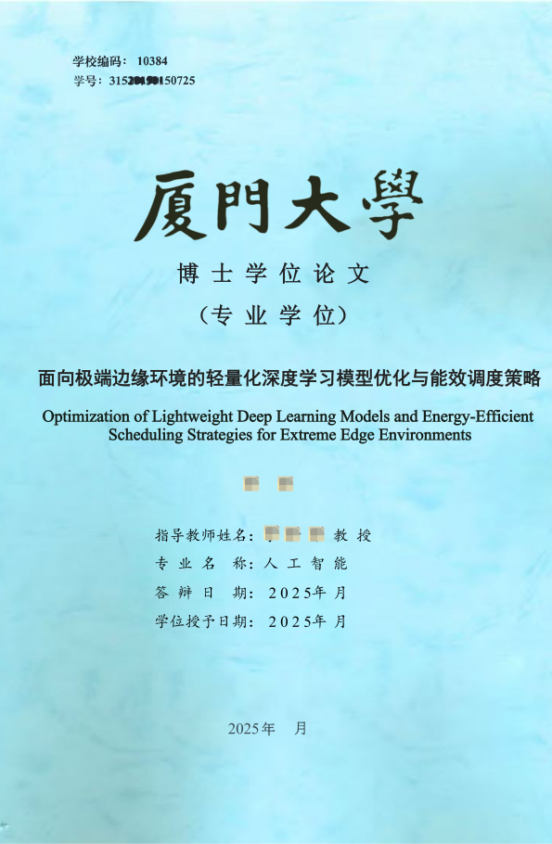
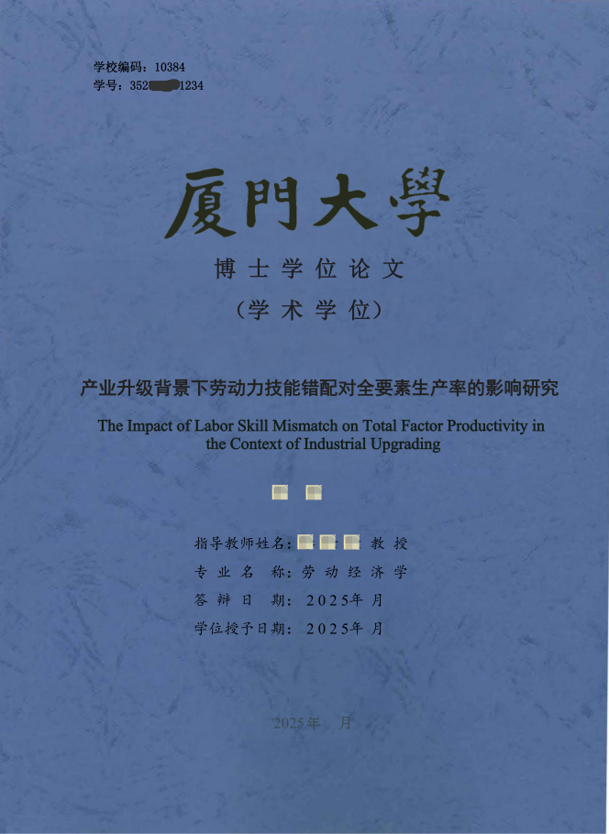

Cover Format of Thesis for Master of Social Sciences (in Light Yellow Color)
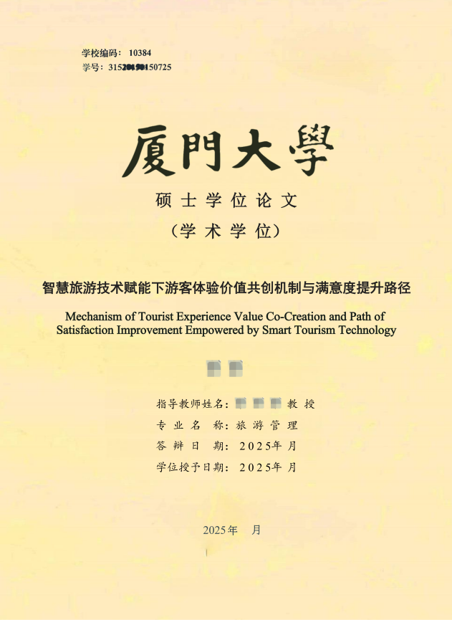
Cover Format of Thesis for Master of Nature Sciences,Engineering and Medicine (in Light Green Color)
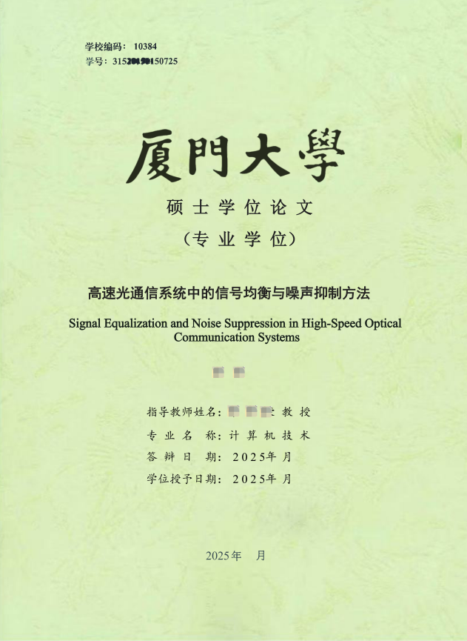

Xiamen University Declaration of Originality for Graduate Theses/Dissertations

This thesis/dissertation（practical achievement report） presents the research that I have performed independently for my master’s/doctoral degree under the guidance of my supervisor. Where the work of others is referenced or quoted in my thesis/dissertation（practical achievement report）, proper attribution is provided in conformance to the laws and the Xiamen University Guidelines for Graduate Scholarly Activity (Interim).

In addition, this thesis/dissertation（practical achievement report） was a research endeavor of the ________ Research Group, received financial support from the funds of the ________ Research Group or Laboratory, and was completed at the ________ Laboratory. (If applicable, fill in the name of the research team or the chief investigator of the research team or the laboratory. If this declaration is not applicable, cross out the corresponding content. Do not leave it blank.)

I declare that I have not committed plagiarism or any other forms of academic misconduct while writing this dissertation（practical achievement report） and that I bear all the consequences and legal responsibilities for my academic conduct.

Declared by:________________(Signature)
Supervisor:________________ (Signature)
Date:
Xiamen University Declaration of Consent to Grant Rights of Use for Graduate Theses/Dissertations

I hereby give my consent for Xiamen University to retain and use copies of my thesis/dissertation（practical achievement report） in accordance with the Law of the People's Republic of China on Degrees and relevant school documents, to send my thesis/dissertation（practical achievement report） (in both paper and electronic form) to educational authorities or designated institutions, and to include my thesis/dissertation（practical achievement report） into the Xiamen University Library and its databases for access by their users. I further give my consent for Xiamen University to include my thesis/dissertation（practical achievement report） into the joint national database of graduate theses and dissertations for indexing purposes, to publish the title and abstract of my thesis/dissertation（practical achievement report） in collections, and to reproduce my thesis/dissertation（practical achievement report） by photocopying, microfilming or any other reasonable means.

My thesis/dissertation（practical achievement report） constitutes:
( ) 1. A classified thesis/dissertation（practical achievement report） as assessed by the Confidentiality Committee of Xiamen University. It will be declassified on ______ (date) and my authorization above will become effective upon declassification.
( ) 2. A non-classified thesis/dissertation（practical achievement report）, and my authorization above becomes effective immediately.

(Please tick as appropriate or fill in the relevant information. A classified thesis/dissertation（practical achievement report） is one that has been assessed as such by the Confidentiality Committee of Xiamen University. Theses/dissertations which have not been assessed as classified by the Confidentiality Committee of Xiamen University are all open-access ones. If this form is left blank, the thesis/dissertation（practical achievement report） will be deemed an open-access one, and the above authorization will apply.)

Declared by:________________ (Signature)
Date:

Declaration on the Use of Artificial Intelligence Tools for Graduate Degree Theses/Dissertations (Practical Achievement Summary Reports)
Generative-AI auxiliary tools have been adopted in the research and writing of this degree thesis (practical achievement summary report). Relevant information is disclosed as required below:

1. Names of Generative-AI Tools Used and Purposes of Application
Tool name: (e.g. DeepSeek, ERNIE Bot, Doubao, Zhipu AI, Qwen and other large AI models, as well as agent tools invoking large-scale AI models, etc.)
Specific purposes: (e.g. Inspiring research ideas, learning of cutting-edge methods, literature retrieval and sorting-out, data analysis and visualization, chart and image generation, content polishing and format standardization, etc.)

2. Boundaries of Use and Responsibility Statement
The core viewpoints, research design, experimental schemes and argumentation processes of this degree thesis (practical achievement summary report) are all completed independently by me. All contents generated by artificial intelligence have been manually reviewed, revised and verified by me, for which I assume full accountability. I shall bear full responsibility for the originality, authenticity and academic compliance of all contents in this thesis (report). No academic misconduct including AI-enabled ghostwriting or falsification has occurred.

3. Commitment
I commit that my application of artificial-intelligence tools in this degree thesis (practical achievement summary report) conforms to relevant national laws, regulations and specific institutional rules of the university. No improper use has been made. I consent to relevant review and supervision, and will independently bear all corresponding liabilities and consequences.

Declared by:________________ (Signature)
Date:

Declaration of Non-Use of Artificial Intelligence Tools for Graduate Degree Theses/Dissertations (Practical Achievement Summary Reports)
During the research and writing of this degree thesis (practical achievement summary report), no generative artificial intelligence tools (referring to large-scale models and their derivative tools capable of automatically generating texts, codes, charts and other content based on prompts) have been used.
All content of this work is completed independently on the basis of personal research, literature review and experimental data. I hereby undertake to comply with the requirements of academic integrity, and confirm that there is no AI-assisted generated content in this thesis (report). I shall independently bear all responsibilities and consequences arising from any breach of this declaration.

Declared by:________________ (Signature)
Date:

List of Defense Committee Members

Chairperson： | XXX | Professor | XX School, XX University
Members： | XXX | Professor | XX Research Institute, XX University
 | XXX | Research Professor | XX Institute
 | XXX | Professor | XX School, XX University
 | XXX | Associate Professor | XX School, XX University

