Sleepy Scene Management

Author: He Yiran (SleepyCat)
Version:1.0.0

Description

In many projects, there is a designated entrance scene from which the project must be started each time.
However, developers often need to switch to and edit other scenes, making the process of scene switching tedious and cumbersome.
Sleepy Scene Management simplifies the scene transition workflow, making it easier to focus on the development and editing process.
The system aims to streamline this workflow with the following features:

- Automated Scene Listing:
Automatically fetches all scenes present in the **build list** and provides a convenient list for selecting the entrance scene.

- Easy Scene Access:
Directly open or additively open scenes from the list for editing, saving you the hassle of manual searching.

- Quick Play from Entrance Scene:
A menu option to quickly launch the project from the entrance scene, no matter which scene(s) you are currently editing.

- Seamless Stop and Resume:
Another menu option to stop the running project and swiftly resume editing the previously open scene(s).

Usage

Let's say for example your project has this file hierarchy.
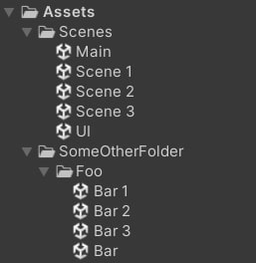
All the actions are included in the Sleepy Scene menu.
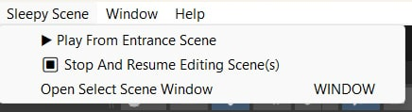
👆You shall see this menu after importing this package correctly.
How to use the menu:
- Opening Scene Selector Window:
Use the Sleepy Scene/Open Select Scene Window menu option to open the Scene Selector Window.
In this window, you can choose the entrance scene and switch between scenes as needed.

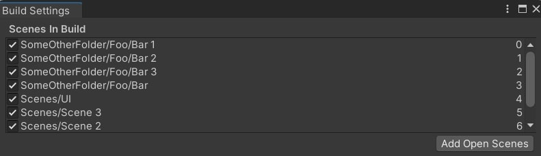
In our example, first make sure you have added all of the scenes you wish to switch use in the Build Settings

Then in the `Select Scene` window, you shall see ↓↓↓:
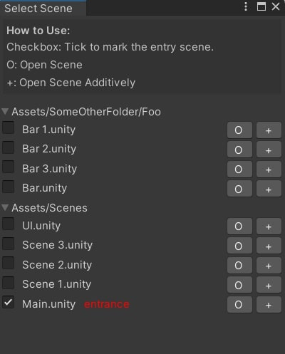

- Playing from Entrance Scene:
Use the Sleepy Scene/ ▶ Play From Entrance Scene menu option to load the entrance scene and start running the project.
(**Note:** If you haven't pre-selected an entrance scene via the Scene Selector Window, the default scene path "Assets/Scenes/Main.unity" will be used as the entrance.)

- Stopping and Resuming:
While the project is running, use the Sleepy Scene/ ⏹ Stop And Resume Editing Scene(s) menu option to stop the project and resume editing the previously open scene(s).

