**A Modern Business Model Using The Ethereum Blockchain Platform And Google Cloud Platform**

Annur Hangga Prihadi

[prihadihangga@gmail.com](mailto:prihadihangga@gmail.com)

<https://hanggaprihadi.github.io/>

**Abstract.** Blockchain technology is the choice in technological developments that promote peer-to-peer systems and decentralized data. The supply chain process currently uses traditional technology, where the data of products is stored in traditional databases. Blockchain technology has the potential to change the process to be more modern due to its transparency in every activity to facilitate tracking and visibility of goods in the supply chain and make records easier to audit. For example, Carrefour Italia reported that it has implemented a food tracking system with blockchain. The author focuses on building business solutions in the supply chain transparency sector with a Minimum Viable Product target in the form of TxN supply chain processes. The author uses Ethereum and its smart contract products to build a business system on the blockchain. The product of this research is a prototype blockchain system that generates TXN in supply chain processes for transparency in ongoing supply chain business activities. The blockchain can record the data, and the entity will find it easier to see blockchain transaction data because transaction data is very transparent.

1. **Introduction**

Blockchain technology is widely recognized as an innovative option for developing peer-to-peer distributed information systems for corporate data. Currently, the blockchain is being used for decentralized currency systems such as Bitcoin, Ethereum smart contracts, the Binance smart chain, and other online resources. It enables organizations to exchange data and complete transactions in minutes without intervention or verification by third parties, such as banks, when processing customer transactions. The blockchain technology also ensures secure distributed information exchanges, which can have a significant impact on organizational management. Additionally, it has the potential to transform the way companies in the supply chain build relationships and share products and information.

Currently, agribusiness supply chains are highly structured, global, and interconnected. Information and documentation regarding agribusiness products, including safety, sustainability, procurement, and other features, are often recorded and stored on paper or in private databases that can only be viewed by trusted third parties. In this situation, accessing data becomes expensive, time-consuming, and prone to errors that threaten business processes, especially in the financial field.

Although the trend of the digital economy continues, agricultural products are still included in one of the least digital industries. However, blockchain technology can change this situation by providing decentralized digital smart contracts that operate independently and automatically to process transactions and automate communication between participants in the supply chain. The food sector can benefit greatly from this technology, which can improve transparency and efficiency in the supply chain.

The aim of this study is to create a blockchain system that generates Txn in the supply chain process to ensure transparency in ongoing supply chain business activities. However, there are limitations to this research. The Minimum Viable Product in the form of Txn occurs only between supply chains that use the Ethereum network, and the smart contract must reside on the Ethereum network.

1. **Ethereum Architecture**

The core idea behind the Ethereum architecture is how users can perform smart contract functions that are built to support the business needs of the blockchain. This architecture is written with smart contracts and shows how interconnected technologies allow the Ethereum ecosystem to work in creating blockchain-based blocks that contain transaction data from users. A mining node is a machine that monitors transactions carried out on the Ethereum blockchain network, and each block contains information.

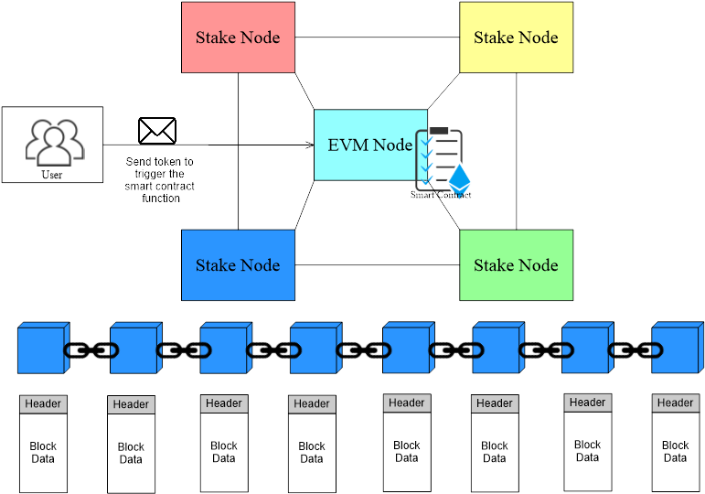

1. **Cloud Architecture**

We can utilize the GCP service called Django Packaged by Bitnami in Deployment Manager to create an online CMS site. This service is directly integrated with Compute Engine and VPC, which makes the process more efficient.

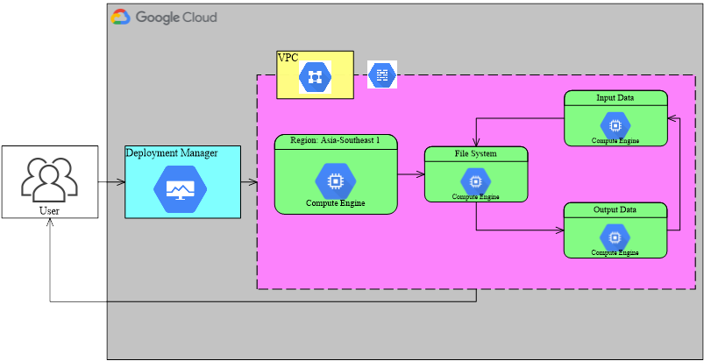

1. **Smart Contract Modification**

To create an Ethereum address, the user must first install the MetaMask application and create an Ethereum account. It is important to note that deploying a smart contract on the Ethereum network requires a fee. Therefore, users need to have Ethereum (ETH) in their accounts, which can be obtained through participating in an airdrop or purchasing from an exchange.

Once the user has Ethereum (ETH), they can proceed to open the Remix Ethereum IDE using the dedicated development environment link (remix.ethereum.org). The user can create and edit smart contracts based on their business needs. For example, they can refer to this link (https://github.com/hanggaa/Example/blob/main/hangga.sol) to learn about smart contracts.

Smart contracts work by creating a new token running on the Ethereum network, allowing entities to send tokens between each other while writing data on the blockchain. After creating or modifying a smart contract, the next step is to match it with the compiler. It is important to ensure that the Solidity version matches, as a compilation process failure may occur if it does not.

Once the smart contract is successfully compiled, the user can run it on the EVM node or on the Ethereum network. The deployment process involves selecting Injected Web3 (MetaMask) as the deploy payment method.

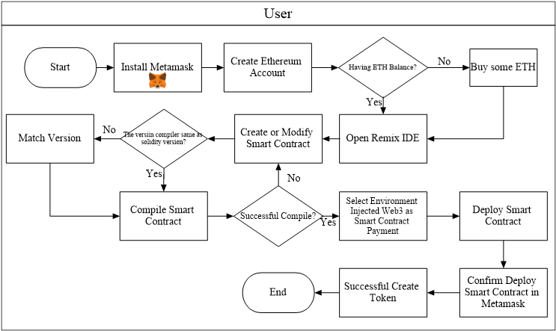

1. **Supply Chain Business Processes Using Blockchain**

As shown in the diagram, all entities involved in the supply chain process (except retail) create labels for goods that are recorded on the blockchain. When purchasing goods between entities, customers can scan the QR code on the product to access the data on the blockchain and view the entities that participated in the previous supply chain process.

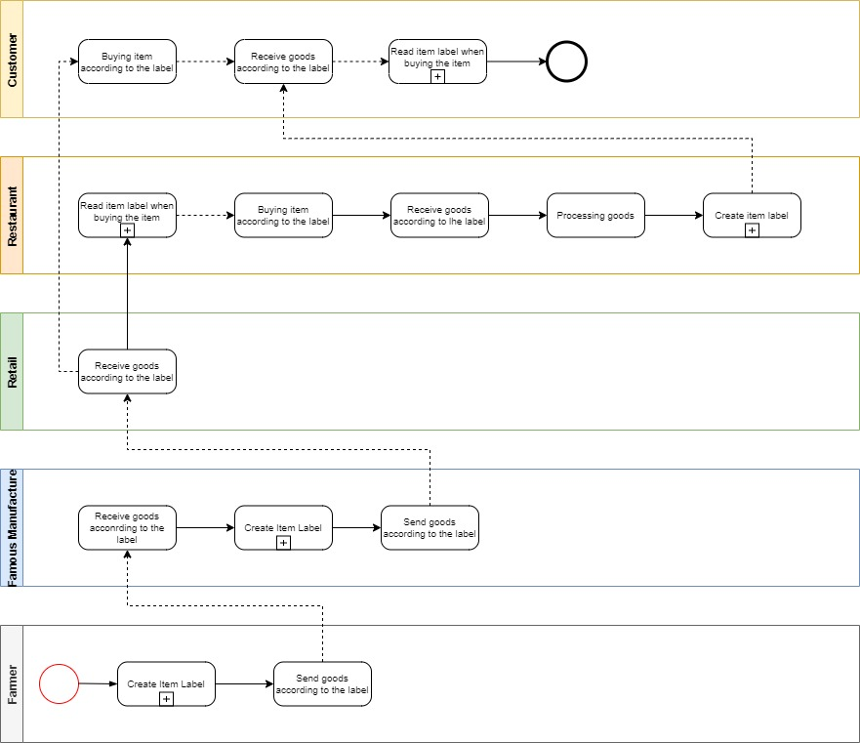

In the process of creating product labels between entities, data must be entered into the blockchain by sending the created tokens to the address used by the next entity, so that the transaction data is recorded into the blockchain. Once the data is successfully recorded into the blockchain, the next step for the entities is to enter the data into the CMS according to their respective businesses. The resulting browser site link from the data entered into the CMS is then converted into a QR code by the entities and pasted onto the product for consumers to see.

When consumers read the product label, they can simply scan the QR code attached by the supply chain entity to the product to see the transaction data recorded on the blockchain throughout the supply chain process. Consumers can also see the origin of the goods to be purchased, depending on the agreement between the parties involved.

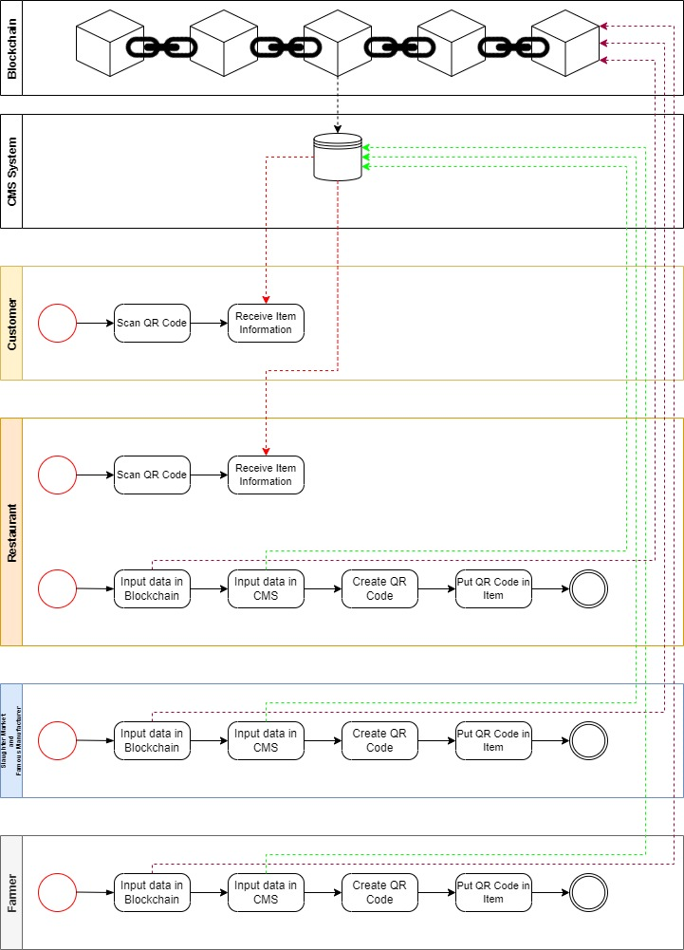

1. **Logistics and Transport Process**

This is a supply chain process that starts with a purchase order activity (purchase order) to the depot. The depot then validates the order and sends an expedition report as well as the order to the warehouse. In the warehouse, the token transfer process, load planning allocation, and expeditions are carried out to assemble and validate orders before they are delivered to retail. If the order is not appropriate at the retail stage, there will be a Proof of Delivery (POD) process, where the retail and depot parties must fill out a form according to existing cases such as damaged, lost, or exchanged goods, lack of products (missed product), and other cases.

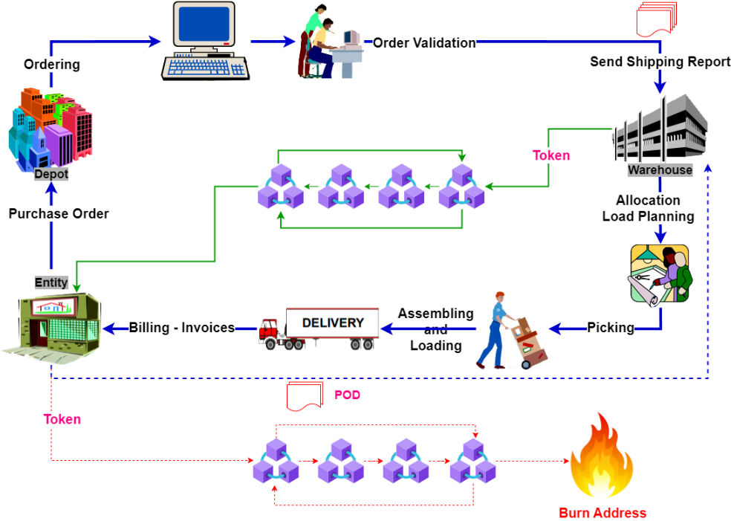

1. **QR Code**

The user copies the website link stored in the QR Code, pastes it into a system that converts it into a new QR Code, and then prints it out to be used as the product label.

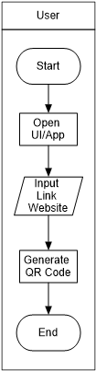

1. **Print QR Code**

The QR code serves as a link that enables customers to trace the supply chain process of the raw materials used in the restaurant. Customers can scan the code using their mobile devices and access the predetermined link, which displays the entire process from sourcing to processing. An example of a QR code is shown in the picture below.



1. **Website Display**

After the user scans the QR code, a web page will appear containing information that has been entered into the CMS, such as photos of purchased goods, blockchain data, goods descriptions, and maps of supply chain entities. Users can view the blockchain data by selecting the "Raw Materials Txn" button to confirm whether the Ethereum addresses of the supply chain actors are working together.

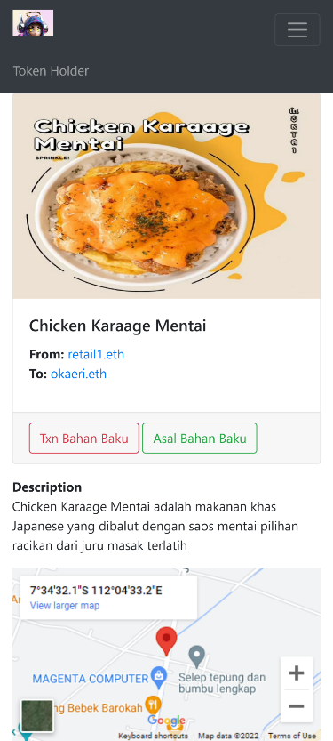

1. **Conclusion**

In this research, it has been proven that the design of the system can prove that the supply chain process becomes transparent with notes in blockchain technology. Smart Contracts facilitate entities to interact with the blockchain. Each entity will find it easier to see blockchain transaction data because the transaction data is very transparent. As a suggestion, it would be better for entities to have a mutual agreement in implementing this supply chain system to provide transparency to end consumers.

**References**

1. J.-G. Song, M. Sung-Jun and J. Ju-Wook, "A Scalable Implementation of Anonymous Voting over Ethereum Blockchain," Sensors, vol. 21, no. 3958, pp. 1-19, 2021.
2. A. K. Shrestha, J. Vassileva and R. Deters, "A Blockchain Platform for User Data Sharing Ensuring User Control and Incentives," vol. 3, pp. 1-22, 2020.
3. G. A. Motta, B. Tekinerdogan and N. Athanasiadis, "Blockchain Application in the Agri-Food Domain: The First Wave," vol. 3, pp. 1-13, 2020.
4. A. Maghfirah and Hara, "Blockchain in Food and Agriculture Supply Chain: Use-Case of Blockchain in Indonesia," International Journal of Food and Beverage Manufacturing and Business Models, vol. 4, no. 2, pp. 53-66, 2019.
5. H.-J. Kim and e. al, "Smart Decentralization of Personal Health Records with Physician Apps and Helper Agents on Blockchain: Platform Design and Implementation Study," JMIR Medical Informatics, vol. 9, no. 6, pp. 1- 14, 2021.
6. I. T. Javed, F. Alharbi, B. Bellaj, T. Margaria, N. Crespi and K. Naseer, "Health-ID: A Blockchain-Based Decentralized Identity," Healtcare, vol. 9, no. 712, pp. 1-21, 2021.
7. A. Hasselgren, Jens-Andreas, K. Kralevska, D. Gligoroski and A. Faxvaag, "Blockchain for Increased Trust in Virtual Health Care:," Journal Medical Internet Research, vol. 23, no. 7, pp. 1-15, 2021.
8. G. Gursoy, C. M.Brannon and M. Gerstein, "Using Ethereum blockchain to store and query pharmacogenomics data via smart contracts," BMC Medical Genomics, vol. 13, no. 74, pp. 1-11, 2020.
9. M. S. Al-Rakhami and M. Al-Mashari, "A Blockchain-Based Trust Model for the Internet of Things Supply Chain Management," sensors, vol. 21, no. 1759, pp. 1-15, 2021.
10. M. S. Ali, M. Vecchio, G. D. Putra and S. S. Kanhere, "A Decentralized Peer-to-Peer Remote Health Monitoring System," Sensors, vol. 20, no. 1656, pp. 1-18, 2020.