**A Modern Business Model Using The Ethereum Blockchain Platform And Google Cloud Platform**

Annur Hangga Prihadi

[prihadihangga@gmail.com](mailto:prihadihangga@gmail.com)

<https://hanggaprihadi.github.io/>

**Abstract.** Blockchain technology is the choice in technological developments that promote peer-to-peer systems and decentralized data. The supply chain process currently uses traditional technology where the data of products is stored in traditional databases. Blockchain technology has the potential to change the process to be more modern due to transparency in every activity to facilitate tracking and visibility of goods in the supply chain and cause easier auditability of records. For example, Carrefour Italia reported that it has implemented a food tracking system with blockchain. The author focuses on building business solutions in the supply chain transparency sector with the Minimum Viable Product target in the form of Txn supply chain processes. The author uses Ethereum and its Smart Contract products to build a business system on the blockchain. The product of this research is a prototype blockchain system that generates Txn in supply chain processes for transparency in ongoing supply chain business activities. The blockchain can record the data and the entity will find it easier to see blockchain transaction data because transaction data is very transparent.

1. **Introduction**

Blockchain technology is widely recognized as an innovative option for developing technologies that facilitate peer-to-peer distributed information systems for corporate data. In its current development, the blockchain can update decentralized currency systems such as Bitcoin, Ethereum smart contracts, the Binance smart chain, and other resources that can be managed online. Blockchain technology allows organizations to exchange data and complete transactions in minutes without the need for intervention or verification by third parties, such as banks, when processing customer transactions. Blockchain technology also ensures the security of distributed information exchange. This may have a significant impact on the management of the organization. It can also change the way companies in the supply chain build relationships and share products and information.

Today, agribusiness supply chains are highly structured, global, and interconnected. information and documentation of agribusiness products on safety, sustainability, procurement, and other features. Information is often recorded and stored on paper or in private databases and can only be viewed by trusted third parties. In this situation, accessing data becomes expensive, time-consuming, and requires action, distortion, and error that threatens the loss of business processes, especially in the financial field. Although the trend of the digital economy continues, agricultural products are still included in one of the fewest digital industries. In this situation, blockchain technology can affect this situation in a different way in one of the fewest digital industries. The food sector can benefit from decentralized digital smart contracts that operate independently and automatically to process transactions and automation between participants in the supply chain.

The purpose of this study is to model the blockchain system that builds Txn in the supply chain process to ensure that ongoing business activities in the supply chain are transparent. Research limitations are as follows A Minimum Viable Product in the form of Txn occurs between supply chains using the Ethereum network and a smart contract that resides on the Ethereum network.

1. **Ethereum Architecture**

The core idea behind the Ethereum architecture is how users perform smart contract functions built to support the business needs of the blockchain. Written with smart contracts, this architecture shows how interconnected technologies allow the Ethereum ecosystem to work to create blockchain-based blocks containing transaction data from users. A mining node is a mining machine that monitors transactions carried out on the Ethereum blockchain network, and each block contains information.

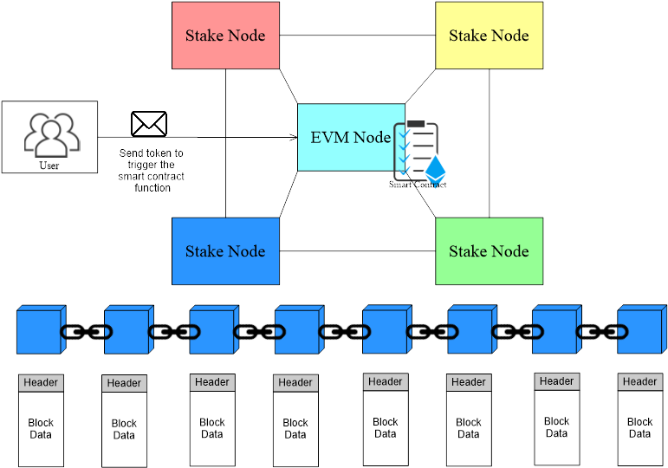

1. **Cloud Architecture**

We can use the GCP service to create an online CMS site. The name of the service is Django Packaged by Bitnami in Deployment Manager, which has been directly integrated with the Compute Engine and VPC to facilitate work.

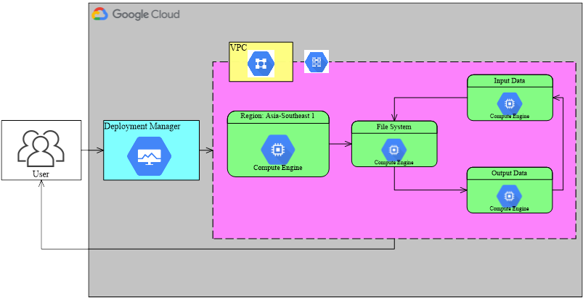

1. **Smart Contract Modification**

The user needs to install the MetaMask application and create an Ethereum account to get the Ethereum address that the user will use. It will cost money to create a smart contract deployed on the Ethereum network. So, first, users must have Ethereum (ETH) by participating in an airdrop or purchasing it from an exchange. Once you own Ethereum (ETH), you can then open the Remix Ethereum IDE using Ethereum’s dedicated development environment at the following link (remix.ethereum.org). Users can create and edit smart contracts to use according to business needs. For example, you can visit this link to learn about smart contracts (https://github.com/hanggaa/Example/blob/main/hangga.sol). The smart contract works when creating a new token running on the Ethereum network, allowing entities to send tokens between entities as a condition for writing data on the blockchain. After creating or modifying the smart contract, the next step is to match it with the compiler. Regardless of whether the Solidity version matches or not, if it does not match, the compilation process will fail. The next step is to compile the smart contract. After a successful compilation process, the user can run the smart contract on the EVM node or on the Ethereum network. The deployment process is done by selecting Injected Web3 (MetaMask) as the deploy payment method.

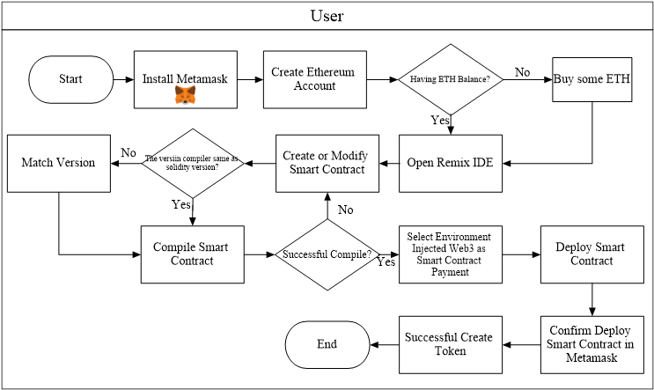

1. **Supply Chain Business Processes Using Blockchain**

It can be seen that all entities (except retail) create labels for goods to be recorded in the blockchain. Before buying goods between entities, you can read the data on the blockchain through a QR code affixed to the goods to see the entities that worked in the previous supply chain process.

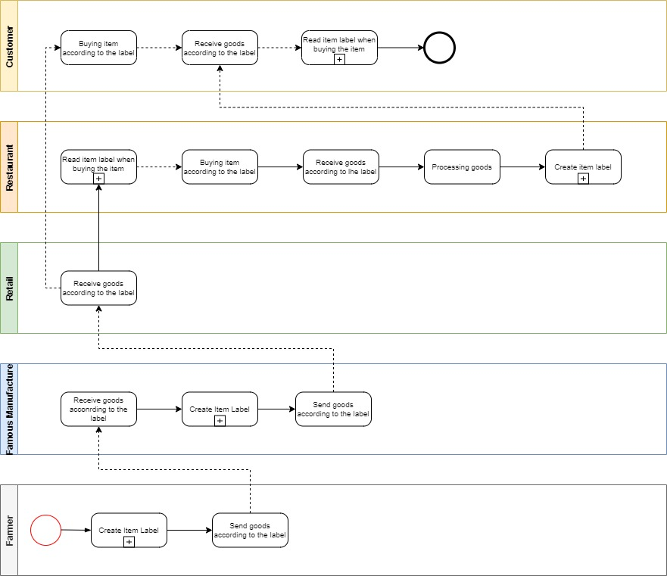

Details of the activity of creating good labels and reading labels when you want to buy products. In the process of creating goods labels between entities, it is necessary to enter data into the blockchain by sending the tokens that have been created to the address used by the next entity so that the data transactions are recorded into the blockchain. Once the data is successfully recorded into the blockchain, the next step is for the inter-entities to enter the data into the CMS according to their respective businesses. The browser site link resulting from the data entered into the CMS is converted into a QR Code by the inter-entity and then pasted into the product so that consumers can see the browser site containing Txn (required) and others. When consumers read the item label, they simply scan the QR code affixed by the supply chain entity to the item to see the supply chain process transactions on the blockchain. Of course, consumers can see the origin of the goods to be purchased (depending on the agreement between the parties).

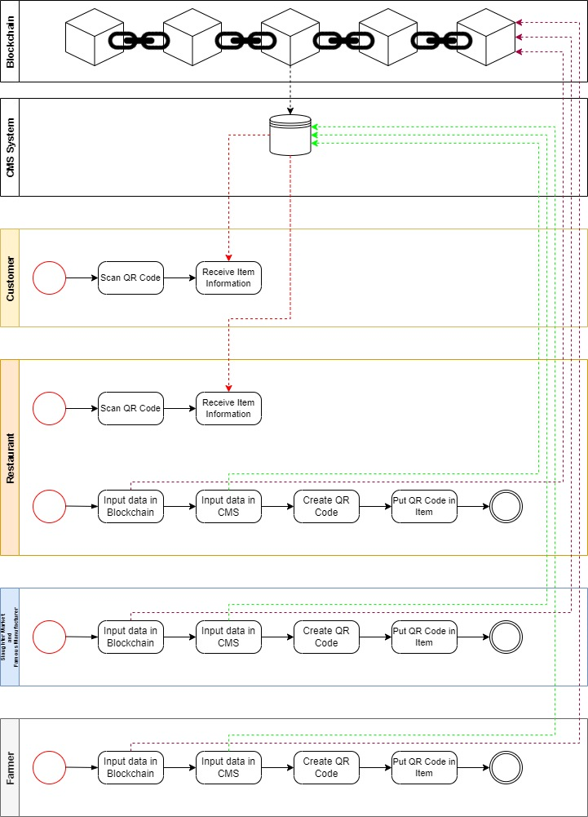

1. **Logistics and Transport Process**

This is a supply chain process that begins with a purchase order activity (purchase order) to the depot, then the depot validates the order and sends an expedition report as well as the order to the warehouse. In the warehouse, the token transfer process, load planning allocation, and expeditions are carried out to be assembled as well as validated orders before being delivered to retail. If the order is not appropriate when at retail, there will be a Proof of Delivery (POD) process where the retail and depot parties must fill out a form according to existing cases such as damaged/lost/exchanged goods, lack of products (missed product), and other cases.

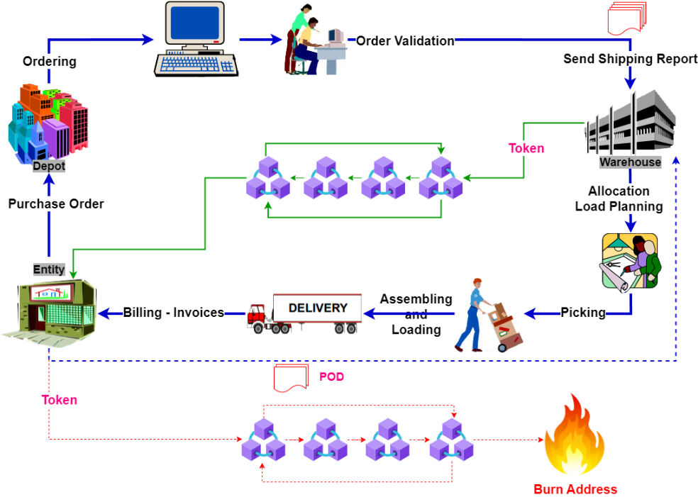

1. **QR Code**

The user copies the website link stored in the QR Code, pastes the link into the QR Code, then generates a system that converts it into a QR Code and prints it out while simultaneously assigning it as the product label.

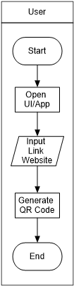

1. **Print QR Code**

The QR Code will display the link and move the customer to the predetermined link so that customers can see the process of the raw material supply chain until it is processed at the restaurant. The picture below is an example of a QR code.



1. **Website Display**

After the user scans the QR code, A web page will appear which contains, according to what has been entered in the CMS, such as photos of purchased goods, information in the blockchain, descriptions of goods, and maps of supply chain entities. Users can see the information in the blockchain when selecting the Raw Materials Txn button to ascertain whether it is true that the Ethereum addresses of supply chain actors work together.

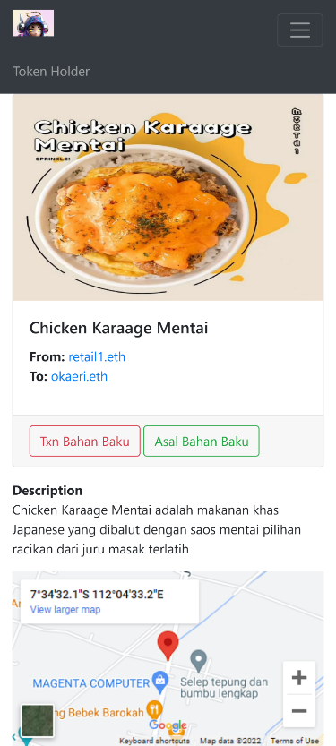

1. **Conclusion**

I have proposed a system for transparency in the supply chain process. I started with the Ethereum Smart Contract to create a token to make it easy for entities to get in touch with the blockchain. The design of this system successfully proves that supply chain transactions from upstream to downstream can be recorded on the blockchain. Each entity will find it easier to see blockchain transaction data because transaction data is very transparent.

**References**

1. J.-G. Song, M. Sung-Jun and J. Ju-Wook, "A Scalable Implementation of Anonymous Voting over Ethereum Blockchain," Sensors, vol. 21, no. 3958, pp. 1-19, 2021.
2. A. K. Shrestha, J. Vassileva and R. Deters, "A Blockchain Platform for User Data Sharing Ensuring User Control and Incentives," vol. 3, pp. 1-22, 2020.
3. G. A. Motta, B. Tekinerdogan and N. Athanasiadis, "Blockchain Application in the Agri-Food Domain: The First Wave," vol. 3, pp. 1-13, 2020.
4. A. Maghfirah and Hara, "Blockchain in Food and Agriculture Supply Chain: Use-Case of Blockchain in Indonesia," International Journal of Food and Beverage Manufacturing and Business Models, vol. 4, no. 2, pp. 53-66, 2019.
5. H.-J. Kim and e. al, "Smart Decentralization of Personal Health Records with Physician Apps and Helper Agents on Blockchain: Platform Design and Implementation Study," JMIR Medical Informatics, vol. 9, no. 6, pp. 1- 14, 2021.
6. I. T. Javed, F. Alharbi, B. Bellaj, T. Margaria, N. Crespi and K. Naseer, "Health-ID: A Blockchain-Based Decentralized Identity," Healtcare, vol. 9, no. 712, pp. 1-21, 2021.
7. A. Hasselgren, Jens-Andreas, K. Kralevska, D. Gligoroski and A. Faxvaag, "Blockchain for Increased Trust in Virtual Health Care:," Journal Medical Internet Research, vol. 23, no. 7, pp. 1-15, 2021.
8. G. Gursoy, C. M.Brannon and M. Gerstein, "Using Ethereum blockchain to store and query pharmacogenomics data via smart contracts," BMC Medical Genomics, vol. 13, no. 74, pp. 1-11, 2020.
9. M. S. Al-Rakhami and M. Al-Mashari, "A Blockchain-Based Trust Model for the Internet of Things Supply Chain Management," sensors, vol. 21, no. 1759, pp. 1-15, 2021.
10. M. S. Ali, M. Vecchio, G. D. Putra and S. S. Kanhere, "A Decentralized Peer-to-Peer Remote Health Monitoring System," Sensors, vol. 20, no. 1656, pp. 1-18, 2020.