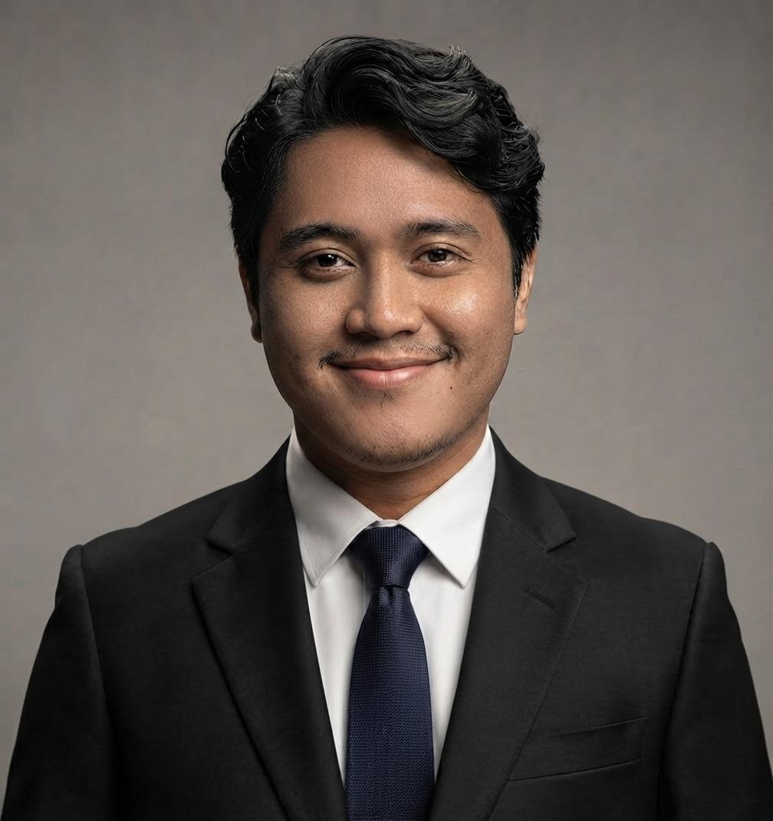
HANGGER SUKMA PRIMA DARSONO
Jakarta Selatan, DKI Jakarta | +62 896 8206 8482 | hanggersukmapd@gmail.com | hanggersukmapd@gmail.com LinkedIn | https://github.com/hanggersukmapd GitHub | https://www.kaggle.com/hanggersukmapd Kaggle

PROFESSIONAL SUMMARY
Informatics Engineering student with a solid academic and project-based foundation in Web Development and System Information. Experienced in the end-to-end web development lifecycle—from database architecture and backend integration to responsive frontend design. Possesses strong analytical thinking and structured problem-solving skills, with a proven ability to independently manage development workflows and deliver scalable digital solutions effectively.

SKILLS
Technical Skills:
- Web Development: Frontend Design, Backend Development, RESTful API, Web Architecture.
- Programming: JavaScript, HTML/CSS, Python, SQL (MS SQL Server, MongoDB).
- Tools: Git/GitHub, Microsoft Excel, Data Documentation, Web Deployment Basics.
Soft Skills:
- Leadership & Collaboration: Kepemimpinan, Bekerja Sama Tim.
- Project & Time Management: Manajemen Waktu, Bekerja Dalam Tekanan.

PROFESSIONAL EXPERIENCE
Web Development & Project Coordinator | Mar 2025 - Sep 2025
- Conducted system architecture design and backend development to support independent research projects and operational needs.
- Developed and validated dynamic web applications using secure coding techniques to optimize system performance and data accuracy.
- Identified system bottlenecks and trends within databases, facilitating troubleshooting and database integration using MongoDB and MS SQL Server.
- Documented development processes and presented technical features clearly to team members, ensuring system functionality was understood and actionable.

ACADEMIC PROJECTS
Research: Analisis Performa Algoritma pada Sistem Informasi Monitoring (Monev) Digital | 2026
- Designing an end-to-end Web Development project to understand user behavior and efficiency in grant program monitoring.
- Utilizing full-stack development tools to perform data manipulation, database structuring, and feature implementation to achieve optimal system response.
- Developing documentation on system trade-offs and real-world performance metrics for administrative users.

EDUCATION
Universitas Mercu Buana | Sep 2022 - Present
Major: Informatics Engineering | GPA: 3.45/4.00
Relevant Coursework: Web Programming, Database Management, UI/UX Design, Software Engineering.

LEADERSHIP & ORGANIZATIONAL EXPERIENCE
Vice Chairman, Student Choir (PSM) Universitas Mercu Buana | Jan 2025 - Present
- Demonstrated initiative and leadership in managing complex logistical digital projects, coordinating team activities, and ensuring deadline-driven results.
- Leveraged strong communication and collaborative skills to lead team members in high-pressure environments.

CERTIFICATIONS
- Improving Deep Neural Networks: Hyperparameter Tuning, Regularization and Optimization - DeepLearning.Al (Jun 2026)
- Neural Networks and Deep Learning - DeepLearning.Al (May 2026)
- Structuring Machine Learning Projects - DeepLearning.Al (Jun 2026)
- Start Your Career With Cisco - ID-Networks (Sep 2023)

AWARDS
- Gold Medal, Malaysian Choral Eisteddfod 2024
- Gold Medal, National Folklore Festival FEB UI 18th

