[**Homework 5-6**](https://github.com/hendraanggrian/IIT-ITM511/blob/assets/assignments/hw5-6.pdf)**: System Modeling & Architectural Design**

**Problem 1**

*Based on your experience with a bank ATM, draw an activity diagram that models the data processing involved when a customer withdraws cash from the machine.*

(Chase, n.d.)

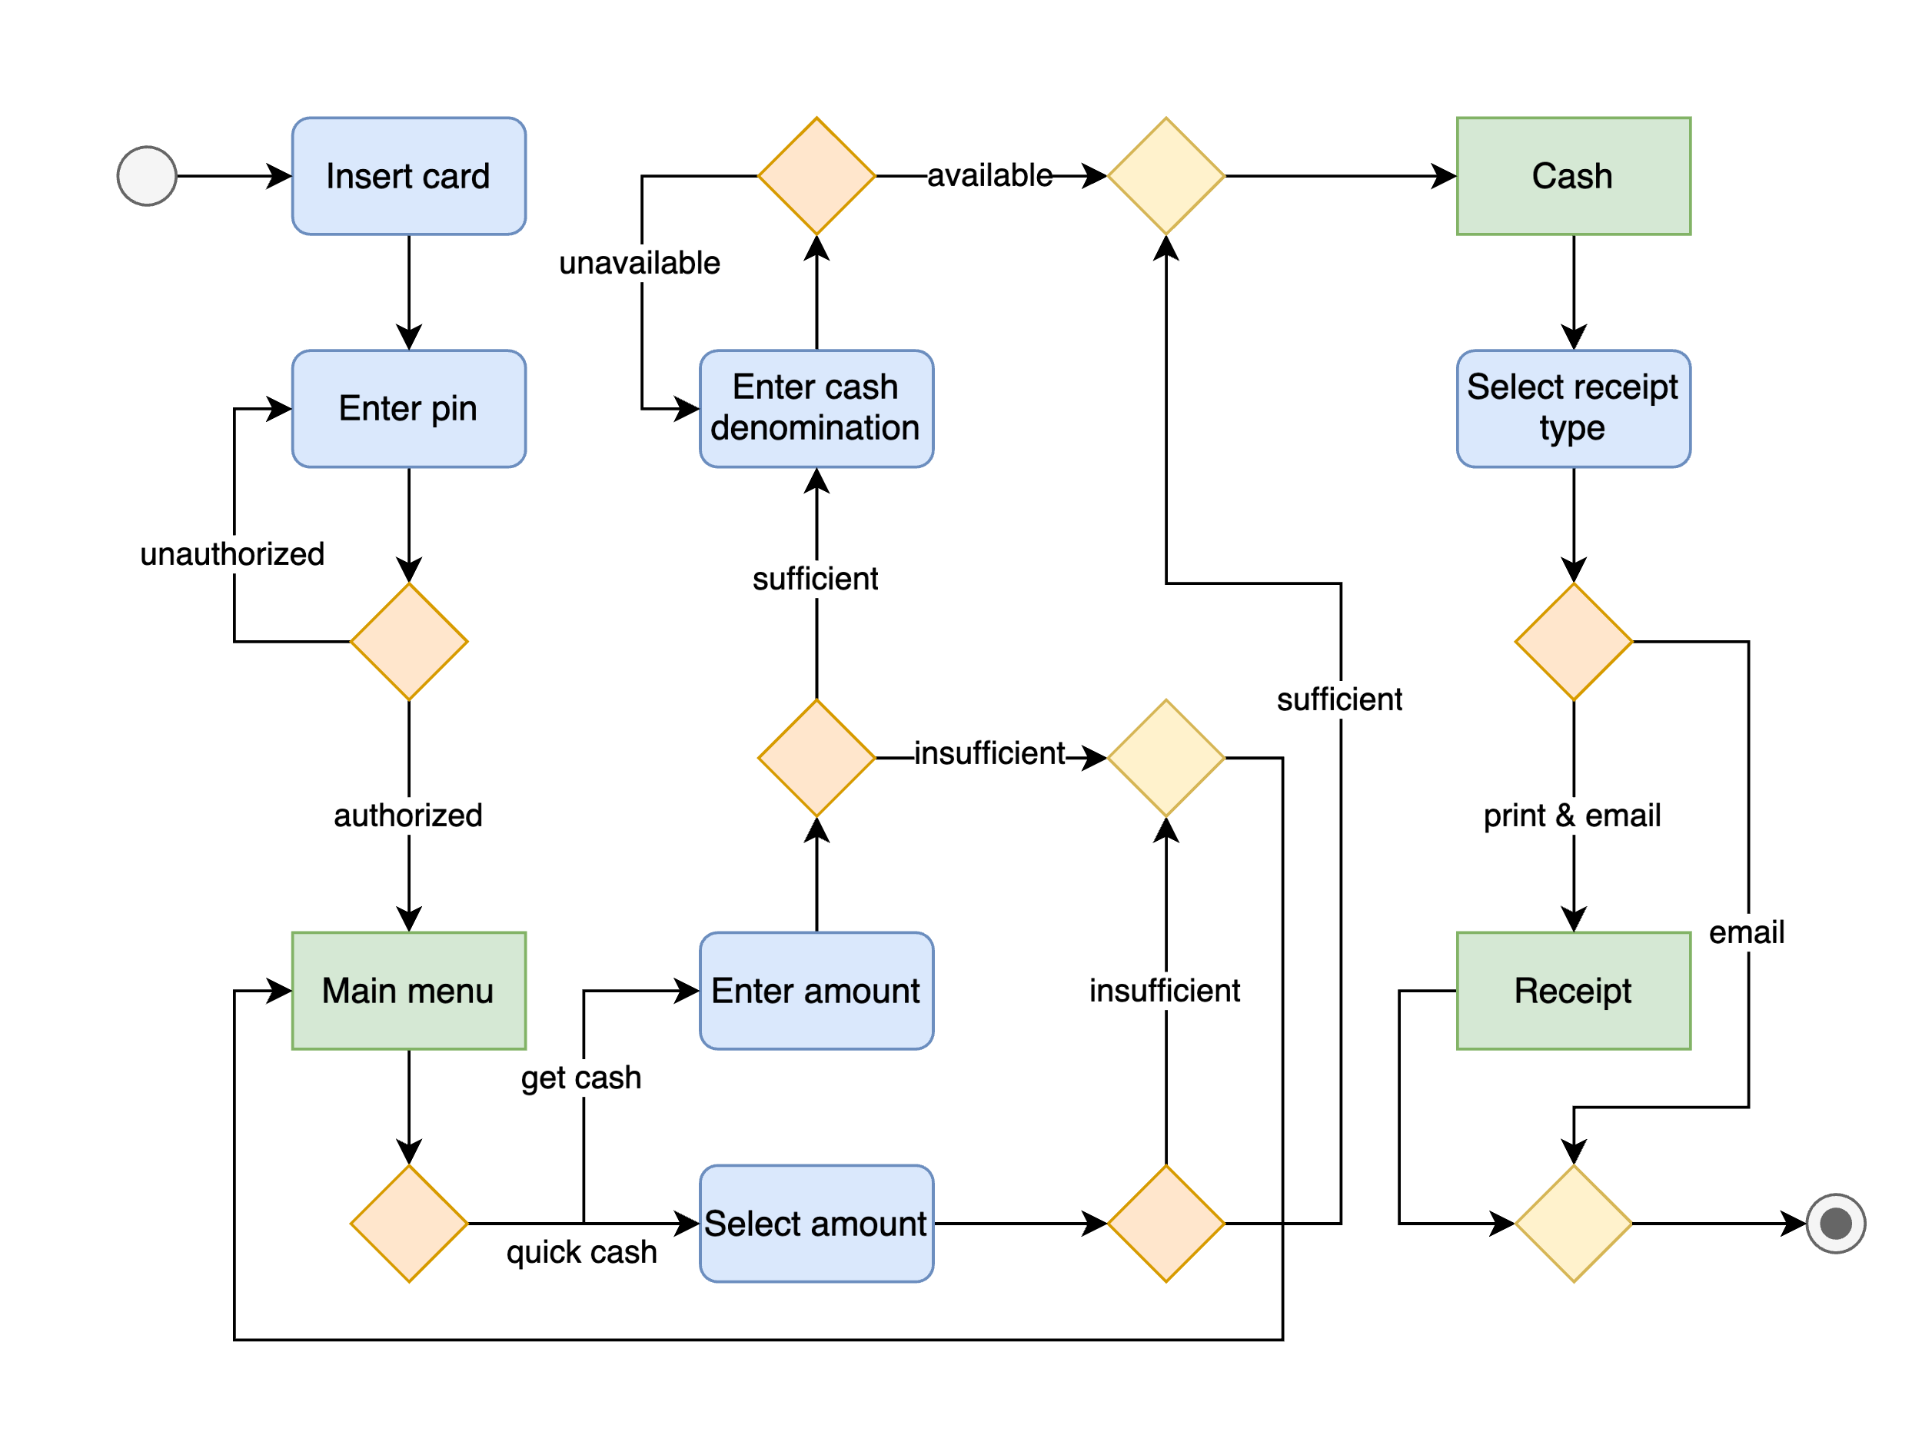

[View source](https://github.com/hendraanggrian/IIT-ITM511/blob/main/assignments/hw5-6/figure1.drawio)

**Problem 2**

*Draw a sequence diagram for the same system. Explain why you might want to develop both activity and sequence diagrams when modeling the behavior of a system.*

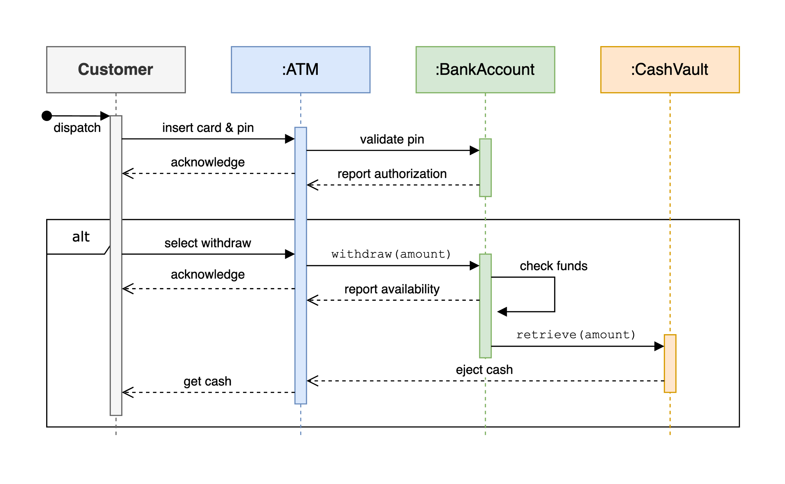

[View source](https://github.com/hendraanggrian/IIT-ITM511/blob/main/assignments/hw5-6/figure2.drawio)

**Problem 3**

*Draw state diagrams of the control software for the software for a DVD player.*

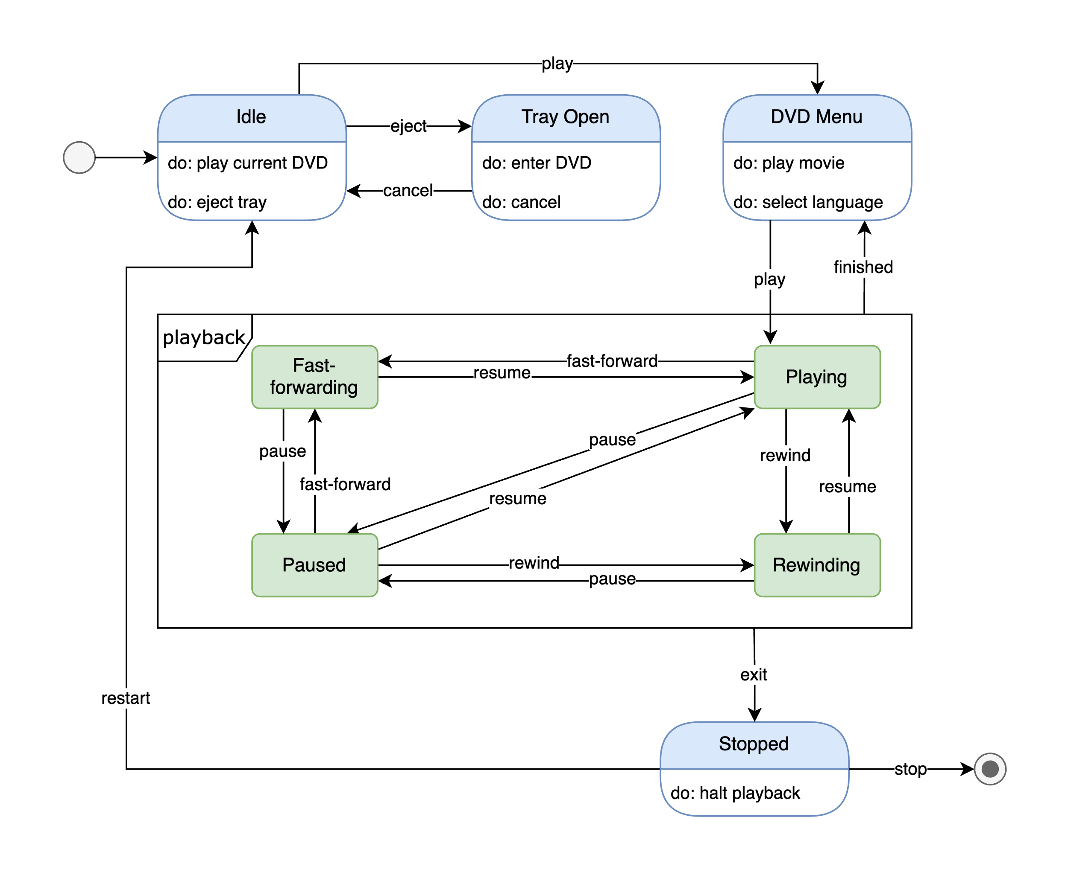

[View source](https://github.com/hendraanggrian/IIT-ITM511/blob/main/assignments/hw5-6/figure3.drawio)

**Problem 4**

*When describing a system, explain why you may have to start the design of the system architecture before the requirements specification is complete.*

Collecting user requirements before proceeding with the code is a typical software development recommendation. On the other hand, there are clear benefits in outlining an architectural design as a proof-of-concept. The initial draft sets the internal expectations for the development team to follow, while the users can provide early feedback on the mockup, thereby shaping consequent requirements. Despite this, a framework redesign may be necessary when the draft underperforms or is wholly unacceptable, resulting in a wasted attempt.

**Problem 5**

*Performance and security may pose to be conflicting non-functional requirements when architecting software systems. Make an argument in support of this statement.*

Building layers of security measures often undermine a system's performance and practicability. Take hashing or encryption as an example. They obfuscate the client's data at the expense of added CPU workload needed for cryptographic conversion (Krasnov, 2017). Meanwhile, efforts to enhance performance – such as skipping data verification and cache storing – rarely align with risk mitigation practices. Therefore, finding the right balance of speed and risks is essential when devising an architectural design.

**Problem 6**

*Should there be a separate profession of ’software architect’ whose role is to work independently with a customer to design the software system architecture? A separate software company would then implement the system. What might be the difficulties of establishing such a profession?*

* **Pro:** A dedicated software architect brings a fresh point of view to the development team. Their unique expertise may help in identifying flaws in existing architectural design. They are also less likely to be conflicted with personal relationships within the team.
* **Con:** Some, myself included, believe architectural design is the responsibility of the leadership in the development team. Delegating this work to an outside employee means the architect potentially has the final say in the decision-making process. Besides, employing an independent architect would increase the overall cost and consumed time.

# Bibliography

*Chase*. (n.d.). Retrieved from ATM 101: https://www.chase.com/digital/customer-service/helpful-tips/business-banking/general/atm-basics/

Krasnov, V. (2017, 12 29). *The Cloudflare Blog*. Retrieved from How "expensive" is crypto anyway?: https://blog.cloudflare.com/how-expensive-is-crypto-anyway/