**455-555 Week 6 Session B Notes**

**Topics & Chapter Readings:**

[Android Previews](https://developer.android.com/studio/preview)

Chapter 9 – Intro to Sqlite3 part 2 (see Powerpoint 2 on Sqlite3 in your content area)

Working with SQL tools & CLI

*More* on External Storage (Working with multiple apps)

Lab 3 review

Week 4 review on Intents

*A look ahead*

Use of Memory & Recovery agents Monday

­­­­­

**[ Database uses ]**

**Ex.** [**Content Provisions**](https://developer.android.com/guide/topics/providers/content-providers)**. Ability to share data with other apps!**

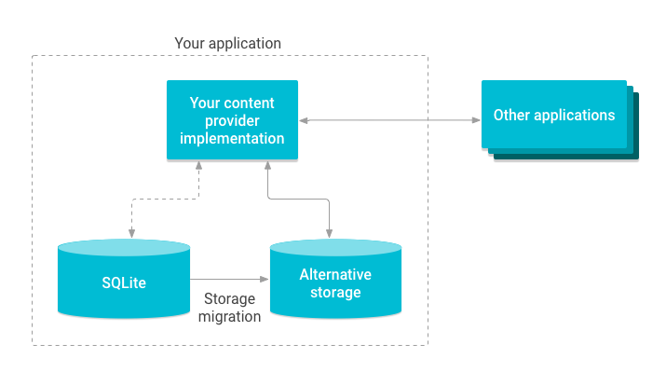

Sqlite tools & CLI

* [Downloads - DB Browser for SQLite (sqlitebrowser.org)](https://sqlitebrowser.org/dl/) – all OSes
* [SQLite Download Page](https://www.sqlite.org/download.html) (Windows)
* Android Studio -> Built in [Database Inspector](https://developer.android.com/studio/inspect/database)!

ToDoList.zip file DB demo available in Demos folder.

**[ *More* on External Storage (Working with multiple apps)** ]

See Week 6 External Storage demo (Bonus) files.

Note usage of Emulator devices across multiple apps!

[ **Lab 3 Review!** ]

Use of Custom Adapter.

Consider layouts

Initial List View layout on start up

via Adapter – the *binder*! layout on start up

List View Containment

Consider java source files (making use of a Data Source)

For *starter* class

Working a timer for the splash screen

**1. Add in a new activity and make it a launcher based one.**

**2. Include a timer in it for automatic loading to another activity file when timer task ends.**

**Sample Code**

**new** Timer().schedule(**new** TimerTask() {  
 @Override  
 **public void** run() {  
 startActivity(**new** Intent(getApplicationContext(),   
 MainActivity.**class**));  
 }  
}, 5000);