Fancy Fonts creation made easy!

Objective: To add some rockin’ fonts to any of your apps! Be Thematic and cool!

Outcome example :

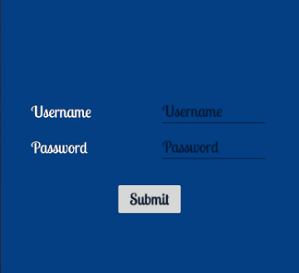

**Note**: A device must have Google Play services version 11 or > to use the Google Fonts provider.

**Steps:**

1. In your layout editor, click on for any desired element, like a TextView and go to attributes (properties) view. Make sure to view **All Attributes** if necessary.

If you don’t even see an attributes view, from your menu go to Window > Restore Default Layout.

From there drill down your **Attributes** list till you find **fontFamily** and choose

**More Fonts…**

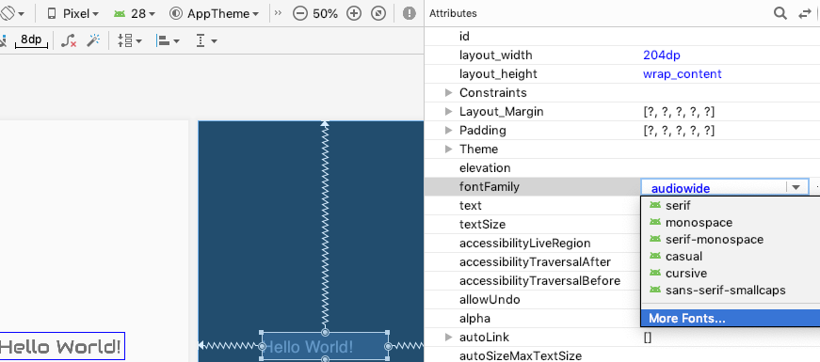

2. The **Resources** window now appears.

In the **Source** drop-down list, select **Google Fonts** if not defaulted.

In the **Fonts** box, select a font under the **Downloadable** area within the box.

Then select **Create downloadable font** and click **OK**.

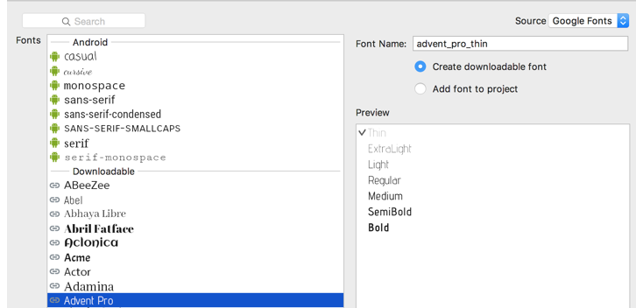

**Note**: To bundle the font in your app, you would select Add font to project.

You should now notice that Android Studio automatically generates the relevant XML file that is needed under your **res > font** folder to render the font correctly in your app, plus it *adds* in the reference to your font in TextView attributes area in xml.

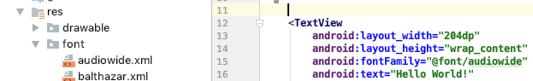

You are now good to go for seeing a cool font for your app! You can always refer to the same atrribute for a particular font for other elements as well!

Refs: <https://developers.google.com/fonts/docs/android>

<https://developer.android.com/guide/topics/ui/look-and-feel/downloadable-fonts.html>

<https://fonts.google.com>

<https://medium.com/material-design-in-action/downloadable-fonts-developers-guide-91b522e4d69e>