### **An example of web3: Storj**

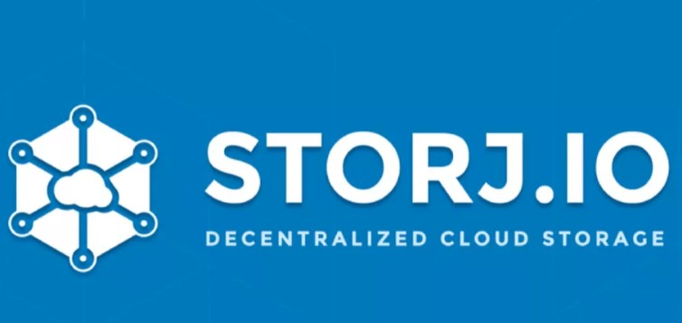

Storj is a decentralized storage solution that allows users to securely store their data in a redundant and fault-tolerant manner. One of the most popular decentralized storage systems is Storj. It’s also one of the most historic. Anyone can store data with Storj.

It makes use of blockchain technology and provides many of the same advantages of cloud storage, but on a more dispersed network. One of Storj’s benefits is that it enables unlimited uploading and downloading at any time. It’s also free to use and open-source.

Anyone can get started with it with only a single click. Users are at the centre of the [payment mechanism](https://coinscreed.com/dogecoin-foundation-is-planning-a-doge-proof-of-stake-mechanism-with-ethereum-co-founder-dogecoin-foundation-is-planning-a-doge-proof-of-stake-mechanism-with-ethereum-co-founder.html) since they can pay as they go.

The Storj platform is powered by the Storj coin. Users can set an expiration date for their data on Storj, making it “self-destructive” in some ways. While this is a relatively new technology, some prominent names in the industry have already teamed with Storj to integrate their solution, including Dropbox and Comcast.