# General applications

* XML provides a standard method to access information, making it easier for applications and devices of all kinds to use, store, transmit, and display data.

# Detail applications

## Web publishing

* Allowing customers to create interactive pages and customize them.
* Storing the data once and then rendering that content for different viewers or devices based on style sheet processing using an Extensible Style Language (XSL)/XSL Transformation (XSLT) processor.

## Web searching

* XML defines the type of information contained in a document, making it easier to return valuable results when searching the Web
* By using XML, Web agents and robots (programs that automate Web searches or other tasks) are more efficient and produce more valuable results.

## E-business applications

* XML implementations make electronic data interchange (EDI) more accessible for information interchange, business-to-business transactions, and business-to-consumer transactions.

## Metadata applications

* XML makes it easier to express metadata in a portable, reusable format.

# Product applications

## XUL

* XUL = XML user interface language
* Application programmers need to define a XUL interface as three discrete sets of components:
  + Content: the XUL document(s), whose elements define the layout of the [user interface](https://en.wikipedia.org/wiki/User_interface)
  + Skin: the CSS and image files, which define the appearance of an application
  + Locale: the files containing user-visible strings for easy [software localization](https://en.wikipedia.org/wiki/Software_localization)
* XUL defines a wide range of elements, which roughly belong to the following types:
  + Top-level elements: [window](https://en.wikipedia.org/wiki/Window_(computing)), page, [dialog](https://en.wikipedia.org/wiki/Dialog_box), [wizard](https://en.wikipedia.org/wiki/Wizard_(software)), etc.
  + [Widgets](https://en.wikipedia.org/wiki/Widget_(computing)): label, [button](https://en.wikipedia.org/wiki/Button_(computing)), [text box](https://en.wikipedia.org/wiki/Text_box), list box, [combo box](https://en.wikipedia.org/wiki/Combo_box), [radio button](https://en.wikipedia.org/wiki/Radio_button), [check box](https://en.wikipedia.org/wiki/Check_box), [tree](https://en.wikipedia.org/wiki/Tree_view), [menu](https://en.wikipedia.org/wiki/Menu_(computing)), [toolbar](https://en.wikipedia.org/wiki/Toolbar), group box, [tab box](https://en.wikipedia.org/wiki/Tab_(GUI)), color-picker, spacer, splitter, etc.
  + Box model: box, grid, stack, deck, etc.
  + Events and scripts: script, command, key, broadcaster, observer, etc.
  + Data source: template, rule, etc.
  + Others: overlay, iframe, browser, editor, etc.
* Example code

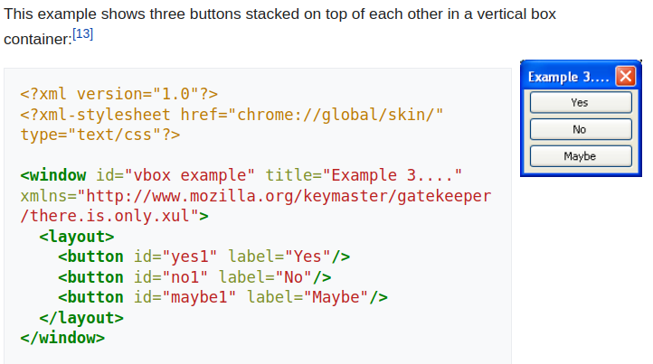

Source: from Wikipedia

# Atom

* General information
* Atom applies to a pair of related Web standards
* The Atom Syndication Format is an XML language used for web feeds, while the Atom Publishing Protocol (AtomPub or APP) is a simple HTTP-based protocol for creating and updating web resources
* Web feeds allow software programs to check for updates published on a website. To provide a web feed, the site owner may use specialized software (such as a content management system) that publishes a list (or "feed") of recent articles or content in a standardized, machine-readable format
* The feed can then be downloaded by programs that use it, like websites that syndicate content from the feed, or by feed reader programs that allow internet users to subscribe to feeds and view their content.
* A feed contains entries, which may be headlines, full-text articles, excerpts, summaries or links to content on a website along with various metadata
* Usage
  + The blogging community uses web feeds to share recent entries' headlines, full text, and even attached multimedia files
  + The providers allow other websites to incorporate a blog's "syndicated" headline or headline-and-short-summary feeds under various usage agreements.
  + Purposes: journalism, marketing, bug reports, or any other activity involving periodic updates or publications
  + Atom also provides a standard way to export an entire blog, or parts of it, for backup or for importing into other blogging systems.
* Example

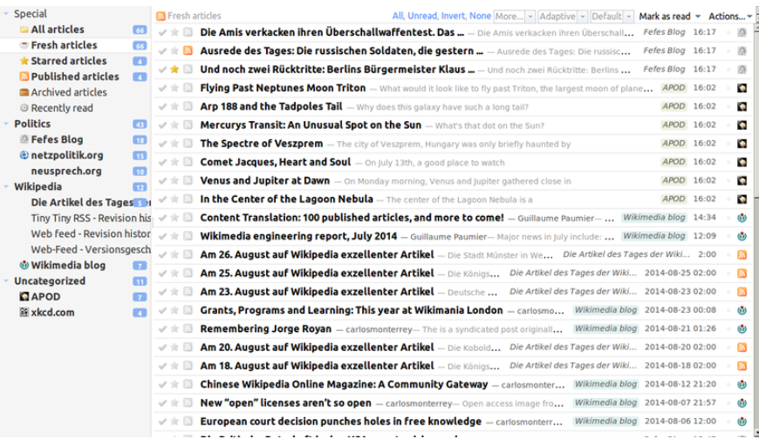

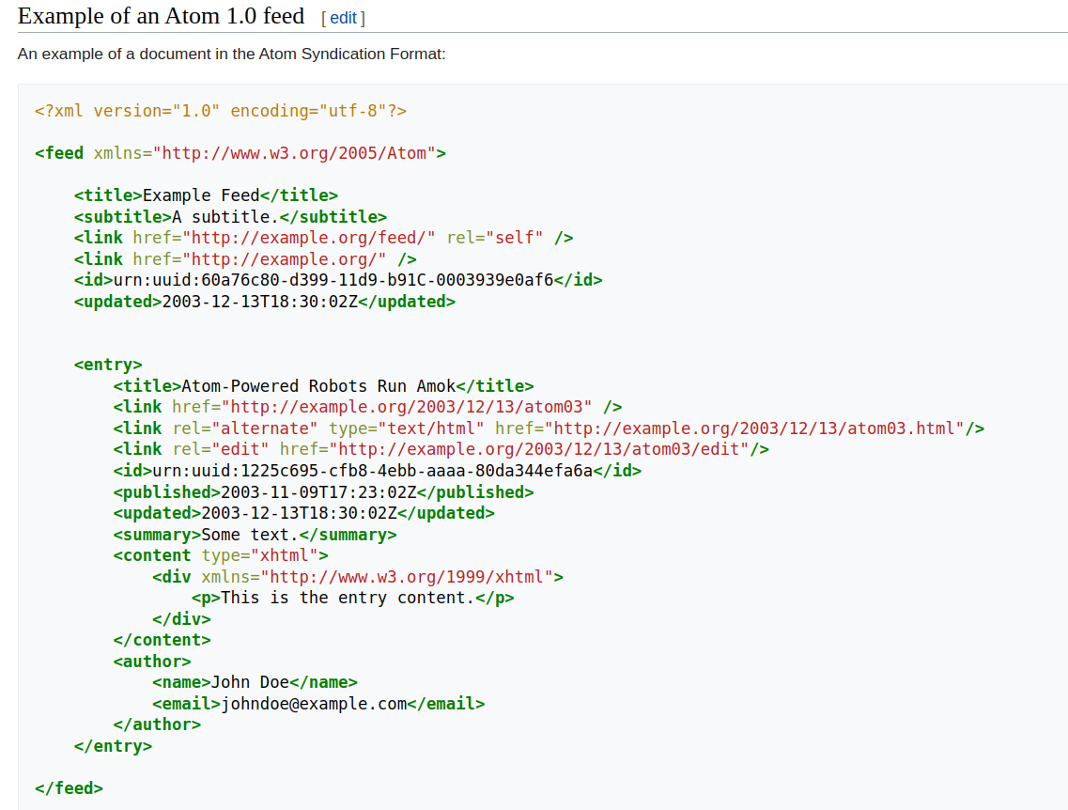

Source: Wikipedia