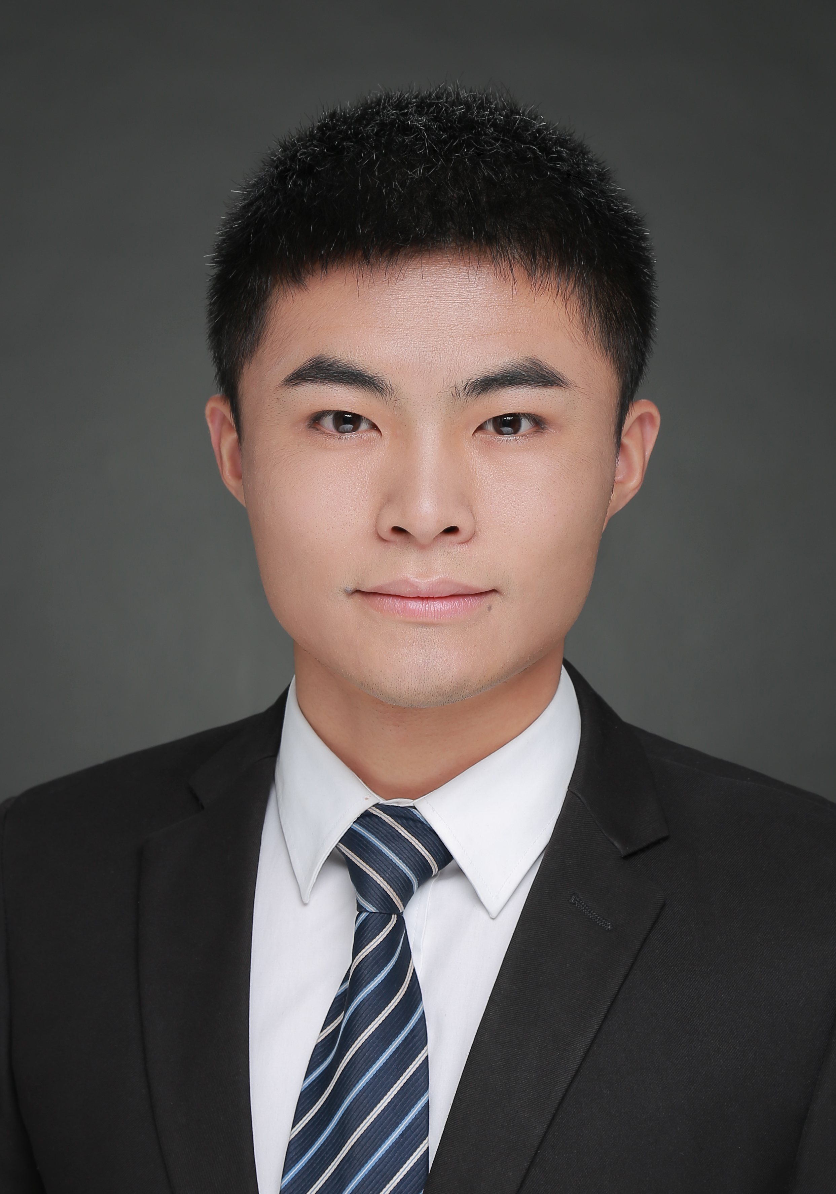
QIANYU HANG
Teaching Assistant
Program in Biological and Agricultural Engineering
North Carolina State University
TEL. +1 (919)-272-4026 E-mail: qhang@ncsu.edu
Address: 158 Weaver Labs, 3110 Faucette Dr. Raleigh, NC 27695-7625, USA

Education Background
- Aug.2017-present PhD student, Program in Biological and Agricultural Engineering, NC State University
- Aug.2015-June.2017 Graduate Student, Program in Environmental Engineering, Research Center for Water Pollution Control, Chinese Research Academy of Environmental Sciences
- Sep.2014-Aug.2015 Graduate Student, Program in Environmental Engineering, University of Chinese Academy of Sciences at Yuquan Road (Mainly for Graduate-curriculum study)
Research Experiences
Aug. 2017-Present
- North Carolina State University, Raleigh, USA
- Principal Investigator: François Birgand, Ph.D (Associate Professor, Department of Biological and Agricultural Engineering, North Carolina State University)
- Continuing Intensive Monitoring of Nutrient and Material Load in Claridge Nursery Stream “the Canal”: assessing the water quality impacts & benefits of a stream restoration in the coastal plain (supported by NC Department of Transportation)
- Major work: Study the long-term response of water quality and hydro-biogeochemical signature to an agricultural coastal plain stream restoration
Apr. 2015-May.2017
- Chinese Research Academy of Environmental Sciences, Beijing, China
- Principal Investigator: Haiyan Wang, Ph.D (Professor, Research Center for Water Pollution Control Technology, Chinese Research Academy of Environmental Sciences)
- Treatment of reverse osmosis concentrated wastewater from Beijing Cuihu Wastewater Treatment Plant using moving bed biofilm reactor (MBBR) technology (supported by National Major Projects on Control and Rectification of Water Body Pollution 2014ZX07216-001-2，2014-2016)
- Major work: Four two-step MBBRs were designed for comparison of different carriers for advanced nitrogen removal of reverse osmosis concentrated wastewater from Cuihu Wastewater Treatment Plant
Sep. 2014-Jan. 2016
- Chinese Research Academy of Environmental Sciences, Beijing, China
- Principal Investigator: Zhaosheng Chu, Ph.D (Professor, Research Center for Lake Environment, Chinese Research Academy of Environmental Sciences)
- Treatment of agricultural runoff with high nitrate and low C/N ratio using constructed wetland technology (supported by National Major Science and Technology Program for Water Pollution Control and Treatment 2012ZX07105-002)
- Major Work: Lab-scale free water surface constructed wetland mesocosms were developed to verify the feasibility of biomass-sulfur based heterotrophic and autotrophic denitrification process for treatment of nitrate-rich agricultural runoff with low C/N ratio through 273-day experiment. And the denitrification performance and nutrients release pattern of this process were also extensively studied. DOM was analyzed by EEM fluorescence PARAFAC method. Besides, the effects of sulfur addition on denitrifying functional genes were evaluated by Q-PCR method and IIIumina Hiseq high throughput sequencing molecular approach
Software
- R/R studio and Sigmaplot
- R markdown/bookdown
- ArcGIS
Courses
- Experimental Statistics for Ecological Engineering I
- Open channel Hydrology
- Engineering Hydrology
- Research Methods I
- Experimental Statistics for Ecological Engineering I
- Biogeochemical Processes for Ecological Engineering
- Fundamentals of Geospatial Information Science and Technology
- Watershed and Wetlands Hydrology (Audit)
Publications
- Qianyu Hang, Haiyan Wang, et al. (2016) Application of plant carbon source for denitrification by constructed wetland and bioreactor: review of recent development. Environ Sci Pollut Res 23(9): 8260-8274
- Haiyan Wang, Qianyu Hang, John Crittenden, et al. (2016) Combined autotrophic nitritation and bioelectrochemical-sulfur denitrification for treatment of ammonium rich wastewater with low C/N ratio. Environ Sci Pollut Res 23(3): 2329-2340
- Quan Yuan, Haiyan Wang, Qianyu Hang, et al. (2015) Comparison of the MBBR denitrification carriers for advanced nitrogen removal of wastewater treatment plant effluent. Environ Sci Pollut Res 22: 13970-13979
- Quan Yuan, Haiyan Wang, Zhaosheng Chu, Qianyu Hang, et al. Influence of C/N Ratio on MBBR denitrification for advanced nitrogen removal of wastewater treatment plant effluent. Desalination and water treatment (Accepted)
- Yuan Quan, Wang Haiyan, Liu Kai, Hang Qianyu, et al., Effect of HRT on denitrification for advanced nitrogen removal of wastewater treatment plant effluent. Research of Environmental Sciences. Jun. 2015 (doi: 10.13198/j.issn.1001-6929.2015.06.21, in Chinese
- Chun-mei Li, Haiyan Wang, Youle Wang, Qianyu Hang et al. (2016) Influence of the liquid-phase chemical method modified MBBR carriers on advanced nitrogen removal of urban wastewater treatment plant effluent. Journal of Environmental Engineering Technology, 6 (4): 307-313 (in Chinese)
- Chang Yang, Wang Tong, Wang Haiyan, Chu zhaosheng, Qianyu Hang et al. (2016) The long-term nitrogen removal efficiency from agricultural runoff in phragmites australis packed surface flow constructed wetland. Journal of Environmental Engineering Technology, 6 (5): 453-461 (in Chinese)
- Liu Kai Wang Haiyan, Ma Mingjie, Zhang Chuanxiang, Yuan Quan，Hang Qianyu, LI Chunmei (2016) Influence of Temperature on Nitrogen Removal from Wastewater Treatment Plant Effluent by Denitrifiation MBBRs, Research of Environmental Sciences, 29(6):877-886 (in Chinese)
Patents Issued
- Wang Haiyan, Chu Zhaosheng, Zhou Yuexi, Ye bibi, Hang Qianyu, et al. A method for wastewater treatment, especially targeted on nitrogen removal, using constructed wetland technology; Chinese Patent no. ZL 201410553821.8 (Nov. 4, 2015)
- Wang Haiyan, Li Chunmei, Chu Zhaosheng, Zhou Yuexi, Hang Qianyu, et al., The hydrophilic modification of MBBR carriers by liquid-phase Chemical Method; Chinese Patent application no. ZL 201610150559.1
Honors and Awards
- 2017 Outstanding Thesis Award
- 2017 Institute First Prize of Studying Award
- 2016 Institute Second Prize of Studying Award

