**- Virtual 3D dorm room after COVID-19**

Please watch this video: <https://www.youtube.com/watch?v=IdACts45y8s>

**- Project description**

I am living in one bed room dorm on campus and I made the 3D VR room almost exactly look like my bed room. I made lots of objects by myself and the objects that I could not make by myself are from sketchfab.com. The COVID 19 is still going on and I made this VR room like my dorm room when the COVID 19 just started and now.

**- Objects**

**Desk with computer and whiteboard.**

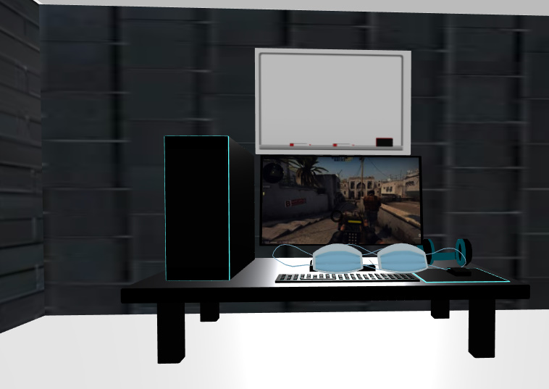

I imported desk with computer and masks from sketchfab.com and I made the whiteboard with a box by myself. I got that whiteboard picture from google. I actually use whiteboard a lot to write down my day plan, so I put it there.

**Refrigerator, Stove with cabinets and oven, hand sanitizer and windows with outside background**

I used boxes for refrigerator and Stove with cabinets and oven. Also, I used the box for the window with background. I was not trying to put window, but I figured out I actually will not be mentally healthy without windows living in my room, so I put it. Also, I put the big hand sanitizer from sketchfab.com. I actually have a big hand sanitizer on my kitchen’s table because during COVID 19, hand sanitizer sold out fast.

**Dumbells with pictures on the wall**

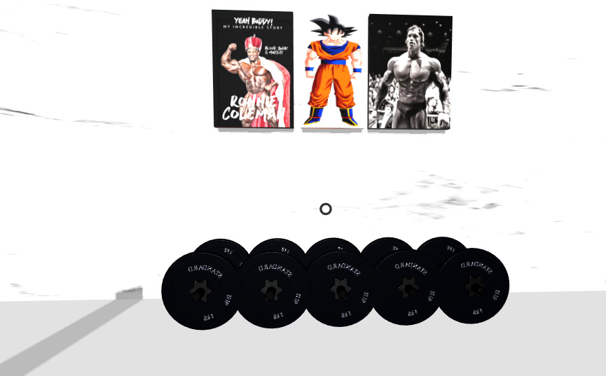

I put some cool pictures for my motivation working out in my room. During covid19, when everything was shut down, I could not go to gym and I actually bought some dumbbells to work out. I love working out and I put those pictures on the wall for my motivation because I am not used to with home training, so I need some motivations to do home training.

**Sofa, TV with speaker, shotguns, Fan, and front door.**

I did not import anything from website for those objects. I pretty much used boxes to make those objects and put pictures that I got from google. I actually don’t have shotguns in my room, but I just put it to make it look cooler. Also, I put some shadows from the sofa too.

**- Project 1 Report**

This project was little hard for me first, but I found very interest in making VR during this project. I have never learned or used HTML or the other things to make VR, but after I watch some lectures on YouTube, I found very interest making my actual room during COVID-19. It is very cool to explore my actual room through VR. I took lots of exams, so I could not really put my best effort and time on this project. I wish I had more time to put more objects because I could not put few objects having lack of ideas in HTML. However, I did my best as much as I can and I am statist fed with my actual room with VR.