**Head Trauma App Design Plan**

🡪 Users: military medics/EMTs in a triage scenario

1. Open app to homescreen: Table view or collection view for all your patients, with an “add new” button for new patient
   * Sidebar option to add a new patient when in a single patient view
2. New patient initial screen: open to questions (based off the Glasgow coma scale)
   * Design ideas: table of questions that change color (one tap = green, two taps = red)
   * Or Y/N on side that turns green or red
   * Or phrase question to favor one response and tap to color the box if it’s true
     + Will design algorithm later that takes answers into the R/Y/G status
     + Rank questions according to level of emergency with the most time sensitive first
3. Take photo screen
   * To track patient
   * Also for potential machine learning app capabilities later
4. Bluetooth: Try to automatically connect to bluetooth bandage as soon as app opens, (run a loading tab animation at the bottom)
   * If connected: turn the background red/yellow/green based on vitals
     + .visible = false for “CONNECT” button
   * If not connected: give option to retry bluetooth connection or cancel bluetooth
   * Pull up icons for pulse ox, heart rate and temperature as soon as bandage bluetooth connects
     + Have them white when not connected and then change color based on the vital info
5. Once done with patient, option to return to gallery mode to view all patients that have been logged or check in another patient

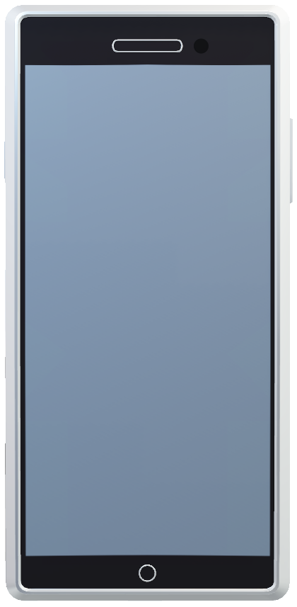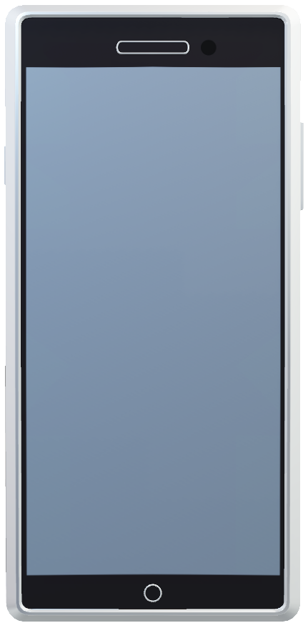** Make updated images for storyboards 2-6

Back end 1:

Blue light flashes while connecting

Audio: “Connected” or “Secure bandage and pull battery tab”; 30 s later. If still bleeding, apply direct pressure and hold until bleeding stops

Sensor begins monitoring… Parameters for sensor:

|  |  |  |  |
| --- | --- | --- | --- |
|  | O2 | HR | TEMP |
| RED | <87% | <45, >110 | <95.9;>101 |
| YELLOW | 88-90% | 46-55; 91-109 | 96-97.4; 99.5-100.9 |
| GREEN | >91% | 56-90 | 97.5-99.4 |

Acquires GPS

Back End 2:

Sensor detects vital signs and calibrates sensor light based on parameters

Lights flash in between Red/Yellow/Green while detecting parameters

Audio:

If Red: “Call 911 and continue to monitor”

“check for pulse”—Start CPR

If Yellow: Continue to monitor

Green: Make sure bleeding stopped and continue to monitor

____________

RED

Low Heart

& Oxygen

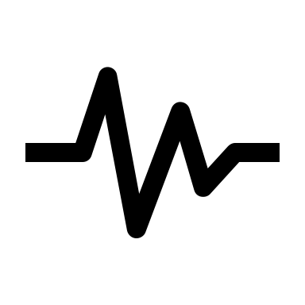

Done

**Questions**

Able to:

OPEN EYES: Y/N

SPEAK : Y/N

MOVE BODY: Y/N

More q’s as needed……

Back End 3:

Algorithm:

AI to assess:

*Age (baby, child, adult, geriatric

* Bleeding head

*eyes open/closed

*Male / or female

Weather calibration if outside

GPS tracking

**Face Photo**

Are you outdoors/indoors?

NEXT or SKIP

Tap to take photo

Accept/Retake

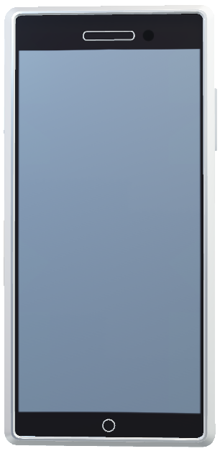

RED

Sends score to ER/EMS

StatusUpdate

HERO ID 001

RED

Adult male, bleeding from head with dropping HR, O2

Risk 5

Indoors

Location Link

Back End 4:

If RED: Questions:

Vomiting? YES/No

Head Bleeding? YES/NO

Skull fracture? YES/NO

“Call 911, apply direct pressure

Turn on Left side”

If Green, continue to monitor

YELLOW

Heart Rate improved

Able to:

Y/N:OPEN EYES

Y/N: SPEAK

Y/N: MOVE BODY

NEXT