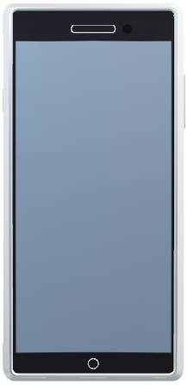

____________

RED

Low Heart

& Oxygen

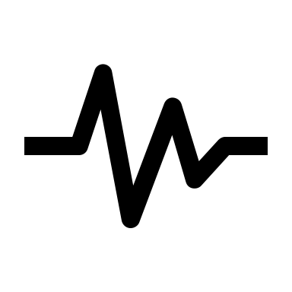

Back end

Blue light flashes while connecting

Audio: “Connected” or “Secure bandage and pull battery tab”; 30 s later. If still bleeding, apply direct pressure and hold until bleeding stops

Sensor begins monitoring…

Parameters for sensor:

|  |  |  |  |
| --- | --- | --- | --- |
|  | O2 | HR | TEMP |
| RED | <87% | <45, >110 | <95.9;>101 |
| YELLOW | 88-90% | 46-55; 91-109 | 96-97.4; 99.5-100.9 |
| GREEN | >91% | 56-90 | 97.5-99.4 |

Acquires GPS

Hero logo

TraumaApp

CONNECT



Pull bandage tab

Success!

Next

Back End:

Sensor detects vital signs and calibrates sensor light based on parameters

Lights flash in between Red/Yellow/Green while detecting parameters

Audio:

If Red: “Call 911 and continue to monitor”

“check for pulse”—Start CPR

If Yellow: Continue to monitor

Green: Make sure bleeding stopped and continue to monitor



RED

Back End:

If RED: Questions:

Vomiting? YES/No

Head Bleeding? YES/NO

Skull fracture? YES/NO

“Call 911, apply direct pressure

Turn on Left side”

If Green, continue to monitor

StatusUpdate

HERO ID 001

RED

Adult male, bleeding from head with dropping HR, O2

Risk 5

Indoors

Location Link

Face Photo

Tap to take photo

Accept/Retake

Are you outdoors/indoors

NEXT or SKIP

Back End:

Algorithm:

AI to assess:

*Age (baby, child, adult, geriatric

* Bleeding head

*eyes open/closed

*Male / or female

Weather calibration if outside

GPS tracking

Sends score to ER/EMS

YELLOW

Heart Rate improved

Able to:

Y/N:OPEN EYES

Y/N: SPEAK

Y/N: MOVE BODY

NEXT