How to check a variable’s type?

* We can check variable's type by a python function call 'type'

In what cases, you will get *SyntaxError* from the compiler telling you that some of your variables have invalid names? Can you give 3 different examples of invalid names?

* Lỗi xảy ra Khi Tên Biến trùng vs một số từ khóa của python, Biến bắt đầu bằng số hoặc chứa các ký tự đặc biệt
* VD
  + “76trombones” because it start with a number
  + “name@” because “@” is not valid
  + “class” because it’s python keyword

The program that calculates the area of a circle.

r=int(input("Radius of cirle="))

S=3.14*(r**2)

print("the area of circle=",S)

The program converts Celsius (0C) into Fahrenheit (0F)

C=int(input("Enter the temperture in Celsius C="))

F=(C*1.8)+32

print("",C,"(C) ="," ",F,"(F)")

Use Python Turtle to draw the following shapes

1. **A square**



from turtle import *

pencolor("green")

fillcolor("yellow")

begin_fill()

speed(0)

for i in range(4) :

forward(200)

left(90)

end_fill()

mainloop()

1. **An equilateral triangle**

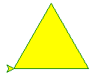

from turtle import *

pencolor("green")

fillcolor("yellow")

begin_fill()

speed(0)

for i in range(3) :

forward(100)

left(120)

end_fill()

mainloop()

1. **A circle (Hint: Google “*Python Turtle Circle*”)**

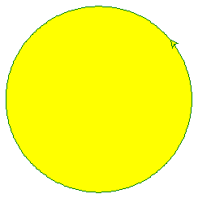

from turtle import *

pencolor("green")

fillcolor("yellow")

begin_fill()

speed(0)

left(90)

for i in range(360) :

forward(2)

left(1)

end_fill()

mainloop()

**4 An equilateral triangle**

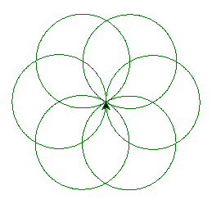

from turtle import *

pencolor("green")

speed(0)

left(90)

for i in range(6) :

for i in range(360) :

forward(1)

left(1)

left(60)

mainloop()

Or even better:

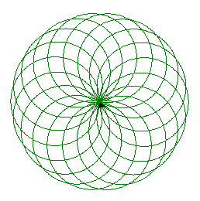

from turtle import *

pencolor("green")

speed(0)

left(90)

for i in range(600) :

for i in range(360) :

forward(1)

left(1)

left(20)

mainloop()