Question:

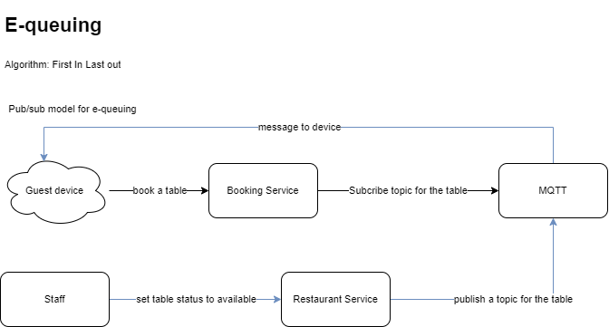

Question:

In case there are 10 guests in the queue, identified by number from 1 to 10,

When the table is set to available, only guest 1 can serve the table (case 1) or all of guest can serve table (case 2)?

Case 1: define a time interval to automatically cancel the booking of guest 1.

Case 2:

* Resolve the problem when more than 1 guests in queue has accepted