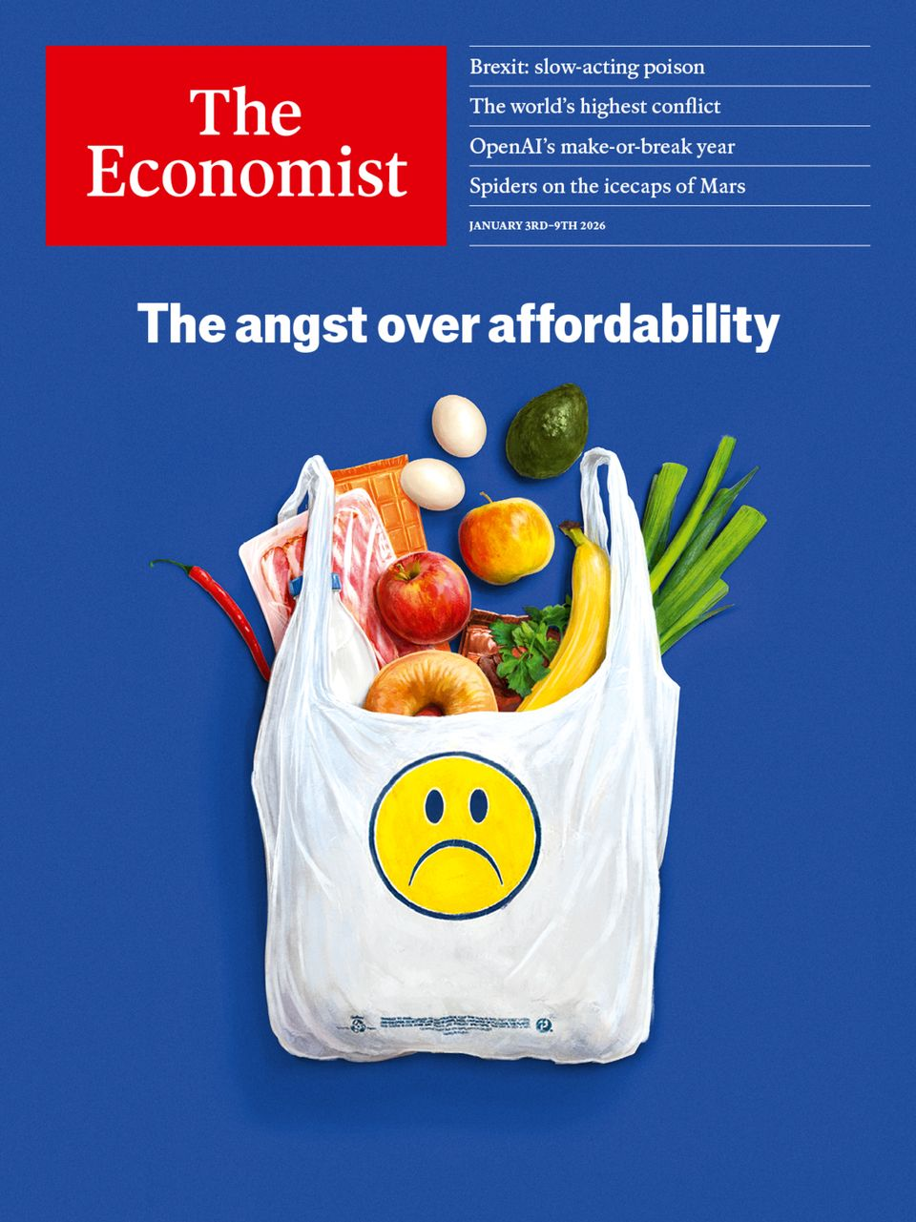

Table of Contents
The world this week
The world this week
The weekly cartoon
Leaders
The truth about affordability
OpenAI’s cash burn will be one of the big bubble questions of 2026
Brazil’s President Lula should not run again
The future of space exploration depends on better biology
Britain and the EU should be bolder in getting closer
Letters
Letters to the editor
By Invitation
It’s fire season for finance, writes Ken Miller
Briefing
America’s affordability crisis is (mostly) a mirage
Britain
It’s time to rethink Britain’s relationship with the EU
How the “take back control” crowd boosted immigration to Britain
Brexit has deepened the British economy’s flaws and dulled its strengths
Nigel Farage is Britain’s most European politician
Europe
The Baltic is becoming a battleground between NATO and Russia
Bulgarians join the euro and eject their government
Europe’s generals are warning people to prepare for war
Russia is blasting Odessa to throttle Ukraine’s economy
Why America still needs Europe
United States
Los Angeles after the flames
America’s most successful mayor stands down
Donald Trump has it in for Brutalism
The Supreme Court has taken the National Guard away from Donald Trump
The economics of megachurches
Middle East & Africa
A lightning advance by separatists has reshaped Yemen’s civil war
Netanyahu wins bigly from his meeting with Trump
Israel recognises Somaliland
The nautical theory of African development
Ghana tries to regulate online prophecies
The Americas
Brazil’s general election will be all about Lula—again
Peru’s not-so-happy new year
Canada’s first Christmas without the Hudson’s Bay Company
Asia
A fragile thaw at the top of the world
Australia’s prime minister gets booed in Bondi
A sham poll in Myanmar opens a new phase of military rule
Cults of personality pervade all levels of Indian politics
China
How China’s property crisis helped crash its art market
People of dubious character are more likely to enter public service
China’s museum boom, take two
International
A half-planet-size gap in global governance is about to get plugged
Patriotism tests loom for big business
Business
OpenAI faces a make-or-break year in 2026
China’s wind giants are coming for Europe
Despite a record year, airlines are grappling with big challenges
A new-year message from the CEO
As Warren Buffett retires, uncertainty looms for Berkshire Hathaway
A Swedish startup wants to reignite Europe’s explosives industry
What flying cars, quantum computing and fusion have in common
Finance & economics
America’s economy looks set to accelerate
Forget affordability. Europe has an availability crisis
China’s property woes could last until 2030
RedBird, a small firm doing big media deals
Investors head into 2026 remarkably optimistic
Science & technology
How to export life to Mars
The spiders on the icecaps of Mars
What is the best way to train for a marathon?
Culture
What self-help books tell us about ourselves
The internet’s vulnerable undersea tendrils
Oleg Lyalin: the spy who loved too much
Restaurants are changing their menus for the age of Ozempic
Economic & financial indicators
Economic data, commodities and markets
Obituary
Brigitte Bardot became, but refused to remain, the image of desire

[Jan 3rd 2026]
- The world this week
- Leaders
- Letters
- By Invitation
- Briefing
- Britain
- Europe
- United States
- Middle East & Africa
- The Americas
- Asia
- China
- International
- Business
- Finance & economics
- Science & technology
- Culture
- Economic & financial indicators
- Obituary
| 下一章节 | 主菜单 |

The world this week
- The world this week
- The weekly cartoon

| 下一章节 | 主菜单 |
| 下一项 | 章节菜单 | 主菜单 |

The world this week

The world this week
12月 30, 2025 05:49 上午


Volodymyr Zelensky met Donald Trump in Florida for talks. Both men said progress had been made towards resolving issues to end the Ukraine war (after their meeting Mr Zelensky suggested he wanted a security guarantee to last up to 50 years). Mr Trump acknowledged that the “thorny” question remained of Russian territorial claims. Meanwhile, Russia attacked Ukraine with 500 drones and 40 missiles, leaving 1m homes in and around Kyiv without power.
After a meeting in Florida with Binyamin Netanyahu·, Israel’s prime minister, Mr Trump said he wanted to push forward with the peace deal for Gaza and urged Hamas to disarm. He also said he would support another attack on Iran if it resumed its weapons-building programme.
A few days earlier Israel became the first country to recognise ·Somaliland as an independent, sovereign state. Both Israel and Somaliland said their joint declaration of mutual recognition was in the spirit of the Abraham accords, American-brokered peace deals between Israel and other countries in the region. Somalia described it as an “unlawful step” that threatened its sovereignty. China issued a statement saying it firmly opposed any attempt to split Somalia.
The main separatist group in southern Yemen·, the Southern Transitional Council (STC), rejected a call by Saudi Arabia to pull back from areas it had captured in early December and which has pushed the Saudi-supported Yemeni government out of its base in Aden. The STC, which is backed by the United Arab Emirates, said that Saudi Arabia had conducted air strikes against its forces (which the Saudis did not acknowledge).
At least three people were killed in Syria as clashes broke out at several demonstrations held by the Alawite community. The protests came shortly after a bomb at an Alawite mosque in the city of Homs killed at least eight people. In March 2025 hundreds of Alawites died amid an outbreak of sectarian violence stirred up by supporters of the ousted Assad regime.
The Nigerian government confirmed that America’s recent missile strikes against terrorists in northern Nigeria had targeted two camps with links to Islamic State. President Bola Tinubu supported the action to stop militants from the Sahel infiltrating the area, the government said.
Mr Trump said that America had carried out an attack on a “dock area” in Venezuela used by drug gangs, the first known direct strike on the country by the US. Reports suggested that the attack was a drone strike conducted by the CIA on a port facility used to store drugs. No one was hurt, according to the reports. The Venezuelan government didn’t comment.
Marco Rubio, America’s secretary of state, congratulated Nasry Asfura on winning the presidential election in Honduras. The election was held on November 30th but the result was delayed amid technical problems and claims of voter fraud. Mr Asfura is backed by Mr Trump. Mr Rubio urged Honduras’s opposition parties to respect the outcome.
Argentina’s Congress passed a budget, the first since Javier Milei became president in December 2023. Since taking office Mr Milei had merely extended the 2023 budget.
China carried out huge military exercises in the seas surrounding Taiwan, which it said were intended as a “serious warning to Taiwan independence separatist forces and external interference forces”. The drills, which encircled the island, used live rounds. Taiwan recently secured an $11bn deal with America for weapons, the largest package of its kind, and has greatly increased its defence budget.


Cambodia and Thailand agreed to halt the fighting that had broken out for a second time in recent months along their disputed border. After the ceasefire was announced both sides went to China for talks with the country’s foreign minister, Wang Yi.
America’s economy grew at an annualised rate of 4.3% in the third quarter, according to a first estimate that had been delayed by the government shutdown. It was the fastest pace of growth in two years· and in part reflected an increase in consumer spending, allaying fears about the economic impact of tariffs.
Alaa Abd el-Fattah, an Egyptian activist who was given British citizenship in 2021, moved to Britain three months after his release from an Egyptian prison. Sir Keir Starmer, the prime minister, and other senior ministers said they were “delighted”, but that was before a series of tweets surfaced from 2010-12 in which Mr Abd el-Fattah expressed support for killing Zionists and the British police, and that he hated white people (he has apologised amid the furore). With ministers denying knowledge of the tweets, the Foreign Office started an investigation into “serious information failures”.
Earlier, the British government increased the threshold at which a new tax kicks in on inherited farm land from £1m ($1.35m) to £2.5m. Farmers’ associations, which have been protesting against the controversial tax, broadly welcomed the decision, but noted there would still be a large tax bill for some.
Shortly before Christmas America’s Department of the Interior suspended leases for five wind farms off the east coast. The government cited “national security risks” and floated the possibility that the turbine towers interfere with radar. Previous attempts by the Trump administration to close offshore wind projects have been blown off course by the courts.

This article was downloaded by e-magazines.top from https://www.economist.com/the-world-this-week/2025/12/30/the-world-this-week
| 章节菜单 | 主菜单 |
| 下一项 | 章节菜单 | 主菜单 | 上一项 |

The world this week

The weekly cartoon
12月 30, 2025 07:15 上午
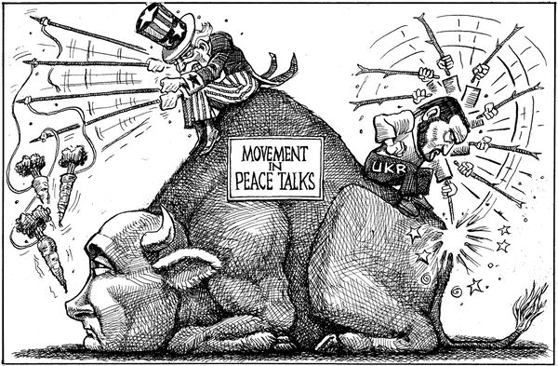

Dig deeper into the subject of this week’s cartoon:Ukraine scrabbles for handholds against Russia’s massive assaultUkraine struggles to cope with America’s destructive peace plansAmerica’s peace initiative has stalled in Moscow
The editorial cartoon appears weekly in The Economist. You can see last week’s here.

This article was downloaded by e-magazines.top from https://www.economist.com/the-world-this-week/2025/12/30/the-weekly-cartoon
| 章节菜单 | 主菜单 |
| 下一章节 | 主菜单 | 上一章节 |

Leaders
- The truth about affordability
Cost of living :: Voters in rich countries are angry about prices. Politicians could make things worse
- OpenAI’s cash burn will be one of the big bubble questions of 2026
The “Towering Inferno” of capital :: There is a dark side to the model-maker’s stunning growth
- Brazil’s President Lula should not run again
Time for fresh faces :: As Joe Biden showed, candidates over 80 carry huge risks
- The future of space exploration depends on better biology
Life off Earth :: Rockets are great, but sewage treatment is what you need for the long haul
- Britain and the EU should be bolder in getting closer
Edging together :: How post-Brexit Britain should approach relations with its nearest and biggest market

| 下一章节 | 主菜单 | 上一章节 |
| 下一项 | 章节菜单 | 主菜单 |

Cost of living

The truth about affordability
Voters in rich countries are angry about prices. Politicians could make things worse
12月 30, 2025 06:36 上午


SLOP, PARASOCIAL and rage bait were contenders for word of the year in 2025. In 2026 an early favourite for that title, at least among pollsters and election strategists, is “affordability”, often paired with the word “crisis”. Having at last found a slogan that seems to work against the spell of Trumpism, Democrats will talk of little else between now and the midterms in November. In Europe, which is better at reposting American memes than coming up with fresh ones, there is talk of a cost-of-living crisis. A transatlantic consensus is forming that prices are out of whack. But are they?
Affordability is a fuzzy term that can mean whatever feels true. Telling people to stop complaining and be happy with their lot—the Marie Antoinette strategy—is not working for a White House where the tone and decor increasingly resemble Versailles. Maddeningly, voters want contradictory things: low prices when they shop, high wages for themselves; not many immigrants but lots of cheap labour; rising house prices when they own and lower ones when their children want to buy.
Read the rest of our cover package
- America’s affordability crisis is (mostly) a mirage·
- Forget affordability. Europe has an availability crisis·
Successful economies are filled with tensions like these. Politicians will naturally say what polls well to win elections. If the only downside of the affordability story were that voters punished incumbents for high prices, that would not be so bad. Yet if the problem is misdiagnosed, the risk is greater that harmful policies will be introduced to “fix” it.
That is because talk of an affordability crisis mixes phantom concerns with real ones. Start with the imagined problems. People are sensitive to the prices of things they buy all the time. A gallon of milk cost $3 in American stores in January 2019 and now costs $4. Food prices have shot up in Europe too, as have energy prices. However, wages are growing faster than prices up and down the income spectrum· on both sides of the Atlantic. In this sense there is no affordability crisis. Besides, nobody should really want prices to return to 2019 levels. If that were the goal, policymakers should seek to imitate Greece after its debt crisis, when it suffered depression and deflation.
There is more to the affordability story than the price of milk or electricity, though. As societies grow richer, the share of spending on goods shrinks and spending on services increases. When Donald Trump was born, 60% of America’s household consumption went on goods. Now the share is below 40%, while that spent on services has risen. Many people have forgotten how long their parents once had to save to buy a tv, and so do not appreciate the globalised supply chains that have made goods so much better and cheaper.
Meanwhile they are shocked by how expensive a haircut is now, let alone child care. Although both goods and services are included in inflation numbers, services remain stubbornly resistant to the huge productivity gains seen in manufacturing. In the euro zone the affordability conundrum in services presents itself in a different way·. Because the prices of services such as health care and home rental are more regulated, the problem is availability more than affordability, and it is often solved by queuing—which does not feel good, either.
That is the first true affordability problem. The second is that though real wages have indeed risen, they have not gone up as fast as assets have. The wealth-to-GDP ratio is close to an all-time high in America. To think through the effects of this, picture two people who earn identical salaries that place them in the top 10% of earners. They have a standard of living that robber barons or monarchs of a bygone era would envy.
Then imagine one of these people also inherited $1m ten years ago. Had this lucky one put the money in the S&P 500, they would now be sitting on $4m. When these two people want to buy a car or a phone, this is not a problem. Ford or Apple can make an additional unit and sell it at the same price. When they want to buy positional goods, such as an apartment in San Francisco with a nice view, they are in competition. For one of them, this feels like an affordability crisis.
These are fundamentally problems of affluence, not of economic malaise. That makes them tough for policymakers to solve. To bring down the prices of housing and energy, for example, governments need to make it easier to build more homes and wind farms. Almost everyone favours this—but only in someone else’s backyard. Prices of services in America are inflated by absurd occupational-licensing rules—which licenced florists and hairdressers fiercely defend. Lowering tariffs would slow inflation, but firms protected by tariffs lobby strenuously for their preservation.
Enacting sensible policies is hard and even countercultural in a world that has, at America’s insistence, turned against free markets and international trade. The danger is that politicians reach for pseudo-fixes that make things worse, such as price controls. Also, in 2026 the American economy will see a fiscal boost from tax cuts, and the Fed will be under political pressure to cut interest rates. President Trump proposes sending out $2,000 cheques to taxpayers, funded by revenue from tariffs. It is hard to think of a combination of policies better designed to raise prices than to place new taxes on imports and then give people free money with which to buy them. It seems that the economic lessons that were learned in the 1970s, when Richard Nixon introduced price controls—and then abandoned them—must be relearned. That could be painful.

Sticky thinking
Once stories about the economy take hold they can be hard to shift. For the past decade America has told itself one about how blue-collar workers were left behind by coastal elites and then rose up in a populist rebellion. The data say this is not true: the real wages of non-college-educated workers were rising in 2016, when Mr Trump was first elected. They have kept rising since. Yet this tale has been used to justify an array of self-harming economic policies. The affordability crisis could become another story which, repeated often enough, is accepted as truthy—facts be damned. That makes it a trap. ■
For subscribers only: to see how we design each week’s cover, sign up to our weekly Cover Story newsletter.

This article was downloaded by e-magazines.top from https://www.economist.com/leaders/2025/12/30/the-truth-about-affordability
| 章节菜单 | 主菜单 |
| 下一项 | 章节菜单 | 主菜单 | 上一项 |

The “Towering Inferno” of capital

OpenAI’s cash burn will be one of the big bubble questions of 2026
There is a dark side to the model-maker’s stunning growth
12月 31, 2025 02:45 上午
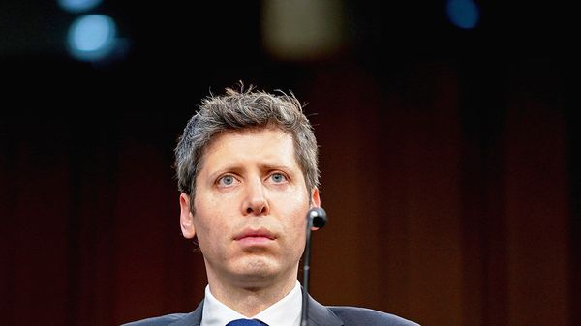

Stockmarket investors may have ended the year worried about the bubbly valuations of generative-AI firms. But private markets still appeared to be living in a parallel universe. In 2025 the venture-capital (VC) industry poured $150bn into big AI startups such as OpenAI and Anthropic, far more than beneficiaries of the previous VC boom received in 2021. Such is its confidence that Open·AI, maker of Chat·GPT, believes it can single-handedly tap private investors for as much as $100bn in 2026·. That would be almost four times the amount raised by the biggest stockmarket listing ever.
If anything, though, even private investors are likely to start asking tough questions. OpenAI, Anthropic and other San Francisco-based AI startups may have demonstrated some of the fastest revenue growth of any companies in history. But they have also burned through cash at “Towering Inferno” rates, as they spend on the chips and cloud computing needed to train and run their models. Both OpenAI and Anthropic will come under increasing pressure to spell out their paths to profit, especially as they consider going public in 2026 or shortly thereafter. For the AI industry in general, it will be a bracing, revealing experience.
Dig deeper
- Open·AI faces a make-or-break year in 2026·
Several factors will draw investors’ attention to the lack of profitability. The first is the gigantic balance-sheets of the big-tech juggernauts that the labs are up against. Cash-gushers such as Google have bountiful resources to put behind their large language models, including their own chips and cloud infrastructure, making their models more efficient to train and run than those of OpenAI and Anthropic, and less reliant on potentially skittish investors. This mattered less when Google’s Gemini struggled to match the capabilities of the standalone model-makers. But now it has caught up.
That feeds into a second problem. More than three years since ChatGPT was launched, the much-vaunted boost to business productivity from AI is yet to come. In the few promising areas, such as coding and customer service, the field is becoming increasingly crowded between OpenAI, Anthropic, Microsoft and tailor-made applications that run on their own and third-party models. No AI lab has a moat big enough to retain an advantage for long, which makes revenues vulnerable.
A third problem is that costs are rising as fast as—or faster than—revenues. Unlike conventional software companies, which generate more profit the more they scale, AI firms face higher costs the bigger they get. A large portion of these costs comes from the computational power needed to train frontier models. Running models for inference is not cheap either, particularly when many users are not paying subscribers. That leaves the firms with some tricky decisions. It is possible to reduce inference expenses by offering short answers, or offset the cost by selling advertising. Both, though, risk degrading the user experience. If the model-makers raise prices instead, they could deter adoption.
Lots of companies have gone from cash-guzzling to cash-printing before. From Netflix to Uber, plenty of startups spent years in the red before generating vast returns. Generative AI could pay out even more, especially if superintelligence arrives. But investors will not wait for ever, and the industry’s star firms need to start fleshing out their business models.
OpenAI in particular should beware hubris. One vc says discussion of cash burn is taboo at the firm, even though leaked figures suggest it will incinerate more than $115bn by 2030. Sam Altman, its boss, said recently that one reason he wants to take OpenAI public is to watch its doubters sell it short. “I would love to see them get burned on that,” he said. Plenty of investors seem prepared to take the bet: both the public equity and debt markets have punished companies with significant exposure to his firm. ■
Subscribers to The Economist can sign up to our Opinion newsletter, which brings together the best of our leaders, columns, guest essays and reader correspondence.

This article was downloaded by e-magazines.top from https://www.economist.com/leaders/2025/12/30/openais-cash-burn-will-be-one-of-the-big-bubble-questions-of-2026
| 章节菜单 | 主菜单 |
| 下一项 | 章节菜单 | 主菜单 | 上一项 |

Time for fresh faces

Brazil’s President Lula should not run again
As Joe Biden showed, candidates over 80 carry huge risks
12月 31, 2025 02:45 上午
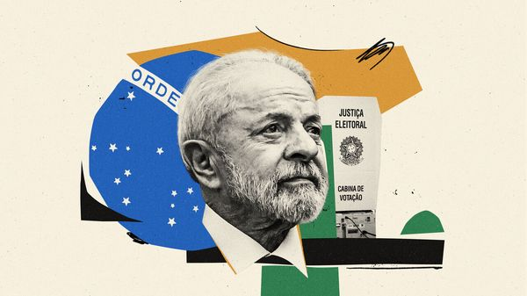

Latin America’s biggest country had a tumultuous 2025. Brazil jailed an ex-president, Jair Bolsonaro, for plotting a coup. President Donald Trump claimed, falsely, that this was a stitch-up, and slapped hefty punitive tariffs on Brazilian goods. Brazil’s left-wing president, Luiz Inácio Lula da Silva, stood up to Mr Trump, and persuaded him largely to back down. Lula, as he is known, is now in a strong position to win re-election in October·.
It would be his fourth term, making him easily the most successful politician in Brazil’s modern democratic era, which began after military rule ended in 1985, and which Mr Bolsonaro sought to curtail. Brazilians have cause to celebrate the survival of their democracy. But they deserve better choices.
Lula is 80. For all his political talent, it is simply too risky for Brazil to have someone so old serve another four years at the top. Charisma is no shield against cognitive decline. Lula is only a year younger than Joe Biden was at the equivalent point in the election cycle of 2024 in the United States, and that ended disastrously. He appears to be in much better shape than Mr Biden was, but he has had health scares. In December 2024 he needed brain surgery to stem internal bleeding after slipping in the bathroom and hitting his head. If he serves another full term, he will be 85 before he retires.
Dig deeper
- Brazil’s general election will be all about Lula—again·
He is also burdened by the corruption scandals that unfolded during his first two terms in office, for which many Brazilians cannot forgive him. And although Brazil’s economy has grown surprisingly fast in the past few years, Lula’s economic policies are mediocre. They focus largely on handouts to the poor, with revenue-raising measures that grow ever less friendly to business, though he has also pleased employers with a reform to simplify taxes.
Despite all these problems—and despite a campaign promise in 2022 that he would not seek a fourth term—Lula has no serious challengers from the centre or the left. He is so good at retail politics that all plausible rivals are keeping their heads down and their mouths shut.
Also, like Mr Biden, he has done almost nothing to groom a successor. The name of his finance minister, Fernando Haddad, was floated; but he was then passed over as being too cerebral. (Mr Haddad stood in 2018 but was trounced by Mr Bolsonaro’s trash-talking populist campaign.) A few young mayors from other left-wing and centrist parties have some support, but not nearly enough to elbow Lula aside.
The president would do his country a favour and burnish his legacy—as Mr Biden did not—by announcing that he will stick to his promise and stand aside. That would allow time for a proper contest to find a new champion of the centre-left.
Meanwhile, on the right, a struggle is raging to succeed the disgraced Mr Bolsonaro, who is serving a 27-year jail sentence but still has a surprising number of supporters, especially among evangelical Christians. He has tapped his eldest son, Flávio, to run for president in his stead. Flávio is unpopular, ineffective, and would almost certainly lose a race against Lula. Other possible candidates are circling, including some competent state governors.
The most prominent of these is Tarcísio de Freitas, the conservative governor of São Paulo. Mr Freitas already polls slightly better against Lula than does Flávio, despite the fact that he is not officially running and refuses to say whether he will. Mr Bolsonaro may yet see that Flávio has no chance and switch his support to Mr Freitas. Regardless, Mr Freitas should have the gumption to throw his hat into the ring. Unlike the Bolsonaros, he is both thoughtful and a democrat. Unlike Lula, he is only 50.
In 2025 Brazil showed that its democratic institutions were robust. Following the law and due process, and setting an example to other countries, its courts locked up an ex-president who had lost an election, made baseless allegations of voter fraud and tried to overturn the result by force. In 2026 Brazilian democracy needs another shot in the arm: a genuine contest between fresh, viable candidates.
Alas, it seems unlikely that Lula will drop out. Perhaps, then, the parties of the right can get their acts together? If they are wise, they will ditch Flávio and unite behind a candidate who can move beyond the polarisation of the Lula-Bolsonaro years. A centre-right figure who slashes red tape but not rainforests, is tough on crime but not dismissive of civil liberties, and who respects the rule of law, could both win and govern well. Brazil has everything to play for in 2026—and the outcome is worryingly uncertain. ■
Subscribers to The Economist can sign up to our Opinion newsletter, which brings together the best of our leaders, columns, guest essays and reader correspondence.

This article was downloaded by e-magazines.top from https://www.economist.com/leaders/2025/12/30/brazils-president-lula-should-not-run-again
| 章节菜单 | 主菜单 |
| 下一项 | 章节菜单 | 主菜单 | 上一项 |

Life off Earth

The future of space exploration depends on better biology
Rockets are great, but sewage treatment is what you need for the long haul
12月 31, 2025 02:46 上午


The typical number of people in space at any given time is currently ten: seven on the International Space Station shared by the space agencies of America, Canada, Europe, Japan and Russia, and three on China’s Tiangong. Jeff Bezos, a celebrity bridegroom and former bookseller, believes that in the coming decades this number will increase by five orders of magnitude to a million or so. Elon Musk, a carmaker and social-media provocateur, suggests similar numbers could soon be settling on Mars. Even if you think such predictions are outlandish, the two tycoons are clearly right about one thing. The number is set to rise.
Various companies are seeking to tap a market for commercial visits to orbiting habitats, either to conduct research, to supervise machinery or simply to hang out enjoying the view and the weightlessness. China and America both say they want permanent Moon bases. Late in 2025 America’s National Academies released a report saying how much better Mars exploration would be if humans joined in the efforts of the robots to which it is currently entrusted. Jared Isaacman, recently confirmed as the new head of NASA, appears enthusiastic about such voyages of exploration.
Dig deeper
- How to export life to Mars·
All this is underpinned by the investments Mr Musk and Mr Bezos have made in reusable rockets, the Starship and the New Glenn, developed by their respective companies, SpaceX and Blue Origin. These launchers are spectacular and stirring achievements of physical science. But if a significant number of people are to make their homes in space, they will need not merely to get there but to be sustained there, too. The physics of combustion chambers needs to be paired with the biology of closed ecosystems.
To live is to take in sustenance and expel waste. Ecosystems are tried and tested means whereby waste for some becomes new sustenance for others. With just ten people in orbit, such biological recycling is not really required; it is possible, if expensive, to ship up food and oxygen and chuck waste overboard. Indeed, on-board ecosystems can even need discouraging. The Soviet-era space station Mir was beset by mould.
But if people are to travel farther from Earth and stay away for longer, they will need to do so as parts of ecosystems that deliver more and more services in terms of food, recycling and environmental regulation. Enthusiasts suggest that the knowledge gained in making that possible might have benefits on Earth, too, where existing ecosystems enjoy the advantages of incumbency to a degree which makes it hard for novel approaches to show their potential mettle. But the development of such ecosystems lags far behind that of rocketry. Until it advances, a human presence in space will be unsustainable·.
“Applied astrobiologists” see themselves as central to that advance. They imagine ecosystems which, when fed with extraterrestrial minerals and ices—be they from the Moon, Mars or asteroids—will expand the scope for life within ever growing confines. Eventually such ecosystems might even spread unconfined. Such are the dreams of rendering Mars habitable through terraforming.

Do as you would be done by
It is a controversial vision. Some recoil on principle; others see its espousal by Mr Musk, a former Trump lieutenant and fan of Europe’s hard right, as an ineradicable taint. And there is a scientific risk: what if it were to come at the expense of existing Martian ecosystems? Though there is no evidence for life on Mars, very hardy microbes could in theory find some parts of it habitable. It would be a fateful step to risk their extinction through the introduction of competitors from Earth. It would be unconscionable to do so before they had been studied.
This is why international agreements on “planetary protection” put the most hospitable-looking bits of Mars firmly out of bounds both for humans and their robots, which though lifeless could carry microbial stowaways. It is a prohibition which makes it more or less impossible to detect what it seeks to protect. Hence the calls for deregulation that would allow a careful investigation of Mars’s most habitable parts but firmly constrain heedless contamination. Such a regime would, among other things, be much easier to defend should spacefaring scofflaws seek to flout it. Governments should welcome it.
The goal should be a new golden rule linking the search for life elsewhere to the spread of life beyond the bounds of Earth. Humans should expand into the cosmos in the same way that, were the situation reversed, we would wish alien life to expand towards us: carefully, respectfully and in happy anticipation.■
Subscribers to The Economist can sign up to our Opinion newsletter, which brings together the best of our leaders, columns, guest essays and reader correspondence.

This article was downloaded by e-magazines.top from https://www.economist.com/leaders/2025/12/30/the-future-of-space-exploration-depends-on-better-biology
| 章节菜单 | 主菜单 |
| 下一项 | 章节菜单 | 主菜单 | 上一项 |

Edging together

Britain and the EU should be bolder in getting closer
How post-Brexit Britain should approach relations with its nearest and biggest market
12月 31, 2025 03:03 上午
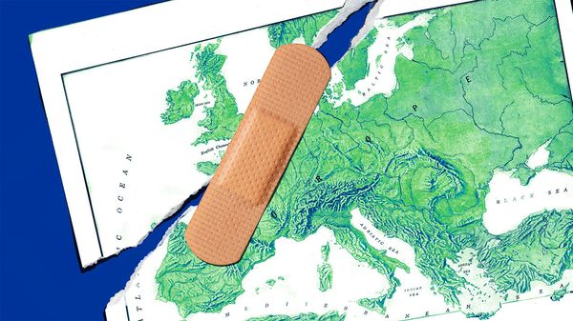

Nearly a decade after Britain’s reckless vote to leave the European Union, debate over Brexit is back. The intervening years have not been happy. Tortuous negotiation under one prime minister, Theresa May, was followed by the hardest possible Brexit deal under another, Boris Johnson, damaging Britain’s economy through new barriers to goods exports. Estimates of the resultant loss to British ·GDP range from an irksome 4% to a dismal 8%·. Even the promise of reduced immigration was not kept. As our latest polling confirms, most Britons now think Brexit was a mistake and favour closer ties with the EU, even more so than with America. Some voices in Britain’s governing Labour Party are floating the once-taboo idea of rejoining the customs union.
The EU, for its part, has plenty of other things to worry about, and Brexit seems like yesterday’s problem. But shifts in geopolitics—a less reliable America, a more menacing Russia—mean that it, too, has reason to rethink its ties with Britain. All this creates an opportunity for the two sides to move closer.
Dig deeper
- Brexit has deepened the British economy’s flaws and dulled its strengths·
- How the “take back control” crowd boosted immigration to Britain·
- Brexit has deepened the British economy’s flaws and dulled its strengths·
There have been promising, if modest, first steps. Britain has rejoined the EU’s Horizon programme, which promotes scientific collaboration. It is returning to the Erasmus scheme, letting young Brits study in Europe and vice versa. As part of a reset in May Britain agreed to realign with the EU’s rules on food safety and animal health, unblocking trade in farm goods and reducing barriers between Northern Ireland and Great Britain. The reset included plans for a broader youth scheme, easier cross-border travel, and a linkage of carbon-adjustment mechanisms and electricity trading. But the talks on all these have been slow.
Both sides are clinging to red lines. Sir Keir Starmer’s government is doggedly sticking to manifesto promises not to rejoin the single market, the customs union or the EU’s system of free movement of people within its borders. Red lines are often unhelpful when negotiating with a much bigger partner. But the EU is also too rigid in insisting on no exemptions from its rules and, as Britain starts moving closer to its single market, on unconstrained free movement. And it is prone to unrealistic demands for money. This recently sank any chance of Britain joining its new SAFE defence-spending fund, which would have been good for both Britain and the EU.
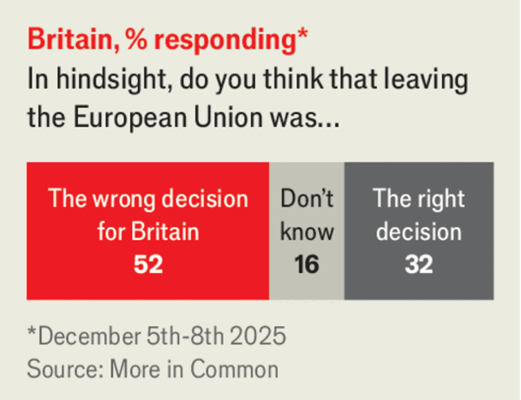

More flexibility is needed. Britain rejoining the customs union might seem like a good start, but is not a quick fix. It would usefully end the need to prove that goods exported from Britain qualify as British, but it would not deal with the obstacles to trade that arise because regulations (eg, on chemicals) now differ between Britain and the EU. It would also mean undoing Britain’s trade deals with America, Australia and East Asia. Better to keep chasing a bigger prize: closer alignment with the single market, with its nearly 500m consumers.
Here the EU resists “cherry-picking” and insists on its reciprocal demand for free movement. However, the reset already allows cherry-picking when both sides agree. As for unrestricted free movement, Liechtenstein (admittedly tiny) is in the single market without it, as is Northern Ireland for goods alone. Switzerland, similarly in the single market for goods, has an emergency brake on migration. Baroness May’s Brexit proposal of 2019, voted down by Britain’s Parliament, would in effect have meant single-market membership in goods without free movement of people.
The best way for Britain to negotiate this would be to seek (and offer) a form of partial membership of the single market in exchange for partial application of free movement (for example, offering free movement for certain professions or services). The EU may anyway need to do this for several applicant countries to its east, including Ukraine. For both Britain and the EU, it is past time for a bolder approach.■
Subscribers to The Economist can sign up to our Opinion newsletter, which brings together the best of our leaders, columns, guest essays and reader correspondence.

This article was downloaded by e-magazines.top from https://www.economist.com/leaders/2025/12/30/britain-and-the-eu-should-be-bolder-in-getting-closer
| 章节菜单 | 主菜单 |
| 下一章节 | 主菜单 | 上一章节 |

Letters
- Letters to the editor
A selection of correspondence :: Also this week, Chinese diplomacy, robotaxis, the office kitchen, parents supporting students, idle chatter

| 下一章节 | 主菜单 | 上一章节 |
| 下一项 | 章节菜单 | 主菜单 |

A selection of correspondence

Letters to the editor
Also this week, Chinese diplomacy, robotaxis, the office kitchen, parents supporting students, idle chatter
12月 30, 2025 05:48 上午


Travel advice
Your article on “dark tourism”, which is when tourists visit sites of atrocities, missed the mark on two important points (“Fatal attractions”, December 6th). One, many sites are actually cultural heritage or memorialisation sites created to preserve the past or prevent future atrocities. Auschwitz is the obvious example. Even if visitors simply come to gawk, the memory and lesson embodied by the site itself will hopefully pervade their consciousness either now or in the future. The Nova site of the Hamas massacre in southern Israel is rapidly turning into a site of memory and commemoration in a similar vein to Auschwitz.
Second, the distinction between tourists and “travellers” is a misnomer. Many of these so-called travellers are simply looking at a site without really “seeing” it, the people, or the culture. Travelling to a place and avoiding regular cafés in order to get the “real experience” does not turn you into an expert on Syria’s dark past. At the very least, it might instil an understanding of the horrors of warfare or torture, but to deem yourself an enlightened expert is just a manifestation of being able to say “I was there” when you might not have been there at all.
Leonard HammerChair on the Holocaust, human rights and comparative genocide
University of ArizonaTucson
Travellers to several of the countries you highlighted, including Afghanistan and Syria, face very real dangers. These countries do not merely appear unsafe, they are unsafe. Afghanistan, Iran, Iraq, North Korea, South Sudan, Syria and Ukraine are on the State Department’s Do Not Travel list. Omitting this context from your piece is particularly concerning with regard to Afghanistan. America and Britain saw several citizens freed this year after being held hostage by the Taliban, but the group continues to unjustly detain at least four Americans, underscoring the serious risks associated with travelling there. Furthermore, the kidnapping threat from the Taliban is serious and prolonged. Where we have data, we know the Americans released this year where held, on average, for 523 days.
Although the State Department may warn against travel to countries such as Iran or Myanmar it does not disclose the specific number of Americans held captive there. Such information is essential because it helps travellers understand the risks they may face. Travel reporting should include this context as well, so readers can make more informed decisions about visiting countries with a history of arbitrary detention or kidnapping.
The world is vast and beautiful, and travel can be deeply enriching and connecting. But safety must come first. Without wading into the ethics of dark tourism, it is worth noting that there is unfortunately no shortage of atrocity sites worldwide. For those interested in visiting one, it may be wiser to choose a location in a region without kidnapping or wrongful-detention threats. Travellers should consult official government advisory pages to understand the risks of visiting certain countries. American travel advisories specifically identify countries that engage in hostage diplomacy through wrongful detention.
People visit dark tourism sites to contemplate loss, not to join the tally. They deserve reporting that helps them avoid becoming the next cautionary tale.
Elizabeth RichardsDirector of hostage advocacy and research
James W. Foley Legacy FoundationPortsmouth, New Hampshire

Trading with China
Chaguan (December 13th) aptly described the “doghouse diplomacy” that now shadows any government crossing China’s red lines. Our research on the 2021-22 dispute between China and Lithuania, broadly confirms your thesis, but adds some twists.
We found that China’s punishment is less a simple trade embargo than a carefully staged performance. Once Lithuania allowed the disputed Taiwanese Representative Office to open, Beijing’s rhetoric turned bellicose, but its economic fist struck with surgical selectivity. For example, imports of visible consumer goods were crushed, satisfying the nationalist gallery. Yet imports of industrial goods, essential for China’s industries, were quietly allowed to rebound to record highs, even as the diplomatic shouting match peaked.
We call this “strategic decoupling”. China alternates between coupling and uncoupling its language and its economic measures over time and across audiences, preserving a fearsome reputation while containing the costs to its own industrial base. Lithuania, for its part, also decoupled, denouncing coercion even as its imports from China rose.
Machiavelli would understand. The lesson for firms and foreign ministries is therefore twofold. China’s bark is ferocious, but its bite is strategic. The key is to figure out whether you are the target or merely the audience.
Yue Ling SimaSheen LevineMike PengUniversity of Texas at Dallas

Taiwan’s economy
You were kind enough to publish my letter critiquing your ranking of the performance of developed economies in 2024 for ignoring the clearly strongest performer, Taiwan (Letters, January 4th 2025). Yet your ranking for 2025 (“Muito bom”, December 13th 2025) repeated the same omission in a year when Taiwan outperformed even more dramatically. Its economy grew at almost three times the rate of your winner, Portugal, and outperformed in basically any other category. Singapore, also omitted in both years, also outperformed your entire list by a bit less.
E. Glen WeylArlington, Massachusetts

People want to own a car
I enjoyed your piece on how “The self-driving economy” (November 29th) will transform urban landscapes. But I disagree with your view that car-ownership rates will fall once robotaxis reach parity with private cars on costs per mile. You suggest that only ferocious gearheads will still want to own a car, but there are several unpriced benefits to ownership. These include reliability (no waiting for a vehicle or wrangling with apps), personalisation (think child seats and nice speaker systems), and secondary uses, such as storing gym kit (when in the office) or golf clubs in the back. There is also the prestige of owning your own car. Whether a Lamborghini genuinely enhances anyone’s coolness is up for debate, but the fact that people still buy them is not.
History indicates that cheaper on-demand mobility does not automatically reduce ownership. The rise of ride hailing was expected to curb car purchases; instead, in cities such as London, Los Angeles and Dubai, ownership stayed steady or even grew. Consumer behaviour is stubbornly resistant to pure cost-per-mile logic.
A more plausible scenario is not a collapse in ownership, but a blurring of categories; fewer vehicles that are only taxis, and more privately owned vehicles spending their idle hours working as robotaxis. Assuming there is still room for the owner’s golf clubs.
Rory SullivanDubai
You presented interesting options on how robotaxis will impact cities. Another possible significant change will be the transformation of public transport into smaller vehicles. Self-driving fleets of small buses will be much more efficient than large buses and sometimes trains. No drivers means lower costs for transport companies.
The consequences of this evolution on urban organisation and the quality of life are mindboggling. Smaller buses can be tailored to individual journeys, doing away with fixed timetables, having to change connections and alighting at a stop far home.
Robobuses could use destination dispatch, a common technology used in the lifts of tall buildings. Each person states their start and end destination and the system optimises traffic, to improve individual journey time and vehicle occupancy. From the transport company’s side, robobuses mean fewer empty vehicles circulating outside peak periods. I’m always amazed how many empty busses there are in Paris, where the statistics for bus occupancy seem to be treated as state secrets.
Jérôme WALTERParis



The office jungle
Bartleby’s satirical interview (November 29th) with the director of a wildlife documentary that observed the habits of snackers and foragers in the office revealed some interesting behaviour from our colleagues that many of us suspected. My request is that the for the documentary’s next season is to feature those two closely related kitchen species, passivus aggressivus and aggressivus prime. Both possess the evolutionarily adapted skill of writing secret notes in the workplace kitchen. Passivus aggressivus prefers diminutive reminders using a handwritten, ancient cursive, whereas aggressivus prime often prints, laminates and plasters memorandums all over the common space. The observed jottings include appliance instructions for dummies, tidiness rants, pleas to support the coffee fund, demands to keep at all times this door shut and that cabinet open, and alarmist warnings about an imminent fridge cleanout. Strong evidence suggests this biological adaptation is passed down through generations. Curiously, these species’ acts are rarely observed, but omnipresent.
Matt KrymanDenver

Earning a crust
The Aggrieved Victims Of Crushing Academic Debt Obligations, or AVOCADOs, (Bagehot, December 6th) have a growing subset, of which I am a member. As a father of one AVOCADO and a higher earner, I am Tending Offspring And Salary Tolerable. The significance of being AVOCADO TOAST is that I now work part-time in the face of a marginal tax rate of 64% from the combination of higher-rate tax, national insurance, student loan and child-benefit repayment. You referred to those millennial favourites, Los Campesinos! I had the pleasure of seeing the band perform recently, and AVOCADO TOAST was well represented in the audience.
Robert HuntCardiff

Silence is golden
Taping your mouth shut when sleeping may or may not bring benefits to a person (Well informed, December 6th). But it would be a great benefit to the world if some people taped their mouths shut while awake.
Avinash DixitPrinceton, New Jersey

This article was downloaded by e-magazines.top from https://www.economist.com/letters/2025/12/30/letters-to-the-editor
| 章节菜单 | 主菜单 |
| 下一章节 | 主菜单 | 上一章节 |

By Invitation
- It’s fire season for finance, writes Ken Miller
Crackle, crackle, whoosh! :: A former top banker predicts that an unreformed pay system and the gutting of regulation will accelerate the next financial crisis

| 下一章节 | 主菜单 | 上一章节 |
| 下一项 | 章节菜单 | 主菜单 |

Crackle, crackle, whoosh!

It’s fire season for finance, writes Ken Miller
A former top banker predicts that an unreformed pay system and the gutting of regulation will accelerate the next financial crisis
12月 30, 2025 05:49 上午
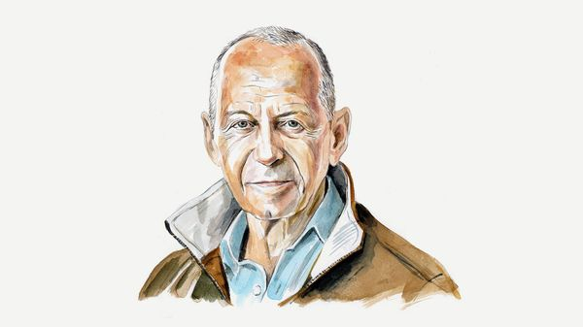

IT IS NOW just over 17 years since the financial crash triggered by the Lehman Brothers bankruptcy, and American stockmarkets are again at or near all-time highs. The two main drivers of investor optimism are artificial intelligence and a substantially loosened regulatory environment. These factors, combined with a Wall Street compensation system essentially unchanged since 2008, have now converged to tee up the next financial debacle.
After the crash of 2008, the Dodd-Frank legislation that President Barack Obama signed in 2010 strengthened the big banks by increasing their capital requirements and imposing other constraints on risk-taking. But Section 956 of that law—the provision directing regulators to curb incentive-based pay that encourages excessive risk—was, in effect, shelved during the first Trump administration and today exists only on paper. The most important reform of incentives on Wall Street never took effect.
Bonuses are the beating heart of the modern financial system. Whereas most Americans think of a bonus as a small percentage of base pay, on Wall Street bonuses are typically multiples of a salary that itself may be several hundred thousand dollars. There was talk of “clawbacks” for bad deals, meant to align dealmakers’ incentives with the long-term health of their employers. But clawbacks remain rare and largely symbolic. Traders, investment bankers and asset managers continue to be rewarded for adding to the bottom line in the current year, even when the transactions they push through generate losses later on.
This culture of outsize, short-term incentives is no longer confined to the traditional banks Dodd-Frank sought to regulate. Pay at non-bank institutions—now vital engines of finance—is just as skewed towards short-termism. Talent has migrated to small, lightly regulated trading shops built around automated models, statistical arbitrage and ultra-high-speed execution. Partners take a share of annual profits. No deferrals. No clawbacks. Most trade with borrowed funds and face no prudential supervisor.
Dodd-Frank never anticipated a world in which the bulk of market-making and intraday liquidity would be handled by automated systems overseen by financial engineers whose bonuses are tied to model profitability, not market stability.
Private credit—now a multi-trillion-dollar shadow-banking sector—compensates its dealmakers on an even more asymmetrical basis than the pre-2008 banks. Executives and originators at these firms earn enormous carried-interest payouts tied to loan-origination volume and fund returns in the early years of a strategy, even though the true performance of these illiquid loans may not be known for a decade. Today’s private-credit industry has recreated the incentive structure that fuelled the subprime-mortgage boom—only on steroids and with less oversight.
Mortgage and consumer-lending shops operate under similar incentives, retaining no long-term exposure to the risks they create. This is precisely the dynamic that produced the last crash, reborn through new channels.
All this is taking place in an era of extreme deregulation. Early in his first term, Donald Trump mandated that for every new regulation issued, two existing regulations had to be eliminated. Major parts of Dodd-Frank were rolled back, releasing all but the biggest banks from heightened oversight and shifting regulators’ focus from rules to “innovation” and growth.
In Mr Trump’s second term, his approach has shifted from changing the rules to replacing the enforcers. Senior positions across the regulatory architecture have been filled with anti-regulators—agency heads drawn from the industries they now oversee, enforcement chiefs whose careers were built on antipathy towards the very rules they are charged with applying, and supervisory officers who openly oppose the concept of supervision. The rules remain; the referees vanish.
As Russell Vought, director of Mr Trump’s Office of Management and Budget and one of the architects of this administrative strategy, put it: “Personnel is policy.” In February, after firing the director of the Consumer Financial Protection Bureau, Mr Trump designated Mr Vought acting director of the agency. Immediately, Mr Vought ordered a sweeping pause in its activities—suspending investigations, enforcement, rulemaking and even the drawing of additional funding. Entire categories of predatory lending were treated as, in effect, non-actionable.
At the Securities and Exchange Commission, cases against big crypto and fintech firms have been dropped or indefinitely paused. The supervisory arms of the Office of the Comptroller of the Currency and the Federal Reserve have reassigned or sidelined career examiners who once scrutinised liquidity mismatches and operational risks. This gives financial institutions leeway to acquire hard-to-sell, higher-yielding long-term assets and finance them with cheaper short-term liabilities, thus increasing profits through a risky “mismatched book”.
Meanwhile, politically connected financial offenders get pardoned. White-collar crime has become negotiable.
When Lehman went bust, its failure caused some $10trn in global equity losses within weeks. It’s impossible to know what will be the spark that sets off the next conflagration. A sudden consensus that AI won’t live up to expectations? A massive corporate fraud? Something else entirely? What’s clear is that, once the blaze begins, plenty of kindling will help it spread—thanks to Wall Street’s obsession with bonuses, hidden illiquidity, mismatched books and unregulated markets. ■
Ken Miller is former vice-chair of Merrill Lynch and Credit Suisse Capital Markets and the author of “High Finance”, a novel based on the collapse of Lehman Brothers.

This article was downloaded by e-magazines.top from https://www.economist.com/by-invitation/2025/12/30/its-fire-season-for-finance-writes-ken-miller
| 章节菜单 | 主菜单 |
| 下一章节 | 主菜单 | 上一章节 |

Briefing
- America’s affordability crisis is (mostly) a mirage
Fake blues :: That doesn’t diminish its political power

| 下一章节 | 主菜单 | 上一章节 |
| 下一项 | 章节菜单 | 主菜单 |

Fake blues

America’s affordability crisis is (mostly) a mirage
That doesn’t diminish its political power
12月 30, 2025 08:45 上午 | Washington, DC
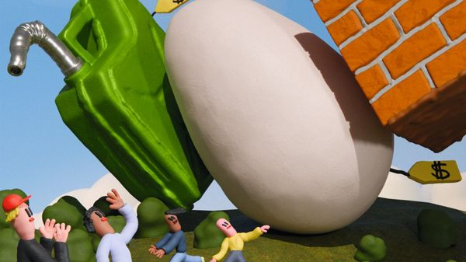

The IRONY is almost painful enough to make you pity the president. Donald Trump won the 2024 election in part by fulminating about inflation, which he blamed on the Democratic Party. He pledged to bring down prices “very, very rapidly” and “Make America Affordable Again”. As Mr Trump was surely aware, that promise was undeliverable; an economy-wide fall in prices is unprecedented outside a deep recession. Besides, since taking office, Mr Trump’s most noteworthy policy on prices has been to raise them further, by adding punishing tariffs to the cost of America’s imports.
A year later, prices are still high and the roles have reversed. After experimenting wanly with a series of lacklustre rallying-cries from “abundance” to “antitrust”, the Democrats have alighted on “affordability” as a galvanising political theme. Zohran Mamdani, on the party’s left, centred his winning campaign in New York’s mayoral election on the subject, promising rent freezes and free buses. Moderates like Mikie Sherrill, New Jersey’s governor-elect, have also embraced the idea: she has pledged to declare a state of emergency on utility costs on day one. Voters seem to agree with Democrats that there is a crisis of affordability.
That has left Mr Trump scrambling. For the most part, he denies that affordability is a problem, calling such claims a “hoax” and a “con job”. Scott Bessent, the treasury secretary, has said, “Americans don’t know how good they have it.” Sean Duffy, the transport secretary, epitomised the administration’s seeming haplessness when asked about expensive food in airports. “There’s not a lot of options,” he replied. “So I don’t have a plan to reduce costs.”
The comeuppance is deserved: having denounced Democrats on the subject, Mr Trump can hardly complain that they are now riling up voters in much the same vein. But on the economics, Messrs Trump, Bessent and Duffy have a point. The notion that Americans can afford less than they used to is essentially false. The strength of Americans’ collective belief otherwise says more about the toxic politics of inflation than it does about the state either of the economy or of household spending power—which both look healthy. The danger is not that politicians fail to bring down prices, but rather that they try to do so, giving damaging and discredited policy ideas like price controls a new lease on life.

The real deal
The clearest gauge of affordability is real wages: how much a paycheck buys, after accounting for inflation. High inflation, especially when driven by shortages of goods, often dents real wages. Workers’ purchasing power took a tumble in Europe·, for instance, after the energy shock precipitated by Russia’s invasion of Ukraine in 2022. In America, however, real wages have marched steadily upward for the past decade. The jump in inflation after the pandemic, which was driven more by over-stimulus than supply shocks, did not interrupt that trend.
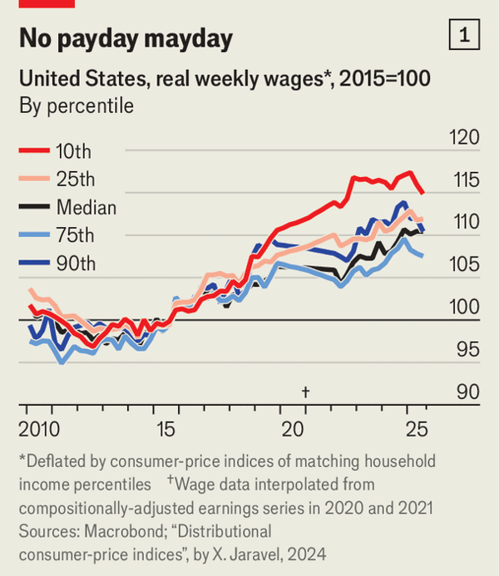

Low-earners have done especially well: their wages leapt in the ultra-tight labour market of the pandemic years. Even after adjusting for differences in spending patterns between poorer and richer households, real wages are close to record highs across the income spectrum (see chart 1), but are strongest of all for the poorest. Never, in other words, has life been so affordable in America for so many—not a point one often hears at campaign rallies.
Whatever the official figures show, affordability alarmists say, a set of essentials such as groceries, energy and housing have become unacceptably costly. The claim is inherently suspect, since all of those things are reflected in the consumer-prices basket used to calculate real wages and adjust benefits. But it is worth considering each of those categories in turn.

Sticker schlock
The case for an affordability crisis is flimsiest for groceries. Notoriously, egg prices quadrupled over the past few years, after mass culls of hens to halt bird flu. But a typical basket of groceries has largely tracked overall inflation (see chart 2). That is no surprise: the inputs into grocery bills are a microcosm of the economy, encompassing goods costs (the food itself), wages (of cashiers and warehouse workers) and rent (paid by the supermarket).
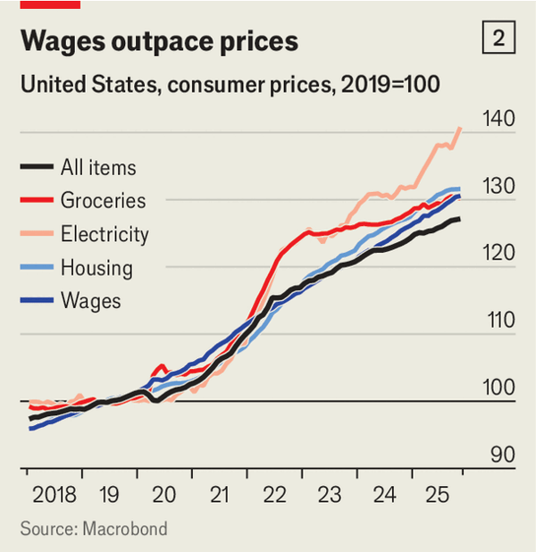

Electricity costs, in contrast, really have outstripped inflation, by over ten percentage points since 2019. Politicians and pundits often blame this on the data centres powering new artificial-intelligence models, which suck up tremendous amounts of power. That is probably unfair: an analysis by The Economist found no evidence that states with more new data centres have higher energy prices. More plausible culprits are the cost of modernising the grid to accommodate renewables and growing exports of liquefied natural gas, which have started to pull America’s lower natural gas prices towards Europe’s higher ones.
Talk of unaffordable electricity, however, neglects the other sort of energy most households consume: petrol, which Americans spend 40% more on. Prices at the pump have plunged over the past few years, following shifts in global oil markets. In fact, since 2019 petrol prices have fallen by more than electricity costs have risen (see chart 3). But the latter trend commands much more attention than the former.
The strongest case for an affordability crisis relates to housing. Living in America’s superstar cities is punishingly expensive. Land is scarce, and restrictive zoning rules have limited house-building for decades. Mortgage, insurance and tax on the average property in Manhattan and Brooklyn are equal to more than 90% of the average household’s pre-tax income there, we calculate. A common rule-of-thumb holds that anything above 30% counts as “unaffordable”. Buying in the other boroughs, or renting, is almost as bad.
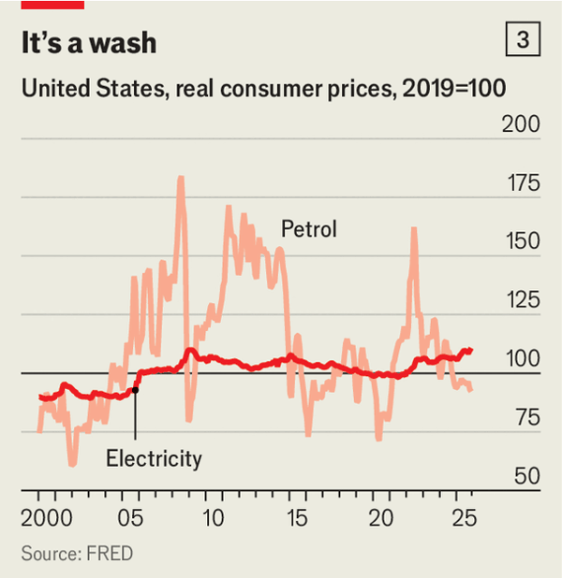

But most of America is not New York or San Francisco. Beyond the most crowded cities, the main spur for housing costs has not been property prices but higher interest rates on mortgages. Until rates began rising in 2022, the average home in most counties was affordable by the 30% rule-of-thumb, even for buyers with only a 10% downpayment. Now, most are not (see chart 4). Homeowners who fixed their mortgages before rates went up have dodged this. The average rate on all outstanding mortgages is still only 4.3%, nearly two percentage points less than the average rate on new mortgages. Still, the squeeze for buyers is real. Rents, which are less directly affected by mortgage rates, are more affordable: the average in most counties is still below that 30% threshold.
Mr Trump, ever the property developer, is alert to the housing issue. His pressure on the Federal Reserve to cut interest rates seems partly motivated by a desire to make mortgages cheaper. “People can’t get a Mortgage because of him,” the president wrote in July on Truth Social, his social-media network, referring to Jerome Powell, the Fed’s chair. More recently, he has toyed with the idea of a 50-year mortgage, which would lower monthly payments.
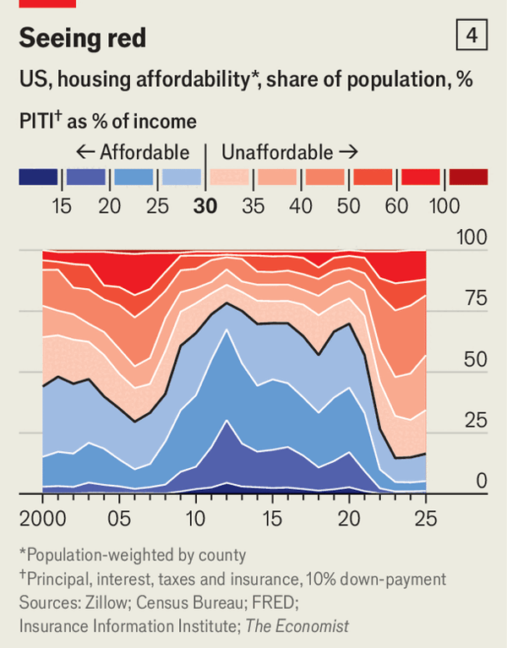

The Fed has been cutting rates of late, since America’s inflation problem is now largely under control. The personal-consumption-expenditures price index, the Fed’s preferred measure of inflation, is running at 2.8% year-on-year. That is a bit above the 2% target, but the 0.8 percentage-point overshoot is the sort of thing that would usually trouble only central bankers, not the voting public. Indeed, inflation has been in roughly that 2-3% range for two years now.
So what is going on? Part of the issue is that people are focused on the level of prices, which are now about 25% higher than before the pandemic. Even if the rate of increase has slowed, prices themselves remain jarringly high. The fact that nominal wages (ie, not adjusted for inflation) have risen by around 30% over the same period seems not to console people. A possible explanation lies in the strange psychology of inflation. Surveys conducted by Stefanie Stantcheva, an economist at Harvard University, suggest that people tend to ascribe price rises to factors beyond their control, but attribute increases in their wages to their own professional prowess. In other words, they believe they deserve not just the real increase in their wages, but the nominal increase, too.
Another problem may be the volatility of prices. At the peak of the inflation shock in 2022-23, about one in five goods and services was seeing an annual price rise of over 10%. And at almost every point over the past five years, there has been some common household purchase that was suddenly spiking in price. Couple that with the tendency of doom-mongers in the news and on social media to amplify stories of wild leaps in prices, and the public could be forgiven for thinking costs have risen much faster than they really have.
Relative price shifts probably play a part, too. For decades goods have been getting cheaper relative to services in America. Child care is much more likely to break a household’s budget than a flat-screen television or a fancy washing machine. That is a direct consequence of the strength of the economy, which has become much more productive, pulling up wages. Still, one person’s wages are someone else’s prices. The flipside of the rising incomes in lowly service jobs is that those services become more expensive. As the weight of Americans’ spending slowly shifts from goods to services, it is easy to interpret the associated costs as an affordability crisis rather than as a reflection of greater prosperity and rising incomes.
Then, finally, come interest rates, which are a price of sorts: the cost of money over time. These soared after the pandemic, as the Fed battled inflation, and have come down only a little since then. High deficits and Mr Trump’s habit of threatening to interfere with the Fed may also be contributing to the buoyancy of long-term rates. Higher rates, in turn, flow through to household costs in all sorts of ways, from more painful credit-card bills to steeper car loans. Research by economists at Harvard and the International Monetary Fund found that incorporating borrowing costs directly into inflation measures helps explain why consumer confidence worldwide is so depressed right now—more than you would expect from looking at unemployment and conventional gauges of inflation.
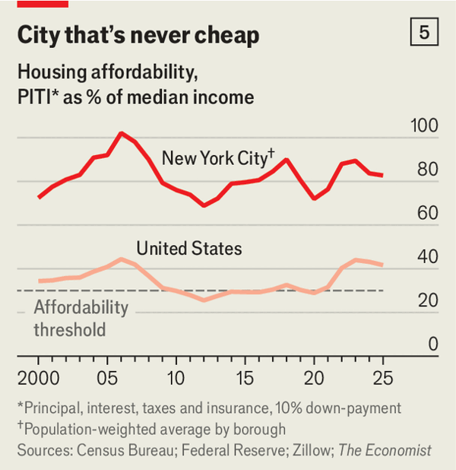

Still, aside from some legitimate gripes about higher interest rates, America’s affordability crisis is mostly a mirage. What does that mean for the politics of affordability? As Mr Trump and his team have discovered, beating voters over the head with economic statistics to assure them that they are doing better than they are feeling is not an effective electoral strategy. Nor are there any obvious short-term fixes: inflation has already fallen; higher wages have more than compensated for higher prices; and cutting interest rates sharply would overstimulate the economy and so unleash another round of inflation.
One conclusion is simply that periods of high inflation are inescapably dire for incumbent politicians. Mr Trump capitalised on this in 2024, but suffered for it in 2025. How long will the popular resentment last? Two years ago Neale Mahoney and Ryan Cummings of Stanford University used historical data about consumer sentiment and inflation to calculate how long it takes for anger about rising prices to dissipate as people reset their expectations of what things should cost. They found a “half-life” of one year, suggesting that people would have mostly moved on after about three years. But it has already been about three years since inflation was at its worst, and the politics of prices are as virulent as ever. The scale and intensity of this inflation surge, coming after decades of nearly flat prices, really do seem to be different. At any rate, the Democrats’ bet that anger about affordability will propel them through the midterm elections in November is looking perfectly plausible.
In the longer run, presumably, voters will move on. If the labour market takes a tumble attention will presumably swiftly shift to unemployment. But in the meantime, politicians are grasping for policies and messages to gratify voters’ insistence that something be done to make life more affordable—however misplaced their ire. A tempting option is to banish inflation by law by imposing price controls.
Economists (and The Economist) are sceptical of price controls, which tend to distort markets, force rationing by some mechanism other than price and do little to remedy the underlying causes of rising prices. American voters, however, have been showing signs of interest, even before “affordability” became the slogan of the moment. Just about the best-polling element of Kamala Harris’s (admittedly sparse) economic platform during the 2024 election was a proposal to ban “price gouging” by grocery stores. In recent months, particularly since Mr Mamdani’s win, the idea has only gained momentum.
Polling suggests that Americans overwhelmingly support caps on increases in grocery prices, rents and credit-card fees. Underlying that view is a distrust in the power of markets and competition to prevent businesses from gouging consumers. Two-thirds of Americans have a negative opinion of big business, up from roughly half before the pandemic, according to Gallup, a pollster.
There are much better ways to improve Americans’ purchasing power. Rolling back Mr Trump’s more damaging policies would make an immediate difference. Tariffs have made goods less affordable. His campaign against the Fed and his deficit-funded tax cuts have also helped keep long-term interest rates high and mortgages dear. His immigration crackdown is reducing the supply of workers and disrupting such industries as construction and agriculture, raising prices. The looming expiry of Obamacare subsidies will make health care much less affordable for some.
But the most beneficial options would take a long time to have a discernible impact. Easing zoning codes to enable more house-building could help lower the cost of housing, yet big construction projects take time. There are ways to capitalise on the data-centre boom by having big technology companies pay for upgrades to the grid, so lowering the burden on consumers; but again the change would take a while to be felt. Easing regulations to hasten the adoption of AI in everything from self-driving cars to hospitals could make a difference, too—but only once the technology has had time to diffuse.

Control freaks
Mr Mahoney and Bharat Ramamurti, a former aide to Joe Biden, Mr Trump’s predecessor as president, and Elizabeth Warren, a left-wing senator, have labelled the mismatch between the urgency of voters’ demands and the slow timescales of the supply-side of the economy “the affordability conundrum”: “Voters want immediate cost relief, but standard policy tools can’t always provide it.” This mismatch, they have suggested, means that supply-side reforms may need to be paired with price controls to provide immediate and visible help.
This route would be perilous. Even price controls originally intended to be temporary have a habit of enduring. Voters’ dangerous enthusiasm for price controls would probably only grow if politicians started advocating them more widely and energetically. And given the questionable empirical justification for voters’ grievances, it is far from clear that any government intervention, no matter how speedy or effective, would necessarily dispel their grievances.
That leaves only one, politically unsatisfying path out of America’s affordability malaise: time. Eventually, Americans will adjust to the new normal of higher nominal prices. If the economy stays on an even keel and real wages continue marching up, that should help. Softer inflation would allow for lower interest rates and so ease the mortgage squeeze. But ultimately the only way the topic of affordability can be detoxified is for voters to forget about it, or at least stop caring. Good luck turning that idea into a rousing placard. ■

This article was downloaded by e-magazines.top from https://www.economist.com/briefing/2025/12/30/americas-affordability-crisis-is-mostly-a-mirage
| 章节菜单 | 主菜单 |
| 下一章节 | 主菜单 | 上一章节 |

Britain
- It’s time to rethink Britain’s relationship with the EU
Brexit revisited :: Almost a decade after Brexit, both sides should be more courageous in getting closer together
- How the “take back control” crowd boosted immigration to Britain
Brexit and the border :: Policymaking turns out to be hard
- Brexit has deepened the British economy’s flaws and dulled its strengths
A slow-acting poison :: The question is what to do about it
- Nigel Farage is Britain’s most European politician
Bagehot :: If there is a European dream, the Reform UK leader has lived it

| 下一章节 | 主菜单 | 上一章节 |
| 下一项 | 章节菜单 | 主菜单 |

Brexit revisited

It’s time to rethink Britain’s relationship with the EU
Almost a decade after Brexit, both sides should be more courageous in getting closer together
12月 31, 2025 02:48 上午 | Brussels and London
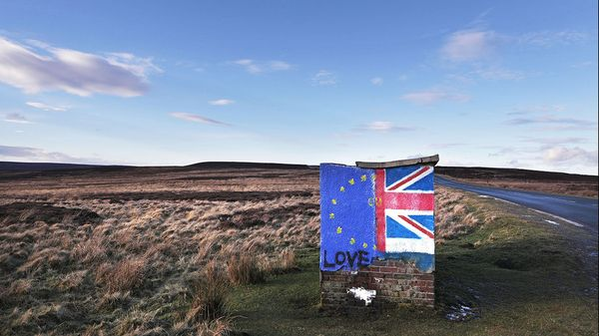

THIS WEEK marks the fifth anniversary of the trade and co-operation agreement (TCA) that sealed Britain’s departure from the European Union. In June it will be ten years since the Brexit referendum. It is a good moment to consider how Brexit has worked and where relations go next.
The economic impact has become clearer·. The Office for Budget Responsibility, Britain’s fiscal watchdog, sticks by the estimate that Brexit has reduced Britain’s GDP by 4% compared with its size had it not happened. A new assessment by the US-based National Bureau of Economic Research concludes that the hit was bigger still. And far from leading to a fall in immigration·, the overall numbers coming in rose sharply.
One consequence has been a huge change in public opinion. The Brexit referendum was won above all on promises of taking back control and lower immigration at no economic cost. Yet in a new survey conducted for The Economist by the pollster More in Common, 52% of respondents now say the decision to leave the EU was wrong; just 32% think it was right (see chart). Only among those over 65 does the balance shift towards Brexit being right. If a referendum were held today, 47% would vote to join, compared with 32% preferring to stay out. A large majority think Brexit has led to higher not lower immigration. And 55% of respondents favour a closer trade relationship with the EU even at the expense of more barriers to trade with America.
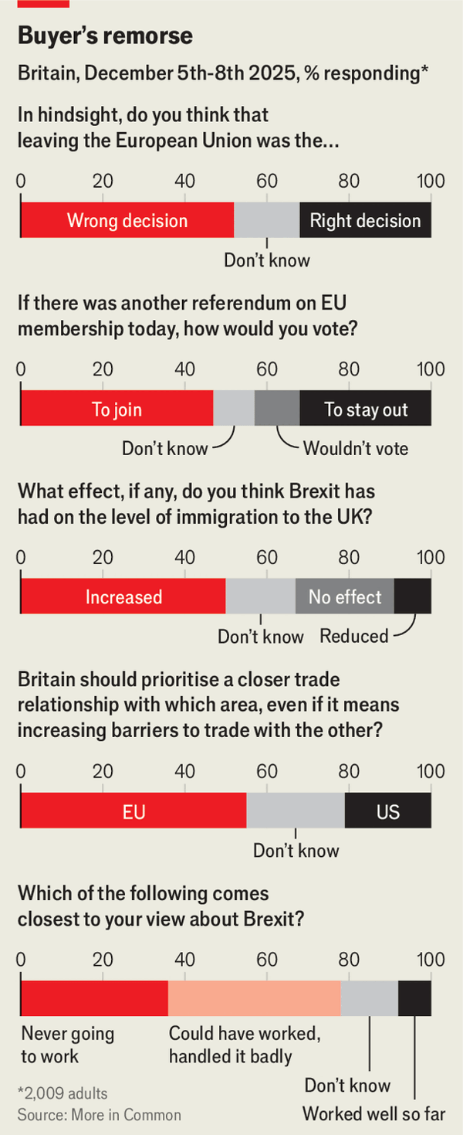

None of this necessarily translates into a burning desire to reopen the Brexit question. As many as 42% of respondents to our poll think it could have worked well but was badly done by politicians. Yet the shift in opinion against Brexit has encouraged Sir Keir Starmer to talk more openly about the damage done, even if the prime minister evinces little desire to soften Labour’s manifesto red lines of saying no to rejoining the EU’s single market, no to a customs union and no to free movement of people.
Changed geopolitics has made a big difference. Russia’s war in Ukraine, an increasingly assertive China and the return of Donald Trump as American president make closer links with Europe look more desirable. A revivified “coalition of the willing” on defence and a bigger role for an E3 group comprising Sir Keir, Emmanuel Macron of France and Friedrich Merz of Germany have a similar effect. All agree that in foreign policy and security, Britain and Europe must work more together.
Domestic politics are also shifting. After Labour’s 2024 landslide victory the new government seemed not to want to talk about Brexit. But, oddly, the rise of Nigel Farage’s populist Reform UK has changed this. As Brexit becomes politically tarnished, many in Labour hope to unite more pro-European voters behind their party. The idea of joining a customs union seems newly appealing: at least one cabinet minister, Wes Streeting, is openly floating it. Whether it would help much is less clear: no European country bar Turkey sees much benefit from a customs union alone, not least as it stops independent trade deals with third countries.
Last May Sir Keir and the European Commission’s president, Ursula von der Leyen, announced a “reset” to bring Britain back under the EU’s sanitary and phytosanitary (SPS) rules, create a youth-experience scheme for freer movement of young people, set up new arrangements for trading electricity and energy, and align carbon-border-adjustment schemes. Yet though the common understanding that underlay this reset was more ambitious than many expected, its impact will still be rather small: by the government’s reckoning, it may add only around 0.3% to Britain’s GDP by 2040.
The nitty-gritty of trade negotiations is also hard. Nick Thomas-Symonds, the minister in charge who is newly promoted to the cabinet, says both sides are going as fast as possible, but he admits that the earliest an SPS deal will take effect is 2027. EU diplomats in Brussels complain that the British always look for exemptions, in this case to continue with gene editing. Agreeing on greater youth mobility is tricky, too. The EU wants any scheme to be unlimited, but Britain wants a cap on numbers. On universities, the British have now agreed to rejoin the Erasmus system of student exchanges in 2027, at a discounted one-year cost of around £570m ($763m). But there will be further arguments about whether EU students should pay similarly high tuition fees to other foreigners.
Another EU-UK summit is due this summer. It is not clear if it will add new suggestions for the trade agenda. In the past the EU has resisted what it calls cherry-picking bits of its single market without accepting the obligations of alignment with EU rules, budget contributions and the free movement of people. Yet the reset is, in effect, an agreed form of cherry-picking. Other areas where the British might now seek to add preferential trade access could include steel, chemicals, pharmaceuticals and cars.
A recent House of Lords committee report suggested that more could be done for services trade. British exports of services to the EU have done relatively well, but new barriers have still had an impact. The Lords report suggested a renewed effort to facilitate touring by musicians and to seek mutual recognition of professional qualifications. Yet as one EU diplomat puts it, there is an “asymmetry of interest” when it comes to services.
And then there is money, not mentioned in May’s common understanding. The EU now insists Britain must pay to play. In November arguments over money derailed a British bid to join a new European defence fund known as SAFE. A French-inspired demand that Britain must pay up to €6bn ($7bn) was described by Lord Ricketts, chairman of the Lords Europe committee, as “bonkers”. Even a lower demand for €2bn proved too much. Charles Grant of the Centre for European Reform, a London-based think-tank, believes the French want to exclude Britain from SAFE. Mr Thomas-Symonds calls himself “ruthlessly pragmatic”: he will not sign up to anything if the price is too high.
The harsh truth is that the EU’s interest in softening the impact of Brexit is limited. It has many higher priorities, including Russia, internal economic reform and its own expansion. The TCA negotiated five years ago was pretty favourable to the EU. In Brussels there is also nervousness over Mr Farage’s rise. Why agree to a better trade deal with Sir Keir today if the next prime minister may tear it up tomorrow?
Yet even a low-priority Britain matters. It is the EU’s largest trading partner. It has a vital role in security. And it has done much to show the folly of leaving the club: Brexit has killed any idea of following suit. Even the risk of a Farage-led government argues for tearing down more barriers. Mr Thomas-Symonds says it would be damaging and unpopular to unpick any deals, as it would mean renewed red tape. The bigger risk is of missing the chance to do more to undo the damage of Brexit.■
For more expert analysis of the biggest stories in Britain, sign up to Blighty, our weekly subscriber-only newsletter.

This article was downloaded by e-magazines.top from https://www.economist.com/britain/2025/12/30/its-time-to-rethink-britains-relationship-with-the-eu
| 章节菜单 | 主菜单 |
| 下一项 | 章节菜单 | 主菜单 | 上一项 |

Brexit and the border

How the “take back control” crowd boosted immigration to Britain
Policymaking turns out to be hard
12月 31, 2025 02:51 上午


Mass immigration pushed Britain out of the European Union. For a dozen years before the 2016 referendum, many Poles and other east Europeans had settled in the country, exercising their right of free movement within the bloc. Britons had grown anxious about immigration and crotchety about David Cameron’s Conservative government, which had tried and failed to suppress the numbers. Fatally for the Remain cause, net migration reached 321,000 in the year to June 2016. It was the highest figure for at least half a century.
Surely a government dominated by Brexiteers could do better after Britain left the union? It promised to. In February 2020 Priti Patel, the home secretary, unveiled a new immigration system that treated Europeans like everyone else. Free movement from the continent would cease. But Britain would welcome more workers from elsewhere, in part by lowering salary thresholds for work visas. The Home Office estimated that the policy change would cut European immigration by 80,000-90,000 a year, while migration from the rest of the world would rise by 30,000.
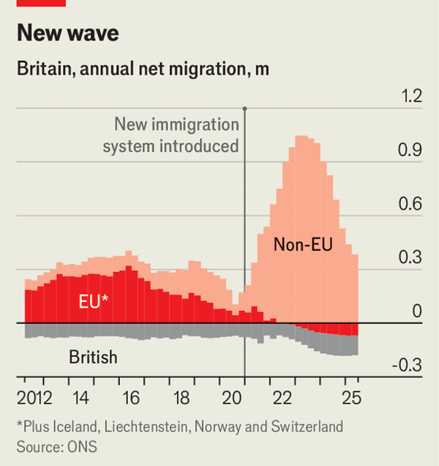

So much for that. European migration fell unexpectedly sharply; soon more were leaving Britain than arriving. Meanwhile the number of people arriving from outside Europe exploded (see chart). Overall net migration reached an amazing 944,000 in the year to March 2023. China’s crackdown on democracy in Hong Kong and Russia’s full invasion of Ukraine sent people spinning towards Britain. Smugglers in France got better at packing asylum-seekers onto boats. But Britain’s more liberal policies towards foreign workers and students, who were given the right to work after graduating, were the main reason for the rush.
Brexit did not exactly cause the surge in immigration: Britain could have loosened visa rules for non-Europeans when it was a member of the eu. But the episode helped bring Brexit into disrepute. Our poll with More in Common finds that only 9% of people think leaving the union suppressed immigration, whereas 50% think it boosted it. And the surge illuminated the profound difficulty of immigration policymaking. Taking back control is one thing. Concocting a policy that draws the kind of migrants Britain desires, in the quantity it can tolerate, is something else entirely.■
For more expert analysis of the biggest stories in Britain, sign up to Blighty, our weekly subscriber-only newsletter.

This article was downloaded by e-magazines.top from https://www.economist.com/britain/2025/12/30/how-the-take-back-control-crowd-boosted-immigration-to-britain
| 章节菜单 | 主菜单 |
| 下一项 | 章节菜单 | 主菜单 | 上一项 |

A slow-acting poison

Brexit has deepened the British economy’s flaws and dulled its strengths
The question is what to do about it
12月 31, 2025 03:40 上午
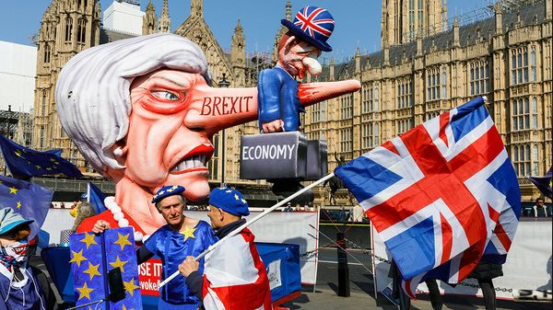

Covid-19 was a gift to Brexiteers. After years of argument over the Vote Leave campaign’s irreconcilable promises, the pandemic finally redirected public attention elsewhere. Boris Johnson, a former prime minister, used it to claim that “Brexit helped save lives”, based on a dubious assertion that leaving the European Union hastened the vaccine roll-out. Yet perhaps the longest-lasting dividend for Brexiteers has been in the pandemic’s effects on economic statistics. By scrambling almost every relevant data series, it has made it harder to assess Brexit’s effects.
Every few months a new study appears saying that Brexit’s costs have been large. Leave supporters retort that the figures are exaggerated because they fail to account for other factors, not least the pandemic. Some of these objections are reasonable. But the fixation on precise numbers misses the broader point. The real problem with Brexit is the way that it lingers like a toxin in the economy’s bloodstream, binding itself to long-standing weaknesses, from higher energy costs to weak investment. That has helped keep Britain stuck on a low-growth path.
The latest skirmish over numbers came in November, when the US-based National Bureau of Economic Research (NBER) published a paper finding that leaving the EU has already reduced British GDP per person by 6-8%. That is well above the predictions made during the 2016 referendum campaign, when the average forecast suggested GDP would be 4% lower in the longer term—a figure that Britain’s fiscal watchdog, the Office for Budget Responsibility, still considers accurate.
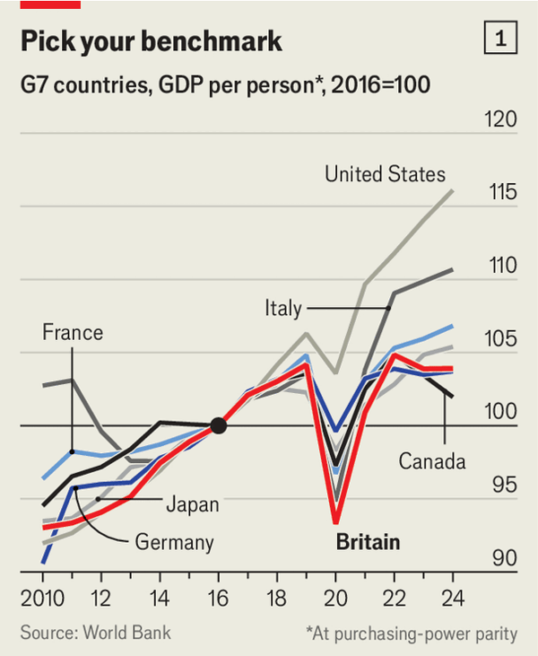

Julian Jessop, a Leave-supporting economist, says the NBER study fails the “smell test”. Its macro estimates benchmark Britain against 33 countries, including America, whose economic outperformance since the pandemic makes it a tricky comparator. Strip America out and Britain’s record has been fairly average among the G7 group of large rich countries. GDP per person grew by 3.9% between 2016 and 2024—less than in France and Italy, but more than in Germany and Canada (see chart 1). This suggests that if the NBER figures were correct and Brexit had not happened, Britain would have grown much more strongly than France or Germany. Mr Jessop is right that this counterfactual smells a bit whiffy.
Yet it is hard to argue that Brexit has been anything other than a source of real economic damage so far. The benefits, such as new trade deals with countries like Australia and India, have been trivial, and Britain has largely failed to use its new regulatory freedom to spur growth. But in three areas, the costs have been great—especially because they have either magnified the country’s existing weaknesses or blunted its strengths.
One of these areas is investment. For decades Britain has languished near the bottom of the G7 league for capital spending on things like infrastructure and R&D, a major cause of its feeble productivity growth. Between 2011 and 2016 it briefly broke out of the rut, with business investment growing by 6% annually. The Brexit vote ended that revival: investment flatlined for the next six years. The pandemic certainly played a part in this, but two separate estimates attribute a 10% shortfall in business investment by 2022 to Brexit alone, reflecting the prolonged uncertainty that deterred investors. Although that uncertainty has now faded, Brexit’s impact lingers, with the episode reinforcing the old habits among British companies—risk-aversion and short-termism—that have long held their investment back.
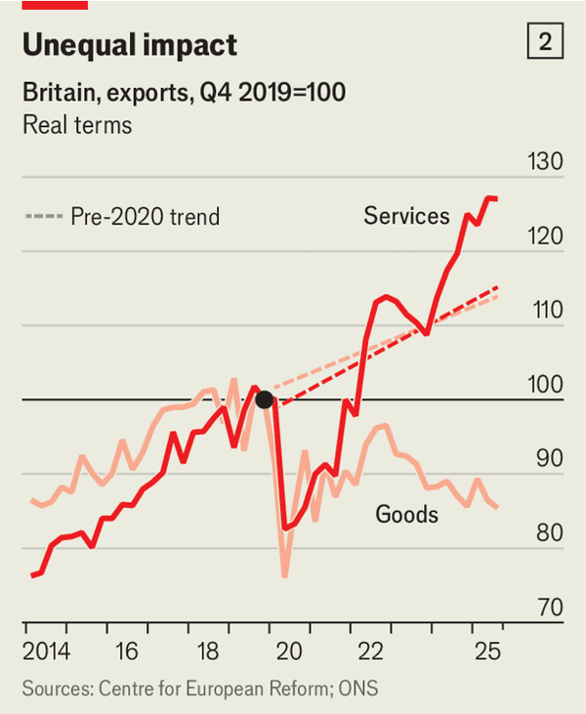

The second area is manufacturing. Britain’s share of global manufacturing exports fell by more than half between 2000 and 2022, dragged down by high labour costs, increasing foreign competition and crippling energy bills. Pre-Brexit, Britain’s access to a single market of half a billion consumers made up for these drawbacks. With that advantage gone and replaced by a host of non-tariff barriers, it is no surprise that goods exports have fallen to nearly 15% below pre-pandemic levels (see chart 2). Worse, this sharp decline occurred for exports to both the EU and the rest of the world, as higher input costs from the EU compounded Britain’s long-standing disadvantages and further eroded the global competitiveness of its manufacturers.
Brexit has not only intensified Britain’s weaknesses; its third major cost has been to dull one of the country’s strengths. Britain is the world’s second-largest services exporter after America. City bankers, arty film-makers and hordes of consultants all contribute to a thriving services economy.
On the surface, Britain appears to have weathered Brexit fairly well on this front: services exports are up by about a quarter since 2019 in real terms. But that mainly reflects a global boom. Britain would almost certainly have done better had barriers not sprung up with the EU, from new licensing requirements for insurers to nationality rules for biologists. A study published in June estimated that services exports are 4-5% lower due to Brexit.

A choice of antidotes
Keen as the Labour government is to now blame Britain’s economic malaise on Brexit, its costs should not be overstated. The economy did not fall off a cliff. Fears that London would lose its status as a global financial centre have gone unrealised. London remains the world’s second-largest such centre, after New York; Britain’s share of global turnover in foreign exchange and interest-rate-derivative trading is in fact higher than in 2016. Worries that lower EU migration would cause serious economic harm have not been borne out either, with higher immigration from outside Europe more than making up the shortfall.
But nor should the costs caused by Brexit be ignored. Labour’s efforts to rectify the damage so far have been small beer: its “reset” deal in May 2025 narrowly focused on food and energy and is estimated to boost GDP by only 0.3% in the long run. Some Labour MPs are flirting with the idea of rejoining the customs union. Frontier Economics, a consultancy, estimates this could increase Britain’s GDP by over 2% in the long run; other forecasters are much more conservative. Yet Labour ruled out joining the customs union in its manifesto and quick action is unlikely.
A more promising remedy might be to tackle the structural problems Brexit has worsened. The referendum and its aftermath distracted politicians from that task for years. If the government began to act on them—reducing planning red tape, cutting industrial energy costs—the toxic effects of Brexit could begin to fade.■
For more expert analysis of the biggest stories in Britain, sign up to Blighty, our weekly subscriber-only newsletter.

This article was downloaded by e-magazines.top from https://www.economist.com/britain/2025/12/30/brexit-has-deepened-the-british-economys-flaws-and-dulled-its-strengths
| 章节菜单 | 主菜单 |
| 下一项 | 章节菜单 | 主菜单 | 上一项 |

Bagehot

Nigel Farage is Britain’s most European politician
If there is a European dream, the Reform UK leader has lived it
12月 31, 2025 09:30 上午


For a man who has spent a life trying to break with the rest of Europe, Nigel Farage is quite fond of the place. “I love Europe,” begins Mr Farage in one of his frequent billets doux to it. “I love the social, economic, political, cultural diversity that exists within this fantastic continent.”
Sometimes he does it for money, such as when Paddy Power, a bookie, hired him to advertise the Ryder Cup, in which Europe’s golfers take on their American peers and create a rare moment of European jingoism. Sometimes it is out of cynicism, allowing Mr Farage to land blows on the European Union from a place of love rather than hate. Mostly, however, it is sincere. Mr Farage may have made a career fighting the eu. But there is more to the continent than a dozen gold stars on a blue flag. And there is more to Mr Farage than his Union Jack socks. There is a strange irony to Mr Farage: he is probably Britain’s most European politician.
After all, Europe is in his blood. Mr Farage’s boast of being descended from 17th-century Huguenot refugees is, his biographer Michael Crick determined, probably made up. It is on the paternal side where Mr Farage’s European roots are clearer. Nicholas and Bena Schrod came to London from Frankfurt in the 1860s. In 1870 Nicholas overheard two men beneath his window discussing the Franco-Prussian war. When one claimed that “40 Englishmen could beat 80 Germans”, Mr Farage’s great-great-grandfather stormed downstairs and assaulted them.
Europe is a lifestyle and Mr Farage has lived it. It was while gallivanting round Europe as a metals trader—often for French banks—that Mr Farage met his German second wife. Europe, argues Umberto Eco, an Italian writer, is a “sexual revolution” in which war was replaced with love. “A young Catalan man meets a Flemish girl—they fall in love, they get married and they become European, as do their children.” Mr Farage offers a variation on a European theme: a British man meets a German woman, they get married, bring up bilingual children and the man leads an independence movement out of the club. Following a separation, Mr Farage now has a French partner and a complicated and fiercely guarded private life. How European.
The bibulous Mr Farage found a natural home in Brussels, where there is still plenty of opportunity for lunch. He owes his political success to the European institutions he pledged to destroy. Britain’s first-past-the-post elections were a sturdy immune system against outsiders such as Mr Farage. The proportional representation used for the European Parliament was a novel virus in Britain’s body politic, allowing Mr Farage’s uk Independence Party (ukip) a foothold and then a stronghold in British politics. Generous eu funding for its parliamentarians helped Mr Farage bootstrap a political movement. He is a beneficiary of something very European indeed: democratic dirigisme.
Many will bridle at the idea of Mr Farage as a European creation, not least Mr Farage himself. A man who has flags on his socks? In France a mayor wears a tricolore on a handsome sash. How can a monoglot typify a polyglot Europe? Four in ten Europeans speak just one language: for many, the continent is still Babel. His vision of Europe, one of “exploring the churches, the battlefields”, jars with more cosmopolitan ideas of the continent. Yet it tallies with a Europe long-dominated by Christian Democratic parties and where the traumas of the 20th century are the moral bedrock of its integration.
By contrast, Mr Farage is at times a rather awkward Englishman. Where his views stand out, they do so in a European way. On Russia he is, by Britain’s hawkish standards, quite the dove. Yet his views are well within the mainstream in, say, Italy. On health care Mr Farage is one of the few British politicians to accept that the nhs is lousy compared with its European cousins and that a European-style insurance model is probably superior. In Britain that idea is verboten; elsewhere in Europe it is common sense.
Mr Farage’s peculiar Europeanness is an example of a certain type of English manoeuvre: men of the world who turn their back on it. Reform UK (and before it ukip) is a party of Kipling-quoters: “What do they know of England who only England know?” It was truly understanding the European project that led Mr Farage to want out, not ignorance of it. In Brussels there was always an affinity between the eu’s most ardent supporters and its fervent critics. Each recognised the project as a far more profound shift than did David Cameron types, who thought it a swap of a bit of sovereignty for extra gdp.
A man who was once an English aberration on the continent is now a European norm. Mr Farage typifies a very European version of populism. Reform resembles Geert Wilders’s Party for Freedom in the Netherlands far more than it does, say, the Republican Party in America. Giorgia Meloni, Italy’s prime minister, provides a template for how a right-wing populist can take power. Jordan Bardella, the populist-right favourite to become French president, came to London for a love-in with Mr Farage. Each has learned from and shaped the other. European politics has become a land of outsiders invited in by voters, who may—slowly—mould the continent’s politics in their image, just as their staid Christian Democratic and stodgy socialist predecessors did before. Perhaps they will create a club Mr Farage would be happy to join.

The European dream
If there is a European dream, Mr Farage is its exemplar par excellence. The Reform leader has worked, lived and loved across a continent that most Britons know only as a holiday destination, his politics shaped by the place that he spent much of his life trying to escape from. Mr Farage helped make Britain leave the eu. But Europe will never leave him. ■
Subscribers to The Economist can sign up to our Opinion newsletter, which brings together the best of our leaders, columns, guest essays and reader correspondence.

This article was downloaded by e-magazines.top from https://www.economist.com/britain/2025/12/29/nigel-farage-is-britains-most-european-politician
| 章节菜单 | 主菜单 |
| 下一章节 | 主菜单 | 上一章节 |

Europe
- The Baltic is becoming a battleground between NATO and Russia
Deep trouble :: Poland, Sweden and others are buying subs to protect pipelines
- Bulgarians join the euro and eject their government
Out with the old :: Huge anti-corruption protests provide a chance for reform
- Europe’s generals are warning people to prepare for war
War readiness :: But western European societies are in denial
- Russia is blasting Odessa to throttle Ukraine’s economy
Black Sea blitz :: Putin’s assault aims to terrorise civilians and cripple ports
- Why America still needs Europe
Charlemagne :: Without European “followership”, America ceases to be a leader

| 下一章节 | 主菜单 | 上一章节 |
| 下一项 | 章节菜单 | 主菜单 |

Deep trouble

The Baltic is becoming a battleground between NATO and Russia
Poland, Sweden and others are buying subs to protect pipelines
12月 31, 2025 02:58 上午


Compared with Russia’s hulking nuclear-powered submarines, Sweden’s a26, at just 66 metres long, is a compact model. But what the Saab-built sub lacks in size it makes up for in stealth and surveillance abilities. A portal built into its bow lets it deploy underwater drones, sensors or divers onto the seabed. For the Baltic Sea’s murky waters, and for the cold war unfolding beneath them, the a26 delivers the most bang for the buck. That at least was the conclusion Poland’s government reached on November 26th, when it decided to buy three of the vessels for an estimated $2.8bn.
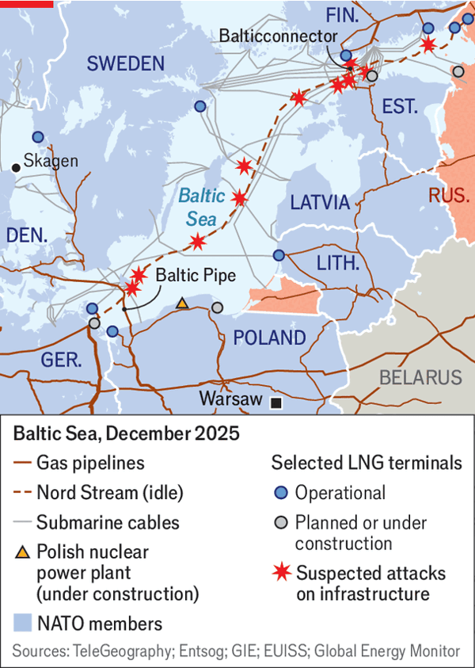

For countries like Poland, having eyes on and under the Baltic is a pressing matter of national security. The sea teems with telecoms and energy infrastructure. A natural-gas pipeline, the Balticconnector, links Finland and Estonia. Another, Baltic Pipe, transports gas from Norway to Poland. Communications and power cables line the seabed. Earlier this year Estonia, Latvia and Lithuania unplugged their power systems from Russia’s grid; of the four links that connect them to the European one, three are underwater. Above the surface, hundreds of wind turbines stand off the coasts of Denmark and Germany, and new ones are rising off Poland’s. The Baltic’s shores host ten lng terminals, with two more under construction.
On paper, nato’s presence in the Baltic has never been stronger. Of the sea’s nine littoral states, all but Russia belong to the alliance. But although nato has a clear edge in the Baltic when it comes to conventional naval power, Russia has the means to wreak havoc. Since 2023 there have been at least 11 suspected acts of sabotage to Baltic Sea infrastructure, many of them linked to Russia’s shadow fleet, the network of tankers the country uses to bypass Western sanctions. The worst were ruptures of the Balticconnector and of a power cable linking Finland and Estonia, probably caused by ships dragging their anchors along the sea floor. Both took months to repair.
Russian spooks may also be using some of the ships for operations above sea level. In September drones that seem to have been launched from ships linked to Russia were spotted over Danish airports. Similar incidents have since taken place in France and Germany.
Hybrid attacks allow Russia to deny involvement, test nato’s mutual-defence clause and gauge each member’s appetite for confrontation. But Vladimir Putin’s regime is also starting to do things in the open. In early October Denmark’s defence intelligence service revealed that Russian warships had pointed their weapons at Danish navy ships and helicopters, and sailed in the direction of Danish vessels, simulating a collision.
Russia will soon have more targets to choose from. Germany, Denmark, Sweden and Finland are building new Baltic Sea wind farms. Poland is even more exposed. It relies on the Baltic’s pipelines and ports for nearly half of its energy imports, and that dependence is growing. By 2040 the country may invest well over $100bn in offshore wind farms and new lng terminals. Poland’s first nuclear power plant, expected to open by 2036, will be less than 2km inshore.
Many of these projects were thought up when the threat from Russia seemed abstract. Now governments are scrambling to protect them—a tough challenge. Radars and satellites can monitor the skies and track ships, even when they turn off their transponders. But tracking what happens below the surface is much harder, which makes the seabed ideal terrain for hybrid attacks.
Much existing surveillance technology, which relies on sonar, is poorly suited to the Baltic. The shallow and cluttered seabed creates acoustic noise, maritime traffic masks underwater activity and sharp changes in salinity distort sound waves. New solutions will plug some of the gaps, including hydro-acoustic sensors, submarines like the a26 and unmanned underwater vehicles (uuvs). But developing an integrated surveillance system, a key nato objective for the Baltic, will take years.
Projects like the a26 face long delays. Sweden’s navy had planned to take delivery of the first of two submarines it ordered from Saab in 2022. That has been pushed back to 2031. (The need to upgrade the shipyard where the subs are built is said to be one of the reasons for the delay.) Poland, whose navy fields only one creaky Soviet-era submarine, will need to wait until the 2030s for the three a26s it has ordered. Meanwhile, Britain’s main military-intelligence agency recently concluded that Russia is modernising its fleet to target undersea cables and pipelines.
So even with new technology to improve monitoring, detection and repairs, nato needs to do more to show Russia that its hybrid attacks will not go unpunished. The response so far has been largely reactive. Under nato’s Baltic Sentry operation, launched in early 2025, the alliance has stepped up patrols on the Baltic. But although nato vessels can hail commercial ships to check whether they have valid registration, under international law their crews are not allowed to board or inspect them.
Some countries have floated more drastic measures. In the wake of the drone incursions over Denmark, Ukraine’s president, Volodymyr Zelensky, suggested closing the Baltic to shadow-fleet tankers. Estonia’s defence minister, Hanno Pevkur, had proposed doing so months earlier.
Such a blockade, however, would almost certainly violate international law. The un Convention on the Law of the Sea guarantees ships, even sanctioned ones, the right to pass through international straits as long as they do not threaten force or violate safety rules. Russia, which uses the Baltic for 60% of its seaborne crude oil exports, would probably consider the closing of Danish straits to shadow-fleet tankers an act of war. A more prudent response would be to deny access to ships that do not meet technical standards, says Jacek Siewiera, former head of Poland’s national security council.
That approach is gaining traction. In October Denmark stepped up controls of tankers at the Skagen anchorage, which connects the North Sea with the Baltic. Poland, meanwhile, is giving its naval deterrent more teeth. A bill passed by the country’s parliament in November allows the navy to use force to protect critical infrastructure, even outside Poland’s territorial waters.
Protection is expensive, but not compared to dealing with attacks. A recent study by rand, a think-tank, put the daily cost of repairing an undersea telecoms cable at €24m ($28m), an oil pipeline at €36m and a gas pipeline at €75m. Such repairs usually take months. Lost energy supplies and connectivity compound the damage. Enough such provocations, and a submarine or two starts to look like a bargain. ■
To stay on top of the biggest European stories, sign up to Café Europa, our weekly subscriber-only newsletter.

This article was downloaded by e-magazines.top from https://www.economist.com/europe/2025/12/23/the-baltic-is-becoming-a-battleground-between-nato-and-russia
| 章节菜单 | 主菜单 |
| 下一项 | 章节菜单 | 主菜单 | 上一项 |

Out with the old

Bulgarians join the euro and eject their government
Huge anti-corruption protests provide a chance for reform
12月 30, 2025 05:49 上午 | Sofia


Back iN the communist days Bulgarians gained a reputation for meek obedience: unlike the Czechs, Hungarians or Poles they never staged a major uprising. “The sword does not cut the lowered head,” goes a local adage. That makes vast protests of the sort that recently swept the country all the more striking. On December 10th an estimated 100,000 people packed the square in front of the National Assembly in Sofia, the capital, calling for the government to resign. Dozens of demonstrations popped up in smaller towns, showing that the anger went beyond urban elites. For a country of 6.4m people where corruption has left many demoralised, it was an impressive turnout.
And it worked. On December 11th the prime minister, Rosen Zhelyazkov of the GERB party, stepped down. The outgoing government was a minority coalition between GERB, an ideologically colourless party of power founded by Boyko Borisov, a three-time prime minister, and the Socialist Party, heir to the former communists. It also included the amusingly named There Is Such A People, a small populist outfit headed by a TV host and pop singer. If no new coalition can be formed, Rumen Radev, the president, will appoint a caretaker government and call an election. It would be the country’s eighth in four years.
Bulgaria has long oscillated between oligarchic machine politics and stumbling efforts at reform. Mr Borisov, a former bodyguard with man-of-the-people charm, has run the country on and off since 2009. His party has presided over widespread corruption, the loss of independence for the judiciary and the political capture of most news media. A huge scandal in 2020 ultimately led to Mr Borisov’s arrest on charges of blackmail, which he denied. But he has not been prosecuted. In 2021 We Continue the Change (PP), a reformist party led by two Harvard-educated economists, Kiril Petkov and Asen Vasilev, formed a short-lived government, but its coalition partners proved unreliable. In 2024 GERB again won an election. Mr Zhelyazkov got the top job, but Mr Borisov was seen as the power behind the throne.
The other big player in machine politics is Delyan Peevski, an oligarch under sanctions from both the American and British governments. A former media mogul, over the past decade he has become the country’s biggest power broker. He has taken over the Movement for Rights and Freedoms (New Beginning), originally a party representing the country’s ethnic Turkish minority. Although not a part of the outgoing government, it lent it crucial support in parliament and played a major role in decision-making. Unlike Mr Borisov, the corpulent Mr Peevski lacks charisma. “He is like a bulldozer, crushing all accepted norms of behaviour,” says Dimitar Bechev, a political scientist at Oxford University.
Bulgaria is poor: the average monthly wage is about €1,300 ($1,530). But its economy has been doing well, growing by 3.4% in 2024. Unemployment is at 3.5% and state debt amounts to just 26% of GDP, the third-lowest in the European Union. Some fear that inflation may get a bump with the country’s switch from its old currency, the lev, to the euro on January 1st, though studies of other countries that have joined the single currency show no persistent inflationary effect.
But the immediate trigger for the demonstrations was the government’s adoption in early December of a budget that would have increased social-security taxes, while raising the salaries of the police and judiciary—both of which are stuffed with political cronies. Some judges were to get €12,000 per month. An attempt to prosecute a respected PP mayor on trumped-up corruption charges helped fuel the anger. Whereas earlier protests drew mainly well-off older folk, the crowds this time included young people, leading some to group them with the recent wave of “Gen Z protests”. Many protesters belonged to the country’s Roma and Turkish minorities.
The demonstrations have restored a sense of elan to the opposition. “People stopped being afraid,” says Mr Vasilev, who as leader of the PP is among those vying to become the next prime minister. “There is no going back after tasting this kind of freedom,” he says.
But political fragmentation makes forming a coherent government difficult. A weak coalition of four or five parties, like those in recent years, will be vulnerable to the patronage-driven politics of Messrs Borisov and Peevski. Mr Vasilev says reformists need a “full majority in parliament” to tackle corruption. Bulgarian voters may soon get yet another chance to provide one.■
To stay on top of the biggest European stories, sign up to Café Europa, our weekly subscriber-only newsletter.

This article was downloaded by e-magazines.top from https://www.economist.com/europe/2025/12/30/bulgarians-join-the-euro-and-eject-their-government
| 章节菜单 | 主菜单 |
| 下一项 | 章节菜单 | 主菜单 | 上一项 |

War readiness

Europe’s generals are warning people to prepare for war
But western European societies are in denial
12月 30, 2025 05:49 上午 | BERLIN, PARIS AND WARSAW

No-nonsense Norway
“We have to accept losing our children.” For France’s citizens, the statement in November by General Fabien Mandon, head of their armed forces, fell like a thunderbolt. The possibility of a conflict with Russia by 2030, he said, meant that everyone—not just the army—had to be ready; France would be vulnerable if it was not prepared to suffer. Yet his words were met with indignation and incredulity.
Western Europe is struggling to grasp that it is living “in a space between peace and war”, as Blaise Metreweli, Britain’s spy chief, put it on December 15th. For countries close to Russia—especially the Baltics, Poland and the Nordics—the concept of “war readiness” is well understood. But in capitals like Paris, which is closer to Algiers than to Kyiv, the threat feels distant: something to watch on the small screen.
Hence the alarm from security chiefs. On December 11th Mark Rutte, the NATO secretary-general, said darkly that “we must be prepared for the scale of war our grandparents or great-grandparents endured”. Days later Air Chief Marshal Sir Richard Knighton, head of Britain’s armed forces, declared that security “cannot be outsourced only to the armed forces”.
Such warnings are dismissed as scare tactics by some opposition politicians. Fabien Roussel, leader of France’s Communist Party, called General Mandon’s speech “intolerable warmongering”. European governments, however, are beginning to respond, in two broad ways. First, by reintroducing some form of military service. Second, by preparing civilians for conflict.
In December the German government agreed on a new army recruitment model. From 2026 all 18-year-olds will get a questionnaire assessing their willingness to serve. From 2027 18-year-old men will take a medical exam. This will build a database of who could be mobilised, part of what Boris Pistorius, the defence minister, calls Kriegstüchtigkeit, or “war readiness”.
The previous month Emmanuel Macron, France’s president, announced ten months of paid, voluntary military service for 18- to 25-year-olds, starting in 2026 (compulsory service was abolished in 1997). Donald Tusk, Poland’s prime minister, is contemplating military training for all adult men, although there are no firm proposals. As in Germany and France, the focus is on building up a reserve—and sending a message to adversaries.
France and Germany have both been inspired by the Nordic countries. Finland and Norway have had military conscription for decades. All Finnish men are called up at 18, and Finns are expected to contribute to the country’s collective defence. Germany is basing its new model on Sweden’s more recent one. In 2018, as part of its “total defence” strategy, the Swedish government reintroduced a system whereby all men and women must register at 18. The army drafts a small share for an 11-month spell of military service. Most defence analysts think Germany will at some point need mandatory service to hit its ambitious recruitment targets.
Europe’s response is uneven, however. Italy suspended conscription in 2005. Guido Crosetto, the defence minister, plans to present a bill for a voluntary reserve force to parliament in 2026. This would help make up the armed forces’ staffing shortfall of 30,000-40,000. But his plans remain sketchy. In Spain the government has raised defence spending. But it plans only a modest headcount increase of 7,000 by 2029, and there is no talk of conscription. Even Britain, which has ambitious rearmament plans, does not talk about it. Its armed forces are launching a “gap year” programme for under-25s.
When it comes to civilian war-readiness, the gap between the Nordics, Baltics and Poland and western countries is even starker. Each year Sweden holds a “preparedness week” to focus minds. In 2024 the government sent every household a 32-page booklet that states: “From the year you turn 16 until the end of the year you turn 70, you are part of Sweden’s total defence and required to serve in the event of war or the threat of war.” The guide explains what to stockpile at home (batteries, torches, tinned food, bottled water, toilet paper, and more) and how to reach a civil-defence shelter. Lithuania’s comparable guide lists everything needed to survive for three days, down to rope and a pair of binoculars. Sweden plans to raise civil-defence spending to SKr19.4bn ($2.1bn) in 2028, up from SKr2.7bn in 2022. “We’re putting a lot of emphasis on taking an all-of-society approach,” says Carl-Oskar Bohlin, minister for civil defence.
Few western European countries have anything comparable. In November the Netherlands sent every household a booklet on preparing for emergencies, including war. France has prepared its citizens for terrorist attacks, but not for the sort of conflict Mr Rutte described: “destruction, mass mobilisation, millions displaced, widespread suffering”. Spain and Italy are not even having the public conversation.
A nine-country poll published in December confirmed Europe’s divisions over the threat: 77% of Poles thought there was a “high risk” of war with Russia in the coming years, next to just 34% of Italians. Europeans did agree that they are not ready. On average 69% said their country would not be able to defend itself against Russia, including 85% of Italians, 69% of Germans, 58% of Poles and 51% of the French. ■
To stay on top of the biggest European stories, sign up to Café Europa, our weekly subscriber-only newsletter.

This article was downloaded by e-magazines.top from https://www.economist.com/europe/2025/12/30/europes-generals-are-warning-people-to-prepare-for-war
| 章节菜单 | 主菜单 |
| 下一项 | 章节菜单 | 主菜单 | 上一项 |

Black Sea blitz

Russia is blasting Odessa to throttle Ukraine’s economy
Putin’s assault aims to terrorise civilians and cripple ports
12月 30, 2025 05:49 上午 | Kyiv
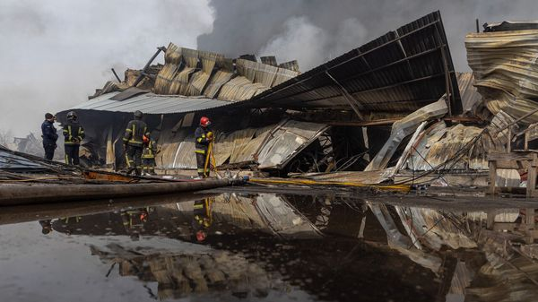

ODESSA HAS endured a lot over the past four years, but in December it experienced a new level of assault. On the night of December 11th-12th Russia launched an unprecedented blitz, pummelling the city with a record 300 drones, bombs and missiles. By morning the region was without electricity, water or heat, and a ship in the port was burning. In the days that followed blackouts became routine, and many denizens relied on pop-up soup kitchens for meals. On December 18th Russia added the threat of physical isolation by striking the Mayaky bridge, a key point on a highway that links the city to Moldova and Europe. That attack killed a mother and injured three children. The next day the Russians hit civilian port infrastructure near the city, killing eight more, including a lorry driver waiting to load grain.
The bombardment has frayed nerves in the exhausted region. Its military significance appears limited, but the economic and political impact is anything but. Ukraine’s third-largest city plays an outsize role in Ukraine’s export-oriented economy, which depends on cheap routes to market. Before the war, Odessa’s three deep-sea ports handled roughly 60% of all exports. In 2023 Ukraine defied Russia’s naval blockade and re-opened a shipping corridor through the Black Sea. Before the latest attacks its share of Ukraine’s exports (which have been reduced by the war) had grown to 60-70%.
Read more of our recent coverage of the Ukraine war
Russia’s blitz puts much of that trade at risk. The ports need 12 megawatts of power to work at full capacity; they now have only two. Loading is limited to the few hours in the day without air-raid alerts. Sources say they are operating at just 30-35% of demand. Delays can render Ukrainian exports uncompetitive. They also complicate insurance: most ships are covered for only a limited time in Ukrainian waters.
That the ports function at all is thanks to insurance, expensive generators and the iron will of labourers working under open skies. Providing air-defence systems used to be a priority for Ukraine’s Western allies, enabling defenders to intercept missiles above the port. That is now essentially absent. Ballistic missiles launched from Crimea land in little over a minute and a half, leaving only seconds to run for shelter. Cluster munitions massively increase the target areas where workers are at risk, and Russia has begun using new weapons like jet-powered drones and bombs. Salvage operations and the smell of burning are part of everyday life. “Everyone is frightened,” says Oleksiy Smolyar, a maritime services executive. “Insurers are hurting too, but no one wants to leave. It’s business. It’s money.”
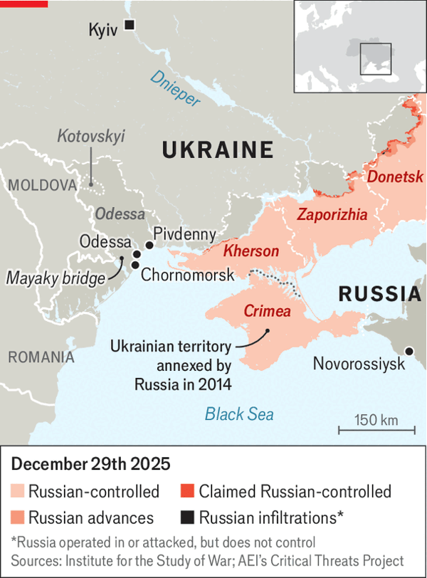

Vladimir Putin has long been fixated on Odessa. He is not alone: the city retains a mystical attraction for many Russians, a legacy of its history as a cosmopolitan free port in the Russian empire. (The feeling is no longer entirely mutual. As one new local joke puts it, “We don’t need electricity to see the Russians are terrorists.”) A week before the bombardment began, Mr Putin raised eyebrows by declaring he planned to seize not only eastern Ukraine’s Donbas region but all of “Novorossiya”, an administrative district of the former Russian empire that included Odessa.
In military terms, such bravado seems absurd. Ukraine’s growing fleet of naval drones means the city is no longer vulnerable to encirclement, as it once was. Recent Ukrainian strikes on Russia’s shadow-fleet tankers and on a submarine in Novorossiysk, a naval base across the Black Sea, suggest Russia’s control of the sea is shrinking, not expanding. Dmytro Pletenchuk, a spokesman for Ukraine’s southern defensive grouping, claims that the submarine was badly damaged by hydraulic shock, noting that it failed to move during a recent alert. “They will lose all their ships in the Black Sea,” he predicts. “They can’t just throw more men at the problem like they do elsewhere. This is an intellectual battle, and so they are losing.”
A more realistic Russian aim is to exploit local political tensions. Many in the region are ambivalent about being ruled from Kyiv; a few are even sympathetic to Russia. Pro-Kremlin social-media channels seed protests by the pro-Russian fringe, while spreading cataclysmic predictions and conspiracy theories to the general audience. One bit of disinformation alleges that Odessa’s blackouts are a result of the government in Kyiv selling power abroad. So far such manipulations have had only limited effect. In Kotovskyi, a residential district far from the city centre, about a dozen people blocked a road after going days without power. They drew little regional support, but the “protests” were reported widely in Russian media.
For now, the bombardment is doing as much to organise Odessans as to demoralise them. Locals report a new sense of community spirit. Businesses and homes with electricity are opening their doors to those without. Social media has filled with offers of free laundry, showers and co-working desks. Emergency workers and the local power company have restored electricity to homes at a record pace. President Volodymyr Zelensky belatedly dispatched a team of senior officials, dismissed the local air-defence commander and declared his government would fight for Odessa. Ukraine’s long-term viability as a nation depends heavily on keeping the city and its ports running. ■
To stay on top of the biggest European stories, sign up to Café Europa, our weekly subscriber-only newsletter.

This article was downloaded by e-magazines.top from https://www.economist.com/europe/2025/12/28/russia-is-blasting-odessa-to-throttle-ukraines-economy
| 章节菜单 | 主菜单 |
| 下一项 | 章节菜单 | 主菜单 | 上一项 |

Charlemagne

Why America still needs Europe
Without European “followership”, America ceases to be a leader
12月 31, 2025 02:56 上午
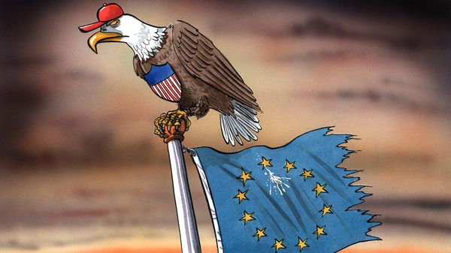

Never since American troops came to Europe’s rescue eight decades ago have the links between the new and old worlds seemed so frayed. MAGA types in Washington ooze contempt for their transatlantic allies. Forget the old barbs about being an open-air museum: Europe is now derided as a migrant-ridden mausoleum hardly worth defending. Indeed, both sides have lost that loving feeling. European pols (with a few populist exceptions) moan that their erstwhile best geopolitical friend has been taken over by an unstable Dummkopf. Because Europe has for decades relied on America for its security, and since an actual war is raging on the continent, the soured relationship is of more immediate concern in Paris, Warsaw and Berlin than in Washington. But America should be mindful, too. President Donald Trump’s predecessors cultivated the alliance because it amplified American influence. Without European “followership”, American power will be less often welcomed or tolerated and more often resisted.
Arguing to MAGA diehards that alienating Europe goes against American self-interest is unlikely to have much effect: efforts to reason with America-Firsters over foreign policy tend to be about as successful as negotiating with a cuckoo clock. A year which started with Vice-President J.D. Vance’s incendiary speech in Munich in February ended with America warning in its latest National Security Strategy that Europe faced “civilisational erasure”. Spooked Europeans have reacted by promising to spend more on defence, as America has long demanded. They have accepted a lopsided trade deal and offered Mr Trump as much flattery as they can stomach. But the gratuitous hostility from Washington has bolstered those who think Europe needs to stand on its own two feet. “Strategic autonomy” used to be a French mantra. Now calls for Europe to wean itself off America are heard in the corridors of power of nations with firm Atlanticist roots, whether Poland, the Netherlands or the Nordics. If that line of thinking takes hold, America won’t know what it’s lost till it’s gone.
Part of Europe’s value to America is just business. Though the European Union is stuck in the economic slow lane, its consumers still buy $3.6trn-worth of goods and services from American firms every year. Europe is like a second home to American corporate giants who have saturated their domestic market. Though China and others are getting richer, Europe for now constitutes the most accessible reservoir of already affluent folk willing to fork out for $200 Nike trainers and $25 monthly Netflix subscriptions. American CEOs who grumble about how hard it is doing business in Europe should try dealing with Indian bureaucracy.
Europeans will continue to buy lots of stuff from America even if they dislike its political leadership. But probably not as much. Notably, nervousness about using American tech services is growing. The International Criminal Court in The Hague is ditching Microsoft Office in favour of a European software suite; in May there were reports one of its prosecutors had lost access to his e-mails after coming under American sanctions (Microsoft denies this). The European Commission, which routinely fines American tech businesses for breaching EU antitrust laws, may soon find itself blacklisted too: on December 24th Thierry Breton, a former commissioner overseeing bits of digital regulation, was banned from visiting America.
Just as America wants to kick its dependence on Chinese imports, Europe increasingly wants to stand free of American goods and services. Some fret that American liquefied natural gas, of which Europe is the biggest buyer, entails much the same dependency as Russian piped gas did before 2022. How about reliance on Visa and MasterCard for processing payments? Meanwhile, Europe is the most avid purchaser of American military hardware. As the continent raises its defence spending, it is trying to spend it on home-grown kit rather than Uncle Sam’s.
Geopolitically, marginalising Europe will also come at a cost. The small peninsula is well sited for American needs. Forward-based radar makes it easier to counteract missiles lobbed by Russia or Iran. Military bases allow the world’s mightiest armed forces to operate in the Middle East and Africa. Having Europe onside helps project power in other ways. Sanctions work best when both sides of the Atlantic join in. By accepting the global supremacy of the dollar, Europeans leave themselves little choice but to enforce America’s boycotts, even when they disagree. Push too hard and they may try to free themselves from that, too.

E pluribus duo
But Europe’s greatest value to its transatlantic ally is as a legitimacy engine. Once home to the original winners of globalisation, the Old Continent has come to accept American hegemony. With Europe in tow, American preferences were transmuted into those of “the West”, or indeed into global norms. Key bits of the international system, from the IMF, the World Bank and even the United Nations, were in effect Euro-American joint ventures. Being the kingpin of an international liberal order may not interest Mr Trump, but it has helped project American heft to places where it might not otherwise reach. Today that may not seem to matter much to Americans. But one day it will, and America may rue the casual way in which it alienated its loyal second fiddle.
To some the idea of a transatlantic “free world” seems outdated. But if the 20th century saw Europe passing the baton of global dominance to America, the 21st will be shaped by America’s contest with China. Europe is almost sure to back even an unreliable democratic ally over an expansionist autocracy. But being endlessly demeaned makes Europeans hesitate over how earnestly to take sides. Americans should think that over before hurling their next volley of insults. ■
Subscribers to The Economist can sign up to our Opinion newsletter, which brings together the best of our leaders, columns, guest essays and reader correspondence.

This article was downloaded by e-magazines.top from https://www.economist.com/europe/2025/12/30/why-america-still-needs-europe
| 章节菜单 | 主菜单 |
| 下一章节 | 主菜单 | 上一章节 |

United States
- Los Angeles after the flames
From the ashes :: A year after the city burned, the recovery has just begun
- America’s most successful mayor stands down
The Michigan Man :: Having fixed Detroit, Mike Duggan now wants to fix partisanship
- Donald Trump has it in for Brutalism
Concrete and politics :: This time the president has the capital’s developers on his side, and possibly public opinion too
- The Supreme Court has taken the National Guard away from Donald Trump
Troops and consequences :: His remaining options for sending in the troops are legally fraught
- The economics of megachurches
Megabusiness :: Why America’s fastest-growing churches don’t get political

| 下一章节 | 主菜单 | 上一章节 |
| 下一项 | 章节菜单 | 主菜单 |

From the ashes

Los Angeles after the flames
A year after the city burned, the recovery has just begun
12月 31, 2025 05:14 上午 | Altadena and Pacific Palisades


EVERY FEW MONTHS the soundtrack of Altadena changes. After a wildfire razed the neighbourhood on January 7th 2025, ash muffled any noise save for fire engines rolling through the streets. When the Army Corps of Engineers cleared up toxic debris their heavy machinery whirred and clanked and echoed as they dragged incinerated cars off the roads. Now the soundscape has changed again. Birdsong is interrupted by the rhythmic thwack of hammers and the high-pitched whine of saws. Altadena has become a construction zone.
The fires that tore across Los Angeles County nearly a year ago killed 31 people and destroyed more than 16,000 buildings. Altadena, Pacific Palisades and parts of Malibu were obliterated. But the toll extended beyond the initial flames and Angelenos are still learning the full extent of the damage. Researchers at Stanford University estimate that 14 others died from exposure to wildfire smoke. In the 90 days after the fires, the number of emergency-room visits for heart-attack symptoms increased by 46%. When a city burns it can take many years to fully recover. Survivors talk about their lives in two parts: before January 7th and after.
As of December permits have been approved for reconstruction of roughly 15% of destroyed buildings. Homeowners find the bureaucracy tortuous but local architects are largely impressed by how the city and county’s notoriously constipated planning systems have responded. Tim Vordtriede, an architect in Altadena, expects a building boom in March as winter rains cease and more permits are approved. Even these nascent efforts can help forecast how the fires will change Los Angeles, and what they reveal about climate risk for the many cities that have sprawled into fire-prone wildlands. Consider two pinch points where California’s policies and climate risk have created toxic situations: home-insurance and investor-owned utilities.
Surveys from Colorado and California suggest that at least two-thirds of residents in fire-prone areas could be underinsured. Wealthier Angelenos in Pacific Palisades may be able to afford to rebuild regardless. Some are taking the opportunity to reimagine their dream home. Rob Kilian’s firm is designing 21 new luxury homes. Some of his clients are asking for golf simulators and movie theatres. Mr Kilian reckons the Palisades will have fewer people than before, not due to fire risk, but because locals are buying up neighbouring lots to build bigger houses and backyards.
Meanwhile, many people in less prosperous Altadena are struggling to afford rent for their temporary homes while continuing to pay down their mortgages. “Next month I’ll be paying on this dirt lot,” says Damon Blount, who lost his home of 26 years. He and his wife, Audra, are too well off for many forms of assistance but too poor to rebuild without financial angst. “It feels like we’re being punished for being middle class,” he adds. For some people, selling up is the only option. That is controversial in a neighbourhood worried that developers and investors want to capitalise on their loss. “Altadena not for sale!” placards proliferate on the same blocks as lots sporting “for sale” signs .
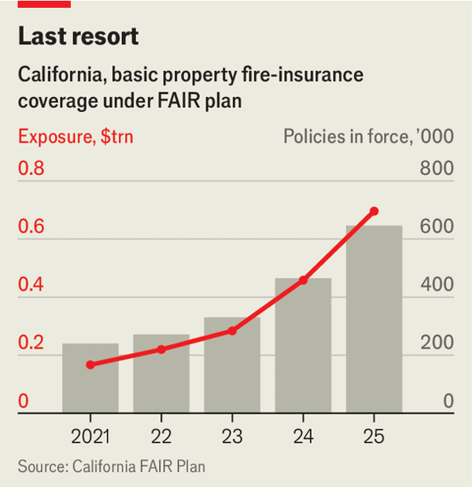

Insurance firms and policymakers aren’t happy either. Californians passed a ballot measure in 1988 that suppressed home insurance rates, which incentivised migration into risky areas. California struck a bargain with insurers in 2023 that allowed firms to raise rates in exchange for continuing to cover risky regions. The deal was also supposed to stabilise the state’s FAIR plan, a pool for residents who can’t get insurance on the private market. Yet in practice policyholders in fire-prone regions have continued to lose coverage, forcing them to buy the last-resort insurance. California’s insurance commissioner charged firms that participate in the pool $1bn earlier this year to prevent insolvency. But that is a short-term solution, and one that could incentivise firms to exit California’s market. In the meantime, ever more Californians are enrolling. The FAIR plan’s exposure has more than tripled since 2022, to nearly $700bn (see chart).
Southern California Edison, one of the state’s big investor-owned utilities, has admitted that its equipment probably caused the fire that razed Altadena. Individuals, LA County and the federal government are all suing the company to try to recoup their losses. The plaintiffs argue that the firm was negligent, but California’s strict “inverse condemnation” standard holds utilities liable for damage caused by their equipment regardless of negligence. Many Altadena residents are depending on a prospective settlement to finance their rebuild. Edison, leery of the litigation, is offering survivors a payout in exchange for giving up their right to sue. The LA fires prompted the state to replenish the fund it uses to help utilities pay wildfire claims that would otherwise be ruinous. Ratepayers and shareholders will foot the bill.
The politics of the recovery have been messy, too. Survivors in Altadena, which is an unincorporated part of LA County, felt ignored and abandoned by their government when an evacuation order came hours later than it should have. Some are hoping to eventually incorporate as a city rather than continue to depend on the county for services. Karen Bass, the mayor of Los Angeles, has made a series of mistakes that could imperil her re-election campaign in 2026. She was abroad when the fires broke out. Gavin Newsom, California’s Democratic governor, is urging the federal government to approve additional aid. Some survivors worry that Mr Newsom’s political feud with Donald Trump has made the president less likely to help California. “Hope is not a strategy”, says Shawna Dawson Beer, who lost her home in Altadena. “You need a fucking plan”.
Mr Blount reckons that the governor’s satirical social posts make no difference to a president who has for years threatened, and indeed tried, to withhold disaster aid from blue states. “There is no money coming,” he says, while staring at the empty space where his home used to be. At sunset the San Gabriel mountains, where the fire began, glow orange above him.■
Stay on top of American politics with The US in brief, our daily newsletter with fast analysis of the most important political news, and Checks and Balance, a weekly note that examines the state of American democracy and the issues that matter to voters.

This article was downloaded by e-magazines.top from https://www.economist.com/interactive/united-states/2025/12/30/los-angeles-after-the-flames
| 章节菜单 | 主菜单 |
| 下一项 | 章节菜单 | 主菜单 | 上一项 |

The Michigan Man

America’s most successful mayor stands down
Having fixed Detroit, Mike Duggan now wants to fix partisanship
12月 30, 2025 08:15 上午 | DETROIT
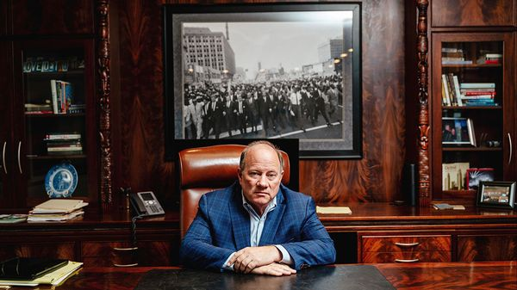
Motown marvel
When The Economist visited Detroit in late 2025 to interview Mike Duggan, the city’s outgoing mayor, the aide scheduling the meeting sent over a piece of redundant information in advance: where to park. Your correspondent found it far more pleasant to amble to and from the Coleman A. Young Municipal Centre on foot.
When Mr Duggan took office, at the start of 2014, the parking instructions would have been more useful. A decade ago, walking through downtown Detroit was an unpleasant and inadvisable move. Skyscrapers that are now home to boutique hotels lay derelict. Street lights did not always function. At night drivers would deliberately blow through red lights rather than stop for potential carjackers.
On January 1st, after three terms in office, Mr Duggan will step down from the mayoralty. He leaves behind a city transformed—and not only in the sense that it is safe to walk to meet him. He has a reasonable claim to have been the most effective mayor in recent American history. In 2024 Census Bureau data showed Detroit’s population growing for the first time since 1957. In the decade to 2023, incomes in the city rose by almost twice the rate of that in the rest of Michigan. Carjackings have fallen by 90%. The city ended 2025 with a $105m budget surplus.
This November Mr Duggan intends to stand for a bigger office: governor of Michigan. After serving as a Democrat for his entire career, he is doing so as an independent. His aim, he says, is to repeat what he achieved in Motown for the whole state. That is, bringing together feuding politicians to work towards a greater good. Is such a goal plausible?
In Mr Duggan’s immodest but persuasive telling, Detroit was saved by breaking down partisan, corrupt politics. Before he took office, he says, “people would go home and watch reruns of that day’s city council meetings to see all the fights”. When Mr Duggan won, after an improbable write-in campaign, he brought this to an end. In the place of chaos, businesses were offered clear, consistent rules. That encouraged investment, and more tax, in turn helping the city to restore services, like street lighting. A virtuous circle began.
Mr Duggan says that he can achieve this for the state of Michigan too, and all the more so if he can win as an independent. “The partisan fighting in this state is the worst I’ve ever seen,” he says. The result, he argues, is an unemployment rate that is the fourth-highest in the nation and school-test results that have declined for decades. If he can win with both Republican and Democratic votes, he will have a mandate to hammer out compromises. What worked for Detroit can work for Michigan too, he says.
To pull off his plan, Mr Duggan has to win over Republicans without deterring too many of the Democrats who until recently, almost universally liked him. He implies this will be straightforward: the “ground is shifting rapidly” under both parties, he says, and “they’re so busy shouting that they don’t realise it yet”. But Donald Trump, with his outsize command of the nation’s attention, and his demands for absolute loyalty, is making his life tricky. In an interview, Mr Duggan refused to criticise the president on anything. Sitting less than half a mile away from Canada, he denied that Mr Trump’s bullying of the country is a problem.
The quieter Mr Duggan is about the president’s failings, and the more unpopular the president gets, the easier Democrats are finding it to hurt him. The former mayor’s priority “is putting himself, his MAGA donors, and corrupt insiders first”, said Curtis Hertel, the state party chairman. Michigan Republicans, meanwhile, are not yet won over by a mayor of a city they still mostly hate. Polling for the governor’s campaign has him sharply trailing both the most likely Democratic and Republican candidates. Mr Duggan should not be counted out: he has done great things before. But partisanship may crush him before he can crush it. ■
Stay on top of American politics with The US in brief, our daily newsletter with fast analysis of the most important political news, and Checks and Balance, a weekly note that examines the state of American democracy and the issues that matter to voters.

This article was downloaded by e-magazines.top from https://www.economist.com/united-states/2025/12/30/americas-most-successful-mayor-stands-down
| 章节菜单 | 主菜单 |
| 下一项 | 章节菜单 | 主菜单 | 上一项 |

Concrete and politics

Donald Trump has it in for Brutalism
This time the president has the capital’s developers on his side, and possibly public opinion too
12月 31, 2025 03:46 上午 | Washington, DC


MARCEL BREUER loved concrete. His way with the material made him famous. His design for the Department of Housing and Urban Development (HUD), in Washington, DC, landed on the National Register of Historic Places less for its curious layout—which resembles a headless person doing the spreadeagle—than its distinction as the first federal building made of precast concrete. Today, its occupants like it rather less. HUD employees call it ten floors of basement. They complain of black mould and toilets that rarely flush. One of the elevator banks hasn’t worked in months. “Welcome to Club HUD,” sighs a weary officegoer.
Donald Trump has little love for federal employees and even less for HUD, whose mission is to provide poor people with housing. But on the subject of its Brutalist headquarters (pictured above and twice more below), he and its staff seem to agree: after half a century the time has come to abandon it. Earlier this year the Trump administration said it would sell the building, along with three other federal properties in the capital managed by the General Services Administration (GSA), an agency that oversees the government’s property portfolio.
Then came a twist. In December a former GSA official alleged in court that the Trump administration really intends to demolish the buildings. The government denies this. But preservationists, caught off guard by Mr Trump’s surprise tearing-down of the East Wing of the White House to build a new ballroom, are sounding the alarm. They worry that he will bypass the capital’s onerous preservation rules and public-consultation requirements just as he did with the East Wing. They are especially worried about the fate of some New Deal-era murals in one of the four properties. The iconic HUD building, they note, informed a Brutalist spree across the city, including the metro.


Preservationists have public opinion on their side in the ballroom fiasco. Footage of the demolition blanketed the news for days and the president’s approval rating took a hit. Brutalism, characterised by hulking, exposed concrete, is a different story. Popular in the 1960s because its main material was cheap, it has been called the movement the public loves to hate and architects dare to love. Also: a style of the “bombproof blockhouse”, “willful, preventable ugliness”, “hostile to human life”, “neo-penitentiary”. Brutalist architects’ mark on Washington includes the headquarters of the FBI. Even the bureaucrat who approved that design described it, in 1967, as “the scariest thing going up in the city”.
Mr Trump has nixed anything resembling Brutalism in future federal commissions. The style’s admirers see his attack, perhaps breathlessly, as an assault on the post-war welfare state itself. Monumental in ambition, Brutalist buildings celebrate the collective good over the individual, they say: everything anathema to Mr Trump.


Less is said about the buildings’ disrepair and lack of functionality, and the fact that retrofitting them is awfully expensive. Washington’s office market is still in the post-covid doldrums, meaning leasing new space is probably cheaper anyway. Several years ago Congress created the Public Buildings Reform Board to find ways to shrink the federal portfolio amid billions of dollars of deferred maintenance costs and low occupancy rates. Dan Mathews, a board member, says private landlords could never have got away with underinvestment as the government has. Nobody would lease these offices on the private market.
Meanwhile the real-estate crowd is largely gung-ho at the prospect of their demolition, not merely their sale, since conversions would probably cost more than new construction. Like HUD, the health and energy departments occupy Brutalist buildings steps from the Mall. The offices themselves are a “liability”; the value is in the land, says Doug Firstenberg, a developer who talks of south-west DC’s potential as a “mixed-use” neighbourhood for retail and residential. Richard Levy, another developer, says facing down preservationists is arduous but doable. He spent eight years fighting them in court to turn a decommissioned GSA heating plant in Georgetown into a building of Four Seasons flats. He drew resolve from an I Ching quotation on his wall that reads: “Perseverance furthers”. ■
Stay on top of American politics with The US in brief, our daily newsletter with fast analysis of the most important political news, and Checks and Balance, a weekly note that examines the state of American democracy and the issues that matter to voters.

This article was downloaded by e-magazines.top from https://www.economist.com/united-states/2025/12/24/donald-trump-has-it-in-for-brutalism
| 章节菜单 | 主菜单 |
| 下一项 | 章节菜单 | 主菜单 | 上一项 |

Troops and consequences

The Supreme Court has taken the National Guard away from Donald Trump
His remaining options for sending in the troops are legally fraught
12月 30, 2025 05:49 上午
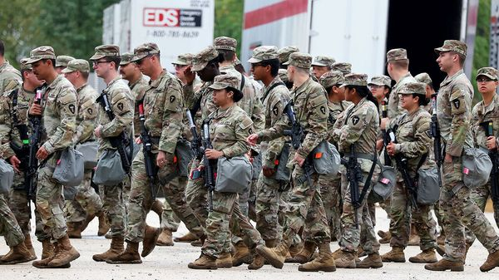

THE FRIDAY news dump is a venerable technique to minimise attention to a controversial announcement. On December 23rd the Supreme Court performed the Christmas equivalent, dealing President Donald Trump a rare and consequential defeat at a time when Americans had other things on their minds. In Trump v Illinois, an emergency plea that had been pending since October, six justices ruled that the president could not, for now, deploy National Guard troops in Chicago to help federal officials manage protests against his immigration policy.
The decision sends about 300 troops home, joining about 200 who departed in November. Its logic also appears to undermine Mr Trump’s deployments in other Democrat-led cities—including Los Angeles, New Orleans and Portland, Oregon—and narrows his remaining legal paths to mobilise troops and send them to cities. Should Mr Trump press on, he would probably have to rely on untested claims of presidential power.
Trump v Illinois turned on a small but consequential point of statutory interpretation. The government had cited Section 12406 of Title 10 of the federal legal code, which allows the president to federalise National Guard units when he is “unable with the regular forces to execute the laws of the United States”. The administration claimed that civilian law-enforcement agents such as those employed by Immigration and Customs Enforcement (ICE) count as “the regular forces”. But Illinois—drawing on the work of Marty Lederman, a law professor at Georgetown Law School—argued that the term refers only to active-duty military forces.
The challengers’ reading persuaded the Supreme Court’s three Democratic appointees and two of Mr Trump’s picks, Brett Kavanaugh and Amy Coney Barrett, along with the chief justice, John Roberts. All those jurists but Justice Kavanaugh went further, holding that Section 12406 cannot by itself justify a troop mobilisation, without another constitutional or statutory justification allowing the government to use the army to enforce the law.
This, the majority noted, introduces a paradox: Mr Trump had insisted that the Guard’s mission was merely to protect federal personnel and property, not to engage in law enforcement. But if the deployment was not intended to enforce the law, the statute did not apply. And if it was so intended, the administration had identified no other law permitting the regular armed forces to carry out such tasks. In areas like this where Congress has legislated, the court suggested, presidential power does not operate in a vacuum.
Could Mr Trump regroup and redeploy Guard troops under another legal theory? One option involves a view of presidential power that includes an inherent authority to protect federal personnel, equipment and property. Mr Trump claims that this “protective power”—long thought to reside in Article II of the constitution—authorises presidents to dispatch troops.

Grab them by the posse
Elizabeth Goitein of the Brennan Centre, a left-leaning think tank, considers this a stretch. The protective power is an “executive-branch” theory, she says, that no “court has ever squarely endorsed”. Another problem: there is no “bright line” between using soldiers to protect federal officials and buildings and deploying them, say, to order civilians to disperse. Such law enforcement by the military is generally barred by the Posse Comitatus Act of 1878.
That leaves the Insurrection Act, a break-the-glass option that allows presidents to declare an emergency that overrides the restrictions of Posse Comitatus. The act has been invoked about 30 times in American history. It authorises presidents to use troops against “unlawful obstructions, combinations, or assemblages, or rebellion” serious enough that states cannot handle them through the “ordinary course of judicial proceedings”. Presidents have almost always used the Insurrection Act with a governor’s consent. The rare unilateral deployments by a president involved state officials defying federal law—such as when Eisenhower sent troops to Arkansas to enforce school desegregation.
Yet the Insurrection Act’s sweeping language about rebellion makes its invocation politically perilous. Most presidents have agreed that only extraordinary situations should call for its invocation, because, as Nicholas Katzenbach, a deputy attorney-general, wrote in 1964, the deployment of federal troops may “aggravate the emotions of the populace or alienate local law enforcement officials”.
The terse majority opinion in Trump v Illinois leaves a host of uncertainties regarding presidential power to deploy troops domestically, as Justice Neil Gorsuch noted in a brief dissent. The law at issue in the case “touches on gravely consequential questions” about the role of the armed forces in domestic law enforcement, yet the statute under review “raises as many questions as it answers.”
The majority opinion does seem to reject the justification Mr Trump’s lawyers chose originally, casts significant doubt on the viability of the constitutional claim and lays down an obstacle-strewn path for finding another way to deploy troops to American cities in present circumstances. Are those admonitions enough to encourage a president not known for self-restraint to stand down? “The fact that there are legal pitfalls”, Ms Goitein says, “does not mean that President Trump won’t try.” ■
Stay on top of American politics with The US in brief, our daily newsletter with fast analysis of the most important political news, and Checks and Balance, a weekly note that examines the state of American democracy and the issues that matter to voters.

This article was downloaded by e-magazines.top from https://www.economist.com/united-states/2025/12/29/the-supreme-court-has-taken-the-national-guard-away-from-donald-trump
| 章节菜单 | 主菜单 |
| 下一项 | 章节菜单 | 主菜单 | 上一项 |

Megabusiness

The economics of megachurches
Why America’s fastest-growing churches don’t get political
12月 31, 2025 03:46 上午 | HOUSTON and ATLANTA


EACH WEEK 45,000 people come to pray in a converted basketball stadium in Houston. On Christmas Eve the unconventional Lakewood Church sanctuary filled with a crowd that looked like a cross-section of America in matching red outfits. When the pastor began telling the story of a baby born in Bethlehem on a starry evening like this one, the massive screens behind him twinkled and smoke machines coated the stage in a cozy fog. A man sang a gospel rendition of “Silent Night” in Spanish and when the beat dropped every person in the bleachers felt the thump of the bass in their body.
Researchers have found that services like this one, at America’s biggest church, can leave people feeling like they are high on drugs. It is perhaps no surprise then that while most American churches are struggling to fill pews, megachurches—the 1,800 or so with Hollywood-style production and mesmerising crowds—are only getting bigger. In the past five years Americans have flocked to the sprawling suburbs of the sunbelt where these churches thrive. When small churches shut during the pandemic, the big ones were ready to absorb their congregants. Today, although most churches have fewer than 100 members, 70% of people attend the largest 10%. The product that they sell is changing Christianity in America.
The megachurch business model is all about growth. At any given service roughly a sixth of the crowd is made up of newcomers, says Scott Thumma of the Hartford Institute for Religious Research. At North Point Community Church outside Atlanta, where fake snow fell during the opening act on a recent Sunday, a battalion of volunteers at the “connections” booth give first-timers gifts and usher them towards “small groups” they can join. To meet prospective congregants closer to home, churches are now franchising. Some rent high-school gyms and theatres that are empty on weekend mornings, others are buying new buildings. Oklahoma’s Life Church has 46 campuses and Alabama’s Church of the Highlands has 27. The expansion has turned church into much more than a Sunday service: it’s where members play pickup sports, attend marriage counseling, take anger-management lessons and send their children to school. Many megachurches now run colleges.
That reach shows up in the money they are bringing in. Surveys run by the Hartford Institute found that between 2020 and 2025, the average megachurch’s annual revenue rose by 25%, from $5.3m to $6.6m. Nearly all of it came from congregant donations. Megachurches report spending half of their cash on staff salaries, just over a third on building maintenance and programming and a tenth on charity. But beyond what they choose to disclose, their finances are a mystery.
Federal tax law exempts churches from filing annual returns and shields them from audits. “The only people keeping an eye on these big churches are insiders,” says Lloyd Hitoshi Mayer of the University of Notre Dame. In 2021 a pastor at another megachurch in Houston was convicted of defrauding investors out of nearly $3.6m. A more recent lawsuit accused church leaders of misusing tithes. The glitz invites more suspicion. Some pastors live in large houses, accept expensive gifts like cars from members and make millions from book deals. About a quarter preach the prosperity gospel, a theology that asserts that God rewards faith with material wealth. “I can’t be a big blessing to people if I’m poor and broke and depressed,” Joel Osteen, the best-known among them and Lakewood’s senior pastor, said on the Oprah show.


For decades megachurches have been trend-setters in the evangelical world. Their worship music and TED Talk–style sermons go viral and they have made jeans and Nike shoes acceptable churchwear. But courting today’s jaded masses incentivises them to avoid anything too substantive, for fear of alienating people. Most megachurches, like a rising share of American protestants, are now non-denominational. Rather than tie themselves to traditional sects with rigid doctrines they are building brands that are designed to be popular and flexible. The result is a Christianity that looks more like a crash course in self-help than an age-old faith anchored in scripture. The central message on Christmas at Lakewood was “don’t stop believing”. Congregants were told that God’s grace is coming and they should keep fighting the devil of depression, or give rehab one more try.


It is for the same reason that the majority of megachurch pastors do not preach politics. Rarely do they even address hot-button issues like abortion or homosexuality from the pulpit. This summer the Trump administration scrapped rules that stripped pastors of some tax exemptions if they publicly endorsed political candidates. Nonetheless most of the churches that responded to the Hartford survey said they had no plans to start doing it. “They’re not prophets screaming into the wilderness, these guys are running multi-million-dollar empires,” says Ryan Burge, who studies religion at Washington University in St Louis. “Why would they imperil that?”
Albert Mohler, the head of the Southern Baptist Theological Seminary, reckons that young people want a Christianity that is more serious and that megachurches will wane if being associated with them doesn’t give their members social capital. He calls the prosperity gospel a “direct threat to biblical Christianity” and a “pseudo-religion”. Inside Lakewood Church there is no cross on display. Instead, at the back of the stadium a giant American flag glows above the bleachers. Here the biggest draw is something easier to follow than any of Jesus’s teachings: the gospel of American capitalism. ■
Stay on top of American politics with The US in brief, our daily newsletter with fast analysis of the most important political news, and Checks and Balance, a weekly note that examines the state of American democracy and the issues that matter to voters.

This article was downloaded by e-magazines.top from https://www.economist.com/united-states/2025/12/26/the-economics-of-megachurches
| 章节菜单 | 主菜单 |
| 下一章节 | 主菜单 | 上一章节 |

Middle East & Africa
- A lightning advance by separatists has reshaped Yemen’s civil war
Yemen’s civil war :: It has also deepened the rift between the Saudis and Emiratis
- Netanyahu wins bigly from his meeting with Trump
Trump and Netanyahu meet again :: The gains for Israel are less clear
- Israel recognises Somaliland
One step closer :: That may exacerbate regional rivalries
- The nautical theory of African development
Bring on the boats :: With more ships plying its rivers and lakes, the continent could be much richer
- Ghana tries to regulate online prophecies
Prove it, prophet :: It is part of a wider effort to tackle misinformation

| 下一章节 | 主菜单 | 上一章节 |
| 下一项 | 章节菜单 | 主菜单 |

Yemen’s civil war

A lightning advance by separatists has reshaped Yemen’s civil war
It has also deepened the rift between the Saudis and Emiratis
12月 31, 2025 02:04 上午 | DUBAI


Editor’s note: On December 30th the United Arab Emirates said it would withdraw its troops from Yemen after Saudi Arabia backed the Yemeni government’s demand for their departure. Its military presence in the country was small, and it made no announcement about a pullback by the Southern Transitional Council.
Civil wars, like revolutions, tend to devour their children. For over a decade the conflict in Yemen has ostensibly pitted the Houthis, an Iranian-backed Shia militia, against a coalition of their foes supported by Saudi Arabia and the United Arab Emirates (uae). Yet the latest chapter in the war has little to do with the Houthis. Instead the coalition has turned on itself.
On December 2nd the Southern Transitional Council (stc), secessionists backed by the uae, went on a lightning offensive across the south-east. They seized territory held by Saudi-backed factions and now control the eight governorates that made up the former South Yemen (see map), an independent state from 1967 to 1990. The power grab has reshaped the war in Yemen. It has also deepened a rift between the two Gulf powers, already at odds in Sudan and elsewhere.
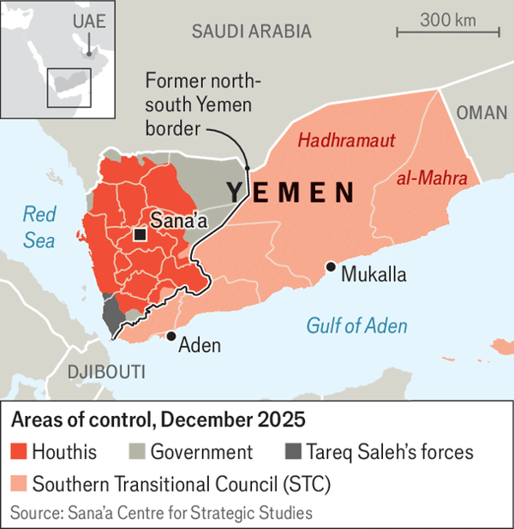

The stc’s romp caught everyone by surprise. Yemen-watchers are still trying to identify the trigger. The Saudis want to negotiate a peace with the Houthis; perhaps the stc wanted to pre-empt that. The separatists may also have been responding to an attempted power grab by a tribal leader in Hadhramaut, an eastern province.
Two weeks before the offensive Muhammad bin Salman, the Saudi crown prince, visited Donald Trump at the White House. He asked the president to push for a peace deal in Sudan, which has been riven by civil war since 2023. The Saudis back the Sudanese army while the uae has sent arms and money to the Rapid Support Forces (rsf), a militia, though it denies it is still doing so. The crown prince suggested that Mr Trump might need to expand American sanctions against the rsf.
For Saudi Arabia the timing of all this does not look coincidental. The kingdom believes the uae’s leaders got the impression that Prince Muhammad asked for sanctions against their country—which the Saudis say is untrue—and subsequently mobilised the stc in Yemen as a riposte. (The uae did not respond to a request for comment.) Propagandists from the two countries have spent the past few weeks sparring with one another on social media.
Either way, the secessionists now hold a sizeable swathe of territory. Their fief also includes most of Yemen’s oil and gas resources (the country once exported more than 100,000 barrels of crude a day).
The anti-Houthi camp has always been fractious. The Saudis were happy to work with the likes of Islah, an offshoot of the Muslim Brotherhood, while the Emiratis, who abhor political Islam, preferred partners such as the stc and Tareq Saleh, a nephew of Yemen’s late longtime dictator. In 2022 the Saudis abruptly sacked the country’s feckless president, and replaced him with an eight-man Presidential Leadership Council (plc). Its leader, Rashad al-Alimi, is a Saudi-backed politician who favours national unity. His deputy, Aiderus al-Zubaidi, is the head of the stc and prefers to partition the country. How they were meant to work together was unclear.
Some diplomats fret that the Saudi-backed camp may join the Houthis against the separatists. That seems unlikely: sometimes, the enemy of your enemy is still your enemy. But the stc’s takeover will deepen tensions within the coalition.
Saudi Arabia shares a long border with Yemen; the Houthis fired hundreds of missiles and drones at its cities throughout the war. The uae is not immune to Houthi attacks: a 2022 drone strike killed three people in Abu Dhabi, its capital. But it is more distant from the conflict. Whereas the Saudis want a stable Yemen that does not shoot at them, the Emiratis see it as part of a broader strategy to exert influence· in the Red Sea and the Horn of Africa. They have worked patiently to build a network of allies across the south.
The question now is how the stc uses its newfound power. One option is to secede. That would be risky without foreign support—but Mr Zubaidi might be able to play a trump card (pun intended). He has said that an independent South Yemen could join the Abraham accords, the 2020 agreements that saw four Arab states recognise Israel. His advisers have made quiet overtures to Jerusalem in recent days.
That may give him leverage with an American president keen to expand the accords. In the waning days of his first term Mr Trump recognised Morocco’s sovereignty over occupied Western Sahara, a territorial claim accepted by only a handful of other countries. That was a reward for Morocco’s decision to join the accords. Could he be convinced to do the same by recognising South Yemen?
But secession would cause a lasting rupture between Saudi Arabia and the uae. The former wants the Houthis to accept a power-sharing deal that would limit their role in Yemen’s government. Were the south to break away, the rump northern state would probably be too weak to impose one. Saudi Arabia would be left with a worst-case scenario: an impoverished North Yemen dominated by the Houthis but cut off from the country’s oil and gas resources. It would probably be stuck bankrolling the Houthis indefinitely.
The stc could also try to consolidate its gains without declaring independence. The status quo looks shaky, though. On December 26th a Saudi jet carried out an air strike near an stc-held military camp in Hadhramaut. No one was killed, but the strike was a clear warning. Four days later the Saudis bombed Mukalla, a port in eastern Yemen, after what the kingdom says was an arms delivery to the STC on two ships that came from the UAE. The separatists are vulnerable internally as well. There have been protests of late in stc-controlled cities over unpaid salaries, blackouts and other indignities. The group’s overtures to Israel are unpopular.
A more optimistic scenario is that Saudi Arabia and the uae negotiate a deal whereby the south enjoys greater autonomy and the Emiratis have more say over a possible settlement with the Houthis. Officials from both countries are talking daily about a possible stc withdrawal from parts of the south-east. That would head off further conflict. It would also reinforce a long-running trend: after a decade of war, Yemen’s future will be decided not by Yemenis but by their foreign backers. ■
Sign up to the Middle East Dispatch, a weekly newsletter that keeps you in the loop on a fascinating, complex and consequential part of the world.

This article was downloaded by e-magazines.top from https://www.economist.com/middle-east-and-africa/2025/12/30/a-lightning-advance-by-separatists-has-reshaped-yemens-civil-war
| 章节菜单 | 主菜单 |
| 下一项 | 章节菜单 | 主菜单 | 上一项 |

Trump and Netanyahu meet again

Netanyahu wins bigly from his meeting with Trump
The gains for Israel are less clear
12月 30, 2025 05:49 上午 | JERUSALEM

And the winner is?
Binyamin netanyahu might consider hiring Donald Trump as his campaign manager. The Israeli prime minister is facing a tough re-election battle in 2026. On his visit to Mar-a-Lago, the American president’s Florida home, on December 29th, Mr Trump gushed that Mr Netanyahu is “a wartime prime minister at the highest level”. With others in charge, he insisted, “Israel right now would not exist.” Israel’s beleaguered prime minister could not have written better election slogans himself.
For Mr Netanyahu, who is lagging in most polls, the perception of a unique partnership with the president is crucial—or so he believes. Mr Trump backed up his warm words with an invitation to his New Year’s Eve bash. He also claimed that he had spoken to Israel’s president, Isaac Herzog, about Mr Netanyahu’s demand for an end to his corruption trial, promising that a pardon was “on its way”. Mr Herzog’s office denied such a conversation had taken place. But that hardly mattered.
The visit may have been a resounding success personally and politically for Mr Netanyahu, but the diplomatic gains for Israel are much less clear. In preparing for the meeting, Israeli officials set out two main objectives. First, they wanted a clear commitment from the president that America would not start reconstruction of the devastated Gaza Strip before Hamas, the Islamist militants who now control the parts of Gaza from which Israel has withdrawn, have disarmed completely. (Israel also wants the last body of a hostage in Gaza to be returned before the next phase of Mr Trump’s peace plan begins.)
Second, Israel wanted assurances from Mr Trump that Turkey, a rival to Israel for influence in the Middle East, would not join the international security force planned for Gaza. On both counts, the normally forthright president was equivocal.
Mr Trump emphasised that Hamas had “a very short period of time to disarm” and that, if it did not, “there will be hell to pay.” But he did not make this a condition of proceeding to the next phase of his peace plan. And in private, American officials say that they are planning to roll out the reconstruction project “within weeks”, while acknowledging that the disarmament of Hamas will take much longer.
Mr Trump’s remarks on Turkey were even more disappointing from Mr Netanyahu’s perspective. He lavished praise on Turkey’s president, Recep Tayyip Erdogan, calling him “a very good friend” and saying that Turkish troops in Gaza remain under discussion. Still worse for the Israeli prime minister, Mr Trump said he is considering selling advanced f-35 stealth fighter-jets to the Turks. Israel fears that will erode its current advantage as the only nation in the region flying the planes.
There was some comfort for Mr Netanyahu in the form of tough talk on Iran, which Israel claims has ramped up ballistic-missile production since the 12-day war in June. “I hear that Iran is trying to build up again,” suggested Mr Trump; if so, “We’ll knock the hell out of them.” But he also emphasised that he would prefer a deal with the Iranians to another attack.
At lunch in Mar-a-Lago, Mr Trump listed all the peace deals he claims to have brokered. “Do I get credit for it? No,” he grumbled. Mr Netanyahu comforted him that while he may have missed out on the Nobel peace prize, he will receive the Israel prize for helping the Jewish people. Mr Trump insists he has ended Israel’s wars in Gaza and with Iran, so will think this well deserved. But if the president considers the job done, he may not offer Israel the security guarantees Mr Netanyahu demands, whatever the personal political gains for the prime minister. ■
Sign up to the Middle East Dispatch, a weekly newsletter that keeps you in the loop on a fascinating, complex and consequential part of the world.

This article was downloaded by e-magazines.top from https://www.economist.com/middle-east-and-africa/2025/12/30/netanyahu-wins-bigly-from-his-meeting-with-trump
| 章节菜单 | 主菜单 |
| 下一项 | 章节菜单 | 主菜单 | 上一项 |

One step closer

Israel recognises Somaliland
That may exacerbate regional rivalries
12月 30, 2025 07:43 上午 | NAIROBI
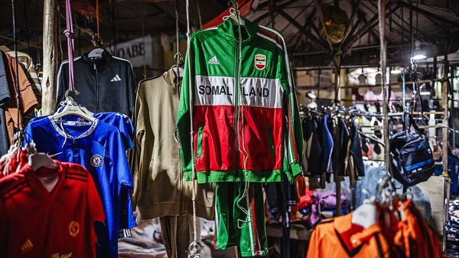
New nation, new merch
When the Israeli flag is sighted on the streets of the Muslim world, it is often being set alight or trampled underfoot. Yet in recent days the Star of David has been plastered on buildings and brandished by jubilant crowds in Hargeisa, the capital of Somaliland. On December 26th Israel became the first country to recognise the breakaway republic as a sovereign state. “I am the happiest man in the world,” says an adviser to Somaliland’s president.
It is a diplomatic coup for Somaliland. Since declaring independence from Somalia in 1991, the statelet has developed a system of government which, though imperfect, has been more stable and democratic than in Somalia, where political dysfunction and civil conflict have prevailed. For this reason many observers, including this newspaper, have argued that Somaliland’s claim to statehood deserves recognition.


Yet Israel’s gambit carries risks. Borders in Africa have been redrawn before, in Namibia, Eritrea and South Sudan. But multilateral bodies such as the un and the African Union (au) signed off on those changes. Israel’s unilateral move could prove destabilising on a continent of weak states and strong ethnic antagonisms. Moreover in recent years rivalries between Middle Eastern countries have created instability across the Horn of Africa, with the United Arab Emirates (UAE) most notably flexing its muscle there. If Israel pushes into the region, rivalries may get nastier still.
Much will depend on whether other countries follow Israel’s suit. For Somaliland, America is its brightest hope. In the past year American diplomats and generals have made several showy visits. They have long been interested in setting up a military base near Somaliland’s port of Berbera. The statelet already has ties to the uae, which has invested heavily in commercial and military facilities at Berbera. Other friendly countries include Britain and Ethiopia. Somaliland has “very big expectations”, says the presidential adviser, that more recognitions are in the offing.
That may be optimistic. Somalia has called Israel’s move “illegal”. The au and the European Union have both criticised it, as has China. Worse for Somaliland, regional heavyweights such as Egypt, Qatar, Saudi Arabia and Turkey have jointly declared their “condemnation in the strongest terms”. This will make others think twice before recognising Somaliland, says Abel Abate Demissie of Chatham House, a think-tank in London. On December 26th Donald Trump dismissed speculation that America was about to recognise it.


Somali and Middle Eastern security sources say Israel may already be using Berbera for surveillance and as a potential base for military operations, with covert support from the UAE, though Somaliland’s presidential adviser denies such reports. If Israel already has facilities in Somaliland, it would probably use them to hit the Iranian-backed Houthis who rule much of Yemen and have targeted Israeli cities in recent years and scared most shipping lines from the Red Sea, previously one of the world’s busiest trade routes. An Israeli presence in Somaliland would also challenge Turkey, which has extensive commercial and military interests in Somalia and, to a lesser extent, Sudan.
Other Muslim powers will be alarmed by signs of deepening collaboration between Israel and the UAE. Egypt, Saudi Arabia and Turkey back the opposite side to the uae in Sudan’s civil war. And they are aligned with Eritrea in its proxy war with Ethiopia, another close ally of the UAE. Israel’s recognition of Somaliland, predicts Mohamed Maareye of tikls, a Somalia-based research group, will intensify rivalries across the Horn of Africa.
In Somalia, meanwhile, al-Shabab, jihadists who control swathes of territory in the south, have denounced Israel as “the biggest enemy of Islamic society”. Widespread hostility to Israel among Somalis may boost their recruitment of fighters. Both al-Shabab and the Houthis, who are said to be forging an alliance, are threatening to attack Somaliland. But none of this dampened the celebrations in Hargeisa. ■
Sign up to the Analysing Africa, a weekly newsletter that keeps you in the loop about the world’s youngest—and least understood—continent.

This article was downloaded by e-magazines.top from https://www.economist.com/middle-east-and-africa/2025/12/30/israel-recognises-somaliland
| 章节菜单 | 主菜单 |
| 下一项 | 章节菜单 | 主菜单 | 上一项 |

Bring on the boats

The nautical theory of African development
With more ships plying its rivers and lakes, the continent could be much richer
12月 30, 2025 05:49 上午 | Addis Ababa


Back in April 2024 a 188-seat passenger ferry arrived at the port of Djibouti, where it was put on a trailer and dragged across a desert. After manoeuvring through dozens of crowded towns, squeezing under overpasses and snapping power lines, it arrived in Addis Ababa, Ethiopia’s capital. Having been hauled north across rebel-infested mountains, in August 2025 it reached Lake Tana, where it is supposed to ferry tourists to and from a glitzy resort built by Abiy Ahmed, the prime minister.
Ethiopia’s state media hailed the end of the ship’s odyssey as a national triumph, but the region around Lake Tana has been buffeted by an insurgency since 2023. So the ferry’s seats have remained empty. Yet despite its apparent absurdity, its journey is a reminder of how few modern boats ply African waterways, and how much richer the continent could be if there were more.
Moving goods and people by water is much cheaper than by land, with transport costs on inland waterways estimated to be between 30% and 60% lower than bulk transport by road and rail. Yet in Africa roughly 80% of freight travels at great cost by road, compared with 45% in America and 25% in Europe. Partly as a result, transport costs in Africa can be up to five times higher than in America. Only 16% of Africa’s trade is intra-regional, compared with 58% in Asia and 67% in Europe.
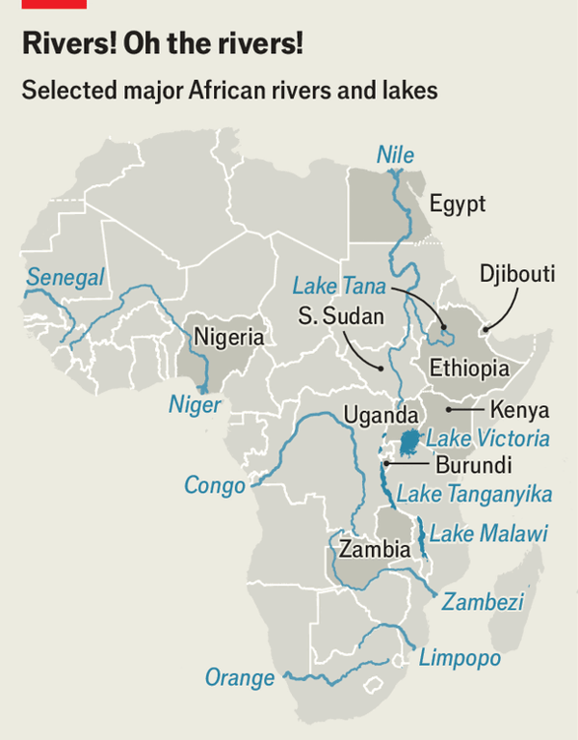

In part, Africa’s dearth of water-based transport reflects the difficulty of transporting boats inland; shipbuilding capacity on the continent is negligible. Large vessels are usually disassembled before travelling overland. This avoids odysseys like that of the Ethiopian ferry. But reassembling the vessels before launching them into the water raises costs still more.
Geography complicates things. Unlike in Europe, Africa’s longest river systems are not connected to each other (see map). Cataracts, rapids and other obstacles impede navigation, especially for larger cargo ships. Colonial rulers built infrastructure to extract resources from the continent, not to encourage intra-African trade.
Post-colonial leaders have done little to reverse this. In Nigeria, for instance, they might have dredged the Niger river and built canals to connect its tributaries, creating a network of waterways spanning 28 of the country’s 36 states. Such a project, says Lanre Badmus of the World Association for Waterborne Transport Infrastructure, would be both transformative and cheaper than building more roads.


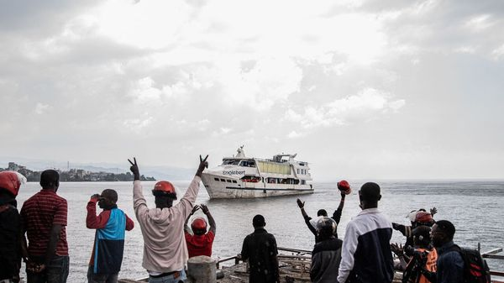

Even where waterways are navigable, waterborne transport has atrophied. Maritime infrastructure in the Great Lakes region has been neglected for decades, says Andrew Mold, eastern Africa director at the UN Economic Commission for Africa. Those lakes connect ten countries with a combined population of 520m, so the lost opportunities for trade are substantial. With decent infrastructure Burundi, for instance, could import maize from Zambia via Lake Tanganyika. Today it largely comes by road, tripling transport costs.
Similar stories can be found across Africa. Decades of conflict in South Sudan have destroyed its river transport and ruined trade along the Nile. South Sudanese joke that theirs is the only section of the river “where fish die of old age”. Yet things are hardly better upstream. Once the dominant mode of transport in Egypt, the Nile now carries less than 1% of the country’s internal trade. Since 2014 Egypt has built more than 6,300km of roads while leaving its river ports to rot. At least one major dam has no lock to let ships pass.
But the tide may be turning. The African Development Bank is pushing a $12bn plan for a water-transport corridor from Lake Victoria to Egypt’s Mediterranean coast. Uganda recently began to import fuel from Kenya via Lake Victoria, thanks to a new pipeline from the coast to Kenya’s lakeside city of Kisumu. East African countries want to harmonise policies, renovate ports and revitalise trade on the Great Lakes. Such schemes face big challenges, from inter-state conflict to financial constraints. But they could make waves. ■
Sign up to the Analysing Africa, a weekly newsletter that keeps you in the loop about the world’s youngest—and least understood—continent.

This article was downloaded by e-magazines.top from https://www.economist.com/middle-east-and-africa/2025/12/30/the-nautical-theory-of-african-development
| 章节菜单 | 主菜单 |
| 下一项 | 章节菜单 | 主菜单 | 上一项 |

Prove it, prophet

Ghana tries to regulate online prophecies
It is part of a wider effort to tackle misinformation
12月 30, 2025 05:49 上午
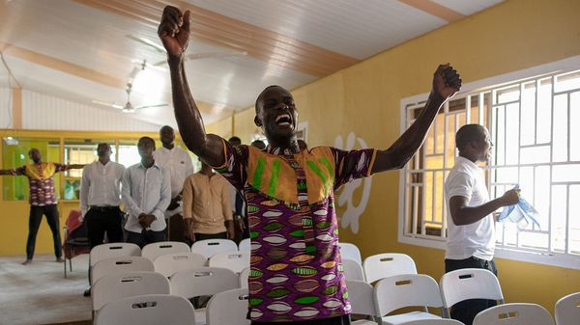

December has always been a busy time for Ghana’s prophets. With the new year in view, pastors are keen to give their flocks a taste of what lies ahead. The best prophecies are vague, plausibly deniable or easy to defer certainty on. Volume helps, too: make enough predictions, and at least one might just come true.
Unlike previous years, however, prophets in 2025 have attracted an unusual level of scrutiny. In August the country’s defence and environment ministers were killed in a helicopter crash, along with six other people. Soon after, clips of videos posted before the accident, showing pastors claiming visions of an aviation disaster, started circulating on TikTok.
Some two-thirds of Ghanaians favour giving divine intervention a role in politics, so the videos were alarming enough to prompt government action. Elvis Ankrah, who is styled as presidential envoy for inter-faith and ecumenical relations, decided to establish a reporting mechanism for sensitive prophecies, asking them to be sent to him for review.
Charismatic preacher-prophets have been a feature of Ghanaian public life since Pentecostalism took hold in the 1980s. But social media have expanded their reach and made their claims more outlandish. Old-timers worry about quality control. Younger pastors will spout “whatever messages make them most popular”, fumes an elderly reverend. Police have threatened to lock up prophets who can’t prove that their predictions have eventually come true.
The prophecy-reporting mechanism is part of wider efforts to rein in the ill effects of online misinformation. A recent bill supposedly aims to help with that, by defining hate speech widely as the promotion of “negative feelings”. Critics worry it may just come to mean anything with which the government does not agree.
For his part, Mr Ankrah appears confident that his mechanism is improving the quality of online predictions. Most of the prophecies Ghanaians have sent his way since it was set up, he recently declared, are total bunk.■
Sign up to the Analysing Africa, a weekly newsletter that keeps you in the loop about the world’s youngest—and least understood—continent.

This article was downloaded by e-magazines.top from https://www.economist.com/middle-east-and-africa/2025/12/30/ghana-tries-to-regulate-online-prophecies
| 章节菜单 | 主菜单 |
| 下一章节 | 主菜单 | 上一章节 |

The Americas
- Brazil’s general election will be all about Lula—again
The great survivor :: The left-wing stalwart has emerged as the favourite; the right is in disarray
- Peru’s not-so-happy new year
Burn, baby, burn :: Hatred of the country’s leaders is hotting up, if effigies are anything to go by
- Canada’s first Christmas without the Hudson’s Bay Company
The corporation that became a country :: From fur-trading outpost to department-store giant, founding a country along the way

| 下一章节 | 主菜单 | 上一章节 |
| 下一项 | 章节菜单 | 主菜单 |

The great survivor

Brazil’s general election will be all about Lula—again
The left-wing stalwart has emerged as the favourite; the right is in disarray
12月 30, 2025 06:36 上午 | Rio de Janeiro
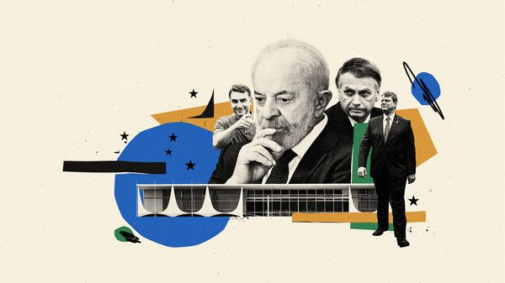

The two most populous countries in the Americas have important elections in 2026. In October Brazilians will choose a president, all 513 federal deputies, 54 of the country’s 81 senators and all 27 state governors. In November voters in the United States will renew Congress and elect 36 governors. The 79-year-old president, Donald Trump, is suffering from the lowest approval ratings of his second term. The latest polls suggest that his opponents will take control of at least one branch of the legislature in 2026 and will be able to start checking Mr Trump’s executive power.
Brazilians may well be kinder to their incumbent president, Luiz Inácio Lula da Silva, known as Lula. That is remarkable. In early 2025 Lula’s approval ratings were crumbling. Tainted by widespread corruption scandals during his first two terms, he has been extremely vulnerable during his current third term to accusations of graft anywhere in his government, such as a scandal at Brazil’s pensions institute. The 80-year-old—just 11 months younger than Joe Biden was at the equivalent point in his aborted re-election campaign against Mr Trump—had just undergone brain surgery. The Brazilian left, dominated by Lula’s Workers’ Party (PT), was on the verge of full-blown panic.
Then came Mr Trump’s tariffs, a failed assault on Brazil’s justice system, and, in November, the jailing of Jair Bolsonaro, Brazil’s former president. The right has flailed in the vacuum left by its populist figurehead. Lula’s approval ratings have surged. As things stand, he is now the favourite to win in October. A fourth term would put him in the same exclusive presidential league as Franklin D. Roosevelt.
When Lula returned to power in January 2023, he promised to finish work left undone during his first two stints as president, between 2003 and 2010. He vowed to end hunger in Brazil, expand access to electricity and reduce taxes on the poor. He took a while to make good on his word, spending much of his first two years in office trying to big up Brazil abroad, often angering foreign allies in the process. Markets panicked about his spendthrift government; in 2024 the real was the world’s worst-performing major currency.
Lula’s finance ministry then made a concerted effort to win back market confidence while maintaining popular support. It squeezed spending on disability benefits and on Bolsa Família, Brazil’s well-regarded welfare programme. Gabriel Galípolo, a Lula appointee who has run the central bank since January 2025, has kept interest rates sky-high. At the same time the government expanded subsidised access to electricity and mortgages, and distributed free cooking gas to the poorest families. In November the Senate passed reforms that mean 16m Brazilians will now pay less or no income tax. Brazil has also benefited from the fall in the value of the dollar since Mr Trump took office in January 2025. The appreciation of the real has slashed food inflation, buoying Lula’s base.
Yet Lula’s greatest gift has come from his opponents’ missteps. In November Mr Bolsonaro began serving a 27-year prison sentence for attempting a coup after losing his re-election bid in 2022. As his prospects of release dimmed, he and his family became desperate. In March his son Eduardo, then a congressman in Brazil, moved to Texas to lobby Mr Trump’s circle. Mr Trump obliged by imposing sanctions on Alexandre de Moraes, the judge who oversaw Mr Bolsonaro’s case, and slapping tariffs on Brazilian imports.
This was deeply unpopular in Brazil. Most people saw the tariffs and sanctions as an affront to the country’s sovereignty. Right-wing presidential hopefuls squir-med as they tried to disassociate themselves from the Bolsonaro family’s machinations, while aiming to win over Bolsonaro supporters. Meanwhile, Lula took to wearing a blue cap proclaiming “Brazil belongs to Brazilians”.
Lula appears to have impressed Mr Trump. After the pair spoke by phone in December Mr Trump called the chat “great” and said “I like him.” Lula has told Mr Trump if he only got to know him he would forget that “loser” Mr Bolsonaro, one insider said. That seems to be happening. In recent weeks Mr Trump has lifted the sanctions on Mr Moraes and removed many tariffs on Brazilian goods, which were driving up food prices in the United States and creating cost-of-living problems for Mr Trump’s supporters.
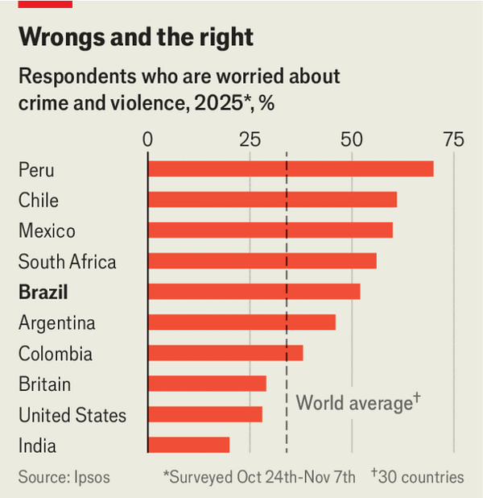

With Mr Bolsonaro in prison and Mr Trump pally with Lula, the right has latched onto security as a way to find an issue on which they can compete with the president. Brazilians now rate crime as their most important problem (see chart). Unlike in the rest of Latin America, security in Brazil is mostly the responsibility of state governments. That makes it harder to blame the president, but also lets state governors take credit for improvements. Thomas Traumann, a leftish political analyst in Rio de Janeiro, says the right is “all talk, no trousers”. “What else do they have to talk about except security?”
They are not helped by the fact that in early December Mr Bolsonaro anointed Flávio, another of his sons, as his political successor. The response was dismal. Most of Brazil’s centre-right parties, which dominate Congress, suggest they will not back him. The real slumped and São Paulo’s stock exchange fell sharply on fears that Lula, whom the business community still does not trust, will crush Flávio and cruise to a fourth term. Bolsonaristas prefer his wife, Michelle, to any of his four sons.
As the right wing is so fragmented, Flávio could still make it to the second round if he stays in the race, though he would almost certainly lose to Lula by quite a margin. The other candidates, all governors of populous states, are relatively unknown. Making it to the run-off “would maintain [Bolsonaro’s Liberal Party] as Brazil’s biggest party and show Bolsonarismo’s strength”, says Jairo Nicolau, the author of a book on Brazil’s right. But it would doom the right to another term under Lula.
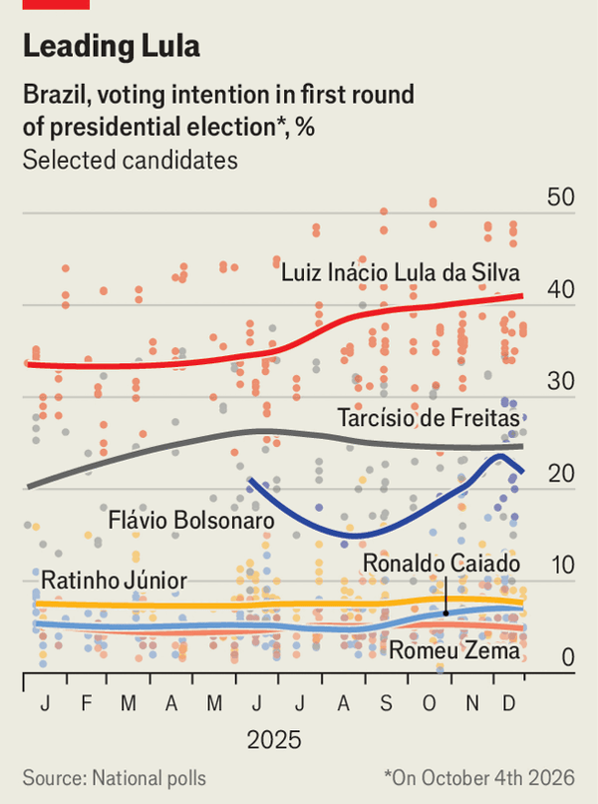

Brazil’s elite had hoped that Mr Bolsonaro would tap Tarcísio de Freitas, his former infrastructure minister, now the governor of São Paulo. Mr Freitas has portrayed himself as a moderate, pandering to bolsonaristas by letting the police run riot in poor neighbourhoods while courting financial bigwigs by privatising São Paulo’s water company. But he will probably run only if he gets Mr Bolsonaro’s blessing. The latest polls show Flávio’s popularity plunging, and Lula’s falling too, though he still leads the field. If Mr Freitas builds and maintains a strong polling lead, then perhaps Mr Bolsonaro will change his mind. That could unite the right, giving Mr Freitas control of a powerful electoral machine and allowing him to court the moderates who will determine the election’s outcome.
Most Brazilians are fed up with both Lula and the Bolsonaros, and want neither on the ballot. They may get half their wish, come October. But not all. ■
Sign up to El Boletín, our subscriber-only newsletter on Latin America, to understand the forces shaping a fascinating and complex region.

This article was downloaded by e-magazines.top from https://www.economist.com/the-americas/2025/12/28/brazils-general-election-will-be-all-about-lula-again
| 章节菜单 | 主菜单 |
| 下一项 | 章节菜单 | 主菜单 | 上一项 |

Burn, baby, burn

Peru’s not-so-happy new year
Hatred of the country’s leaders is hotting up, if effigies are anything to go by
12月 30, 2025 05:48 上午 | Lima
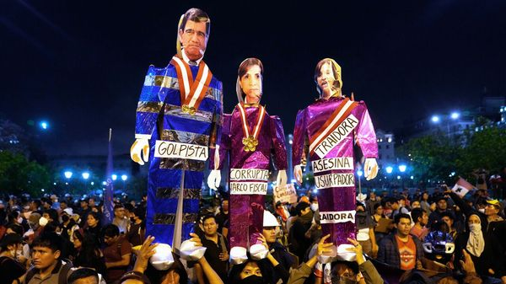

Many annual traditions in Peru are laced with superstition. Some folk flaunt yellow underwear, the colour of luck, to ring in the new year. Others hide lentils in their purses to bring wealth. And many bid a cathartic farewell to the old year by burning effigies of hated public figures—especially politicians. “People want to burn them in real life, but since they can’t do that, they burn effigies instead,” says Yacco Vásquez, who for the past 13 years has made and sold muñecos de fin de año. Gathering round a bonfire with loved ones to watch officials frazzle may be one of the gentler aspects of Peruvian politics.
In late December effigies of officials new and old dangle from market stalls near parliament and the presidential palace in Lima, the capital. Slogans on dummies of Jóse Jerí, the interim president, are particularly rude. Another effigy is a collage of every lawmaker in Congress, a sign of contempt for the legislative body. “I hate them all, but I hate these the most,” a customer said as he snapped up dolls depicting Mr Jerí, Dina Boluarte, the most recent former president, and Rafael López Aliaga, a leading presidential candidate: three of the hottest figures of hate this year.
Four of Peru’s former presidents are behind bars. The presidential election in April has so far offered a raft of unpopular candidates, so there is plenty of fuel for the fires. Peruvians have been hit by a wave of violent crime while much-needed reforms have failed to materialise. “There’s a sense that everyone is corrupt, nothing ever changes. That creates space for revenge, even if symbolic,” says Alex Huerta-Mercado of the Pontifical Catholic University of Peru.
Some say the tradition stems from European pagan rites of renewal brought to South America by Spanish colonists; others contend native Andean customs were an influence. Whatever the initial spark, Peru’s politicians seem bent on keeping the flames alive.
The effigies people buy are an insight into voters’ thinking, says Mr Vásquez. Sales of the likeness of Keiko Fujimori, a regular (failed) presidential candidate, which used to sell like hotcakes, dipped this year. So did those of Martín Vizcarra, a recently convicted ex-president (he is appealing his conviction), whose brother is running on a promise to pardon him. Yet in a crowded race that could just signify irrelevance. Whoever wins will surely feature in next year’s bonfires, a tradition that Peruvians love more, it seems, than their leaders. ■
Sign up to El Boletín, our subscriber-only newsletter on Latin America, to understand the forces shaping a fascinating and complex region.

This article was downloaded by e-magazines.top from https://www.economist.com/the-americas/2025/12/30/perus-not-so-happy-new-year
| 章节菜单 | 主菜单 |
| 下一项 | 章节菜单 | 主菜单 | 上一项 |

The corporation that became a country

Canada’s first Christmas without the Hudson’s Bay Company
From fur-trading outpost to department-store giant, founding a country along the way
12月 30, 2025 09:04 上午 | Yellowknife

Turn out the lights
One thousand kilometres from the ochre rock and limitless lakes where the Hudson’s Bay Company (HBC) once held dominion over a territory four times larger than the Holy Roman Empire, what’s left of Canada’s retail colossus has been slowly dying in a Toronto courtroom.
On December 11th the Ontario Superior Court of Justice gave two of Canada’s wealthiest families permission to buy the original five-page vellum charter that had created the company in 1670 for C$18m ($13m). The document, which gave the HBC sway over a third of what would become modern Canada, will be displayed at museums across the country. A month earlier, the same court handed leases for 25 stores, all that was left of the old HBC, back to their landlords, ending a legal tussle that had dragged on throughout 2025.
Many of these once-graceful stores had long ago fallen into shabbiness. Power to the escalators in the Ottawa one had been cut off for months before its final closure in June 2025, compelling its last few customers to trudge up dingy staircases to reach the final sales. Hordes of faceless mannequins were among the last items sold off: C$50 a pop.
The properties are a monument to retail trends—the HBC stores are far from the only plush outlets to fall prey to online shopping. But they are also “portholes into Canada’s past”, says Stephen Bown, author of “The Company: The Rise and Fall of Hudson’s Bay Empire”. Over more than three centuries the HBC shaped not just Canadian commerce, but Canada itself.


It started with a mission. In 1670 King Charles II of England backed his cousin, Prince Rupert, and a group of investors on a daring quest. They would search for the mythical “North-West Passage” to Asia. But their real goal was to grab a slice of the lucrative fur trade on land claimed for the crown 60 years earlier by an English explorer, Henry Hudson. “These were aristocrats looking for a diversionary lark and adventure,” says Mr Bown. So was born “The Governor and Company of Adventurers of England Trading into Hudson’s Bay”.
The adventurers would probably have starved or frozen to death without the fish, pemmican and shelter provided to them by Dene, Inuit, Cree, Chipewyan and other indigenous people who welcomed them to Hudson’s Bay. They taught the newcomers how to cut ice for water and served as guides into the interior of an unknown North America. In exchange they took needles, knives and other basic goods.
The royal charter empowered the HBC to make laws, wage war and run commerce across a territory that would eventually stretch from Hudson’s Bay to all lands “not already possessed by the subjects of any other Christian Prince or State”. Possession by people living in the icy north before Christians arrived did not count.
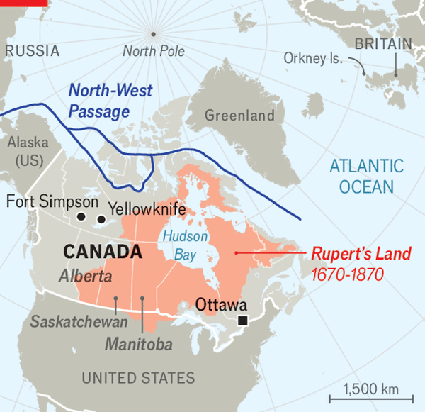

The company sold much of it, christened “Rupert’s Land”, to the emerging Canadian state in 1869 for £300,000 ($50m in today’s money). Indigenous people were neither consulted nor given a share of the proceeds. Rupert’s Land became Canada’s middle. The HBC started to look more like a traditional firm. Its outposts expanded, selling everything from salt to dog-sled harnesses, petrol to parkas. These shops provided employment for young indigenous men across the country. They were among the “Bay Boys” who swept floors, pumped diesel and loaded sleds with buckshot, lard and fishing line.
Norman Yakeleya, a former minister in the Northwest Territorial government, was one of them. He worked as a child clerk in the trading post in Fort Simpson, 630km (390 miles) west of Yellowknife, the capital. He was 16 and on a fast track to a manager’s job in Inuvik when he was mocked and shunned by white workers in the HBC warehouse. “I didn’t know what was wrong,” he recalls. “I thought, ‘Why are they laughing at me?’” It was one of Mr Yakeleya’s earliest experiences of racism. He quit and never went back to HBC.
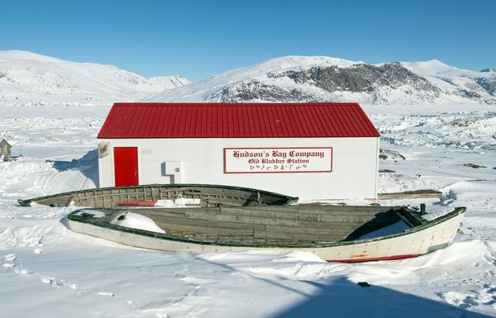

At the beginning of the 20th century HBC was unrivalled as Canada’s prime retailer. To log-cabin outposts were added sleek department stores. Come 2003 HBC enjoyed sales of C$7.3bn while employing 70,000 people. By January 2025 the company had just C$3.3m cash in hand while owing over C$2bn. Sales had dropped to C$1.1bn. Only 9,000 employees remained when HBC was liquidated in June.
The demise of HBC has prompted a burst of nostalgia. Demand for its iconic cream-coloured blankets, introduced in 1779 with their distinctive green, scarlet, yellow and indigo stripes, has shot up. For those bidding up prices on eBay they may represent a slice of Canada from a steadier time, before Donald Trump started clamouring for a 51st state.

The opposite of nostalgia
Others feel less warmly. James Ross, a Bay Boy who became the chief of the Teetl’it Gwich’in First Nation in the Northwest Territories, says the way Mr Trump talks about Canada’s sovereignty reminds him of how HBC treated his ancestors. “How come no one compares that to the Hudson Bay Company coming in to take over our lands and change the history of our indigenous peoples for ever?” he asks.
The Hudson’s Bay warehouse in Yellowknife is in trendy Old Town. Thick wooden shelves once groaned with washing machines, axes and sacks of sugar. Now they are empty and dusty. The building is a short drive from Mr Yakeleya’s handsome home. To him, it is just a reminder of HBC’s unsavoury past. ■

This article was downloaded by e-magazines.top from https://www.economist.com/the-americas/2025/12/21/canadas-first-christmas-without-the-hudsons-bay-company
| 章节菜单 | 主菜单 |
| 下一章节 | 主菜单 | 上一章节 |

Asia
- A fragile thaw at the top of the world
Holding the line :: The Economist gained rare access to India’s tense border with China
- Australia’s prime minister gets booed in Bondi
Antisemitism :: His government promises gun buybacks and stricter hate laws
- A sham poll in Myanmar opens a new phase of military rule
A brutal ballot :: The country’s rebels are on the back foot
- Cults of personality pervade all levels of Indian politics
Banyan :: The focus is on individuals over institutions

| 下一章节 | 主菜单 | 上一章节 |
| 下一项 | 章节菜单 | 主菜单 |

Holding the line

A fragile thaw at the top of the world
The Economist gained rare access to India’s tense border with China
12月 31, 2025 03:51 上午 | Karu, Leh and Tangtse


It WOULD ONCE have taken a week to travel from Leh—the joint capital of Ladakh, a territory in India’s far north—to Tangtse, a village less than 50km from India’s disputed border with China. Even five years ago, the trip would have eaten up a day. But when your correspondent made the same passage in November—crossing the Chang La pass (pictured) at an altitude of around 17,600 feet, the same as Everest’s base camp—the journey was zippy by comparison. Newly paved roads brought him towards the border in about four hours.
Speedier travel in the mountains is one by-product of a bloody clash between India and China that took place in 2020 in the Galwan valley, high up in Ladakh. That incident, the worst mêlée in more than 50 years, blew up ties between the world’s two most populous countries. Both sides rushed troops to the region, and began building infrastructure. The Economist was recently given rare access to Indian military facilities across eastern Ladakh (see map), to see how things have changed in the five years since. We agreed not to name bases or military personnel.
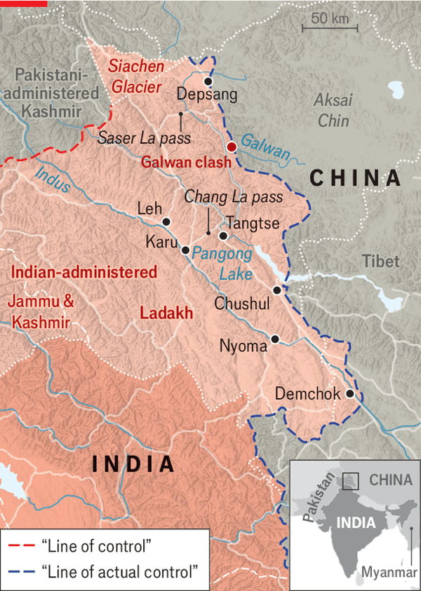

The Galwan clash took Sino-Indian relations to their “lowest point since the 1962 war”, notes Vijay Gokhale, a former Indian ambassador to China. Direct flights stopped for five years; tourism was halted; India began turning away Chinese investment. Yet a partial thaw is occurring. “We face tremendous cyber-attacks on a daily basis,” says an official in Delhi. “But we also have huge economic dependencies.” In August Narendra Modi, India’s prime minister, visited China for the first time since 2018. Direct flights restarted in October. China has resumed the export of rare-earth materials and magnets.
Donald Trump has played a role in this, by making India less sure that it can keep strong ties with America. He has imposed swingeing tariffs on India, condemned it for importing Russian oil and embraced Pakistan’s army chief. But the rapprochement between India and China might not have happened at all, were it not for a thaw on the ground in Ladakh. So any disruption to the fragile peace in the mountains could throw ties back into disarray.
India and China have long disagreed on where their border lies. Each side claims vast swathes held by the other. In lieu of a border they have a Line of Actual Control (LAC). But even that is imprecise. In a dozen or so areas, the two sides differ on where the LAC runs—a discrepancy that led to the deadly brawl in 2020.
After Galwan each side pulled their forces slightly back from the LAC, suspended some patrols and created buffer zones which neither side could enter. Then, in late 2024, came a diplomatic breakthrough that reduced friction further: the two sides agreed that each would allow the other to resume weekly foot patrols at two points in the borderlands (at Depsang, a high-altitude plain, and Demchok, a valley). Patrols are co-ordinated so that troops from the two sides do not pass within 300 metres of each other, says an officer; soldiers exchange a “friendly wave”. During a four-day war between India and Pakistan in May, India felt confident enough to divert two brigades from the LAC to the border with Pakistan, according to a Western official.
Critics, including some local officials and retired Indian generals, argue that the buffer zones favour China by denying India access to well-worn patrol routes and precluding farmers from grazing cattle on good land. Indian military officers in Ladakh deny this. They say the creation of a no-man’s-land has affected China just as much. They also say that Chinese troops have scrupulously adhered to last year’s agreement. Whereas Chinese officials frequently ignore their hotlines with America, they always pick up the phone to Indian officers. Parlay sessions stretch to several hours. The atmosphere is “not cordial”, says an officer, “but not inimical”.
Yet tour the region and it is clear that some knock-on effects of the Galwan clash will last for years. In 2020 India had a single division in Ladakh. Today it has more than twice that, plus an armoured brigade. Your correspondent was shown an airbase bristling with permanently deployed air-defence systems that, before Galwan, were emplaced there only sporadically. In mid-November India opened a new airbase at Nyoma, just 25km from the LAC.
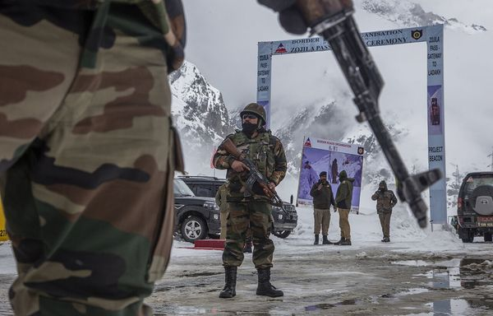

Operating at these altitudes is hard. Leh is at 11,500 feet and Tangtse higher still. Engines, batteries and other machinery have shorter lives than they would elsewhere. Heating trolleys are wheeled under warplanes to warm them up. Soldiers need two weeks to acclimatise fully, so troops rushed to the area in a crisis must rest on arrival or risk sickness that could reduce the strength of a force by 30%.
In the past year China has halved the number of its own forces in eastern Ladakh. Both sides now have similar numbers of tanks and armoured forces in the region. The challenge for India is that China’s side of the LAC—Aksai Chin, a territory that India claims as its own—is a plateau. That allows it to move forces from rear areas to the LAC in only two nights, much faster than India can. This problem would be lessened if India could spot a build-up in advance. But Indian officials acknowledge that real-time coverage from satellites remains patchy. “We can’t look consistently deep into China,” says one officer.
The border conflict is increasingly a race to plant new infrastructure. Indian officials say that China has forced civilians to move closer to the border, to villages near Pangong lake (which is split between the two sides). That is because having housing and other amenities in these areas makes it easier to keep troops in forward locations. A new bridge over the lake that opened in July 2024 will allow China to move forces around much more quickly. All told, the number of Chinese structures along the LAC has risen ten-fold since Galwan.
India seeks to keep up. “If he builds a hut,” says one senior officer, “we build a hut.” India has constructed underground ammunition dumps and tunnels. A new road over the Saser La pass, at 17,660 feet, will provide routes to the LAC which are less vulnerable to Chinese interdiction. But China’s rate of infrastructure development, swelled by larger budgets, is at least four times that of India, says one officer.
That is not to say that China could roll in with ease. Ladakh’s topography and altitude complicate any simple assessment of the military balance. Because of thinner air, Chinese planes that take off from the heights of Aksai Chin can carry less than Indian warplanes that take off from plains south of Ladakh. China has a far larger stock of missiles, but precision-strikes in the mountains are tricky. “Terrain”, says one officer, sharing a late-evening brandy as the temperature plunges to ten degrees below freezing, “is the great leveller.”
The evidence on the ground suggests that China and India have lowered the risk of another big clash in the region. That is good news for anyone gambling that their frosty ties will keep thawing. Yet the root causes of tensions between the two countries remain. China’s rapid growth has cast a shadow in India’s neighbourhood. China’s swelling navy is a routine presence in the Indian Ocean. And the vast differences over the border, which stretches east from Ladakh to Myanmar, remain largely unbridged. “What I can say,” observes Mr Gokhale, “is that the state of armed coexistence will remain for a long while.” ■
Stay on top of our India coverage by signing up to Essential India, our free weekly newsletter.

This article was downloaded by e-magazines.top from https://www.economist.com/asia/2025/12/29/a-fragile-thaw-at-the-top-of-the-world
| 章节菜单 | 主菜单 |
| 下一项 | 章节菜单 | 主菜单 | 上一项 |

Antisemitism

Australia’s prime minister gets booed in Bondi
His government promises gun buybacks and stricter hate laws
12月 30, 2025 05:49 上午 | Sydney


Afortnight has passed since two gunmen inspired by Islamic State (IS), a jihadist terrorist group, fired on people celebrating Hanukkah at Bondi Beach in Sydney, killing 15. Alongside the grief have come bitter recriminations. The conservative Liberal-National coalition, Australia’s main opposition, is heaping blame on the Labor prime minister, Anthony Albanese. It says he failed to fight antisemitism that has mounted in Australia since Hamas attacked Israel on October 7th, 2023. Foreigners point fingers, too. In the immediate aftermath of the massacre, Binyamin Netanyahu, Israel’s prime minister, accused Mr Albanese’s government of taking “no action” to counter hatred of Jews.
Mr Albanese has pushed back. He has noted that in July 2024 his government appointed Australia’s first-ever special envoy to combat antisemitism; that in February 2025 it tightened hate-speech laws; and that it has found money to safeguard synagogues and other Jewish sites. Yet many Australians think all this too meagre. Just before Christmas the prime minister attended a vigil for those murdered in Bondi Beach. He received boos from the crowd.
Under pressure, Mr Albanese’s government is pumping out reforms. He has unveiled a gun-buyback scheme—the largest since a 1996 mass shooting in Tasmania. John Howard, who was prime minister at the time of those killings, has accused the government of talking tough on firearms to distract from its failure to curb antisemitism. Yet polls suggest stricter gun laws enjoy broad support among voters on both the left and right.
Mr Albanese has also announced a review of Australia’s federal police and its domestic intelligence service. Australians agree with him that there were clearly “real issues” with intelligence before the attack by Sajid Akram and his son Naveed. The younger Mr Akram had once been investigated by security services; it is odd that his father was permitted to own six firearms. Whether the authorities should have spotted that the pair had travelled weeks before the attack to the southern Philippines (where IS-linked groups are active) is another live debate.
None of this is controversial. When it comes to eradicating antisemitism, Mr Albanese is going to have to navigate somewhat more contested ground. His government has announced a further tightening of hate-speech laws. It has also promised it will “work through the implementation” of 13 recommendations contained in a report that its antisemitism envoy, Jillian Segal, handed to the government in July. But Ms Segal’s report provoked considerable debate when it was first unveiled. It pushes for adopting an official definition of antisemitism that some people claim would encompass criticism of Israel. It also calls for public money to be withheld from institutions such as universities when they are deemed not to have taken enough action against hate.
State authorities in New South Wales, of which Sydney is the capital, are moving more swiftly than the federal government. In the early hours of December 24th state legislators handed local police new powers to restrict public protests for up to three months after a terrorist attack (supporters of Palestine fear their rallies, in particular, will be curbed). The state is also promising to pass a law in the new year that might criminalise the use of slogans such as “globalise the intifada”.
Chris Minns, the governor of New South Wales, has received praise for his leadership in the weeks after the Bondi massacre—even as Mr Albanese, a Labor colleague, has been panned. Yet some politicians and civil-liberties groups are alarmed by the rush to rewrite rules. Ben Saul, a law professor in Sydney and the UN’s special rapporteur on human rights and counter-terrorism, has warned against disproportionate restrictions on expression and association. “Overreach does not make us safer,” he wrote on social media. “It lets terror win.” ■

This article was downloaded by e-magazines.top from https://www.economist.com/asia/2025/12/30/australias-prime-minister-gets-booed-in-bondi
| 章节菜单 | 主菜单 |
| 下一项 | 章节菜单 | 主菜单 | 上一项 |

A brutal ballot

A sham poll in Myanmar opens a new phase of military rule
The country’s rebels are on the back foot
12月 30, 2025 05:49 上午 | Chiang Mai


Tayzar San is the most wanted man in Myanmar. In 2021 the wiry and bespectacled doctor led the first protest against the military junta that had toppled Myanmar’s democratically elected government. In the years since then, he has avoided capture, aided by a supportive population; he pops up in settlements across the country to lead demonstrations against the junta. In early December he appeared in Mandalay, the second-biggest city, to protest against the regime’s latest ploy: a sham election that began on December 28th. Delighted locals applauded and flashed the three-finger salute (a symbol of opposition to military rule) before their hero slipped back into the shadows.
That appearance (pictured), in a market right by a military headquarters, was one of Dr Tayzar San’s most daring yet. But it came at the end of a disastrous year for the rebels who are fighting the ruling generals. Armies representing Myanmar’s many ethnic minorities have lost battles with the junta in the country’s hilly borderlands. Youngsters from the Burman majority who are fighting in the centre of the country have taken a pounding, too. Lately the regime has launched brutal new offensives aimed at acquiring territory ahead of the election, which is being held in three phases and concludes only on January 25th. Its forces are gaining ground.
All of this marks a stunning reversal for Myanmar’s revolutionaries. At the end of 2024 they appeared to have the junta on the run. For a time it had seemed possible that resistance forces might lay siege to Mandalay. Whispers spread that the army was on the brink of collapse.
Four factors help explain why things have turned out so differently. First are the actions of China. It has been cutting the supply lines to rebel groups that operate along its border with Myanmar, for fear of the instability that might follow were the junta to fall. It instructed two big rebel groups to give back to the government territory the rebels had won in 2024 (when one of these militias refused to comply, China kidnapped its leader, releasing him only after it signed a truce with the junta). China also ordered the two groups to stop selling ammunition to other rebel armies. That has left rebels who are still fighting desperately short of bullets.
Second, Donald Trump’s evisceration of the US Agency for International Development (USAID) has hit some rebel groups hard. USAID never supplied the armed groups directly, but it did provide assistance such as food aid to populations under their care. The agency’s closure has therefore handed rebel groups a lot more work. Consider the resistance in Karenni state, along the Thai border. By the end of 2023, the rebels had conquered most of the state. But in 2025 they had to shift 60% of their military budget (about $10m) to meeting humanitarian needs, according to their governing council. They have since lost the state’s biggest settlements to a junta counter-offensive.
The third and fourth factors relate to changes in tactics. In 2024 the junta began conscripting young men. Analysts think there are now 80,000 to 100,000 conscripts in its forces. Many are often high on amphetamines, and are thought to have received training from Russian advisers who have seen combat in Ukraine. These youngsters are being sent to attack rebel positions in huge waves. With too few bullets to mow down each onslaught, the rebels are being forced to withdraw.
If its ground war is growing more primitive, the junta has become more innovative in the air. At the outset of the conflict its forces made comparatively little use of drones. But they have since acquired much Chinese kit. In addition, soldiers in the centre of the country have been attacking schools and health clinics in rebel-held areas using motorised paragliders similar to those employed by Hamas when it attacked Israel on October 7th 2023. These assaults are making it difficult for rebels to administer the territory they have won.
Pulling off a rigged election would cap the junta’s successes. In large swathes of the country fighting is going to make voting impossible. But the generals insist that any constituency that is able to open even a single polling station will elect a member of parliament; they have lately stepped up attacks to make sure that this can happen in as many places as possible. In theory some 55 parties have registered to take part, in addition to the junta’s preferred political party. In reality all credible opposition has been banned. Already, more than 200 people have been arrested and charged with interfering with the poll, including some who simply cheered on Dr Tayzar San in Mandalay.
The poll may nevertheless give the junta the appearance of legitimacy. Myanmar has been shunned by most of its neighbours since 2021, when the junta massacred protesters. Min Aung Hlaing, its leader, has been banned from summits held by the Association of South-East Asian Nations, a regional bloc; several of its members have withdrawn their ambassadors from the country. But some South-East Asian countries have started to regret cold-shouldering the regime. They are now looking for an excuse to reopen talks on a wide range of issues.
The sham vote may also help resolve tensions within the ruling junta. Some of its brass regard Min Aung Hlaing as dim and inept; they still blame him for military losses in 2024. Foreign diplomats speculate that after the election he will give up one of his two titles, either that of president or commander-in-chief. He may see that as a way of mollifying rivals without giving up much real power. But some analysts think it could result in a more consensual kind of leadership. That is widely thought to be the reason that Chinese diplomats (who are said to find Min Aung Hlaing difficult to work with) have been pushing the general to hold a vote.
Even if that is what happens, there is little reason to think life for Myanmar’s people will improve. Dr Tayzar San and his fellow revolutionaries reject the idea that a sham election will change anything. After five years of marching and fighting, they are holding out for a real one. ■

This article was downloaded by e-magazines.top from https://www.economist.com/asia/2025/12/24/a-sham-poll-in-myanmar-opens-a-new-phase-of-military-rule
| 章节菜单 | 主菜单 |
| 下一项 | 章节菜单 | 主菜单 | 上一项 |

Banyan

Cults of personality pervade all levels of Indian politics
The focus is on individuals over institutions
12月 30, 2025 05:49 上午


NARENDRA MODI, India’s prime minister, is a once-in-a-generation political phenomenon. He commands support for his Bharatiya Janata Party (BJP) across class, caste and language. He is the face of his party in national elections, state elections and even local elections. In India’s Westminster-style parliamentary system, only a lucky few have the chance to vote for him directly. But after nearly 12 years of his prime ministership it is no exaggeration to say that every vote cast for the BJP is a vote for Mr Modi.
This is in part because of the elaborate cult of personality built around him. It is a rare morning that Mr Modi’s face is not in the papers—across both advertisements and news reports. He is a mascot for welfare schemes and an icon who graces every central-government website. He looks out from social-media ads and down from billboards. India’s biggest cricket stadium is named after him. A rail service to the capital, Namo Bharat, takes part of its name from a short version of his. There is even a road named after his mother. A visitor to India will encounter Mr Modi’s face more often in one day in Delhi than Xi Jinping’s in a month in Beijing.
Placing personality at the centre of politics is not new in India. Supporters of Indira Gandhi, an autocratic prime minister, famously conflated her with the nation itself, claiming that “India is Indira and Indira is India.”
But Mr Modi’s party has perfected the art. And other politicians are catching on. Supporters of Subrahmaniam Jaishankar, the foreign minister, promote their man on social media as a no-nonsense negotiator with lasers shooting from his eyes. Nitin Gadkari, the minister for roads, is projected as the only thing standing between a national infrastructure buildout and a return to bullock carts on rutted tracks.
In Maharashtra, a wealthy state administered by an unwieldy, BJP-led coalition of three parties, there is a running battle of personalities. The state’s leader has sponsored billboards showing him showering rose petals at the feet of a medieval warrior-king. These images make no pretence of advertising any policy; the only legend they bear is “Devabhau”, a short, familiar name for the chief minister. In response his deputy’s party published adverts featuring their man’s face. The next election is not due until 2029.
Such behaviour is not restricted to the BJP and its allies. In states run by the opposition, the local satrap is usually as inescapable as Mr Modi is in the rest of the country. In West Bengal it is impossible to get away from Mamata Banerjee, the chief minister, whose image is plastered across walls and public spaces with a devotion usually reserved for Bengali mothers. Tamil Nadu’s leader, M.K. Stalin, is seen everywhere in his state, often alongside his late father, a former chief minister, emphasising not just personality but familial continuity. In neighbourhoods across India local legislators disfigure the cityscape with illegal banners celebrating their own achievements or wishing each other happy birthday.
Even the bureaucracy is not immune. After E. Sreedharan, a civil servant, oversaw the successful roll-out of Delhi’s metro network in the early 2000s, his thoughts on public transport came to be treated as pronouncements from above. A.P.J. Abdul Kalam, a scientist who played a big role in India’s nuclear tests of 1998, was so admired that he was made the president of India. Visit any improving district of India and ask what has changed, and locals will heap credit on a new administrator.
It is easy to see why figures from the prime minister downwards invest so much effort—and advertising money—in building up their image. India has barely updated its structures of governance from the feudal-colonial system it inherited at independence. Officials in post-British India simply slotted into older roles; they are still able to rule by diktat. Voters know this and reward charismatic characters accordingly.
But this system is not good enough. With 1.45bn people, 28 states, vast economic disparities and weak public services, India is too complex to be run by a handful of well-recognised individuals, no matter how energetic or gifted they might be. Personality politics comes at the cost of building up institutions and state capacity that can survive bad leaders and incompetent officials. Not all attempts at building personality cults are rewarded. But their proliferation is a sign of Indian politics heading in the wrong direction.■
Subscribers to The Economist can sign up to our Opinion newsletter, which brings together the best of our leaders, columns, guest essays and reader correspondence.

This article was downloaded by e-magazines.top from https://www.economist.com/asia/2025/12/30/cults-of-personality-pervade-all-levels-of-indian-politics
| 章节菜单 | 主菜单 |
| 下一章节 | 主菜单 | 上一章节 |

China
- How China’s property crisis helped crash its art market
More Monet, more problems :: A gold-framed view into the world of China’s wealthy
- People of dubious character are more likely to enter public service
Civil servants :: A new study shows that customs and tax officials are the dodgiest
- China’s museum boom, take two
Chaguan :: Once-empty halls now heave with visitors—and treasures

| 下一章节 | 主菜单 | 上一章节 |
| 下一项 | 章节菜单 | 主菜单 |

More Monet, more problems

How China’s property crisis helped crash its art market
A gold-framed view into the world of China’s wealthy
12月 30, 2025 05:49 上午 | Shanghai


IT WAS ONE of the flashiest art deals in history. In late 2015 Liu Yiqian, a cab driver-turned-property magnate, paid $170m for Amedeo Modigliani’s 1917 painting “Nu Couché”, the second-highest amount ever paid for a piece of art at auction at the time. And he did so with his Amex card, a fact he happily revealed to the press. All this was meant to show the world that there was more to China’s nouveaux riches than steel and concrete.
The tycoon’s trajectory, although stunning, was not atypical. A property boom that kicked off in the early 2000s became one of the biggest, fastest generators of wealth in history. Art deals became an easy way for billionaires to flaunt their riches. Xu Jiayin, the founder of Evergrande, once the world’s most indebted property firm, was an avid collector. Many launched art museums; Mr Liu and his wife founded two in Shanghai. The mood soon turned. Mr Xu’s company began to collapse in 2021. In 2023 Mr Liu put 39 of his works up for auction. Of those, ten went unsold and the rest fetched prices below their expected value. In September his company, Tianmao Group, delisted from the Shenzhen stock exchange after posting two years of losses.
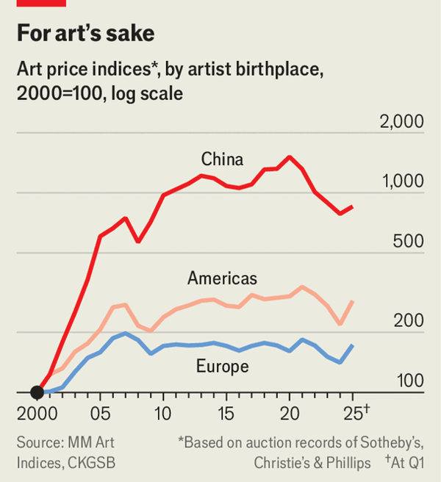

Art sales offer a gold-framed view into the world of China’s wealthy. The boom years have finished (see chart). Covid lockdowns, capital controls and the state’s distaste for opulence have set back the market. But nothing has hurt art prices in China more than the collapse of the property sector. In a mirror image of the wider economy, confidence to buy is now low and spending on everything from foreign masterpieces to Chinese showstoppers has slumped.
Between 2000 and 2020 the prices of art tracked by the MM Chinese Art Price Index increased about 15-fold, making it one of the world’s best investments—a period when the property market also boomed. The index, launched by Mei Jianping of the Cheung Kong Graduate School of Business and Michael Moses, an art-investment expert, tracks 327 works of art by Chinese artists from 1988 to 2022 and the prices at which they have changed hands, often repeatedly. Art and property share some traits as investment classes, notes Mr Mei. They are both illiquid assets and in a rout, it is not surprising to see tycoons attempting to sell both. “Liquidity is like oxygen to them,” he says. Selling art is one way to breathe again.
Average property prices have fallen to roughly the levels seen in 2016. The latest readings of the MM Chinese Art Index have fallen to approximately those of 2009, meaning the works it tracks have fallen back to the prices they were sold at more than 15 years ago. Art sales within China declined by 31% in 2024 compared with the year before. China’s most famous living artists have been hit hard by the downturn, notes Rupert Hoogewerf of Hurun, a consulting firm. One such is Zhou Chunya, known for oil paintings of German shepherd dogs with very large tongues. The transaction values of his pieces fell by 43% year over year in 2024.
But the property crash explains only part of what has transpired in China’s art world over the past five years. The pandemic and the country’s long covid-19 lockdowns have caused lasting problems. Covid hurt art-viewing everywhere as galleries and museums closed to the public. And just as the world was reopening in 2022, China’s leader, Xi Jinping, doubled down on pandemic controls.
Another problem concerns the Communist Party’s ambivalent view of the art world. It promotes visiting art exhibitions as a sign of China’s openness and of its engagement with the world. At the same time, leaders have become less tolerant of conspicuous displays of wealth. Last year the state banned social-media posts meant only to show off expensive clothing and lifestyles. Bankers were told this year to keep private their flashy consumption. For several years China’s richest have been toning down their public images. The extravagance demonstrated by tycoons such as Mr Liu has become a thing of the past. Far fewer large art deals are publicly announced these days.
There are also more practical reasons for the party to dislike splashy spending on art. Regulators worry that foreign purchases are a means of shifting large amounts of money abroad. China enforces strict capital controls and allows individuals to move only $50,000 in or out of the country each year. Elites have long sought means of moving their fortunes out of the purview of the state; art deals are often a source of outflows. Mr Liu’s $170m Amex swipe, for instance, probably required hefty overseas capital remittances.
Measures have tightened in recent years. By 2017 many Chinese collectors needed to pay in instalments. First-time art buyers, or those unaffiliated with galleries or cultural foundations, may these days be refused permission to transfer large sums overseas, says a Hong Kong-based wealth adviser who has helped arrange art deals. This can kill purchases outright. Some collectors without sizeable offshore wealth have given up on large buys.
Even as prices fall, some aspects of the art market are improving. Property developers made flashy deals because they wanted the world to perceive them as cultured. (The same thinking created a boom in expensive wine during that era.) More collectors today invest in art out of genuine interest and appreciation, says Zhao Li of the Central Academy of Fine Arts in Beijing. It is unlikely that such a trend will whip up prices in the same way property tycoons did. But overall this is a healthy development for the market, he says.
The property wealth is not coming back soon: prices may continue to fall for another half-decade. This has left a financial hole at the centre of China’s art world. Tech billionaires have been conspicuously inactive in the market. Many are known to collect art, but have kept this private. A crackdown on the tech industry starting in 2021 probably made executives even less willing to engage with China’s art scene in a public way.
This may also change. Some young tech-industry bosses are interested in getting involved in art, says Mr Zhao; his academy has been communicating with some of them recently. Rumour has it that a prominent tech tycoon may soon launch a major art museum or foundation. Mr Hoogewerf believes that a new burst of wealth creation in industries outside real estate—such as big tea-shop chains and makers of popular collectable toys—might lead to more art transactions in 2026. If that is true, the fate of China’s art and property markets may finally diverge for the first time in a quarter of a century. ■
Subscribers can sign up to Drum Tower, our new weekly newsletter, to understand what the world makes of China—and what China makes of the world.

This article was downloaded by e-magazines.top from https://www.economist.com/china/2025/12/30/how-chinas-property-crisis-helped-crash-its-art-market
| 章节菜单 | 主菜单 |
| 下一项 | 章节菜单 | 主菜单 | 上一项 |

Civil servants

People of dubious character are more likely to enter public service
A new study shows that customs and tax officials are the dodgiest
12月 30, 2025 12:12 下午


According to new figures, 3.7m young Chinese sat the annual civil-service exam in November, a record. Some may not have had pristine motives for doing so. In a new working paper, John Liu of the University of Hong Kong and others use plagiarism in master’s theses to measure the level of dishonesty. Those who plagiarised more, they find, were more likely to go on to work in the public sector. Once inside they were likely to be promoted more quickly, too.
The authors come to this finding through a massive volume of data work. They trawled through 6m dissertations from CNKI, a Chinese repository of academic articles, and checked them against public records of civil-service exam-takers, identifying 120,000 civil servants and their dissertations. They used another 400,000 dissertations from non-civil servants for comparison. Messrs Liu and others ran the essays through an algorithm, producing a “plagiarism score” for each that described overlap with previous work.
The results are intriguing. People who entered the public sector had plagiarism scores that were 15.6% above the average. Customs and tax officials were the worst, with 25% and 26% higher scores than their private-sector peers. Once inside the civil service, cheaters climbed up the ranks 9% faster in the first five years of their careers than their more honest peers. From 2009 onwards plagiarism-detection software was gradually rolled out at universities across China. That reduced crooked behaviour, but those with higher scores were still more likely to enter the public sector.
The link between future dishonest behaviour and aggressive borrowing from published sources in past academic work may seem tenuous. But an experiment run by the authors seems to demonstrate that this variable reflects an enduring character trait. They invited 443 people as part of a job application to roll dice, rewarding them based on the outcome. The rolls were, however, unmonitored. People who plagiarised in their dissertations, they found, also reported improbably high rolls.
The authors explored the real-world impact of these tendencies by examining a database of 140m court rulings. Comparing the records of plagiarising judges with those of academically honest peers, they found that the cheaters were 10% more likely to favour the government over citizens in lawsuits, 15% likelier to rule for state-owned enterprises over private firms and 12% likelier to side with bigger firms than smaller ones. These judges, it seems, may have been susceptible to lobbying. When trials were livestreamed over the internet, these effects disappeared.
Performance evaluation in the civil service is notoriously subjective. Fudging metrics or sucking up to superiors may come easily to those with fewer moral scruples, which helps with promotion. Yet that does not explain why plagiarisers were more likely to enter the civil service in the first place. Worryingly for China, it may be that these people self-select into the public sector, suggests Shaoda Wang, a co-author on the paper, perhaps because they expect to thrive there. ■
Subscribers can sign up to Drum Tower, our new weekly newsletter, to understand what the world makes of China—and what China makes of the world.

This article was downloaded by e-magazines.top from https://www.economist.com/china/2025/12/30/people-of-dubious-character-are-more-likely-to-enter-public-service
| 章节菜单 | 主菜单 |
| 下一项 | 章节菜单 | 主菜单 | 上一项 |

Chaguan

China’s museum boom, take two
Once-empty halls now heave with visitors—and treasures
12月 30, 2025 09:05 上午


Niko wang, a man in his 30s with thick black glasses, has his own marketing business. This affords him the flexibility to go to museums during the week—an essential ability for culture vultures in China. Its big museums have become almost too crowded to visit on weekends and holidays. On a recent Thursday morning at a new branch of the Zhejiang provincial museum in Hangzhou he pointed to a digital sign indicating that there were just 400 people in the museum at that moment, well below capacity. “What a treat!” Mr Wang said. Booking entries for China’s most popular museums, he sighed, is now almost as difficult as buying train seats during the annual crush for the Lunar New Year. You need to be logged onto the museums’ apps, with a fast trigger finger, as soon as tickets become available.
A decade ago the “museum boom” in China was a term of scorn. In their headlong pursuit of growth and modernity, officials around the country had funded grand new museums. Many sat empty. Today, China is again in the grips of a museum boom. But this time it means something else: a giant increase in visitors and a big leap in exhibition quality, especially of ancient splendours.
In 2007 China had about 1,700 museums attracting some 250m visits per year. Since then the number has more than quadrupled to 7,000, while annual visits are up nearly six-fold to 1.5bn. Some museums are packed. The most prominent extend their opening hours into the evening during public holidays. An exhibition on ancient Egypt in Shanghai this past summer drew so many people that the museum kept it open for 168 straight hours in its final week. A new scandal over allegations that a former director of the Nanjing Museum stole a Ming masterpiece—and perhaps more—in the 1990s shows that museums are squarely in the public eye as guardians of Chinese cultural heritage. (He denies wrongdoing.)
For the state, the museum push has a strong ideological element. That is clearest in exhibitions extolling the greatness of the Communist Party (none focuses on its blunders, of course). Yet these often evoke muted enthusiasm from visitors. It is easy to get close to displays of the party’s flag in the National Museum in Beijing. By comparison, it is an hour’s wait in the very same museum to see the sapphire-and-ruby-encrusted crown worn by a Ming empress four centuries ago.
Somewhat more subtly, exhibitions about pre-modern China also have a political agenda, presenting unified narratives that weave together disparate regions and peoples into a harmonious tapestry that culminates in the present. One repeat visitor is Xi Jinping. In 2012, shortly after taking power, he used an exhibition about the party’s revolutionary roots as a backdrop for his first speech about the “Chinese dream” of rejuvenating the nation. He has since been to more than a hundred cultural and historical sites, and often shows one or two to visiting foreign leaders—a reflection of his pride, but also a message about the weight of China’s 5,000 years of history.
Nevertheless, to stop at politics would be to miss the bigger trend. People are free to choose how to spend their leisure time in China. The fact that they are opting in ever-bigger numbers to go to museums is revealing. Patriotism is part of it. “Following the rise of the Chinese economy, many people have naturally wanted to learn more about their own history and culture,” says Jing Zhongwei, an archaeology professor at Zhejiang University, which also hosts an excellent museum.
What’s more, the price is right. Since 2008 China has made most of its public museums free. With Mr Xi’s support, they can count on stable funding. China’s private art museums are, by contrast, worse off·. They have lost benefactors. And they charge. That’s a hard sell in a slowing economy—especially when public museums are so good.
China’s history museums used to feature dreary displays of dusty artefacts in dimly lit cases. Now visitors are treated to cutting-edge exhibitions. In recent travels your correspondent checked out a dozen. In Beijing 3D printings form full-scale replicas of Buddhist cave walls from China’s far west. In Hangzhou augmented-reality glasses bring ancient street scenes to life. In Chengdu a giant hologram-like video shows how archaeologists peel back the soil to reveal relics at each stratum.

Keep digging
Allied to this is a spate of discoveries that have generated remarkable new content for China’s museums. Famously, the Nationalists moved the country’s finest imperial collections to Taiwan when they fled there from the mainland in 1949. Yet they also left countless treasures underground. Modern archaeology had just got started in China in the 1920s, and was then set back by war and revolution. Only in the past four decades have archaeologists worked intensively and continuously throughout the country. That enabled major excavations, from the bronze-age wonders of Sanxingdui in Sichuan to the 5,000-year-old Liangzhu settlement in Zhejiang and the Shimao pyramid in Shaanxi. Each of these—and many more—now has its own museum. Some display artefacts almost as soon as they are dug out. “Everyone wants to see what’s hot,” says Mr Jing.
These findings provoke fascinating debates about history. Gone is the traditional view of the plains near the Yellow River as a single source of Chinese civilisation. The question now among historians and others is to what extent various regions evolved independently. The Communist Party’s preferred narrative is that a central influence, an essence of modern China, coursed through them all. With so many invaluable items on display and more emerging from the ground all the time, China’s museum-goers can draw their own conclusions. ■
Subscribers to The Economist can sign up to our Opinion newsletter, which brings together the best of our leaders, columns, guest essays and reader correspondence.

This article was downloaded by e-magazines.top from https://www.economist.com/china/2025/12/29/chinas-museum-boom-take-two
| 章节菜单 | 主菜单 |
| 下一章节 | 主菜单 | 上一章节 |

International
- A half-planet-size gap in global governance is about to get plugged
Conservation at sea :: A new treaty offers hope of curbing the destruction of the oceans
- Patriotism tests loom for big business
The Telegram :: Economic nationalism makes it harder for multinationals to navigate the world

| 下一章节 | 主菜单 | 上一章节 |
| 下一项 | 章节菜单 | 主菜单 |

Conservation at sea

A half-planet-size gap in global governance is about to get plugged
A new treaty offers hope of curbing the destruction of the oceans
12月 30, 2025 05:49 上午


ON LAND, HUMANS’ desire to protect the richness of natural life is as old as Eden; in its modern guise, terrestrial conservation dates back to the founding in 1872 of America’s Yellowstone Park. In contrast, the desire to protect the seas’ biological diversity is more recent. More often, the ocean has been viewed as a place of plunder or pursuit: a giant global commons, a free-for-all for fishermen and the last frontier for mineral wealth. Besides in Antarctica, no global treaty has managed conservation in the high seas—less than 1% of which are formally protected.
Yet protection of the ocean beyond countries’ national jurisdictions is about to take a big leap forward, when a new high-seas treaty, with 145 signatories and ratified by 81 and counting, comes into force on January 17th. The agreement reflects a growing awareness of accelerating declines in many species of fish, sharks, turtles, squid and more. It also signals an increased understanding of the ocean’s importance in regulating the climate, since it is the planet’s biggest carbon sink. The agreement also recognises that climate change and other man-driven factors such as pollution are harming the ocean’s productivity, depleting the seas of oxygen, for instance, and harming the ability of the ocean to absorb atmospheric carbon dioxide. Still, that such an agreement has been reached in an age when multilateralism is under attack elsewhere is striking (even though America has not signed up to it). Greenpeace, a campaigning group, plausibly describes the treaty as “the biggest conservation victory ever”.
The Biodiversity Beyond National Jurisdiction agreement (BBNJ) covers all of the ocean outside countries’ individual remit, usually defined by their 200-nautical-mile (370km) exclusive economic zone (EEZ). Admittedly, many of biological hotspots, such as coral reefs, as well as most of the fish caught, are not in the high seas but within shallow and often productive EEZs. For all that, international waters account for 61% of the ocean, 43% of Earth’s surface and, with an average depth of 4,100 metres, two-thirds of its biosphere. Possibly millions of species that inhabit this space, from microbes to unknown bottom-dwelling fish, are yet to be documented.
For many scientists and policymakers the need for an agreement to protect living marine resources in the high seas is urgent. In large parts of the ocean, biodiversity—that is, the diversity of life at different scales—is in severe decline, with whole ecosystems threatened. The immense and baleful human impact on marine biodiversity is most obviously seen in a sharp decline in commercial fish stocks in the past several decades. Of 1,320 populations of 483 species in one study, 82% are being removed faster than they can repopulate.
The most prominent managers of fish stocks are a collection of 17 so-called regional fisheries management organisations (RFMOs). Yet with a few notable exceptions, such as in the western and central Pacific, the RFMOs, in essence producer lobbies, have done a poor job. For instance, the spawning population of the bluefin tuna has fallen by four-fifths in the western Atlantic in recent decades and by two-thirds in the eastern Atlantic.


Worse, they tend to be interested only in their target species and have a scanty mandate to ensure the broader health of the marine environment. Yet the size of bycatch from some of the main fishing techniques—above all, gill netting (laying vast curtains of nets) and long-lining (fishing with miles-long lines off which hang thousands of hooks)—can be staggering.
Indeed the populations of many slow-to-grow and slow-to-reproduce species, such as sharks, dolphins and turtles, which make up a significant part of the bycatch of licensed fisheries, are often devastated far more than productive target species, such as skipjack tuna, that grow and reproduce fairly quickly. A target stock is rarely fished to extinction before an unprofitable fishery is abandoned. Rather, a proportion of the population is left behind and can typically recover.

A sea of troubles
But when it comes to the population of a bycatch species, Callum Roberts of the University of Exeter points out: “You can wipe every single one of them out and no one’s paying attention.” Largely as a consequence of these fisheries’ practices, populations of oceanic megafauna have seen massive declines and at least one species, the vaquita porpoise of the eastern Pacific, is on the point of extinction. The scale of the bycatch slaughter is a key factor in helping build global support for BBNJ.
Another hugely harmful practice is bottom-trawling, where vast nets held open by heavy rollers and steel plates plough their way across the seabed. Though most such trawling takes place within EEZs, it also takes place on the high seas. This is especially damaging around seamounts. There are thousands of these underwater mountains in the Atlantic, Indian and Pacific oceans, collectively equivalent in area to all of Europe. They are often hotspots for biodiversity because they force upwellings of deep-sea, nutrient-rich currents and create crucial oases where commercial species of migratory fish feed or spawn. In 2025 a practice that was largely out of mind for the general public was brought into stark view in “Ocean”, a film by Sir David Attenborough, a British zoologist and cultural treasure. For the first time, graphic underwater shots showed a bottom-trawl in action, swallowing or flattening everything in its path and leaving desolation behind. Fragile seabed ecosystems can take centuries or even millennia to recover.
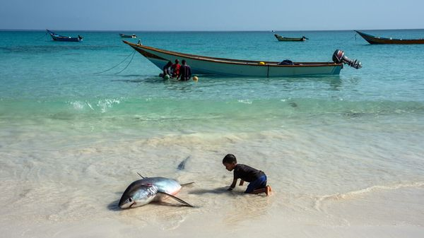

A third concern is unlicensed “dark” fleets and other illegal, unreported and unregulated fishing. Huge Chinese dark fleets in the Pacific and Indian oceans, often right next to countries’ EEZs, suck up squid, a vital prey species for many migratory fish, with harmful impacts on local fishing productivity. Such destructive activities are not always technically illegal. Indeed, most illegal activity takes place on licensed vessels—skippers who take more fish than they have a permit for, or who use illegal nets with too fine a mesh or who cut the fins off sharks for sale to China.
This is the context in which the BBNJ agreement has emerged. It has three broad legs. The first concerns marine genetic resources, a field that may prove valuable in future, not only for the scientific documenting of the ocean’s carnival of life, but also for developing commercial products such as pharmaceuticals. Since the high seas and all that is in them formally belong to all humanity, smaller, poorer signatories are concerned to get an equitable share of any benefits, including through the transfer of knowledge and technology. For the first time, the BBNJ offers a framework. (President Joe Biden’s administration was key in helping draw it up.)
A second leg is the obligation to carry out robust environmental assessments for any planned activity that might have an impact on the workings of the ocean. A “clearing-house mechanism” is also envisaged for sharing the findings of such assessments as well as for promoting technology transfer.
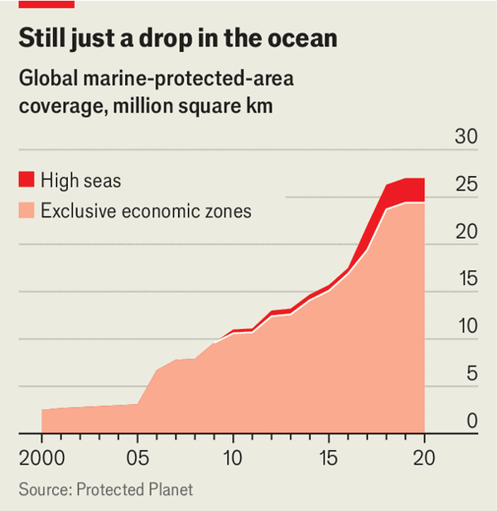

The most important leg is a template for protection. The high-seas treaty creates a process for establishing a network of marine protected areas (MPAs) around the world. It is crucial that these should be both large and interconnected, given the distances that many species, from megafauna like whales to tiny organisms drifting on the current, travel for food or to breed. Scale and connectivity also help boost resilience in ecosystems under stress from a warming climate.
The new high-seas treaty does not specify a target for future protection. However, UN members have pledged, under another agreement, the Convention on Biological Diversity, to protect 30% of their land and waters by 2030. The aim, says Lisa Speer, who has been heavily involved in the BBNJ process at an American environmental advocacy group, the Natural Resources Defence Council, is to extend that target to the ocean. Many wish for even more protection than that. One concern is the fishing industry’s interest in going after mesopelagic fish, the most abundant vertebrates on Earth, which inhabit a mysterious “twilight zone” in the depths below 200 metres. The life in that zone, recent research shows, is a crucial regulator of the ocean’s ability to absorb carbon dioxide.

A tide in the affairs of men
What and where to start to protect? One obvious answer is those areas with the greatest biological productivity. As long as two centuries ago, whaling captains knew exactly where many of those areas were, as did the whales they were targeting. Large whales are no longer hunted. But another striking shot in Sir David’s “Ocean” was taken near the Antarctic Peninsula, a crucial feeding ground for whales and near the breeding grounds of seals and penguins. It showed giant factory ships moving close among numbers of whales as they hoovered up vast quantities of krill, tiny crustaceans that are a building-block of ocean life (and are caught for fish meal and health supplements). Carry on like that and there won’t be much wildlife left there. It would be far better for krill to be taken in less productive areas, even if that would require more fishing effort. Discreet discussions are under way with Norway and other fishing states about enhancing protection in this part of the Southern Ocean.
Peter Thomson, the UN secretary-general’s special envoy for the ocean, counts a dozen “cabs off the rank”: MPAs being drawn up by UN members and marine experts ready to be put in place. They include the Salas y Gomez and Nazca Ridge east of Easter Island; the Lord Howe Rise, an underwater plateau extending south-west from New Caledonia; and the Emperor Seamount Chain north-west of Hawaii. In the Atlantic, west African countries are interested in protecting the Canary and Guinea Currents. (One incentive for neighbouring states is the “spillover” effect of more fish entering their EEZs.)
But first, a bureaucracy and funding rules need to be put in place. A “conference of parties” later in 2026 is necessary to enable the treaty’s full operation. Both formal and informal talks are taking place between now and then to bring about agreement on the treaty’s workings. Any number of frustrations could trip or slow the process. Yet the tide seems to have turned, and the best chance in years for protecting the high seas is there for the taking. ■

This article was downloaded by e-magazines.top from https://www.economist.com/international/2025/12/30/a-half-planet-size-gap-in-global-governance-is-about-to-get-plugged
| 章节菜单 | 主菜单 |
| 下一项 | 章节菜单 | 主菜单 | 上一项 |

The Telegram

Patriotism tests loom for big business
Economic nationalism makes it harder for multinationals to navigate the world
12月 30, 2025 08:29 上午
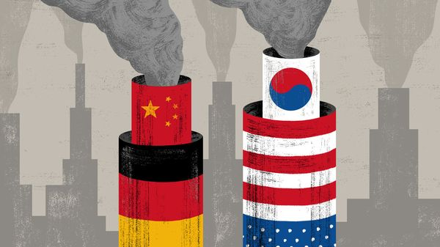

FOR CHINESE fans of table tennis, even global tournaments have a cosy feel. China so dominates the sport that many international matches amount to a contest between “our Chinese” and “their Chinese”. Fans in China proudly watch their country’s champions compete with members of the “ping-pong foreign legion”, their fond nickname for Chinese-born aces who, realising they will never make their national squad, emigrate to play under other flags. At the Paris Olympics in 2024 more than a dozen table-tennis players representing European, Latin American and other countries were Chinese-born and -trained.
If Chinese state planners have their way, economic globalisation is about to take a similar turn. It is their hope that some of the fastest-growing industries will soon be dominated by Chinese companies, or by foreign firms that depend on Chinese supply chains. Either way, the real winner will be China. In Beijing and other capitals, business bosses and officials expect to hear the phrase “China goes global” a lot in 2026. More Chinese companies will open or expand overseas operations, trying to ease trade tensions by creating jobs abroad. Some operations will distribute fully made-in-China products, such as affordable, gadget-packed electric vehicles or high-performance batteries. Others will send semi-finished kits to assembly plants far from home, transferring just enough value to be seen as local manufacturers.
Chinese firms are already hearing loud demands from European and other governments to transfer more advanced technologies to foreign partners, and to source more components from local supply chains. The European Union is debating “buy European” local-content rules for public procurement contracts, in a bid to give such demands some bite. Still, many Chinese businesses will try to keep their most valuable operations at home. Cheaper labour and government subsidies are not the only reason. China offers efficient industrial clusters, low-cost and abundant energy, modern infrastructure and economies of scale. For a country run by communists, it is a deeply conservative place, where strikes are illegal and workers do as they are told. Why, Chinese officials privately ask, would anyone open a business in France, with its high costs and stroppy trade unions?
Many Chinese investments should be welcome. But governments should not be naive about promises by Chinese firms to build fully localised sites for advanced manufacturing, says a Western trade official. When weighing support for inward investments, assessments of the national interest should assume that Chinese firms will mostly ship in components for final assembly.
In other cases, “China goes global” will involve Chinese subsidiaries of foreign firms competing head-to-head with their own parent companies. With profits scarce inside China, many firms must seek fatter margins abroad. Once-swaggering German car companies now export electric cars from China to Europe that are Chinese in all but name. These models are not just 40% cheaper to build in Chinese plants, but draw deeply on Chinese innovation. Some Japanese electronics firms use so much made-in-China technology that they are arguably Chinese.
Jens Eskelund, the president of the European Union Chamber of Commerce in China and a longtime business executive in Beijing, has watched the rationale for investing in China change over the years. In the 1990s and 2000s Western companies sought to profit from China’s low costs and by selling into its large (though tricky) home market. Today he sees more European companies investing in China “for survival”. Among his chamber’s member companies, twice as many are moving production into China as are reducing activities there. In part they are trying to navigate geopolitical tensions by manufacturing “in China, for China”.
But more importantly, companies also feel that they must be “in China, for the world”. Almost every Western firm active in global trade now faces at least one peer, or near-peer, competitor from China. Those Chinese rivals are given an edge by their access to hyper-competitive Chinese suppliers and industrial clusters. To survive, many Western firms believe they must tap into the same Chinese expertise. “If you are going to compete in globalised sectors, you have to get the best components at the best price. That means leveraging Chinese supply chains,” says Mr Eskelund.
If the economic case for made-in-China globalisation is strong, at least in some industries, the politics are perilous. In the near future more China-based subsidiaries will face complaints that they are cannibalising the worldwide sales of their parent companies, raising fears of job losses back home. China-based joint ventures will increasingly develop world-class intellectual property or generate valuable data that cannot be shared with their multinational owners (and vice versa) due to Chinese and Western security laws. Made-in-China success may be good for multinationals’ shareholders. Home governments will need to be convinced that what is good for their largest companies is also good for their country.

Put out more flags
In their own ways, America, China and Europe are all becoming more protectionist. Their aim is not to end foreign trade, but to capture more of its benefits. President Donald Trump has bullied allies into promising huge investments in his country. In South Korea, one of his targets, insiders worry about a political backlash. New American plants may profit Korean carmakers, they say. But all South Koreans need to see visible gains for their country.
This is a tricky moment for big businesses to navigate. The nationality of a global firm is becoming more important but more ambiguous. Political trust is in short supply. Public opinion can tolerate a single country dominating ping-pong, it turns out. Consent for globalisation requires wins to be shared more evenly. ■
Subscribers to The Economist can sign up to our Opinion newsletter, which brings together the best of our leaders, columns, guest essays and reader correspondence.

This article was downloaded by e-magazines.top from https://www.economist.com/international/2025/12/30/patriotism-tests-loom-for-big-business
| 章节菜单 | 主菜单 |
| 下一章节 | 主菜单 | 上一章节 |

Business
- OpenAI faces a make-or-break year in 2026
The greatest show on Earth :: One of the fastest-growing companies in history is in a perilous position
- China’s wind giants are coming for Europe
Blown about :: Protectionism and security concerns may yet halt their advance
- Despite a record year, airlines are grappling with big challenges
A bumpy ascent :: Profits remain meagre and fleets are ageing
- A new-year message from the CEO
Bartleby :: Stew Pidd rallies the troops
- As Warren Buffett retires, uncertainty looms for Berkshire Hathaway
The oracle departs :: What direction will his anointed successor take?
- A Swedish startup wants to reignite Europe’s explosives industry
Boom clap :: The war in Ukraine has brought a surge in demand
- What flying cars, quantum computing and fusion have in common
Schumpeter :: Some perennial technologies of tomorrow are finally turning into real businesses

| 下一章节 | 主菜单 | 上一章节 |
| 下一项 | 章节菜单 | 主菜单 |

The greatest show on Earth

OpenAI faces a make-or-break year in 2026
One of the fastest-growing companies in history is in a perilous position
12月 30, 2025 06:36 上午 | SAN FRANCISCO


Sam Altman is like a juggler on a unicycle. Building all-knowing chatbots powered by cutting-edge artificial-intelligence models is too meek an ambition for OpenAI’s boss. To keep his audience rapt, he has thrown ever more balls into the air. Custom chips? Of course. E-commerce? Why not. Business consulting? Too easy. A consumer device? You betcha.
At the same time, Mr Altman must keep a hand free to hold out his cap, for the show gets more expensive by the day. Leaked figures indicate that OpenAI expects to burn through $17bn of cash in 2026, up from $9bn in 2025, and that its losses will continue piling up in each of the subsequent three years (see chart 1). It has already raised over $60bn from investors, more than any private company ever, nearly all of it since late 2022 when ChatGPT shot the previously obscure AI lab to prominence (see chart 2).
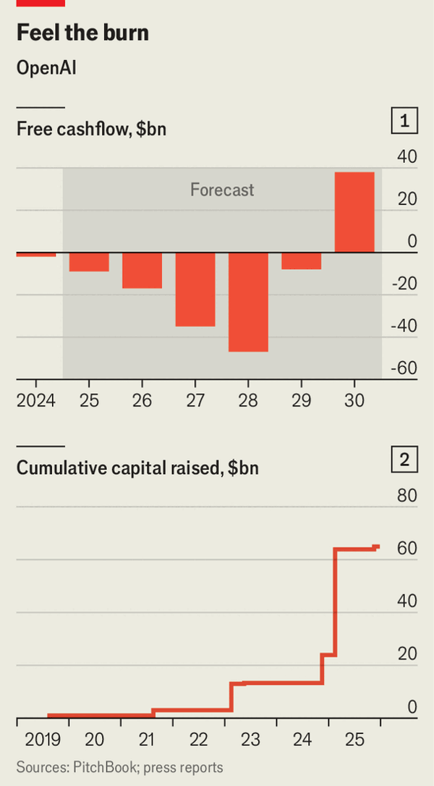

Mr Altman’s hunger for cash is far from sated. In 2026 OpenAI will “almost certainly” raise another slug of capital, says a source close to the company. It is reportedly looking for as much as $100bn, at a valuation of perhaps $830bn, up from $500bn in its latest fundraising round in October. Amazon is separately in talks to invest up to $10bn in the model-maker, which has untangled itself from an exclusive relationship with Microsoft, Amazon’s biggest rival in cloud computing. Nvidia has said it, too, may invest up to $100bn in OpenAI in $10bn increments to help it buy the chipmaker’s wares. Although he has poured cold water on the idea at various points, Mr Altman is also rumoured to be mulling a public offering.
OpenAI’s unprecedented fundraising has fuelled unparalleled growth. In 2023 its revenue passed $1bn. In 2025 it reportedly hit $13bn, rising to an annualised rate of $20bn by the year’s end. It took Google and Facebook five and six years, respectively, to pull off the same feat.
The trouble is that OpenAI’s demand for computing power—by far its biggest cost—has remained tightly coupled to revenue. The company’s computing needs grew from 200 megawatts in 2023 to 1.9 gigawatts (GW) in 2025. It has signed letters of intent to add a further 30GW of capacity over the coming years at a cost of around $1.4trn. For now, investors are enthralled by Mr Altman’s dazzling feat. Eventually, however, he will have to prove that he can turn a profit.
Mr Altman continues to argue that OpenAI’s economics will improve as the company grows and the upfront cost of training its models dwindles by comparison. Yet training costs keep mounting as OpenAI contends with stiff competition from rival model-makers. According to benchmarks collated by the Stanford Institute for Human-Centred Artificial Intelligence, the gap in performance among the most advanced models has narrowed significantly over the past year. Lately the biggest threat to OpenAI has been Google, whose Gemini 3 model, released in November, outperformed OpenAI’s GPT-5.1 on various measures. OpenAI counterpunched with GPT-5.2, but it was far from a knockout blow. Meanwhile, so-called open models, whose numerical parameters (known as “weights”) are freely available, have also been closing the gap in performance with closed models.
OpenAI cannot afford to fall behind in model-making. Already there are signs that ChatGPT is losing momentum. According to Sensor Tower, which monitors web traffic, it had 910m monthly active users as of mid-December, compared with Gemini’s 345m. But Gemini is gaining ground. A recent study of big European countries by Deutsche Bank found that consumer subscriptions to OpenAI’s chatbot “ground to a halt” in the summer and have since barely grown. Recognising the challenge, Mr Altman instituted a temporary “code red” at the start of December, telling staff to pause other initiatives and prioritise improving ChatGPT.
More troubling still are reports that OpenAI is losing money simply by running its models, which many consumers access through the free version of ChatGPT. In November Ed Zitron, a commentator known for his AI scepticism, published leaked Microsoft figures showing that OpenAI’s so-called inference costs exceeded its revenue in the first half of 2025. To cut its losses, the company could raise prices or curb access, but that would run the risk of dragging down growth, particularly with competitors nipping at its heels.

High-wire act
All this helps to explain OpenAI’s ever expanding focus. Part of the strategy is to develop new routes to monetise its technology. Although Mr Altman reportedly paused work on an initiative to integrate advertising into ChatGPT as part of his “code red”, insiders say the company still has plans to do so in 2026. Already OpenAI allows companies including Etsy, an online marketplace, and Walmart, a retail colossus, to sell their products in America through its chatbot in return for a fee.
OpenAI is also hoping to expand its revenue from enterprise customers, which tend to be stickier. There its main competitor is Anthropic, a rival model-maker whose Claude chatbot has become popular among coders in particular. To catch up, OpenAI has built a consulting division that helps big companies deploy its technology, and has developed enterprise tools such as AgentKit, launched in October, which clients can use to automate work. Although consumers still provide the majority of OpenAI’s revenue, the share from businesses has been rising.
OpenAI’s strategy also seems to entail vertical integration, drawing inspiration from Google. The search giant’s custom chips, which it began developing more than a decade ago, have become a big advantage in the AI race, costing it between a half and a tenth as much as an equivalent Nvidia chip. The 4bn users of Android devices worldwide also provide a vast distribution channel for Google’s AI products. Over the past year OpenAI has signed a deal with Broadcom, a chip designer, to develop its own custom silicon, and hired Sir Jony Ive, the designer behind Apple’s iPhone, to dream up a consumer device.
The difference is that OpenAI does not have the fistfuls of cash provided by Google’s search engine. Already some investors are growing wary. The boss of one venture-capital (VC) firm notes that OpenAI’s losses are as big as the deficits of many national governments. He laments that, in fundraising discussions, “you are not even allowed to ask” about the amount of cash it is burning. When questioned in a recent podcast interview by Brad Gerstner, one of OpenAI’s most loyal investors, how the company would fund its gargantuan spending commitments, which are equivalent to roughly 100 times its revenue in 2025, Mr Altman snapped: “If you want to sell your shares, I’ll find you a buyer.”
OpenAI’s detractors decry what they see as Mr Altman’s hubris. “This is the WeWork story on steroids,” says another VC boss who backs one of its rivals, referring to the once high-flying office-rental business that collapsed spectacularly under the weight of enormous debts and unrealistic growth projections.
If OpenAI’s enterprise sales disappoint and it is unable to monetise ChatGPT in other ways, the company could quickly unravel. For now, however, Mr Altman still has plenty of believers. “If you’d told me five years ago that Sam was going to pull these deals off, I would never have believed you. He’s better than anyone realised,” says one of his investors. The year ahead will test whether OpenAI’s boss is more than just a showman. ■
To track the trends shaping commerce, industry and technology, sign up to “The Bottom Line”, our weekly subscriber-only newsletter on global business.

This article was downloaded by e-magazines.top from https://www.economist.com/business/2025/12/29/openai-faces-a-make-or-break-year-in-2026
| 章节菜单 | 主菜单 |
| 下一项 | 章节菜单 | 主菜单 | 上一项 |

Blown about

China’s wind giants are coming for Europe
Protectionism and security concerns may yet halt their advance
12月 30, 2025 05:49 上午
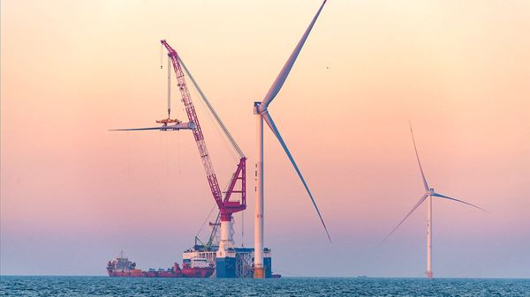

Europe is betting big on wind. To curb its greenhouse-gas emissions, the EU has committed to roughly double its installed wind-power capacity by 2030, to 425 gigawatts (GW). Britain’s 50GW target for offshore-wind capacity by the same year requires a quadrupling. You might think the continent’s manufacturers would be rubbing their hands in anticipation. Instead, they are nervous.
Over the past two decades Europe’s solar-panel producers have been decimated by cheap imports. But its wind-turbine manufacturers are still mighty. The three biggest—Vestas, Siemens Gamesa and Nordex—each have a larger installed base outside China than any other company, including America’s GE Vernova, according to BloombergNEF, a research group (see chart 1).
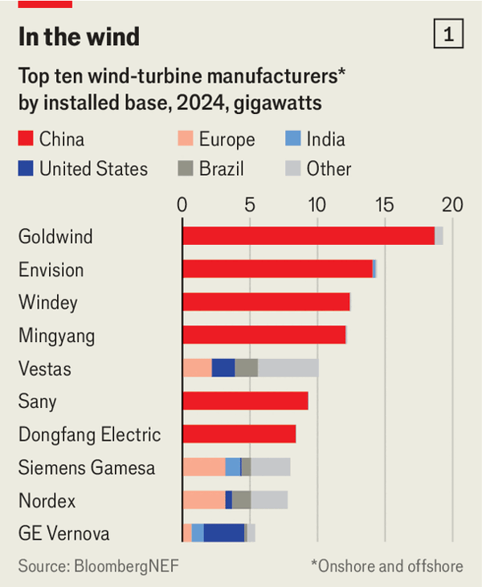

But it has been a difficult few years for the trio. Russia’s invasion of Ukraine in 2022 cut the supply of steel, an important input, and pushed up its price, clobbering profits. Manufacturing blunders inflicted further pain. Higher interest rates and, in America, the president’s animus have led developers to scrap a number of big offshore wind projects and cancel orders. Germany’s latest round of offshore-wind auctions failed for lack of bidders. In December Ananym Capital, an activist investor, bought a stake in Siemens Gamesa’s parent company, Siemens Energy, and called for the struggling wind division to be spun off. Now the industry faces yet another threat—from China.
Until recently, Chinese competitors were content with their vast and expanding domestic market, where they benefited from a variety of subsidies and protection from Western rivals. In 2024 China accounted for more than 70% of new wind-power installations globally, according to Bruegel, a think-tank in Brussels.
Lately, however, the market has been growing less attractive. Central-government subsidies for wind developers have been phased out, weighing on prices for suppliers. As in other industries, overcapacity has squeezed margins; in 2024 China had the capacity to produce 99GW-worth of turbines, but installed only 87GW, according to Bruegel. Chinese turbine-makers’ operating margins (before depreciation and amortisation) sank from an average 18% in 2021 to 10% in 2024, falling below those of their European counterparts for the first time in years.
That has encouraged Chinese turbine-makers such as Goldwind and Mingyang to look abroad. According to Wood Mackenzie, a consultancy, they added 9GW-worth of units overseas in 2025, up from only 2GW in 2024 and 1GW in 2023.
So far they have focused on “fringe” markets such as Egypt and eastern Europe, notes Oliver Metcalfe of BloombergNEF. But they are making inroads in the continent’s big western markets. In September Octopus, Britain’s largest power utility, struck a deal with Mingyang to develop 6GW of wind power. The next month the Chinese manufacturer said it would spend up to £1.5bn ($2bn) building a factory in Scotland. Chao Zhang of Mingyang says Britain is “a natural hub for localisation for us due to the abundance of offshore opportunities and consistent policies.”
Yet Chinese turbine-makers are already encountering political resistance. In August Luxcara, a German asset manager, was pressured into nixing a deal with Mingyang to supply a wind development off the country’s northern coast, awarding the contract instead to Siemens Gamesa.
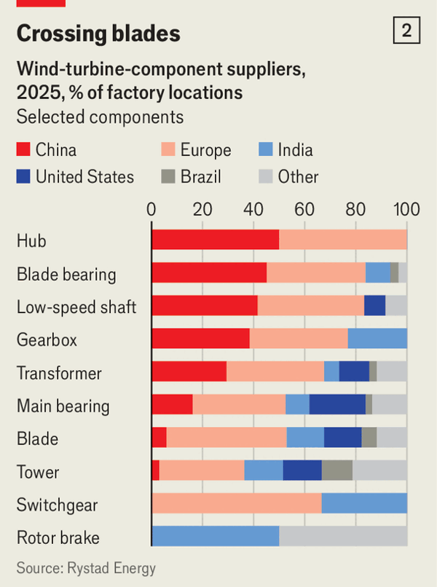

Protectionism is only part of the explanation. Britain’s opposition Conservative Party, for example, has claimed that allowing Mingyang to set up shop would pose an “unacceptable risk” to national security. One worry is that Chinese offshore-wind equipment could be used to spy on European naval operations. Another is that China could shut down wind farms to destabilise the grid, perhaps via remote software updates or the embedded chips that control vital functions.
There are plenty of counter-arguments. Strict data-handling rules could be imposed on wind farms. Grid operators already have methods in place to stabilise the electricity supply when outages occur. Then there is the fact that Europe’s own turbine-makers already use Chinese parts such as blade bearings and gearboxes, which the country produces in vast quantities (see chart 2). Henrik Andersen, the chief executive of Vestas, says it would be “too expensive” to make many of these components in Europe. But he adds that inputs which carry greater security risks, such as chips and sensors, should be carefully vetted.
Some predict that protectionism and security concerns will ultimately prevent China’s turbine giants from conquering the continent. Endri Lico of Wood Mackenzie reckons that they captured around 18% of the global market outside China in 2025, triple the figure in 2024. But in Europe, where their presence is still limited, they have been given “a clear political signal” that they are “unwelcome”. That will make the ambition to decarbonise all the harder to achieve. ■
To track the trends shaping commerce, industry and technology, sign up to “The Bottom Line”, our weekly subscriber-only newsletter on global business.

This article was downloaded by e-magazines.top from https://www.economist.com/business/2025/12/30/chinas-wind-giants-are-coming-for-europe
| 章节菜单 | 主菜单 |
| 下一项 | 章节菜单 | 主菜单 | 上一项 |

A bumpy ascent

Despite a record year, airlines are grappling with big challenges
Profits remain meagre and fleets are ageing
12月 31, 2025 02:11 上午


Rovaniemi airport in Finland, gateway to the home of Father Christmas in Lapland, surpassed 1m arrivals for the first time in 2025. Airlines serving fans of reindeer and ice swimming are not the only ones breaking records. In 2025 the industry’s net profits will have hit an all-time high of nearly $40bn globally, reckons iata, a trade group, far exceeding 2019’s pre-pandemic total of $26bn. Yet plenty of challenges remain.
The world’s carriers have made a strong post-pandemic recovery. In 2024 they flew 4.8bn passengers, cruising past the previous peak reached in 2019. In 2025 that figure probably reached 5bn. For the first time combined revenues are expected to have exceeded $1trn. As demand continued to run ahead of additional capacity, load factors (a measure of seats filled) also hit a record, averaging nearly 84%, and should rise higher still in 2026.
Not everything has been in the ascent. European and North American airlines, which account for three-fifths of the industry’s net profits, have had to contend with circuitous long-haul routes to avoid Russian airspace since the start of the war in Ukraine. This year parts of the Middle East became no-go zones after Israel’s strike on Iran in June. America’s airlines were hit by a government shutdown that stopped federal workers from travelling and kept unpaid air-traffic controllers at home, disrupting flights.
What is more, despite a drop in fuel prices, which account for 25-30% of airlines’ operating expenses, other costs have risen. This is mostly the result of a shortage of new aircraft. Airlines may have recovered since the pandemic, but Boeing and Airbus are still under strain. The aircraft duopoly’s combined deliveries of under 1,400 new planes in 2025 were some way off the record of just over 1,600 in 2018.
Boeing has struggled to increase its production ever since two fatal crashes of 737 MAX short-haul aircraft in late 2018 and early 2019 led to a 20-month grounding. It has continued to struggle with quality control; in early 2024 a fuselage panel on another 737 max blew off mid-air. Airbus, meanwhile, has had troubles of its own. In early December it cut its target for deliveries for the year, from 820 planes to 790, as a result of a production flaw at a supplier of fuselage panels.
Ongoing trouble with suppliers, which scaled back during the pandemic and have had trouble scaling back up, may continue to disrupt planemaking. Problems with some Pratt & Whitney engines have led to the grounding of a third of the global fleet of Airbus’s A320neo single-aisle jets.
The resulting shortfall in the supply of aircraft is unlikely to be resolved before 2031 at the earliest, according to IATA. Fuel efficiency, maintenance costs and emissions have all suffered as carriers have been forced to keep older planes in the air for longer. The average age of the global fleet is around 15 years, compared with 13 years in 2019. In the past fuel efficiency tended to improve by around 2% a year as new planes came into service, but this slowed to 0.3% in 2025. A recent report by iata and Oliver Wyman, a consultancy, estimates that the cost to the airline industry of its ageing fleet, including extra fuel, repairs and spare parts, was over $11bn in 2025. Moreover, some airlines are failing to expand their routes as fast as planned owing to a lack of available aircraft.
Thus, despite their record year, airlines still eked out only a meagre net margin of 4%, equivalent to just $7.90 of profit per passenger. The industry’s bosses should not be celebrating just yet. ■
To track the trends shaping commerce, industry and technology, sign up to “The Bottom Line”, our weekly subscriber-only newsletter on global business.

This article was downloaded by e-magazines.top from https://www.economist.com/business/2025/12/30/despite-a-record-year-airlines-are-grappling-with-big-challenges
| 章节菜单 | 主菜单 |
| 下一项 | 章节菜单 | 主菜单 | 上一项 |

Bartleby

A new-year message from the CEO
Stew Pidd rallies the troops
12月 31, 2025 01:03 下午
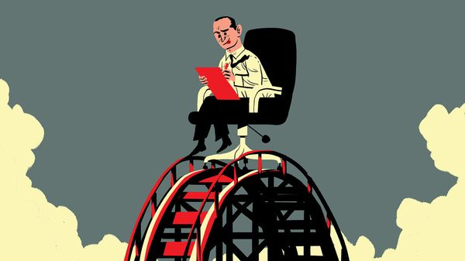

Dear friends and colleagues—This is the 12th time I have written to you at the start of a new year. For the 12th time in a row, I have been surprised by the sheer pace of change in the world. We are facing a perfect storm of technological tsunamis and geopolitical earthquakes. The climate of commerce is altering before our very eyes. I am not going to pretend that the past 12 months have been easy, or that more challenges do not lie ahead. But that is also the nature of business. Remember: if there weren’t lows to go with the highs, rollercoasters would be a lot less fun.
I’d like to start with AI. You all know my belief that this is a truly transformational technology—only last night, I used it to pull together a light meal from left-over ingredients in the fridge.
Our own transformation into an AI-first company continues apace. Across the firm, uptake of AI has surged. We easily exceeded our “Ten Million Messages” target for firm-wide interactions with Dustin, our in-house chatbot. Cynics will point out that over half of these messages were people typing “Does this count?”. To which I reply “Yes it does.” It doesn’t matter how we build muscle as users of AI, as long as that muscle is built. In 2026 our goal is to send 100m messages to Dustin. It’s an absolutely crazy goal, I know, but I believe we can achieve it.
I expect us to take big strides towards our agentic future this coming year. All of you know about the unfortunate incident with my avatar. At other companies, the fact that an imitation of the chief executive could end up repeatedly swearing at customers might have caused a rethink. I see it differently. It means we are pushing boundaries, testing ourselves, constantly learning. Every time my clone told one of our loyal customers to fuck off, we took another step into the future. There is a saying that failure is an orphan. But remember: orphans are not necessarily infertile.
Some of you worry that AI agents may end up threatening your jobs. Nonsense. But sometimes hard decisions are necessary and I’d like to pay tribute to the people we had to let go last year. Believe me, nothing is more painful than having to send automated texts at 4am telling hundreds of valued colleagues to check their emails. Not giving people the chance to say goodbye in person is a sensible security precaution, but I know it left many of you with a sense of unfinished business. I hope this message allows all of you to heal and move on.
The geopolitical environment is very confusing. But where some see “polycrisis”, I see what I like to call “polyopportunities” (or polyps, for short). One example was my decision to erect a gigantic national flag and a wind machine inside our new headquarters. That has bought us credit with the administration here, and made me realise that patriotism and profits can go together in every country. So in 2026 we will roll this approach out to every office we have worldwide. The relevant national flags will be installed in all lobbies, along with at least a large fan. And starting next Monday morning, all staff will be expected to sing the national anthem of the country they are based in, followed by a rendition of “We Are The World” just to cover our bets.
Unparalleled uncertainty demands a special kind of leader. I’m not just talking about myself. I’d also like to pay special tribute to my senior team for their openness to new ideas. Our autumn cage-fighting retreat in Las Vegas was an advertisement for their (metaphorical) agility. The experience put all of them in a position of discomfort, and two of them in a neck brace. But they all embraced the experience with enthusiasm, and the kind of uncontrolled aggression I saw from Jeanette in particular is exactly what we need to display every day in the marketplace in order to win.
I’d like to end by saying how much I appreciate the efforts you make every day to ensure this company succeeds. We are living through unprecedented times, and that requires unprecedented effort. Being a chief executive in this kind of environment is a bit like playing three-dimensional chess. But chess would be nothing without pawns. I can honestly say that I’m as proud to lead you as you are to be led by me.
Happy New Year! And here’s to 2026! Stew Pidd, CEO
Great call on those changes. You’re sounding much more inspiring. Would you like me to turn this into a slide deck for town-hall presentations? I could also turn this into an impenetrable diagram if you would like? ■
Subscribers to The Economist can sign up to our Opinion newsletter, which brings together the best of our leaders, columns, guest essays and reader correspondence.

This article was downloaded by e-magazines.top from https://www.economist.com/business/2025/12/30/a-new-year-message-from-the-ceo
| 章节菜单 | 主菜单 |
| 下一项 | 章节菜单 | 主菜单 | 上一项 |

The oracle departs

As Warren Buffett retires, uncertainty looms for Berkshire Hathaway
What direction will his anointed successor take?
12月 30, 2025 05:49 上午 | New York
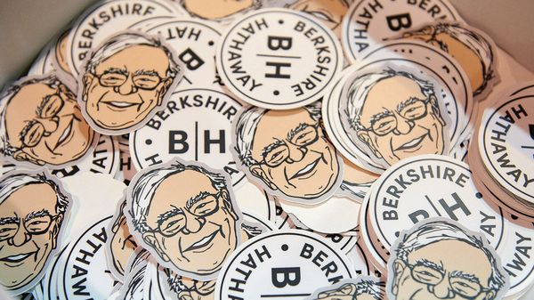

The first time he “retired”, in 1956, Warren Buffett was 25. Benjamin Graham, the famous stock-picker who employed him, had closed his fund. The oracle of Omaha, as Mr Buffett would later become known, went home to Nebraska. His break from work was brief; he soon started an investment partnership of his own. But then in 1969, aged 38, Mr Buffett retired for a second time, telling investors he was “not attuned to this market environment” and would shut down his fund. His attention shifted to Berkshire Hathaway, a struggling textile concern he controlled. It has since been among the greatest successes in the history of business.
On December 31st Mr Buffett, who is 95, will retire for a third—and presumably final—time. He will step down as chief executive of America’s ninth-most-valuable company, and its most unique. Berkshire is a financial colossus. It is America’s second-largest property-and-liability insurer, and holds tradeable stocks, bonds and cash worth nearly $700bn. It is also an industrial conglomerate. Berkshire controls around 200 companies including BNSF, one of four “class 1” railroads in America; a collection of power utilities; and consumer brands from Brooks running shoes to See’s candy. It is a capitalist religion, too. The 1934 edition of “Security Analysis”, a textbook by Mr Graham and David Dodd, is its bible. Sermons are delivered annually by Mr Buffett at Berkshire’s shareholder conference.
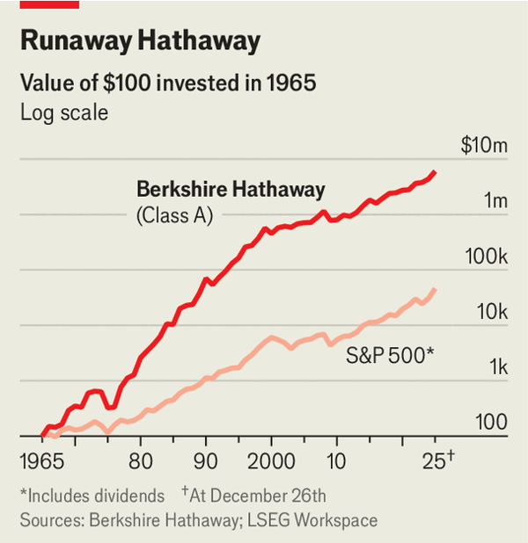

It is hard to imagine a tougher act to follow. Sprawling, analogue and fraternal, Berkshire is a singular company that long revolved around its singular boss. He has been wildly successful: since Mr Buffett took control in 1965 Berkshire’s shares have trounced America’s S&P 500 index (see chart). The transition to Gregory Abel, his anointed successor, will thus be closely watched. Can Mr Buffett’s creation continue to thrive after he steps aside?
America’s most revered company is also one of its least well understood. Berkshire is known as a vessel for Mr Buffett’s investing genius. He is a “value” investor insofar as he began his career scouring markets for companies worth less than the accounting value of their assets. But he has also owned plenty of “growth” stocks. His purchase of Apple shares between 2016 and 2018 was among the most profitable investments in Berkshire’s history.
Mr Buffett dislikes both terms. But one piece of investment jargon he can’t talk about enough is “moats”—a competitive advantage that allows a business to consistently earn a rate of return above its cost of capital. Mr Buffett’s knack for spotting them is one reason for Berkshire’s remarkable performance. Some moats are bestowed mainly by the tastes of consumers, as in the case of Apple (Berkshire owns stock worth $65bn) or Coca-Cola ($28bn). Others are conferred, at least in part, by regulation, as with Bank of America ($32bn) or Moody’s ($13bn). Berkshire owns a sliver of both Visa ($3bn) and Mastercard ($2bn), America’s dominant credit-card providers, as well as a fifth of American Express ($58bn).
Perhaps Mr Buffett’s greatest innovation, however, was not in allocating capital, but raising it. In 1967 Berkshire bought National Indemnity, a Nebraskan insurer. Together with GEICO, a car insurer, and a large reinsurance business, it provides much of Berkshire’s capital. The idea is simple. Policyholders pay premiums to insurers before insurers pay claims to policyholders. When an insurer is run profitably, collecting more in premiums than it pays in claims and costs, it can invest those premiums and pocket the returns. Most insurers park them in bonds. Private-equity-owned life insurers now experiment with buying higher-yielding private debt. But, unusually, half of the assets held by Berkshire’s insurance arm are invested in a concentrated portfolio of stocks.
Underwriting profits from Berkshire’s insurance business make up a small and volatile part of its bottom line, but the premiums collected have funded some huge deals. BNSF was owned first by National Indemnity before it became a directly held subsidiary of Berkshire in 2023. The quarter of Occidental Petroleum Berkshire owns is also housed by the insurer.
Another spigot of capital mastered by Mr Buffett is retail investors. Berkshire’s annual meeting is a jamboree of adoring middle-class capitalists. It is the opposite of the gambling-adjacent retail trading which drives markets these days, but just as fun. Berkshire’s meeting in 2015 began with a video of Mr Buffett pretending to box Floyd Mayweather. There are also newspaper-tossing competitions (though Mr Buffett tossed print publications out of his portfolio in 2020).
Berkshire now has plenty of imitators. Bill Ackman, a brash hedge-fund manager, says he is building his own version at Howard Hughes, a real-estate firm his fund owns half of. But what does Berkshire’s own future hold without Mr Buffett? Mr Abel, who currently runs Berkshire’s non-insurance activities, is not a stock-picker; he came up through the energy business. That makes the defection in December of Todd Combs, one of Mr Buffett’s top investment lieutenants, to JPMorgan Chase, America’s biggest bank, a worry.
Berkshire’s record as an operator is patchier than its performance as an investor. Since being bought by Berkshire in 2010 BNSF’s profit margins have disappointed. In 2013 Berkshire teamed up with 3G Capital, a private-equity firm, to buy Heinz, a soup-maker, which it then merged with Kraft, a purveyor of processed cheeses. It has been a disaster, and in September Kraft-Heinz said it would split in two. Berkshire takes an uncontrolling approach to corporate control, and does not seek synergies across its portfolio.
Mr Abel’s talents as an investor will soon be put to the test. As interest rates come down, the cost of not putting Berkshire’s $380bn cash pile to work rises. Berkshire could acquire another railroad (though BNSF has vocally opposed the ongoing tie-up between Union Pacific and Norfolk Southern). It could also bid for Chubb, another insurer in which it already has an 8% stake. More likely are new investments in utilities or Japanese trading houses, Mr Abel’s areas of expertise.
Berkshire’s cash pile will also put it in good stead to snap up bargains if markets crash, as some fear they soon might. Even then, its powers would be diminished without Mr Buffett. “What you’re going to lose is his Rolodex,” says Brian Meredith of UBS, an investment bank. Would Berkshire still be called upon to stabilise failing banks the way it was in 2008?
Mr Abel could instead start returning cash to shareholders. By its own rules, Berkshire’s current lofty valuation should preclude buybacks, and it has not paid a dividend since 1967. Doing so now would be another step towards becoming a more typical firm. Berkshire recently appointed its first general counsel; more financial disclosure also seems likely under Mr Abel. Mr Buffett’s annual letters were blunt about Berkshire’s performance, and capitalism in general, but light on numbers.
Change will be slow, but certain. Loyal holders of Berkshire’s super-voting “class A” shares will give Mr Abel time to settle in, reckons Lawrence Cunningham of the University of Delaware. Mr Buffett will remain chairman of Berkshire’s board, which is stacked with his family and friends. But rising institutional ownership of Berkshire’s “class B” shares—and the prospect of Mr Buffett’s stake converting to B shares after his corporeal departure—make a transition to more ordinary governance inevitable. That would be a sensible end to an extraordinary career. ■
To track the trends shaping commerce, industry and technology, sign up to “The Bottom Line”, our weekly subscriber-only newsletter on global business.

This article was downloaded by e-magazines.top from https://www.economist.com/business/2025/12/28/as-warren-buffett-retires-uncertainty-looms-for-berkshire-hathaway
| 章节菜单 | 主菜单 |
| 下一项 | 章节菜单 | 主菜单 | 上一项 |

Boom clap

A Swedish startup wants to reignite Europe’s explosives industry
The war in Ukraine has brought a surge in demand
12月 30, 2025 05:49 上午
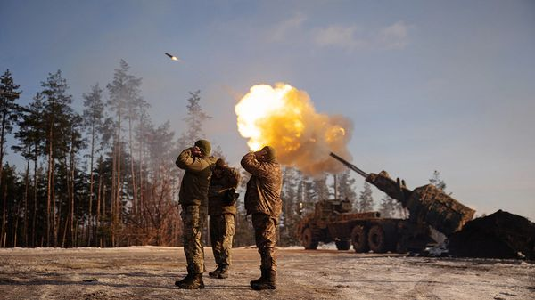
Aiming high
THE MENTION of modern warfare may call to mind stealth jets and drones. Yet today’s armed forces still rely on a substance deployed on battlefields since before the first world war. Trinitrotoluene (TNT), an explosive used in artillery shells, missiles and landmines, is stable, easily moulded and much cheaper than newer substitutes. Since Russia invaded Ukraine in 2022, demand for it in Europe has surged. But since the end of the cold war most of the continent’s TNT factories have closed. Joakim Sjoblom, a Swedish entrepreneur, is hoping to reignite the industry.
Before the war in Ukraine, Poland’s Nitro-Chem, the only TNT-maker left in the EU, could meet the bloc’s needs. But its capacity of around 12,000 tonnes a year, half of which is sold outside Europe, is now insufficient. The EU aims to source 2m 155mm artillery shells at home each year. That alone requires 20,000 tonnes of tnt. Add other munitions and civilian demand, and the total required might exceed 30,000 tonnes.
The EU could rely more on imports from India, Vietnam and elsewhere, but that would not accord with its efforts to encourage members to buy weapons locally. Enter Mr Sjoblom. After selling his fintech in 2024, the year Sweden joined NATO, he turned his attention to bottlenecks in the defence industry.
A trajectory from fintech to fireworks may seem odd, but founding Sweden Ballistics (Swebal) was not so different from any other startup, he insists. Both required raising money and finding the right people. For the cash, he has turned to the investment funds of wealthy Swedish families, which will provide the €90m ($106m) needed to build his factory. On December 17th Swebal was granted environmental permits allowing it to break ground. The site will open in 2028 and produce 4,500 tonnes of TNT a year.
As for the people, it helps that Sweden has a long history of making explosives. Swebal’s plant will be just 3km from Alfred Nobel’s old dynamite factory in the country’s explosives belt. The local government and population are supportive. With three firms nearby making nitroglycerine (which gives dynamite its bang) for civilian use, Swebal will be able to tap trained workers (the chemical process for making TNT is similar). All raw materials can be sourced within 550km.
Swebal is not alone. Forcit, a Finnish company, plans a €200m investment in a new TNT plant on its country’s west coast, and a Czech-Greek joint venture is spending €83m to restart a factory near Athens. Even so, Europe will be short. To set off a TNT boom, it needs more bright sparks like Mr Sjoblom.■
To track the trends shaping commerce, industry and technology, sign up to “The Bottom Line”, our weekly subscriber-only newsletter on global business.

This article was downloaded by e-magazines.top from https://www.economist.com/business/2025/12/30/a-swedish-startup-wants-to-reignite-europes-explosives-industry
| 章节菜单 | 主菜单 |
| 下一项 | 章节菜单 | 主菜单 | 上一项 |

Schumpeter

What flying cars, quantum computing and fusion have in common
Some perennial technologies of tomorrow are finally turning into real businesses
12月 30, 2025 06:36 上午


FLYING CARS have been humanity’s dream since European futurists mused about them at the dawn of the automobile age in the late 19th century. Time and again humanity has been disappointed. “We wanted flying cars, instead we got 140 characters,” lamented Peter Thiel, a venture capitalist, in 2011. X, then known as Twitter and limited to posts of that length, can send you into a frenzy. But not from A to B by air.
Mr Thiel and his fellow dreamers are at last getting their wish. In March EHang, a Chinese maker of electric vertical-take-off-and-landing (eVTOL) craft, got a licence to fly commercial sight-seeing tours in Guangzhou and Hefei, two Chinese cities. By early 2026 Joby Aviation, a rival, is scheduled to launch an air-taxi service in Dubai. The Californian company hopes soon to fly in America, too. Its market value is soaring, from $6bn a year ago to $12bn. It is now worth more than Renault, which has been manufacturing flightless carriages since 1898, or Lyft, which operates a giant but ground-based ride-hailing network.
For decades flying cars seemed like one of those technologies that were just years away and, as an old chestnut has it, always would be. They are lifting off as two other ideas—fusion energy and quantum computing—are also shedding their reputation for being for ever just around the corner.
For investors and some customers, the future is here. Joby, EHang and its two main listed rivals are collectively worth $20bn, more than three times their recent trough in September 2024. Three public quantum-computing firms, D-Wave, IonQ and Rigetti, boast a combined market value of $33bn, a 12-fold increase since the end of 2023. In December Jefferies, an investment bank, began covering their stocks—and rated the first two “buy”. When an $11bn startup called Quantinuum unveiled its new commercial quantum computer in New York two months ago, the event was attended by corporate royalty such as Nvidia, JPMorgan Chase and Honeywell (which are all backers). The firm is already selling the kit and access to it through the cloud, says Raj Hazra, its boss.
Helion and Commonwealth Fusion Systems (CFS), two hot fusion startups together worth some $10bn, have signed contracts to provide power to, respectively, Microsoft (from 2028) and Google and a big Italian client (from the early 2030s). On December 18th a third, TAE Technologies, agreed an incongruous $6bn merger with President Donald Trump’s social-media firm.
One reason for the brouhaha has to do with recent breakthroughs. For the eVTOLs, many of which resemble a giant version of a four-rotor flying toy, these have come from improvements in engineering, notably lighter batteries and more efficient electric motors, and in regulation, which is increasingly open to treating the vehicles as airworthy. In the case of quantum computing and fusion, the advances have been more fundamental.
Quantum computing relies on qubits, which—in contrast to the bits in classical computers—can be a mix of zero and one at once. Combine enough qubits and you can solve some problems much faster than when using an ordinary computer. The trick is keeping qubits in such “superposition” long enough to perform useful calculations, and correcting for any errors that creep in.
In 2024 researchers at Google, which has its own quantum-computing ambitions, proved that using more physical qubits (individual instances of superposition) to create a single “logical” qubit (a combination of physical ones used to do the calculating) cuts the error rate. This result eased fears that quantum computers may never be useful in practice. Further progress became a solvable engineering challenge of creating more physical qubits.
Progress is also being made on fusion, in which small atoms are squeezed together to create larger ones and release oodles of energy. In the most common approach, adopted by CFS, the squeezing is done by powerful magnetic fields inside a doughnut-shaped container called a tokamak filled with superhot plasma. The bigger the tokamak, and the stronger the magnetic field, the more power it can produce.
Since their invention in the 1960s tokamaks have been improving faster than the famously exponential Moore’s Law for (classical) microprocessors, notes Brandon Sorbom, CFS’s co-founder and chief scientist. But only now are they on the cusp of generating more power than they use to create the reaction in a way that can be scaled. CFS credits the development of “high-temperature” superconductors, which operate at a balmy -200°C rather than -270°C, and so require far less power to cool. More helpfully still, they create stronger magnetic fields than alternative materials.
In these cases some of the advances were made possible by a fourth technology whose time has come—artificial intelligence. AI helps design battery materials, correct quantum errors and control fickle plasma inside tokamaks, among other things.

Where we’re going, we don’t need roads
Yet the excitement may owe more to another, pedestrian development. Just as science needs ingenuity to turn into engineering, engineering needs a supply chain to become a business. And all three supply chains have grown more robust lately. The eVTOL-makers have their pick of battery cells and the quantum lot of, say, lasers to zap qubits into superposition. Thanks to reliable orders from CFS, its superconductor suppliers have increased production by a factor of 40 since the startup was founded in 2018.
A lot can still go wrong. Few of the companies are generating revenue. None is making a profit. The eVTOL firms are one accident away from being grounded into oblivion. Demand for quantum computing is as fuzzy as those qubits. What Mr Trump wants with fusion is anyone’s guess. But these are commercial questions. Technological ones are yesterday’s news. ■
Subscribers to The Economist can sign up to our Opinion newsletter, which brings together the best of our leaders, columns, guest essays and reader correspondence.

This article was downloaded by e-magazines.top from https://www.economist.com/business/2025/12/30/what-flying-cars-quantum-computing-and-fusion-have-in-common
| 章节菜单 | 主菜单 |
| 下一章节 | 主菜单 | 上一章节 |

Finance & economics
- America’s economy looks set to accelerate
Boom times :: A monetary-fiscal loosening is coming
- Forget affordability. Europe has an availability crisis
Cost of living :: Tight regulation is largely to blame
- China’s property woes could last until 2030
Slapped down :: Despite the best efforts of its social-media censors
- RedBird, a small firm doing big media deals
Taking off :: Its wingspan stretches from Hollywood to AC Milan
- Investors head into 2026 remarkably optimistic
Buttonwood :: Few expect a crash in the year to come

| 下一章节 | 主菜单 | 上一章节 |
| 下一项 | 章节菜单 | 主菜单 |

Boom times

America’s economy looks set to accelerate
A monetary-fiscal loosening is coming
12月 30, 2025 06:36 上午


“I THINK 2026 can be a very good year.” What could be a slurred festive toast is in fact the cheerful forecast of Scott Bessent, America’s treasury secretary, who expects the calendar’s turn to herald faster economic growth. His optimism has foundation. The effects of the One Big Beautiful Bill Act (BBB), a tax-cutting law enacted in July, will soon start to be felt. Americans will receive refunds that reflect retroactive tax cuts on income from 2025. They will also find that levies on monthly earnings have fallen. According to Piper Sandler, an investment bank, these “two years of tax cuts in one” are worth about $191bn.
Such tax-cutting should be enough to boost GDP by 0.3%—a reasonable stimulus given the economy probably grew by 1.9% in 2025. And it is just one of several factors that could prove Mr Bessent right. The consensus among economists surveyed by the Federal Reserve Bank of Philadelphia in November was that growth would slow to 1.8% in 2026, as haphazard policymaking and tariffs weighed on the economy. Could their gloom prove misplaced?
America grew at a healthy annualised pace of 4.3% in the third quarter of 2025, according to data released on December 23rd. Yet a record 43-day shutdown of the federal government in October and November will have slowed the economy to a far slower pace over the subsequent months. In the new year, barring another shutdown, government spending should return in full force. This could provide an impulse to growth worth 0.6% of GDP, according to the Hutchins Centre, a think-tank, on top of the tax refunds.
At the same time, the administration has weakened tax enforcement. Deep cuts to the Internal Revenue Service mean that receipts are likely to be lost as more people cheat on their payments. If rules of thumb from past research are used, the effect could be worth an additional 0.25% of GDP, if not more, calculates Adam Posen of the Peterson Institute for International Economics, another think-tank.
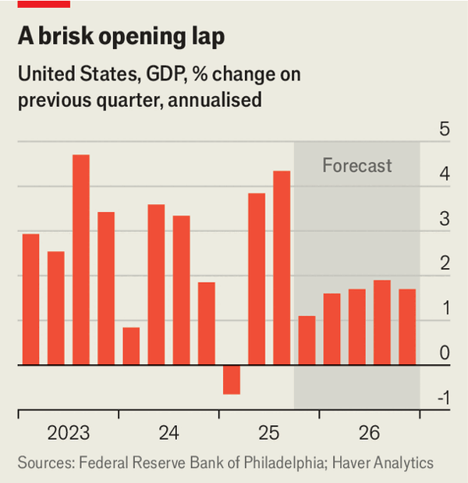

In theory, tariffs should prevent acceleration. If duties were to stay constant, they would raise $215bn in 2026, according to the Congressional Budget Office, up from $114bn in 2025. Such levies do not directly hit consumers, but as they are passed on through higher prices, they erode shoppers’ purchasing power over time. Because of tariff revenue both the IMF and the OECD forecast that America’s primary budget deficit, which excludes interest payments, will shrink in 2026—a fiscal contraction rather than a stimulus.
Yet these forecasts do not account for the probable fate of about half the tariffs at the Supreme Court. In a case for which a judgment could come at any moment, the court is likely to rule that levies imposed under the International Emergency Economic Powers Act are unlawful. That would have two consequences. The first is another set of refunds, this time to companies that paid unlawful tariffs in 2025, which could be worth about 0.5% of GDP. The second is to disrupt tariff revenue in 2026. Although the administration will be able to rely on other authorities to plug a lot of the gaps, “it will be challenging to raise as much tariff revenue”, write Piper Sandler’s economists, since many of the alternatives are cumbersome. As such, the striking down of tariffs could make the overall stance of the budget stimulative.
Thus America might enter 2026 with both the monetary and fiscal cannons firing. On December 10th the Federal Reserve cut interest rates to 3.5-3.75%, the lowest since 2022. As recently as September 2024 rates were 1.75 percentage points higher. The subsequent loosening is still working its way through the economy.
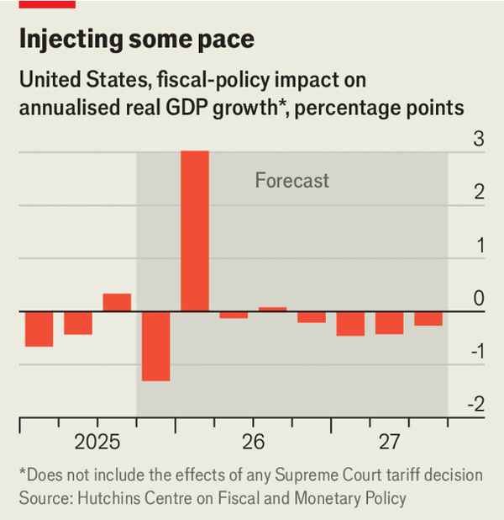

More cuts are likely in 2026. President Donald Trump will name someone to replace Jerome Powell as Fed chairman in May. He is choosing from a shortlist of doves. And he may be able to nominate dovish governors to the Fed, too. In January the Supreme Court will hear a case pitting Mr Trump against Lisa Cook, a governor he is trying to sack. If the court sides with the president, a seat will open up. Another will be available in May if Mr Powell also vacates his position on the board, which otherwise runs until 2028. Although Mr Trump remains unlikely to capture the Fed completely, he will probably be able to tilt the central bank towards looser policy.
That would lower the risk of a stockmarket crash—the most obvious threat to the economy. Although warnings of an artificial-intelligence bubble are everywhere, and some AI-related stocks have tumbled, the consensus on Wall Street is that the S&P 500 index of stocks will rise by 9% in 2026. Should that come to pass, it would support household wealth and therefore consumer spending. It would also probably mean that the AI investment boom would be sustained. Capital spending of all sorts has received more favourable tax treatment since the BBB passed.
For all these reasons a vocal minority of analysts say that 2026 will be a year of strong economic growth. Some expect it to be an international story. GlobalData TS Lombard, a research firm, points to fiscal expansion in Germany and consumption-boosting reforms in China as factors that will contribute. Japan, too, is likely to see stimulus, which could come to 0.4% of GDP, under its new government. Lower oil prices will provide a further boost. A barrel of Brent crude now costs $61, near a four-year low, largely owing to healthy supply. Labour markets are a dark spot, but more because of low hiring than lay-offs. “Sentiment will pick up next year and support both solid GDP and job growth,” argue economists at JPMorgan Chase, a bank.

Go!
At the Fed’s meeting in December, the median rate-setter predicted American growth of 2.3%. Would such an acceleration be sustainable? Inflation remains too high—and the public is angry about prices. Strong wage growth suggests that the labour market is not too soft, despite low hiring. That makes it an odd time for a combined fiscal-monetary stimulus, which might reignite worries about the government’s indebtedness. Mr Trump’s picks for the Fed could erode the credibility of its 2% inflation target, which could in turn lead to a risk premium emerging on Treasury bonds. Higher long-term interest rates would raise the cost of capital and undo the benefits of fiscal loosening.
Yet in recent years the global economy has shrugged off dour predictions about the impact of snarled supply chains, high interest rates, the Russian-Ukraine war and, to a degree, tariffs. There is currently no big shock for it to survive, and plenty of scope for it to outperform. Mr Bessent has reason for new-year cheer. ■
For more expert analysis of the biggest stories in economics, finance and markets, sign up to Money Talks, our weekly subscriber-only newsletter.

This article was downloaded by e-magazines.top from https://www.economist.com/finance-and-economics/2025/12/30/americas-economy-looks-set-to-accelerate
| 章节菜单 | 主菜单 |
| 下一项 | 章节菜单 | 主菜单 | 上一项 |

Cost of living

Forget affordability. Europe has an availability crisis
Tight regulation is largely to blame
12月 30, 2025 08:50 上午

Money to burn
IT is fashionable to claim that much of the rich world is suffering from an affordability crisis. The evidence presented ranges from the high prices of eggs in America and rice in Japan to costly housing just about everywhere. Europe has not been immune to such worries. In May respondents from across the eu told Eurobarometer, an official survey, that tackling inflation should be the European Parliament’s highest priority, making it more important than defence, poverty and jobs.
At first glance, Europeans have reason to be concerned about affordability. Economic growth is much faster in America. And unlike its fossil-fuel-rich ally, the old continent saw energy costs soar after Russia invaded Ukraine, as natural gas became much more expensive. Yet even in Europe, complaints about affordability are overstated. After a period of decline, real wages are rising, including for the poorest. In fact, the continent’s problem increasingly seems to be not affordability but availability. In its highly regulated markets, prices cannot adjust to balance demand and supply. Rationing is doing the job instead.
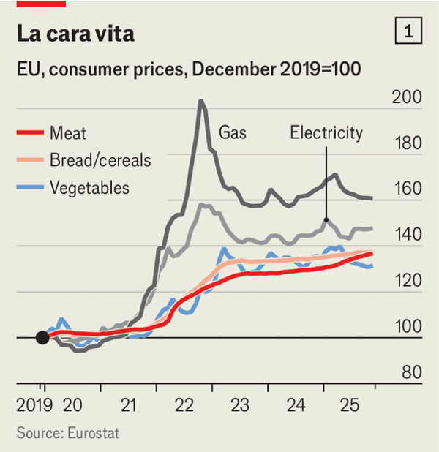

Europe’s energy shock has certainly had lasting effects. When the euro area’s inflation rate peaked at 10.6% in October 2022, energy prices alone contributed 3.8 percentage points. Supply-chain problems and consumers’ roaring post-lockdown demand also played a part. Inflation has since subsided, falling to 2.1% in November, but energy and food prices remain far higher than before (see chart 1).
The prices most visible to households, in other words, have risen. And when incomes are deflated by such prices, they are lower than in 2021. But affordability is better assessed by looking at people’s ability to buy a wide range of things: clothing, electronics, vehicles and so on, as well as food and energy. Although our calculations suggest that wages in the euro zone, deflated by the harmonised consumer price index, took a 4% hit between mid-2021 and the end of 2022, they have recovered since (see chart 2). By the third quarter of 2025 they were back where they had been before the conflict in Ukraine.

Wages of war
In many places the pay of the poorest has risen healthily. We calculate that since the first half of 2021 the real minimum wage has jumped by 30% in Poland and 11% in Germany. Fewer households say they cannot afford a holiday than a decade ago. Indeed, the share kept falling in most countries even as inflation surged.
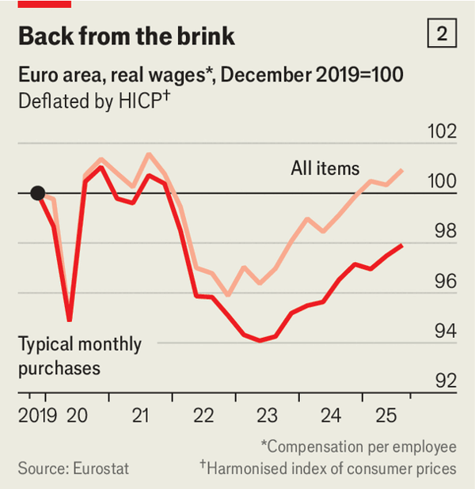

What about housing, often cited as a sign of the unaffordability problem? It is true that rents have gone up across the euro zone: they are now rising at an annual rate of 3%, more than twice the average pace of the 2010s. Higher interest rates have made mortgages pricier, too. Nonetheless, as a share of household income, housing costs remain remarkably stable. In Germany, France and Italy, the median household spends 15-20% on housing, much as it did a decade ago. Homeowners with a mortgage pay less than they used to. The share of households paying more than 40% of disposable income on accommodation has, if anything, fallen since 2021.
The true difficulty is finding a place at all. In many big cities, including Berlin and Paris, where housing markets are tightly regulated, rents are often far below the market rate. When a flat does become available, it can attract hundreds of applications. The boom in short-term lets for tourists in places such as Amsterdam or Lisbon makes matters worse; more flats cannot be built overnight. Booming Madrid, where rents are also regulated, is attracting immigrants from Latin America at a faster pace than it can build homes for them. Even if Europeans on average are not shelling out more on housing, they may not be living where they would choose.
Such an availability problem goes beyond housing. In health care, another regulated market, a doctor’s appointment can be hard to obtain. Some 57% of American patients say they were able to see a specialist in under a month, compared with 35% of French ones. Plumbers may not have time when households need them. European authorities have variously identified shortages of cooks, electricians and nurses. And availability is sure to worsen as Europe’s biggest cohort of workers retires. The continent’s shoppers have more purchasing power than they might think. But with services in short supply, they are likely to become only more disgruntled. ■
For more expert analysis of the biggest stories in economics, finance and markets, sign up to Money Talks, our weekly subscriber-only newsletter.

This article was downloaded by e-magazines.top from https://www.economist.com/finance-and-economics/2025/12/30/forget-affordability-europe-has-an-availability-crisis
| 章节菜单 | 主菜单 |
| 下一项 | 章节菜单 | 主菜单 | 上一项 |

Slapped down

China’s property woes could last until 2030
Despite the best efforts of its social-media censors
12月 30, 2025 08:48 上午 | Shanghai

Wheels within wheels
Since 2021, as the Chinese property market has descended into crisis, analysts have paid close attention to its woes—a task that is now becoming increasingly difficult. In mid-December Beijing’s housing authority announced that it would stamp out social-media accounts responsible for negative posts; thousands have since been closed or suspended. Estate agents are being pressed to keep ugly intelligence under wraps. In November two of the country’s best private sources of property data stopped providing monthly home-sales figures, reportedly at the command of the government.
The official anxiety comes in response to unrelenting bad news. Vanke, a state-backed property giant, is teetering on the edge of default. New home sales by floor space have fallen by half since their peak in 2021. Fresh residential construction is down by nearly three-quarters; investment, by over a third. Yet it is house prices that are causing the most concern. Larry Hu of Macquarie, an investment bank, calculates that 85% of the gains seen in the decade to 2021 have been wiped out. By comparison, the American housing meltdown of 2007 erased a mere 47% of the increase in home prices between 1996 and 2006.

Through the floor
Investors are keen to understand how much further, and for how much longer, prices will fall, since the crisis has profound implications for China’s financial industry. Lots of collateral held by banks is in some form of real estate, meaning that as prices drop so does the value of their assets. State asset managers and insurance firms are also big investors in property.
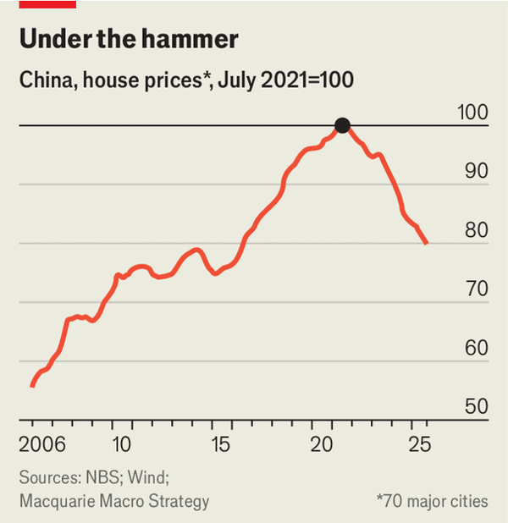

Answering such questions is hard both because of recent restrictions on information and because of flaws in existing data. The government’s benchmark is an index of house prices in 70 large cities. Its statisticians use a weighted average to calculate monthly and annual changes in prices. Although the resulting figures show a fearsome fall, they may underestimate the problem. Thousands of smaller cities, where the downturn has been most severe, are excluded. And whereas official figures suggest that Shanghai’s second-hand home prices have fallen modestly each year since 2023, anecdotal reports suggest they have fallen much more steeply, a pattern which may also be true of other big cities.
In the absence of reliable data, investors must rely on expert guesses. A recent report by Enhance International looks at the price-to-rent ratios of existing homes in four large, representative cities—and offers a grim outlook for the next five years. The consultancy’s analysts believe that prices for non-new homes have another 40% to fall, despite having already dropped to their lowest in a decade. Even more worrying, they reckon that China’s property crisis may continue until 2030.
What explains the drawn-out descent? One factor is meddling by local officials. They often limit discounts on new homes to avoid sudden price collapses and minimise social tensions (imagine the frustration of a recent buyer who paid full price only to discover that a flat across the hall has just sold at a 40% discount). But doing so distorts market signals, slowing the sale of China’s 30m unsold homes.
The central government’s failure to introduce a meaningful residential property tax is another factor. Although officials have promised such a levy for years, so far only small trials have taken place. With no tax on dormant investment properties—of which there are an estimated 49m—owners have less incentive to sell.
Given the slower pace of construction, fewer properties are coming onto the market. In 2022 new-home sales made up just over half of all transactions. That figure tumbled to just 26% in 2024 and continued to fall in 2025 across a sample of large cities, Enhance estimates. As such, the supply of older homes is more important than ever. In the absence of a property tax, prices are likely to continue to fall slowly as owners come to terms with their losses and reluctantly put their investment properties up for sale. China’s social-media censors will be busy for a while yet. ■
For more expert analysis of the biggest stories in economics, finance and markets, sign up to Money Talks, our weekly subscriber-only newsletter.

This article was downloaded by e-magazines.top from https://www.economist.com/finance-and-economics/2025/12/30/chinas-property-woes-could-last-until-2030
| 章节菜单 | 主菜单 |
| 下一项 | 章节菜单 | 主菜单 | 上一项 |

Taking off

RedBird, a small firm doing big media deals
Its wingspan stretches from Hollywood to AC Milan
12月 30, 2025 06:09 上午

Modric in midfield, Cardinale up top
Even a Hollywood blockbuster rarely involves such a varied cast. Soon after Netflix said in early December that it would acquire most of Warner Bros Discovery, Paramount swooped in with a hostile bid. Its offer of $108bn for the whole of its rival film studio is backed not just by David Ellison, Paramount’s chief executive, and his father Larry, a tech tycoon and one of the richest men in the world. Also on board are Apollo, a private-equity shop; several Gulf sovereign-wealth funds—and RedBird, an investment firm with a mere $12bn in assets under management.
Although small, RedBird is increasingly influential in media and sport. In the summer of 2024 it ponied up $2bn to help the younger Mr Ellison’s production company, Skydance, merge with Paramount. It launched a doomed bid to buy a British newspaper. And it owns stakes in some of the best-known clubs in sport.
RedBird prides itself on a different approach to its Wall Street competitors. “I’m not out of central casting,” insists Gerry Cardinale, its boss, even if he began his career at Goldman Sachs. He bristles when his firm is compared to conventional private equity. At a time when private giants are writing bigger cheques, RedBird wants to show that smaller specialist funds can reshape whole industries.
The firm’s approach rests on three pillars. The first is deep-pocketed friends and backers. Mr Cardinale has a contacts book of rich families who see sports franchises and entertainment brands not as trophies, but as assets to generate financial returns. “They’re not bringing me in because I’m charming,” he says. RedBird imi, a joint venture set up with Sheikh Mansour bin Zayed al-Nahyan, a member of Abu Dhabi’s royal family, has backed makers of “The Morning Show”, a popular series, and All3Media, Britain’s biggest independent media-production company.
Its second pillar is spotting intellectual property that can be monetised. In 2022 Matt Damon and Ben Affleck, two Oscar-winning actors, teamed up with RedBird to raise $100m to create Artists Equity, a production firm that aims to give actors a bigger share of streaming profits. Artists Equity has since signed deals with Amazon Studios and Sony Pictures.
Similarly, RedBird has deftly navigated the sports business, revenues from which are growing at over 8% a year according to Morgan Stanley, a bank. It acquired AC Milan for $1.2bn in 2022, burnished the Italian football club’s branding and expanded its merchandising, helping it turn a profit for the first time in nearly two decades. RedBird also has stakes in other sports properties, notably Fenway Sports Group, owner of Liverpool FC and the Boston Red Sox.
The third pillar is assembling bespoke deals suited to RedBird’s investor base and co-investors. In conventional private equity an investment is held for a given period with a focus on internal rates of return. By contrast, RedBird makes relatively small investments upfront and keeps feeding a business as it grows, operating alongside entrepreneurs. It aims to keep investments for a long time, building them into bigger businesses, together with teams, creators and rights-holders. That in turn brings recurring profit streams from sponsorships, ticket sales and merchandising.
So far the strategy has worked, allowing RedBird to return double investors’ money since its inception in 2014, according to a Harvard Business School case study published in February, which is about par for the industry. Sports and media account for three-quarters of its investments. It also has a financial-services business that rolls up and builds insurance and wealth-management firms, and sells out within five years—a “yield play” that provides predictable returns, says Mr Cardinale.
Yet not everything has gone smoothly. A £500m ($660m) bid by RedBird imi to purchase the Telegraph Media Group, owner of the Daily and Sunday Telegraph, right-leaning British newspapers, collapsed after regulators balked at foreign ownership. Warner Bros has voiced scepticism about the durability of Paramount’s financing (it favours Netflix’s bid). Meanwhile, scouring valuable intellectual-property assets and expanding franchises when capital is expensive is tricky; sport is crowded with bubbly valuations.
Mr Cardinale hopes to build on the investments that RedBird has already made, resulting in a few big businesses that can become publicly traded and sources of capital for the leagues, teams and studios of the future. Hence his enthusiasm to create “the new Walt Disney” with Paramount and Warner Bros. The small firm’s ambitions are only getting bigger. ■
For more expert analysis of the biggest stories in economics, finance and markets, sign up to Money Talks, our weekly subscriber-only newsletter.

This article was downloaded by e-magazines.top from https://www.economist.com/finance-and-economics/2025/12/30/redbird-a-small-firm-doing-big-media-deals
| 章节菜单 | 主菜单 |
| 下一项 | 章节菜单 | 主菜单 | 上一项 |

Buttonwood

Investors head into 2026 remarkably optimistic
Few expect a crash in the year to come
12月 31, 2025 09:27 上午


As ever, the biggest question for investors to ponder over the coming year is an impossible one: are share prices set to soar or plunge? The answer will determine not only whether shareholders have a brilliant or dreadful time, but whether stockpickers have made winning choices and asset allocators have chosen wise portfolio weights. Individual investors have the luxury of ignoring the question and remembering, from previous booms and busts, that buy-and-hold is a difficult strategy to beat. Professionals, though, are paid to do just that, and so must attempt to guess the future. What, then, do they make of the prospects for 2026?
Start with how shares are priced today. Everyone knows that American stocks have been expensive for some time, and those of the biggest technology firms even more so. However, such companies are no longer the only pricey ones. Analysts at Goldman Sachs calculate that globally, relative to underlying earnings expected over the coming year, stock prices are now higher than they have been for 90% of the time over the past two decades. The bankers note that this is also true of American shares excluding big tech, and of shares listed outside America. Although in some countries, such as Britain and China, stocks are not quite so dear relative to their recent history, almost nowhere do they look cheap.
In other words, a bull market that was once fuelled by bets on American exceptionalism and the profitmaking potential of artificial intelligence has become far broader. Some traders, it is true, will be buying expensive shares simply because they believe they will soon be able to sell them on for even more. Should this mentality become widespread, prices would rise far above the level that underlying earnings could justify, and the risk of a crash would loom large. Assuming investors in aggregate remain rational, however, high valuations amount to a bet that corporate profits are set to grow unusually fast across much of the world.
If this bet is correct, rising earnings could fuel steady returns for shareholders in spite of stocks’ expensive starting point. Broadly speaking, this is what the Wall Street strategists who earn their living by advising investors think will happen in 2026. A recent survey by Bloomberg, a data provider, shows that the average such strategist expects America’s S&P 500 share index to climb by 9% over the coming year. This would be a decent return but an unspectacular one, since over the past three years it has risen at an annualised 23%. Although the forecasters had a range of views around this average, it was the narrowest since at least 2018. The most bearish thought that the index would rise by 1%, the most bullish by 18%.
Whatever their point estimates for where stock prices will end the year, fund managers must also worry about the risk of an explosion. And so another way of gauging their expectations is to look at the market price of protection against such a risk. If you believe that a blow-up is unlikely, but still want to guard against some of the damage one would bring, you might buy a “put” option on the index. This is a contract giving you the right, but not the obligation, to sell the basket of stocks in the index at a pre-set price (the “strike”). Choose a strike that is, say, 30% below the index’s current level, and you are protected from any losses beyond that point.
The prices of such contracts therefore contain information about the probability that traders assign to a stockmarket crash. Victor Haghani and James White, both of Elm Wealth, an investment firm, have crunched the numbers for options on the S&P 500. They reckon that the market assigns a probability of around 8% to a severe plunge (meaning one to a trough that is more than 30% below the current level) at some point in 2026. Although non-negligible, this probability is barely higher than the historical frequency of similar drawdowns, which has been around 7% over the past century.
Options traders, then, do not seem overly worried about a stockmarket crash. In fact, they are more concerned about missing out if prices leap far higher than expected. The price of options that would pay out if the S&P 500 jumped by 30%, calculate Messrs Haghani and White, implies that the probability of this is around 11%. To those who fear stocks are in a bubble, this will not offer much comfort. After all, the people buying such options might well be the same bullish lot who have bid share valuations to their current heights.■
Subscribers to The Economist can sign up to our Opinion newsletter, which brings together the best of our leaders, columns, guest essays and reader correspondence.

This article was downloaded by e-magazines.top from https://www.economist.com/finance-and-economics/2025/12/30/investors-head-into-2026-remarkably-optimistic
| 章节菜单 | 主菜单 |
| 下一章节 | 主菜单 | 上一章节 |

Science & technology
- How to export life to Mars
Choose life :: A new science—applied astrobiology—is taking shape
- The spiders on the icecaps of Mars
Ziggy played guitar :: Astrobiologists think they could point to more habitable areas on the red planet
- What is the best way to train for a marathon?
Well informed :: Most people train too fast

| 下一章节 | 主菜单 | 上一章节 |
| 下一项 | 章节菜单 | 主菜单 |

Choose life

How to export life to Mars
A new science—applied astrobiology—is taking shape
12月 30, 2025 06:36 上午 | BERKELEY, CALIFORNIA


LIGHTHAVEN, ONE kilometre down Telegraph Avenue from the campus of the University of California, Berkeley, is a rambling conference facility which dedicates itself to “hosting events and programmes that help people think better and to improve humanity’s long-term trajectory”. A few months ago, scientists gathered to talk about Mars. Specifically, how to create viable ecosystems on the red planet.
The discussions ranged from the practical (how can directed evolution make microbes more tolerant of Martian conditions?) to the pragmatic (what things that astronauts most need can be produced by microbes?) to the seemingly preposterous (how to send a billion “solar sails” into orbit around Mars, to reflect terawatts of warming sunshine onto the surface).
The purpose of the workshop, titled “Green Mars”, was to develop an “up-to-date perspective on the feasibility of terraforming Mars”. Such terraforming, which would consist of re-engineering the frigid, all-but-airless, radiation-baked and seemingly lifeless planet in order to make it habitable, has been discussed in scientific journals since the early 1970s.
But despite the idea making it onto the cover of Nature, a prestigious journal, in 1991, it has hardly entered the mainstream. For the most part it has remained the preserve of an academic fringe fascinated by thought experiments and the producers and consumers of science fiction, realms which often overlap.
This is now changing. The series of launchers developed by SpaceX—partially reusable today, quite possibly entirely so within a year or two—are rapidly reducing the cost of getting to orbit. The potential for sending payloads and people to Mars is therefore becoming plausible in a way that it never has before.
Mars is not an accidental beneficiary of a general technological trend. It is to a large extent the original cause. Elon Musk, SpaceX’s boss, has been talking for decades about settling the planet one farther out from the Sun. It is this that has led him to push back the frontiers of rocketry. Specific pronouncements Mr Musk makes about the timing and ambition of his plans for putting people on Mars are best treated with a scepticism born of long experience. But he has done a huge amount to make the idea more plausible than ever.

Look at those cavemen go
Others are following in SpaceX’s slipstream. They do not all share Mr Musk’s obsession with Mars; but they are all interested in expanding the human realm beyond Earth. America’s government is interested in using the newly cost-effective commercial hardware offered by SpaceX and its would-be rival, Blue Origin, to further its plans to return astronauts to the Moon in the next few years. China wants to use its own increasingly impressive capabilities to the same end. A number of private companies believe that the sort of agile development which made today’s launch systems possible means there could be a promising business in building private space stations to accommodate researchers, government-funded astronauts and private citizens.
Jed McCaleb, a software billionaire responsible for various blockchain innovations, owns one of those companies, VAST. He hopes to see it launch its first space station, Habitat-1, in 2026, and imagines a profitable future thereafter. But that is not the only reason he is doing it. “I believe that people need to get out into the solar system,” he says. “If you’re just limited to Earth, the world becomes, like, very zero sum. We need a place to push out into.”
Orbital habitats are a beginning. But if this sort of frontier mindset has a natural home in the solar system, it is Mars. It is with that in mind that, through a non-profit organisation called the Astera Institute, Mr McCaleb has become the leading funder of research into terraforming Mars, and was thus the sponsor of the Berkeley meeting. A source of funds and the prospect that people will actually be going to Mars before too long probably explains the new interest in terraforming on their own. But there is a broader intellectual context, too: the creation of what Robin Wordsworth, a researcher at Harvard University, calls “applied astrobiology”.

No small affair
Astrobiology was invented in the 1990s to provide a unified context for scientific thought about life beyond Earth, whether in the distant past of Mars, or under the icecaps of Jupiter’s and Saturn’s frozen moons, or on the “exoplanets” that had just been discovered around other stars. Because looking for life is an all-or-nothing approach—which had up until that point routinely ended up in the “nothing” camp—astrobiology framed itself instead as a study of the circumstances and contexts in which life might be found, how it might come about and the habitability which might sustain it.
This was a smart scientific move, and also a politically astute one. Astrobiology gave NASA a way to pull together seemingly disparate research interests and align them with a topic that fascinated the public. The space agency’s first orbiting telescope devoted to the study of exoplanets, Kepler, was designed to concentrate on those in the “habitable zones” of stars like the Sun—the region around a star that is neither too close nor too far away for water to remain liquid on its surface. The destinations chosen for NASA’s remarkable Mars rovers, Curiosity and Perseverance, were places which looked as if they might have been habitable in the planet’s distant past, again because of the evidence of ancient water in those places.
Dr Wordsworth’s idea of applied astrobiology, developed at a workshop at Harvard in 2024, takes the idea of focusing on habitability a step further. Astrobiology becomes the context not just for the study of life beyond Earth, but for the study of life from Earth moving beyond its planetary confines: a science not just of studying habitability, but of creating it.
As in the 1990s, the idea has the practical advantage of bringing together areas of study that were previously separate. Space science and human spaceflight have often, in the past, been pitted against each other. As the Harvard workshop’s summary put it, “There are significant benefits to an approach that treats [searching for extraterrestrial life and supporting human life in space] as different aspects of the same essential inquiry.” One benefit is broadening the repertoire of astrobiology. Emphasising the need to make things habitable refashions it into an experimental science.


What might such experiments look like? Showing that it is possible to grow food, or fibres for clothing, in the constraints of a space station or a Moon base would be examples. And as various participants at the Green Mars workshop pointed out, such work would also have the advantage of being economically fulfilling. Keeping a person fed, watered and clothed in orbit currently requires sending up a couple of tonnes of consumables a year, at a cost of around $2m a tonne. With a routine off-Earth population of just ten—seven people on the International Space Station and three on its smaller Chinese counterpart—this is not ruinous, nor is it all that profligate to throw their waste overboard for incineration by re-entry. But in a future world with Moon bases, private space stations and possible missions to Mars the costs begin to mount.
This has spurred a practical interest in growing plants and microbes in space. Mr McCaleb says there are two companies developing systems for doing biological research to be flown on Habitat-1. Erika Alden DeBenedictis, a biologist who runs Pioneer Labs, a biotech company spun off from the Astera Institute, says that the company may well collaborate with such hardware makers as it works on biological systems which can help keep space habitats habitable.

It’s the freakiest show
A longer-term goal is systems that do not just maintain habitability, but embody it. Dr DeBenedictis talks of creating an engineered environment which would not just support life, but which would create the materials needed for its life-supporting capacity to be expanded.
An Earthly example would be the spread of life onto a new, sterile lava flow. Pioneer species of microbes first break down the inorganic surface—what scientists call regolith. Hardy lichen and plants then follow. As life begins to take hold, the processes which turn regolith into soil accelerate. Things produced by life—organic carbon compounds, biologically available forms of nitrogen and the like—make more life possible.
Dr Wordsworth has looked at the possibility of trying something like this out on Mars using “solid-state greenhousing”. The idea is to spread out a layer of material, such as an aerogel, that is transparent to visible sunlight but opaque to both the ultraviolet (which is very intense at the Martian surface) and the thermal infrared parts of the spectrum. The light that came through would warm the regolith below; the insulating properties of the material would stop that warmth dissipating into the thin air. Such layers already occur naturally (though not biologically) in some regions of Mars·.
Add such a surface layer to regolith with ice and carbon dioxide frozen into it and you could conceivably get a near-surface habitable zone in which carefully chosen photosynthetic microbes could make a living. If they, or creatures in an ecosystem that was based on them, could also make more materials the greenhouse was made of, you might possibly have a basis for the sort of self-enlarging environment Dr DeBenedictis is imagining.
It is at this sort of point—if not before—that some non-applied astrobiologists, and members of the public, will start to feel concerned. Since humans first ventured into space worries about “planetary protection” have led to procedures meant to stop any life there might be out there from causing problems on Earth and also to stop life from Earth contaminating the environment of living things elsewhere.
There is no evidence of life on Mars at the moment. Nevertheless missions to the planet are diligently scrubbed and sterilised so as to minimise the number of Earthly microbes they take with them, just in case they might do some harm. And the parts of the planet most likely to have some microbial life have been put out of bounds for any missions at all.
The planetary-protection rules formulated by COSPAR, an international scientific body to which national space programmes pay heed, take this approach. At the moment, any bit of Mars which looks unusually habitable is liable to be rated a “special region” for planetary-protection purposes. And sending missions to special regions is not allowed.
A recent report from America’s National Academies on what human astronauts could do to advance astrobiology research on Mars (executive summary: lots) summed up the problem clearly. “[N]ot visiting Special Regions would…minimise or eliminate the chance of finding extant Martian life.” Martian astrobiology thus finds itself in a double bind; the more likely a place looks to support life, the less possible it is to study it.
You do not need to treat the very idea of international authorities with unbridled scorn, as Mr Musk does, to think that this approach needs revisiting. The idea that explorers should operate under such constraints until there is a “definitive answer” to the question of life on Mars today is “totally unrealistic”, says Dr DeBenedictis. Beyond the logical difficulties inherent in proving something’s absence, she points out, there is also the practical issue that, on Earth, finding life in extreme environments is a matter of experiment as much as observation. Scientists take samples from, say, a bit of permafrost, and put them into conditions that might be to life’s liking in order to see if anything responds. Similar approaches will be needed elsewhere. “Terraforming Mars could be reconstrued as the greatest search-for-life experiment you could imagine,” suggests Dr DeBenedictis. “You just heat up the mud ball and see if it turns green, right?”
Experiments with solid-state greenhousing might work to these ends. Edwin Kite, a geoscientist at the University of Chicago who is running a group at the Astera Institute, has a grander warming on offer. Where previous ideas about terraforming Mars focused on adding greenhouse gases to the atmosphere, Dr Kite is exploring the possibility of using solid particles that are far more effective at delivering warming than those greenhouse gases could ever be.
One option would be tiny iron filings optimised to reflect infrared wavelengths; another would be nanoparticles of carbon a single atom thick with similar properties. Models suggest this technology could have truly remarkable power. The average surface temperature of Mars might in principle be raised by 30°C (54°F) or so over the course of a few decades by a system which pumped optimised aerosols into the atmosphere at a rate of just one cubic metre a minute. That level of warming could be enough to thaw out a significant amount of Mars’s frozen water.
Dr Kite is very aware that when models show such dramatic effects it is because lots of things which could go wrong do not. In the models, the particles released at the surface are lifted up high into the atmosphere, stay separate rather than clumping together, spread more or less evenly around the planet and float around for a fair bit of time. None of those conditions may actually hold, and it is to investigate some of them that he wants to fly a “precursor” mission—a lander which releases a few kilos of particles from the Martian surface and tracks their progress.
Such a mission would provide data with more immediate relevance than its implications for the prospects of a deliberate global climate change. Near the surface of Mars the contrast in temperature between the surface (which warms in the sun) and the air above it (which doesn’t) can create intense turbulence: “By some measures…the turbulence is more vigorous than anywhere on Earth,” says Dr Kite.
There is a similar “dual use” aspect to the precursor missions which Dr DeBenedictis says that Pioneer might propose: bioreactors on the surface of Mars that could be loaded with Martian atmosphere and regolith to see how various sorts of microbes fare under such conditions. The main purpose would be to start producing the sort of data which will be needed if astronauts on Mars are to come close to living off the land. But another result would be a new sense of how inhospitable the regolith actually is, and thus what level of effort is really necessary to protect Mars from the scum of the Earth.

Wonder if we’ll ever know
The idea of trying to grow things on Mars just to see if you can is not new. In the late 1990s Chris McKay, a NASA scientist who was an astrobiologist before the term had been invented, suggested a “Mars Biology Demonstrator”: its purpose would be to grow a plant on the planet and send pictures of its progress back home. The idea did not find favour with NASA. But a young South African tech millionaire found it fascinating, and looked into doing it off his own bat. Mr Musk went on to discover that the cost of launching such a mission would be prohibitive, and so decided that he would create a space-launch business instead. At some point the idea of a simple flower on Mars was lost, superseded by the idea of a new branch of humanity.
As yet SpaceX has not concentrated on the biological aspects of putting humans on Mars. Dr DeBenedictis points out that much of the company’s success is based on ruthless prioritisation of the next crucial problem to solve. Paul Wooster, who heads SpaceX’s plans for Mars, says that with large spaceships and smallish crews, early missions will be able to take consumables along with them. It is also the case that building cool new rockets is both closer to the hearts of aerospace engineers and more obviously commercial than the applied biology of Martian agronomy and waste reclamation.
But the technology to put humans on Mars will also allow all sorts of new scientific endeavours there. Astrobiological experiments that apply to the understanding of past and potential future life on Mars will undoubtedly be among them. They will not in themselves lead to self-sufficient colonies, let alone terraforming. But they will expand human understanding of life in a cosmic context. And that will be a reward in itself. ■
Curious about the world? To enjoy our mind-expanding science coverage, sign up to Simply Science, our weekly subscriber-only newsletter.

This article was downloaded by e-magazines.top from https://www.economist.com/science-and-technology/2025/12/30/how-to-export-life-to-mars
| 章节菜单 | 主菜单 |
| 下一项 | 章节菜单 | 主菜单 | 上一项 |

Ziggy played guitar

The spiders on the icecaps of Mars
Astrobiologists think they could point to more habitable areas on the red planet
12月 30, 2025 05:49 上午

Blooms in spring (left); spiders in summer (right)
While the northern hemisphere of Earth makes its way through winter, the southern hemisphere of Mars is reaching the end of spring, and as a result it is blooming, with patches of darkness blossoming under the watchful eyes of orbiting satellites. Discovered in the early 2000s, they are of astrobiological interest because they indicate local conditions that could be more habitable than Mars’s surface is at other times.
In its winter, the high latitudes of Mars’s southern hemisphere become cold enough that carbon dioxide freezes out of the atmosphere to form a frosty dry-ice icecap roughly a metre thick. As spring comes, dust trapped within the opaque dry ice warms it from within, turning it translucent. Sunlight reaches the surface under the dry ice to warm it. The base of the dry ice turns back into gas. The pressure of that gas, trapped between the surface regolith and its translucent covering, builds up; the ice layer thins. Eventually the strength of the latter can no longer constrain the former, and pressurised gas bursts out in little fountains, carrying dark dust with it. The dust settles on the surface of the deflating icecap, forming a distinctive bloom.
The radial patterns that these processes leave behind look like stylised starbursts. Presumably because David Bowie neglected to write any songs about the starbursts from Mars, the patterns became known as spiders, and scientists now recognise a range of “araneiform” erosional features created by flows of pressurised dry ice in these parts of Mars.■
Curious about the world? To enjoy our mind-expanding science coverage, sign up to Simply Science, our weekly subscriber-only newsletter.

This article was downloaded by e-magazines.top from https://www.economist.com/science-and-technology/2025/12/30/the-spiders-on-the-icecaps-of-mars
| 章节菜单 | 主菜单 |
| 下一项 | 章节菜单 | 主菜单 | 上一项 |

Well informed

What is the best way to train for a marathon?
Most people train too fast
12月 30, 2025 05:49 上午


For many would-be marathoners, January seems as good a time as any to dust off their trainers and begin the journey to running 26.2 miles (42km). To hit a goal time or even just complete the race without injury, runners need to follow a training plan.
Running ability depends on three main factors, each partly genetic but all amenable to training. The first is the lactate threshold: the point at which lactate builds up in the blood faster than it is cleared away. The threshold marks the highest intensity at which the body can meet energy demands aerobically before it starts to rely more heavily on less efficient pathways. The second factor is VO₂ max, the maximum rate at which the body can deliver and use oxygen during exercise. Both of these can improve quickly with training.
The third factor is how much energy a person expends to cover a given distance in a given time. This depends on both body shape and technique, and tends to change more slowly.
There have been no high-quality randomised controlled trials comparing the effectiveness of different marathon-training plans, but analysis of large datasets of active runners can provide insights. One study, published in 2024 by researchers based across Britain, Ireland and New Zealand, analysed 16 weeks of training data from roughly 120,000 marathon runners who logged their runs on Strava, an exercise-tracking app.
Their main finding was that distance matters during training. The fastest marathoners—those finishing in less than two-and-a-half hours—covered roughly three times as many kilometres per week as the slowest. The number of long runs completed and the number of days spent training were also correlated with faster times. For example, runners whose training involved ten long runs (those over 20km) were, on average, nearly 50 minutes faster, in the final race, than those who completed none.
Crucially, much of this training was done at low intensity. Almost all the extra distance logged by the eventual faster runners was completed at an “easy” pace, slower than marathon speed and below the lactate threshold. Lower-intensity training seems to improve aspects of running physiology with lower risk of injury and less need for long recovery breaks.
Elite athletes typically spend around 80% of their time running slowly but for casual runners this can seem counter-intuitive. Indeed, Cailbhe Doherty of University College Dublin says that most casual runners are “working too hard” during their training.
Even as a race draws near, there are still measures that can be taken to improve performance. Tapering training becomes critical—cutting mileage three weeks before the event, rather than just one, can improve finishing times by up to 2.6%. This rest allows muscles to replenish their glycogen stores (chains of glucose molecules).
Carbohydrate loading in the final 48 hours is vital for the same reason. Dr Doherty recommends consuming eight to ten grams of carbohydrate per kilogram of body weight—a surprisingly difficult target for most people to hit.
In summary, run at a comfortable pace as often as possible for as long as possible. It may not be time-efficient, but it seems that the best way to race fast is to train slow. ■
After a free, evidence-based guide to health and wellness? Sign up to our weekly Well Informed newsletter.

This article was downloaded by e-magazines.top from https://www.economist.com/science-and-technology/2025/12/26/what-is-the-best-way-to-train-for-a-marathon
| 章节菜单 | 主菜单 |
| 下一章节 | 主菜单 | 上一章节 |

Culture
- What self-help books tell us about ourselves
Publishing :: The genre holds up an unflattering mirror to society
- The internet’s vulnerable undersea tendrils
The watery web :: A new book examines the various threats to subsea cables
- Oleg Lyalin: the spy who loved too much
Espionage :: His defection in the cold war helped MI5 turn the tables on the KGB
- Restaurants are changing their menus for the age of Ozempic
World in a dish :: The challenge is enticing those with reduced appetites to dine out

| 下一章节 | 主菜单 | 上一章节 |
| 下一项 | 章节菜单 | 主菜单 |

Publishing

What self-help books tell us about ourselves
The genre holds up an unflattering mirror to society
12月 30, 2025 06:36 上午
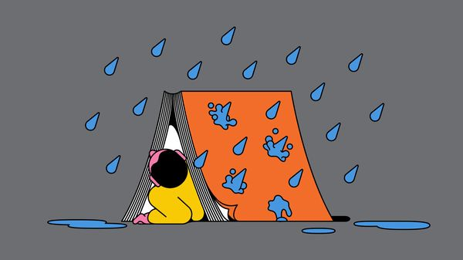

To understand modern self-help books, open “Always Remember: The Boy, the Mole, the Fox, the Horse and the Storm”. The sequel to “The Boy, the Mole, the Fox and the Horse”—and no doubt the prequel to the “The Boy, the Mole, the Fox, the Horse and the Massive Royalty Cheque”—these animal parables topped Britain’s bestseller charts at Christmas. They have sold many millions of copies (often a bad sign) and been described as “heartwarming” (a worse one).
Open this volume and it does not disappoint. Its animal protagonists are fond of life, each other and of saying things about love in a charming handwritten font. Its insights are supposedly aimed at children, yet loved by adults. “Sometimes your mind plays tricks on you. It can tell you you’re no good, that it’s all hopeless,” reads one entry, which recently went viral on Instagram. “But remember this; you are loved, and important, and you bring to this world things no one else can. So hold on.” The tone is like that of Winnie the Pooh, but without the grit and darkness.
These days the self-help genre is expansive, including picture books and poetry as well as tips for climbing the career ladder. Yet it is rarely as instructive as it claims: buy “The Seven Habits of Highly Effective People” and it is far from assured that you too will become a Highly Effective Person. All the same, such books are often profitable and always telling. They provide invaluable guides for social historians, for they tell us a little about who we want to be and even more about who we actually are. Read through a century of self-help and you are offered an archaeology of anxiety.
In a seminal Victorian volume called “Self-Help” Samuel Smiles told his readers, who were trapped in a hierarchical society, that all they needed for success was “Will” and the “HABIT OF ATTENTION”. “Think And Grow Rich” (1937) taught Depression-era American readers that what they really needed to be wealthy was to visualise themself “ALREADY IN POSSESSION OF THE MONEY”. “Atomic Habits”, a bestseller published in 2018, teaches time-poor modern readers that they need only follow the “Four Laws of Behaviour Change”.
More recent volumes show other traits. God, increasingly prominent in cultural life, has made His appearance in self-help sections, too. Reid Hoffman, the co-founder of LinkedIn, once said that social networks do best when they “tap into one of the seven deadly sins” such as greed or pride. Run your eye down a list of bestselling self-help guides—past titles include “The Five Types of Wealth” and “Mini Habits for Weight Loss”—and it seems that they do as well. The seven deadly sins may lead to seven-figure sales.
Many other self-help books commit their own, bespoke self-help sins. Vast numbers commit the sin of Tiresome Capitalisation; many commit the sin of graphs with no scale; several commit the sin of using the ghastly word “elevate”; others commit the unforgivable sin of poetry. “Each day I’m surprised/by the newness that I see…[by] the complexity of me” runs a poem in a newly released anthology called “Joy Chose You” which may well leave you feeling/that Revulsion Chose You, Too.
A lot of them aim at an antique grandeur. Stoicism is popular: Marcus Aurelius’s “Meditations” has a 4.7-star score on Amazon; a forthcoming book is entitled “How To Live Like A Stoic”. However, the style and aims of most are very modern—and nowhere more so than in their obsession with time. Smiles’s “Self-Help” was first published in 1859, the same decade in which Britain became the world’s first predominantly urban society. People who had once lived in a world in which to everything there was a season—a time to sow; a time to reap; a time to sleep—now lived their lives to the sound of the ticking clock.
That sound echoes impatiently through the genre. Where Marcus Aurelius had meditated on the futility of human endeavour given the “infiniteness of eternity”, modern self-help moves at a quicker clip. The recent bestseller “4,000 Weeks” reminds you that this period is a human lifespan. “Atomic Habits” offers the “Two-Minute Rule” to improve productivity.
Self-help is in one way a genre weighed down by the cares of adulthood. In another, it is curiously infantile. (See again “The Boy, the Mole, the Fox, the Horse and the Very Profitable Publishing Franchise”.) Peruse a list of self-help bestsellers, from “Why Has Nobody Told Me This Before?” to “Can’t Hurt Me”, and it may well feel less like a reading list for adults than the words of a tantruming child. Even when authors deploy a more adult vocabulary, the tone can be childishly petulant: one hit self-help book instructs in “The Subtle Art of Not Giving A F*ck”.
This, says Svend Brinkmann, a Danish psychology professor and the author of “Stand Firm”, an anti-self-help self-help book, is typical: there is a “prioritisation of whatever…is childish” in much of self-help. Many books celebrate the “authenticity” of untrammelled emotion and encourage readers to let go of “the ‘false self’”. The idea that every thought and feeling must be given free rein is surely a product of the solipsistic social-media age.
Books may evoke stoicism—but they do so in an un-stoical way. The subtitle of that forthcoming stoic book is “A Handbook for Happiness”. Happiness, in the English sense of the word, is not a very classical aim. “Happiness” (which shares a root with words like “happenstance”) is a fickle thing: a glancing blow of good fortune, not a perpetual state to be striven for. Ancient philosophers were not looking for something that “comes and goes” but to “live a good life”, says James Warren, a professor of philosophy at Cambridge University. You do not manage to live a good life just “by reading a book”.
Perhaps the biggest question raised by self-help books is: do they help selves? There is some slim evidence that they can, but the effects are small. There is much better evidence for other things that actually make people happy, and most involve what Iris Murdoch, a philosopher and novelist, called “unselfing”: playing with a pet or with children, going for a walk in nature, going to the theatre or socialising. Fulfilment is “all unselfing”, says Professor Brinkmann: it is found when “your attention [is] turned away from yourself into the world”. So perhaps this January you should read an un-self-help book instead. ■
For more on the latest books, films, TV shows, albums and controversies, sign up to Plot Twist, our weekly subscriber-only newsletter

This article was downloaded by e-magazines.top from https://www.economist.com/culture/2025/12/30/what-self-help-books-tell-us-about-ourselves
| 章节菜单 | 主菜单 |
| 下一项 | 章节菜单 | 主菜单 | 上一项 |

The watery web

The internet’s vulnerable undersea tendrils
A new book examines the various threats to subsea cables
12月 30, 2025 05:49 上午

Routing problems
The Web Beneath The Waves. By Samanth Subramanian. Columbia Global Reports; 128 pages; $18 and £12.99
In January 2022 the Hunga Tonga-Hunga Ha‘apai volcano erupted with the force of a nuclear bomb, sending a plume of ash nearly 60km into the sky. For the island nation of Tonga, 65km away, an eerie silence followed. The sole undersea cable connecting it to the rest of the world had been snapped by an underwater avalanche from the volcano. Tongans could not text loved ones to say they were unharmed. Banks shut down; hospitals could not transfer patient records; pilots had to fly blind. The subscription for a satellite-backup system had lapsed and, with no internet access, it could not be renewed.
In a sense, we all now live on Tonga—but most of us haven’t noticed yet, argues Samanth Subramanian. The supposedly disembodied virtual world depends on 1.4m km of fibre-optic cables sitting on the ocean floor. These “scrawny, unprotected” things, no fatter than a garden hose, carry 99% of the world’s internet traffic. The modern world depends on this fragile filigree of subsea cables. The internet is so embedded into everyday life that it is only when it stops working that this dependence becomes apparent.
Mr Subramanian charts the history of this submarine wiring, and its vulnerability to physical, geopolitical and commercial interference. He notes that modern maps of fibre-optic cables look uncannily similar to those of imperial-era telegraph cables—partly for historical and political reasons, but also because existing routes are known to be safe, avoiding jagged rocks or seismic activity. He explains how cables are laid and repaired by a handful of firms. And he highlights the growing tensions around this subsea network.
Cables can be broken, accidentally or deliberately, by a stray anchor. They can be tapped by divers operating from submarines. America will not let its companies use cable-laying ships with links to China, or allow cables from China to land on its shores. For its part, China claims a right to oversee cable-laying and maintenance throughout the South China Sea, not just in its own territorial waters. It also meddles in other ways: having opened with Tonga, Mr Subramanian’s book ends with an account of a blackout in 2023, this time in the Matsu islands of Taiwan, cut off when Chinese vessels “accidentally” severed a cable.
Mr Subramanian is right to worry that what has long been a multinational, collaborative industry is becoming splintered along geopolitical lines. He notes that tech giants are among the biggest funders and users of subsea cables, “a situation primed for oligopolistic misbehaviour”. But he does not substantiate his claims that this lets them “hoover up every last scrap of data” or “dictate internet policy” abroad.
That is a minor quibble. These deep-sea shenanigans could easily be dry stuff, but this book wisely focuses on the people who build and maintain the network, and the very human consequences of their successes and failures. More books should be this short. The length of a novella, it makes a snappy point about a meaty topic: namely, that far from being weightless, the cloud is anchored firmly in the real world. ■
For more on the latest books, films, TV shows, albums and controversies, sign up to Plot Twist, our weekly subscriber-only newsletter

This article was downloaded by e-magazines.top from https://www.economist.com/culture/2025/12/30/the-internets-vulnerable-undersea-tendrils
| 章节菜单 | 主菜单 |
| 下一项 | 章节菜单 | 主菜单 | 上一项 |

Espionage

Oleg Lyalin: the spy who loved too much
His defection in the cold war helped MI5 turn the tables on the KGB
12月 30, 2025 09:06 上午


The Defector. By Richard Kerbaj. Blink; 304 pages; £25. To be published in America by Pegasus in September; $29.95
For Oleg Lyalin it was a dream posting. After a dull stint in Klaipeda, on the Baltic coast, he was on his way to “swinging London” in 1969. Ostensibly he was joining a Soviet trade mission; in fact Lyalin, a hard-drinking philanderer, worked for Department V, a kgb outfit that specialised in sabotage and assassinations. Two years later, he became one of the cold war’s most important defectors, handing Britain’s security service, MI5, a trove of intelligence that restored its reputation and led to the expulsion of 105 Soviet spies.
Drawing on recently declassified intelligence, Richard Kerbaj tells a gripping story of Lyalin’s role in helping to turn the tables in a spying game that the West had been losing. Unlike Oleg Gordievsky, who began passing secrets to MI6, Britain’s foreign intelligence service, a few years later, the reasons for Lyalin’s defection were personal rather than ideological.
Lyalin walked into a police station and declared himself a KGB officer. He wanted to be formally expelled so he could return home as a hero and divorce his wife. (He was involved with five other women.) In return, he would provide MI5 with information about the KGB’s mission in Britain and continue working for it from Moscow.
A few months later, police arrested Lyalin, who was driving erratically down Tottenham Court Road, “shouting and swearing”. Lyalin’s disgruntled wife, meanwhile, had been in touch with his bosses in Moscow questioning his loyalty to the cause. The result was an order to pack his bags and face “severe administrative action”.
Defection was the only option. Three weeks later, the British government ordered the mass expulsion of Soviet spies. The author argues that Lyalin’s defection “saved” MI5. That may be going too far, but it restored the agency’s confidence after Kim Philby, a British spy, was revealed in 1963 to be working for Moscow.
The way the game is played has changed, but the story still has resonance: Vladimir Putin choreographs the same kind of “grey-zone” operations against the West as his Soviet predecessors. As Sir Richard Moore, the outgoing head of MI6, recently stressed: “Many of our best and most highly motivated agents have been volunteers...Our door is always open.” ■
For more on the latest books, films, TV shows, albums and controversies, sign up to Plot Twist, our weekly subscriber-only newsletter

This article was downloaded by e-magazines.top from https://www.economist.com/culture/2025/12/30/oleg-lyalin-the-spy-who-loved-too-much
| 章节菜单 | 主菜单 |
| 下一项 | 章节菜单 | 主菜单 | 上一项 |

World in a dish

Restaurants are changing their menus for the age of Ozempic
The challenge is enticing those with reduced appetites to dine out
12月 30, 2025 05:48 上午


Otto’s, a restaurant in London, is known for serving generous portions of indulgent dishes: lobster, canard à la presse and burgers heaped with caviar and foie gras. But when a regular customer informed Otto Tepassé, the owner, that he was taking weight-loss medication and would be dining out less frequently, Mr Tepassé decided to adapt. The restaurant launched a menu of “exquisite bites” such as pan-fried veal. “You get all the luxury,” says Mr Tepassé, “but in small quantities.”
Other restaurants are downsizing their dishes, too. At the Fat Duck (pictured), a three-Michelin-starred restaurant in Berkshire, Heston Blumenthal offers a “Mindful Experience” option. (“Sometimes less really is more,” the menu claims.) The Banc, which has outposts in London and Dubai, has launched a mini menu with smaller portions of dishes such as sea bream. Renwick Hospitality Group, which owns several restaurants in New York, has added snack-size options to its menus (see below).
GLP-1 drugs such as Ozempic, Wegovy and Mounjaro mimic the hormone that signals fullness, suppressing the appetite and helping people to eat less. They have rapidly gained popularity: global spending on them reached roughly $54bn in 2024 and is expected to rise as pharmaceutical companies compete to make the medicine, often delivered by injection, more effective and easier to use. About one in eight American adults has taken a GLP-1 drug for weight loss, according to Gallup, a pollster. KAM, a research firm, estimates that between 4% and 7% of British adults are users. That is a similar proportion to the number of vegetarians (5%) or those with food allergies (6%).


Might the drugs take a bite out of the restaurant industry? Currently most GLP-1 users come from middle- or high-income households: the same people who can afford to dine out regularly. (In Britain 58% obtain the medication privately, 32% receive it through the National Health Service and 10% acquire it in other ways.) KAM finds that 57% of users plan to visit restaurants for special occasions only. For restaurateurs, that is an unpalatable prospect.
Though GLP-1 users want less food, they are willing to fork out for treats. And restaurants can slap a big mark-up on a tiny plate. “We’ve always seen in retail that if you shrink a product, you can still charge proportionately more for it than you would…if it was a bigger item,” says Jonny Forsyth of Mintel, another research outfit. “The same psychology applies here.”
Casual eateries are taking note. Donald Trump recently announced deals with drug firms to lower their prices, so weight-loss jabs may soon be available to more Americans. Clinton Hall, a burger joint in New York, has launched a “Teeny-Weeny Mini Meal”. Cuba Libre, an American chain, offers a “GLP-Wonderful” menu. For restaurants, it is time to think small. ■

This article was downloaded by e-magazines.top from https://www.economist.com/culture/2025/12/29/restaurants-are-changing-their-menus-for-the-age-of-ozempic
| 章节菜单 | 主菜单 |
| 下一章节 | 主菜单 | 上一章节 |

Economic & financial indicators
- Economic data, commodities and markets
Indicators ::

| 下一章节 | 主菜单 | 上一章节 |
| 下一项 | 章节菜单 | 主菜单 |

Indicators

Economic data, commodities and markets
12月 30, 2025 05:49 上午
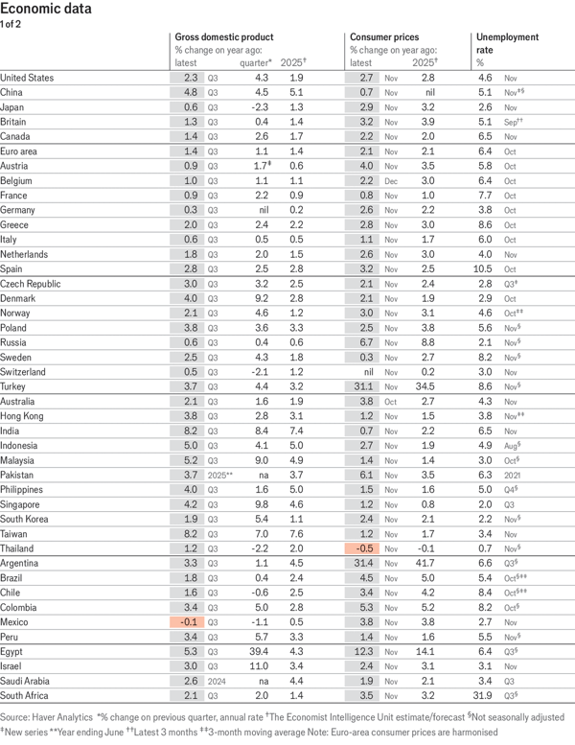

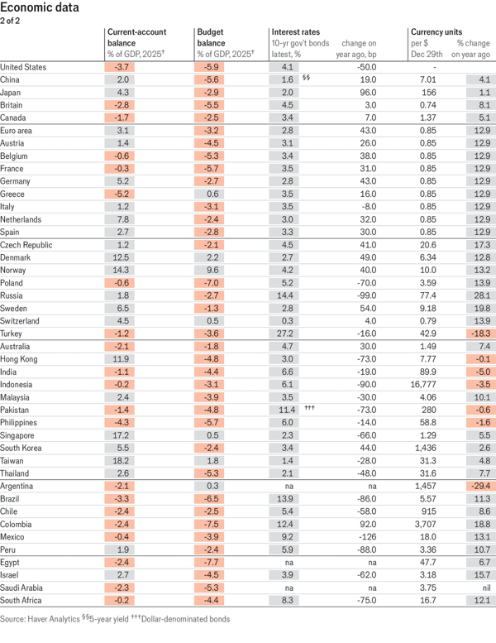

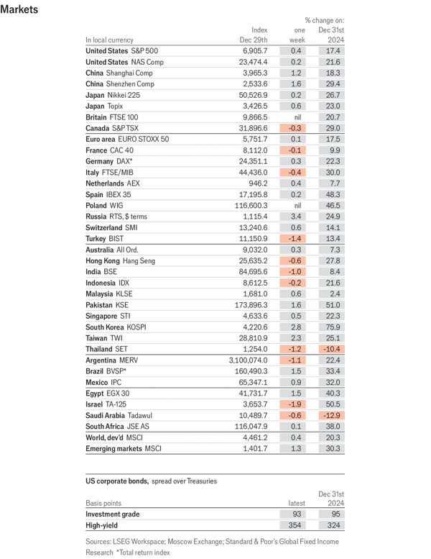

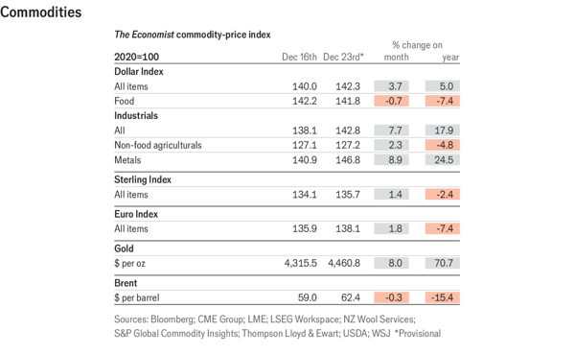

This article was downloaded by e-magazines.top from https://www.economist.com/economic-and-financial-indicators/2025/12/30/economic-data-commodities-and-markets
| 章节菜单 | 主菜单 |
| 主菜单 | 上一章节 |

Obituary
- Brigitte Bardot became, but refused to remain, the image of desire
Huntress and hunted :: The actress turned animal-rights campaigner died on December 28th, aged 91

| 主菜单 | 上一章节 |
| | 章节菜单 | 主菜单 |

Huntress and hunted

Brigitte Bardot became, but refused to remain, the image of desire
The actress turned animal-rights campaigner died on December 28th, aged 91
12月 30, 2025 06:36 上午


AS IF WASHED up and dead, a man lay face-down at the edge of the sea. Close-up, a naked foot could be seen approaching him; a young, shapely foot, evidently a woman’s. It paused, then pressed on his cheek. To step on him, perhaps? To caress him? Or just to flip him over, as one might with the body of an animal?
This trailer, for the film “And God Created Woman” (1956), left the answer deliberately unclear. That foot might have done anything. The smart shirt of the “corpse”, and his handsomeness, suggested he might be revived fairly soon. What the trailer suggested less obviously was the barefoot arrival of a new star: a kittenish temptress, fatally attracted and attractive to men and, in the panting assessment of Paris Match, “immoral from head to toe”.
This was the film that made Brigitte Bardot an international sensation. And who would have expected it? A fastidiously well-brought up girl, of pious parents and from the 16th arrondissement, the product of private schools and young dancing star of the Paris Conservatoire, now rolling round most athletically on beaches and on beds. The girl whose hair was originally brown and who, each time she looked in the mirror, thought she was ugly, now with gloriously wild blonde tresses, brooding eyes and, behind those sultry lips, just the tiniest glimpse of two front teeth to drive a man completely wild.


In retrospect, it was not quite such a shock. It had been building for a while. At 15, despite her parents’ disapproval, she was on the cover of Elle magazine. She posed in bikinis, and by 17 had started a rip-roaring affair with Roger Vadim, an assistant to a film director. Her shocking portrayal of desire was quite natural. When, at 18, she married him, he found parts for her, innocently titillating, but enough to get her mobbed in 1954 at the Cannes Film Festival. There was something she wanted in all this. Yet whether she really wanted it was not so clear.
From that point the press kept after her. They had plenty to go on: four marriages, the first three of a few years each, and at least as many long-lasting passionate amours, usually with fellow actors. Several times—because of lovers’ arguments, or spats about casting—she tried to kill herself, though not very hard. Men could be beasts, but for confidence she needed one close.
In all she made nearly 50 films, usually rickety comedy dramas secured by her pouts, tossed hair and lively romps in meadows. Audiences devoured “Babette Goes to War”, in which she played a hapless sexy heroine of the French resistance, and “Viva Maria!”, in which she was a Central American stripper-cum-revolutionary, hamming it up in huge hats with Jeanne Moreau. She, though, thought nothing of this stuff. The only one she rated was “La Vérité” (1960), where as usual she played a young woman who slept around, but this time in a complex, grown-up set of relationships that ended in a murder mystery. Here she was on screen not just to undress, but to act, with her hair tightly pulled back to confront police and judges and her face sternly set. But in 1973, at 39, she quit the awful circus for good.
By then Bardolatry, her word, was well established. Her fame had brought a freak wave of opulence and glitter to St Tropez, the sleepy little fishing port on the Riviera where she lived from 1958. In the 1960s she became the official face of Marianne, the symbol of France, of which she was declared as great a product as Roquefort cheese and the wine of Bordeaux. Would-be Bardots in her tight, skimpy clothes and with her smudgy look had appeared everywhere. She was even taken up by the philosophes, especially the female ones, who declared that she represented unloosed free will in the face of the tyrannical male gaze.


More and more, though, the gaze of any human made her feel uncomfortable. Behind every dustbin and every bush she sensed a photographer stirring. She had become a creature to be hunted. Increasingly she felt she did not like humanity much; that she might even be allergic to it. Animals, by contrast, moved her deeply. It was not entirely a new feeling. As a teenager, in the throes of first love with Vadim, he had appeared to her as a wild wolf thrilling and luring her. Once her youth and beauty had been given to men like him (and millions of others), she would follow her soul, and give the best of herself to animals.
She did not do so by halves. All her jewellery was sold to set up the Brigitte Bardot Foundation, mostly to build shelters for abused donkeys, horses or bears in various parts of the world. She campaigned against the annual seal-cull in Canada, factory-farming of chickens, wolf-hunting, bullfighting and the fur trade. Her own compatriots were rebuked for eating horse meat, and Jews and Muslims castigated for their methods of slaughter. While she was about it, she inveighed against Muslims generally as savages and invaders. Five times she was convicted under France’s anti-racism laws, but she was not done yet. She was also as rude as she could be about “butt-jiggling” gay men and the “idiotic” #MeToo movement. The devil-may-care bikini-sporting adolescent still wanted to make the public seethe with indignation.
She was not a recluse, she insisted. But as long as humans treated animals as cruelly as they did, she would take the animals’ side. She even wished her son Nicolas (by her second husband, Jacques Charrier) could have been a little dog. At one point near the century’s end she lived with 14 dogs, 60 cats and a herd of goats, who wandered freely in her villa in St Tropez and shared her meals and bed. When in 1996 she exchanged vows with a fourth husband, a star of the French far right, she announced that he had the character of a pig. It was no insult. Pigs were wise.
Still she felt she had not found her spiritual home. She longed for real solitude, in a hut by the edge of the sea. Walking out in the dawn, barefoot, might she see another fine male body lying on the sand as if dead? And if she did, what would she do next? ■

This article was downloaded by e-magazines.top from https://www.economist.com/obituary/2025/12/29/brigitte-bardot-became-but-refused-to-remain-the-image-of-desire
| 章节菜单 | 主菜单 |

