1. C:\DassaultSystemes\R2020x\3DSpace\server\Apps\BusinessProcessServices\V6R2020x\Modules\ENOFramework\AppInstall\Programs\config.xml中添加以下内容

<BOTYPE name="YF_SupplierPart" includes="basic" />

<BOTYPE name="YF_CustomerPart" includes="basic"/>

<BOTYPE name="YF_ColorPart" includes="basic" />

<BOTYPE name="YF_Requirement" includes="basic" />

<BOTYPE name="YF_Mold" includes="basic"/>

<BOTYPE name="YF_PrdBaseline" includes="basic"/>

<BOTYPE name="YF_DA" includes="basic" />

<RELATIONSHIPTYPE active="true" includes="" name="YF_PrdAlternate" searchable="false"/>

<RELATIONSHIPTYPE active="true" includes="" name="YF_PrdSubstitute" searchable="false"/>

<RELATIONSHIPTYPE active="true" includes="" name="Manufacturing Responsibility" searchable="false"/>

<RELATIONSHIPTYPE active="true" includes="" name="YF_PrdRelatedSP" searchable="false"/>

<RELATIONSHIPTYPE active="true" includes="" name="YF_PrdRelatedCP" searchable="false"/>

<RELATIONSHIPTYPE active="true" includes="" name="YF_SPRelatedSupplier" searchable="false"/>

<RELATIONSHIPTYPE active="true" includes="" name="YF_CPRelatedCustomer" searchable="false"/>

<RELATIONSHIPTYPE active="true" includes="" name="YF_CRRelatedDA" searchable="false"/>

<RELATIONSHIPTYPE active="true" includes="" name="YF_PrdRelatedColorPart" searchable="false"/>

<RELATIONSHIPTYPE active="true" includes="" name="YF_PrdRelatedMold" searchable="false"/>

<RELATIONSHIPTYPE active="true" includes="" name="YF_MoldRelatedPlant" searchable="false"/>

<RELATIONSHIPTYPE active="true" includes="" name="YF_PrdRelatedBaseline" searchable="false"/>

<RELATIONSHIPTYPE active="true" includes="" name="MCO Change Authority" searchable="false"/>

1. C:\DassaultSystemes\R2020x\3DSpace\server\Apps\BusinessProcessServices\V6R2020x\Modules\ENOFramework\AppInstall\Programs\config_CV_Core.xml中添加以下内容

<RELATIONSHIPTYPE.EXTFIELDS includes="ro.navigation" name="YF_PrdAlternate"/>

<RELATIONSHIPTYPE.EXTFIELDS includes="ro.navigation" name="YF_PrdSubstitute"/>

<RELATIONSHIPTYPE.EXTFIELDS includes="ro.navigation" name="Manufacturing Responsibility"/>

<RELATIONSHIPTYPE.EXTFIELDS includes="ro.navigation" name="YF_PrdRelatedSP"/>

<RELATIONSHIPTYPE.EXTFIELDS includes="ro.navigation" name="YF_PrdRelatedCP"/>

<RELATIONSHIPTYPE.EXTFIELDS includes="ro.navigation" name="YF_SPRelatedSupplier"/>

<RELATIONSHIPTYPE.EXTFIELDS includes="ro.navigation" name="YF_CPRelatedCustomer"/>

<RELATIONSHIPTYPE.EXTFIELDS includes="ro.navigation" name="YF_CRRelatedDA"/>

<RELATIONSHIPTYPE.EXTFIELDS includes="ro.navigation" name="YF_PrdRelatedColorPart"/>

<RELATIONSHIPTYPE.EXTFIELDS includes="ro.navigation" name="YF_PrdRelatedMold"/>

<RELATIONSHIPTYPE.EXTFIELDS includes="ro.navigation" name="YF_MoldRelatedPlant"/>

<RELATIONSHIPTYPE.EXTFIELDS includes="ro.navigation" name="YF_PrdRelatedBaseline"/>

<RELATIONSHIPTYPE.EXTFIELDS name="MCO Change Authority" includes="ro.navigation" />

1. 启动mql，重建索引

* set context user creator;
* clear searchindex;
* set system searchindex file C:\DassaultSystemes\R2020x\3DSpace\server\Apps\BusinessProcessServices\V6R2020x\Modules\ENOFramework\AppInstall\Programs\config.xml;
* clear searchindex;
* start searchindex mode full;

1. 修改C:\Apps\as20x\as-3dspaceCas\webapps\3dspace\WEB-INF\classes\RIPE\resources\ENORelNav_GeneralProperties.properties，新增支持索引的类型

supported_types = "Company";"YF_SupplierPart";"YF_CustomerPart";"YF_ColorPart";"YF_Requirement";"YF_Mold";"YF_PrdBaseline";"YF_DA";"MCO";"MCAD Model";"MCAD Assembly";"MCAD Component";"MCAD Representation";"CATDrawing";"CATAnalysisResults";"Workspace";"Personal Workspace";"Workspace Vault";"Document";"PLMCoreReference";"PLMCoreRepReference";"Change";"Project Management";"Task Management";"CLIN";"WBSE"

1. C:\Apps\as20x\as-3dspaceCas\webapps\3dspace\WEB-INF\classes\RIPE\profiles\ENORelNav_Profiles.json，定义UI中的关系组合

"roles": {

"CSV": {

"profiles": [ "WhereUsed", "Designer", "ProjectManager", "MBOM_analyst_V6", "Process_analyst_V6", "Resource_analyst_V6", "Simulation", "ModelicaRelation", "WhereUsed_Material", "V6Knowledgeware", "EBOM_Relations", "ReviewInterference", "Change_Traceability", "Change_Responsibility", "Change_Impact", "AER_Contract","SimulationProcess","Issue_Relations" , "ModelRelatedStructures" , "Power_Traceability"]

},

{

"name" : "Change_Traceability",

"relations": [

{"name":"changeaction_from"},{"name":"changeaction_to"},

{"name":"changeorder_from"},{"name":"changeorder_to"},

{"name":"changebreakdown_from"},{"name":"changebreakdown_to"},

{"name":"MCOChangeAuthority_to"},{"name":"YF_CRRelatedDA_to"},

{"name" :"resolvedTo_to"}, {"name" :"resolvedTo_from"}

]

},

{

"name" : "Power_Traceability",

"relations": [

{"name":"YF_PrdAlternate_to"},

{"name":"ManufacturingResponsibility_from"},

{"name":"YF_PrdRelatedSP_to"},

{"name":"YF_PrdRelatedCP_to"},

{"name":"YF_PrdRelatedColorPart_to"},

{"name":"YF_PrdRelatedMold_to"},

{"name":"YF_PrdRelatedBaseline_to"},

{"name":"YF_MoldRelatedPlant_to"},

{"name":"YF_SPRelatedSupplier_to"},

{"name":"YF_CPRelatedCustomer_to"}

]

}

注：YF_PrdSubstitute比较特殊，此处无法展示

1. C:\Apps\as20x\as-3dspaceCas\webapps\3dspace\WEB-INF\classes\RIPE\profiles\ENORelNav_By_Type_Profiles.json中，定义各类型的对象所显示的关系

{

"name" : "VPMReference",

"relations": [{"name" :"v6_implementScope_from" },{"name" :"v6_implementScope_to" },{"name" :"v6_ProductOutputOfMBOM_from" },{"name" :"v6_MBOMOutputOfProcess_from" },{"name" :"v6_capableRsc_from" },

{"name" :"v6_cad_document_to"},{"name" :"v6_cad_document_from" },{"name" :"XCADItem_from" },{"name" :"v6_drawing_from" },{"name" :"mat_MadeOf_from"},{"name" :"mat_CoveredBy_from"},

{"name" :"mat_DecalAppliedBy_from"},{"name" :"isr_ctxt_from"},{"name" :"isrgroup_ctxt_from"},{"name" :"rvw_ctxt_from"},{"name" :"rvw_validated_from"},{"name" :"mkp_ctxt_from"},

{"name" :"partspecification_from" },{"name" : "engineeringDefinition_from"},{"name" :"caproposedwhere_from"},{"name" :"carealizedwhere_from"},{"name":"YF_PrdAlternate_to"},{"name":"ManufacturingResponsibility_from"},{"name":"YF_PrdRelatedSP_to"},{"name":"YF_PrdRelatedCP_to"},{"name":"YF_PrdRelatedColorPart_to"},{"name":"YF_PrdRelatedMold_to"},{"name":"YF_PrdRelatedBaseline_to"}]

},

{

"name" : "Change Order",

"relations": [{"name" :"changeaction_to"},{"name" :"changeorder_from"},{"name" :"changebreakdown_from"},{"name" :"MCOChangeAuthority_to"},{"name" :"YF_CRRelatedDA_to"}]

},

{

"name" : "Change Request",

"relations": [{"name" :"changeaction_to"},{"name" :"changeorder_to"},{"name" :"YF_CRRelatedDA_to"}]

},

,{

"name" : "YF_Mold",

"relations": [{"name" :"YF_MoldRelatedPlant_to"}]

},

{

"name" : "YF_SupplierPart",

"relations": [{"name" :"YF_SPRelatedSupplier_to"}]

},

{

"name" : "YF_CustomerPart",

"relations": [{"name" :"YF_CPRelatedCustomer_to"}]

},

1. 修改C:\Apps\as20x\as-3dspaceCas\webapps\3dspace\WEB-INF\classes\RIPE\patterns\Customer_Patterns.json，定义Relational Explorer中索引的信息

,{

"name": "YF_PrdAlternate_to",

"computepath": "to",

"queries" : [{ "definition":[{"navigationType" : "relation","qualityFilter" : {"rel_type" : "YF_PrdAlternate"}, "direction" : "to"}]}]

},

{

"name": "ManufacturingResponsibility_from",

"computepath": "from",

"queries" : [{ "definition":[{"navigationType" : "relation","qualityFilter" : {"rel_type" : "Manufacturing Responsibility"}, "direction" : "from"}]}]

},

{

"name": "YF_PrdRelatedSP_to",

"computepath": "to",

"queries" : [{ "definition":[{"navigationType" : "relation","qualityFilter" : {"rel_type" : "YF_PrdRelatedSP"}, "direction" : "to"}]}]

},

{

"name": "YF_PrdRelatedCP_to",

"computepath": "to",

"queries" : [{ "definition":[{"navigationType" : "relation","qualityFilter" : {"rel_type" : "YF_PrdRelatedCP"}, "direction" : "to"}]}]

},

{

"name": "YF_PrdRelatedColorPart_to",

"computepath": "to",

"queries" : [{ "definition":[{"navigationType" : "relation","qualityFilter" : {"rel_type" : "YF_PrdRelatedColorPart"}, "direction" : "to"}]}]

},

{

"name": "YF_PrdRelatedMold_to",

"computepath": "to",

"queries" : [{ "definition":[{"navigationType" : "relation","qualityFilter" : {"rel_type" : "YF_PrdRelatedMold"}, "direction" : "to"}]}]

},

{

"name": "YF_PrdRelatedBaseline_to",

"computepath": "to",

"queries" : [{ "definition":[{"navigationType" : "relation","qualityFilter" : {"rel_type" : "YF_PrdRelatedBaseline"}, "direction" : "to"}]}]

},

{

"name": "YF_MoldRelatedPlant_to",

"computepath": "to",

"queries" : [{ "definition":[{"navigationType" : "relation","qualityFilter" : {"rel_type" : "YF_MoldRelatedPlant"}, "direction" : "to"}]}]

},

{

"name": "YF_SPRelatedSupplier_to",

"computepath": "to",

"queries" : [{ "definition":[{"navigationType" : "relation","qualityFilter" : {"rel_type" : "YF_SPRelatedSupplier"}, "direction" : "to"}]}]

},

{

"name": "YF_CPRelatedCustomer_to",

"computepath": "to",

"queries" : [{ "definition":[{"navigationType" : "relation","qualityFilter" : {"rel_type" : "YF_CPRelatedCustomer"}, "direction" : "to"}]}]

}

1. 修改C:\Apps\as20x\as-3dspaceCas\webapps\3dspace\WEB-INF\classes\RIPE\patterns\ENORelNav_ECM_Patterns.json，定义Relational Explorer中索引的信息

,{

"name": "MCOChangeAuthority_to",

"computepath": "to",

"queries" : [{ "definition":[{"navigationType" : "relation","qualityFilter" : {"rel_type" : "MCO Change Authority"}, "direction" : "to"}]}]

},

{

"name": "YF_CRRelatedDA_to",

"computepath": "to",

"queries" : [{ "definition":[{"navigationType" : "relation","qualityFilter" : {"rel_type" : "YF_CRRelatedDA"}, "direction" : "to"}]}]

}

1. 修改C:\Apps\as20x\as-3dspaceCas\webapps\3dspace\webapps\SNNavigationMap\SNNavigationMap_en.js 定义国际化

define("DS/SNNavigationMap/assets/nls/SNNavigationMap_ECM", {

Change_Traceability: "Change Traceability",

Change_Responsibility: "Change Responsibility For",

Change_Impact: "Change Impact",

changeaction: "Change Action",

changeaction_from: "Change Action For",

changeaction_to: "Change Action",

changeorder: "Change Order",

changeorder_from: "Change Order For",

changeorder_to: "Change Order",

changebreakdown: "Change Breakdown",

changebreakdown_from: "Parent Change",

changebreakdown_to: "Child Change",

changefollower: "Change Follower",

changefollower_from: "Change Follower For",

changefollower_to: "Change Follower",

changereviewer: "Change Reviewer",

changereviewer_from: "Change Reviewer For",

changereviewer_to: "Change Reviewer",

technicalassignee: "Change Assignee",

technicalassignee_from: "Change Assignee For",

technicalassignee_to: "Change Assignee",

resolvedTo: "Resolved Issue",

resolvedTo_from: "Resolved Item",

resolvedTo_to: "Resolved By",

MCOChangeAuthority_to: "MCO Change Authority",

YF_CRRelatedDA_to: "Deviation Authorization",

caproposedwhere_from: "Proposed Change of",

caproposedwhere_to: "Proposed Change",

carealizedwhere_from: "Realized Change of",

carealizedwhere_to: "Realized Change"

});

define("DS/SNNavigationMap/assets/nls/SNNavigationMap_Customer", {

Power_Traceability:"Power Traceability",

YF_PrdAlternate_to:"Alternate Part",

ManufacturingResponsibility_from:"Related Plant of Product",

YF_PrdRelatedSP_to:"Related Supplier Part",

YF_PrdRelatedCP_to:"Related Customer Part",

YF_PrdRelatedColorPart_to:"Related Color Part",

YF_PrdRelatedMold_to:"Related Mold",

YF_PrdRelatedBaseline_to:"Related Baseline",

YF_MoldRelatedPlant_to:"Related Plant of Mold",

YF_SPRelatedSupplier_to:"Related Supplier",

YF_CPRelatedCustomer_to:"Related Customer"

});

同样把SNNavigationMap_zh.js也加一下

Change_Traceability: "更改可跟踪性",

Change_Responsibility: "更改以下项的责任",

Change_Impact: "更改影响",

changeaction: "更改操作",

changeaction_from: "更改以下项的操作",

changeaction_to: "更改操作",

changeorder: "更改订单",

changeorder_from: "更改以下项的顺序",

changeorder_to: "更改订单",

changebreakdown: "更改分类",

changebreakdown_from: "父更改",

changebreakdown_to: "子级更改",

changefollower: "更改遵循者",

changefollower_from: "更改以下项的遵循者",

changefollower_to: "更改遵循者",

changereviewer: "更改审阅者",

changereviewer_from: "更改以下项的审阅者",

changereviewer_to: "更改审阅者",

technicalassignee: "更改受托人",

technicalassignee_from: "更改以下项的受托人",

technicalassignee_to: "更改受托人",

resolvedTo: "已解决问题",

resolvedTo_from: "已解决项目",

resolvedTo_to: "解决人",

MCOChangeAuthority_to: "MCO",

YF_CRRelatedDA_to: "Deviation Authorization",

caproposedwhere_from: "Proposed Change of",

caproposedwhere_to: "Proposed Change",

carealizedwhere_from: "Realized Change of",

carealizedwhere_to: "Realized Change"

});

define("DS/SNNavigationMap/assets/nls/SNNavigationMap_Customer", {

Power_Traceability:"物理模型关系追溯",

YF_PrdAlternate_to:"全局替换",

ManufacturingResponsibility_from:"工厂",

YF_PrdRelatedSP_to:"供应商件",

YF_PrdRelatedCP_to:"客户件",

YF_PrdRelatedColorPart_to:"颜色件",

YF_PrdRelatedMold_to:"模具",

YF_PrdRelatedBaseline_to:"基线",

YF_MoldRelatedPlant_to:"工厂",

YF_SPRelatedSupplier_to:"供应商",

YF_CPRelatedCustomer_to:"客户"

});

物理模型关系追溯 - 测试截图：

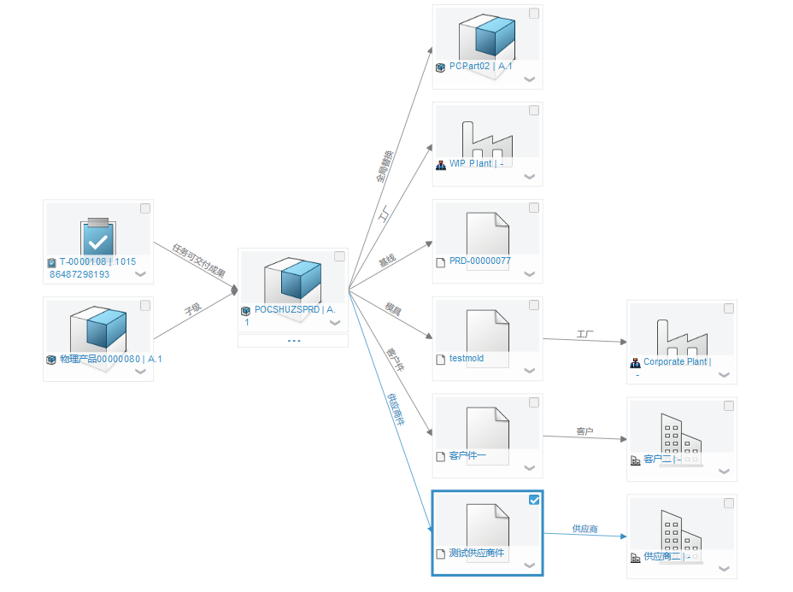

变更关系追溯 – 测试截图

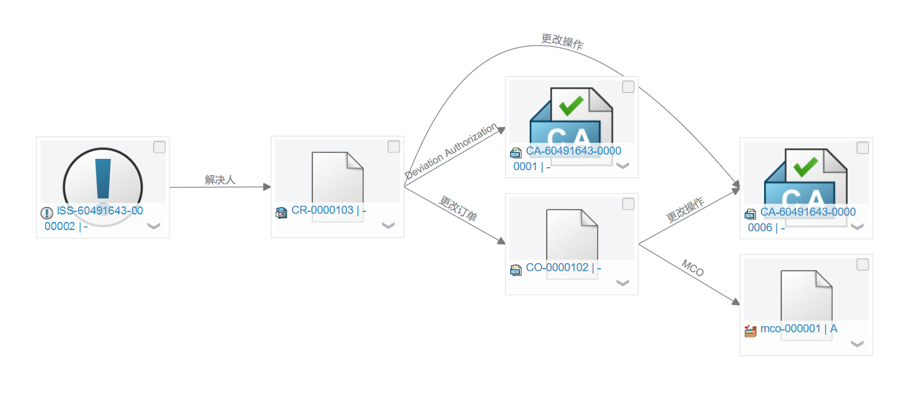

代码包：（2.0增加从CO展到DA，调整DA关系在en环境下的显示名）

