**查看当前事物隔离级别：**

**select @@tx_isolation;**

**读取未提交**

mysql> set session transaction isolation level read uncommitted;

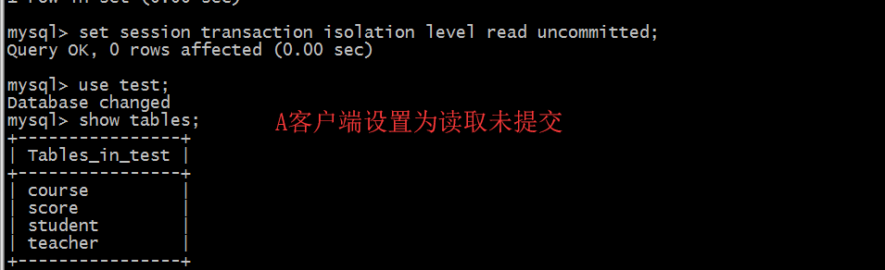

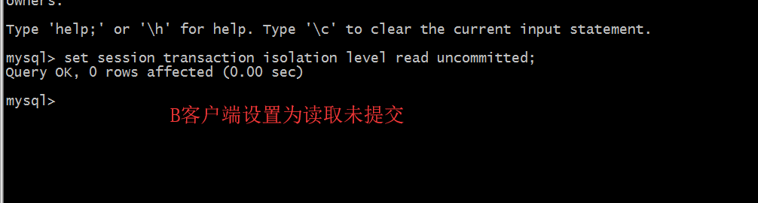

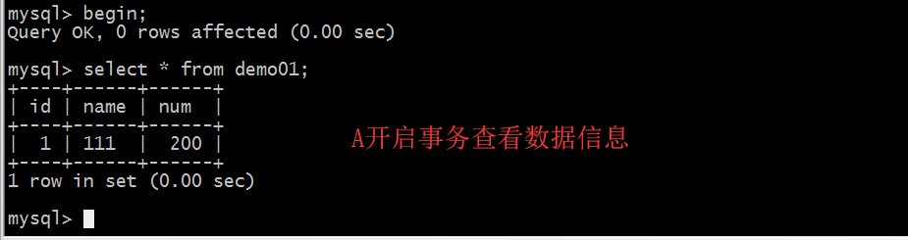

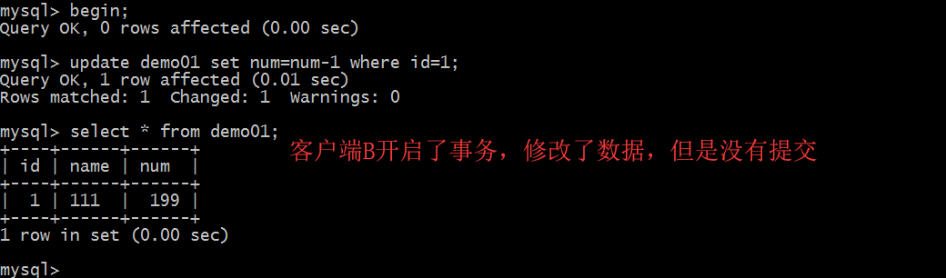

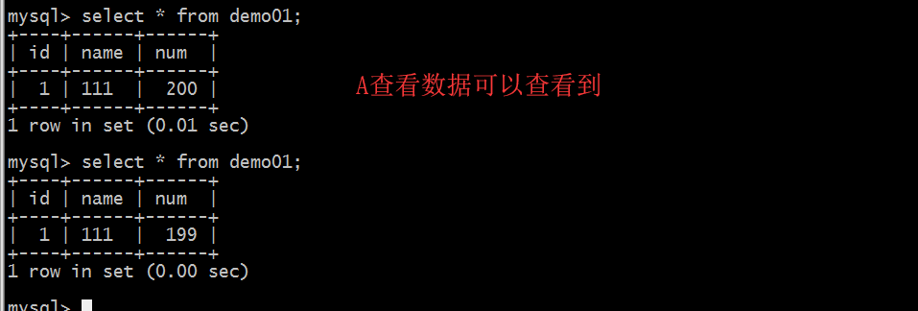

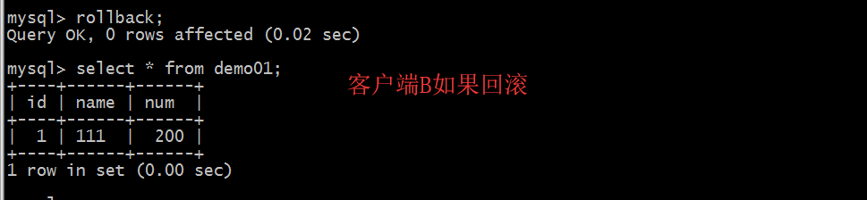

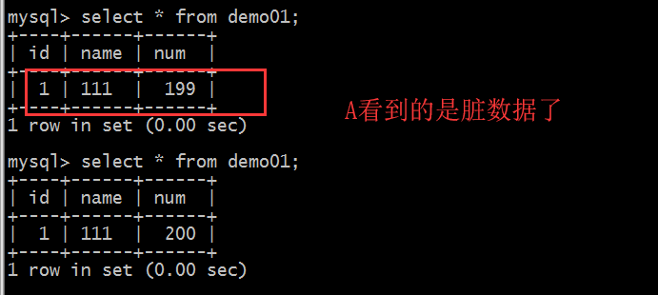

**读已提交**

mysql> set session transaction isolation level read committed;

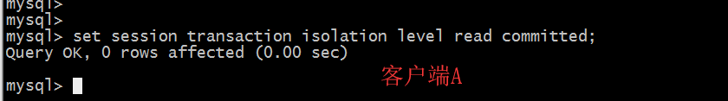

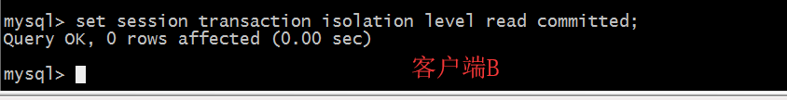

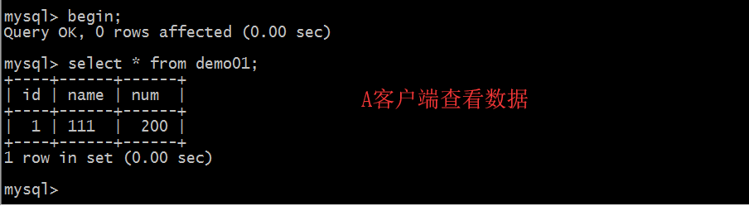

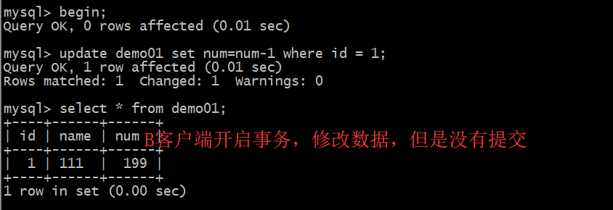

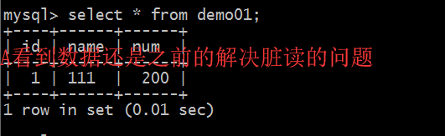

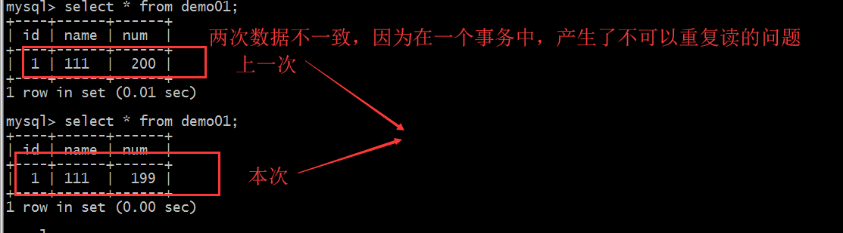

1. 可重复读mysql> set session transaction isolation level repeatable read;

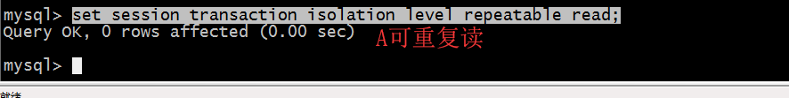

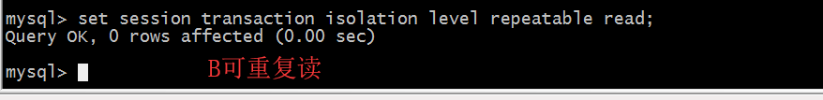

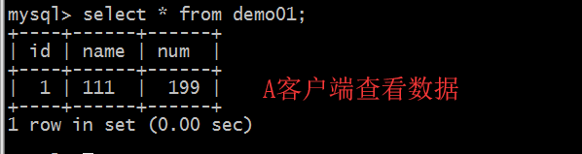

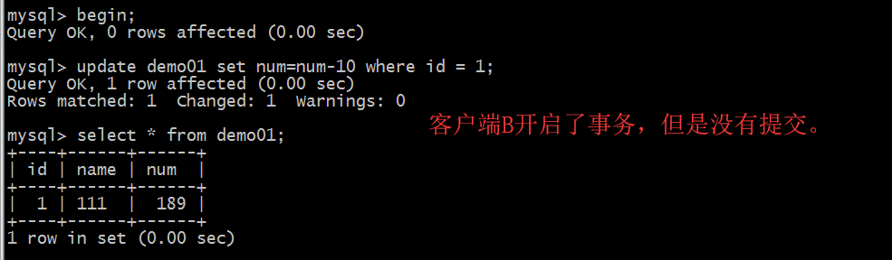

客户端A

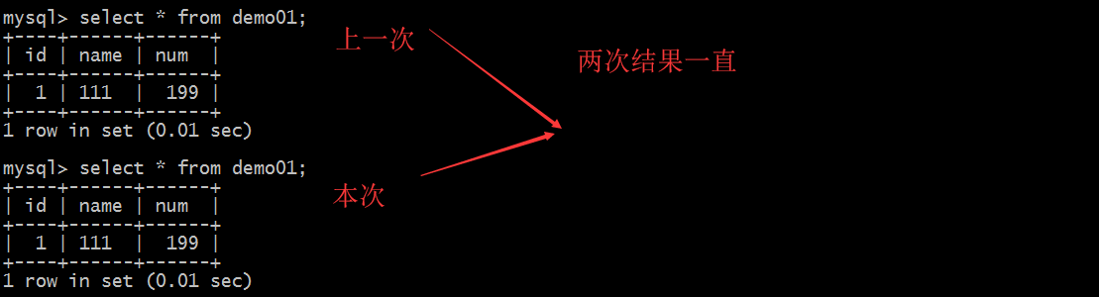

串行化

基本不用所以不用考虑