**Drout Advertising Research Project**

1. **Stereotype Analysis:**

**1.1: Correlation between education levels and stereotyping perception**

I would separate education level into three different categories:

* High school diploma.
* Associate degree, bachelor degree, some undergraduate courses.
* Master degree, doctorate, JD (Juris Doctor)

Here, I introduce the pivot table for **high-education scholars** with:

* Rows: Gender
* Columns: Reinforcing
* Values: Count of respondents
* Filter: Education level

| **Count of Respondent** | **Reinforcing** |  |  |
| --- | --- | --- | --- |
| **Gender** | **Drastic** | **Influential** | **Grand Total** |
| Female | 1 |  | 1 |
| Male |  | 2 | 2 |
| **Grand Total** | **1** | **2** | **3** |

The number of high scholars in both genders is 3, but all of the respondents feel that advertisements “drastically” or “influentially” reinforce gender stereotypes. For checking whether the respondents are children or adults who only pursue high school diplomas, I made another pivot table to check what age high school scholars are:

| **Count of Respondents** | **Column Labels** |  |
| --- | --- | --- |
| **Age** | **High school diploma** | **Grand Total** |
| 22 | 2 | 2 |
| 27 | 1 | 1 |
| **Grand Total** | **3** | **3** |

As you can see, the respondents are likely adults who only pursue high school diplomas, and this also generates some interesting **insights**:

1. Critical media awareness among less-formally educated adults: Although the number of these respondents is not many compared to other groups, this demographic is aware of gender-based advertisement. The reason might be from their own experience, or the gender stereotype is so clear in the advertisement.
2. Target for media literacy campaign: Because this group has a strong perception of gender stereotypes in ads, targeted audiences can be fostered empowerment campaigns more.
3. One thing that we need to take into account is that this demographic is often the primary consumers, so advertisers may need to consider their messages in advertising carefully.

The next group that we will consider is **Associate degree, bachelor degree, some undergraduate courses.**

| **Count of Respondent** | **Reinforcing** |  |  |  |  |
| --- | --- | --- | --- | --- | --- |
| **Gender** | **Drastic** | **Influential** | **Limited** | **Trivial** | **Grand Total** |
| Female | 24 | 33 | 1 |  | 58 |
| Male | 3 | 7 | 3 | 3 | 16 |
| **Grand Total** | **27** | **40** | **4** | **3** | **74** |

This group tends to have the largest proportion of respondents. However, we **would not compare the data based on gender** here because there are more women than men in this survey but rather focus on the proportion of reinforcing scale:

| **Gender** | **Count of Respondent** |
| --- | --- |
| Female | 86 |
| Male | 19 |
| **Grand Total** | **105** |

**Insights:**

1. Broader spectrum of perception among educated groups (From “Drastic”, “Influential” to “Limited”, “Trivial”: Higher education may broaden the lens through which the respondents evaluate it. They are likely to have more critical thinking when approaching the issue. However, the majority of the perceptions are still “Drastic” and “Influential”, which means the higher educated scholars also perceive that advertisements reinforce gender stereotypes.
2. Both the high school scholars and more educated respondents show concern about the reinforcement of stereotypes. Therefore, media campaigns need to work harder to break these biases.

The last group that we will consider is **Master degree, doctorate, JD (Juris Doctor)**.

| **Count of Respondent** | **Reinforcing** |  |  |  |
| --- | --- | --- | --- | --- |
| **Gender** | **Drastic** | **Influential** | **Limited** | **Grand Total** |
| Female | 7 | 19 | 1 | 27 |
| Male |  | 1 |  | 1 |
| **Grand Total** | **7** | **20** | **1** | **28** |

**Insights:**

1. As “Influential” has the largest proportion from high school diploma to master’s degree, this suggests that advanced education levels do not have correlation with awareness of gender stereotypes. Another way of saying this is that audiences are aware of gender stereotypes despite education levels.
2. Therefore, advertisers should be aware that they should acknowledge the contents of their advertisement because audiences are aware of gender stereotypes despite education levels.

**1.2: Exposure to gender-stereotyped ads based on Income and Age:**

* Rows: Income
* Columns: Average number of subscribed gender stereotype advertisements viewed every day.
* Values: Average number of ads reported
* Filter: Age group

Since the filter is “Age group”, I would like to group the income into groups. This makes sense because the choice of products depends on the income we have:

* 19-24: Is likely to be influenced by social media and marketing.
* 25-34: Increase awareness of gender equality due to professional and social exposure.
* 35-68: May be more critical of unrealistic portrayals of gender roles → possibly encouraging empowerment advertisements.

Let’s start with the group age from **19-24 aged group**:

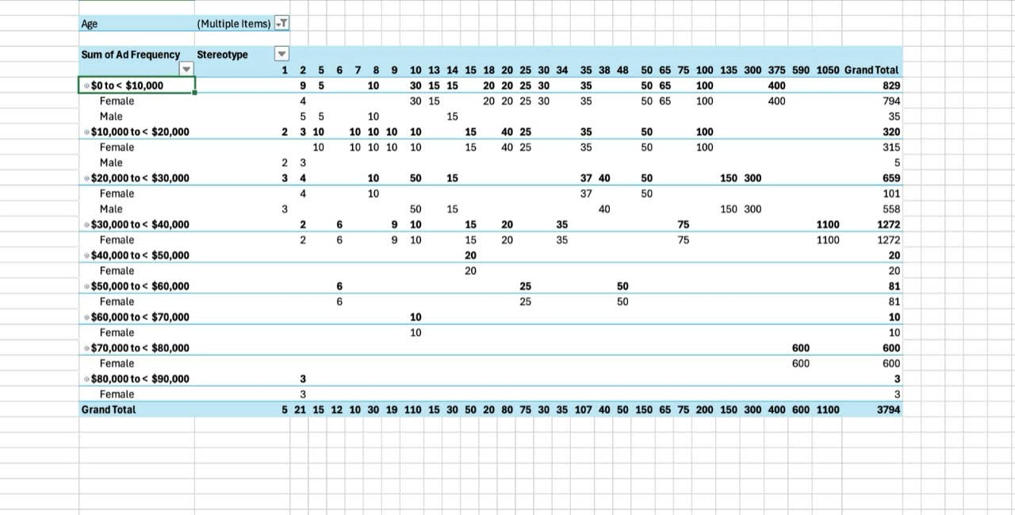

**Insights:**

* The proportion of ad frequency to exposed gender stereotype advertisements are high (for example: 8 out 10 advertisements are subscribed to traditional ads).
* As the number of advertisements frequency increases, the number of subscriptions of these gender stereotype advertisements increase → Advertising relies heavily on stereotypical portrayals.
* There is some data demonstrating extreme exposure of traditional advertisements in this age group. For example: 100, 136, 300, 375, 590, 1050 subscriptions of gender stereotype advertisements are seen in this age group.
* General trend suggests that people across income brackets consume media that tends to reinforce gender stereotypes.

Next, let’s see the data for the **25-34 aged group**:

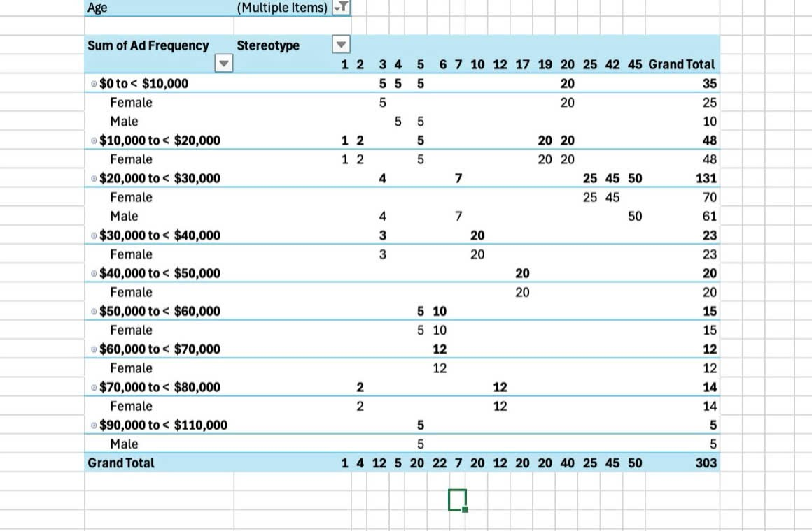

**Insights:**

* The income range now expands to $110,000.
* The ratio of frequency to exposure of traditional ads is still significant - about 4 out of 5 advertisements are subscribed to gender stereotypes.
* However, less extreme frequency is noticed compared to the younger aged group. This age group is still consuming media, but they are likely to be more selective in their ads consumption compared to the younger consumers.

→ It is possible that the older the age group is, the more they move toward targeted ads than broad advertisement.

Lastly, we will discover the pattern for the **35-68 aged group:**

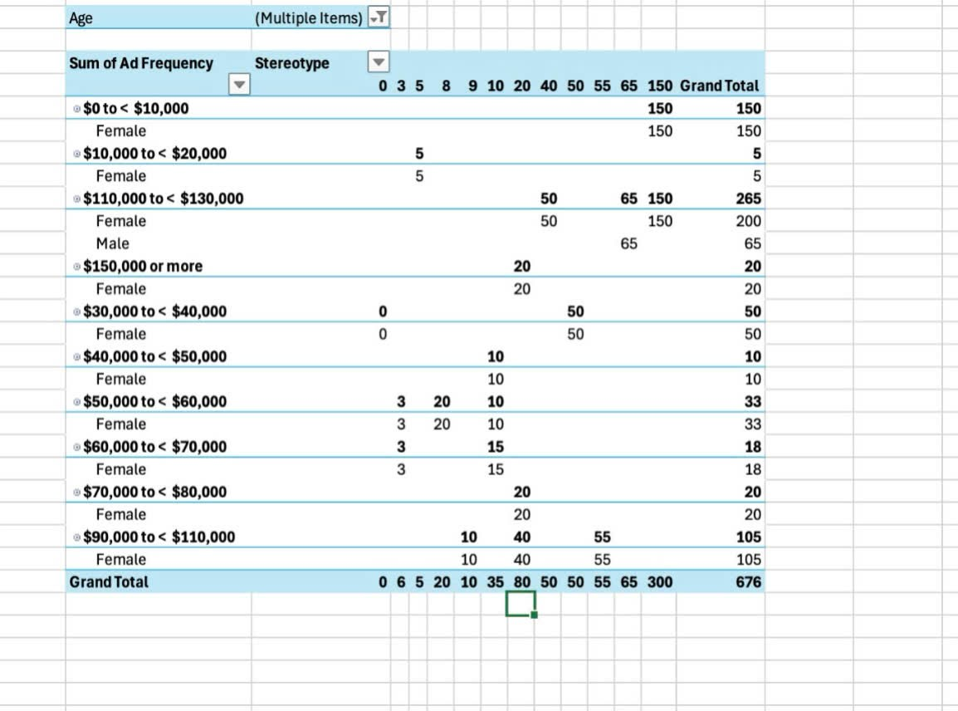

**Insights:**

* Still, there is high exposure in gender stereotypes despite income range and age group. → There is a potential of normalization of stereotypes which makes it harder for the individuals to resist these portrayals.

**Conclusion for gender stereotype analysis:**

* There is no correlation between income, age, education level and gender to the exposure of gender stereotype advertisements.
* It seems like the consumers may be accustomed to ads reinforcing gender stereotypes, leading to tolerance of these advertisements → In the Empowerment advertising analysis, we would discover if there is a growing interest in consuming empowerment ads.

1. **Empowerment advertising analysis:**

**2.1: Relationship between empowerment advertising and spending pattern**

* Rows: Average annual spending on beauty products
* Columns: Percentage of empowerment ads viewed per day
* Values: Counts of respondents
* Filter: Gender

Here, we choose “Gender” as a filter to easily compare and to have deep insights of the relationship between spending patterns and empowerment advertising.

**Men:   
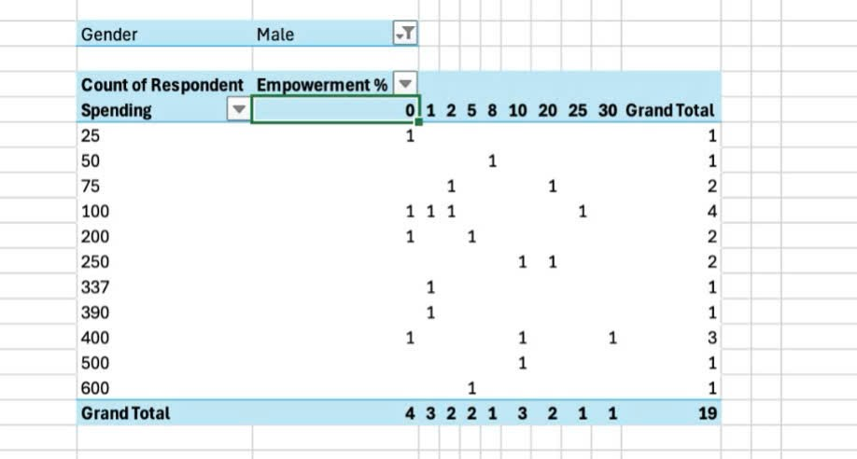**

**Women:**

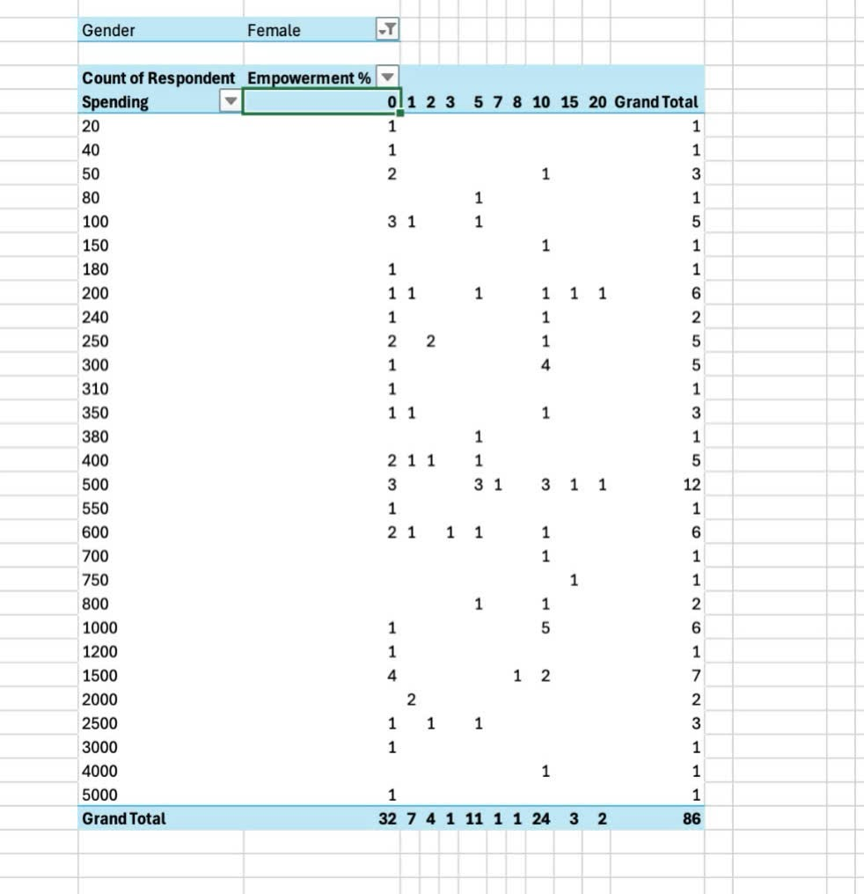

**Insights:**

* Most men spend from $100 to $400 for beauty/ hygiene products, while the range of spending of women is more diverse → possibly influenced by broader expenses to different product categories.
* An interesting point here is that both genders observe a very low percentage of advertisements that are viewed or heard per day currently utilize empower-ment advertising (0% to 10%) → The media is dominated by gender stereotype ads.

*Therefore, are the products purchased from the gender stereotype advertisements?*

→ There is a high chance that the buyers are buying products from the traditional ads, according to the gender stereotype analysis; however, this also indicates that **advertising has a significant influence on purchase behaviour**.

**2.2: Agreement with empowerment advertising by income and gender**

* Rows: Income
* Columns: Transform (Agreement level)
* Values: Count of respondents
* Filter: Gender

To make it easier to analyze, I would like to put “Gender” as a filter to easily compare the data.

**Men:**

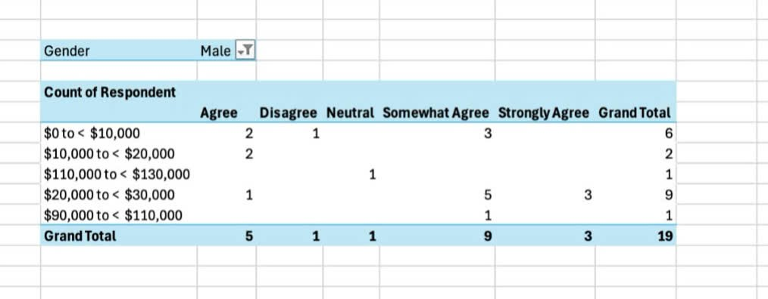

**Women:**

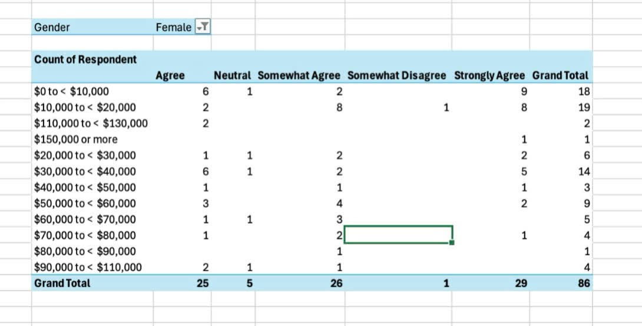

**Insight:**

* For both genders, the “Agree” spectrum (From “Somewhat Agree” to “Strongly Agree”) is dominant → Audiences are interested in hearing more empowerment advertising.
* Most of the people who choose in the “Agree” spectrum are in the low-income group (from $0 to $40,000). However, we need to remember that most respondents are from this income group, so we should avoid making assumptions based on **biases**.
* Instead, there is a potential growing demand for inclusivity for low income groups here.

1. **Cross analysis of Stereotyping and Empowerment insights:**

* According to stereotyping, we can conclude that there is no relationship between income, age, education level and awareness of gender stereotypes, but audiences genuinely have social awareness.
* Gender stereotype advertisements tend to dominate the market more, perhaps this stems from the fact that these advertisements are easier to produce because the messages can be clearly conveyed.
* There is a contradiction between consumer preferences and media strategy as most audiences agree that empowerment advertisements can transform cultural gender stereotypes. It is possible that the audiences are more socially conscious, and there is a growing demand for inclusivity for every type of beauty.
* **Recommendation:** 
  + Advertisers can gradually shift to empowerment messaging to fully convey the inclusivity message in their marketing campaigns. This will increase engagement and create a stronger cultural impact on society.
  + However, in order to not eliminate any potential clients, advertisers do not need to exclude immediately the campaigns for traditional advertisements, but keep for members who want to follow the beauty standards.