**Automatic grain size determination in metallographic images using deep learning**

**Abstract:** Grain size is one of the most important parameters in the metallographic microstructure analysis, and in most experiments this information is usually obtained by manual processes. However, those manual processes can take a long time and increase accidental errors. At present, the segmentation of metallographic image is limited by the complexity of traditional digital image processing, which makes the application scope of one algorithm narrow and specific, without universality. On the other hand, it is difficult to identify grain boundaries in the images with low contrast and bad defined boundaries. In the paper, we apply a deep convolutional neural network segmentation model to enable new automated microstructure segmentation for complex microstructure, usually manually and subjectively evaluated. The improved U-Net network is used to realize grain segmentation. The effectiveness of this method is verified by extensive metallographic images, and a practical case is given. It has a significant advantage for low contrast images, fuzzy boundary and complex structure of metallographic image edge extraction. The grain size was calculated according to American Society for Testing Material (ASTM) standards.

**Key words:** grain size; metallographic microstructure analysis; improved U-Net network; grain segmentation (关键词可以是摘要中没有，而正文中有的词么？)

Abstract：问题的背景或重要性。目前的方法受限于**导致无法解决**问题。本文提出了一个**方法，利用**解决该问题。方法主要步骤。实验结果表明，我们方法的**效果（准确率之类）比已有的高出多少。在**方面具有明显的先进性。

1. **Introduction**

Introduction（可包括若干文献）

问题的应用背景（意义很重大，3句左右）。

已有的解决方法（从大的原理角度阐述，注意与Related Work相比，更抽象，更方法论）。

虽然可行但存在难以解决的**问题。因此我们提出了**方法。该方法利用了**原理/方法，能够解决**问题。

本文的主要贡献：1,2,3（3条左右，干货）。

本文后续章节安排。

The microstructure of a material determines its properties, and the microstructure of materials mainly depends on their chemical composition and processing technology [1]. Among them, the determination of grain size plays an important role in the research of metal materials. It can obtain information related to material properties, such as yield strength, tensile strength, elongation, etc., which has an important impact on material properties [2]. Especially in the analysis of metal microstructure, the information of grain boundary, grain size and grain distribution can be obtained by image analysis, and these parameters can be estimated by automatic methods of image processing and mathematical morphology [3]. The traditional method of grain size determination is manual, time-consuming and error-prone. With the development of computer technology and image processing technology digital image processing and pattern recognition technology have become the main tools for automatic quantitative metallographic analysis and particle size determination [4,5,6]. There are specialized software for commercial metallographic Image analysis, such as image-pro Plus, Image Tool, and Image J. Although these devices reduce manual workload, they improve some analysis efficiency to some extent. But for the software operation is also more cumbersome, and need a considerable part of the cost. Moreover, it is very difficult to identify the image with more noise for the boundary blur. The most common problem is the low generality of existing methods due to the different characteristics of metallographic images of different alloys. Jiang et al. used the multi-scale geodesic expansion algorithm to restore and reconstruct grain boundaries based on the improved definition of expansion [7].Deng et al. proposed a new algorithm based on Canny algorithm and gray contour line to obtain the closed edge of metallographic structure [8].C. Park and Yu Ding et al. used convex analysis to divide the composite boundary into individual components, and used the missing value estimation based on FPCA (functional principal component analysis) to recover the missing components of the boundary [9]. Dengiz et al. Used neural network and fuzzy logic algorithm to detect the grain boundary of the alloy [10]. Łukasz Rauch et al. The use of feedback pulse coupled neural network optimization bionic optimization algorithm is part of the microstructural images [11]. Although good results can be obtained, the generality is still too poor to apply the metallographic image type I studied.

In this paper, a method to automatically measure the grain size of 690 alloy is introduced. According to the characteristics of this material, an edge detection algorithm based on deep learning is proposed. After the pretreatment of the metallographic image, the grain segmentation of the image was carried out, and the discontinuous grain boundary reconstruction was studied, and the reliability of grain boundary extraction was discussed.

1. **Related work**

Many researchers at home and abroad spent a lot of time on theoretical exploration and experimental research on grain boundary extraction. Currently, the main train of thought for studying the mainstream is divided into two directions [12]. One is the grain in metallographic image segmentation, the purpose is to get pieces of whole grain, grain size and grain between adjacency is grain boundary, the main methods are: watershed segmentation algorithm [13] [14], level set segmentation algorithm, clustering segmentation algorithm, etc. Secondly, some operators are used to extract grain boundaries directly from metallographic images, such as canny operator [15], Sobel operator [16] and kirsch operator.

For the first research idea, the main research focus is the grain in metallographic image. Many researchers have applied some excellent digital image segmentation algorithms to the grain segmentation of metallographic image. As for the second research idea, it mainly focuses on the research of grain boundary extraction in metallographic images, and the most common method is to apply the edge extraction algorithm to grain boundary extraction in metallographic images. Many researchers continue to try on the basis of the existing algorithm, broaden their thinking, and achieve certain results by combining other algorithms. However, according to the changes of the data set, the processing methods of these two roads will vary greatly, and it is difficult to accurately segment the more complex metallographic images. In recent years, with the rapid development of computer vision, deep learning is widely used in cell segmentation, road scene segmentation, etc., and achieved excellent results, so deep learning is combined with metallographic microstructure.

Since 2012, deep learning methods [17] have dominated many computer vision applications. This includes object recognition and detection, scene fusion, semantic segmentation and depth map prediction. The success of depth science is often attributed to the fact that convolutional neural network (CNN) can effectively represent the visual data hierarchy, and combine the low-level image features (edges, color gradients) into the higher-level features (such as object parts) corresponding to the abstract quality of the image theme. Recently materials scientists have begun to explore the limited applications of modern computer vision techniques for flexible and universal microstructure characterization.[18] and [19] explored these techniques in the context of microstructure classification. [20] and [21] used the pre-trained CNN representation to study the relationship between the processing conditions and the microstructure obtained through the descending and visualization techniques.[22] CNN segmentation model was used to identify the constituent phase of steel structure.

In recent years, various depth CNN architectures have been developed for intensive pixel-level tasks [23], such as semantic segmentation [24], edge detection, depth map, surface normal prediction [25], etc. Conceptually, it is the modern deep CNN that computes a highly nonlinear function by layer-by-layer combination of convolution, activation, and pooling (i.e., down-sampling) functions whose parameters are obtained from large annotated data sets through some variants of stochastic gradient descent [25,26].The classification neural network simplifies the input image into a single potential feature vector, in which the neural network designed for the pixel level task generates a potential representation for each pixel of the input image. This is usually achieved by fixed bilinear interpolation [26] or learning deconvolution operations [27]. In the latter network, the popular architectures are SegNet [24], Bayesian SegNet [28], u-net [29] with large data increment, and fully convoluted DenseNets [23]. In particular, u-net [29] is designed for medical image segmentation tasks with small data sets, and it relies on powerful data expansion to achieve good performance. Currently very new are deeplabV3+ and so on.

In this work, we applied the deep learning method to the image segmentation of complex microstructure data, aiming to extend the scope of quantitative analysis to the current subjective evaluation or evaluation of the microstructure system through laborious manual annotation.

1. **Method**

The preparation of metallographic samples mainly includes sampling, grinding, polishing and etching with appropriate etching agent, and then taking metallographic pictures with a microscope. Since。。。， Digital image must be processed after acquisition to meet the requirements of automatic determination of particle size. However, there are many factors that affect the quality of the image, such as lighting conditions and surface irregularities.Fig.1a shows the original metallographic image, which has low contrast, high noise and many uncertain boundaries. Traditional image processing methods, such as global threshold method (bimodal method, iteration method and OTSU method) and edge detection operators such as Sobel, Prewitt, Canny operator, cannot get ideal results.Fig.1b is the result of threshold value obtained by OTSU method, indicating that the grain boundary and background cannot be separated by this method.

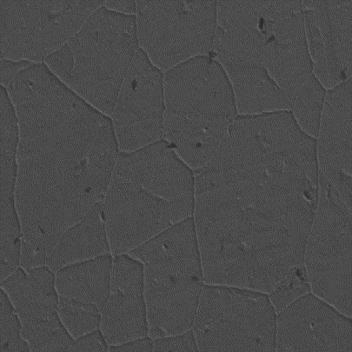 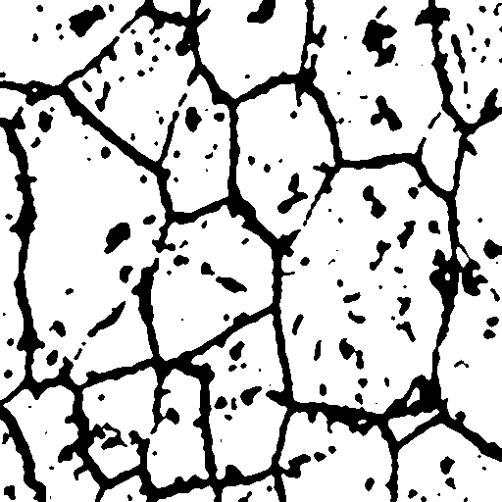

a b

fig1 metallographic image: a is the original image, and b is the image segmented by the threshold method

Method flow chart

**Pre-Processing**

During the preparation of metallographic samples, digital image often produces noise due to the existence of defects. Additional pretreatment should be carried out to eliminate noise. Median filtering and gaussian filtering are the most common denoising methods. Median filtering is a nonlinear filtering, which keeps edge information by removing salt and pepper noise, while gaussian filtering is a smooth linear filter, which can effectively eliminate gaussian noise. According to the need to choose a specific method to eliminate noise.

**U-Net**

U-net network structure is a deformation structure of convolutional neural network, as shown in fig2. The entire u-net neural network consists of two main parts, namely the contracting path and expanding path. The search path is mainly used to capture the contextual semantic information in the image to extract the image feature structure. The expansion path, as opposed to it, is to precisely locate the parts of the image that need to be segmented. U-Net can take advantage of data enhancement operations to train some rare data samples, especially those related to the medical field. Therefore, the proposed U-Net network structure is very effective for deep learning of medical images with few training samples, which is mainly used for medical image segmentation.

Before applying it to the analysis of microscopic metallographic images, some super parameter of the original u-shaped network are adjusted. Inspired by (4,5), considering the deeper structure, the number of channels in each convolution layer is increased by 0.5 times to improve the ability of model fitting and generalization. In addition, set the image input dimension to 256×256 pixels.

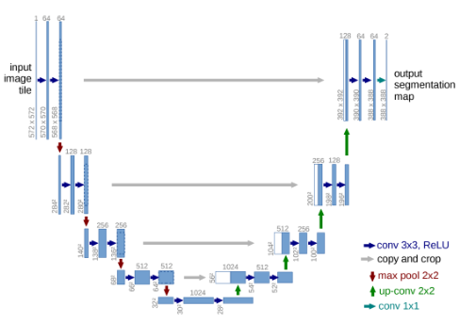

Fig2: unet network structure diagram

**Measurement of Performance**

Metallographic image segmentation is essentially a pixel-level classification task. In addition, there are far fewer boundary pixels than non-boundary pixels due to highly unbalanced instances. In order to accurately measure the performance of the proposed model, the following formula 1 scores, accuracy and recall degree are given in this paper, and then the intersection on the Union (IOU) is introduced, which is finally used in this study.

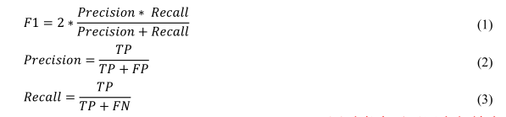

Where TP is True Positive, FP is False Positive, and FN is False Negtive, respectively. F1 considers both precision and recall, and calculates the harmonic average recall of precision and recall.F1 scores range from 0 to 1.The larger the F1 score, the better the model’s performance.

Many previous classification studies have used precision as the primary performance measure, which may be valid when different result categories have about the same number of observations. However, metallographic data sets often have highly unbalanced distribution characteristics. In this study, another intuitive and informative metric, the IOU[18], was introduced and adopted. As shown in figure 3, an IOU is defined as the area of the intersection (the green area) divided by the area of the union (the red area).The intersection represents the ground truth value and the area covered by the prediction, and the union represents the ground truth value or the area covered by the prediction. If the prediction fits the facts perfectly, the corresponding IOU is 100%.

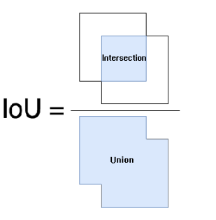

Fig3 definition of IOU

**DataSet**

In this paper, the self-made metallographic data set (690 alloy) was used to divide the selected images into blocks without overlapping. Finally, the pixel size of the metallographic image after cutting into blocks was 512*512, with a total of 90 grayscale image samples. The metallographic image label produced by Labelme software is binary image. The prepared data set (including the original data and its corresponding label data) was divided into 60 pieces as the training set, 15 pieces as the verification set and 15 pieces as the test set. The picture of the graph of data set is light and dark, the shape is varied, have extensive.

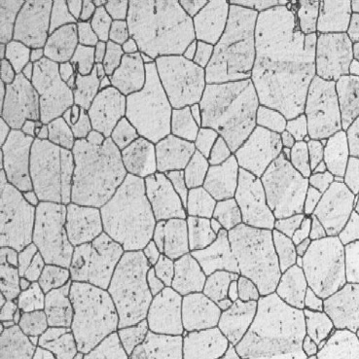 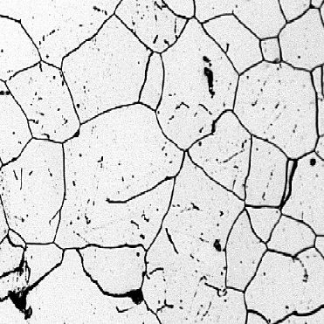

a b

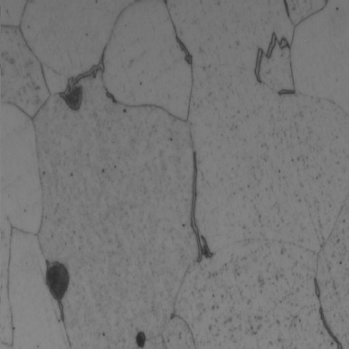 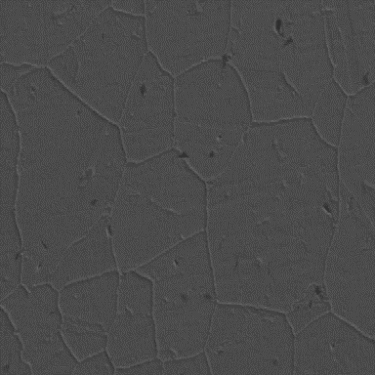

c d

fig4 original metallographic image sample

Compared with the general natural data set, the number of natural data sets is very limited. In this paper, translation, rotation and horizontal inversion are adopted to expand the data set of metallographic data that need to be trained. The data set expanded in this way makes the network model have the invariance of change and good robustness, and improves the training effect of the network model.

**Model Application**

The amount of training data of u-net model is further increased by data expansion. For hyperparameter tuning, Adam optimizer is used and the learning rate is 0001. The number of training sets was set to 60 and the binary cross entropy was used as the loss function. Relu activation functions are used in all layers except the last one, which USES the sigmoid function. In addition, the batch size is set to 5.

Because deep learning methods often require a large number of annotated training images, it is important to investigate whether data from one source can be used to train models that will apply to data from different sources.(consider two training sets, one a pure 690 alloy metallographic diagram and the other a mixed single-phase picture, considering its versatility.).

1. **Experiment and Discussion**

**Deep Learning Dataset Establishment**

Taking FIG. 4a as an example, the Labelme label was used to generate FIG. 4e. As the marked red boundary was too thick, the small crystal was almost covered. Firstly, the area of 8*8 is used for smoothing and denoising, and then the binarization is carried out. Morphology is used to extract the skeleton, also known as binary image refinement. This algorithm can refine a connected region into the width of a pixel, which is used for feature extraction and target topology representation, such as f. however, as the boundary has only one pixel, the loss rate to 0.002 is very low, the accuracy to 98%, but the effect is very poor. This is because the proportion of the boundary is very small in the background, so it is used. Therefore, the method of corrosion in morphology is used to thicken the boundary. Finally, the label of figure a is like g.

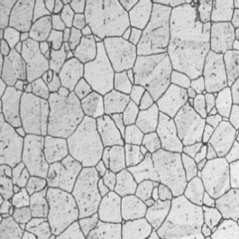 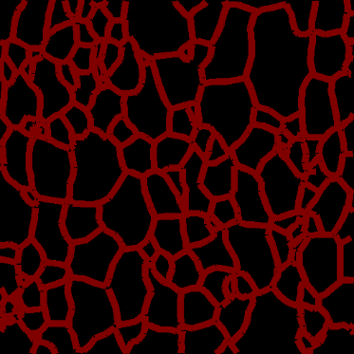

a e

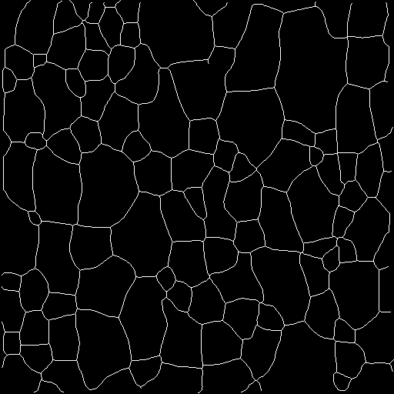 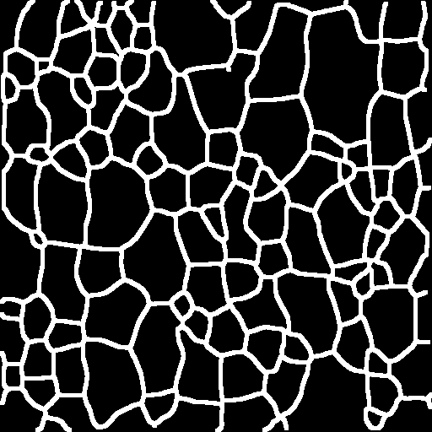

f g

fig5 Labelme is used to label the image

**Morphological method**

In order to facilitate the extraction of grain boundary and grain quantitative information, the gray scale map was converted into a binary map. After the binarization, there is a large amount of dotted salt and pepper noise, and the median filter method is used to remove it. In order to save the linear boundary and similar linear grain substructure adopts spot clean division, 8 connected neighborhood pixels model is adopted to search for "filter" image edge. the edge sealing spots pixel and spot pixel threshold set by the first comparison, proper maintenance, remove spots and reserve the substructure grain internal similar rod. The structure after noise elimination is like the "track" diagram. The "track" diagram still has many breakpoints that need to be fixed. This paper adopts the expansive corrosion technique in morphology, that is, the open operation (corrosion before expansion), to get the "opening" diagram.

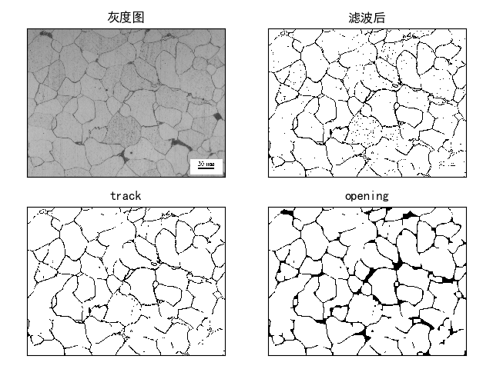

Fig 6: Results obtained by morphological methods

Although the noise is basically eliminated, the boundary becomes discontinuous and cannot achieve the effect of automatic rating.

**Watershed method**

Watershed algorithm is an important algorithm in grain segmentation, but for metallographic images with too much noise, it is easy to produce over-segmentation. The effect is shown in FIG. 7, which is very poor. It’s not going to be able to do the automatic rating.

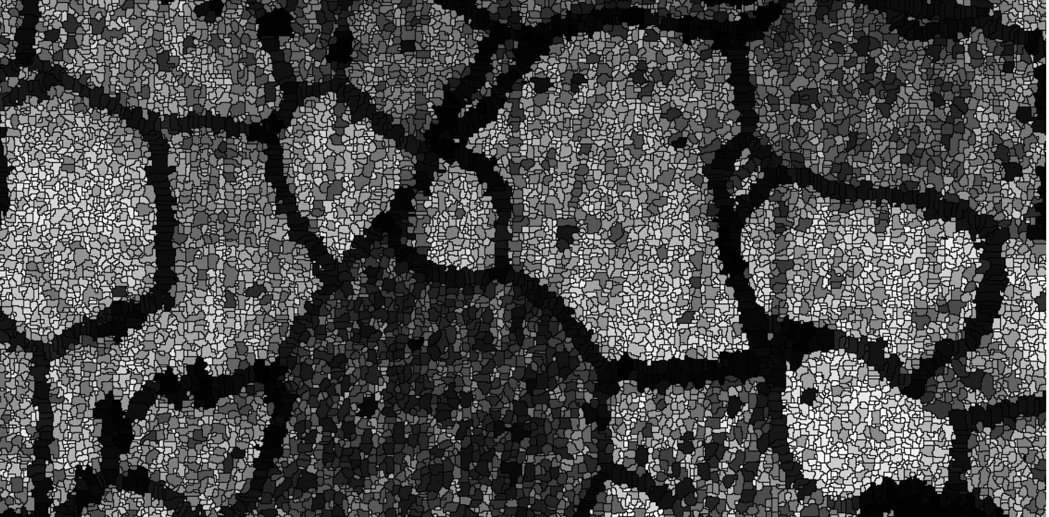

Fig.7 The results obtained through the watershed

**Directly with U-Net**

The structure of the direct u-net training network is as follows:

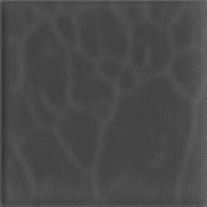

Fig 8 The results obtained directly by U-Net method

Because the contrast of the picture is very poor, if you use the u-net network for training, not very good results.

**Improved**

Firstly, the training image is processed with grayscale and median filtering, and then the 8*8 region is used to smooth the denoising. Finally, an adaptive threshold binarization is carried out. Then it was trained with a preliminary improved u-net.

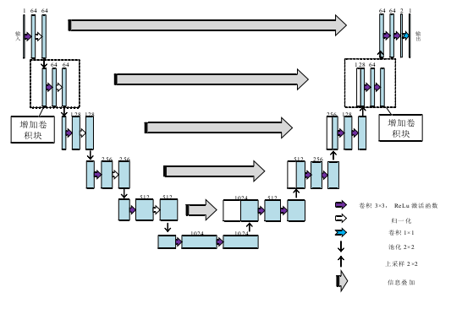

Fig9: preliminarily improved u-net

The test is as follows:

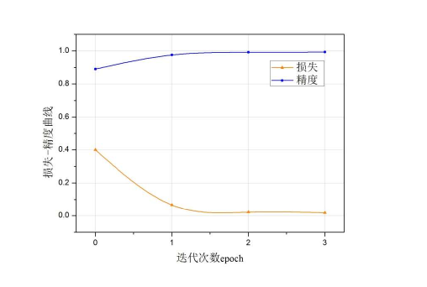

Fig 10: Number of iterations and loss relation graph

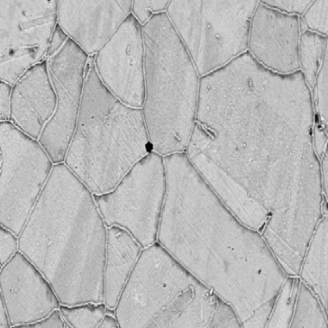 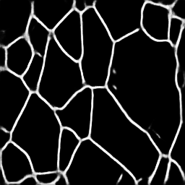

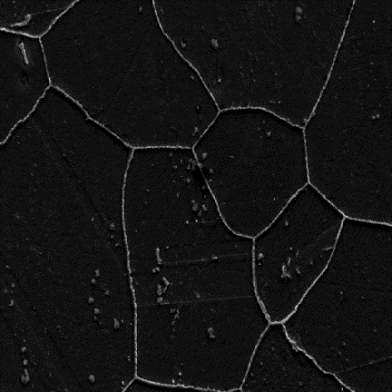 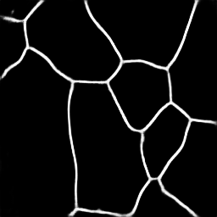

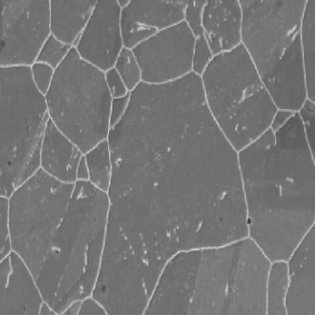 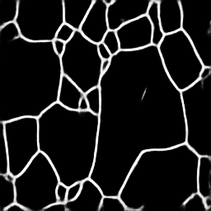

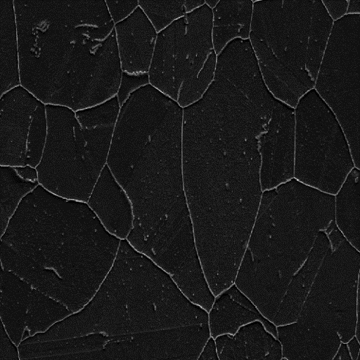 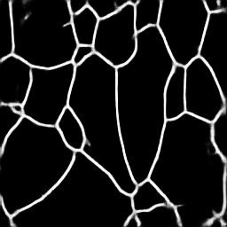

Fig 11: Results of our method

其他网络的对比表格（deeplab系列 segNet PixelNet）

**Grain size rating**

According to ASTM standard e112-12 [25], three commonly used methods for calculating particle size are provided. These are the comparison processes，the plane measurement processes and the intercept processes. The comparison process does not require the calculation of particles, intercepts, or intersections. But it compares the images to a series of standard hierarchical images. Planar measurements involve the actual count of particles in a known area. The intercept method involves the number of grains intercepted by a test line or intersected by a test line, that is, the unit length of the test line. ASTM standard (e112-12) recommends the use of plane measurements and intercept methods to improve machining accuracy. They are repeatable and reproducible with an accuracy of 0.25 units of particle size and 0.5 units of particle size. With the same precision, the intercept method is faster than the plane method.

The intercept method and the plane method can produce the same level precision. But the intercept method is faster than the plane method. According to the advantages of the intercept method, the selected intercept method is used to determine the grain size. The grain size can be calculated as follows:



Where, l is the average intercept length in mm, and G is the grain size in the equation.

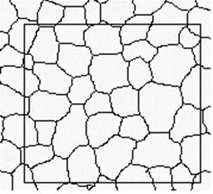 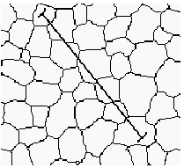

The area method Cutting line method

Measure the grain area step：

A. Select a rectangular area to calculate the area of the rectangular area

B. Calculate the number of grains: ( is the number of grains in the box, is the number of grains across the box boundary, minus 1 because the grains on the corner were counted twice, a total of four corners, so we need to subtract 1)

C. The grain area is obtained by dividing the rectangular area by the number of grains

D. Calculate the number of grains in unit area (mm2), and the grain size level

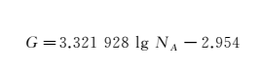

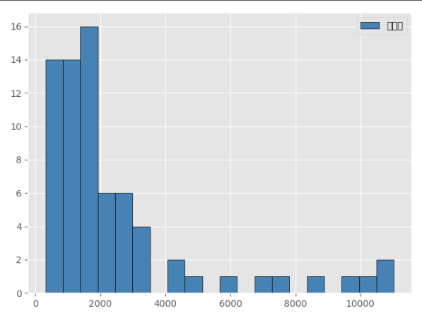

Fig 12 Area distribution statistics

Grain size level statistics：

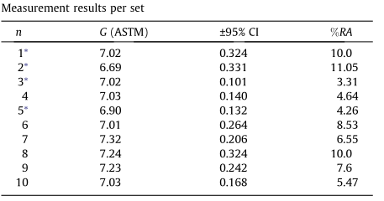

1. **Conclusion and Future Work**

Automatic determination of grain size by deep learning technique is a new method for microstructure analysis of materials. In this study, a deep learning-based segmentation method was proposed for the defects and features in the metallographic image of 690 alloy, and the mathematical morphology and watershed methods were compared to extract and reconstruct grain boundaries. Experimental results show that this method is superior to the traditional metallographic image processing method. The grain boundary obtained by this method is complete and continuous in a short time. In order to improve the accuracy and performance of this method, further research will be carried out and an enhanced image processing algorithm for metallographic analysis will be adopted. After digital image processing, more detailed shape fact；or, fractal dimension and other parameters can be obtained to describe the microstructure characteristics of high-strength aluminum alloy, so as to establish the characterization system of high-strength aluminum alloy.

参考文献：

1.Segmenting images with complex textures by using hybrid algorithm

2. Shan L N, Li D Y. China Foundry Machinery & Technology[J],2005(1): 4 (in Chinese)

3. Automatic grain size determination in microstructures using image processing

4. Ortalan V, Herrera M, Morgan D G et al. Ultramicroscopy[J], 2009, 110: 67

5. Peregrina-Barreto H, Terol-Villalobos I R, Rangel-Magdaleno J Jet al. Measurement[J], 2013, 46(1): 249

6. Wang K X, Zeng W D, Zhao Y Q et al. Rare Metal Materials and Engineering[J], 2011, 40(5): 784 (in Chinese)

7. Jiang M X, Chen G H. Optics and Precision Engineering[J], 2011, 10: 33 (in Chinese)

8.Deng S C, Liu T G, Xiao Z X. Optics and Precision Engineering[J], 2010, 18(10): 2314 (in Chinese)

9. Park C, Huang J Z, Ding Y et al. IIE Transactions[J], 2012, 44(7): 507

10. Orhan Dengiz, Alice E Smith, Ian Nettleship. Computers inIndustry[J], 2005, 56: 854

11 Łukasz R, Łukasz S, Kusiak J. Artifical Intelligence and Soft Computing [M]. Heidelberg: Springer Berlin, 2010: 80

[12] Research on the Algorithm Used for Grain Boundary Extraction from Metallographic Images and Design of Intelligent Rating Software(朱建栋)

[13] Vincent L, Soille P. Watersheds in Digital Spaces: An Efficient Algorithm Based

on Immersion Simulations[J]. IEEE Trans.patt.anal. & Machine.intell, 1991, 13(6):583-598.

[14] Li C, Huang R, Ding Z, et al. A Level Set Method for Image Segmentation in the Presence of Intensity Inhomogeneities With Application to MRI[J]. IEEE Transactions on Image Processing A Publication of the IEEE Signal Processing Society, 2011, 20(7):2007.

[15] Canny J. A Computational Approach to Edge Detection[M]. IEEE Computer Society, 1986.

[16] Gao W, Zhang X, Yang L, et al. An improved Sobel edge detection[C]// IEEE International Conference on Computer Science and Information Technology. IEEE, 2010:67-71.

[17] Yann LeCun, Yoshua Bengio, and Geoffrey Hinton. “Deep learning”. In: Nature 521.7553 (2015),pp.436–444.Issn:1476-4687.Doi:10.1038/nature14539.url: http://dx.doi.org/10.1038/nature14539(cit. on pp. 2, 3).

[18] Brian L. DeCost and Elizabeth A. Holm. “A computer vision approach for automated analysis and classification of microstructural image data”. In: Computational Materials Science 110 (2015), pp. 126–133.doi: 10.1016/j.commatsci.2015.08.011 (cit. on p. 2).

[19] Aritra Chowdhury et al. “Image driven machine learning methods for microstructure recognition”. In: Computational Materials Science 123(2016), pp. 176–187 (cit. on p. 2).

[20] Nicholas Lubbers, Turab Lookman, and Kipton Barros. “Inferring Low-Dimensional Microstructure Representations Using Convolutional Neu-ral Networks”. In: CoRR (2016). arXiv: 1611.02764 [physics.comp-ph] .url: http://arxiv.org/abs/1611.02764v1 (cit. on p. 2).

[21] Brian L. DeCost, Toby Francis, and Elizabeth A. Holm. “Exploring the microstructure manifold: image texture representations applied to ultrahigh carbon steel microstructures”. In:ActaMaterialia133(2017),pp.30–40.doi:10.1016/j.actamat.2017.05.014 . url:http://arxiv.org/abs/1702.01117 (cit. on p. 2).

[22] Seyed Majid Azimi et al. “Advanced Steel Microstructural Classification by Deep Learning Methods”. In: Scientific Reports 8.1 (2018). issn:2045-2322. doi: 10.1038/s41598-018-20037-5. url: http://dx.doi.org/10.1038/s41598-018-20037-5 (cit. on p. 2).

[23] Panqu Wang et al. “Understanding Convolution for Semantic Segmen-tation”. In: CoRR (2017). arXiv: 1702.08502 [cs.CV]. url: http://arxiv.org/abs/1702.08502v1 (cit. on p. 3).

[24] V. Badrinarayanan, A. Kendall, and R. Cipolla. “SegNet: A Deep Convolutional Encoder-Decoder Architecture for Scene Segmentation”.In: IEEE Transactions on Pattern Analysis and Machine Intelligence PP.99 (2017), pp. 1–1. issn: 0162-8828. doi: 10.1109/TPAMI.2016.

2644615 (cit. on pp. 3, 4).

[25] A. Bansal, B. Russell, and A. Gupta. “Marr Revisited: 2D-3D Alignment via Surface Normal Prediction”. In: 2016 IEEE Conference on Computer Vision and Pattern Recognition (CVPR). 2016, pp. 5965–5974. doi:10.1109/CVPR.2016.642 (cit. on p. 3).

[26] Bharath Hariharan et al. “Hypercolumns for Object Segmentation and Fine-Grained Localization”. In: The IEEE Conference on Computer Vision and Pattern Recognition (CVPR). 2015 (cit. on p. 4).

[27] Jonathan Long, Evan Shelhamer, and Trevor Darrell. “Fully convolutional networks for semantic segmentation”. In: 2015 IEEE Conference on Computer Vision and Pattern Recognition (CVPR) (2015). doi:10.1109/cvpr.2015.7298965 . url: http://dx.doi.org/10.1109/

cvpr.2015.7298965 (cit. on p. 4).

[28] Alex Kendall, Vijay Badrinarayanan, and Roberto Cipolla. “Bayesian Segnet: Model Uncertainty in Deep Convolutional Encoder-Decoder Architectures for Scene Understanding”. In: CoRR (2015). arXiv: 1511.02680 [cs.CV] . url: http://arxiv.org/abs/1511.02680v2 (cit. on

p. 4).

[29] Olaf Ronneberger, Philipp Fischer, and Thomas Brox. “U-Net: Convolutional Networks for Biomedical Image Segmentation”. In: Medical Image Computing and Computer-Assisted Intervention – MICCAI 2015 (2015), pp. 234–241. issn: 1611-3349. doi: 10.1007/978-3-319-24574-4_28 .url: http://dx.doi.org/10.1007/978-3-319-24574-4_28 (cit. onpp. 4, 12).

[30] Simon Jégou et al. “The One Hundred Layers Tiramisu: Fully Convolutional DenseNets for Semantic Segmentation”.In:CoRR(2016).arXiv:1611.09326 [cs.CV] . url: <http://arxiv.org/abs/1611.09326v2> (cit. on p. 4).

[31] Karen Simonyan and Andrew Zisserman. “Very Deep Convolutional Networks for Large-Scale Image Recognition”. In: CoRR abs/1409.1556(2014). url: http://arxiv.org/abs/1409.1556 (cit. on pp. 4, 5).

[32] Vinod Nair and Geoffrey E. Hinton. “Rectified Linear Units Improve Restricted Boltzmann Machines”. In: Proceedings of the 27th International Conference on International Conference on Machine Learning. ICML’10.Haifa, Israel: Omnipress, 2010, pp. 807–814. isbn: 978-1-60558-907-7.url: http://dl.acm.org/citation.cfm?id=3104322.3104425 (cit.on p. 4).