PRACTICAL ASSIGNMENT REPORT
Cleaning and Analyzing Hotel Booking Data
Group: Nhóm 10 · Course: Data Analysis with Python · Lecturer: Dr. Tran Hung
Name | Student’s ID | Phụ trách chính
Hà Nhật Huy | 11253519 | A1-A5, B1-B4, C1-C3, D1-D5(Câu 1 - Câu 5), Bonus 2
Lê Minh Quân | 11257109 | A6, B5-B8, C4-C4+, D6-D10(Câu 6 - Câu 10), Bonus 1

Submission date: …/…/……

1. Objectives and Data Source 3
1.1. Objective 3
1.2. Unit of analysis 3
1.3. Source and licence 3
1.4. Period 3
1.5. Limits of the data 3
2. Data Quality and Processing 4
2.1 Overview before and after cleaning 4
2.2 Three representative cleaning decisions 4
2.2.1 Decision 1. Defining the booking as the unit of analysis Error! Bookmark not defined.
2.2.2 Decision 2. Harmonising labels and reconciling is_canceled with reservation_status Error! Bookmark not defined.
2.2.3 Decision 3. Converting invalid dates and measurements to missing instead of correcting them Error! Bookmark not defined.
2.3 Why missing values were retained 6
3. Findings from the Data 7
3.1 Insight 1: Cleaning changed both the number of bookings and the measured cancellation rate 7
3.2 Insight 2: City Hotel has a higher cancellation rate than Resort Hotel 7
3.3 Insight 3: The 2016 monthly pattern differs between the two hotels 8
3.4 Insight 4: Cancellation rates rise with booking lead time 8
3.5 Insight 5: Non Refund bookings are almost always recorded as canceled 10
3.6 Insight 6: Groups has the highest cancellation rate, but the gap narrows within one deposit type Error! Bookmark not defined.
4. Limitations and Recommendations 13
4.1 Limitations 13
4.2 Recommendations for data and next questions 13
5.Division of Work 14
Appendix 15
Appendix A. Cleaning log (20 logged rules) 15
Appendix B. Supplementary results for Questions 3 and 4 16
Appendix C. Top 10 guest countries (Question 5) 17
Appendix D. Cancellation rate by market segment and deposit type (Question 6, supplementary) 18
Appendix E. Average daily rate, non-canceled bookings (Question 8) 18
Appendix F. Length of stay, non-canceled bookings (Question 9) 19
Appendix G. Room type changes at check-out (Question 10) 19

1. Objectives and Data Source

1.1. Objective
This report presents a descriptive analysis of booking records from two hotels in Portugal. It addresses ten questions on cancellations, seasonality of arrivals, booking lead time, guest country, market segments, deposit type, average daily rate (ADR), length of stay and room reassignment. The analysis is written from the viewpoint of a hotel group's revenue-management team. It describes and compares groups; it does not estimate causal effects.

1.2. Unit of analysis
One booking corresponds to one distinct booking_id. The raw file has 10,325 rows and 24 columns, but a row is an extraction record, not a booking: the file was assembled from several extractions, so one booking can appear in more than one row. After cleaning, the data contain 10,000 bookings: 6,702 (67.0%) at City Hotel and 3,298 (33.0%) at Resort Hotel.

1.3. Source and licence
The data come from Antonio, de Almeida and Nunes (2019), which documents booking demand at a resort hotel in the Algarve and a city hotel in Lisbon. The analysed file is a random sample of the 119,390 bookings in the original dataset (retrieved from the TidyTuesday repository, week of 11 February 2020). It was prepared for teaching: formatting errors, missing values, contradictory records and duplicate rows were inserted deliberately. The results therefore describe this sample and are not the hotels' actual operating performance.
Reference: Antonio, N., de Almeida, A., & Nunes, L. (2019). Hotel booking demand datasets. Data in Brief, 22, 41–49. https://doi.org/10.1016/j.dib.2018.11.126 (CC BY 4.0). Teaching version of the dataset, accessed 04/10/2026.

1.4. Period
Arrival dates run from 1 July 2015 to 31 August 2017; the latest reservation-status update in the source is 14 September 2017. Only 2016 covers all twelve months, so totals for 2015 and 2017 are not compared with 2016.
Variable definitions used in this report:
- adr: average daily rate, the booking's price per night in euro. It is not realised revenue.
- is_canceled: 1 for both canceled and no-show bookings.
- lead_time: number of days between the booking entry and the arrival date.

1.5. Limits of the data
The data contain no realised revenue or profit, no reasons for cancellation and no guest reviews. According to the source authors, guest country is usually confirmed at check-in, so it may be less reliable for cancelled bookings. The findings concern two hotels in one country during 2015–2017 and cannot be generalised to the hotel industry.

2. Data Quality and Processing

2.1 Overview before and after cleaning
Table 1. Data quality before and after cleaning.
Indicator | Before (n = 10,325 rows) | After (n = 10,000 bookings) | Note
Rows / bookings | 10,325 | 10,000 | Denominators differ (input rows vs. clean bookings).
Distinct booking_id | 10,145 | 10,000 | 215 codes trimmed/uppercased (strip().upper()).
Duplicated on 23 cols | 180 (raw) / 181 (norm) | 0 | 1 duplicate hidden by case/whitespace issue.
Repeated booking_id | 325 | 0 | 181 exact duplicates dropped (B1); 144 merged (B8).
City Hotel label | 6,763 | 6,702 | 151 variant spellings normalized; deduplicated.
is_canceled contradicting reservation_status | 41 rows | 0 | 40 recomputed (B4); 1 dropped in B1.
Canceled bookings | 3,769 | 3,741 | Cleaned flags written as yes/True/1.0.
Cancellation rate | 36.50% | 37.41% | +0.91 pp change due to data cleaning.
Missing adr | 0.24% (25 cells) | 0.36% (36 cells) | 11 values outside 0–1,000 or non-numeric set to missing.
Missing lead_time | 0.10% (10 cells) | 0.31% (31 cells) | 21 values below 0 or above 800 days set to missing.
Missing country | 1.23% (127 cells) | 1.07% (107 cells) | 113 of the 127 missing cells lie in representative rows; 6 of these were filled from another row of the same booking (B8).
Source: outputs/tables/q01_before_after.csv, outputs/quality_report.csv.

2.2 Three representative cleaning decisions

2.2.1 Decision 1. Defining the booking as the unit of analysis
Problem. booking_id had spaces or lower case in 215 cells (R00096, "BK044016 "), which inflated the number of distinct codes to 10,145. 181 rows repeated another row on all 23 business columns (R00608 repeats R00041), and 144 rows shared a booking_id with another row but differed in content. In 15 bookings the non-missing values disagreed: lead_time in 7 and adr in 8 (BK051775: adr 208.90 in R02322, 198.9 in R03865).
Rule. booking_id was trimmed and upper-cased before any comparison. Exact duplicates were removed, keeping the first row. The remaining rows with the same booking_id were merged column by column, taking the first non-missing value in ascending row_id order; this filled 22 missing cells. For the 15 conflicts, the value from the lowest row_id was kept and the conflict was flagged in the note column of row_lineage.csv.
Rationale. Duplicate detection on all 24 columns finds nothing because row_id is unique. The data dictionary treats bookings with different codes as different bookings, so rows were never merged on content alone: 1,759 bookings that match another booking on all other business columns were kept (a possible case is a group booking several identical rooms). The file does not say which extraction is authoritative, so a documented rule was used instead of averaging.
Impact. Without this step the data would hold 325 surplus rows (3.1% of the file), and duplicated records would count twice. Conflicts affect 15 of 10,000 bookings (0.15%).

2.2.2 Decision 2. Harmonising labels and reconciling is_canceled with reservation_status
Problem. After exact duplicates were removed, 865 rows (896 cells) carried a non-standard label in seven categorical columns (R00010, "city hotel"), and 272 cells in is_canceled and is_repeated_guest used yes/no, True/False or 1.0/0.0. In addition, 40 rows were contradictory: 29 with status Check-Out and 11 with Canceled or No-Show. In R00856, is_canceled is 1 while the status is Check-Out; the status date (20 September 2016) equals the arrival date (17 September 2016) plus the three booked nights.
Rule. Labels were mapped to the standard sets with dictionaries keyed on a normalised string; no unrecognised label remained (invalid count 0 in quality_report.csv). Where reservation_status was valid, is_canceled was recomputed from it (Check-Out → 0; Canceled and No-Show → 1); where it was missing, the standardised flag was kept. The meal label "Undefined" (101 rows) was recoded to SC, which the source documentation treats as the same thing.
Rationale. reservation_status is the final state recorded with a date, and the dates support it. Of the 29 contradictory Check-Out rows, 28 have a valid arrival date, status date and night count, and in all 28 the status date equals arrival plus booked nights. All 11 contradictory Canceled or No-Show rows have a status date on or before arrival. These rows were corrected, not deleted.
Impact. The reconciled rate is 37.41% (3,741 of 10,000 bookings), against 36.50% from the literal value "1" on raw rows. Exact label matching would also have missed 151 City Hotel rows with variant spellings.

2.2.3 Decision 3. Converting invalid dates and measurements to missing instead of correcting them
Problem. Arrival dates came in four formats: ISO (8,330 rows), dd/mm/yyyy (822), dd-Mon-yyyy (512) and "Month d, yyyy" (626); 25 were blank and 10 were not dates (R00030, "not_a_date"). Among the dates in the four formats, six were non-existent (R00169, "31/02/2016") and eight were outside the observation window (R00888, "2020-01-15"). adr carried a currency marker (€ or EUR) in 40 rows (R00081, "€114.30") and a decimal comma in 81 (R00432, "62,00"); 11 values were outside 0–1,000 or non-numeric (R00080, "-11"). A further 21 lead times were outside 0–800 days or non-numeric.
Rule. Each date format was parsed explicitly, reading dd/mm/yyyy day first; non-existent or out-of-window dates were set to missing with the reason logged. Currency markers were removed and the decimal comma replaced by a point (95,50 → 95.5); out-of-domain values were set to missing. Admissible but unusual values were kept: 132 bookings with ADR = 0 (120 non-canceled), lead times up to 709 days, 38 zero-night stays and 10 zero-guest bookings.
Rationale. The data support the day-first reading. Among 494 input rows with status Check-Out, a dd/mm/yyyy arrival date and a valid status date and night count, the status date minus the arrival date equals the booked nights in all 494 rows under the day-first reading, but in only 52 (10.5%) under a month-first reading. Where no such evidence exists (R00888), the true value cannot be reconstructed.
Impact. The 49 bookings without a valid arrival date (0.49%) are excluded only from Question 3, and the 31 without lead time only from Question 4 (n = 9,969). ADR statistics (Question 8) rest on 6,121 non-canceled bookings with ADR > 0; 120 zero-ADR and 18 missing-ADR non-canceled bookings are reported separately.

2.3 Why missing values were retained
Missing values were kept as missing; they were not imputed and not used as grounds to delete records.
- No evidence supports a replacement. Assigning the 107 bookings with unknown country to the most common country (PRT) would raise Portugal's share from 40.05% to 41.12% with no supporting observation.
- Deleting rows would discard usable information. 347 bookings (3.47%) have at least one missing value in the business columns, yet most remain valid for analyses that do not use the missing field. Each analysis therefore uses all available cases for its variables and states its denominator (9,969 for lead time, 9,997 for market segment, 6,121 for ADR).
- Missingness is low. After cleaning, the highest rates among the original columns are 1.07% (country), 0.49% (arrival_date), 0.36% (adr) and 0.31% (lead_time) (Table A2).
Missing rates for adr, lead_time and arrival_date are higher after cleaning because values that were present but invalid are now recorded as missing. reservation_status is missing for 25 bookings because 26 input rows held only a date in that field; the date was moved to reservation_status_date (B2) and the status left empty. The label "Unknown" is used only when presenting results and is never stored. The process that generated the missing values was not tested, so an association between missingness and cancellation cannot be excluded.

3. Findings from the Data
Six findings are reported, one per topic: data quality, hotel, seasonality, lead time, deposit type and market segment. Each states its denominator, a comparison and a limitation. All statements describe associations in a sample of two hotels in 2015–2017; none describes a cause.

3.1 Insight 1: Cleaning changed both the number of bookings and the measured cancellation rate
Cleaning changed both the booking count and the measured cancellation rate. The input contains 10,325 rows but only 10,000 distinct bookings: 181 exact duplicate rows were removed and 144 rows sharing a booking_id were merged (Table 1). The cancellation rate is 36.50% on raw rows (3,769/10,325, counting the literal value “1”) and 37.41% on cleaned bookings (3,741/10,000), an increase of 0.91 percentage points (Table 2). Cleaning also standardized 105 cancellation flags and recomputed 40 from reservation_status. Limitation: 15 bookings had conflicting lead_time or adr values, resolved using the lowest row_id.

3.2 Insight 2: City Hotel has a higher cancellation rate than Resort Hotel
Figure 1. Cancellation rate by hotel. n = 10,000 bookings
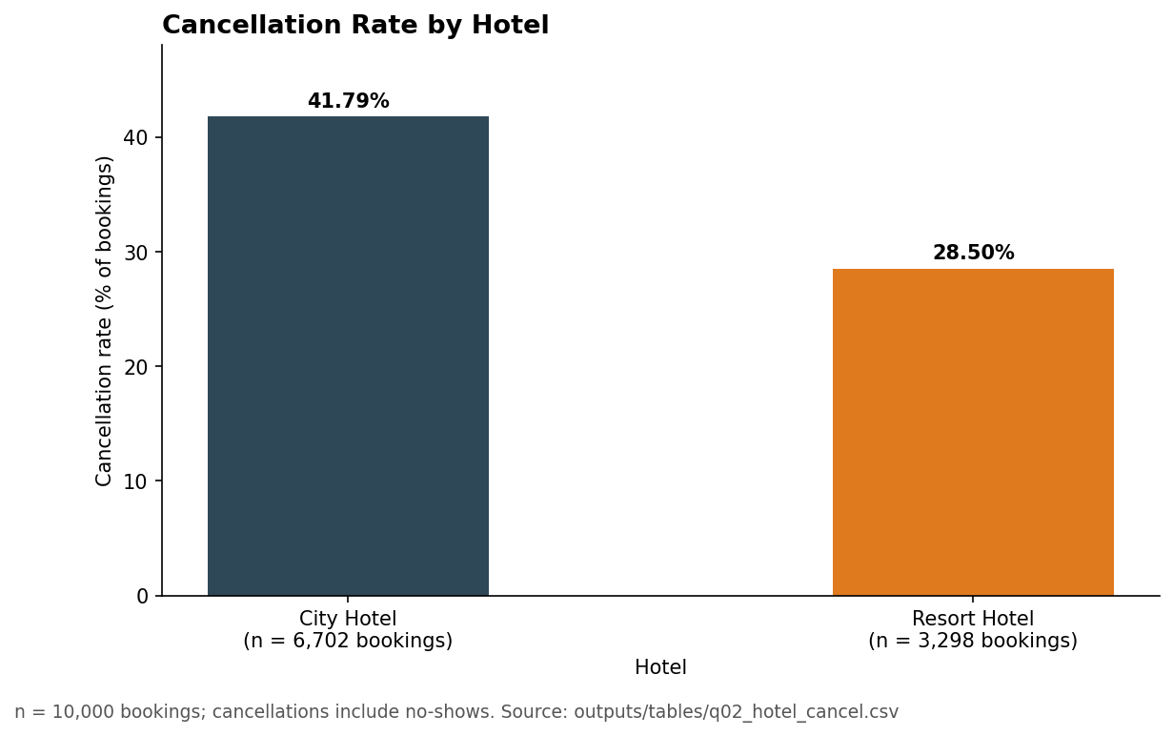
Source: outputs/tables/q02_hotel_cancel.csv.

Table 3. Bookings and cancellations by hotel.
Hotel | Bookings | Share of bookings (%) | Canceled | Cancellation rate (%)
City Hotel | 6,702 | 67.02 | 2,801 | 41.79
Resort Hotel | 3,298 | 32.98 | 940 | 28.50
Source: outputs/tables/q02_hotel_cancel.csv.

City Hotel has a higher cancellation rate than Resort Hotel. Of the 10,000 cleaned bookings, 6,702 (67.02%) are City Hotel bookings, of which 2,801 were canceled (41.79%); Resort Hotel has 3,298 bookings, of which 940 were canceled (28.50%) (Table 3, Figure 1). The gap is 13.29 pp, and the City Hotel rate is 1.47 times the Resort Hotel rate. City Hotel accounts for 74.87% of all canceled bookings (2,801 of 3,741) against 67.02% of all bookings. Limitation: the hotels differ in type and location (Lisbon and Algarve) and the data contain no cancellation reasons, so the gap is not explained.

3.3 Insight 3: The 2016 monthly pattern differs between the two hotels
Figure 2. Bookings by arrival month in 2016, by hotel
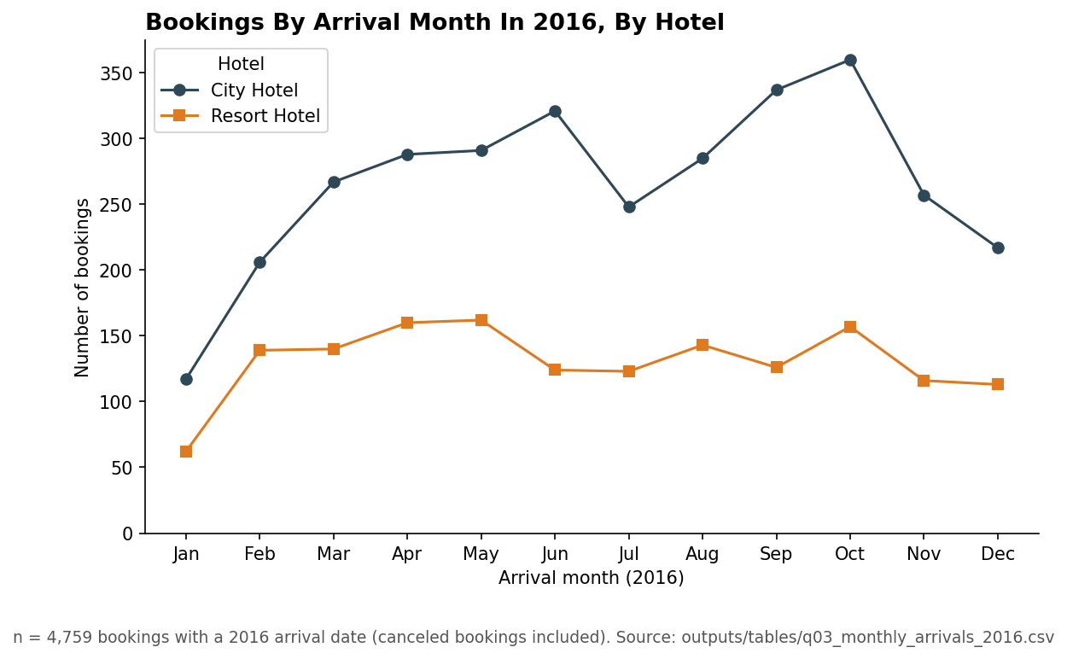
Source: outputs/tables/q03_monthly_arrivals_2016.csv; monthly values in Table B1.

The 2016 monthly pattern differs between the two hotels. Of 4,759 bookings with a 2016 arrival date (canceled bookings included), City Hotel peaks in October with 360 bookings and is lowest in January with 117, a ratio of 3.08; Resort Hotel peaks in May with 162 and is lowest in January with 62, a ratio of 2.61 (Figure 2, Table B1). From February to December, Resort Hotel's monthly counts stay between 113 and 162, while City Hotel's range from 206 to 360. The combined cancellation rate is 40.62% in October and 22.35% in January, a gap of 18.27 pp. Limitation: one full year only, and the monthly cancellation rate is not split by hotel.

3.4 Insight 4: Cancellation rates rise with booking lead time
Figure 3. Cancellation rate by booking lead-time group.
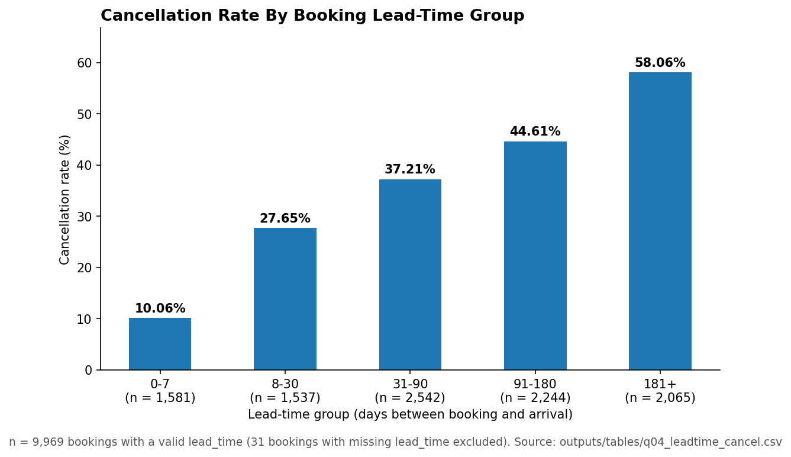
Source: outputs/tables/q04_leadtime_cancel.csv.

Table 4. Cancellation rate by lead-time group.
Lead-time group (days) | Bookings | Canceled | Cancellation rate (%)
0-7 | 1,581 | 159 | 10.06
8-30 | 1,537 | 425 | 27.65
31-90 | 2,542 | 946 | 37.21
91-180 | 2,244 | 1,001 | 44.61
181+ | 2,065 | 1,199 | 58.06
Source: outputs/tables/q04_leadtime_cancel.csv.

Cancellation rates rise with booking lead time. Across 9,969 bookings with a valid lead_time (31 excluded), the rate rises at every step across the five groups: 10.06% for 0-7 days (1,581 bookings), then 27.65%, 37.21% and 44.61%, and 58.06% for 181 days or more (2,065 bookings) (Table 4, Figure 3). The longest-lead group is 48.00 pp above the shortest, or 5.77 times its rate. Median lead time is 74 days at City Hotel and 61 days at Resort Hotel (Table B2). Limitation: this is an observed association; it is not split by deposit type or sales channel and does not identify why guests cancel.

3.5 Insight 5: Non Refund bookings are almost always recorded as canceled
Figure 4. Reservation status by deposit type (share within each deposit type)
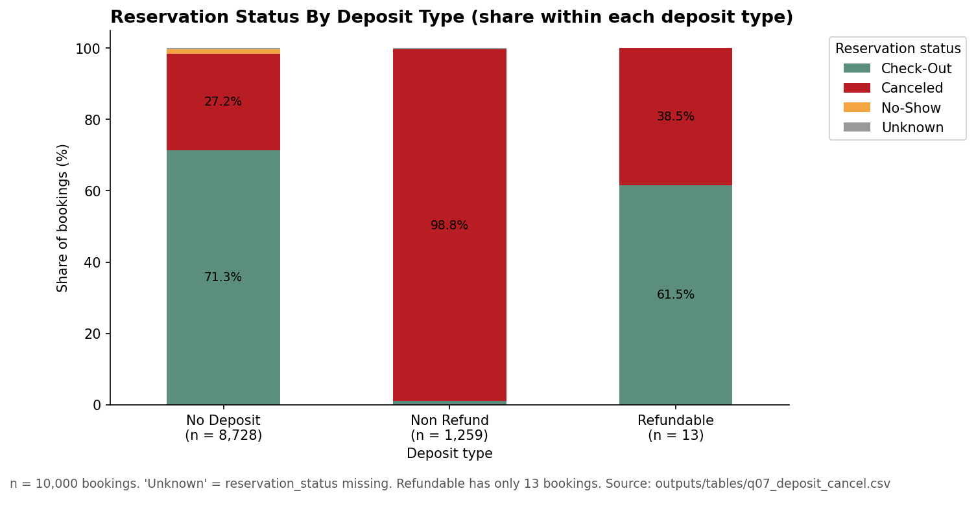
Source: outputs/tables/q07_deposit_cancel.csv.

Table 5. Reservation status by deposit type.
Deposit type | Bookings | Canceled, n (%) | Check-Out, n (%) | No-Show, n (%) | Status missing, n (%)
No Deposit | 8,728 | 2,377 (27.23) | 6,224 (71.31) | 105 (1.20) | 22 (0.25)
Non Refund | 1,259 | 1,244 (98.81) | 12 (0.95) | 0 (0.00) | 3 (0.24)
Refundable | 13 | 5 (38.46) | 8 (61.54) | 0 (0.00) | 0 (0.00)
Source: outputs/tables/q07_deposit_cancel.csv.

Non Refund bookings are almost always recorded as canceled. Of 1,259 Non Refund bookings, 1,244 (98.81%) have the status Canceled and 12 (0.95%) Check-Out; 3 have no status. Of 8,728 No Deposit bookings, 27.23% are Canceled and 1.20% No-Show (Table 5, Figure 4). Non Refund bookings make up 12.59% of all bookings but 34.31% of the 3,626 bookings with status Canceled. Refundable has 13 bookings and is too small for comparison. Limitation: the data do not allow the pattern to be attributed to the deposit itself; deposit terms and recording rules are not documented in the file.

3.6 Insight 6: Groups has the highest cancellation rate, but the gap narrows within one deposit type
Figure 5. Cancellation rate by market segment
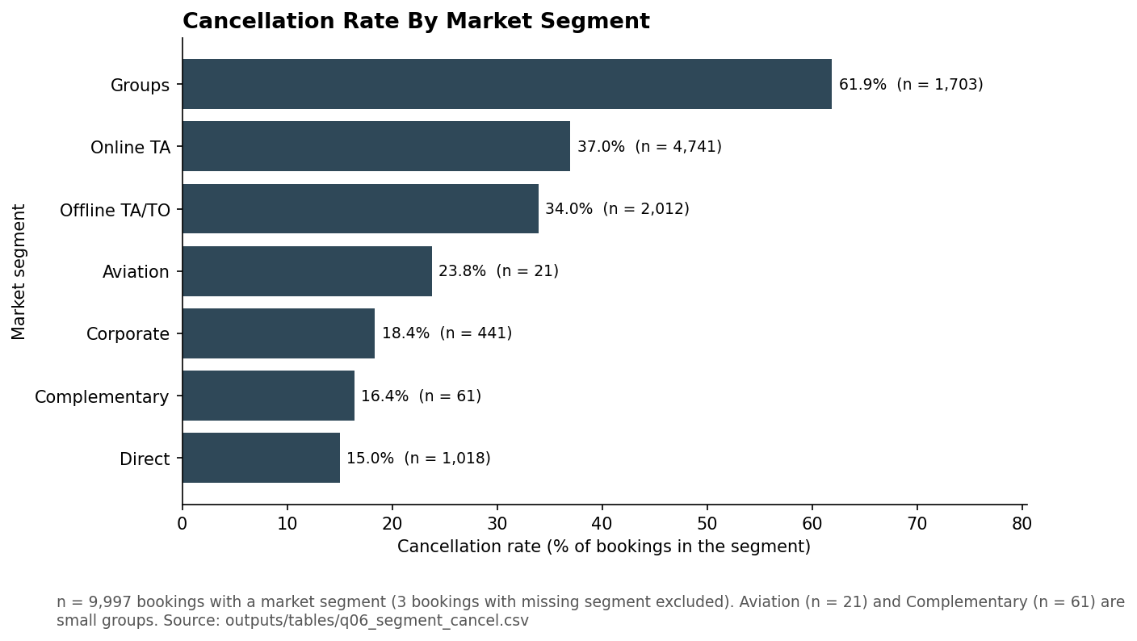
Source: outputs/tables/q06_segment_cancel.csv.

Table 6. Bookings and cancellation rate by market segment (n = 9,997 bookings with a market segment; 3 without).
Market segment | Bookings | Share (%) | Canceled | Cancellation rate (%)
Online TA | 4,741 | 47.42 | 1,753 | 36.98
Offline TA/TO | 2,012 | 20.13 | 683 | 33.95
Groups | 1,703 | 17.04 | 1,054 | 61.89
Direct | 1,018 | 10.18 | 153 | 15.03
Corporate | 441 | 4.41 | 81 | 18.37
Complementary | 61 | 0.61 | 10 | 16.39
Aviation | 21 | 0.21 | 5 | 23.81
Source: outputs/tables/q06_segment_cancel.csv.

Table 7. Cancellation rate within deposit type, five largest segments.
Market segment | No Deposit: bookings | No Deposit: rate (%) | Non Refund: bookings | Non Refund: rate (%)
Online TA | 4,734 | 36.88 | 5 (n < 30) | 100.00
Offline TA/TO | 1,602 | 17.10 | 410 | 99.76
Groups | 880 | 27.95 | 813 | 99.02
Direct | 1,016 | 14.96 | 2 (n < 30) | 50.00
Corporate | 412 | 13.35 | 28 (n < 30) | 92.86
Source: outputs/tables/x01_segment_deposit_cancel.csv (supplementary table)

Groups has the highest cancellation rate, but the gap to other segments narrows within one deposit type. Among 9,997 bookings with a market segment, Groups has 1,054 cancellations in 1,703 bookings (61.89%), against 153 in 1,018 (15.03%) for Direct, a gap of 46.86 pp (Table 6, Figure 5). However, 813 Groups bookings (47.74%) are Non Refund, with a cancellation rate of 99.02%. Within No Deposit, Groups cancels at 27.95% (880 bookings), 12.99 pp above Direct (14.96%, 1,016 bookings) and below Online TA (36.88%, 4,734 bookings) (Table 7). Limitation: contract terms are not recorded, and Aviation (n = 21) and Complementary (n = 61) are small.

4. Limitations and Recommendations

4.1 Limitations
Figures depend on conventions and cleaning rules. No-Show is counted as canceled (105 bookings, all No Deposit); 40 contradictory flags were recomputed from reservation_status; 15 conflicting bookings were resolved by a lowest-row_id rule. Preparation alone moved the cancellation rate from 36.50% to 37.41%. Another valid rule set could give slightly different absolute values; comparisons between groups use the same rules throughout.
Seasonality rests on a single year. Only 2016 has all 12 months. Monthly counts include canceled bookings, are not numbers of guests staying, and are small in places (62 Resort Hotel bookings in January 2016).
Associations are observed, not isolated. Lead time, deposit type, market segment and country overlap, and no model separates them: 813 of 1,703 Groups bookings are Non Refund, and the Groups–Direct gap falls from 46.86 pp to 12.99 pp within No Deposit. The Portugal rate (57.68%, Appendix C) was not broken down by deposit type or segment. The data record no cancellation reasons.
adr and revenue_est are not revenue. adr is a nightly rate in EUR; revenue_est covers non-canceled bookings only and omits services, costs and refunds.
Quality of country. Guest country is usually confirmed at check-in, so it may be less accurate for canceled bookings; 107 bookings have no country. The code CN (101 input rows) was not merged with CHN, because the data give no evidence for doing so.
Small groups. Refundable has 13 bookings, Aviation 21 and Complementary 61; among Check-Out bookings with both room codes (Appendix G), room types B, C and H have 64, 50 and 23. Their rates are unstable.
Scope. The data cover two hotels in Portugal from July 2015 to August 2017 and are a sample into which errors were inserted deliberately; findings do not represent the hotel industry or forecast later years.

4.2 Recommendations for data and next questions
Cancellation reasons and timing. Record the reason for cancellation. The interval between cancellation and arrival can already be computed from reservation_status_date and arrival_date for canceled bookings.
Deposit and refund terms by segment and period. Obtain the conditions applied, to examine why Non Refund bookings are almost always recorded as canceled and why Groups bookings concentrate in Non Refund.
Several full years with an events calendar. At least two or three full years, with event calendars for Lisbon and the Algarve, would separate seasonality from year-to-year variation.
Further descriptive questions (no machine learning). (a) Cancellation rate by lead-time group × deposit type; (b) monthly cancellation rate by hotel, to check whether the 13.29 pp gap appears in most months; (c) bookings per segment × deposit-type cell, to flag unstable rates.

5. Division of Work
Member | Work completed | Parts the member can explain | Contribution
A: Ha Nhat Huy - 11253519 | Survey of missing values (A1–A3); cleaning rules B1–B4; derived columns, monthly summary and quality report (C1–C3); Questions 1–5 and Figures 1–4, (fig01–fig04); Insights 4-6; README draft. | All cleaning rules; Questions 1–5; two results from Questions 6–10 | 50%
B: Le Minh Quan - 11257109 | Issue catalog (A6); cleaning rules B5–B8 and row lineage; automatic validation (C4); Questions 6–10 and Figures 5–8 (fig05–fig08); Insights 1-3; report all sections. | All cleaning rules; Questions 6–10; two results from Questions 1–5 | 50%

Each member reviewed the other's code, figures and text before the final run, and the notebook was re-run from the start with Restart & Run all.

Appendix

Appendix A. Cleaning log (20 logged rules)
Table A1. Cleaning log.
Step | Field(s) | Issue (summary) | Affected rows | Changed cells | Removed rows
B1 | 23 business columns | Exact duplicate rows | 181 | 0 | 181
B2 | reservation_status, reservation_status_date | Date written in the status column | 26 | 52 | 0
B3 | 11 columns | Empty, missing-value codes and "Undefined" (segment, channel) set to missing | 286 | 289 | 0
B4 | 7 categorical columns | Non-standard labels | 865 | 896 | 0
B4 | meal | "Undefined" recoded to SC | 101 | 101 | 0
B4 | is_canceled, is_repeated_guest | yes/no, True/False, 1.0/0.0 recoded to 0/1 | 272 | 272 | 0
B4 | reserved_room_type, assigned_room_type | Lower case, extra spaces, codes outside A–P | 114 | 114 | 0
B4 | is_canceled | Contradiction with reservation_status | 40 | 40 | 0
B5 | arrival_date | Invalid or outside 2015-07-01 to 2017-08-31 | 49 | 24 | 0
B5 | reservation_status_date | Invalid or outside 2014-10-01 to 2017-09-14 | 10 | 10 | 0
B6 | lead_time | Outside 0–800 or non-numeric | 21 | 21 | 0
B6 | stays_in_weekend_nights | Outside 0–20 or non-numeric | 10 | 10 | 0
B6 | stays_in_week_nights | Outside 0–50 or non-numeric | 7 | 7 | 0
B6 | adults | Outside 0–10 or non-numeric | 0 | 0 | 0
B6 | children | Outside 0–10 or non-numeric | 0 | 0 | 0
B6 | babies | Outside 0–10 or non-numeric | 5 | 5 | 0
B6 | total_of_special_requests | Outside 0–5 or non-numeric | 0 | 0 | 0
B6 | adr | Currency symbol, decimal comma, outside 0–1,000 | 11 | 11 | 0
B7 | country | Non-standard code, full name or missing-value code | 199 | 199 | 0
B8 | booking_id | Rows with the same booking merged (288 rows involved) | 288 | 22 | 144
Source: outputs/cleaning_log.csv. A row can meet several detection rules, so affected_rows must not be summed across rules. For B5 arrival_date, 49 rows meet the rule, of which 25 were already blank, so 24 cells changed value.

Table A2. Missing values before and after cleaning (selected columns).
Column | Before: missing (n = 10,325 rows) | Before: invalid values set to missing | After: missing (n = 10,000 bookings)
country | 127 (1.23%) | 0 | 107 (1.07%)
arrival_date | 25 (0.24%) | 24 | 49 (0.49%)
adr | 25 (0.24%) | 11 | 36 (0.36%)
lead_time | 10 (0.10%) | 21 | 31 (0.31%)
reservation_status | 0 (0.00%) | 26 (dates in the wrong column) | 25 (0.25%)
Source: outputs/quality_report.csv. "Invalid" means a value that was present but violated the data conventions.

Appendix B. Supplementary results for Questions 3 and 4
Table B1. Bookings by arrival month, 2016 (Question 3). Denominator: 4,759 bookings with a 2016 arrival date; the cancellation rate is computed on all bookings of the month, both hotels combined.
Month | City Hotel | Resort Hotel | Total | Cancellation rate (%)
1 | 117 | 62 | 179 | 22.35
2 | 206 | 139 | 345 | 33.04
3 | 267 | 140 | 407 | 33.42
4 | 288 | 160 | 448 | 37.28
5 | 291 | 162 | 453 | 39.29
6 | 321 | 124 | 445 | 37.30
7 | 248 | 123 | 371 | 30.19
8 | 285 | 143 | 428 | 36.68
9 | 337 | 126 | 463 | 40.17
10 | 360 | 157 | 517 | 40.62
11 | 257 | 116 | 373 | 39.68
12 | 217 | 113 | 330 | 37.58
Total | 3,194 | 1,565 | 4,759
Source: outputs/tables/q03_monthly_arrivals_2016.csv.

Table B2. Lead time (days) by hotel (Question 4). Denominator: bookings with a valid lead_time (n = 9,969).
Hotel | Bookings with valid lead time | Mean | Median | Q1 | Q3 | Max
City Hotel | 6,683 | 110.78 | 74 | 24 | 164 | 629
Resort Hotel | 3,286 | 92.99 | 61 | 12 | 154 | 709
Source: outputs/tables/q04_leadtime_stats.csv.

Appendix C. Top 10 guest countries (Question 5)
Table C1. Top 10 countries by number of bookings.
Rank | Country | Bookings | Share of all 10,000 bookings (%) | Cancellation rate (%)
1 | PRT | 4,005 | 40.05 | 57.68
2 | GBR | 999 | 9.99 | 19.72
3 | FRA | 876 | 8.76 | 19.06
4 | ESP | 700 | 7.00 | 24.57
5 | DEU | 650 | 6.50 | 18.62
6 | ITA | 294 | 2.94 | 33.67
7 | IRL | 281 | 2.81 | 23.84
8 | BEL | 201 | 2.01 | 18.41
9 | USA | 198 | 1.98 | 24.75
10 | BRA | 192 | 1.92 | 41.15
Source: outputs/tables/q05_top10_country.csv.
Figure C1. Top 10 guest countries by number of bookings
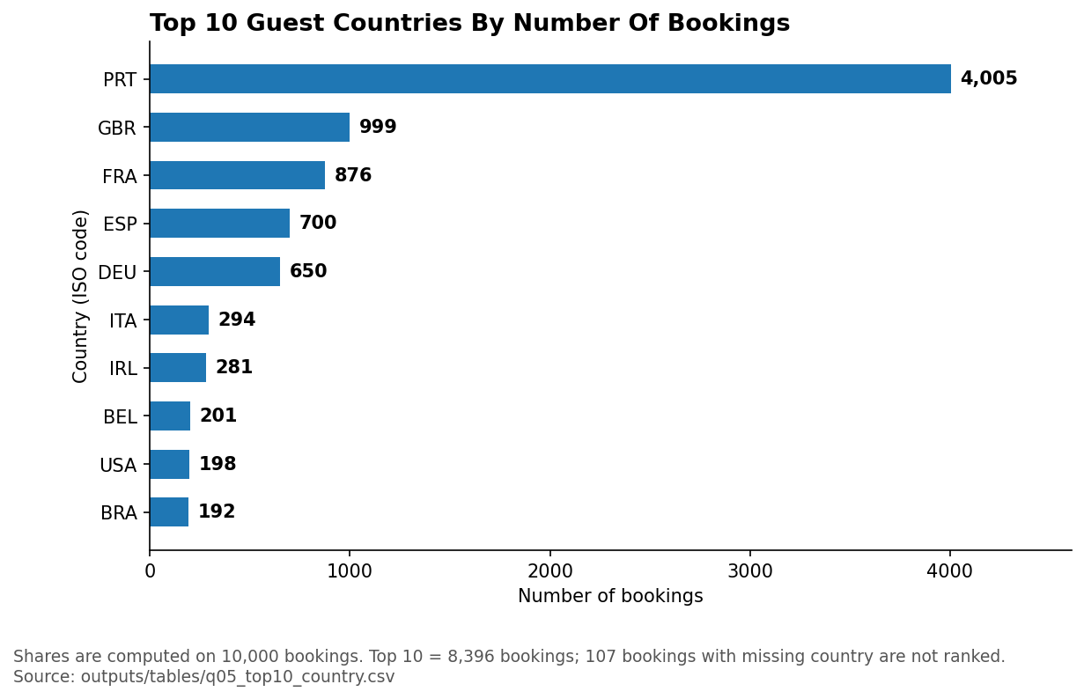
Source: outputs/tables/q05_top10_country.csv.

9,893 bookings have a country code and 107 do not (reported separately). The Top 10 holds 8,396 bookings (83.96% of all bookings). Portugal (PRT) is the largest market, with 4,005 bookings (40.05%) and a cancellation rate of 57.68%; PRT accounts for 2,310 of the 3,741 canceled bookings (61.75%). GBR, FRA, ESP and DEU have cancellation rates between 18.62% and 24.57%. The data contain no information on the composition of guests within a country, and the Portugal rate was not split by deposit type or segment.

Appendix D. Cancellation rate by market segment and deposit type (Question 6, supplementary)
Table D1. Cancellation rate by market segment and deposit type. Denominator: bookings in each segment × deposit-type cell.
Market segment | Deposit type | Bookings | Canceled | Cancellation rate (%)
Aviation | No Deposit | 21 | 5 | 23.81
Complementary | No Deposit | 61 | 10 | 16.39
Corporate | No Deposit | 412 | 55 | 13.35
Corporate | Non Refund | 28 | 26 | 92.86
Corporate | Refundable | 1 | 0 | 0.00
Direct | No Deposit | 1,016 | 152 | 14.96
Direct | Non Refund | 2 | 1 | 50.00
Groups | No Deposit | 880 | 246 | 27.95
Groups | Non Refund | 813 | 805 | 99.02
Groups | Refundable | 10 | 3 | 30.00
Offline TA/TO | No Deposit | 1,602 | 274 | 17.10
Offline TA/TO | Non Refund | 410 | 409 | 99.76
Online TA | No Deposit | 4,734 | 1,746 | 36.88
Online TA | Non Refund | 5 | 5 | 100.00
Online TA | Refundable | 2 | 2 | 100.00
Source: outputs/tables/x01_segment_deposit_cancel.csv. Cells with fewer than 30 bookings are unstable.

Appendix E. Average daily rate, non-canceled bookings (Question 8)
Table E1. ADR statistics by hotel (EUR per night).
Hotel | Bookings | Mean | Median | Min | Max | Q1 | Q3
City Hotel | 3,828 | 108.18 | 100.65 | 4.50 | 336.00 | 80.75 | 126.90
Resort Hotel | 2,293 | 93.60 | 75.00 | 6.00 | 349.67 | 51.50 | 120.00
Source: outputs/tables/q08_adr_stats_by_hotel.csv.

Figure E1. Distribution of average daily rate (ADR), non-canceled bookings
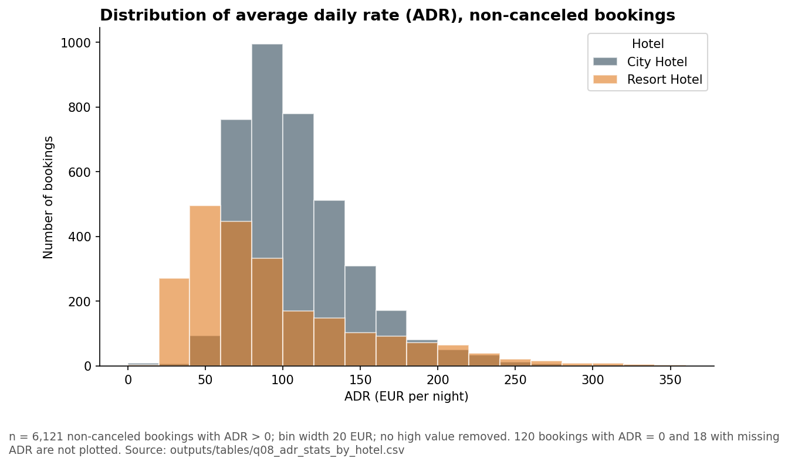
Source: outputs/tables/q08_adr_stats_by_hotel.csv.

Of 6,259 non-canceled bookings, 6,121 have ADR > 0, 120 have ADR = 0 and 18 have a missing ADR. The central half of ADR values (Q1–Q3) spans 51.50–120.00 EUR at Resort Hotel (width 68.50) and 80.75–126.90 EUR at City Hotel (width 46.15). The mean exceeds the median at both hotels (City Hotel by 7.53 EUR, Resort Hotel by 18.60 EUR), which indicates a right-skewed distribution, more strongly at Resort Hotel. ADR is a nightly rate, not revenue, and the data are not split by season.

Appendix F. Length of stay, non-canceled bookings (Question 9)
Table F1. Share of stays of 1–3 nights.
Hotel | Non-canceled bookings with valid total_nights | Stays of 1–3 nights | Share (%)
City Hotel | 3,884 | 2,730 | 70.29
Resort Hotel | 2,350 | 1,192 | 50.72
Both hotels | 6,234 | 3,922 | 62.91
Source: outputs/tables/q09_stay_nights.csv.
Figure F1. Distribution of booked nights, non-canceled bookings
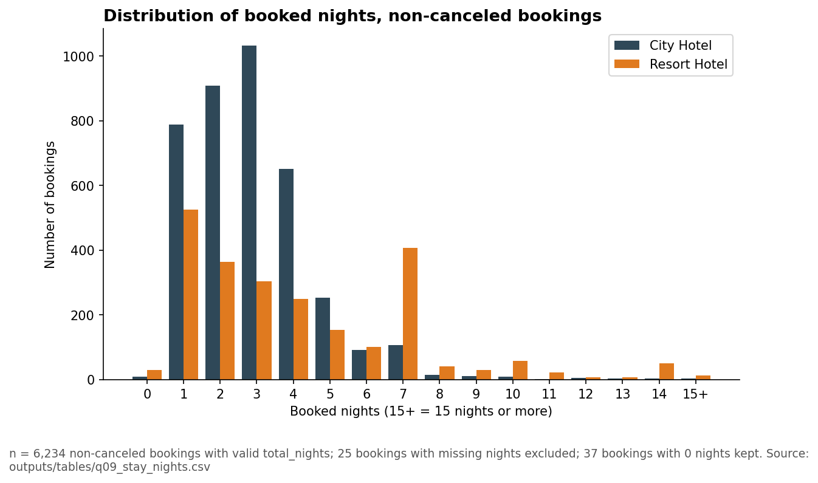
Source: outputs/tables/q09_stay_nights.csv.

Stays of 1–3 nights are the majority at both hotels, more clearly at City Hotel. Resort Hotel shows a separate cluster at 7 nights: 406 bookings (17.28% of 2,350), more than the 4-night (249) and 5-night (153) groups of the same hotel, whereas City Hotel has 107 seven-night bookings (2.75% of 3,884). The data contain no trip purpose, so the 7-night cluster is not explained. Booked nights are the nights reserved, not necessarily the nights stayed.

Appendix G. Room type changes at check-out (Question 10)
Table G1. Room type change rate by hotel. Denominator: Check-Out bookings with both room codes valid (n = 6,242).
Hotel | Bookings | Changed | Change rate (%)
City Hotel | 3,891 | 561 | 14.42
Resort Hotel | 2,351 | 583 | 24.80

Table G2. Room type change rate by reserved room type.
Reserved room type | Bookings | Changed | Change rate (%)
A | 4,287 | 948 | 22.11
D | 1,137 | 114 | 10.03
E | 397 | 47 | 11.84
F | 174 | 15 | 8.62
G | 110 | 3 | 2.73
B | 64 | 11 | 17.19
C | 50 | 4 | 8.00
H | 23 | 2 | 8.70
Source: outputs/tables/q10_room_change_by_hotel.csv, outputs/tables/q10_room_change_by_reserved_type.csv.

The change rate is 24.80% at Resort Hotel and 14.42% at City Hotel, a gap of 10.38 pp; over both hotels it is 1,144 of 6,242 (18.33%). Room type A is the largest group (4,287 bookings) and has the highest change rate (22.11%) among the types with at least 100 bookings. Types B, C and H have fewer than 70 bookings, so their rates are unstable. The data record only whether the room type changed, not the reason (upgrade, downgrade, lack of availability or guest request). The denominator of this question (6,242) differs from that of Question 9 (6,234) because the populations differ: Question 10 uses 6,242 Check-Out bookings that have two valid room codes, whereas Question 9 uses 6,234 non-canceled bookings that have a valid number of nights. The broader non-canceled population contains 6,259 bookings; 25 have missing total_nights and are excluded from Question 9.

