AGCL Tool Manual
Technical Report
Duc Minh Le
duclm@hanu.edu.vn
Department Software Engineering, Hanoi University

Introduction
This manual brielfy describes the implementation of AGCL in a software tool named jDomainApp [1] and how to set up and run the CourseMan software example using this tool.

Installation
Download the AGCL binary from GitHub [2] and place it in a directory on your the local hard drive. The binary basically includes a set of jar files that you can import and run directly in an IDE (e.g. Eclipse) or from the command line. Table 1 below describes the library files and the programs contained in these libraries that we will focus on in this guide. We will explain how to run the programs from the command line.
Table 1: AGCL library files
Library file | Description
domainapp.jar | The jDomainApp tool [1].
postgresql-9.2-jdbc4.jar | PostgreSQL JDBC driver (used for PostgreSQL DBMS)  - Used to run the CourseMan software examples
scrollabledesktop.jar | Third-party library for building the main GUI.  - Used to run the CourseMan software examples
agcl.jar | Implementation of the AGCL language.
courseman-act-example.jar | Contains the CourseMan-ACT model (see Section 2.1).
examples-data.zip | Contains the SQL script file for populating some test data for the CourseMan example.

CourseMan-ACT: CourseMan Example for Behavioural Modelling
Figure 1 shows the package structure of the CourseMan-ACT model example. This example implements the software model that is referenced in paper [3]. It consists of the domain classes that make up the domain model, the activity classes of the behavioural modelling patterns discussed in the paper, the software modules and software that are created from these classes.
Figure 1: CourseMan-ACT model example (file: courseman-act-example.jar).
The entire binary of CourseMan-ACT is provided in the file courseman-act-example.jar.
Snapshot 1 in Figure 1 shows the top-level package structure. Snapshot 2 lists the content of the sub-package vn.com.courseman.modules. This package contains the software modules for the domain classes mentioned in the paper. For example, the module vn.com.courseman.modules.authorisation (first module in the list) contains the domain class Authorisation and the software module created from this class. The five versions of the enrolment management activity that are used in the paper are implemented as modules in the package vn.com.courseman.modules.enrolmentmgmt. This package is show in snapshot 3. Note that package forkedandjoined is an extra package that implements another version of the activity not mentioned in the paper.
Finally, snapshot 4 shows the software generators for all the CourseMan software prototypes of the enrolment enrolment activity mentioned in paper [3]. These software are created from combinations of the software modules mentioned above. We briefly describe below the five CourseMan software that are of relevance to the paper:
- Sequential Software: CourseMan software that demonstrates the sequential behavioural pattern.
- Decisional Software: CourseMan software that demonstrates the decisional behavioural pattern.
- Forked Software: CourseMan software that demonstrates the forked behavioural pattern.
- Joined Software: CourseMan software that demonstrates the joined behavioural pattern.
- Merged Software: CourseMan software that demonstrates the merged behavioural pattern.

Installing PostgreSQL DBMS
The CourseMan software examples in this guide use the PostgreSQL DBMS to store objects. Please download and install this DBMS from the PostgreSQL web site (http://www.postgresql.org). The PostgreSQL version that is used for the software examples is version 9.5.6. Later versions may be used but have not been tested.
Please ensure that PostgreSQL is configured to listen on the default port, which is 5432.

Creating a Database for CourseMan Software Examples
After installing PostgreSQL, use its database manager (pgAdmin) to:
- create a user account: user = "admin", password = "password"
- create a database named domainds, which is owned by the user admin created in step 1 (see Figure 2). This database is used by the CourseMan software examples.

Creating the CourseMan Test Data
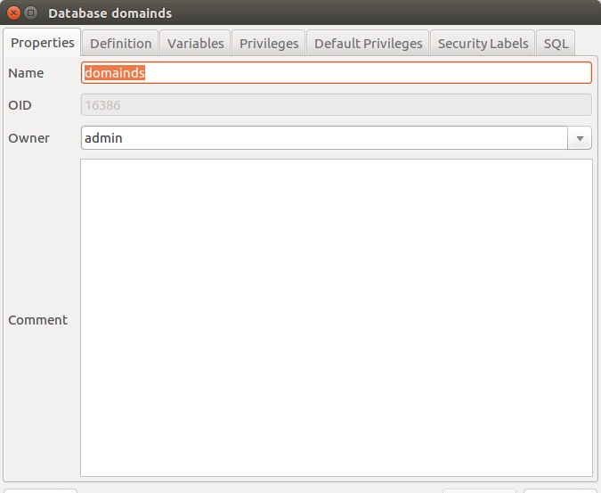
Figure 2: The properties dialog of the database domainds.
Follow the steps below to import pre-defined test data for the three domain classes: CourseModule, SClass and Orientation.
- Open the PostgreSQL database manager (pgAdmin)
- Connect to the domainds database
- Open the SQL Editor and open the file courseman-data.sql (from the examples/data directory in the examples-data.zip file)
- Execute the file to populate the tables of the three aforementioned domain classes with data
Note: this script also create three tables. Thus, if we run the script after the CourseMan software has been run then we need to comment out the CREATE statements from the file before running the script. This is because CourseMan software automatically create the underlying tables of the domain classes.

Running the CourseMan Example
Sections 3.1-3.5 the explain how to run five CourseMan software using the CourseMan-ACT model. As discussed earlier, these software demonstrate the five behavioural modelling patterns of paper [3].

Sequential Software

Command
java -Dlogging=true -cp lib/domainapp.jar:lib/postgresql-9.2-jdbc4.jar:lib/scrollabledesktop.jar:
lib/agcl.jar:lib/courseman-act-example.jar
vn.com.courseman.software.SequentialCourseManSoftware

Result
- Figure 3 displays the main GUI and GUI action that starts off the activity
- Figure 4 displays the subsequent actions that need to be taken on each GUI till finished
Figure 3: The main GUI and first action to be taken.
Figure 4: The subsequent actions to be taken on each GUI.

Decisional Software

Command
java -Dlogging=true -cp lib/domainapp.jar:lib/postgresql-9.2-jdbc4.jar:lib/scrollabledesktop.jar:
lib/agcl.jar:lib/courseman-act-example.jar
vn.com.courseman.software.DecisionalCourseManSoftware

Result
- Figure 5 displays the actions taken for the first case of the activity (help is requested).
- Figure 6 displays the actions taken for the second case of the activity (help is not requested).
Figure 5: Decisional pattern example (2): help IS requested.
Figure 6: Decisional pattern example: help is NOT requested.

Forked Software

Command
java -Dlogging=true -cp lib/domainapp.jar:lib/postgresql-9.2-jdbc4.jar:lib/scrollabledesktop.jar:
lib/agcl.jar:lib/courseman-act-example.jar
vn.com.courseman.software.ForkedCourseManSoftware

Result
- Figure 7 displays the actions taken for the activity.
- Figure 8 displays the Payment and Authorisation objects that are created by enrolment processing.
Figure 7: Forked pattern example: actions to be performed on the GUI.
Figure 8: The two result objects of Enrolment processing: Payment and Authorisation.

Joined Software

Command
java -Dlogging=true -cp lib/domainapp.jar:lib/postgresql-9.2-jdbc4.jar:lib/scrollabledesktop.jar:
lib/agcl.jar:lib/courseman-act-example.jar
vn.com.courseman.software.JoinedCourseManSoftware

Result
- Figure 9 displays the actions performed on the GUI for the activity.
- Figure 10 displays the three objects created in the activity.

Figure 9: Joined pattern example: actions to be performed on the GUI.
Figure 10: The three result objects: Payment, Authorisation, Enrolment Approval.

Merged Software

Command
java -Dlogging=true -cp lib/domainapp.jar:lib/postgresql-9.2-jdbc4.jar:lib/scrollabledesktop.jar:
lib/agcl.jar:lib/courseman-act-example.jar
vn.com.courseman.software.MergedCourseManSoftware

Result
- Figure 11 displays the actions performed on the activity's GUI and the objects that are created.

Figure 11: Merged pattern example: actions performed on the GUI.

References
[1] D. M. Le, “jDomainApp: A Domain-Driven Application Development Framework in Java version 3.0,” Hanoi University, 2016.
[2] D. M. Le, AGCL implementation in jDomainApp. vnu-dse, 2018.
[3] D. M. Le, D.-H. Dang, and V.-H. Nguyen, “Activity-Based Modelling of Domain-Driven Software with Two Annotation-Based Domain Specific Languages [Extended],” VNU University of Engineering and Technology, Apr. 2018.

