class5_script_2.R

hanheejo

2025-01-22

# Class5  
plot(1:10)

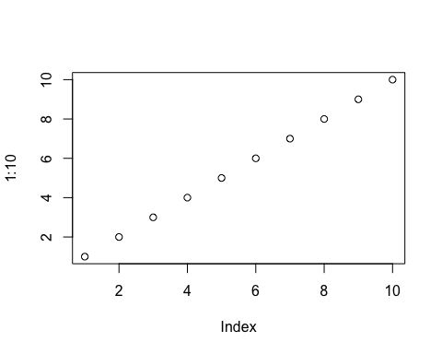

x <- 1:50  
plot(x, sin(x), typ="l", col="blue", lwd=3, xlab="x", ylab="sin(x)")

