LAB 7: Working With Text
7.1 Introduction
7.2 Command Line Pipes and Redirection
7.2.1 Step 1
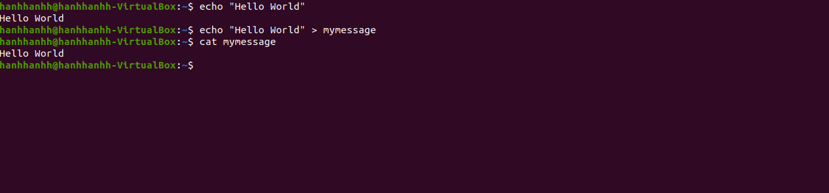
7.2.2 Step 2
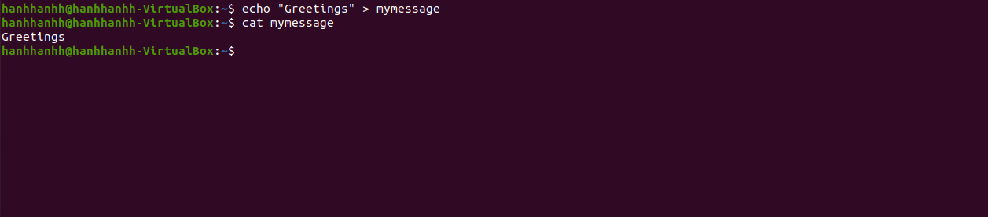
7.2.3 Step 3
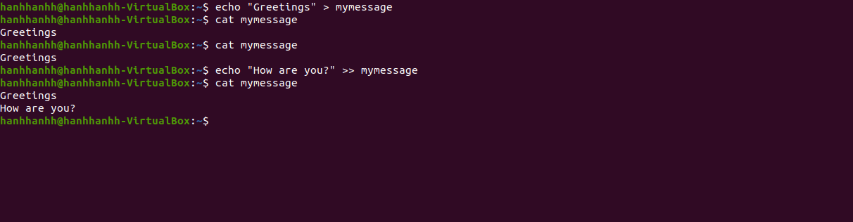
7.2.4 Step 4
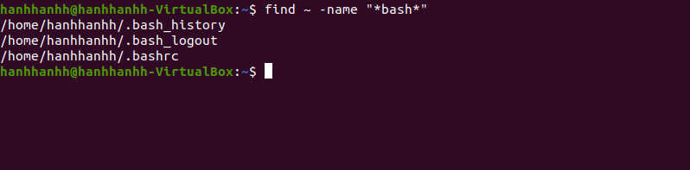

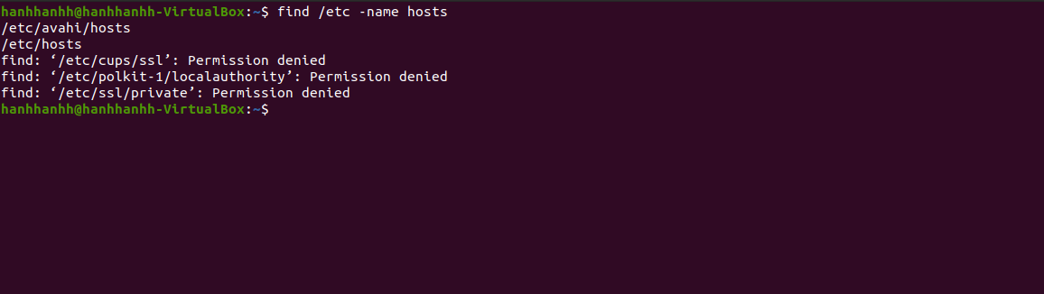

7.2.5 Step 5
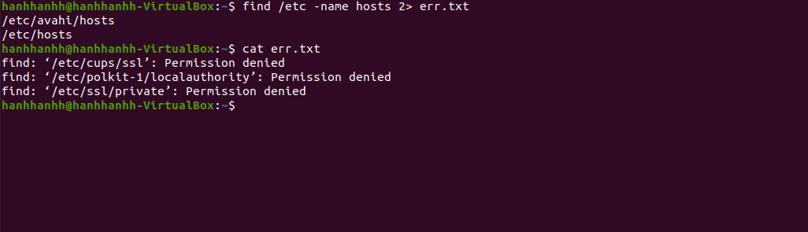
7.2.6 Step 6
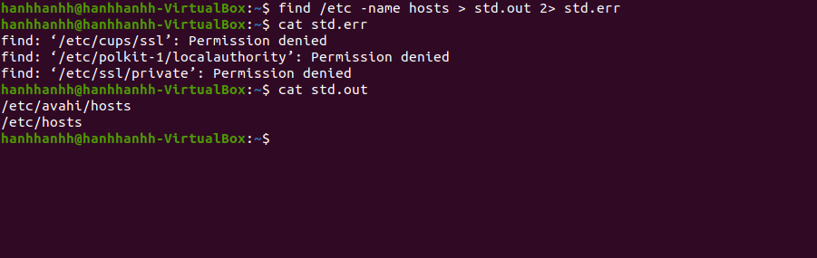
7.2.7 Step 7
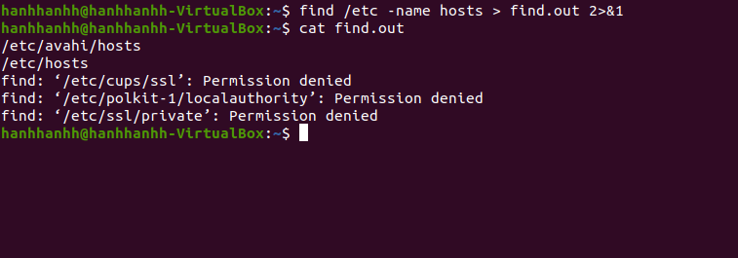
7.2.8 Step 8
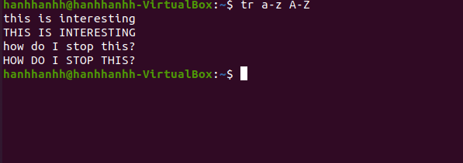
7.2.9 Step 9


7.2.10 Step 10
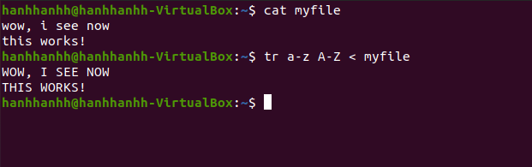

7.2.11 Step 11
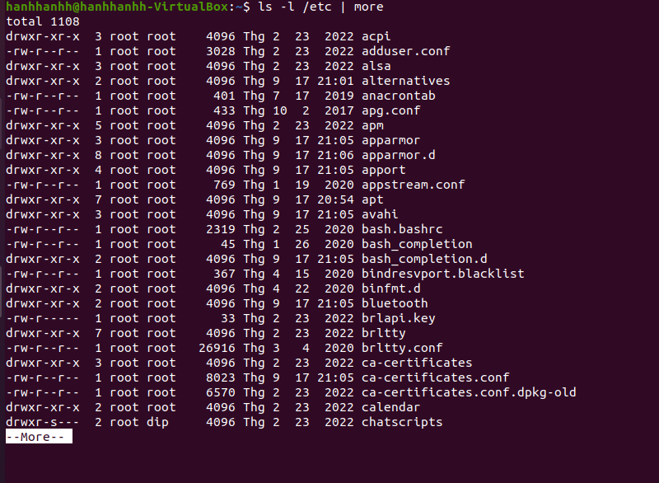
7.2.12 Step 12
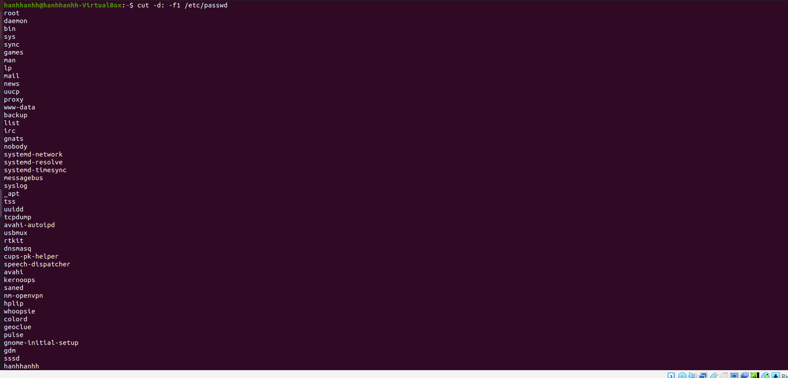
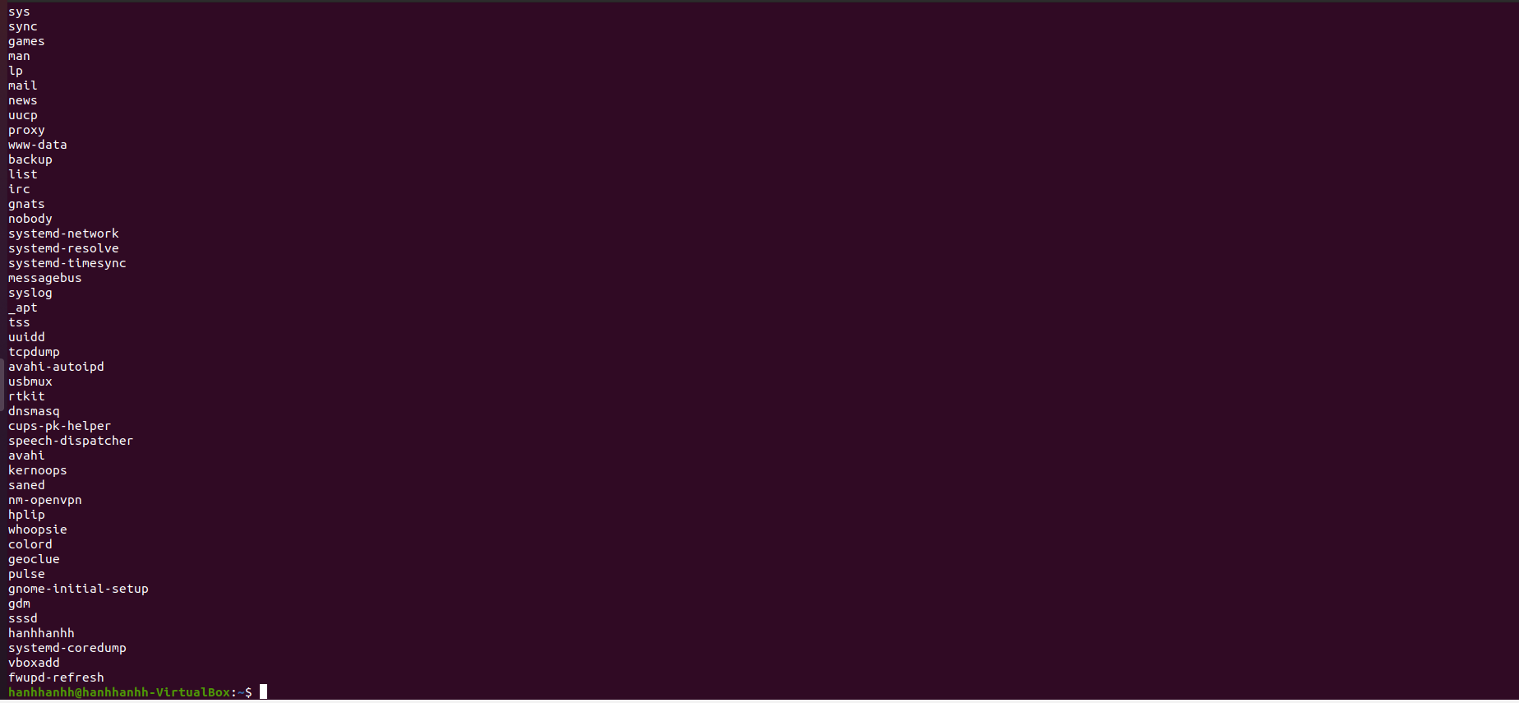
10.2.13 Step 13
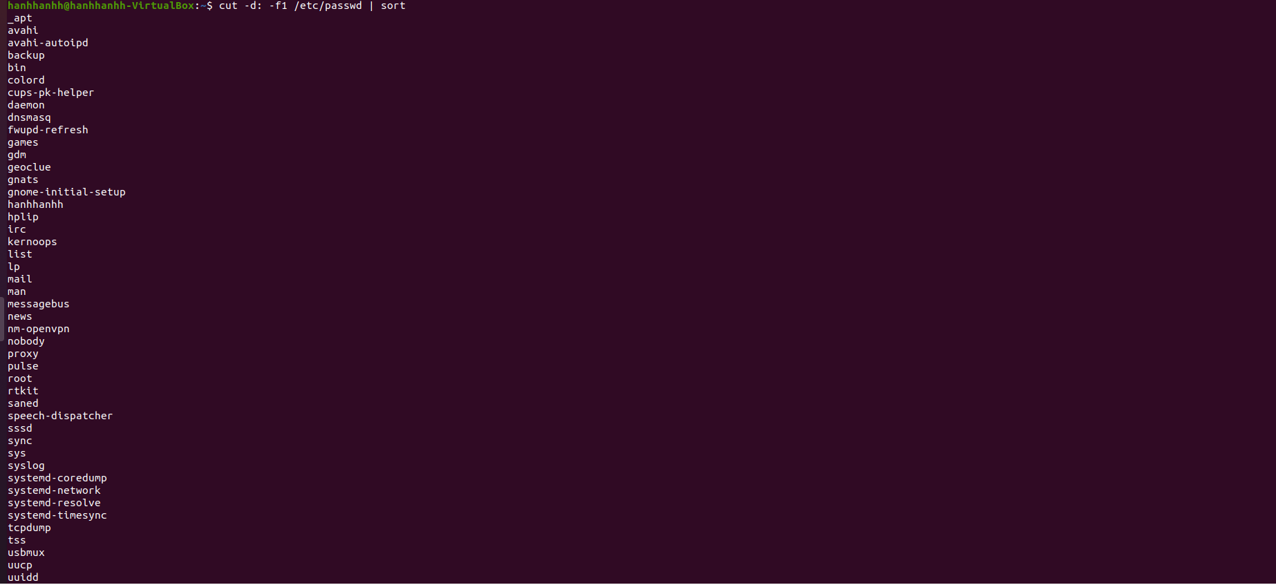

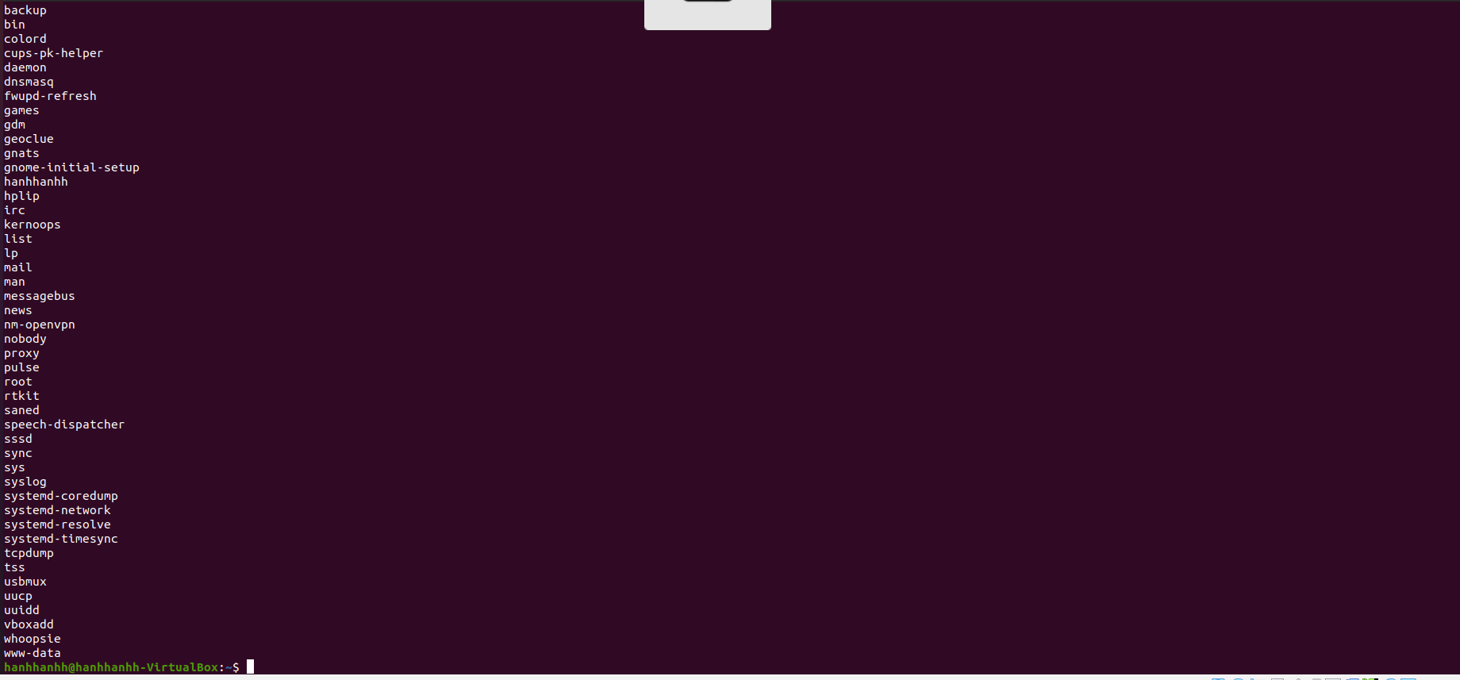

10.2.14 Step 14
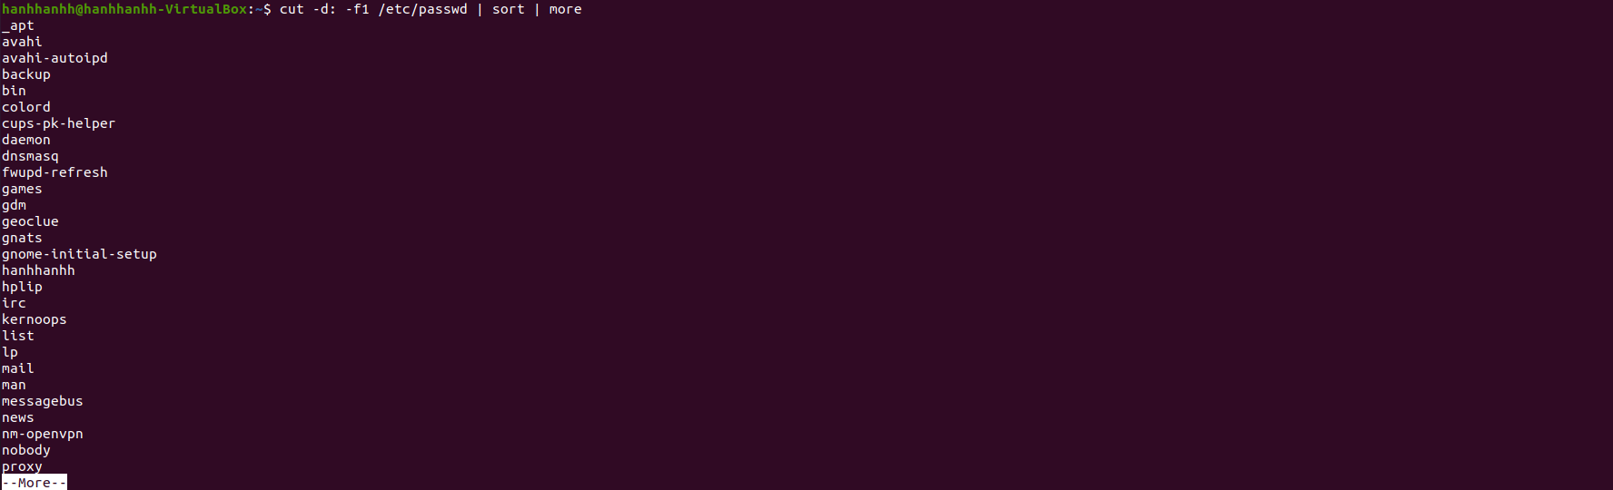
10.3 Viewing Large Text Files
10.3.1 Step 1
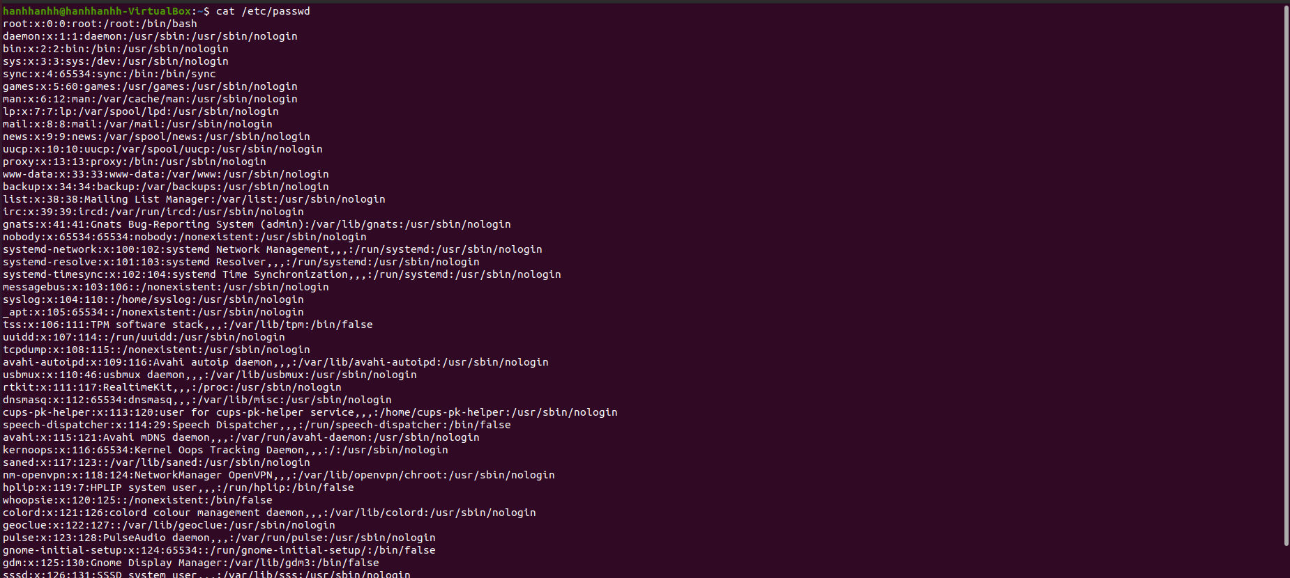

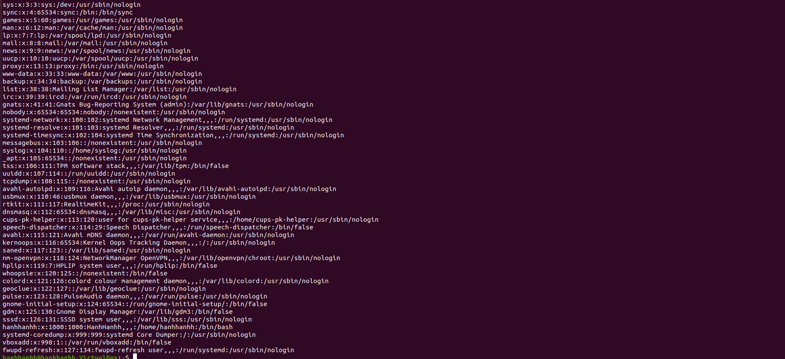

10.3.2 Step 2
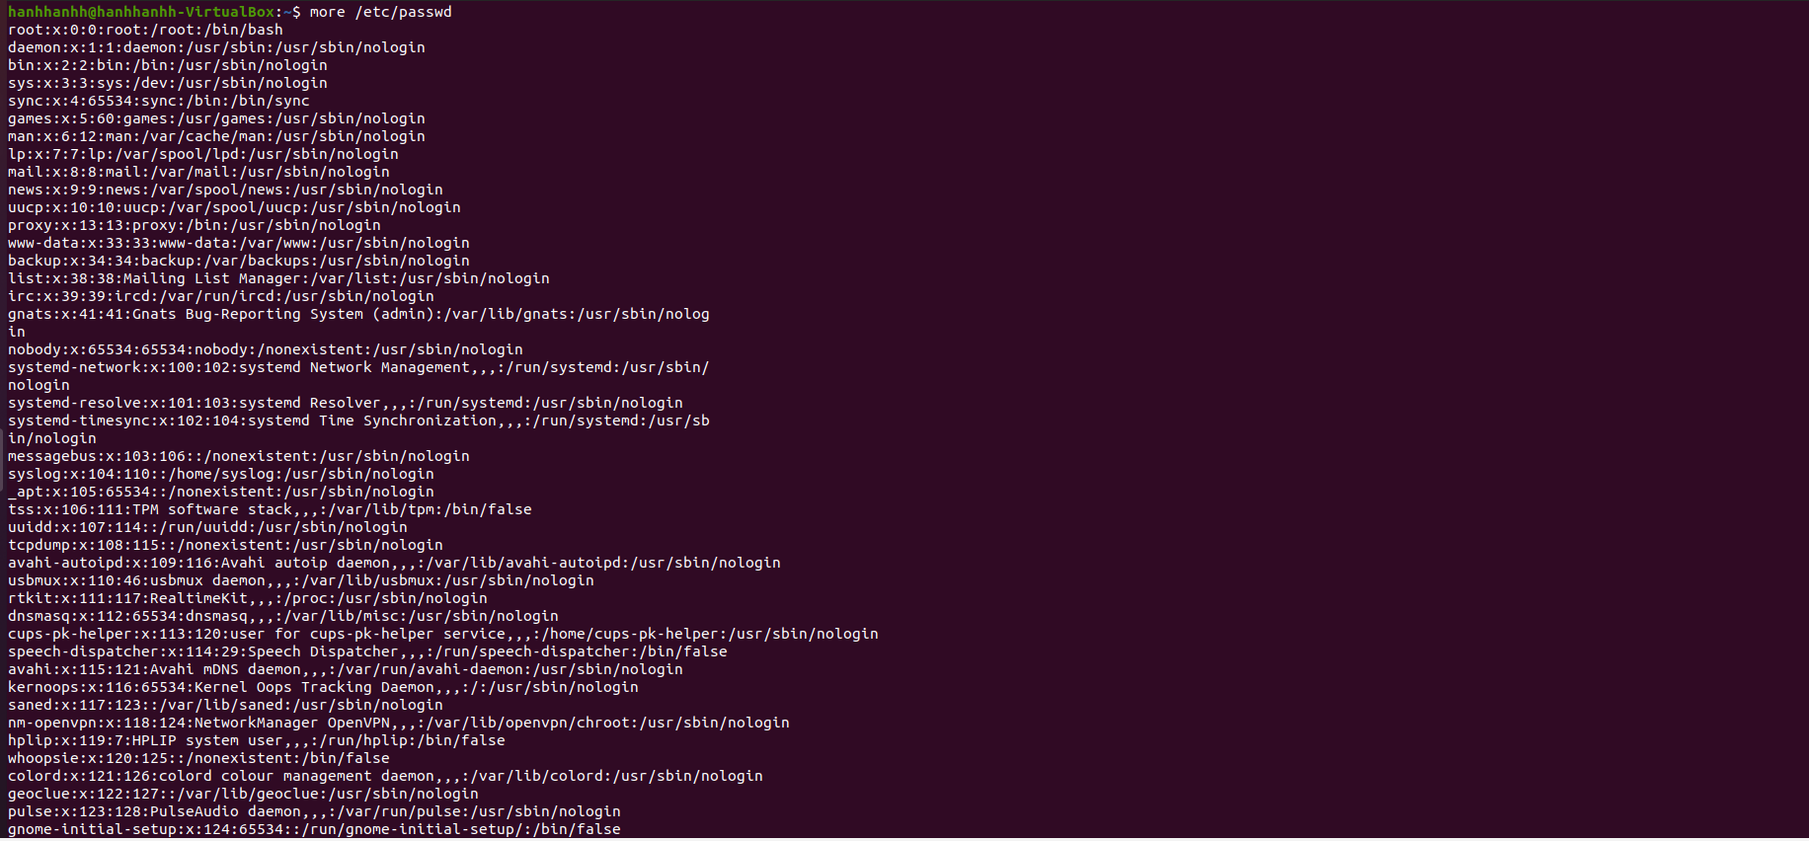

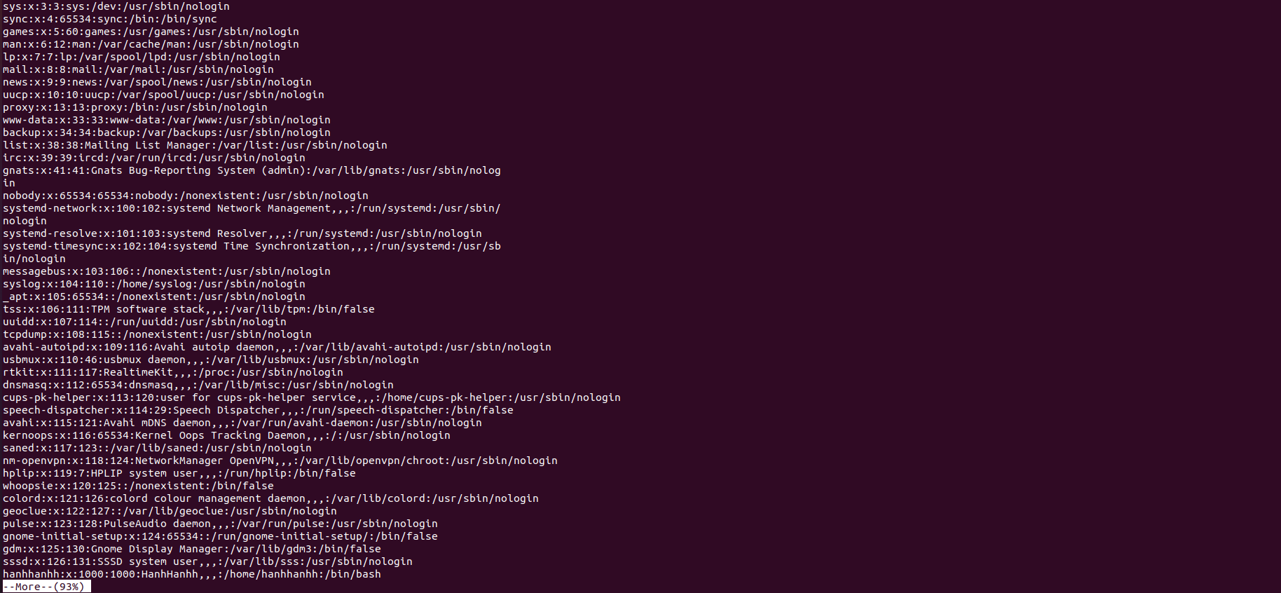

10.3.3 Step 3
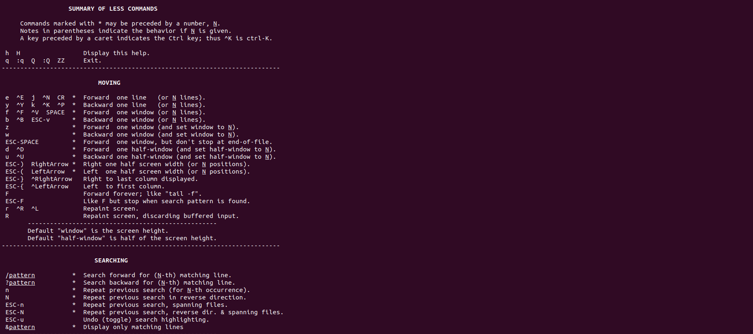

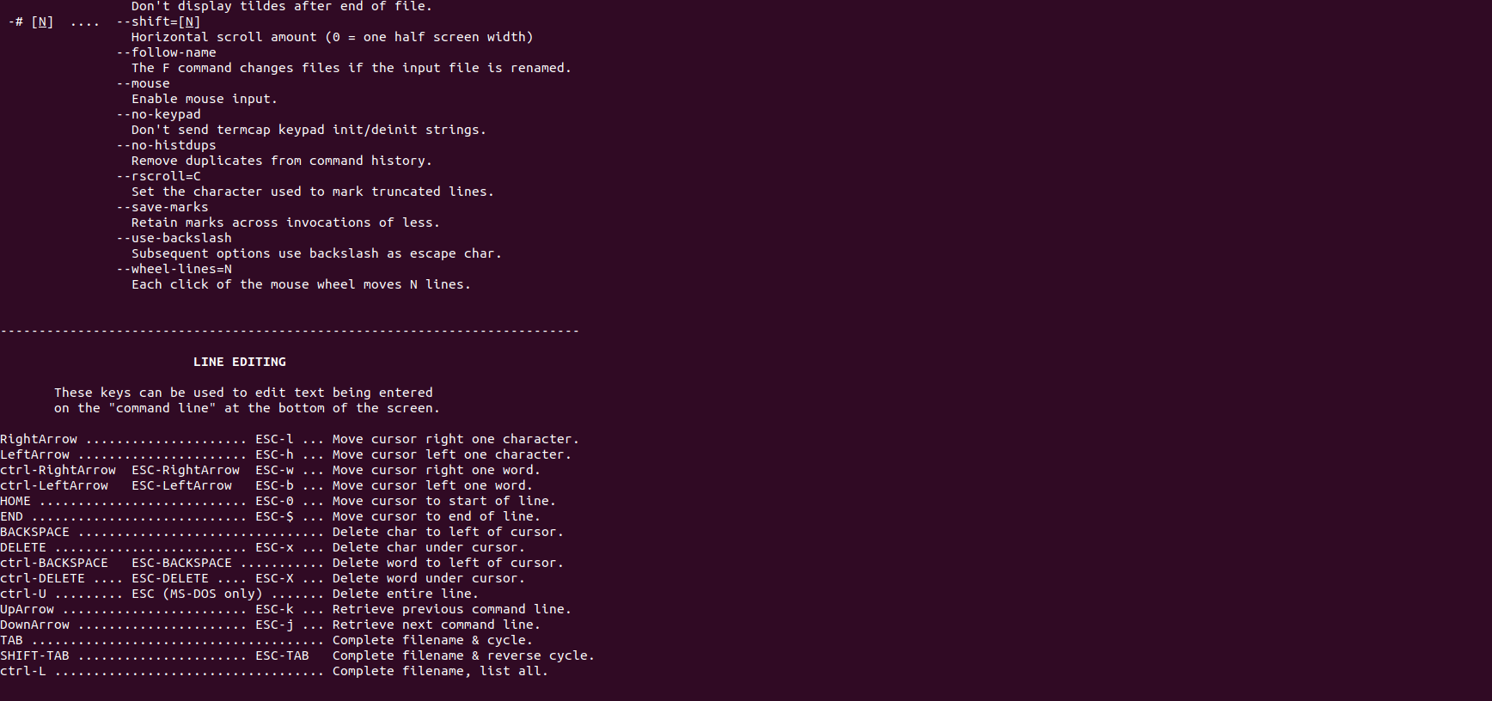

10.3.4 Step 4
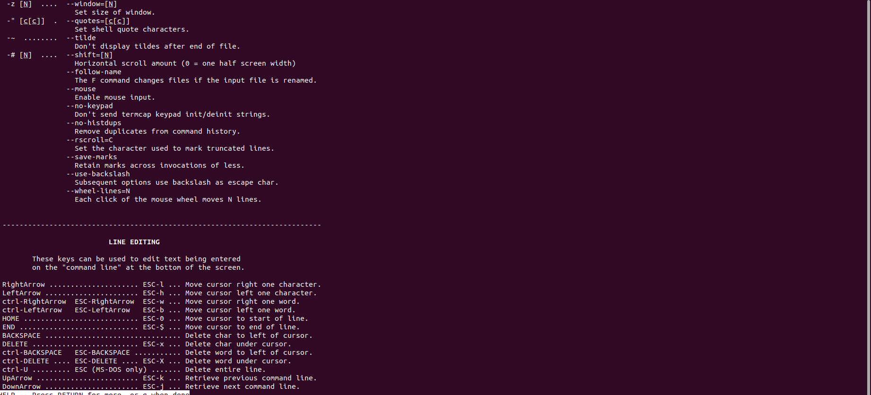

10.3.5 Step 5

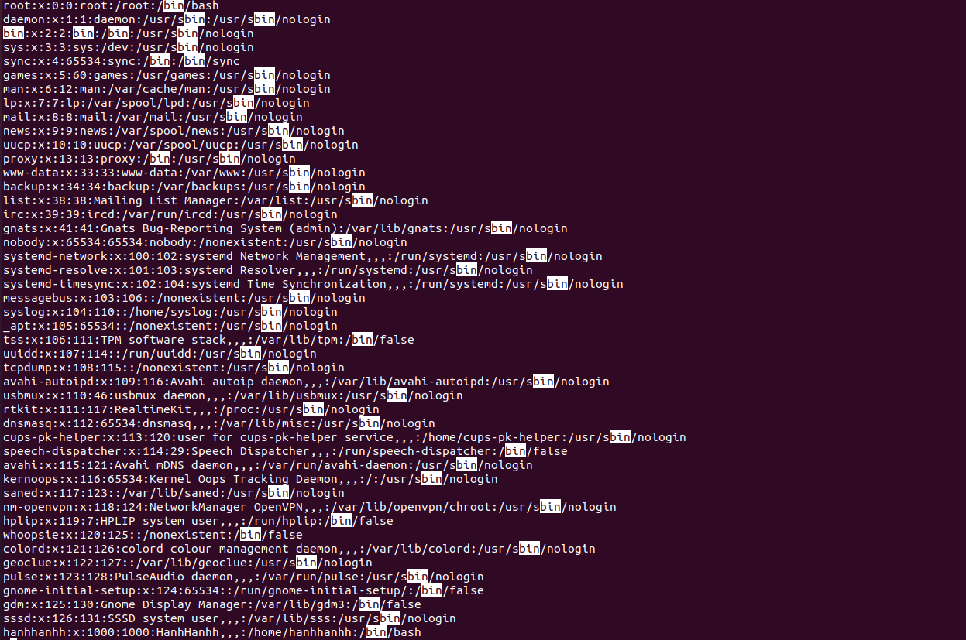

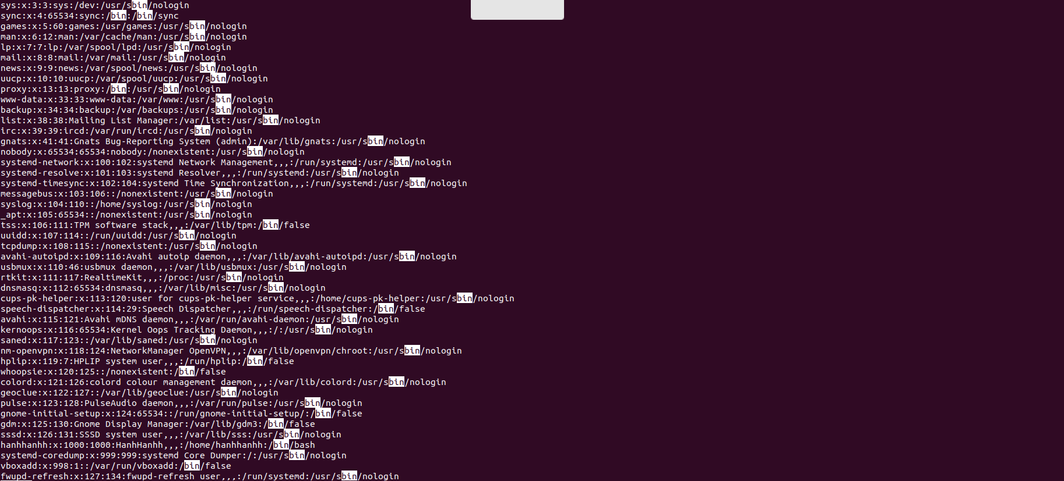

10.3.6 Step 6
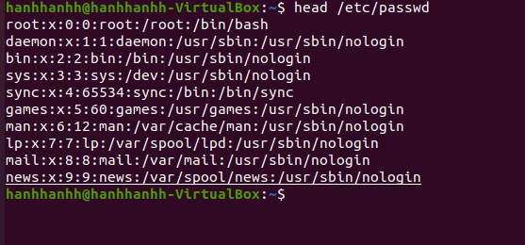

10.3.7 Step 7

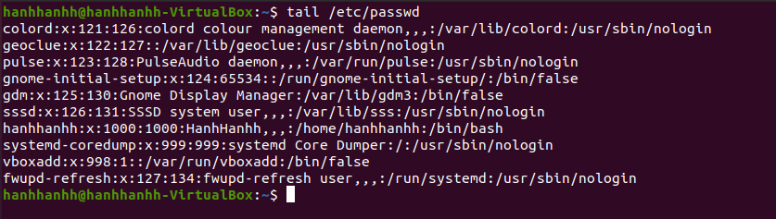

10.3.8 Step 8

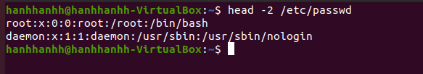

10.3.9 Step 9

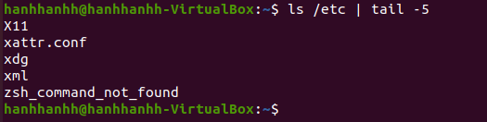

10.3.10 Step 10
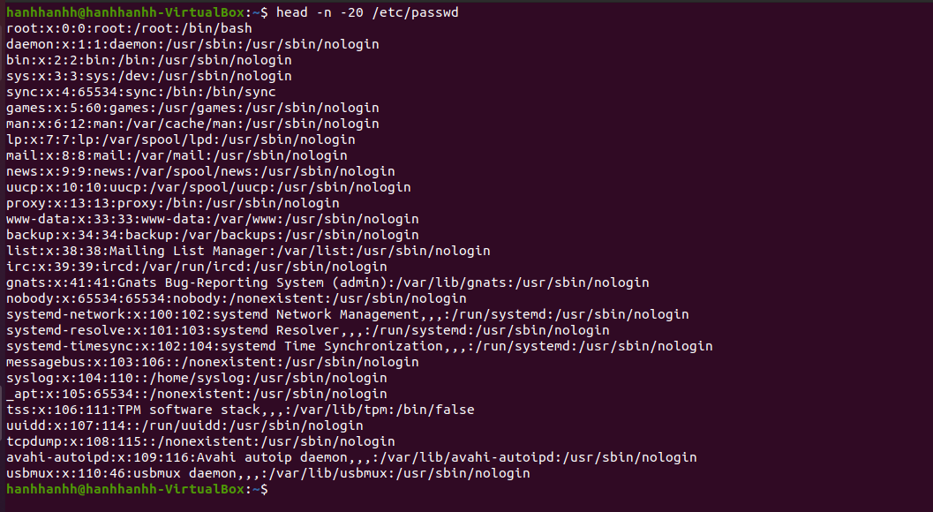

10.4 Searching Text Using Regular Expressions
10.4.1 Step 1
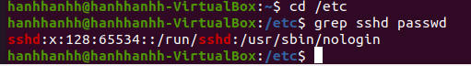
10.4.2 Step 2
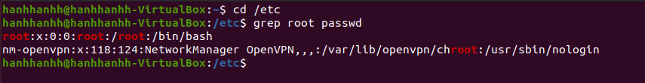
10.4.3 Step 3
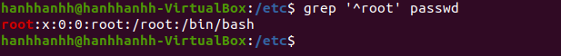

10.4.4 Step 4

10.4.5 Step 5
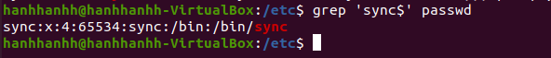

10.4.6 Step 6

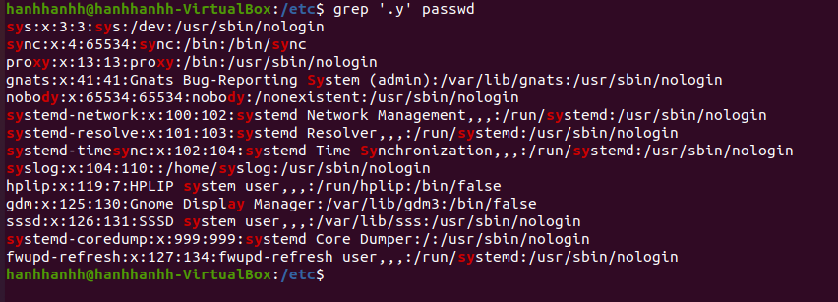

10.4.7 Step 7

10.4.8 Step 8
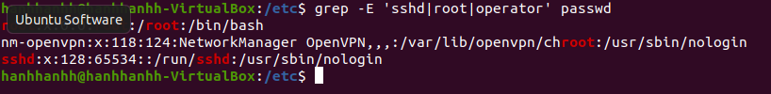
10.4.9 Step 9
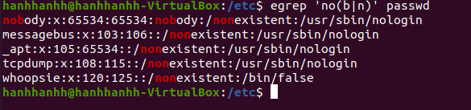
10.4.10 Step 10
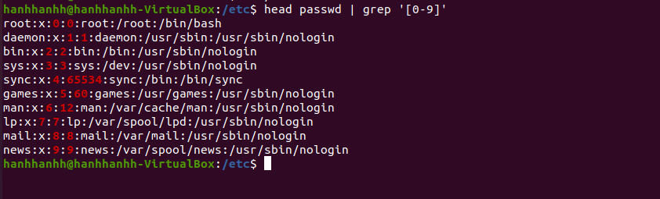
10.4.11 Step 11
