1. Given the provided data, what are three conclusions we can draw about Kickstarter campaigns?
   1. Conclusion 1  
      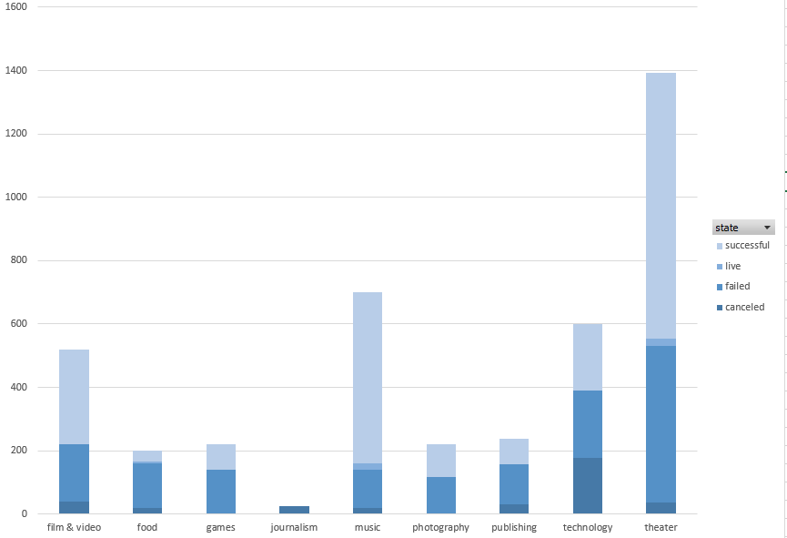

Theater and music have higher successful rate and files & video and food have failed rate.

* 1. Conclusion 2

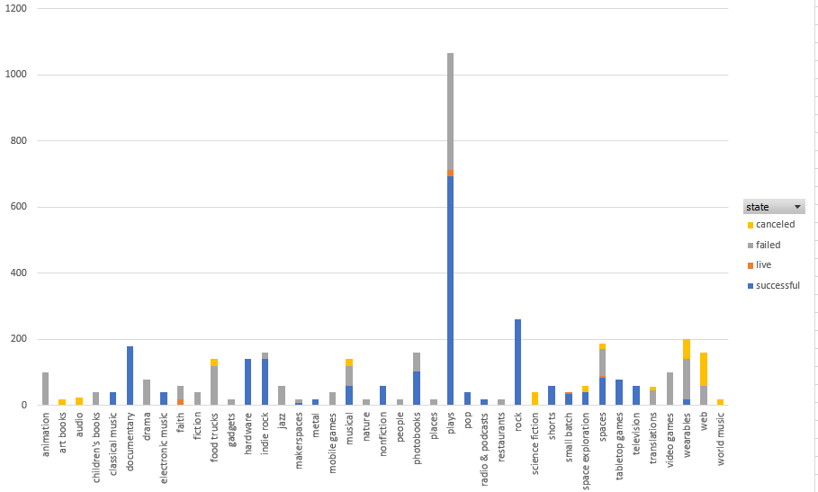

Being broken down by sub-categories, we can tell which one is successful and which one is not with the given data. While there are categories with 100% successful rates such as classical music, documentary, electronic music, hardware, metal, non-fiction, pop, radio and podcasts, rock, shorts, small batch, table top games, and television, there are also categories with 100% unsuccessful such as animation, children’s books, drama, faith, fiction, food trucks, gadgets, jazz, mobile games, nature, people, places, restaurants, translations, videogames and web. The play category is dominant with its highest successful and unsuccessful rate.

* 1. Conclusion 3

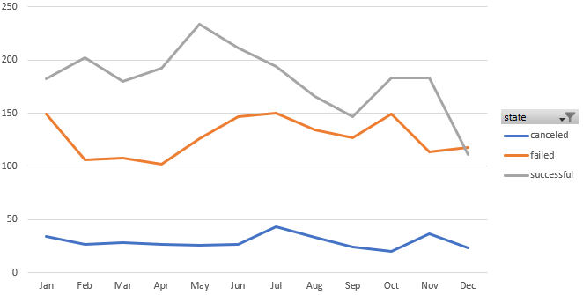

Both successful and unsuccessful rates decrease around May and finally meet in December.

1. What are some limitations of this dataset?
   1. The dataset does not cover all categories
   2. The dataset is not big enough to cover all states
   3. Not enough sources for the dataset to show the accurate conclusion
2. What are some other possible tables and/or graphs that we could create?
   1. A graph to show percentages of successful and unsuccessful project
   2. A graph broken down by state and rate
   3. A graph to show profit by rate