


TRƯỜNG CAO ĐẮNG CÔNG NGHỆ THỦ ĐỨC
KHOA CÔNG NGHỆ THÔNG TIN

BÁO CÁO KẾT QUẢ TÌM HIỂU GOOGLE SEARCH API

NĂM HỌC 2018 – 2019

CHỦ ĐỀ : ĐƯA URL WEBSITE TỪ KEYWORD SEARCH ĐƯỢC LÊN DATABASE
GVHD: Phan Thanh Nhuần

SVTH: Nguyễn Xuân Nguyên Hạnh – 16211TT2452

Tp. Hồ Chí Minh, Tháng 4 năm 2019

GDA1 Google Search API

Project Code: GDA1
Document Code: GDA1_Google_Search_API_v1.0

Ho Chi Minh, April 2019
Record of change
*A - Added M - Modified D - Deleted
Effective Date | Changed Items | A*  M, D | Change Description | New Version
15-Apr-2019 | First release | A |  | 1.0

SIGNATURE PAGE
ORIGINATOR: Nguyen Xuan Nguyen Hanh 15-Apr-2019

REVIEWERS:

APPROVAL:

Category
1. SEARCH KEY DATA FROM GOOGLE SEARCH 4
1.1. Search any information (index screen) 5

SEARCH KEY DATA FROM GOOGLE SEARCH
It contains following functionalities:
- Look for any information
- Save website information on database.

  - Search any information (index screen)
    - Overview
This screen is used to search any information from Google Search
    - Actors
All user can search any information here
    - Workflows
Scenario | Actor | System
User input any keyword in the textbox | 1.Go to this screen (index screen)
User input any keyword in the textbox | 2.Input keyword in the textbox
Click Button“Search” | 1.Click button “Search” | Load data from google search.
    - External interfaces
      - Prototype:
User input any keyword in the textbox and click button “Search”.
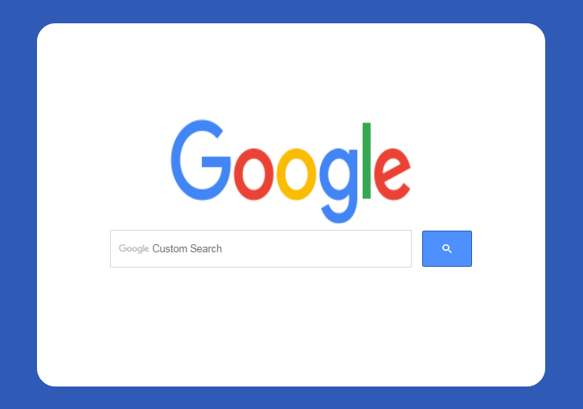
Button

      - Screen description
No | Field name | Control type | Required | Data type | Default value | Description
Field
1 | Google search | Input text | Yes | value | null | Search by keywork
Button
2 | Icon Search | Button | Yes | N/A | N/A | Click look for data from keyword
  - Save website information on database
    - Overview
This screen is show information Url website searched on database
    - Actors
Before user inputed keyword to the search then user had gone to phpmyadmin to see information
    - Workflows
Scenario | Actor | System
Phpmyadmin | 1. Go to phpmyadmin | 2.Show results
    - External interfaces
      - Prototype:
Show result information saved
