Introduction

Protocol Specific Analysis Options for Tempo Gui are located at:
z:\labtools\matlab\tempo_analysis\protocolspecific\moog\

Where z: should be the mapped network drive:
\\napa\parent

The main analysis file for curve fitting is:
DirectionTuningPlot_Curvefit.m

All routines called by this file start with:
Curvefit_*

Normally the curve fitting is run with tempo_gui or batch_gui.
Talk to Greg for a description of these tools.
To run tempo_gui or batch_gui you need to add these to matlab path:

z:\labtools\matlab\tempo_htb
z:\labtools\matlab\tempo_analysis

The curve fitting analysis consists of four phases:
1) loading the data
2) fitting a model to the data
3) computing statistics for the model/data
4) plotting the model(s) vs. the data

All of these phases have associated options that are contained in the options file. The default options file is Curvefit_default_options.m but this file can be specified as an optional argument to DirectionTuningPlot_Curvefit. Currently only a backdoor script can use the optional options file argument OPT_FILE, since this hook is not supported by tempo_gui or batch_gui.

Every phase of the analysis contains a backdoor hook, so that
you do not have to wait for the gui every time.

Raw data files for Zebulon MOOG experiments are located at:
Z:\Data\MOOG\Zebulon\Raw\*.htb

Run Examples

1) To create a single fit from tempo_gui
- open tempo_gui

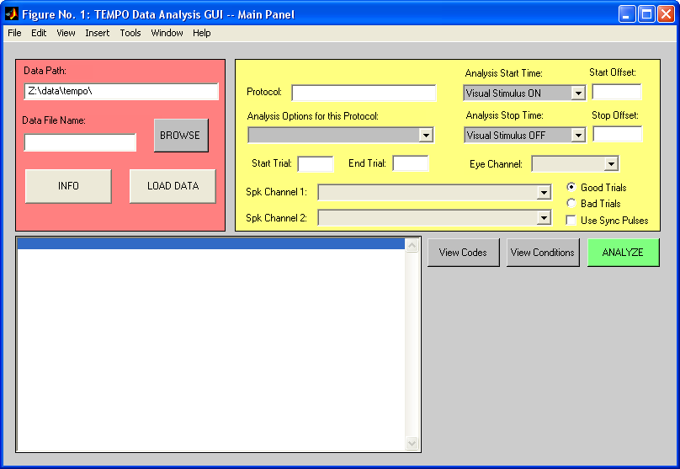

- load desired data file by browsing to it and clicking ‘load’

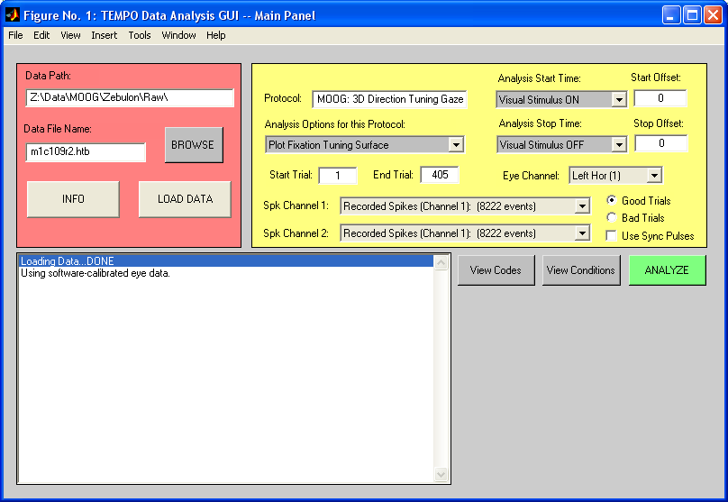

- pick curve fitting analysis option ‘Output Data for Curve Fitting’ and set start offset to 500 and stop offset to -500.

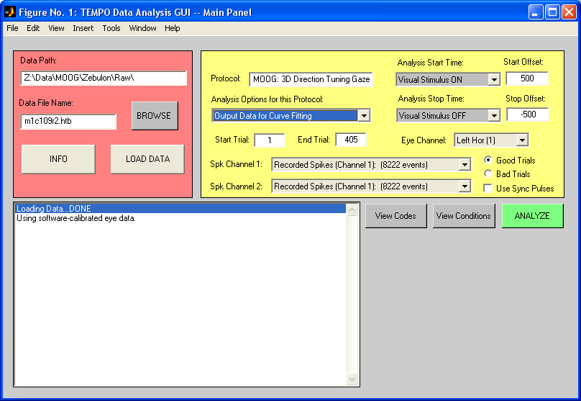

- set options to create data and fitting backdoors:
  - pick fitting models, ie:
fitting_models = [@Curvefit_head_centered_ng @Curvefit_eye_centered_ng];
fitting_bounds = [@Curvefit_head_centered_bounds_ng @Curvefit_eye_centered_bounds_ng];
fitting_tuning_models = [@Curvefit_cos_tuning_7p @Curvefit_cos_tuning_7p];

this picks head centered model and eye centered model using the 7 parameter cos tuning.

  - pick number of fitting iterations, more takes longer, ie:
minimization_iterations = 100;

  - pick which phases to run and which backdoors to build:
use_backdoor_load = 0;
build_backdoor_load = 1;
use_backdoor_fit = 0;
build_backdoor_fit = 1;
save_figures = 0;

% which phases of the fitting to run, dependent in sequence.
run_load = 1;
run_fit = 1;
run_compute_stat = 0;
run_plot = 1;

  - pick backdoor file names and directory, ie:
backdoor_dir = fullfile('work','tempo_backdoor');
backdoor_fit_file = fullfile(backdoor_dir, 'results.txt');

- click ‘Analyze’ button

2) To create multiples fits from batch_gui
- open batch_gui

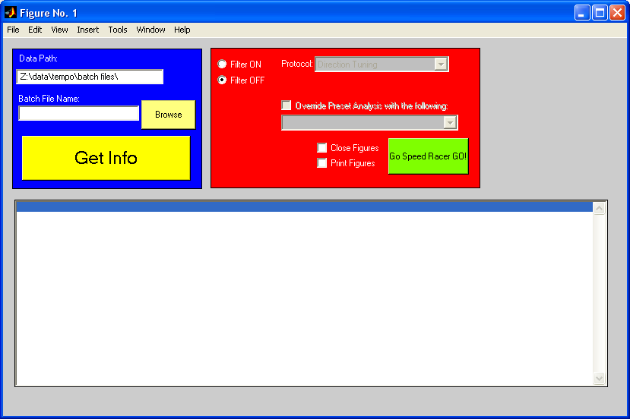

- pick a batch file (talk to Greg for details of creating batch file) from z:\data\tempo\batch_files :

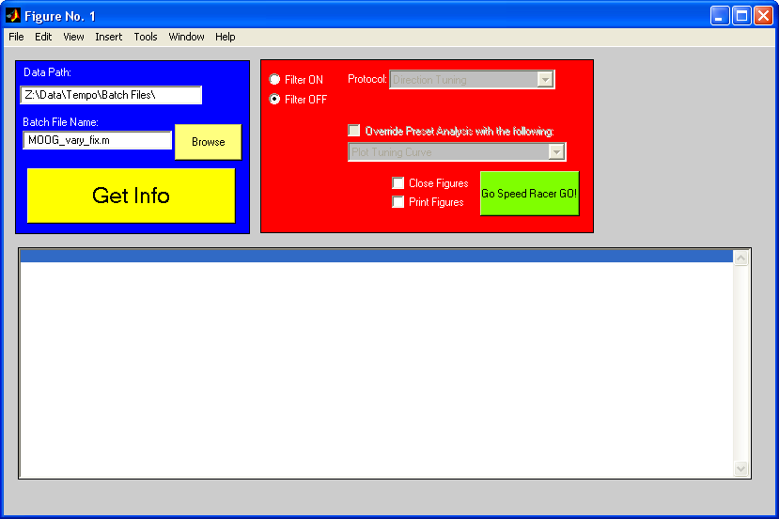

- set curve fitting options as in example 1
- click ‘Go Speed Racer GO!’

3) Creating plots or stats after backdoor is created.

- If you didn’t change the directory options, you will now have a directory tempo_backdoor in your matlab work directory that has backdoor .mat files that contain the trial data, and a results.txt file that contains the minimized parameters and residuals for the fitting. You can now use these backdoor files to create plots or compute statistics of the model/data.
- Once you have the backdoor files, you can run a local script instead of using the batch_gui or tempo_gui. Copy this script from z:\labtools\matlab\tempo_analysis\protocolspecific\moog\batch_cmd.m and edit to meet your needs.
- Set options for creating plots:
  - pick use backdoors and create plots, ie:
% which plots to generate
plot_contour = 1;
plot_R2_export = 1; % export only, plot somewhere else
plot_param_export = 1; % export only, plot somewhere else

use_backdoor_load = 1;
use_backdoor_fit = 1;
save_figures = 1;

% which phases of the fitting to run, dependent in sequence.
run_load = 1;
run_fit = 1;
run_compute_stat = 1;
run_plot = 1;
- Run batch_cmd (parameters specify batch file directory and file name to use) or run batch_gui (this will take longer since it still loads the htb data for each cell).

Future Work

Make changes to tempo_gui and batch_gui to support passing in options file for curve fitting analysis.

