Bai 1 :
SINGLETON PATTERN
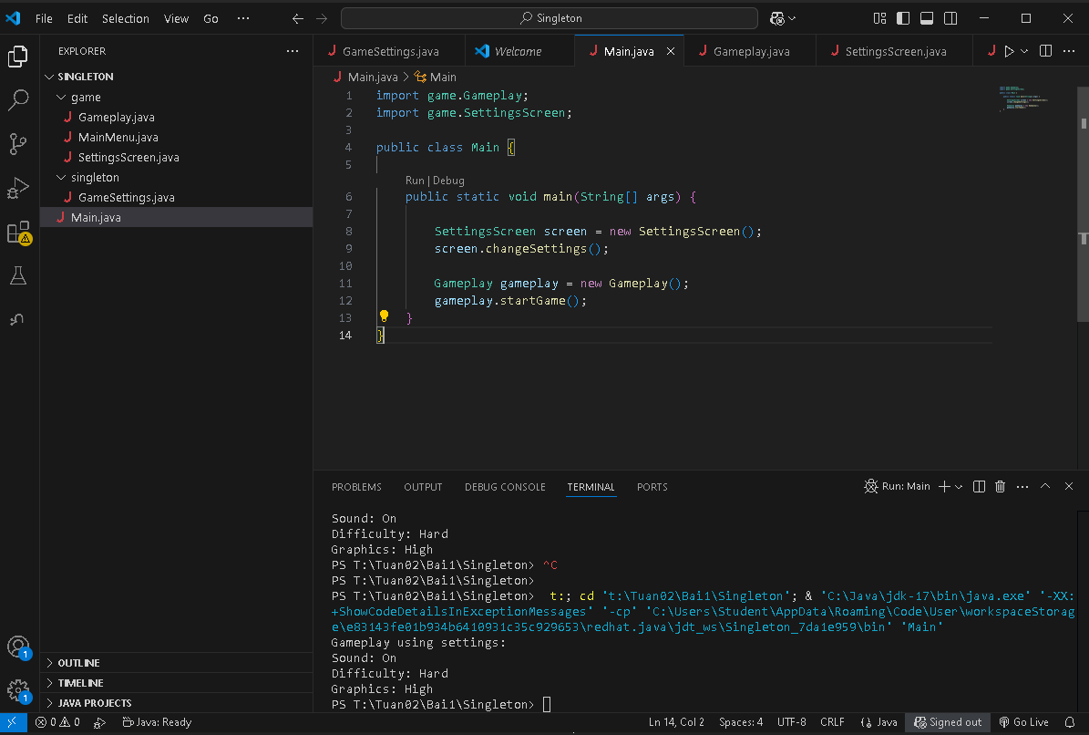
FACTORY PATTERN
