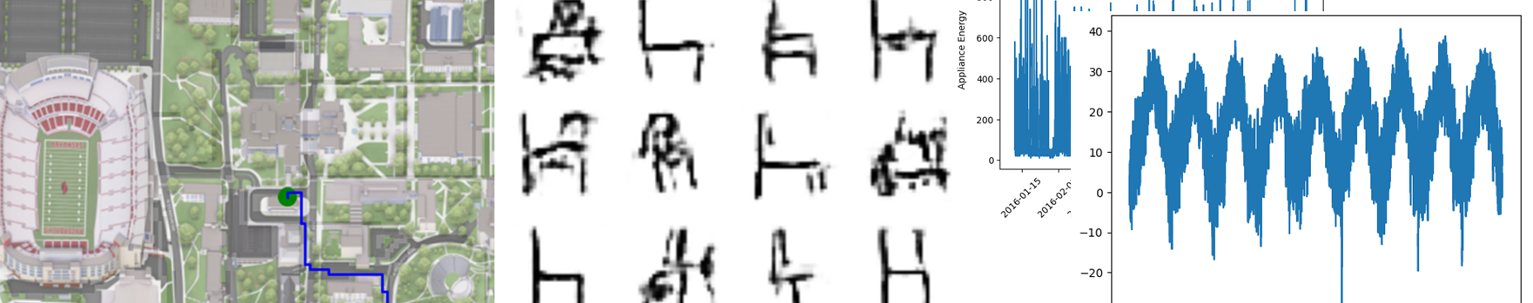

Homework 5: Student’s Choice

The goal of this homework assignment is to give you the opportunity to explore a topic you are interested in. There are three areas provided that you are welcome to explore: Time-Series Modeling, Reinforcement Learning, or Generative Models. If you have a different machine learning area that has not be covered in the course you are interested in run it by me. You are only required to complete **one** of the following assignment options:

---------------------------------------------------------------------------------------------------------------------

Option 1 – Reinforcement Learning

**Goal:** Understand and implement a popular and common reinforcement method, Q-Learning.

**Assignment:**

1. Read up on Q-Learning. This includes the github and external resources. Make sure you have a general understanding of the training process and utilization. Include a discussion in your report.
2. Using the provided Q-Learning class (in the tutorial), and implement it yourself. Following the tutorial, use Q-Learning to solve a maze.
   1. A maze of the UARK campus is provided and can be used to determine the optimal path to class but you can get creative. To make a maze, you will just need to provide a numpy matrix with 0’s and -1’s. 0’s indicate where the agent can move and -1’s are walls. You will also need to specify the starting point and the goal.
3. Report back the following:
   1. A figure of the pathing described by the final trained Q-Table and total reward
   2. Plot of total Reward per episode
   3. A heatmap of the Q-Table
4. Discuss the impact observed by altering different parameters such as max steps, alpha, gamma, epsilon, epsilon_decay, epsilon_min, etc.
5. **Grad Students Only:** Prepare a short presentation explaining reinforcement learning/ Q-learning. This should include fundamental concepts and a brief demo based on your work.

*\* Those interested in going further in this direction are encouraged to look into Deep Q learning and check out https://gymnasium.farama.org/. Additionally, there are so many other types of reinforcement learning models out there to look into.*

*---------------------------------------------------------------------------------------------------------------------*

Option 2 – Generative Models

**Goal:** Understand and implement some popular generative models. For this assignment you will perform image generation, text to image generation, and text generation. You will learn how to use some popular models from hugging face.

**Dataset:** For this assignment you will use images of small drawings from the [Quick,Draw! Dataset](https://quickdraw.withgoogle.com/data) released by Google under the CC BY 4.0 License.

**Assignment:**

1. Read up on GANs, Diffusion models, and LLMs. This includes the github and external resources. Make sure you have a general understanding of how they work and are used for generation. Include this discussion in your report.
2. Use the homework template provided to implement a gan for generating fake sketches of a class of your choice. Include generated images within you report.
3. Use a diffusion model from hugging face to perform text to image translation. Include some prompts and generated images in your report.
4. Utilize a LLM from hugging face to produce outputs within python. Include outputs and inputs in your report.
5. **Grad Students Only:** Prepare a short presentation explaining generative models. This should include fundamental concepts and a brief demo based on your work.

* *Those interested in going further in this direction are encouraged to look into cycle GANs and pix2pix or look further into finetuning hugging face models.*

---------------------------------------------------------------------------------------------------------------------

Option 3 – Time Series Modeling

**Goal:** Understand and implement time series regression and forecasting.

**Dataset**: Weather Data From

**Assignment:**

1. Read up on Time-Series Data
2. Create a Time-Series Regression Model for predicting one future temperature value using a several different inputs.
3. Create a model sequence to one regression model for predicting temperature from previous temperature values.
4. Loop over this model to predict outputs.
5. Create a sequence to sequence model
6. **Grad Students Only:** Prepare a short presentation explaining generative models. This should include fundamental concepts and a brief demo based on your work.