**Heart Attack Prediction Model**

1. **Two Python files have been created: 'Heart.py' and 'Heart.ipynb.' The Python version used is 3.10.9**
2. **After selecting the best model and running 'train.py,' you will see the following output message indicating that a file was created and saved, as shown below** 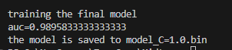
3. **Create a 'predict' file to load the model and use the 'waitress' command, as your environment is Windows and not Linux compatible.**



1. **Open a new terminal and run 'predict-test.py**
2. **Install 'pipenv' and add the required libraries. This will generate a 'Pipfile' and 'Pipfile.lock but for this project conda was used instead.**
3. **Unfortunately, I couldn't create a Docker image, as I need to update Windows, and I don't have administrative privileges to do so.**