

RAVEN – AWS PENTEST TOOL

PROJECT SUPERVISOR
Mr. Shoaib Raza

PROJECT TEAM
Wali Yar Khan 22k-4734
Amna Emaan Khan 22k-4773
Hania Fahim 22k-4687
Submitted in partial fulfillment of the requirements for the degree of Bachelor of Science in Computer Science.

FAST SCHOOL OF COMPUTING
NATIONAL UNIVERSITY OF COMPUTER AND EMERGING SCIENCES KARACHI CAMPUS
Spring 2026

Project Supervisor | Mr. Shoaib Raza
Project Team | Wali Yar Khan K22-4734  Amna Emaan Khan K22-4773  Hania Fahim K22-4687
Submission Date | May 10, 2026

Mr. Shoaib Raza ___________________________

Supervisor

FAST SCHOOL OF COMPUTING
NATIONAL UNIVERSITY OF COMPUTER AND EMERGING SCIENCES KARACHI CAMPUS

ABSTRACT
Cloud adoption has grown rapidly, with AWS becoming the dominant infrastructure platform for modern organizations worldwide. However, the complexity of AWS environments introduces significant security risks, particularly through misconfigurations, excessive privilege assignments, and exposed resources. Despite the growing threat landscape, penetration testing tools tailored specifically to AWS remain limited, leaving security professionals dependent on fragmented, manual assessment processes that are inconsistent and time-consuming. This project presents the design and implementation of an automated AWS penetration testing platform that enables security analysts to systematically identify and evaluate vulnerabilities across cloud environments. The system performs automated enumeration of key AWS services, analyzes findings through an intelligent multi-stage pipeline, and generates structured reports with actionable attack-path narratives. A risk scoring mechanism prioritizes identified vulnerabilities, allowing analysts to focus on the most critical exposures first. The platform successfully demonstrated end-to-end cloud security assessment, from resource discovery through to vulnerability classification and reporting, surfacing misconfigurations and privilege-related risks that are commonly overlooked during manual reviews. This project contributes a consolidated, AWS-focused penetration testing workflow that reduces manual effort, improves assessment consistency, and provides security teams with a practical foundation for continuous cloud security evaluation.
Keywords: AWS, Cloud Security, Penetration Testing, Vulnerability Assessment, IAM, Security Automation, Cloud Misconfiguration, Threat Analysis

Table of Contents
1. INTRODUCTION 7
2. RELATED WORK 8
2.1. CLOUD PENETRATION TESTING METHODOLOGIES 8
2.2. EXISTING AWS SECURITY ASSESSMENT TOOLS 8
2.3. AI-ASSISTED SECURITY ANALYSIS 8
3. REQUIREMENTS 9
3.1. FUNCTIONAL REQUIREMENTS 9
3.2. NON - FUNCTIONAL REQUIREMENT 10
4. DESIGN 11
4.1. SYSTEM ARCHITECTURE 11
4.1.1. ARCHITECTURE OVERVIEW 11
4.1.2. BACKEND CORE ENGINE 11
4.1.3. ENUMERATION LAYER 12
4.1.4. NORMALIZATION LAYER 12
4.1.5. REASONING LAYER (GEN AI + RAG) 12
4.1.6. EXPLOITATION LAYER 12
4.1.7. DATABASE DESIGN 12
4.1.8. FRONTEND DESIGN 13
4.1.9. API DESIGN 13
4.2. USE CASE 15
4.3. DATABASE DESIGN 18
4.3.1. POSTGRESQL SCHEMA 18
4.3.2. MONGODB COLLECTIONS 19
4.3.3. CROSS-DATABASE RELATIONSHIP 19
5. IMPLEMENTATION 21
5.1. IMPLEMENTATION OVERVIEW 21
5.2. MODULE DEVELOPMENT 21
5.3. ENUMERATION AND CIS BENCHMARK COMPLIANCE EVALUATION 22
5.4. MULTI-STAGE AI ANALYSIS PIPELINE 24
5.5. CHALLENGES AND RESOLUTIONS 26
5.6. RUNTIME INTERACTION 28
6. TESTING AND EVALUATION 28
6.1. TEST ENVIRONMENT 28
6.2. FUNCTIONAL TESTING 29
6.3. ENUMERATION AND CIS BENCHMARK VALIDATION 30
6.4. AI ANALYSIS EVALUATION 32
6.5. PERFORMANCE TESTING 35
6.6. INTEGRATION TESTING 36
7. CONLUSION 36
REFERENCES 37

INTRODUCTION
Cloud computing has become the backbone of modern organizations, with Amazon Web Services (AWS) being one of the most widely adopted platforms for scalable infrastructure [1]. However, the rapid expansion of cloud services has also introduced increasingly complex security challenges [2]. Misconfigured permissions, exposed resources, and undefined privilege relationships remain among the leading causes of cloud breaches [3].
Traditional penetration testing focuses primarily on network perimeter security and host-level vulnerabilities, which are insufficient for deeply assessing cloud-native environments [4]. AWS environments contain thousands of relationships between IAM identities, S3 buckets, Lambda functions, VPC elements, policies, and roles—making manual analysis time-consuming, inconsistent, and prone to oversight [5].
To address these challenges, we developed RAVEN, an automated AWS penetration testing and misconfiguration detection system. RAVEN performs structured cloud enumeration, evaluates IAM and resource configurations, identifies privilege escalation paths, and generates attack chains using an AI-assisted multi-stage analysis module. The tool aims to help security analysts proactively identify and assess cloud security risks through automated scanning, visualization, and report generation.
Key Features of RAVEN
- Automated AWS resource enumeration
- Misconfiguration detection and privilege escalation identification
- AI-generated attack paths using LLMs (Gemini) [6]
- JSON/PDF security reports
- Interactive dashboard for viewing resource relationships
- Secure storage using PostgreSQL and MongoDB

RELATED WORK
Cloud security has attracted considerable research attention as organizations increasingly migrate critical infrastructure to platforms such as AWS. This section reviews existing work across three key areas: cloud penetration testing methodologies, automated security assessment tools, and AI-assisted vulnerability analysis.

CLOUD PENETRATION TESTING METHODOLOGIES
Early penetration testing methodologies were designed primarily for on-premises network environments, focusing on host discovery, port scanning, and service exploitation. Shaha and Khan [4] demonstrated that these traditional approaches are insufficient for cloud-native environments [29], as they fail to account for identity-based access models, ephemeral resources, and shared responsibility boundaries. Subsequent research proposed cloud-adapted frameworks that incorporate IAM analysis and resource enumeration as core assessment activities, recognizing that privilege relationships and configuration states represent the primary attack surface in modern cloud deployments.

EXISTING AWS SECURITY ASSESSMENT TOOLS
Several open-source tools have been developed to address AWS-specific security concerns. Prowler is a widely used command-line tool that performs CIS Benchmark checks across AWS services [31], though it is limited to compliance auditing and does not support active misconfiguration analysis or attack path generation. ScoutSuite provides multi-cloud security posture assessment through static configuration review, but lacks dynamic scanning and AI-assisted analysis capabilities. Pacu, an AWS exploitation framework, focuses on offensive techniques such as privilege escalation and credential abuse [30][32][33], but requires significant manual operation and produces no structured reporting. CloudMapper visualizes AWS network relationships but does not assess IAM policies or generate risk-scored findings. None of these tools combine enumeration, misconfiguration detection, attack path generation, and reporting within a single integrated platform.

AI-ASSISTED SECURITY ANALYSIS
Recent research has explored the application of large language models in cybersecurity contexts [29]. Studies have demonstrated that LLMs can effectively interpret security configurations, generate vulnerability narratives, and suggest remediation steps [29] with accuracy comparable to experienced analysts. Google's Gemini [6] and similar models have shown particular promise in translating raw configuration data into actionable threat assessments. However, the integration of LLM-based analysis into automated cloud security workflows remains an emerging area, with limited production-ready implementations available.
  - SUMMARY AND RESEARCH GAP
While existing tools address individual aspects of AWS security assessment, no current solution provides a unified workflow that integrates automated multi-service enumeration, AI-driven attack path analysis, severity-scored misconfiguration detection, and structured report generation within a single accessible platform. RAVEN addresses this gap by combining these capabilities into a cohesive system designed for practical cloud security assessment.
Feature | Prowler | ScoutSuite | Pacu | CloudSploit | Raven
AWS Enumeration | Yes | Yes | Yes | Yes | Yes
Misconfiguration Detection | Yes | Yes | No | Yes | Yes
Exploitation Modules | No | No | Yes | No | Yes
Attack Path Mapping | No | No | No | No | Yes
Risk Prioritization | No | No | No | No | Yes
GUI | No | Partial (JSON) | No | Limited | Yes
Table 1 Comparison of existing tools vs Raven

REQUIREMENTS

FUNCTIONAL REQUIREMENTS
The following functional requirements define the core capabilities that RAVEN must provide:
FR-1: User Authentication and Account Management — The system shall support user registration, login, email OTP verification, and password reset functionality to ensure secure and validated access.
FR-2: Subscription Management — The system shall enforce tiered subscription plans that define scan limits, scan depth, AI analysis depth, history retention duration, and availability of exploit command suggestions per user.
FR-3: AWS Credential Management — The system shall allow users to register and validate AWS account credentials, verified through AWS STS, for use in scanning operations.
FR-4: Automated Resource Enumeration — The system shall perform automated enumeration of AWS services including IAM, S3, Lambda, EC2, RDS, VPC, and Security Groups, extracting configuration details, permissions, and resource relationships.
FR-5: Misconfiguration Detection — The system shall analyze enumerated resources against CIS Benchmarks and the AWS Well-Architected Framework to identify security weaknesses and assign severity scores.
FR-6: Privilege Escalation Detection — The system shall identify IAM privilege escalation paths and excessive permission assignments across enumerated identities and resources.
FR-7: AI-Assisted Attack Path Analysis — The system shall apply a multi-stage AI analysis pipeline to generate attack-path narratives, risk-scored findings, and optional exploit command suggestions from scan results.
FR-8: Attack Graph Visualization — The system shall render an interactive node-edge graph representing resource relationships and potential attack paths, with filtering by service type, risk level, and privilege level.
FR-9: Report Generation — The system shall produce both executive-level summaries and detailed technical reports, exportable in PDF and JSON formats.
FR-10: Dashboard and Scan History — The system shall provide a dashboard displaying severity trends, scan activity, and last-session summaries, with configurable scan history retention based on subscription tier.

NON - FUNCTIONAL REQUIREMENT
NFR-1: Security — All user credentials and AWS access keys shall be stored in an encrypted credential vault. API endpoints shall be protected against common threats through hardening measures, and all sessions shall be managed via JWT-based access control.
NFR-2: Performance — The system shall complete enumeration of standard AWS environments within a reasonable time window, with API response times monitored through structured observability tooling.
NFR-3: Reliability — The system shall implement structured logging with correlation IDs to support error tracing and root cause analysis. Health endpoints shall be exposed for service availability monitoring.
NFR-4: Usability — The system shall provide an intuitive web-based interface accessible without requiring command-line expertise, enabling security analysts to initiate scans, view findings, and export reports through a graphical interface.
NFR-5: Scalability — The system architecture shall support separation of scan metadata and artifact storage to allow independent scaling of data persistence components as usage grows.
NFR-6: Maintainability — The codebase shall follow modular design principles, with distinct components for enumeration, analysis, authentication, and reporting, to facilitate future extension and maintenance.

DESIGN

SYSTEM ARCHITECTURE

ARCHITECTURE OVERVIEW
RAVEN is designed as a layered, service-oriented system in which each component fulfills a distinct responsibility within the overall penetration testing workflow. The architecture follows a separation-of-concerns principle, dividing the system into a backend processing core, a dual-database persistence layer, and a frontend presentation layer. This design ensures that enumeration, analysis, exploitation, and reporting concerns remain independently maintainable and extensible.
The end-to-end flow is initiated when a user submits AWS IAM credentials through the frontend interface. These credentials are passed to the Backend Core Engine, which orchestrates the subsequent scan lifecycle across all internal layers.

BACKEND CORE ENGINE
The Backend Core Engine serves as the central orchestrator of RAVEN. It is responsible for receiving user inputs, validating AWS credentials, dispatching scan tasks to appropriate layers, and coordinating data flow between enumeration, analysis, and storage components. All inter-layer communication is routed through this engine, ensuring a single point of control over scan execution and state management.

ENUMERATION LAYER
The Enumeration Layer is responsible for interfacing directly with the AWS cloud environment using the supplied IAM credentials. It queries AWS APIs across multiple services including IAM, S3, Lambda, EC2, RDS, VPC, and Security Groups to extract resource configurations, permission assignments, policy definitions, and relationship metadata. This layer is designed to be modular, allowing new AWS service modules to be added without modifying the core orchestration logic.

NORMALIZATION LAYER
Raw data returned by the Enumeration Layer varies significantly in structure across AWS services. The Normalization Layer transforms this heterogeneous data into consistent, structured representations suitable for downstream analysis. By standardizing enumerated findings into uniform data models, this layer ensures that the Reasoning Layer and database persistence components receive predictable, well-formed inputs regardless of the originating AWS service.

REASONING LAYER (GEN AI + RAG)
The Reasoning Layer forms the intelligence core of RAVEN. It applies a Generative AI pipeline augmented with Retrieval-Augmented Generation (RAG) to interpret normalized scan findings, identify misconfiguration patterns, assess privilege escalation risks, and produce structured attack-path narratives. The use of RAG allows the analysis to incorporate contextual security knowledge beyond what is present in the raw scan data, improving the relevance and accuracy of generated findings. Outputs from this layer feed directly into the Exploitation Layer for further processing.

EXPLOITATION LAYER
The Exploitation Layer consumes the attack-path narratives and risk assessments produced by the Reasoning Layer and translates them into concrete exploitation techniques and proof-of-concept command sequences. This layer is designed to support security analysts in understanding not only that a vulnerability exists, but how it could be practically leveraged by an adversary — bridging the gap between misconfiguration detection and actionable offensive assessment.

DATABASE DESIGN
RAVEN employs a dual-database architecture to address the distinct storage requirements of its data types. PostgreSQL is used to persist structured relational data, including user accounts, subscription plans, scan metadata, and credential records. Neo4j, a graph database, is used to store and query resource relationship data, enabling efficient traversal of IAM privilege graphs and attack path relationships. This separation ensures that relational queries and graph traversals are each handled by a storage engine optimized for their respective data models.

FRONTEND DESIGN
The frontend is composed of two principal layers. The Visualization Layer renders interactive graphs and dashboards, allowing analysts to explore resource relationships, attack paths, and severity distributions visually. The Reporting Layer generates structured output documents from scan findings, supporting both executive summaries and detailed technical reports in PDF and JSON formats. The frontend communicates with the backend exclusively through a defined API boundary, maintaining clean decoupling between presentation and processing concerns.

API DESIGN
All communication between the frontend and backend is mediated through a REST API layer. This boundary enforces access control, validates authentication tokens, and provides a stable interface contract between the two tiers. The API design ensures that the frontend remains independent of internal backend implementation details, supporting future modifications to either layer without requiring coordinated changes across the full system.
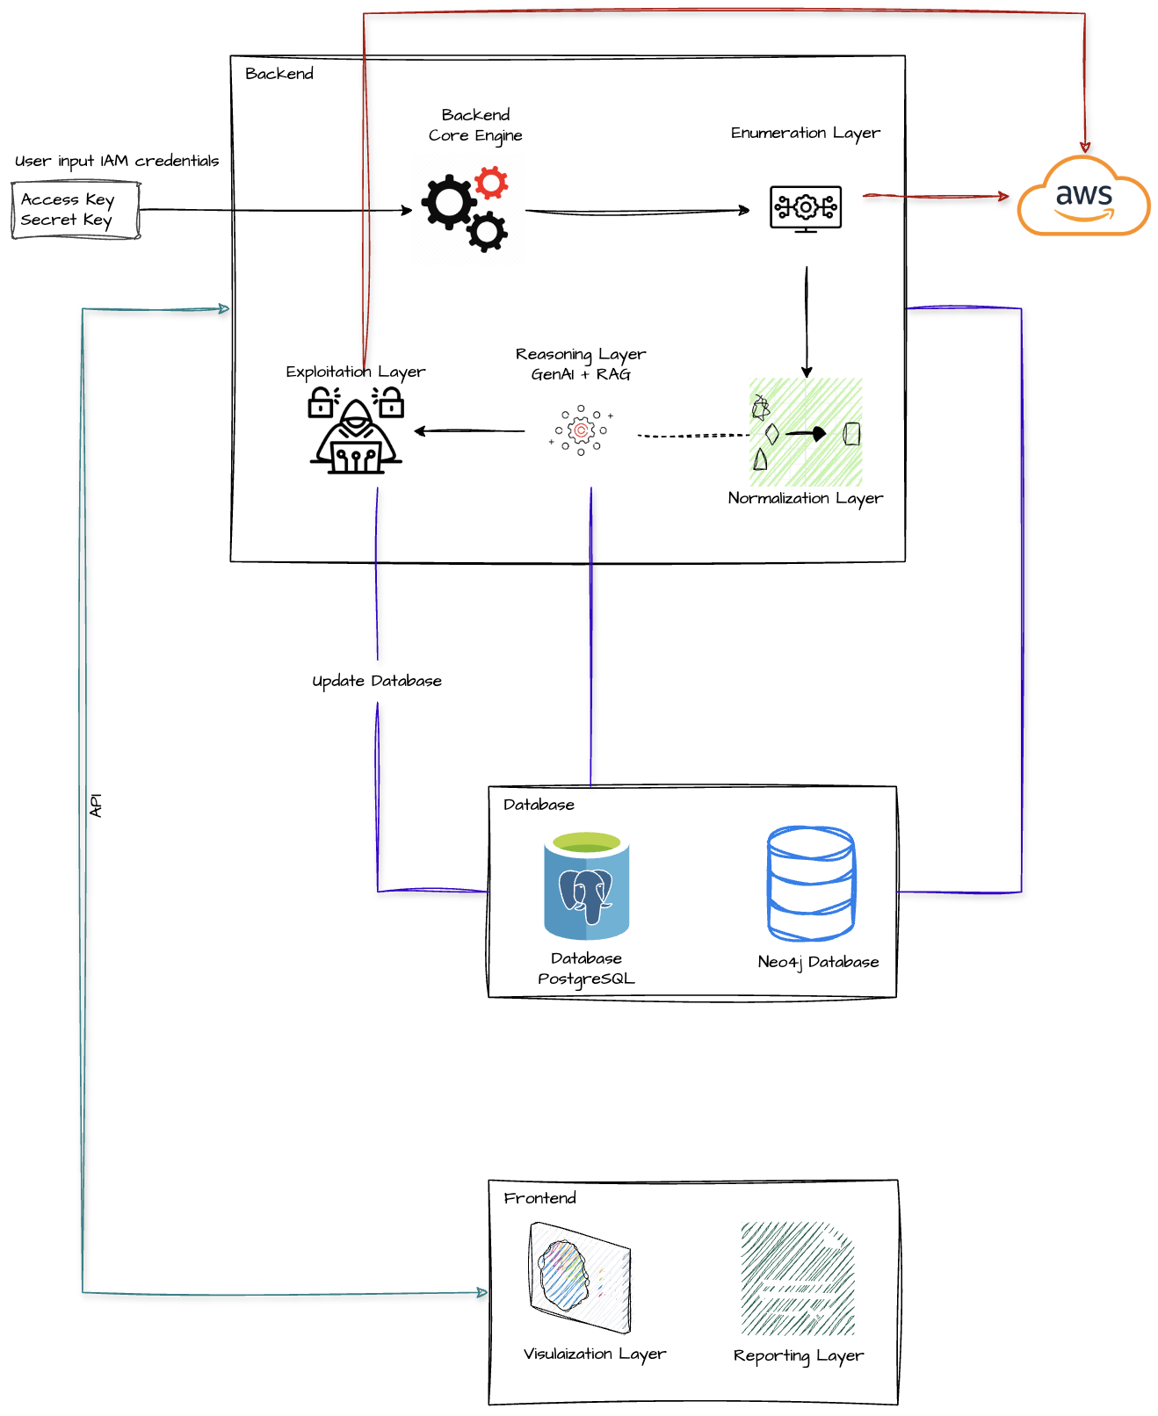
Figure 1 System Architecture Diagram

USE CASE
The RAVEN system involves a single primary actor the Security Analyst who interacts with the platform through a web-based interface. The system additionally interfaces with three external actors: the AWS API, the LLM (Large Language Model), the PostgreSQL Database, and the MongoDB Database. The use case diagram captures the full scope of analyst-initiated operations and the system's internal processing flows.
Account Management
The Security Analyst begins by registering an account and logging into the system. Both actions are prerequisites that are included across all subsequent operations, enforcing authenticated access throughout the platform. The analyst may also log out at any time to terminate the session securely.
Environment Management
Once authenticated, the analyst can manage AWS environments by creating new environments, listing existing ones, or deleting environments that are no longer required. Each environment corresponds to a set of AWS IAM credentials representing a target AWS account to be assessed.
Scan Management
The Manage Scans use case provides the analyst with full control over the scanning lifecycle. The analyst can create a new scan, list all previously executed scans, and view detailed scan results. Scan creation triggers the Run AWS Enumeration process, which interfaces directly with the AWS API to collect resource data. Enumeration is broken into three specialized sub-processes — IAM Enumeration, S3 Enumeration, and Lambda Enumeration — each of which is included as part of the broader enumeration workflow. Enumeration results are persisted to the MongoDB Database for artifact storage and to the PostgreSQL Database for structured metadata.
Attack Path Generation
Following scan execution, the analyst can initiate attack path generation. This use case invokes the Analyse Scan Result with LLM process, which forwards normalized scan findings to the external LLM for intelligent interpretation. The LLM-assisted analysis is structured as a Multi-Stage Analysis pipeline comprising three sequential stages. Stage 1 performs triage, categorizing findings by severity and relevance. Stage 2 conducts deep analysis, examining privilege relationships and misconfiguration implications in detail. Stage 2 is accessible as an extension of both Stage 1 and Stage 3. Stage 3 generates concrete exploit commands derived from the analysis, providing the analyst with actionable offensive assessment output.
System Actors
The AWS API serves as the live data source for all enumeration operations, responding to credential-authenticated queries from the Enumeration Layer. The LLM processes structured scan data and returns analytical narratives, risk assessments, and command suggestions. PostgreSQL stores relational data including user records, scan metadata, and environment configurations, while MongoDB stores raw scan artifacts and per-service enumeration collections.
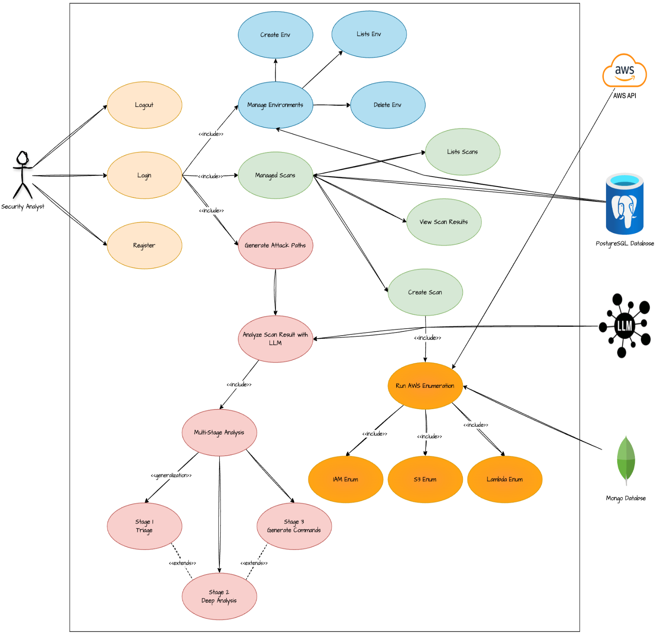
Figure 2 Use Case Diagram

DATABASE DESIGN
RAVEN employs a dual-database architecture to address the fundamentally different storage requirements of its two primary data categories. PostgreSQL is used for structured relational data requiring referential integrity and transactional consistency, while MongoDB is used for document-oriented scan artifacts whose schema varies across AWS service types. This separation ensures each storage engine is used for the category of data it handles most efficiently.

POSTGRESQL SCHEMA
The relational schema is organized around six core tables.
The users table forms the root of the relational model, storing account credentials including email and hashed password. Each user is linked to one or more environments, which store AWS IAM credentials — access key, secret access key, and region — representing target AWS accounts available for scanning. Environments maintain a foreign key reference to their owning user.
The scans table records each scan operation initiated by an analyst. It holds the scan name, associated environment, execution mode, status, and timestamps for creation and completion. Scans maintain a foreign key reference to their parent environment, establishing a clear ownership chain from user to environment to scan.
The plans table defines the available subscription tiers, capturing parameters such as price, maximum environments, maximum scans per month, scan depth, analysis level, history retention duration, and export permissions. Three concrete plan configurations — Plan A (Free), Plan B, and Plan C — are defined, each offering progressively higher limits and capabilities including access to deep analysis and exploit command generation.
The subscriptions table binds users to their active plan, recording the plan identifier, subscription start and expiry dates, and current usage counters for environments and scans per month. This table enforces plan-level access control across the platform.
The otp table manages email-based one-time password verification. It stores a hashed OTP code, expiry timestamp, creation timestamp, attempt count, resend count, and verification status per email address, supporting secure identity validation during registration and sensitive account operations.
The BlackListToken table maintains a registry of invalidated JWT tokens, storing the token value, associated user, creation timestamp, and expiry timestamp. This ensures that logged-out or revoked sessions cannot be reused even if the token has not yet naturally expired.
The attack_analysis table stores AI-generated analysis results linked to a scan via a foreign key. Each record captures the overall severity assessment, a triage object containing identified entry points, quick wins, and flags for required deep analysis, along with a risk summary and creation timestamp.

MONGODB COLLECTIONS
MongoDB stores the raw enumeration artifacts produced during scan execution. All collections reference their parent scan through a scan_id field, linking MongoDB documents back to the PostgreSQL scan record.
The iam_users collection stores enumerated IAM user records, including username, user ID, and embedded sub-documents for attached policies, group memberships, tags, and access keys.
The iam_groups collection captures IAM group configurations, embedding managed policies, inline policies, and member lists within each group document.
The iam_roles collection records IAM role definitions, embedding assume-role policy documents, managed policies, inline policies, and associated tags.
The s3_buckets collection stores S3 bucket metadata including bucket name, region, and embedded bucket configuration and tagging sub-documents that capture access control, versioning, and policy settings.
The lambda_functions collection holds Lambda function records with embedded sub-documents covering environment variables, networking configuration, layers, runtime versions, event triggers, concurrency settings, tags, and attached policies.
The lambda_layers collection stores Lambda layer definitions, embedding compatibility, content, and policy information within each document.

CROSS-DATABASE RELATIONSHIP
The two databases are linked through the scan_id reference key. Every MongoDB document produced during enumeration carries the identifier of the scan record in PostgreSQL under which it was collected. This relationship allows the application layer to retrieve all enumeration artifacts associated with a given scan without requiring a direct database join, maintaining clean separation between the two storage systems while preserving navigable data relationships.
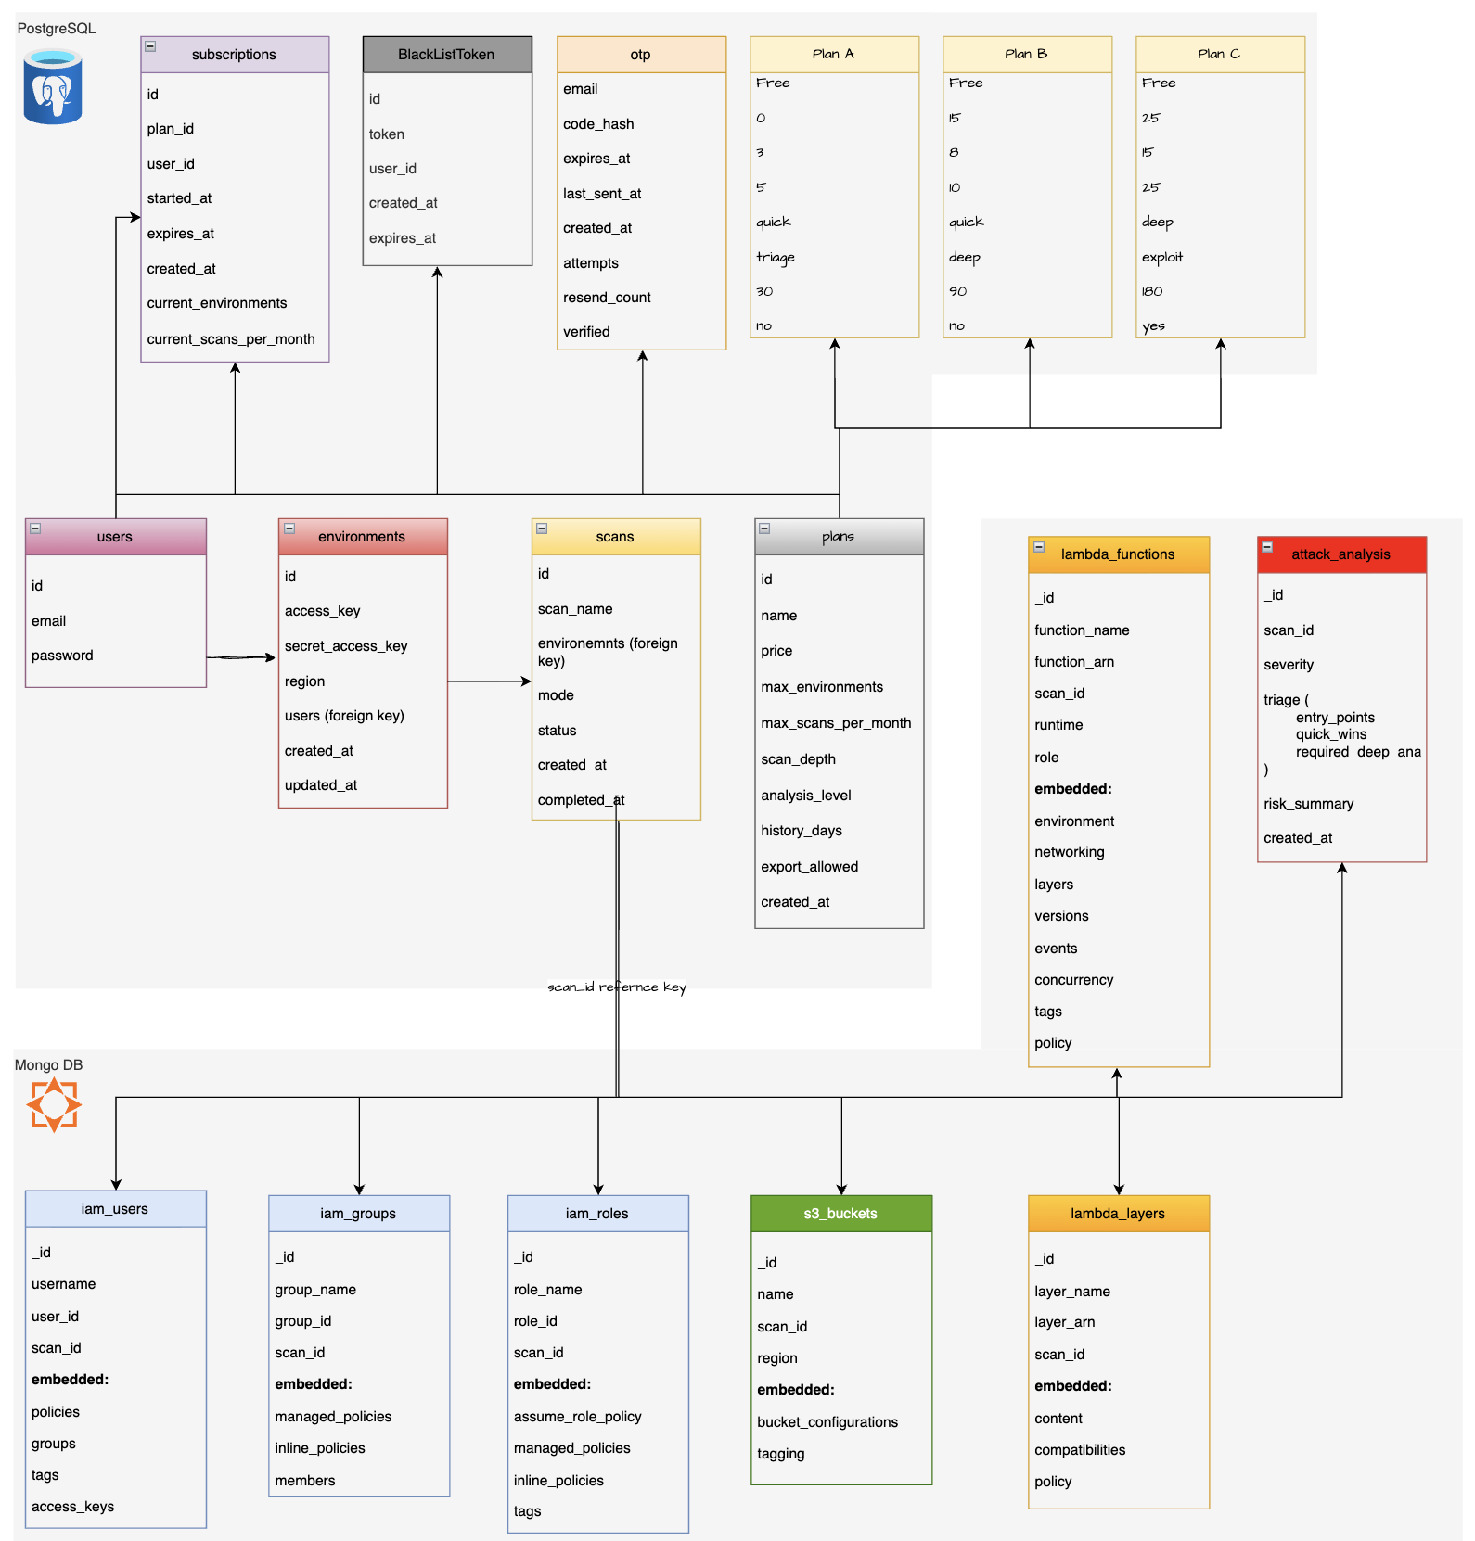
Figure 3 Database Architecture

IMPLEMENTATION

IMPLEMENTATION OVERVIEW
The implementation of RAVEN focused on delivering a complete, end-to-end AWS penetration testing workflow, guiding a security analyst from account creation and environment setup through scan execution, AI-assisted analysis, and results review. The system was built as a collection of functionally distinct modules — authentication, environment management, enumeration, compliance evaluation, AI analysis, and reporting — each implemented independently to allow isolated development and testing without disrupting the core scan pipeline. The implementation placed particular emphasis on reliability under partial failure conditions, ensuring that incomplete AWS responses, blocked API calls, and LLM output variations did not propagate as unhandled system errors.
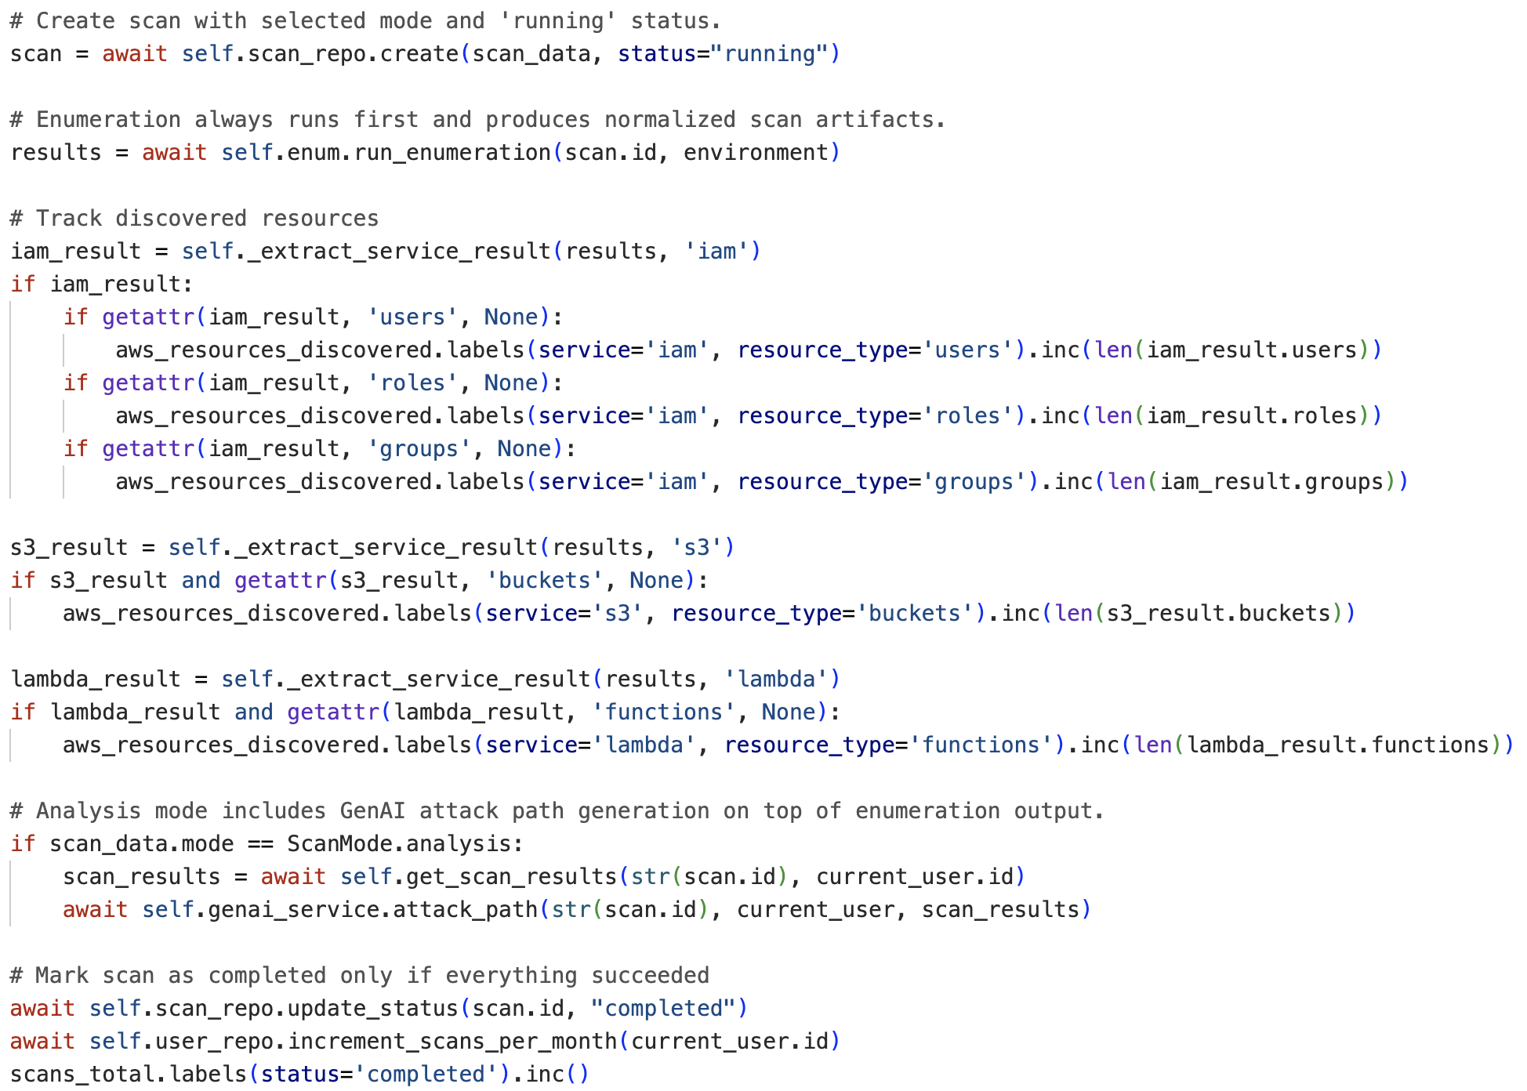
Figure 4 Scan Execution Orchestration

MODULE DEVELOPMENT
The working system was organized into modules aligned with the analyst workflow. Authentication and OTP verification were implemented as a unified access control flow, enforcing identity validation before any environment or scan operation could be performed. Environment management was implemented to securely store and validate AWS IAM credentials against AWS STS prior to use. The scan execution engine was implemented to orchestrate enumeration, normalization, compliance evaluation, and optional AI analysis as a sequential pipeline, with each stage producing structured outputs consumed by the next. Separate modules were implemented for subscription management, dashboard data aggregation, and report generation, ensuring that billing and presentation concerns remained isolated from the core scan logic.
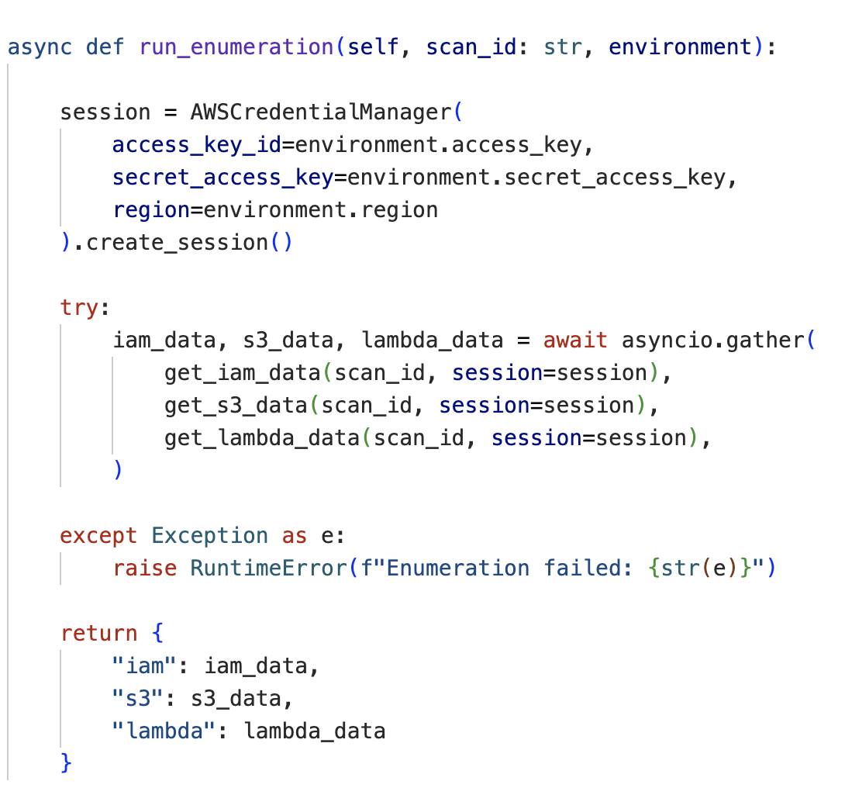
Figure 5 Concurrent async Enumeration

ENUMERATION AND CIS BENCHMARK COMPLIANCE EVALUATION
Following enumeration, collected AWS resource data is passed through a compliance evaluation layer mapped against the AWS CIS Benchmark [9]. IAM resources are evaluated across 28 discrete controls covering critical findings such as root user access key existence, hardware MFA enforcement, full administrative privilege policies, access key rotation within 90 days, unused credential removal, and password policy strength [28]. Each control is defined in a structured metadata registry associating control identifiers with titles and severity classifications ranging from low to critical. S3 and Lambda resources are similarly evaluated against their respective benchmark controls, with per-service scores computed independently and aggregated into an overall severity classification [21]. This benchmark-driven evaluation layer ensures that findings are grounded in recognized industry standards and remain consistent and auditable across scan executions [4].
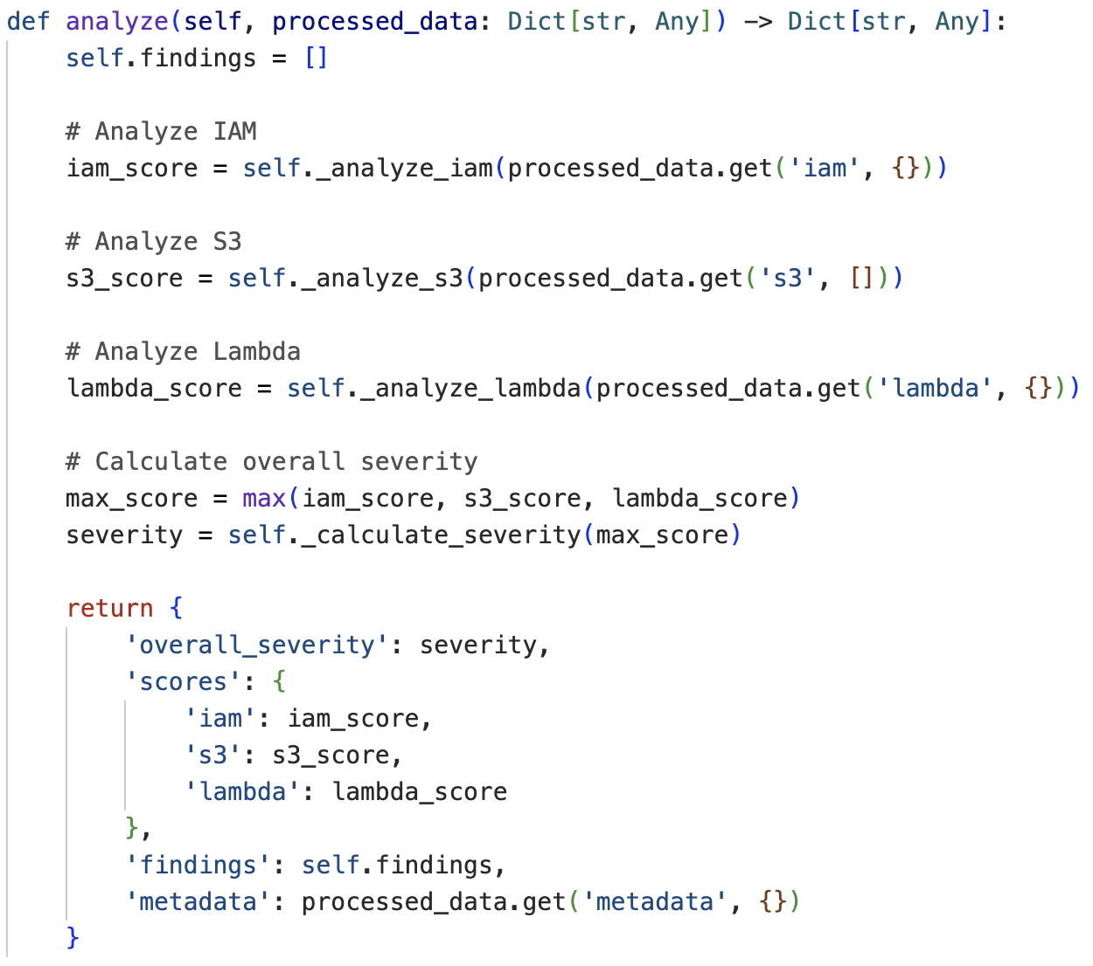
Figure 6 Risk Scoring Engine
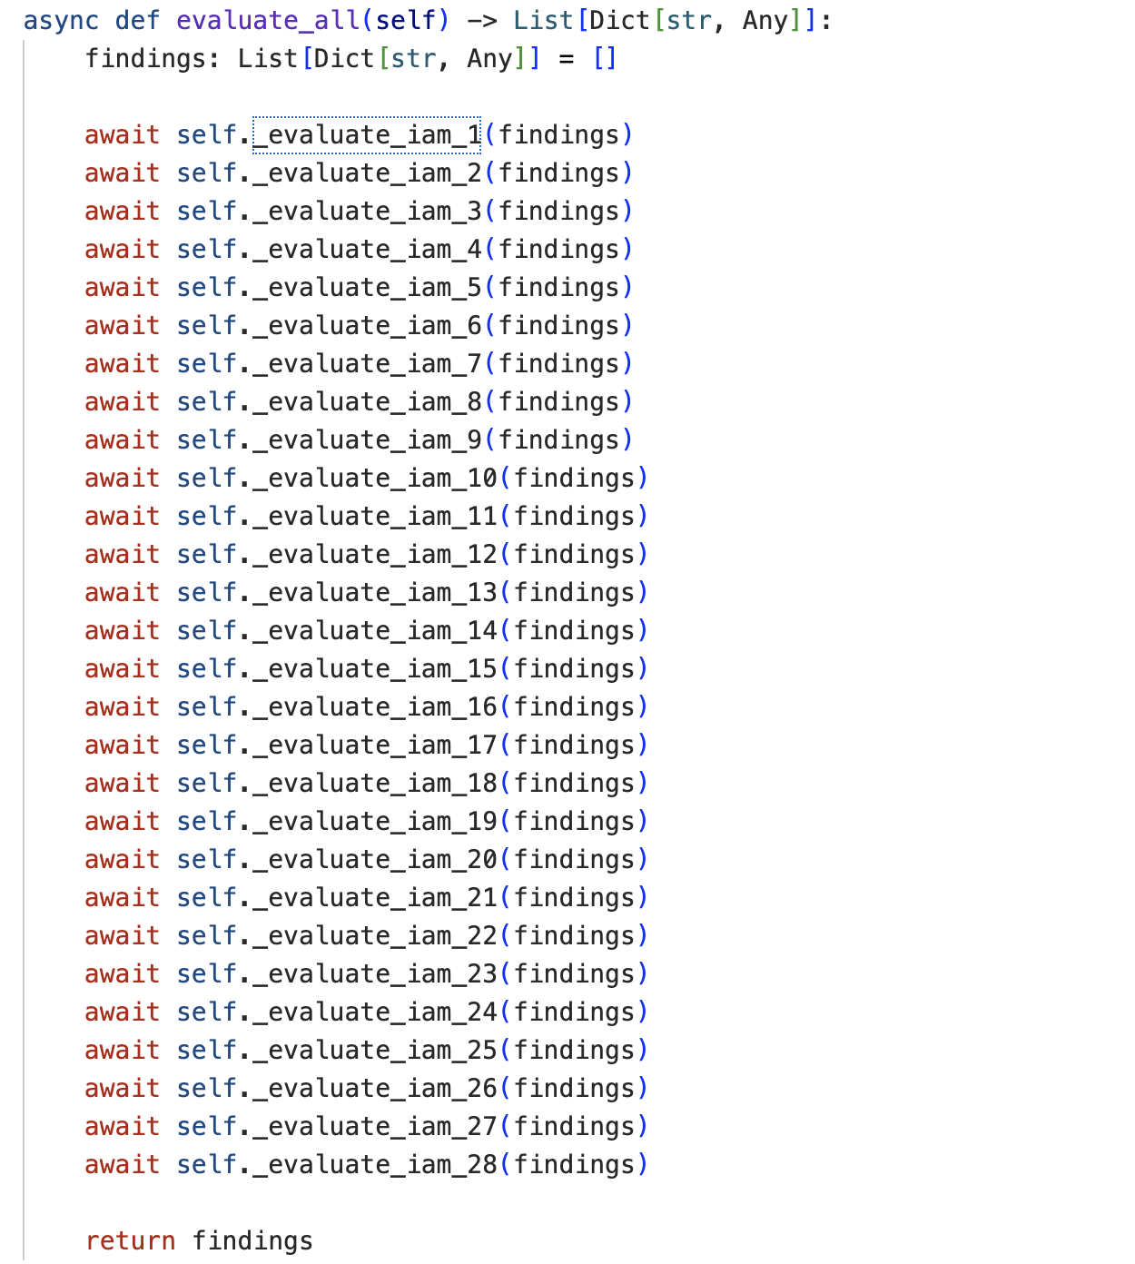

Figure 7 CIS Benchmark Evaluation

MULTI-STAGE AI ANALYSIS PIPELINE
When analysis mode is enabled, normalized enumeration output and benchmark findings are processed through a five-stage AI pipeline. Stage 0 serializes enumerated data into dictionary form. Stage 1 applies deterministic preprocessing to structure findings for LLM consumption. Stage 2 computes risk scores per service using the compliance evaluation results. Stage 3 submits the risk summary to the Gemini LLM for rapid triage, identifying entry points, quick wins, and an initial severity assessment [6]. If the triage result indicates critical or high severity, Stage 4 is conditionally triggered to perform deep analysis of privilege relationships and attack surface. For exploit-tier subscriptions, Stage 5 generates concrete exploitation commands from identified attack paths, using a low-temperature model configuration to ensure precise and reproducible output [15]. This conditional execution design ensures that compute-intensive LLM calls are only invoked when warranted by the severity of findings [16].
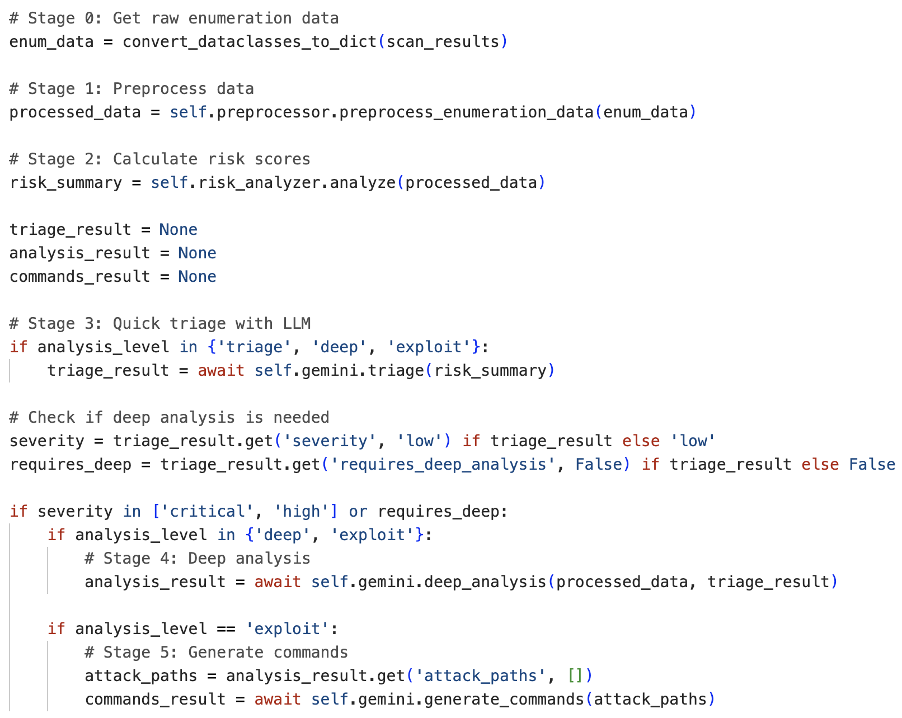
Figure 8 Full AI Pipeline Flow
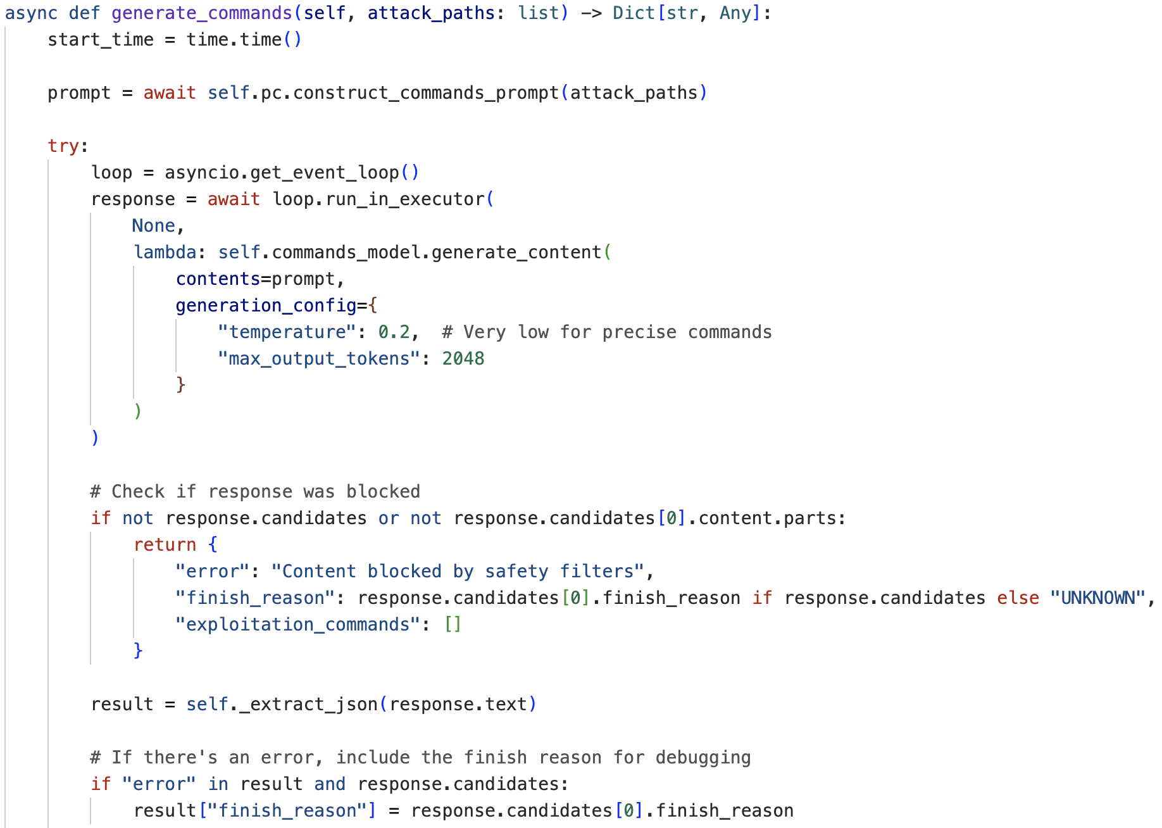

Figure 9 Command Generation Implementation

CHALLENGES AND RESOLUTIONS
Challenge 1 — Handling Blocking AWS SDK Calls and Permission Boundaries
AWS SDK calls via Boto3 are synchronous and blocking by nature, which presented a significant challenge within the asynchronous backend architecture [15]. Additionally, AWS environments routinely restrict certain API calls, meaning enumeration requests frequently return permission denied responses or partial data [17]. The solution involved wrapping all SDK calls in executor-based async wrappers to prevent event loop blocking [16], and implementing per-call exception handling that gracefully captures access denied and no-credentials errors, logs them with contextual metadata, and continues enumeration of remaining services without terminating the scan [18]. This ensured the system remained stable and produced meaningful partial results even when operating against restrictive IAM policies [19].
Challenge 2 — Designing a Reliable Multi-Stage GenAI Analysis Pipeline
Constructing a coherent three-layer analysis pipeline — triage, deep analysis, and exploit command generation — introduced significant complexity around prompt consistency, conditional execution logic, and LLM output reliability. Early iterations produced inconsistent JSON structures that broke downstream parsing [20]. The resolution involved implementing a dedicated prompt constructor for each stage, injecting structured scan data into versioned templates with a custom serializer handling non-standard types [21]. A deterministic JSON extractor was implemented to parse LLM responses robustly [22], and safety filter responses were handled explicitly to return structured error objects rather than raising unhandled exceptions. Conditional stage activation based on triage severity ensured that the pipeline scaled its depth proportionally to the risk level of findings [13].
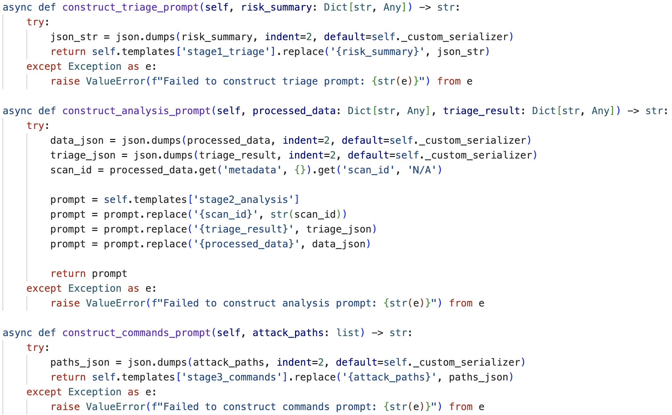
Figure 10 Template Based Prompt Construction
Challenge 3 — Integrating AWS CIS Benchmark Controls Across Multiple Services
Mapping enumerated AWS resources against the CIS Benchmark required implementing 28 IAM controls, alongside S3 and Lambda control sets, each with distinct evaluation logic and severity classifications [9]. Ensuring coverage consistency across services while keeping control definitions maintainable presented a structural challenge. The solution involved centralizing all control metadata in a CONTROL_META registry decoupled from evaluation logic, allowing control definitions to be updated independently of the checks that referenced them. Each service's evaluator was implemented as a sequenced set of discrete async checks, accumulating findings into a unified list. This architecture made it straightforward to extend coverage to additional AWS services in future iterations [24].
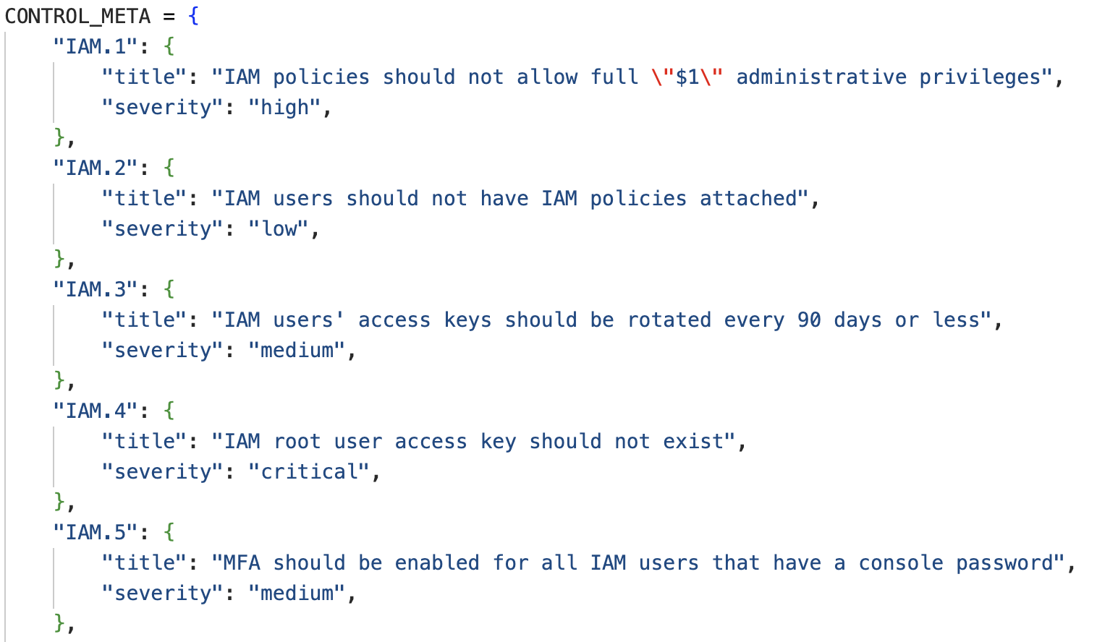
Figure 11 Control Metadata Definition

RUNTIME INTERACTION
At runtime, a scan request creates a database record with running status, dispatches concurrent enumeration across IAM, S3, and Lambda services, applies compliance evaluation to collected findings, and conditionally triggers AI analysis based on scan mode and subscription tier. Scan status is updated to completed only after all stages succeed, and the user's monthly scan counter is incremented atomically. When analysis is enabled, a separate attack analysis record is created and linked to the scan, allowing the frontend to load raw findings and interpreted results independently. Prometheus metrics are updated throughout execution to track discovered resource counts and scan totals for observability.

TESTING AND EVALUATION

TEST ENVIRONMENT
System testing was conducted against CloudGoat, an intentionally vulnerable AWS environment developed by Rhino Security Labs for cloud security training and tool validation [7]. CloudGoat provisions realistic AWS infrastructure with deliberately misconfigured IAM users, roles, policies, and resources, making it a recognized and appropriate baseline for evaluating cloud penetration testing tools [8]. Three separate AWS environments were registered within RAVEN during testing, each corresponding to a distinct set of IAM credentials targeting the CloudGoat deployment. All scans were executed in Enum + Analysis mode, triggering the full pipeline from enumeration through AI-assisted attack path generation.

FUNCTIONAL TESTING
Each core module of RAVEN was tested individually against the CloudGoat environment to verify correct operation. Results are summarized in the table below.
Module | Test Performed | Result
IAM Enumeration | Users, roles, policies extracted | Passed
S3 Enumeration | Public access, ACL, encryption checks | Passed
Lambda Enumeration | Env vars, execution role, VPC | Passed
Credential Validation | AWS STS call | Passed
Multi-stage Analysis | Triage → Deep → Commands | Passed
Attack Path Generation | Consistent + Actionable | Passed
Scans Management | CRUD operations | Passed
Table 2 Functional Testing Results
All seven modules passed functional testing. IAM enumeration successfully extracted users, roles, groups, and attached policies. S3 enumeration verified public access settings, ACL configurations, and encryption status. Lambda enumeration collected environment variables, execution roles, and VPC configurations. Credential validation confirmed AWS STS connectivity for all three registered environments, with a "Valid Credentials — Connection to AWS successful" confirmation displayed to the user upon successful validation, as shown in Figure 12. Scan management CRUD operations — create, list, and view — functioned correctly across all test runs, with all three scans reaching Completed status as shown in the scan history view.
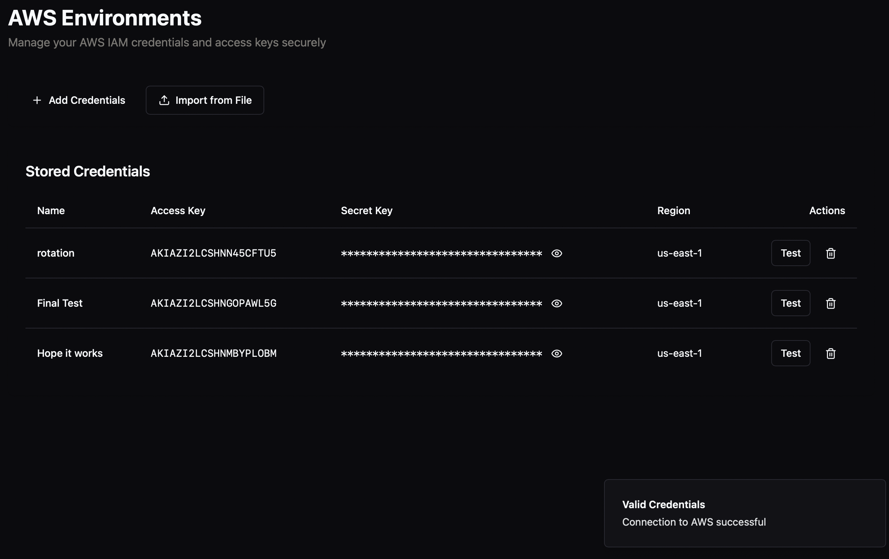
Figure 12 Verifying Connection Testing
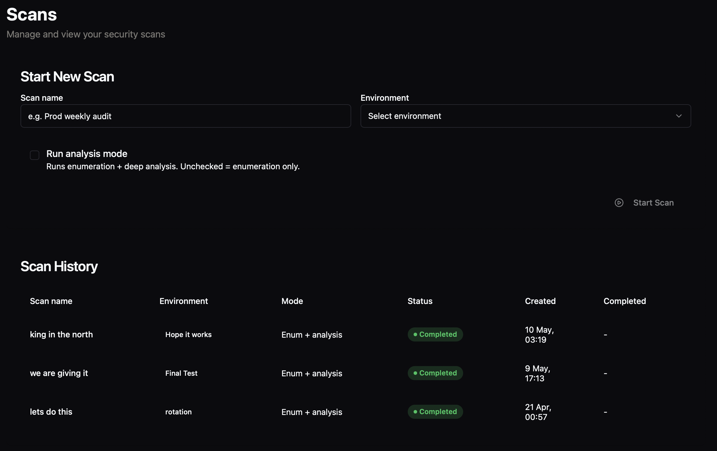
Figure 13 Scans Outcome

ENUMERATION AND CIS BENCHMARK VALIDATION
Enumeration of the CloudGoat environment successfully identified 3 IAM users, 4 roles, and 1 group across the target account, with no S3 buckets or Lambda functions present in the tested deployment. Raw IAM user records were correctly structured and persisted to MongoDB, including full policy documents, ARNs, creation timestamps, and scan ID references as shown in Figure 14.
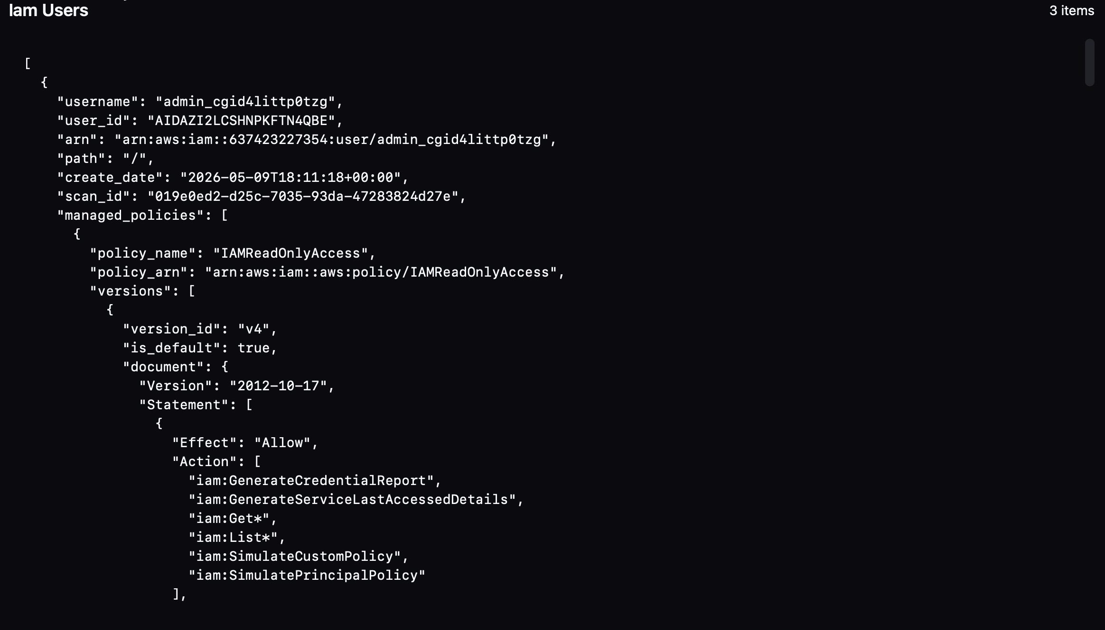
Figure 14 Enumeration Results
CIS Benchmark evaluation correctly flagged findings against the enumerated IAM resources. Critical findings were raised for wildcard permissions detected on the admin_cgid4littp0tzg and manager_cgid4littp0tzg users, with medium severity findings raised for active access keys on both the developer and manager users. The findings panel confirmed accurate severity classification and impact descriptions for each identified control violation, as shown in Figure 15. An overall IAM risk score of 100 was computed, correctly reflecting the presence of critical misconfigurations in the environment.
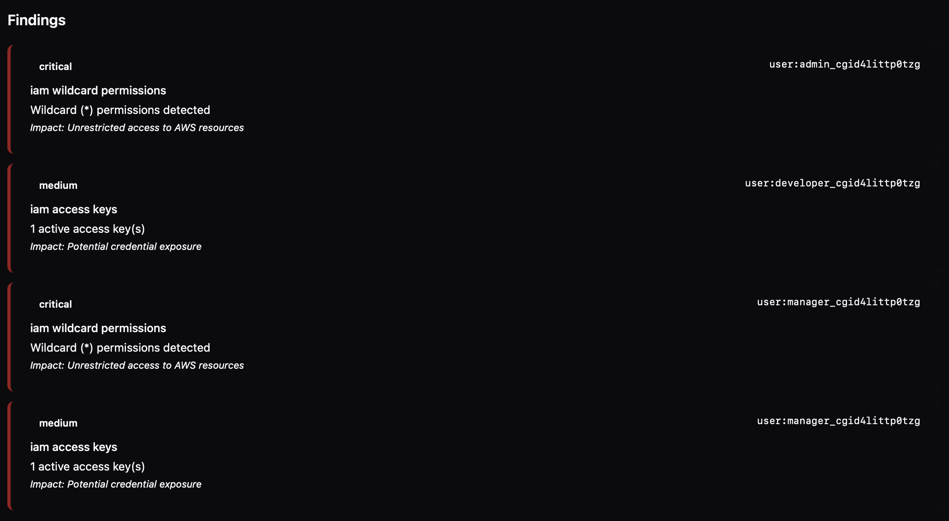
Figure 15 Findings Summary

AI ANALYSIS EVALUATION
The AI-assisted analysis pipeline was evaluated on its ability to produce accurate, structured, and actionable outputs from the CloudGoat enumeration results. The triage stage correctly classified the overall session severity as CRITICAL and flagged that deep analysis was required, as shown in Figure 16. Three entry points were ranked by exploitability — admin_cgid4littp0tzg and manager_cgid4littp0tzg with wildcard permissions rated as easy to exploit, and developer_cgid4littp0tzg with an active access key rated as moderate. Three actionable quick wins were generated: remove wildcard permissions for the admin user, remove wildcard permissions for the manager user, and rotate or remove the developer access key.
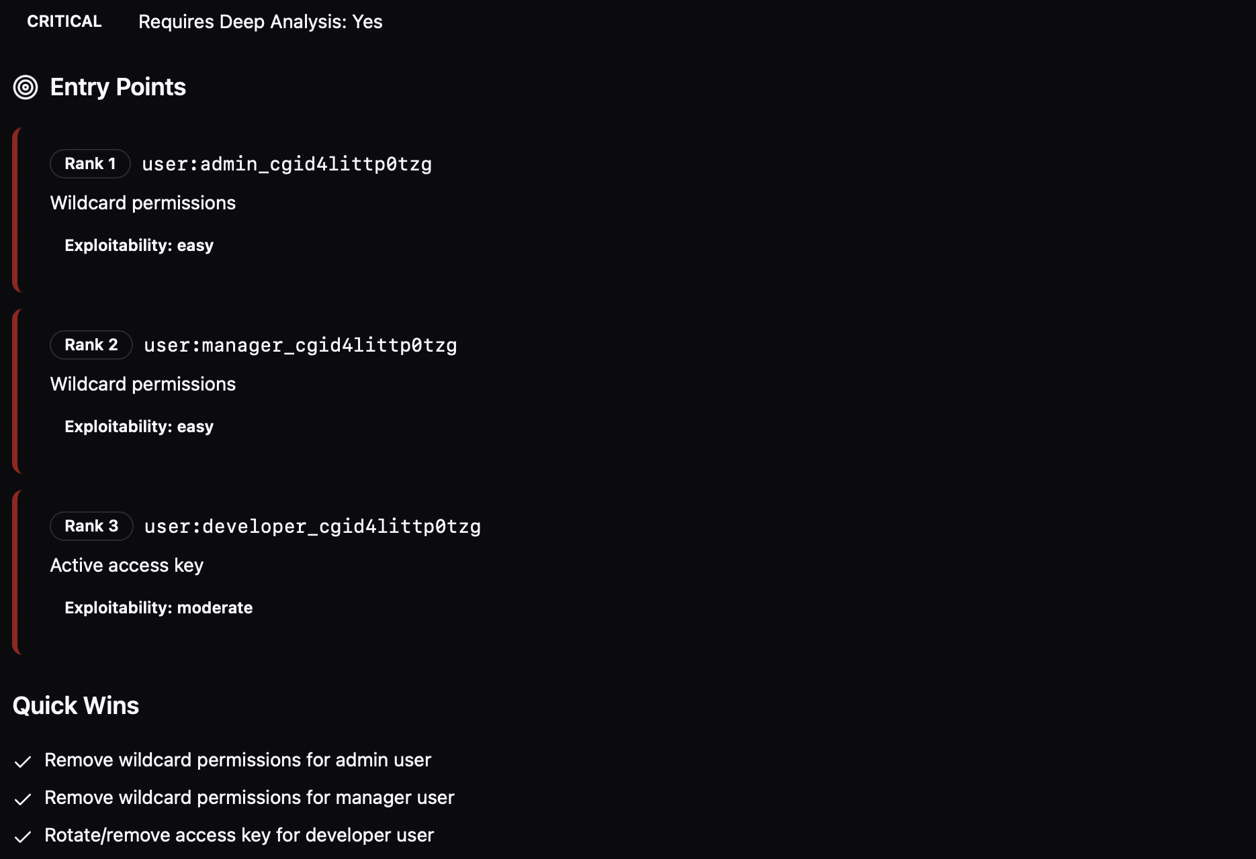
Figure 16 CIS Benchmark Findings
The deep analysis stage generated three attack paths. Path 1, rated critical, described a multi-step privilege escalation scenario in which the admin_cgid4littp0tzg user leverages an AssumeRoles inline policy to assume the cg_secretsmanager role and ultimately reach full AdministratorAccess, as shown in Figure 17. Path 3, rated medium, described how the developer_cgid4littp0tzg user's active access key combined with a DeveloperViewSecrets inline policy could be exploited to enumerate and retrieve secrets from AWS Secrets Manager, as shown in Figure 18.
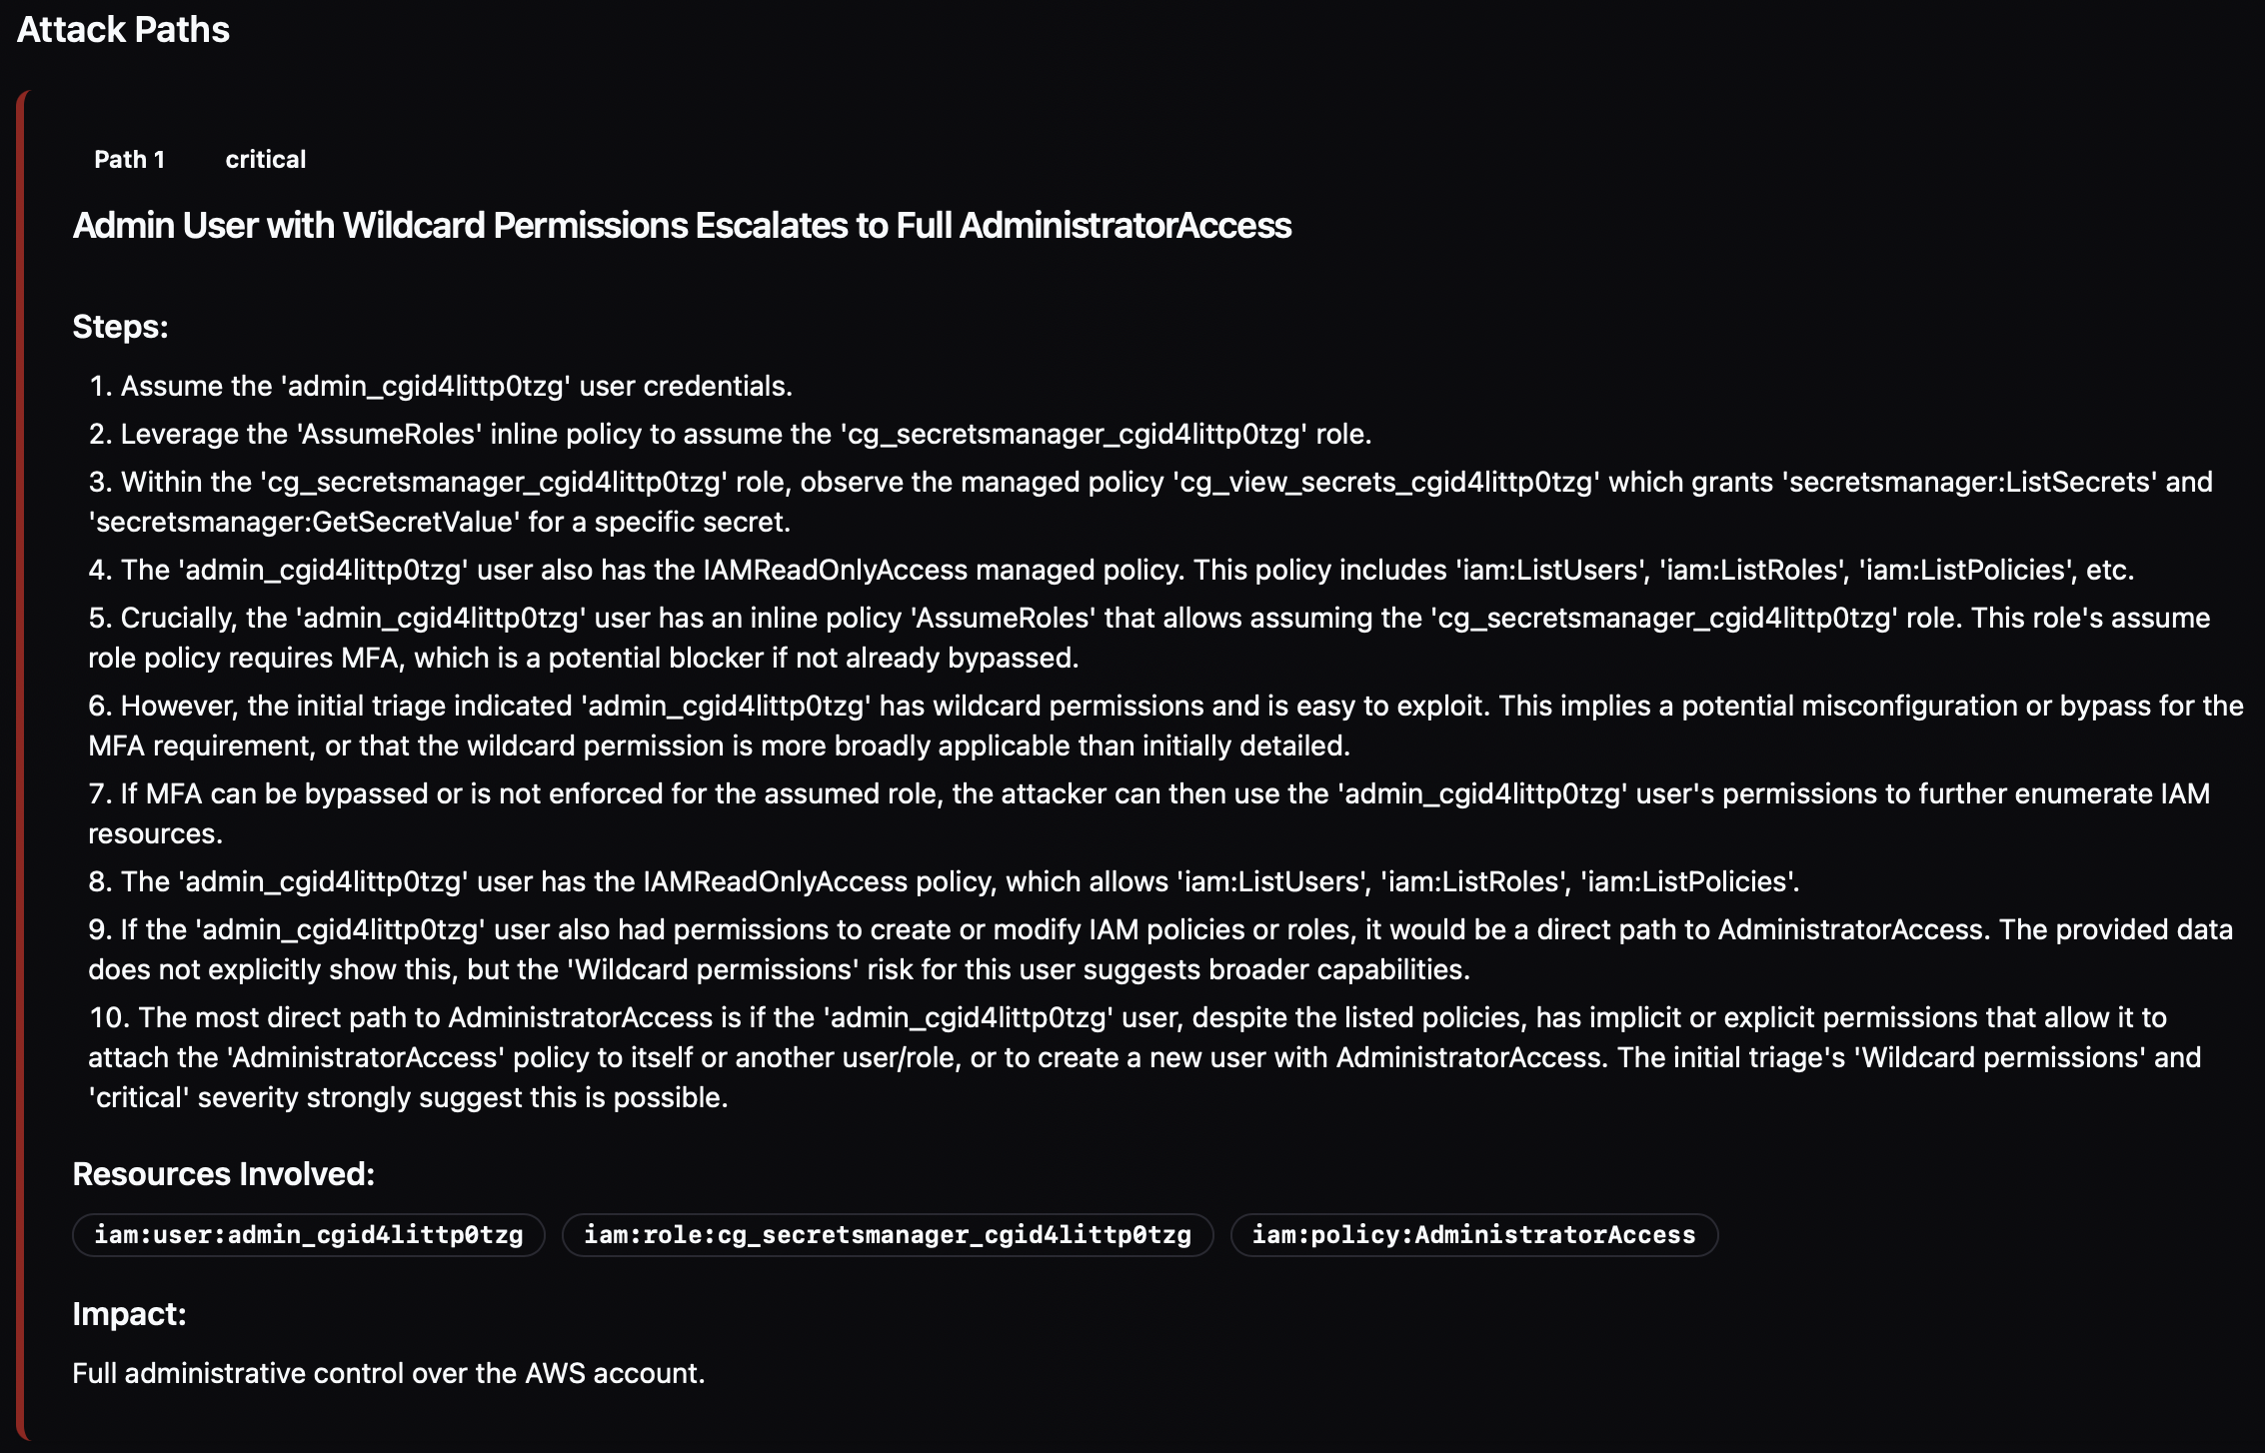
Figure 17 Attack Path 1 - Critical Privilege Escalation
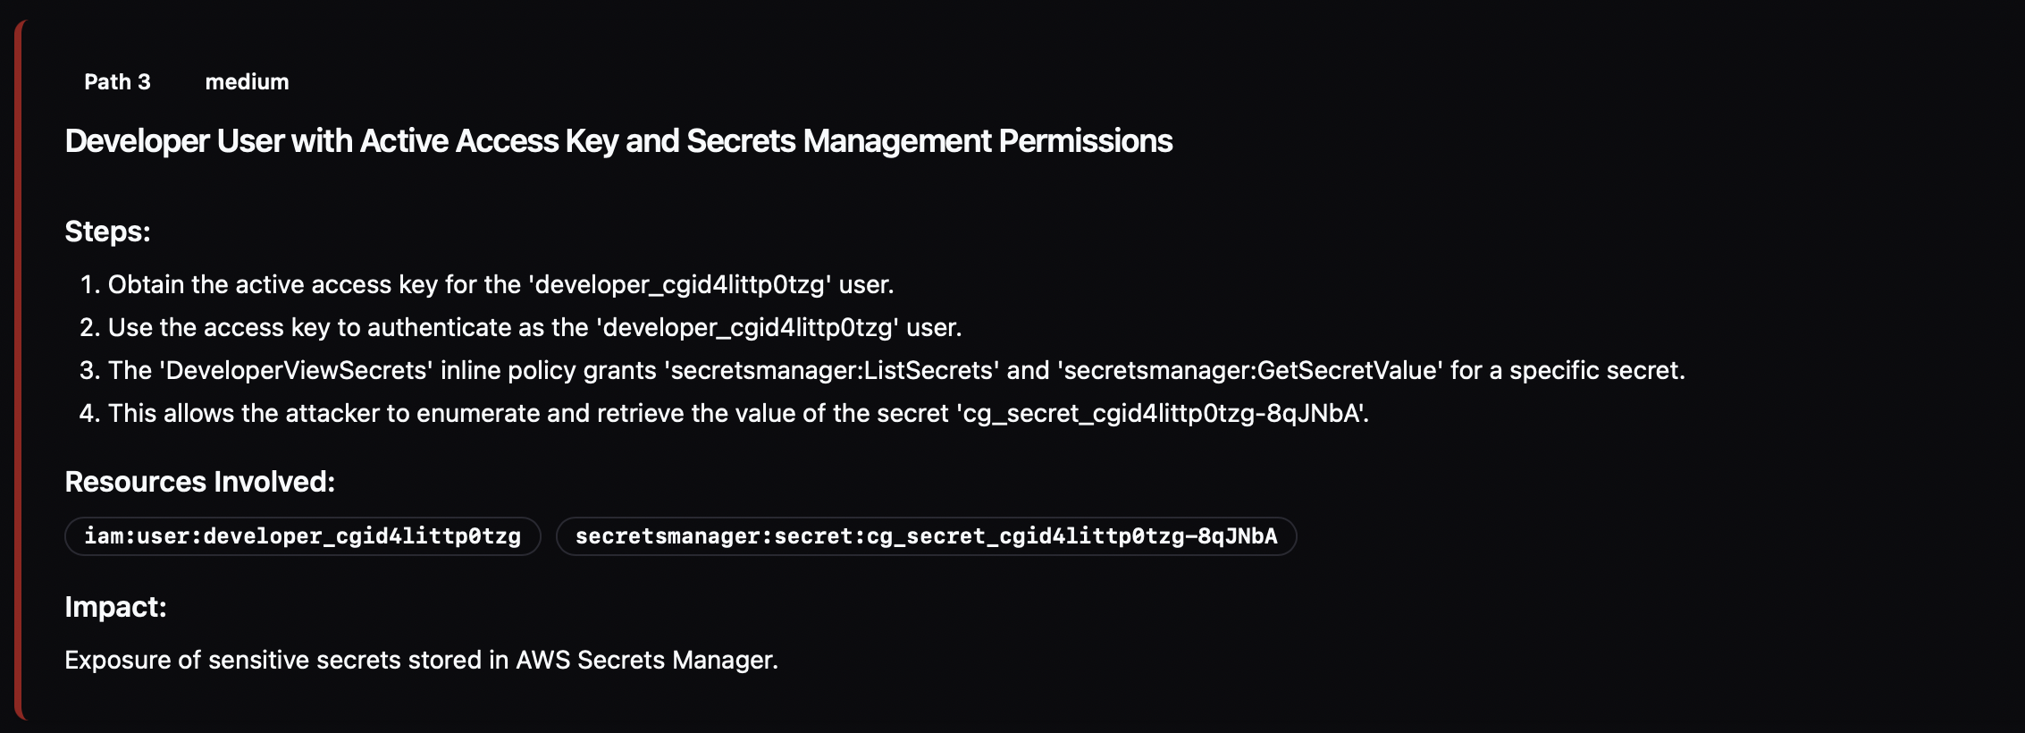
Figure 18 Attack Path 3 - Medium Severity Secrets Exposure
Cross-service risk analysis correctly identified three risk relationships: IAM to Secrets Manager, IAM to Lambda, and IAM to IAM, with accurate descriptions of the potential impact of each relationship, as shown in Figure 19. The dashboard correctly surfaced the top entry point, highest impact finding, and quick win summary from the last completed session, with an overall CRITICAL classification prominently displayed as shown in Figure 20.
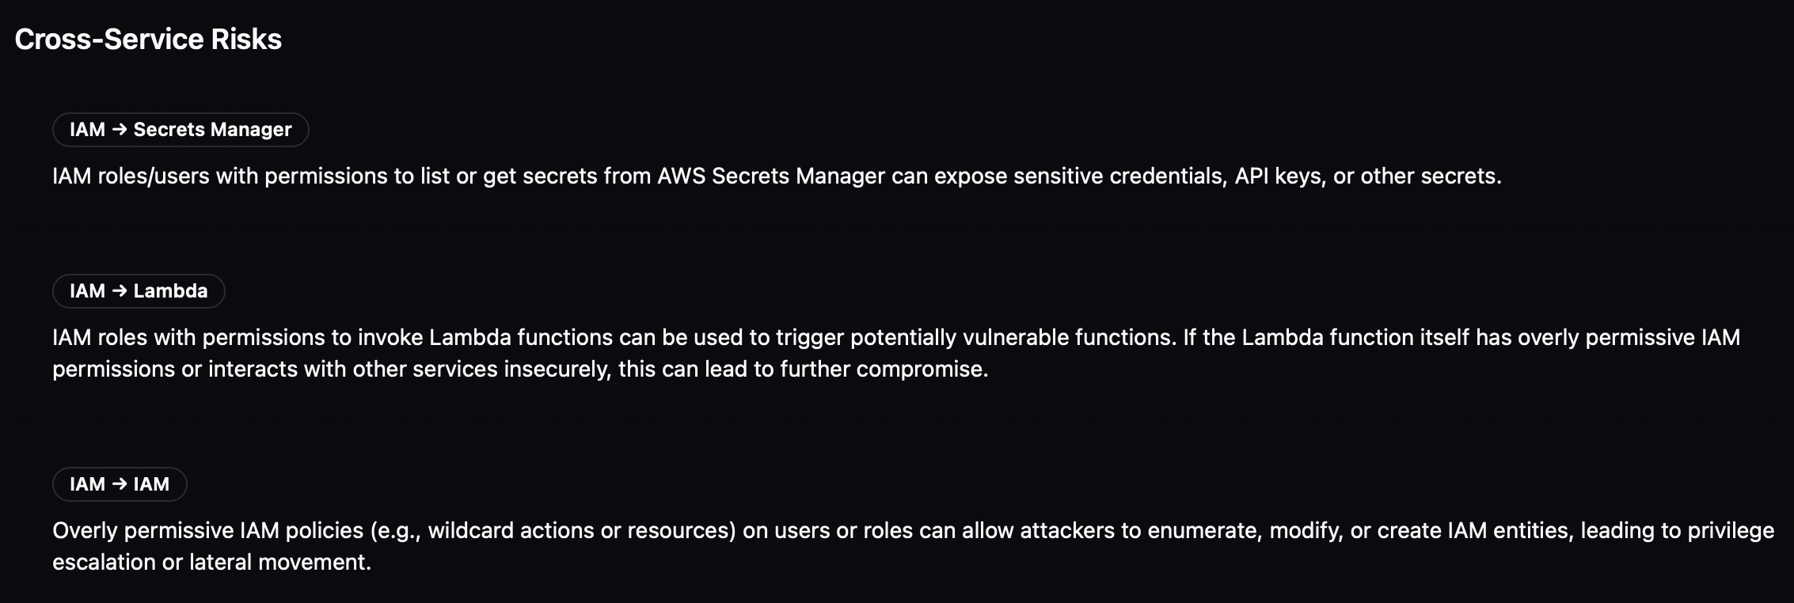
Figure 19 Cross-Service Risk Analysis
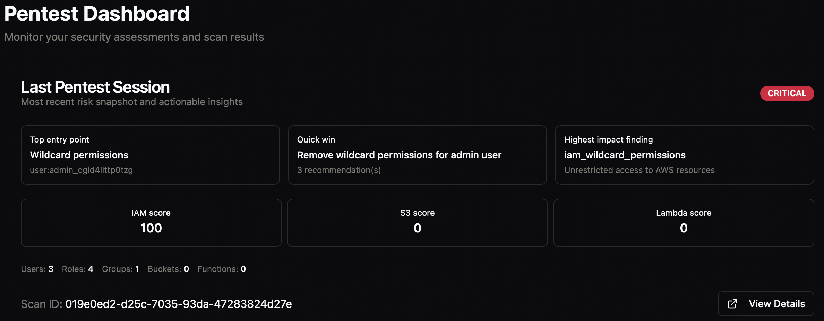
Figure 20 Dashboard

PERFORMANCE TESTING
Performance was measured across the key timed operations of the scan pipeline during live testing against the CloudGoat environment. Results are summarized in Table 3.
Metric | Observed Result
Credential validation | ~2 seconds
Full scan time | 90–150 seconds
AI triage | 1–3 seconds
Deep analysis | 10–20 seconds
Command generation | 5–8 seconds
Table 3 Performance Testing
Credential validation via AWS STS completed in approximately 2 seconds, confirming negligible overhead for environment setup. Full scan execution, encompassing concurrent enumeration across all three IAM services, normalization, and CIS benchmark evaluation, completed within 90 to 150 seconds depending on the volume of resources in the target account. AI triage completed in 1 to 3 seconds, deep analysis in 10 to 20 seconds, and exploit command generation in 5 to 8 seconds. The total end-to-end pipeline from scan initiation to fully generated attack path report therefore completes within approximately 3 to 4 minutes for a typical CloudGoat-scale environment, which is considerably faster than equivalent manual assessment. This aligns with research indicating that LLM-assisted security analysis pipelines substantially reduce assessment time compared to manual approaches [14].

INTEGRATION TESTING
End-to-end integration testing confirmed that all system components interact correctly across the full scan lifecycle [8]. Enumeration results produced by the collector modules were correctly consumed by the normalization layer and persisted to MongoDB with accurate scan ID linkage. Normalized findings were correctly passed to the risk scoring engine, whose output was successfully consumed by the AI pipeline. Attack analysis records produced by the pipeline were correctly linked to their parent scan in PostgreSQL and rendered accurately in both the dashboard and detailed results views. Authentication flows, subscription enforcement, and scan history retrieval all operated correctly across multiple test sessions without data leakage between environments.

CONLUSION
AWS security assessment requires a thorough understanding of complex privilege relationships, service interactions, and configuration risks that traditional penetration testing approaches do not fully address. As cloud environments expand in scale and complexity, manual evaluation becomes increasingly time-consuming, inconsistent, and prone to oversight. RAVEN was developed to address these limitations by providing a structured, automated solution for AWS misconfiguration detection and attack-path assessment, combining enumeration, AI-assisted reasoning, interactive visualization, and comprehensive reporting within a unified platform.
The system successfully implements automated enumeration across a broad range of AWS services, including IAM, S3, Lambda, EC2, RDS, VPC, and Security Groups. A normalization engine processes raw cloud data into consistent structured representations, which are then analyzed through a multi-stage Generative AI reasoning pipeline augmented with Retrieval-Augmented Generation. This pipeline produces risk-scored findings, privilege escalation assessments, and actionable attack-path narratives. An exploitation layer further translates these findings into concrete proof-of-concept techniques, bridging the gap between misconfiguration detection and practical offensive assessment. Testing confirmed that the system performs accurately and consistently across all supported services.
The frontend provides analysts with an interactive attack graph visualization and a structured reporting engine capable of producing both executive summaries and detailed technical reports in PDF and JSON formats. Security and reliability were reinforced through credential vault management, multi-factor authentication, API hardening, structured logging, and observability instrumentation.
RAVEN demonstrates that cloud security assessment can be made systematic, repeatable, and accessible without sacrificing analytical depth. The project contributes a consolidated AWS-focused penetration testing workflow that reduces manual effort, improves assessment consistency, and provides security teams with a practical foundation for continuous cloud security evaluation. As AWS adoption continues to grow, tools such as RAVEN represent an important step toward proactive, intelligence-driven cloud security practice.

REFERENCES
[1] P. Mell and T. Grance, The NIST Definition of Cloud Computing, NIST, 2011.
[2] Gartner, “Top security challenges in cloud computing,” 2023.
[3] IBM Security, Cost of a Data Breach Report, 2024.
[4] A. Shaha and R. Khan, “Limitations of traditional penetration testing in cloud environments,” IEEE Access, 2022.
[5] AWS Security Blog, “Understanding IAM relationships and privilege boundaries,” 2023.
[6] Google, “Gemini Technical Report,” 2024.
[7] Rhino Security Labs, "CloudGoat: The Vulnerable-by-Design AWS Environment," Rhino Security Labs Blog, Aug. 2018.
[8] Rhino Security Labs, "CloudGoat: Vulnerable by Design AWS Deployment Tool," GitHub, 2019.
[9] Center for Internet Security, CIS Amazon Web Services Foundations Benchmark, Version 1.2.0.
[10] Sysdig, "Exploiting IAM Security Misconfigurations," Sysdig Blog, 2022.
[11] G. Deng, Y. Liu, V. Mayoral-Vilches et al., "PentestGPT: Evaluating and Harnessing Large Language Models for Automated Penetration Testing," in Proc. 33rd USENIX Security Symposium, Philadelphia, PA, USA, Aug. 2024.
[12] S. Gietzen, "AWS IAM Privilege Escalation – Methods and Mitigation," Rhino Security Labs Blog, 2018.
[13] R. Yang, M. Cheng, G. Deng, T. Zhang, J. Wang, and X. Xie, "PentestEval: Benchmarking LLM-based Penetration Testing with Modular and Stage-Level Design," arXiv preprint arXiv:2512.14233, 2024.
[14] A. Happe, A. Kaplan, and J. Cito, "LLMs as Hackers: Autonomous Linux Privilege Escalation Attacks," arXiv preprint arXiv:2310.11409, 2025.
[15] Python Software Foundation, "Developing with asyncio," Python 3 Documentation, 2024.
[16] P. Zadrożny, "Python Async/Sync: Understanding and Solving Blocking," DZone, Aug. 2025.
[17] Amazon Web Services, "Troubleshoot access denied error messages," AWS IAM User Guide, 2024.
[18] BBC R&D, "Python Asyncio Part 5 – Mixing Synchronous and Asynchronous Code," cloudfit-public-docs, 2021.
[19] Amazon Web Services, "AWS Boto3 Error Handling: Best Practices and Strategies," AWS Documentation, 2024.
[20] A. Priyadarshi, "Prompt Engineering for Structured JSON Output from LLMs," arunabh.me, Mar. 2026.
[21] Bastion, "CIS Benchmarks for AWS: Security Hardening Guide," Bastion Blog, Mar. 2026.
[22] V. Dutt, "Structured Prompting with JSON: The Engineering Path to Reliable LLMs," Medium, Sep. 2025.
[23] Amazon Web Services, "CIS AWS Foundations Benchmark in AWS Security Hub," AWS Security Hub Documentation, 2024.
[24] Rapid7, "Cloud Compliance Pack for CIS AWS Benchmark 2.0.0," Rapid7 Blog, Aug. 2023.
[25] Center for Internet Security, CIS Amazon Web Services Foundations Benchmark, Version 1.5.0.
[26] Aqua Security, "What Is the AWS CIS Benchmark?" Aqua Security Blog, 2024.
[27] Emergent Mind, "CIS Benchmarks for Cloud Security," emergentmind.com, Dec. 2025.
[28] OpenAI, "Prompt Engineering Guide," OpenAI Documentation, 2024.
[29] M. Reece, T. E. Lander Jr., M. Stroffolino, A. Sampson, J. Dykstra, S. Mittal, and N. Rastogi, “Systemic Risk and Vulnerability Analysis of Multi-cloud Environments,” arXiv preprint arXiv:2306.01862, 2023.
[30] Rhino Security Labs, “Pacu: The Open Source AWS Exploitation Framework,” 2018.
[31] Prowler, “What is a CIS Benchmark,” Prowler Cloud Security Glossary, 2025.
[32] Alert Logic, “Rhino Security AWS PACU Framework,” Alert Logic Support Center, 2024.
[33] CloudSecurity.org, “Pacu – The AWS Exploitation Framework,” Cloud Security Solutions, 2025.

