**Portfolio Optimization using Python (with Pakistani Companies)**

**Introduction**

This project demonstrates the process of portfolio optimization using Python.  
We analyze daily returns of five companies listed in Pakistan’s stock market:

* National Foods Limited (NATF)
* Pakistan State Oil (PSO)
* Systems Limited (SYS)
* Pakistan Petroleum Limited (PPL)
* Fauji Fertilizer Company Limited (FFC)

The goal is to calculate expected returns, risk, and identify the best allocation of funds across these assets to maximize risk-adjusted performance measured by the Sharpe Ratio. The project also includes visualization of the efficient frontier and the optimal portfolio.

**Step 1: Data Preparation**

* Stock returns data of National Foods, PSO, Systems Limited, PPL, and FFC was loaded into Python.
* Missing values (represented as “–”) were cleaned by replacing them with NaN and dropping incomplete rows.

**Step 2: Mean Returns and Covariance**

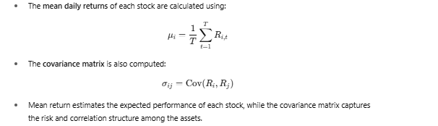

**Output:**

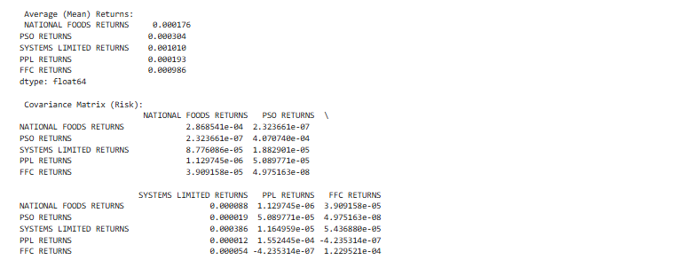

**Step 3: Risk-Free Rate**

**Output:**



**Step 4: Portfolio Functions**

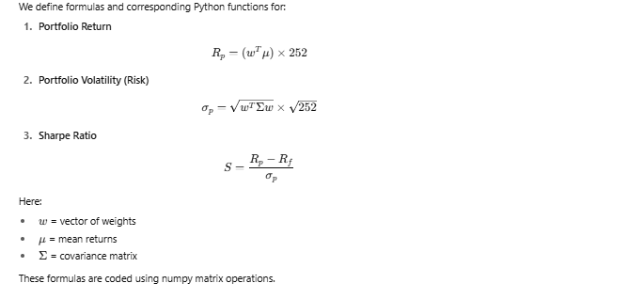

**Step 5: Optimization Setup**

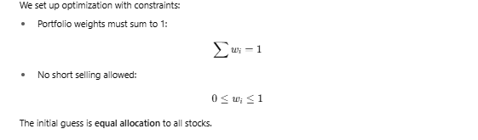

**Step 6: Running Optimization**

* Using the SLSQP method from scipy.optimize, we minimize the negative Sharpe Ratio.
* This automatically maximizes the Sharpe Ratio under the given constraints.
* The output gives us the optimal portfolio weights.

**Step 7: Optimal Portfolio (Results)**

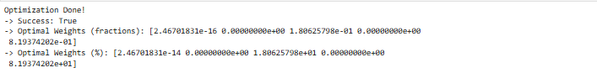

**Optimal Weights (fractions)**  
These are the portfolio weights in decimal (fractions) form.

* + 2.46701831e-16 = 0.0000000000000002467 ≈ 0% → basically zero (this is just rounding error).
  + 0.00000000e+00 = exactly 0%
  + 1.80625798e-01 = 0.1806 → 18.06%
  + 0.00000000e+00 = 0%
  + 8.19374202e-01 = 0.8193 → 81.93%

**Optimal Weights (%)** Same as above, but expressed in percent form instead of decimals:

Which means:

* + Stock 1 → ≈0%
  + Stock 2 → 0%
  + Stock 3 → 18.06%
  + Stock 4 → 0%
  + Stock 5 → 81.93%

From these weights we calculated:

* Optimal Portfolio Return (Rₚ)
* Optimal Portfolio Volatility (σₚ)
* Optimal Sharpe Ratio (S)

**Step 8: Efficient Frontier**

* Efficient frontier was constructed by targeting different returns and finding the minimum risk allocation for each.
* This produced a blue dotted line showing the best achievable trade-off between risk and return using these five stocks.
* The **optimal portfolio** was marked as a red star.

**Step 9: Visualization**

1. Efficient Frontier Plot → shows combinations of National Foods, PSO, Systems, PPL, and FFC.
2. Optimal Portfolio Star → highlighted on the frontier.
3. Weights Bar Chart → showing portfolio allocation across the five companies (major weight on FFC + Systems).

**Key Learnings**

* Portfolio optimization balances risk and return across multiple assets.
* Diversification benefits are driven by covariance between stocks.
* The Sharpe Ratio is a useful measure for finding the best risk-adjusted return portfolio.
* Real-world constraints (no short selling, weights must sum to 1) are necessary for practical results.
* Visualization (efficient frontier and weight charts) makes results more intuitive.
* In this case, Fauji Fertilizer (FFC) and Systems Limited together formed the best portfolio, while National Foods, PSO, and PPL were excluded due to weaker contribution to Sharpe Ratio.