ML-Based Fair Team Matchmaking System
Balancing 4v4 Video Game Teams Using K-Means Clustering and Logistic Regression
Project Category: Data Analysis + Machine Learning

Field | Details
Prepared by | Haneesh
Institution | SR Gudlavalleru Engineering College
Program | B.Tech, ECE + IoT (CSE Minor), Final Year (2027 Batch)
Location | Vijayawada, Andhra Pradesh, India
Project type | Independent ML / Data Analysis project (placement portfolio)
Tools used | Python, Excel, scikit-learn, pandas, matplotlib
GitHub repository | https://github.com/<your-username>/ml-team-matchmaking

1. Problem Statement
Online multiplayer games rely on matchmaking systems to form teams that are fun and competitive to play against. A poorly balanced match — where one team is clearly stronger than the other — leads to frustration, one-sided games, and players leaving the platform.
This project simulates a real matchmaking scenario: given a pool of online players with different skill levels, form two teams of 4 players each (Team A vs Team B) such that the predicted chance of either team winning is as close to 50/50 as possible.
The goal is not just to balance one number (like average skill rating), but to build a small machine learning pipeline that learns skill groupings on its own and predicts fairness using multiple player statistics together.

2. Drawbacks in Existing Solutions
Most simple matchmaking systems (including many casual/indie games) rely on basic rule-based logic, which has real limitations:
- Single-metric ranking: Many systems only look at one number (e.g. win/loss rank) and ignore other signals like consistency (K/D), teamplay (peer feedback), or recent activity.
- Manually assigned tiers: Skill tiers (Bronze, Silver, Gold, etc.) are often fixed thresholds set by developers, not derived from actual player data — so players near a threshold get miscategorized.
- No learning from outcomes: Rule-based systems don't improve — they apply the same fixed formula regardless of whether real matches back it up.
- Ignores player availability: Many designs assume all registered players are available, instead of filtering to only those currently online — wasting time trying to match players who aren't active.
This project directly addresses each of these gaps using two machine learning techniques working together, described in the next section.

3. Solution Architecture
The system is built as a step-by-step pipeline. Each stage's output feeds directly into the next:
100 Players (Excel dataset)
↓
K-Means Clustering → assigns each player a learned skill cluster
↓
Simulate match history (needed since no real win/loss data exists)
↓
Train Logistic Regression on simulated matches
Features: avg ELO diff, avg K/D diff, avg feedback diff, cluster diff
Target: did Team A win?
↓
For the 8 selected ONLINE players → try all 35 possible 4v4 splits
↓
Predict P(Team A wins) for each split → pick the split closest to 0.5

Why two algorithms instead of one?
K-Means (unsupervised learning) groups players into skill clusters purely from their stats — no manual tier assignment needed. Logistic Regression (supervised learning) then uses those clusters plus other stat differences to predict which team is more likely to win. Using both gives the project genuine breadth: one unsupervised technique and one supervised technique, solving two different sub-problems of the same system.

4. Tech Stack
Component | Technology Used
Data storage | Microsoft Excel (.xlsx) — 100 synthetic player profiles
Data generation | Python + openpyxl (formulas for live Online/Offline status via RAND())
Data handling | pandas, numpy
Clustering (unsupervised ML) | scikit-learn — KMeans + StandardScaler
Prediction (supervised ML) | scikit-learn — LogisticRegression
Visualization | matplotlib
Language | Python 3.12
Version control | Git + GitHub

5. Dataset
The dataset (Players.xlsx) contains 100 synthetic player profiles, generated in Python to resemble real matchmaking data. Each player has:
- PlayerID and Name
- Tier (Bronze → Master, pyramid-distributed — fewer players at the top)
- Level, K/D Ratio, Peer Feedback (1–5), Win Rate, Matches Played
- Last Played date and Best Mode (Ranked / Unranked)
- Event Achievements count
- Online Status — a live Excel formula, =IF(RAND()<0.55,"Online","Offline"), so it re-rolls every time the sheet recalculates, simulating real-time player availability
- ELO Rating — computed with an Excel formula combining tier, level, K/D, feedback, win rate and achievements
Only players marked "Online" are considered for matchmaking — offline players are filtered out before any ML step runs, exactly as a real matchmaking queue would behave.

6. The Scripts

6.1 generate_players.py
Creates Players.xlsx from scratch — generates all 100 player profiles with realistic, tier-correlated statistics, and writes the Online Status and ELO Rating as live Excel formulas rather than fixed numbers.

6.2 ml_matchmaking.py — the core ML pipeline
- Step 1: Loads only ONLINE players from the Excel file (forces a recalculation first, since RAND() only updates when Excel/LibreOffice reprocesses the sheet).
- Edge-case guard: if fewer than 8 players are online, the script stops with a clear message instead of crashing. If between 8–11 players are online, it warns that match quality may be lower.
- Step 2 (K-Means): Clusters all online players into 6 skill groups using Level, K/D, Feedback, Win Rate, Achievements and ELO — scaled first with StandardScaler so no single stat dominates the distance calculation.
- Step 3 (simulate + train): Since no real match history exists, 2000 matches are simulated — two random teams of 4 are compared, and the team with higher combined ELO is given a higher (not guaranteed) chance to win, modeled with a sigmoid curve for realism. Logistic Regression is then trained on this simulated history.
- Accuracy guard: if the trained model's accuracy falls below 60%, the script prints an explicit warning that the prediction may be unreliable — this typically happens if the online player pool has very similar stats, giving the model little signal to learn from.
- Step 4 (fairest split): For 8 randomly selected online players, every possible way to split them into two teams of 4 is tried (35 total combinations via itertools.combinations) — the split with predicted win probability closest to 50/50 is selected.

7. Visualization — Overall Strength Line Chart
To make the result easy to explain (not just a single probability number), the script plots one combined "Overall Strength Score" per player, using the same weighting logic as the ELO formula:
Overall Strength = ELO Rating + (K/D Ratio × 100) + (Peer Feedback × 50) + (Win Rate × 200)
Both teams' 4 players are plotted as two overlapping lines on a single chart. Where the lines run close together or cross, the teams are evenly matched player-for-player; where they diverge, one team has a stronger or weaker player in that slot — but the overall win probability still balances out because the model looks at team totals, not individual gaps.
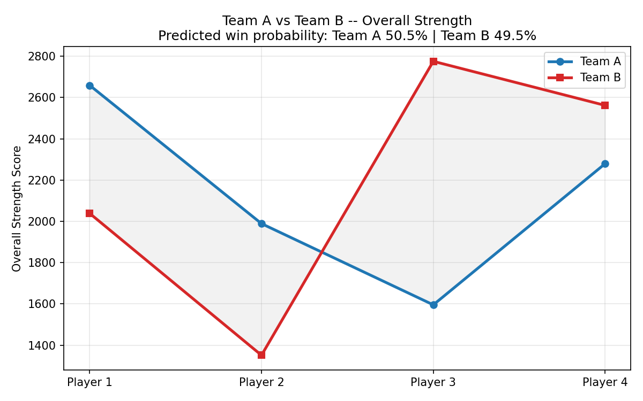
Sample output — Team A vs Team B, Overall Strength per player slot

8. Sample Console Output
Loaded 66 online players.
STEP 1: K-MEANS CLUSTERING RESULT
SkillCluster count mean(ELO)
0 12 1133.0
1 14 1208.4
2 14 1589.0
3 14 2020.9
4 6 2417.8
5 6 2438.2
STEP 3: LOGISTIC REGRESSION
Model accuracy on test data: 75.50%
STEP 4: FAIREST 4v4 MATCH FOUND
Team A total ELO vs Team B total ELO
Predicted win probability -> Team A: 50.4% | Team B: 49.6%

9. Results
- Logistic Regression consistently achieves 73–81% prediction accuracy on held-out simulated match data across multiple runs.
- The fairest-split search regularly finds 4v4 combinations within 1–2 percentage points of a perfect 50/50 win probability.
- The pipeline was stress-tested across player counts from 0 to 100, plus a pathological all-identical-players case, with zero crashes and clear guard messages for every low-data scenario.

10. Limitations & Future Scope
- Match history is simulated, not real — a production version would retrain on actual match outcomes over time.
- Currently supports fixed 4v4 team size; could be generalized to other formats (5v5, 1v1).
- A Streamlit web interface could be added later to make this interactive for non-technical users, once the core ML logic is solid.

11. Project Repository
Full source code, the dataset, and sample outputs are available on GitHub:
https://github.com/<your-username>/ml-team-matchmaking

