# **Coversheet for BSc Neuroscience and Psychology Submissions**

|  |  |
| --- | --- |
| K-number | K20002990 |
| Student number | 20002990 |
| Module Title and Code:  (e.g. 4PAHPBIO Psychology and the Brain) | 6PASNCNS Computational Neuroscience |
| Assignment Deadline: | 01/12/2023 |
| Question Attempted (if appropriate):  (e.g. Q3 Describe the ionic basis of the action potential) | Write up a lab report involving applying brain models to open data. Include an introduction, methods, results and discussion. |
| Submitted file name:  (e.g. 4PAHPBIO_ K1426325_Question 3) | 6PASNCNS_K20002990_Report |
| Word Count (where a limit is specified): | Introduction: 517 (Minimum 200 words)  Methods: 445 (Minimum 200 words)  Results: 309 (Minimum 200 words)  Discussion: 531 (Minimum 200 words)  Total: 1802 / 2000 words |
| Referencing system used (please tick **one** box) | Kings Author-date (based on APA 6)  APA 7 |
| Please identify any **one** aspect of your answer for which you would like specific feedback comments (this could be a section of your answer, or how successfully you have incorporated previous feedback: please paste here the feedback that you referred to in preparing your answer, if applicable). |  |

# Introduction

It is estimated that approximately 0.32% of the world's population suffers from schizophrenia, a severe mental disorder that is frequently referred to as a form of psychosis (World Health Organisation, 2022). This mental disorder is commonly characterised by both positive and negative symptoms, such as delusions and lack of emotions (NHS, 2023). Despite decades of research, the exact aetiology and pathophysiology of schizophrenia remain elusive, and there is no definitive cure for the disorder (McCutcheon et al., 2020). Currently there are only symptomatic treatments are available, which often have adverse side effects and limited efficacy. Therefore, there is a pressing need to identify reliable biomarkers and novel therapeutic targets for schizophrenia.

One promising avenue of research is to investigate the network resilience of patients with schizophrenia, which refers to the ability of brain networks to restore and recover their basic functionality in the face of perturbations or damages (Zhang et al., 2020). Network robustness can serve as an indication to network resilience, as robustness looks at the networks’ ability to retain connectivity in the event of brain damage (Lyndall et al., 2010). Graph theory is the mathematical approach to studying graphs of networks made up of nodes (areas of the brain) and edges (connections). By applying graph theory to analyse the functional connectivity of the brain, network robustness can reveal the adaptability of the brain network for people with schizophrenia and shed light on the underlying mechanisms and potential interventions for the disorder.

Network robustness can be assessed by simulating random attacks on the network, which can mimic effects of random failures or disruptions in the brain (Chen & Cheng, 2015). These attacks involve deleting a percentage of nodes from the graph and observing how the network responds to the loss of connectivity. One of the main outcomes of interest is the largest component size, which represents the number of nodes that are still connected in the largest subgraph of the network. A high largest component size indicates that the network is more robust, as it can retain most of its connectivity even after losing some of its nodes. A low largest component size indicates that the network is less robust, as it breaks down into smaller, isolated components after losing some of its nodes.

However, the existing literature on network robustness and resilience in schizophrenia is sparse and inconsistent. For instance, research conducted by Lynall et al. found that schizophrenia patients exhibited significantly higher network robustness than controls under both random and targeted attacks, indicating a higher resilience (Lynall et al., 2010). On the other hand, other research has also shown that individuals with schizophrenia have a reduced network resilience when compared to controls (Iglesias-Parro et al., 2023). However, this paper suggesting that people with schizophrenia have higher network resilience overall, does not look at robustness of the network. Therefore, we aim to further investigate and replicate findings by Lynall on network robustness in schizophrenia, using simulated random attacks on networks derived from functional resonance imaging (fMRI) data. We hypothesized that there will be a significant difference in network robustness between individuals with schizophrenia and controls.

# Methods

## Resources

We obtained fMRI data from the University of Lausanne, where they performed fMRI scans on matched participants diagnosed with schizophrenia based on the DSM IV criteria (N = 27, mean age = 42 ± 9.6 years) and healthy controls (N = 27, mean age = 35 ± 6.8 years) during an eyes-open resting state task (American Psychiatric Association, 2000; Jakub Vohryzek et al., 2020). Out of the 27 schizophrenia patients, 24 were on medication at the time of scanning, with a mean chlorpromazine equivalent dose of 431 ± 288 mg. All participants were scanned using a 3-Tesla MRI scanner equipped with a 32-channel head-coil.

## Procedure

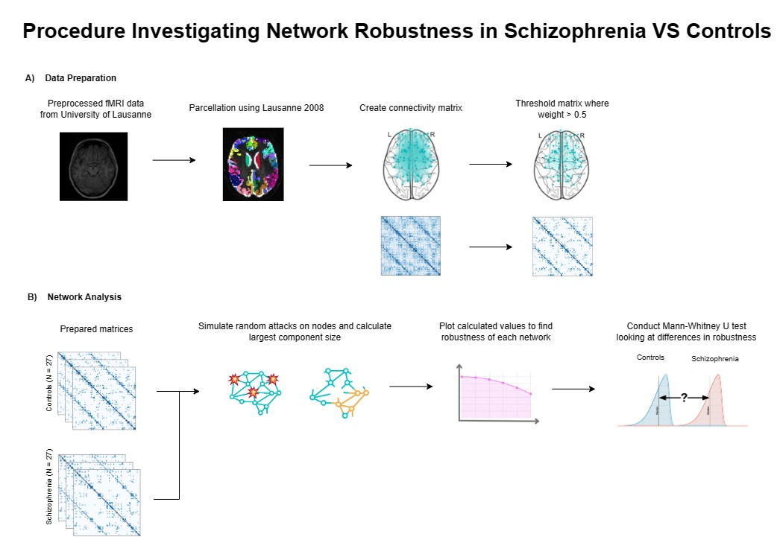

*Figure 1* ***Data preparation and network analysis procedure for investigating network robustness in schizophrenia vs controls.****(A) Data Preparation: fMRI data was pre-processed and parcellated using Lausanne 2008 atlas. Connectivity matrices were computed based on the correlation between brain regions and thresholded to retain the edges with weights greater than 0.5. (B) Network Analysis: Simulated random attacks on the network and calculated largest component size was plotted to calculate robustness. A Mann-Whitney U test was performed to compare the network robustness between schizophrenia and control groups.*

For the data preparation, Jakub et al. pre-processed the collected fMRI data and mapped this data to the Lausanne 2008 atlas which defined 83 structural parcellations of the brain (figure 1a). A functional connectivity matrix was then created by looking at the correlations in functional connectivity over a time series between the different regions of interest (ROI). These ROIs effectively represent the graph theory nodes.

To reduce noise in the connectome, we applied a threshold of 0.5 to the connectivity matrices, as shown in figure 2B (Dimitriadis et al., 2017). This criterion retained only the edges that had a strength in weight greater than 0.5 (Figure 1a). We opted for this thresholding method as it allowed us to preserve the individual variability in the number of edges across participants, which was relevant for our analysis.

## Analysis

Simulated random attacks on nodes for each network was then conducted by removing approximately 10% of nodes (8 nodes) at a time, until approximately 50% of nodes (40 nodes) were removed. We applied graph theory to calculate and record the size of the largest component(s) within the network after each attack (Figure 1b).

Figure 2 Simulated curved line plot to demonstrate how robustness would be calculated, by taking the area under the curve for when the fraction of nodes are on the x axis and size of the largest component is on the y axis

Robustness (ρ) was then calculated by plotting the fraction of nodes removed (n) against the largest component size and calculating the area under the curve to represent ρ (Figure 1a, Figure 2). This calculation is a modified version of the robustness calculation made in Lynall et al., where the number of nodes attacked is used on the x axis instead of the proportion of nodes. This allows our calculations to be applicable to other analysis that may use different parcellations and maintain a similar result. After plotting the curve, we calculated the area under the curve using the trapezium rule, which approximates the area by dividing it into trapezoids and summing their areas.

Once the network robustness value was calculated for each participant, the results were tested for normality using Shapiro-Wilkes test before conducting a Mann Whitney U test to compare the differences in network robustness between groups, with alpha level .05.

# Results

This study aimed to investigate the differences in network robustness as an indication of network resilience for individuals diagnosed with schizophrenia compared to controls. Based on previous literature, it was hypothesised that patients with schizophrenia would have a significant difference in network robustness compared to controls. Robustness was defined as the area under the plotted curve for when the largest component size is against the proportion of nodes. This measure was compared between groups using a Mann Whitney U test.

Figure 3 Line plot showing the average largest component size after each attack on nodes for both groups alolng with their error bars, indicating the robustness for each group.

Overall, we can see that majority of largest component size after each attack were very similar, except for between 30-50%, where schizophrenia group have a slightly steeper slope, decreasing the area under the line and indicating a lower network robustness for schizophrenia patients than controls (*figure 3)*. However, the error bars overlap for each attack, showing there is large variance for these means and may not have a significant difference in between largest component sizes for each random attack.

Figure 4 Boxplot showing the variability in robustness for schizophrenia and control groups

The boxplot for the schizophrenia group has a lower median for network robustness and a larger interquartile range (Mdn = 26.99, IQR = 2.27) than the boxplot for controls (Mdn = 27.42, IQR = 1.59), suggesting that schizophrenia has a lower central tendency and more variability in robustness than controls (Figure 4). The boxplot for schizophrenia group is also slightly left skewed as the lower whisker is longer than the upper and there are also outliers underneath the plot, whereas the controls boxplot is more symmetrical, but do have more outliers below.

The Shapiro-wilks test showed that the robustness data for both schizophrenia and controls was not normally distributed (Schizophrenia (W = .96, p = .34), Controls (W = .93, p = .07)). Therefore, we conducted a non-parametric test, Mann Whitney U, which found that there was no significant difference in robustness between groups (U = 322.5, p = .47).

# Discussion

In line with Lynall et al., we predicted that there would be a significant difference in network robustness indicating network resilience when investigating the functional data for people with schizophrenia and healthy controls (Lynall et al., 2010). However, our data was not sufficient in finding a significant difference in network robustness, and therefore, does not support the existing literature that suggests a difference.

A possible reason for this discrepancy is the differences in the thresholding methods used to reduce noise (Dimitriadis et al., 2017). We applied a single threshold of retaining edges that were higher than 0.5 in weight, whereas Lynall et al. used multiple thresholds, retaining 35% to 50% of the strongest edges (Lynall et al., 2010). Due to limitations of our analysis, we were unable to replicate Lynall’s thresholding methods, which would prevent losing relevant data. Thresholding is also an arbitrary process that can affect the network properties and the results of the analysis (van Wijk et al., 2010). Therefore, our results may have found no significant differences as the thresholding methods used did not match the better approach used by Lynall and only looked at a single, arbitrary threshold.

Moreover, Lynall et al. matched their participants with premorbid IQ, and years of education in addition to age and sex. However, our participants were only matched for age. Furthermore, in Lynall’s study, all patients with schizophrenia were receiving antipsychotic drugs, whereas our study only included 24 out of 27 participants taking medication. This discrepancy in medication status may have also influenced the results, as antipsychotic drugs may have modulatory effects on the brain networks and their resilience (Pettersson-Yeo et al., 2011). Therefore, the differences in premorbid IQ, education, and medication between our study and Lynall’s study may have contributed to the differences in the network robustness findings.

We understand that graph theory is a very simplistic and reduced approach to describe the complexity and depth of how the brain functions. This approach is also quite removed from the biological processes that may lead to dysfunctions in connectivity for people with schizophrenia. Therefore, it is important to acknowledge that results from this study are closer to abstract ideas than realism and may require further analysis to establish that these results directly translate to physical processes.

Moreover, the measure for robustness was a very simplified metric, which only considered the area under the curve of the plot of the fraction of nodes removed versus the size of the largest component after each removal. However, this measure did not account for the changes in the connectivity of the network after the node attacks, which could also indicate how fragmented or integrated the network became. An alternative paper investigating robustness also looked at the global and local efficiency in addition to largest component size after attacks, which is the measure of how efficiently information is exchanged between neighbours of nodes and across the whole network (Joyce et al., 2013). Considering these measures may approach a more holistic and detailed view of measuring the effects of attacks to represent robustness, closer indicating the networks’ resilience. Therefore, we suggest that this measure could be revised for a more accurate and representative outcome of network robustness.

# References

American Psychiatric Association. (2013). Diagnostic and Statistical Manual of Mental Disorders. *Diagnostic and Statistical Manual of Mental Disorders*. https://doi.org/10.1176/APPI.BOOKS.9780890425596

Chen, P.-Y., & Cheng, S.-M. (2015). Sequential defense against random and intentional attacks in complex networks. *PHYSICAL REVIEW E*, *91*, 22805. https://doi.org/10.1103/PhysRevE.91.022805

Dimitriadis, S. I., Salis, C., Tarnanas, I., & Linden, D. E. (2017). Topological filtering of dynamic functional brain networks unfolds informative chronnectomics: A novel data-driven thresholding scheme based on orthogonal minimal spanning trees (OMSTs). *Frontiers in Neuroinformatics*, *11*, 238952. https://doi.org/10.3389/FNINF.2017.00028/BIBTEX

Iglesias-Parro, S., Soriano, M. F., Ibáñez-Molina, A. J., Pérez-Matres, A. V., & Ruiz de Miras, J. (2023). Examining Neural Connectivity in Schizophrenia Using Task-Based EEG: A Graph Theory Approach. *Sensors (Basel, Switzerland)*, *23*(21), 8722. https://doi.org/10.3390/S23218722

Jakub Vohryzek, Yasser Aleman-Gomez, Alessandra Griffa, Jeni Raoul, Martine Cleusix, Philipp S. Baumann, Philippe Conus, Kim Do Cuenod, & Patric Hagmann. (2020). Structural and functional connectomes from 27 schizophrenic patients and 27 matched healthy adults. In *Zenodo*. https://doi.org/10.5281/ZENODO.3758534

Joyce, K. E., Hayasaka, S., & Laurienti, P. J. (2013). The Human Functional Brain Network Demonstrates Structural and Dynamical Resilience to Targeted Attack. *PLOS Computational Biology*, *9*(1), e1002885. https://doi.org/10.1371/JOURNAL.PCBI.1002885

Lynall, M.-E., Bassett, D. S., Kerwin, R., McKenna, P. J., Kitzbichler, M., Muller, U., & Bullmore, E. (2010). Functional Connectivity and Brain Networks in Schizophrenia. *Journal of Neuroscience*, *30*(28), 9477–9487. https://doi.org/10.1523/JNEUROSCI.0333-10.2010

McCutcheon, R. A., Reis Marques, T., & Howes, O. D. (2020). Schizophrenia—An Overview. *JAMA Psychiatry*, *77*(2), 201–210. https://doi.org/10.1001/JAMAPSYCHIATRY.2019.3360

NHS. (2023, April 13). *Symptoms - Schizophrenia - NHS*. https://www.nhs.uk/mental-health/conditions/schizophrenia/symptoms/

Pettersson-Yeo, W., Allen, P., Benetti, S., McGuire, P., & Mechelli, A. (2011). Dysconnectivity in schizophrenia: Where are we now? *Neuroscience & Biobehavioral Reviews*, *35*(5), 1110–1124. https://doi.org/10.1016/J.NEUBIOREV.2010.11.004

van Wijk, B. C. M., Stam, C. J., & Daffertshofer, A. (2010). Comparing Brain Networks of Different Size and Connectivity Density Using Graph Theory. *PLOS ONE*, *5*(10), e13701. https://doi.org/10.1371/JOURNAL.PONE.0013701

World Health Organisation. (2022, January 10). *Schizophrenia*. https://www.who.int/news-room/fact-sheets/detail/schizophrenia

Zhang, Y., Shao, C., He, S., & Gao, J. (2020). Resilience centrality in complex networks. *Physical Review E*, *101*(2), 022304. https://doi.org/10.1103/PHYSREVE.101.022304/FIGURES/5/MEDIUM