**Tugas 4 - Edge Detection**

**IF5153 - Pemrosesan Pengelolaan Data Multimedia**

Nama : Mohamad Hanifan

NIM : 23518026

**A. Image Result**

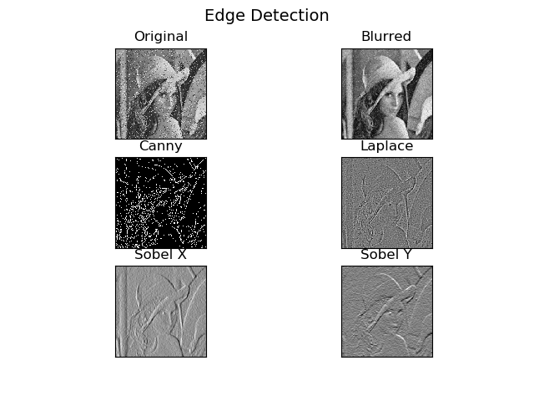

**Gambar 1.** Hasil *Edge Detection* menggunakan beberapa metode

**B. Kode Program**

|  |
| --- |
| import cv2  import numpy as np  from matplotlib import pyplot as plt  # img = cv2.imread('building.jpg')  img = cv2.imread('lena_noise.png')  img = cv2.cvtColor(img, cv2.COLOR_BGR2GRAY)  blur = cv2.GaussianBlur(img, (3,3), 0)  canny = cv2.Canny(blur, 175, 175)  laplacian = cv2.Laplacian(blur, cv2.CV_64F, ksize=5)  sobelx = cv2.Sobel(blur, cv2.CV_64F, 1, 0, ksize=5)  sobely = cv2.Sobel(blur, cv2.CV_64F, 0, 1, ksize=5)  plt.figure(1)  plt.subplot(321), plt.imshow(img, cmap='gray'), plt.title('Original')  plt.xticks([]), plt.yticks([])  plt.subplot(322), plt.imshow(blur, cmap='gray'), plt.title('Blurred')  plt.xticks([]), plt.yticks([])  plt.subplot(323), plt.imshow(canny, cmap='gray'), plt.title('Canny')  plt.xticks([]), plt.yticks([])  plt.subplot(324), plt.imshow(laplacian, cmap='gray'), plt.title('Laplace')  plt.xticks([]), plt.yticks([])  plt.subplot(325), plt.imshow(sobelx, cmap='gray'), plt.title('Sobel X')  plt.xticks([]), plt.yticks([])  plt.subplot(326), plt.imshow(sobely, cmap='gray'), plt.title('Sobel Y')  plt.xticks([]), plt.yticks([])  plt.suptitle('Edge Detection', size=14)  plt.savefig('Result')    plt.show() |