Soil temperature and moisture transmitter (type 485)
PR-3000-TR-N01
Ver 2.0


Chapter 1 Product Introduction

1.1 product description
The sensor is suitable for the measurement of soil temperature and moisture. After comparison with the German original high-precision sensor and the calibration of the actual soil drying weighing method, the sensor has high accuracy, fast response and stable output. It is less affected by soil salinity and is suitable for various soil qualities. Can be buried in the soil for a long time, resistant to long-term electrolysis, corrosion resistance, vacuum potting, completely waterproof。
The sensor is widely used in scientific experiments, water-saving irrigation, greenhouses, flowers and vegetables, grassland pastures, soil rapid measurement, plant cultivation, sewage treatment, grain storage and the measurement of the moisture content and temperature of various particulate matter。

1.2 Features
▇ High measurement accuracy, fast response speed and good interchangeability.
▇ It is less affected by the soil salt content and can be applied to various soil qualities.
▇ The electrode adopts specially treated alloy material, which can withstand strong external impact and is not easy to damage.
▇ Completely sealed, resistant to acid and alkali corrosion, can be buried in the soil or directly into the water for long-term dynamic detection.
▇ High precision, fast response, good interchangeability, probe insertion design ensures accurate measurement and reliable performance。

1.3 Main parameters
DC power supply (default) | DC 4.5-30V
Maximum power consumption | 0.5W（24V DCPower supply）
Operating temperature | -40℃~+80℃
Soil moisture parameters | Range | 0-100%
Soil moisture parameters | Resolution | 0.1%
Soil moisture parameters | Accuracy | 0-50%内2%，50-100%内3%
Soil temperature parameters | Range | -40~80℃
Soil temperature parameters | Resolution | Resolution：0.1℃
Soil temperature parameters | Accuracy | ±0.5℃
Protection class | IP68
Probe material | Anti-corrosion special electrode
Sealing material | Black flame retardant epoxy resin
Default cable length | 2m
Dimensions | 45*15*123mm
output signal | RS485(Modbus protocol)
Dimensions：
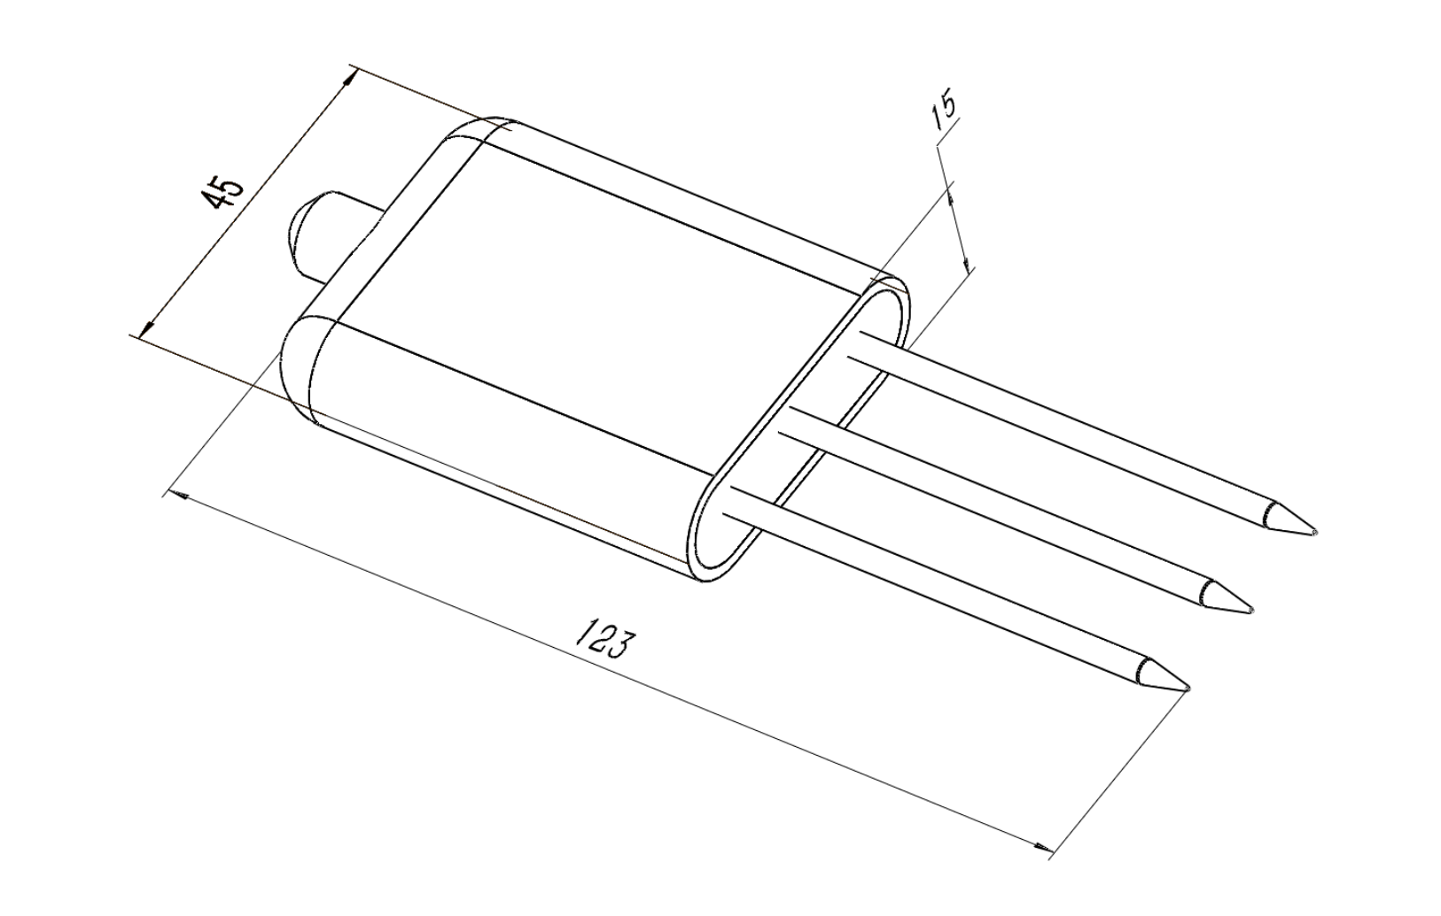
Equipment size drawing (unit：mm）

1.4 System framework diagram
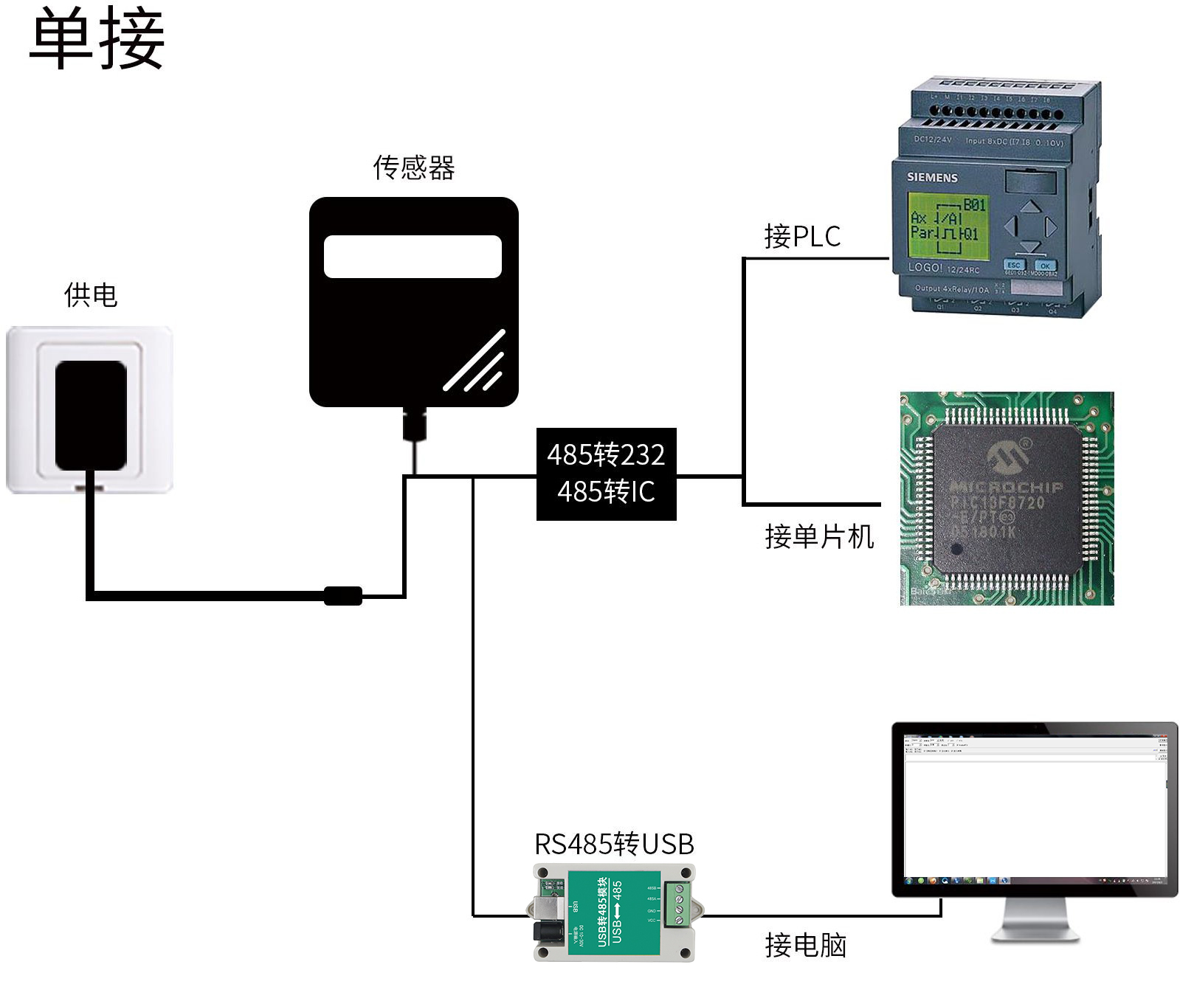
This product can also be used by combining multiple sensors on one 485 bus. In theory, one bus can be 254 485 sensors, and the other end is connected to a PLC with a 485 interface, connected to a microcontroller through a 485 interface chip, or using USB to 485 to communicate with Connect to the computer, use the sensor configuration tool provided by our company to configure and test (only one device can be connected when using the configuration software)。
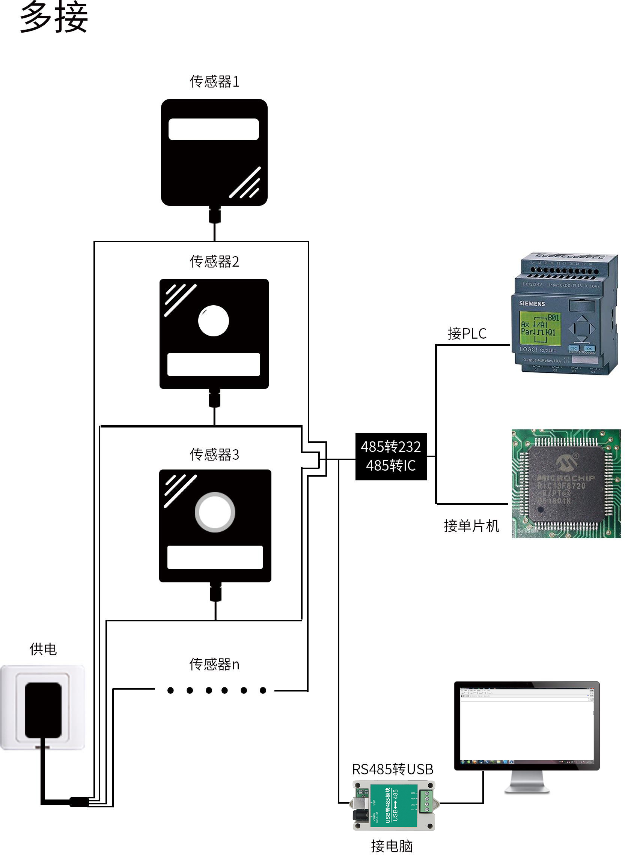

Chapter 2 Hardware Connection

2.2 Interface Description
The power interface can be 4.5-30V for wide voltage power input. When connecting the 485 signal line, pay attention to that the two lines A\B cannot be reversed, and the addresses of multiple devices on the bus must not conflict。

2.2.1 Sensor wiring
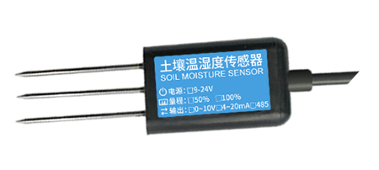
Thread color | Explanation | Remarks
brown | Power positive | 4.5-30V DC
black | Power ground | GND
yellow | 485-A | 485-A
blue | 485-B | 485-B

Chapter 3 How to use

3.1 Quick test method
Choose a suitable measurement location, avoid stones, ensure that the steel needle does not touch hard objects, throw away the topsoil according to the required measurement depth, maintain the original tightness of the soil below, hold the sensor vertically into the soil, insert It is not allowed to sway from side to side. It is recommended to measure multiple times within a small range。
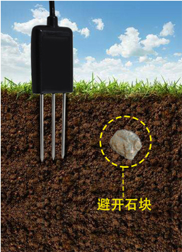

3.2 Buried survey method
Dig a pit> 20cm in diameter vertically, insert the steel needle of the sensor horizontally into the pit wall at a predetermined depth, and fill the pit tightly. After a period of stability, it can be measured and recorded for several days, months or even longer.。
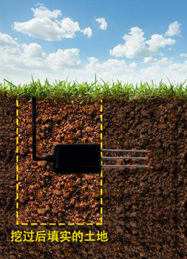

3.3 Precautions
1. The steel needle must be fully inserted into the soil during measurement.
2. Avoid direct sunlight on the sensor causing excessive temperature. Pay attention to lightning protection when using in the field.
3. Do not bend the steel needle violently, do not pull the sensor lead forcibly, and do not drop or hit the sensor violently.
4. The protection grade of the sensor is IP68, which can soak the sensor in the water.
5. Due to the existence of radio frequency electromagnetic radiation in the air, it is not appropriate to stay in the air for a long time。
Chapter 4 Configuration Software Installation and Use
Our company provides the matching "485 parameter configuration software", which can easily use the computer to read the parameters of the sensor, and flexibly modify the device ID and address of the sensor。
Note that there is only one sensor on the 485 bus when using software to automatically acquire。

4.1 Sensor connected to computer
After the sensor is properly connected to the computer via USB to 485 and provides power, you can see the correct COM port in the computer ("COM"-"Computer-Properties-Device Manager-Port" to view the COM port)。
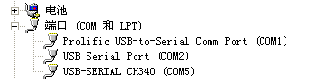
Open the data package, select "Debug software" --- "485 parameter configuration software", find 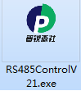 Just open。
If no COM port is found in the device manager, it means that you have not installed the USB to 485 driver (available in the data package) or the driver is not installed correctly, please contact the technical staff for help。

4.2 Use of sensor monitoring software
① The configuration interface is as shown in the figure. First, obtain the serial number according to the method in section 3.1 and select the correct serial port.
② Click the test baud rate of the software, the software will test the current device baud rate and address, the default baud rate is 4800bit/s, the default address is 0x01.
③ Modify the address and baud rate according to the needs of use, and at the same time can query the current functional status of the device.
④ If the test is unsuccessful, please recheck the device wiring and 485 driver installation。
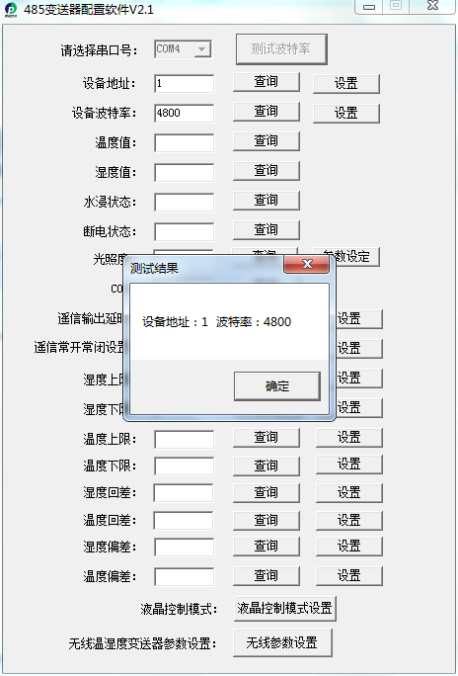

Chapter 5 Communication Protocol

5.1 Communication basic parameters
Coding | 8-bit binary
Data bit | 8 bit
Parity bit | NO
Stop bit | 1 bit
Error checking | CRC (Redundant Cyclic Code)
Baud rate | 2400bit/s、4800bit/s、9600 bit/sCan be set, the factory default is 4800bit/s

5.2 Data frame format definition
Using Modbus-RTU communication protocol, the format is as follows:
Time of initial structure ≥ 4 bytes
Address code = 1 byte
Function code = 1 byte
Data area = N bytes
Error check = 16-bit CRC code
End structure ≥ 4 bytes of time
Address code: It is the address of the transmitter, which is unique in the communication network (factory default 0x01).
Function code: instruction function instruction issued by the host, this transmitter only uses function code 0x03 (read register data).
Data area: The data area is specific communication data, pay attention to the high byte of 16bits data first!
CRC code: two-byte check code。
Host inquiry frame structure：
address code | function code | Register start address | Register length | Check digit low | Check digit high
1 byte | 1 byte | 2 byte | 2 byte | 1 byte | 1 byte
Slave response frame structure：
address code | function code | Effective bytes | Data area | Second data area | Nth data area | Check code
1 byte | 1 byte | 1 byte | 2 byte | 2 byte | 2 byte | 2 byte

5.3 Register address
register  address | PLC or configuration address | content | operating | Definition description
0000 H | 40001 (Decimal) | Water content | Read only | Real-time value of water content (expand 10 times)
0001 H | 40002 (Decimal) | Temperature value | Read only | Real-time temperature value (enlarge 10 times)
0050 H | 40081 (Decimal) | Temperature calibration value | Read and write | Integer (expand 10 times)
0051 H | 40082 (Decimal) | Calibration value of water content | Read and write | Integer (expand 10 times)
07D0 H | 42001 (Decimal) | Device address | Read and write | 1~254 (factory default 1)
07D1 H | 42002 (Decimal) | Device baud rate | Read and write | 0 for 2400  1 for 4800  2 for 9600

Note: There is no temperature value and temperature calibration value register for single moisture equipment

5.4 Sample communication protocol and explanation
Example: Read the temperature and humidity value of device address 0x01
Inquiry frame (hexadecimal)：
address code | function code | starting address | Data length | Check digit low | Check digit high
0x01 | 0x03 | 0x00 0x00 | 0x00 0x02 | 0xC4 | 0x0B
Response frame (hexadecimal): (for example, the temperature is -9.7℃, the humidity is 48.6%RH）
address code | function code | Return valid  Bytes | Humidity value | Temperature value | Check digit low | Check digit high
0x01 | 0x03 | 0x04 | 0x01 0xE6 | 0xFF 0x9F | 0x1B | 0xA0

Temperature calculation:

When the temperature is lower than 0 ℃, the temperature data is uploaded in the form of complement.

Temperature: FF9F H (Hexadecimal) = -97 => Temperature = -9.7℃

Humidity calculation:

Humidity: 1E6 H (Hexadecimal) = 486 => Humidity = 48.6%RH
Chapter 6 Common Problems and Solutions
No output or output error
possible reason:
① The computer has a COM port, and the selected port is incorrect.
②、Baud rate is wrong.
③ The 485 bus is disconnected, or the A and B lines are reversed.
④ If the number of devices is too large or the wiring is too long, power should be supplied nearby. Add a 485 booster and increase 120Ω terminal resistance.
⑤, USB to 485 driver is not installed or damaged.
⑥ Equipment damage。

