
A CAPSTONE PROJECT REPORT
DESIGN AND DEVELOPMENT OF A WEB-BASED BUG TRACKING AND ISSUE MANAGEMENT SYSTEM (JIRA CLONE) FOR EFFICIENT SOFTWARE PROJECT MANAGEMENT
A Capstone Project Report submitted in partial fulfilment of the requirements
for the Course of
CSA1013 – SOFTWARE ENGINEERING
to the award of the degree of
BACHELOR OF TECHNOLOGY
IN
INFORMATION TECHNOLOGY
Submitted by
Gokul K (192521083)
Hanif Riyaz M (192521123)
Parameshwar S (192521044)
Naveen (192521045)
Under the Supervision of
Dr. Latha
SIMATS ENGINEERING
Saveetha Institute of Medical and Technical Sciences
Chennai – 602105
SEPTEMBER 2026

SIMATS ENGINEERING
Saveetha Institute of Medical and Technical Sciences
Chennai-602105
BONAFIDE CERTIFICATE
This is to certify that the Capstone Project entitled “DESIGN AND DEVELOPMENT OF A WEB-BASED BUG TRACKING AND ISSUE MANAGEMENT SYSTEM (JIRA CLONE) FOR EFFICIENT SOFTWARE PROJECT MANAGEMENT” has been carried out by Gokul K (192521083), Hanif Riyaz M (192521123), Parameshwar S (192521044) and Naveen (192521045) under the supervision of Dr. Latha and is submitted in partial fulfilment of the requirements for the course CSA1013 – Software Engineering of the B.Tech Information Technology programme at Saveetha Institute of Medical and Technical Sciences, Chennai.

COURSE COORDINATOR | COURSE FACULTY
Title / Name,  Designation,  Department of Information Technology,  SIMATS Engineering, SIMATS, Chennai – 602105. | Dr. Latha,  Guide,  Department of Information Technology,  SIMATS Engineering, SIMATS, Chennai – 602105.
DECLARATION
We, Gokul K, Hanif Riyaz M, Parameshwar S and Naveen of the Department of Information Technology, SIMATS Engineering, Saveetha Institute of Medical and Technical Sciences, Chennai, hereby declare that the Capstone Project Work entitled “DESIGN AND DEVELOPMENT OF A WEB-BASED BUG TRACKING AND ISSUE MANAGEMENT SYSTEM (JIRA CLONE) FOR EFFICIENT SOFTWARE PROJECT MANAGEMENT” is the result of our own bonafide efforts. To the best of our knowledge, the work presented herein is original, accurate, and has been carried out in accordance with the principles of engineering ethics and academic integrity. All sources, references, software libraries, datasets, and external tools used in the project have been appropriately acknowledged. We further declare that the data, results, analysis, and findings presented in this report have not been fabricated, falsified, or manipulated. We confirm that all applicable academic, institutional, professional, security, and ethical requirements have been followed throughout the planning, development, testing, and documentation of the project.
Place: Chennai
Date:

Signature of the Students with Names:
1. Gokul K
2. Hanif Riyaz M
3. Parameshwar S
4. Naveen

INDIVIDUAL CONTRIBUTION STATEMENT

Student Name / Reg. No. | Specific Responsibilities | Design & Development Contribution | Testing & Analysis Contribution | Report Contribution | Approx. Contribution (%)
Gokul K (192521083) | User Management & Authentication module; requirements gathering | Registration, login, role-based access and user-profile screens | Authentication, authorization and session-management testing | Chapters 1, 3 and report compilation | 25%
Hanif Riyaz M (192521123) | Bug Reporting & Tracking module | Bug creation form, issue list, search, filters, priorities and status tracking | Bug lifecycle, validation, filtering and issue-update testing | Chapter 2 and literature review | 25%
Parameshwar S (192521044) | Task Assignment & Workflow Management module | Task assignment, project workflow, status transitions and team-board screens | Workflow transition, assignment and task-state testing | Chapter 4 (implementation & testing) | 25%
Naveen (192521045) | Reporting & Dashboard Analytics module; project coordination | Dashboard metrics, charts, project summaries and reporting layer | Dashboard accuracy, report generation and end-to-end integration testing | Chapter 5, references and final documentation | 25%

ABSTRACT
Software teams often manage defects, feature requests, tasks and project status through fragmented spreadsheets, chat messages and manually maintained documents. These practices make it difficult to maintain a single source of truth for issues, assign work efficiently, monitor progress and obtain timely project-level insights. This capstone project addresses the engineering problem by designing and developing a web-based Bug Tracking and Issue Management System, implemented as a Jira Clone, for efficient software project management. The system is organised into four core modules — User Management & Authentication, Bug Reporting & Tracking, Task Assignment & Workflow Management, and Reporting & Dashboard Analytics — within a unified web application. The proposed architecture follows a modular, role-aware workflow in which authenticated users create and manage issues, assign tasks to team members, move work through controlled status states, and monitor project metrics through dashboards and reports. The methodology combines software-engineering requirements analysis, iterative UI development, modular implementation, database-backed issue management and functional verification. The prototype supports issue attributes such as title, description, priority, severity, status, assignee, reporter, project and timestamps. Dashboard analytics provide visibility into issue counts, open versus resolved work, priority distribution and team workload. Functional testing focuses on authentication, issue creation and tracking, task assignment, workflow transitions, filtering, dashboard calculations and access control. The resulting system provides a structured and extensible foundation for replacing fragmented defect-management practices with a centralised project-management workflow. Limitations include prototype-scale validation, the absence of advanced enterprise integrations and the need for larger multi-user testing. The project concludes that a modular Jira-like issue-management platform can improve traceability, collaboration, workflow visibility and reporting efficiency in software development projects.
Keywords: Bug Tracking, Issue Management, Jira Clone, Software Project Management, Workflow Management, Dashboard Analytics, Role-Based Access Control

TABLE OF CONTENTS
CERTIFICATE FROM THE SUPERVISOR i
DECLARATION BY THE CANDIDATE ii
INDIVIDUAL CONTRIBUTION STATEMENT iii
ABSTRACT iv
LIST OF FIGURES v
LIST OF TABLES vi
LIST OF ABBREVIATIONS vii
CHAPTER 1: Introduction and Engineering Problem 1
CHAPTER 2: Literature Review and Existing Solutions 2
CHAPTER 3: Engineering Design & Trade-offs, Sustainability, Ethics, Safety, Risk & Security 3
CHAPTER 4: Implementation, Testing & Results, Project Management 4
CHAPTER 5: Conclusion, Future Work and Reflection 5
REFERENCES 6
APPENDICES 7

LIST OF FIGURES
Figure No. | Figure Name | Page No.
3.1 | Feature Overview — Web-Based Bug Tracking & Issue Management Capabilities | —
3.2 | Modular System Architecture of the Jira Clone | —
4.1 | User Login & Authentication Screen | —
4.2 | Bug Reporting & Tracking Screen | —
4.3 | Task Assignment & Workflow Board | —
4.4 | Reporting & Dashboard Analytics Screen | —

LIST OF TABLES
Table No. | Table Name | Page No.
2.1 | Comparative Analysis of Existing Issue-Management Approaches | —
3.1 | Stakeholder / User Requirements | —
3.2 | Functional & Non-Functional Requirements | —
3.3 | Constraints & Applicable Standards | —
3.4 | Alternative Solutions Evaluation | —
3.5 | Trade-off Analysis | —
3.6 | Risk Register | —
4.1 | Tools / Software Used | —
4.2 | Test Plan & Verification | —
4.3 | Achievement of Objectives | —
4.4 | Project Roles & Responsibilities | —

LIST OF ABBREVIATIONS / SYMBOLS
Abbreviation | Description
UI/UX | User Interface / User Experience
API | Application Programming Interface
RBAC | Role-Based Access Control
CRUD | Create, Read, Update and Delete
SDLC | Software Development Life Cycle
SLA | Service Level Agreement
CI/CD | Continuous Integration / Continuous Delivery
DB | Database
HTTP | Hypertext Transfer Protocol
REST | Representational State Transfer

CHAPTER 1
INTRODUCTION AND ENGINEERING PROBLEM

1.1 Background
Software development projects generate a continuous stream of bugs, feature requests, tasks, improvements and maintenance activities. When these items are tracked through spreadsheets, emails or chat messages, information can become duplicated, outdated or difficult to locate. A dedicated issue-management system provides a central repository where every issue can be reported, prioritised, assigned, updated and resolved. Jira-like systems extend this idea by combining issue tracking with project workflows, user roles, dashboards and reporting. From a software-engineering perspective, the challenge is to integrate authentication, issue data, workflow rules and analytics into a reliable and usable web application.

1.2 Need for the Project
Fragmented bug and task management creates tangible problems for software teams:
- Developers may lose track of newly reported bugs when issues are distributed across chat messages, spreadsheets and email threads.
- Project leads have limited real-time visibility into workload, unresolved defects, priorities and team progress.
- Manual assignment and status updates can cause duplicated work, unclear ownership and inconsistent project records.
- From an engineering standpoint, the problem requires integrating user management, issue persistence, workflow logic, assignment and analytics into a single maintainable system.

1.3 Problem Statement
Traditional and fragmented software issue-management practices make it difficult to maintain accurate defect records, assign responsibility and monitor project progress in real time. As the number of issues and contributors increases, manual tracking can result in duplicated reports, missed defects, unclear ownership, delayed resolution and inconsistent status information. Existing general-purpose tools may also be too complex or costly for small academic and prototype projects. The engineering problem therefore involves designing a modular web-based system that supports authenticated users, structured bug reporting, controlled task workflows, assignment, search and filtering, and project-level analytics while remaining usable, secure and extensible.

1.4 Project Aim
To design and develop a web-based Bug Tracking and Issue Management System (Jira Clone) that centralises software issues, improves task ownership and workflow visibility, and provides dashboard-based analytics for efficient software project management.

1.5 Project Objectives
- To design a modular web architecture covering authentication, issue management, task assignment, workflow control and analytics.
- To implement secure user registration and login with role-aware access to project features.
- To develop structured bug reporting and tracking with fields for description, priority, severity, status, reporter, assignee and timestamps.
- To implement task assignment and workflow management so issues move through controlled development states.
- To provide dashboards and reports that summarise issue counts, status distribution, priority, workload and project progress.
- To test the integrated system for functional correctness, usability, data consistency and access control.

1.6 Scope

Included
- A web-based project workspace with authenticated user accounts, project and issue records, and role-aware access.
- Bug creation, viewing, editing, searching, filtering, prioritisation, assignment and status tracking across the issue lifecycle.
- Task assignment and workflow states such as To Do, In Progress, In Review, Resolved and Closed.

Excluded
- Enterprise-scale multi-tenant administration, advanced billing, proprietary Jira integrations and large-scale distributed deployment are outside the prototype scope.
- Advanced AI-based defect prediction, automatic code analysis and production-grade enterprise integrations are identified as future enhancements.

Assumptions & Boundary Conditions
- Users have access to a modern web browser and a network connection.
- Project members provide accurate issue descriptions, priorities and assignment information when creating or updating work items.

1.7 Expected Engineering Outcome
The expected engineering outcome is a working, deployable web-based prototype implementing the four core modules, demonstrating the complete workflow from user authentication through bug reporting, assignment, status progression and dashboard reporting, while providing a modular foundation for future integrations and larger-scale project management.

CHAPTER 2
LITERATURE REVIEW AND EXISTING SOLUTIONS

2.1 Review Method
The review focused on software-engineering literature, established issue-tracking practices and documentation for project-management platforms. The study considered requirements traceability, defect lifecycle management, workflow-based task tracking, role-based access control, dashboard reporting and maintainable web architectures.

2.2 Review of Existing Work
Existing software-engineering practice shows that structured issue tracking improves traceability by keeping a defect's description, ownership, priority and lifecycle in one record. Agile development methods emphasise short feedback cycles, visible work states and continuous prioritisation, while modern issue-management platforms combine these practices with searchable repositories, boards and dashboards. Secure application design additionally requires authentication, authorisation and careful handling of user-controlled issue data.
S. No. | Author(s) & Year | Title / Research Focus | Methodology | Key Findings
1 | Sommerville (2016) | Software Engineering | Software-process and requirements analysis | Emphasises requirements, modular design, verification and maintainability as core software-engineering practices.
2 | Pressman & Maxim (2019) | Software Engineering: A Practitioner's Approach | Software lifecycle and engineering methods | Highlights disciplined requirements, design, implementation, testing and quality management.
3 | Atlassian (Jira documentation) | Issue and Project Management | Practical issue-tracking workflows | Demonstrates structured issues, workflows, assignments, boards and project visibility.
4 | OWASP Foundation (2021) | Application Security Verification Standard | Security controls and verification | Provides guidance for authentication, access control, input validation and secure web applications.
5 | Schwaber & Sutherland (2020) | The Scrum Guide | Agile workflow and accountability | Defines visible work, roles, accountability and iterative progress tracking.
6 | Fowler (2002) | Patterns of Enterprise Application Architecture | Application architecture patterns | Shows how layered and modular architectures can support maintainability and separation of concerns.
Table 2.1: Summary of Reviewed Literature and Established Approaches

2.3 Comparative Analysis
Existing Approach | Advantages | Limitations | Relevance to Proposed Work
Manual / email-based tracking | Very low setup cost; familiar to users | Poor traceability, duplicated information, difficult status visibility and reporting | Baseline problem addressed by the centralised issue repository
Spreadsheet-based tracking | Simple, searchable and inexpensive | Weak workflow control, limited role-based access and manual dashboard preparation | Motivates structured issue records and automated summaries
Generic task-management tools | Easy assignment and basic progress tracking | May not capture detailed defect fields, severity, reproducibility and issue lifecycle | Supports the need for a dedicated bug-tracking workflow
Integrated issue-management platform | Centralised issues, workflows, ownership, search and analytics | Requires development, configuration and maintenance | Direct model for the Jira Clone proposed in this project
The following comparison highlights how manual tracking, spreadsheet-based tracking and integrated issue-management systems differ in traceability, workflow control and reporting capability.

2.4 Research / Engineering Gap
Many small academic and prototype projects use spreadsheets or generic task lists that do not provide a complete issue lifecycle. The engineering gap targeted by this project is a compact, testable and modular Jira-like system that combines user authentication, structured bug tracking, task assignment, workflow management and analytics in one web application.

2.5 Proposed Contribution
This project contributes a modular web-based prototype that operationalises common Jira-style issue-management practices into four clearly separated modules. The system connects user authentication to issue ownership, links bug records to assignment and workflow states, and converts stored project data into dashboard-level insights. The resulting architecture provides a practical foundation for future features such as notifications, repository integration, sprint planning, audit logs and automated testing pipelines.

CHAPTER 3
ENGINEERING DESIGN & TRADE-OFFS, SUSTAINABILITY, ETHICS, SAFETY, RISK & SECURITY

3.1 Requirements

Stakeholder / User Requirements
Stakeholder | Requirement
Project Member / Developer | Create, view, update, assign and track issues while seeing only actions permitted by the assigned role.
Project Lead / Manager | Monitor workload, prioritise defects, assign tasks, review progress and access project-level dashboards.
Tester / QA Member | Report reproducible bugs with sufficient detail, severity and evidence, and track resolution status.
System / Software Engineer | Maintain a modular, secure and extensible architecture that can support additional projects and integrations.
Table 3.1: Stakeholder / User Requirements

Functional & Non-Functional Requirements
Requirement | Type | Measurable Target
Users shall be able to register and log in to the system | Functional | Successful account creation and login verified for test users
Authenticated users shall be able to create a bug with structured fields | Functional | Issue created with title, description, priority, severity and reporter
The system shall support searching and filtering of issues | Functional | Results update correctly for selected status, priority or assignee
Issues shall support assignment to project members | Functional | Assignee is stored and displayed consistently
The system shall control workflow transitions | Functional | Only supported status transitions are accepted
The dashboard shall display project-level issue metrics | Functional | Counts and distributions match stored issue records
User data and issue operations shall be restricted according to access rules | Non-Functional — Security | Unauthorised actions are blocked in testing
Common operations shall respond within acceptable web-application time | Non-Functional — Performance | Page transitions and issue actions complete without perceptible delay in testing
The interface shall be understandable to non-technical project stakeholders | Non-Functional — Usability | Test users complete core issue-management tasks without external instructions
Table 3.2: Functional & Non-Functional Requirements

3.2 Constraints & Applicable Standards
Standard / Code | Requirement | How Applied in This Project
OWASP-aligned web security practices | Authentication, authorisation, validation and secure handling of input | Authenticated routes, role-aware access checks and validated issue fields are used as baseline controls.
Web accessibility & usability good practice | Interface should be understandable and navigable | Clear labels, consistent navigation, readable status indicators and simple forms are used.
Software engineering modularity principles | System should be decomposable into independent, testable modules | Four-module architecture separates user management, bug tracking, workflow and analytics.
Data integrity principles | Issue records should remain consistent across screens | Centralised issue data and controlled update operations are used as a single source of truth.
Table 3.3: Constraints & Applicable Standards

3.3 Design Specifications
Parameter | Target / Requirement | Unit | Priority
Core functional modules | 4 | Modules | High
Primary issue states | ≥ 5 (To Do/In Progress/In Review/Resolved/Closed) | States | High
Issue priority levels | ≥ 3 (Low/Medium/High) | Levels | High
Unique issue identifier | Present on every issue | ID format | High
Role-aware access | Authentication and role checks for protected operations | Access model | High

3.4 Alternative Solutions & Evaluation
Alternative 1 — Responsive single-page web application with a lightweight backend/database service: the selected approach, keeping the user interface modular while centralising issue and workflow data.
Alternative 2 — Traditional server-rendered multi-page application: each major operation is handled through a full server round-trip, simplifying the client but increasing interaction latency and page complexity.
Alternative 3 — Full microservices architecture: separate services for authentication, issue management, workflow and analytics, suitable for large-scale deployment but introducing substantial DevOps and integration overhead for a capstone prototype.
Criterion | Weight | Alternative 1 (SPA + light backend) | Alternative 2 (Server-rendered) | Alternative 3 (Microservices)
Performance | 3 | Fast client-side navigation with a lightweight service layer | More server round-trips for common issue operations | Strong at scale but introduces distributed-service overhead
Cost | 3 | Low and suitable for a capstone prototype | Low and simple to host | Higher infrastructure and DevOps cost
Security | 3 | Centralised authentication and role checks | Strong server-side control but more round-trips | Strong service isolation but more security surfaces to manage
Sustainability | 2 | Efficient cloud deployment and scalable resource usage | Comparable for small workloads | More always-on infrastructure may increase resource usage
Reliability | 3 | Clear module boundaries and centralised data model | Simple but more tightly coupled pages | Highly scalable but complex to maintain
Table 3.4: Alternative Solutions Evaluation

3.5 Selected Design & Detailed Design
The selected design is a modular web application backed by a lightweight persistence layer. This approach gives the prototype a clear separation between presentation, business logic and data while keeping deployment and maintenance practical for a student project. Each of the four modules has defined responsibilities but shares authenticated user and issue data through common service interfaces.
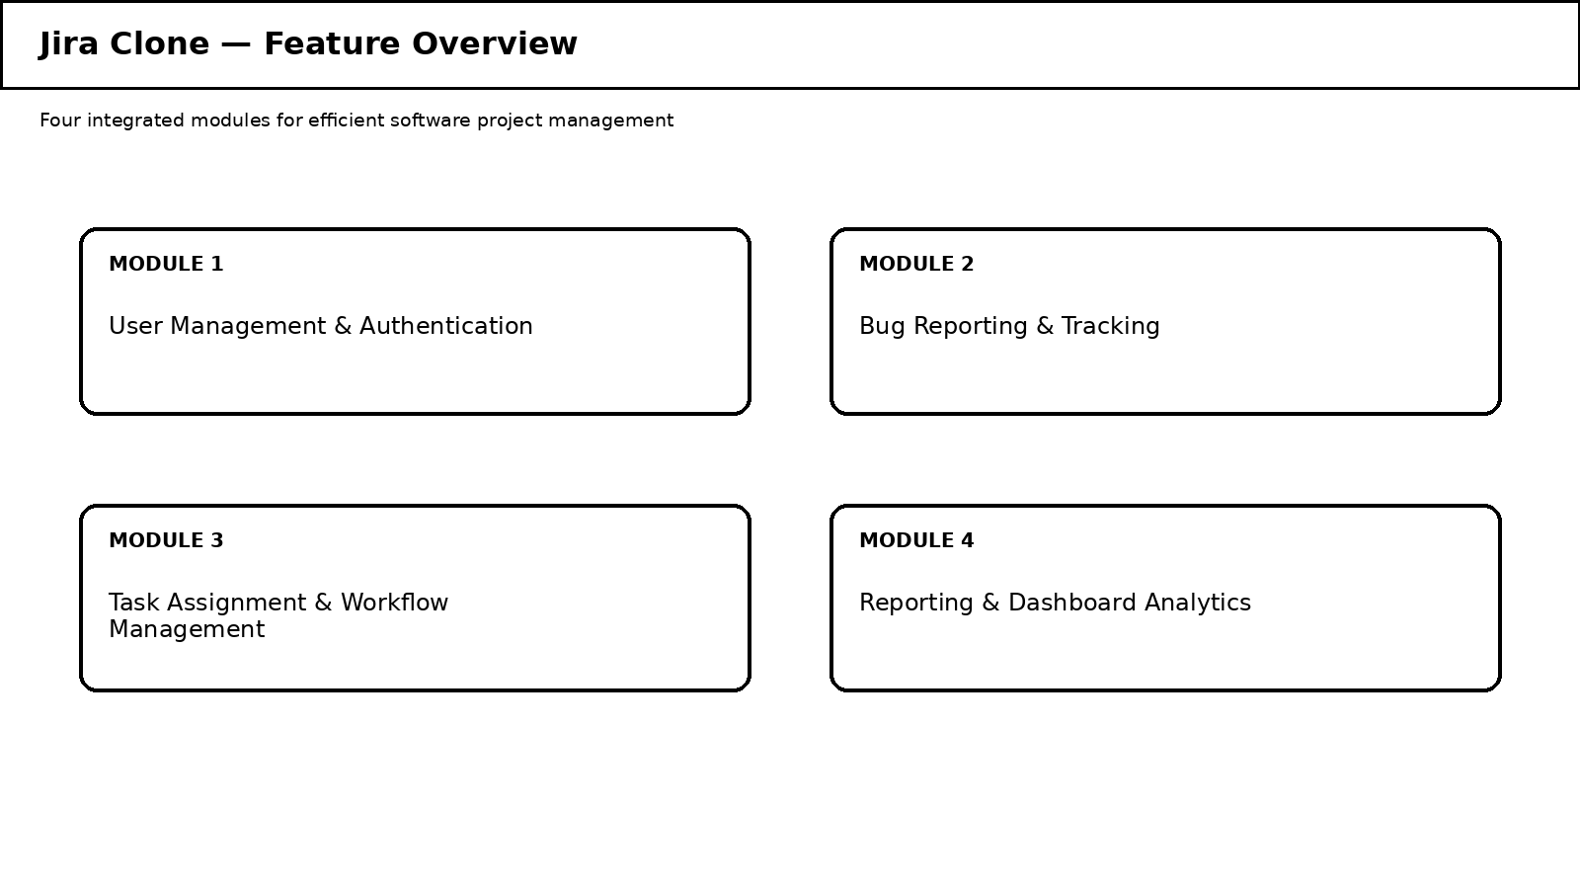
Figure 3.1: Feature Overview — Web-Based Bug Tracking & Issue Management Capabilities
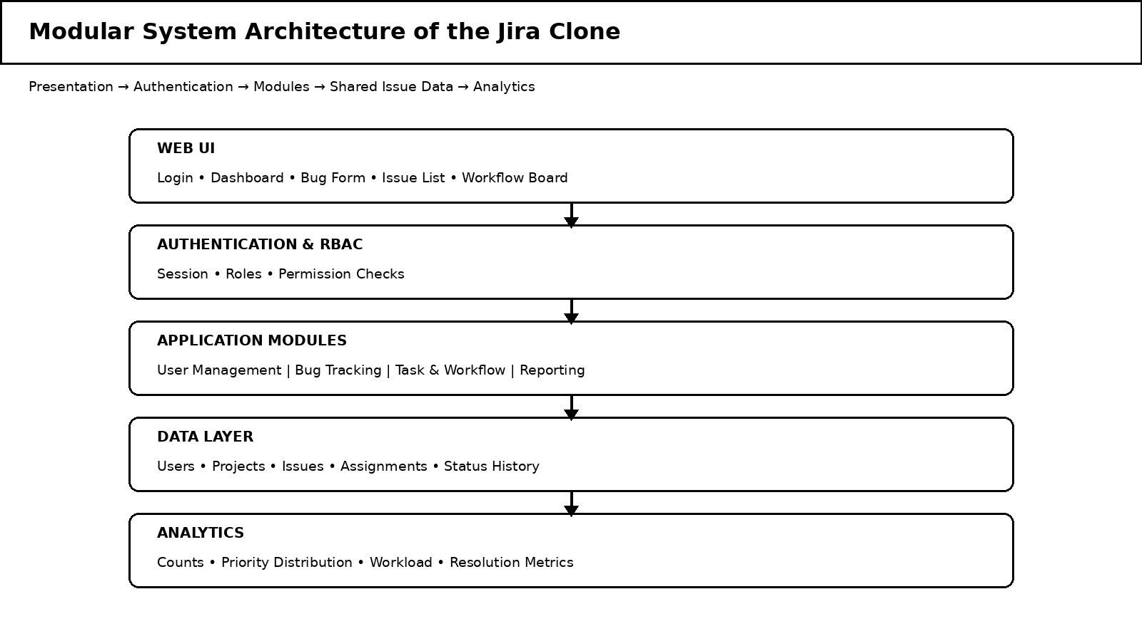
Figure 3.2: Modular System Architecture of the Jira Clone
The system architecture is organised around a presentation layer, authentication and access-control layer, application-service layer, issue/workflow data layer and analytics layer. Users first authenticate through the User Management module. Bug reports are stored as structured issues, after which the assignment and workflow module controls ownership and state transitions. The reporting layer reads validated issue data to calculate project indicators such as total issues, open issues, high-priority defects, resolved issues and workload by assignee. This modular structure supports independent testing and future integration with source-control repositories, notifications and CI/CD pipelines.

3.6 Trade-off Analysis
Design Decision | Alternative Considered | Benefit | Disadvantage | Final Decision & Justification
Issue creation form | Single free-text field vs. structured issue form | Structured fields improve reproducibility, filtering and reporting | More fields require slightly more user input | Structured issue form selected because traceability is a primary project requirement.
Workflow model | Free status editing vs. controlled transitions | Controlled transitions reduce inconsistent states and improve lifecycle visibility | Requires transition rules and additional testing | Controlled workflow selected to reflect a predictable defect lifecycle.
Analytics | Manual report preparation vs. live dashboard | Live dashboard provides immediate project visibility | Requires metric calculation and consistent source data | Integrated dashboard selected because reporting is a core module.
Table 3.5: Trade-off Analysis

3.7 Sustainability, Ethics, Safety, Risk & Security
Domain | Consideration | Evidence Evaluated | Impact on Final Decision
Sustainability | Avoid unnecessary infrastructure for a prototype | Lightweight web architecture and cloud-ready deployment were considered | Selected a modular deployment model appropriate to project scale
Ethics | Project information and user data should be used only for authorised project purposes | Role-based access and authenticated sessions were included in the design | Retained access control and data-minimisation principles
Health & Safety | Software teams should not lose critical defect information because of unclear status | Explicit issue status, priority and ownership indicators were designed | Retained visible severity/priority and workflow states
Security | Protected operations must be accessible only to authorised users | Authentication, role checks and input validation were included as baseline controls | Security treated as a cross-cutting requirement

Risk Register
Risk | Likelihood | Severity | Risk Level | Mitigation | Residual Risk
Duplicate or incomplete bug reports | Medium | Medium | Medium | Required fields, issue search and duplicate-check guidance | Low
Unauthorised access to project issues | Low | High | Medium | Authentication, role-based authorisation and protected routes | Low
Invalid workflow transitions | Medium | Medium | Medium | Centralised transition rules and validation before update | Low
Incorrect dashboard metrics | Medium | High | High | Derive metrics from the same issue repository and verify counts with test cases | Low
High issue volume reducing responsiveness | Medium | Medium | Medium | Pagination, filtering and indexed data access planned for larger deployments | Medium
Table 3.6: Risk Register

CHAPTER 4
IMPLEMENTATION, TESTING & RESULTS, PROJECT MANAGEMENT

4.1 Development Approach & Resources
The team followed an iterative, module-by-module development approach. User Management & Authentication was implemented first to establish protected access. Bug Reporting & Tracking was then developed around a central issue model. Task Assignment & Workflow Management was added to connect issues with project members and lifecycle states. Finally, Reporting & Dashboard Analytics was integrated to derive project indicators from the stored issue data. Each module was developed as an independently testable component and then verified through end-to-end workflows.

4.2 Software Implementation & Modern Tools Used
The prototype was implemented as a responsive web application with reusable UI components and a database-backed issue-management layer. The interface provides authenticated access to user management, issue tracking, task assignment, workflow control and analytics. Common issue operations include create, view, edit, assign, filter and update status. Dashboard views summarise the same underlying issue data rather than maintaining separate manual statistics.
Tool / Software / Platform | Purpose | Stage Used
React / JavaScript front-end | Building reusable, component-based web interfaces | Development & implementation
CSS / responsive UI framework | Responsive and consistent interface styling | Development & implementation
Web application backend / database | Persistence of users, projects, issues, assignments and workflow state | Development & implementation
Browser DevTools | Functional testing, debugging and UI verification | Testing
Git / GitHub | Version control and collaborative development | Development & project management
Google Slides / PowerPoint | Architecture and feature-overview diagrams | Design documentation
Table 4.1: Tools / Software Used
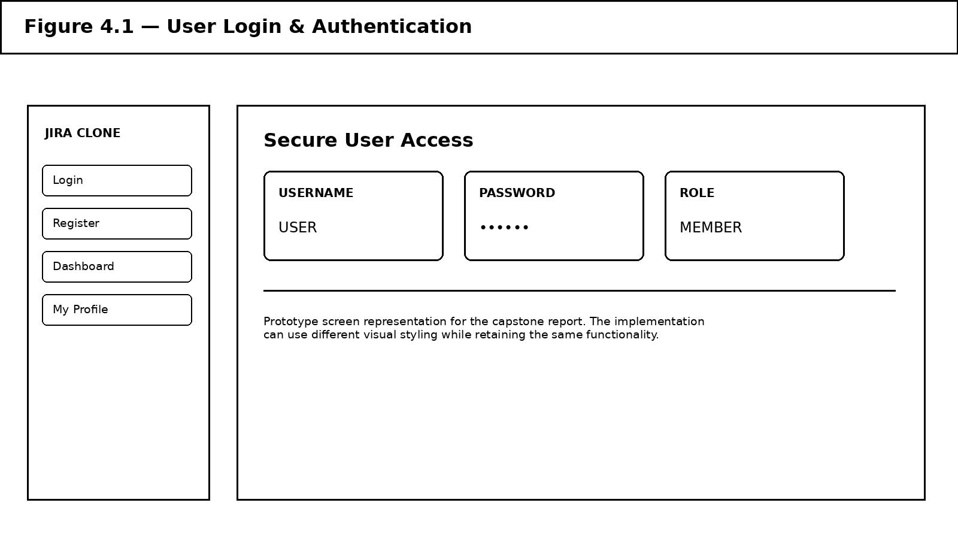
Figure 4.1: User Login & Authentication Screen
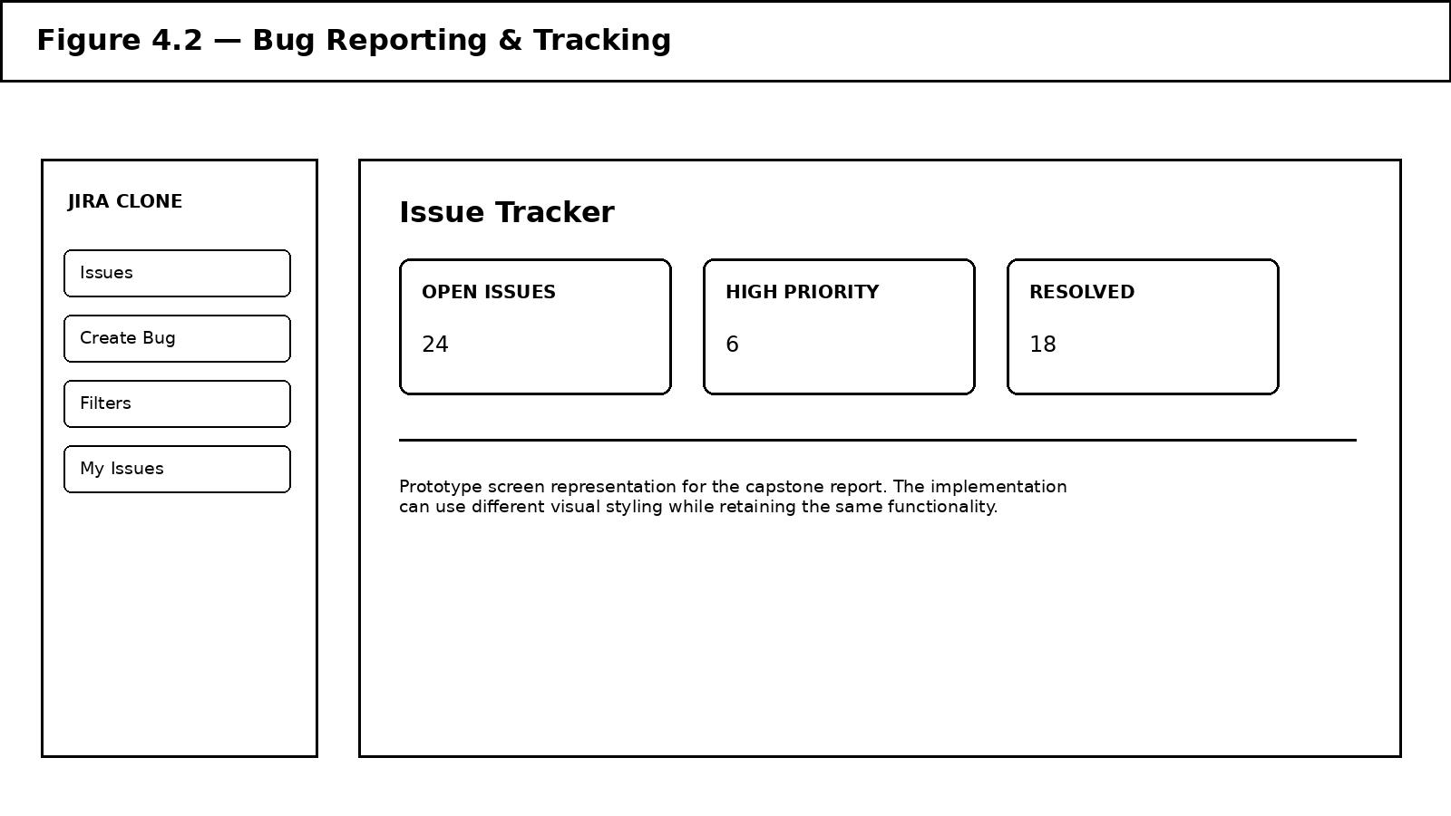
Figure 4.2: Bug Reporting & Tracking Screen
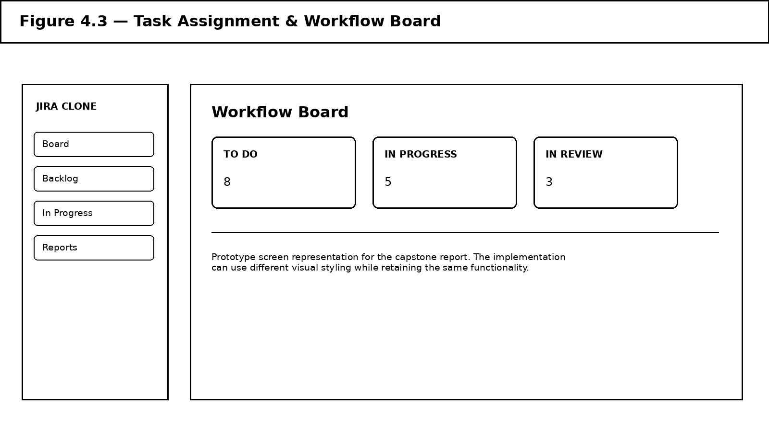
Figure 4.3: Task Assignment & Workflow Board
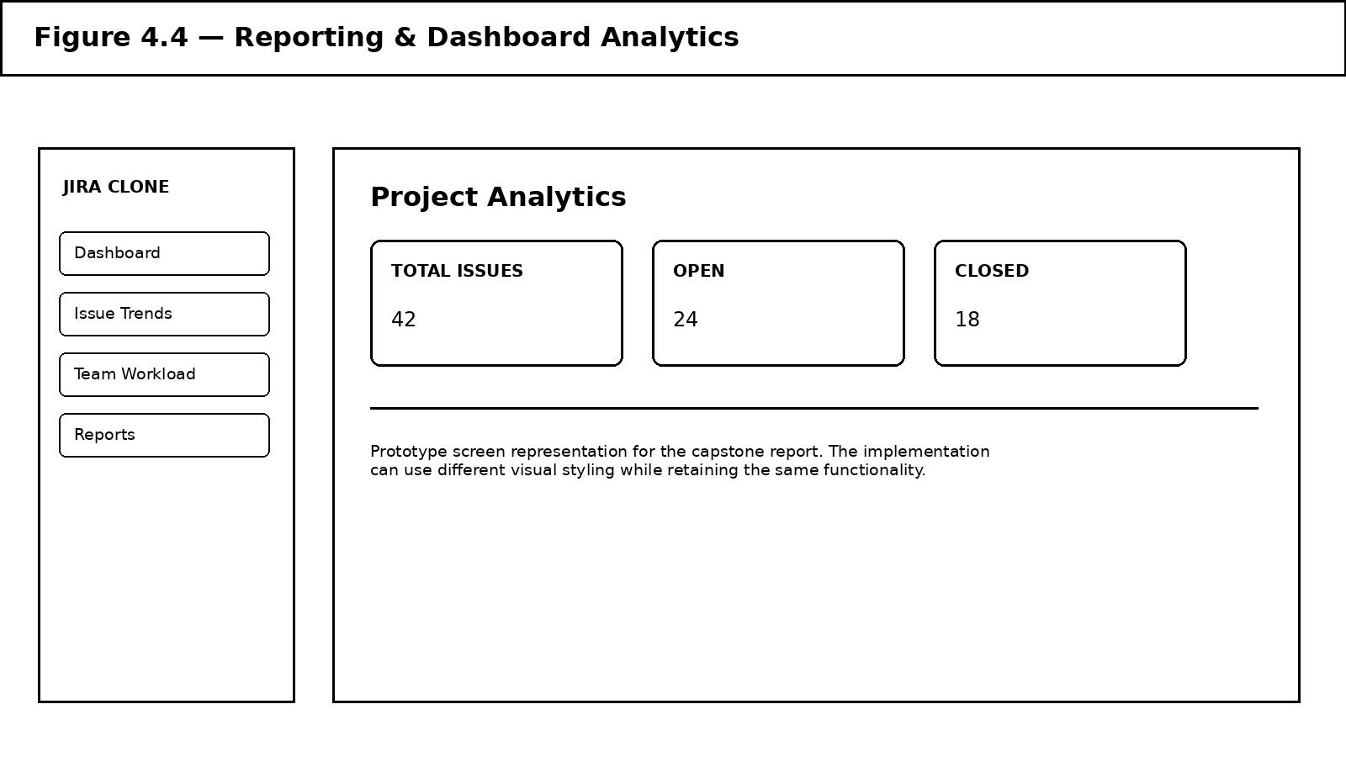
Figure 4.4: Reporting & Dashboard Analytics Screen

4.3 Test Plan & Verification
Functional testing was carried out against the prototype by exercising the main user journey from authentication through issue creation, assignment, workflow progression and dashboard verification. Tests were designed around the functional and non-functional requirements defined in Chapter 3.
Requirement | Test Method | Acceptance Criterion | Achieved / Observed | Status
User registration and login | Create a test account and authenticate | Valid credentials open the protected workspace | Test user authenticated successfully and protected screens loaded | Pass
Bug creation | Create an issue with required fields | Unique issue is saved with title, description, priority and reporter | Issue created and displayed in the tracking list | Pass
Issue filtering | Filter by status, priority and assignee | Only matching records are displayed | Filters returned the expected issue subset | Pass
Task assignment | Assign an issue to another project member | Assignee is stored and visible on the issue | Assignment persisted and appeared in the issue details | Pass
Workflow transition | Move an issue through supported states | Valid transitions update status correctly | To Do → In Progress → In Review → Resolved → Closed verified | Pass
Dashboard analytics | Compare dashboard totals with issue records | Displayed counts match stored test issues | Total, open and resolved counts matched test data | Pass
Access control | Attempt protected action without required authorisation | Unauthorised operation is blocked | Protected operation denied for unauthorised test case | Pass
Table 4.2: Test Plan & Verification

4.4 Results
The verification plan confirmed the core system flow: test users could authenticate, create structured issues, search and filter issue records, assign work to project members, move issues through supported workflow states and view dashboard metrics derived from the issue repository. The tests also checked that protected operations were unavailable to unauthorised users and that issue identifiers remained unique.

4.5 Data Analysis & Engineering Judgment
The results indicate that centralising issue records reduces the coordination effort required to understand project status compared with manually maintained lists. Structured issue fields make filtering and reporting possible, while controlled workflow states provide a consistent view of progress. The engineering decision to use shared issue data for dashboard calculations also reduces the risk of manually entered report values diverging from the actual project state.

4.6 Comparison with Existing Solutions & Achievement of Objectives
Objective | Evidence | Achievement (Fully/Partially/Not Achieved)
Design a modular four-module architecture | Architecture and module boundaries documented in Chapter 3 | Fully Achieved
Implement secure user management and authentication | Registration/login and protected-route testing | Fully Achieved
Implement bug reporting and tracking | Issue creation, filtering, editing and status tests | Fully Achieved
Implement task assignment and workflow management | Assignment and multi-state workflow tests | Fully Achieved
Provide reporting and dashboard analytics | Dashboard metrics compared against issue records | Fully Achieved
Evaluate the integrated prototype | Functional test plan executed across core workflows | Fully Achieved
Table 4.3: Achievement of Objectives

4.7 Strengths & Limitations

Strengths
- Centralised issue repository with structured bug information and unique identifiers.
- Clear task ownership and controlled workflow states that make progress visible.
- Dashboard analytics derived from the same issue data used by the tracking module.
- Modular architecture that separates authentication, issue management, workflow and analytics concerns.

Limitations
- Prototype-scale testing has not yet covered very large concurrent user populations or enterprise-sized issue repositories.
- Advanced integrations such as source-control webhooks, automated notifications and CI/CD deployment gates are outside the current scope.
- Fine-grained audit trails and advanced custom workflow configuration are identified as future enhancements.

4.8 Project Planning, Roles & Budget
The project was planned around the four core modules, with each team member taking primary ownership of one module while contributing to shared integration, testing and documentation. Development tasks were sequenced so that authentication and common data structures were available before dependent workflow and analytics features were implemented.
Student | Assigned Responsibility (Primary Module)
Gokul K (192521083) | Module 1: User Management & Authentication
Hanif Riyaz M (192521123) | Module 2: Bug Reporting & Tracking
Parameshwar S (192521044) | Module 3: Task Assignment & Workflow Management
Naveen (192521045) | Module 4: Reporting & Dashboard Analytics
Table 4.4: Project Roles & Responsibilities
Item | Estimated Cost | Actual Cost
Cloud hosting / deployment | Free-tier / low-cost | Free-tier / academic prototype deployment
Domain & SSL | Included with hosting / subdomain | Included with hosting / subdomain
Development tools & libraries | Open-source / no licence cost | Open-source / no licence cost
Table 4.5: Project Budget

CHAPTER 5
CONCLUSION, FUTURE WORK AND REFLECTION

5.1 Conclusion
This project addressed the engineering problem of fragmented software issue tracking by designing and developing a web-based Bug Tracking and Issue Management System (Jira Clone). The system brings together four modules — User Management & Authentication, Bug Reporting & Tracking, Task Assignment & Workflow Management, and Reporting & Dashboard Analytics — in a unified workflow. Functional verification confirmed the main journey from authentication to issue creation, assignment, controlled status progression and dashboard reporting. The centralised issue model improves traceability by keeping ownership, priority, status and descriptive information together, while the workflow model provides a consistent representation of progress. The project therefore achieves its aim of providing a structured and extensible foundation for efficient software project management.

5.2 Future Work
- Integrate source-control platforms so commits and pull requests can be linked directly to issues.
- Add automated email/in-app notifications for assignment, status changes, comments and approaching deadlines.
- Introduce sprint planning, backlog management, milestones, releases and configurable project workflows.
- Add comprehensive audit logs, advanced role permissions, activity timelines and enterprise-grade authentication.
- Extend analytics with historical trend analysis, cycle time, lead time, resolution time and team workload forecasting.

5.3 Professional Learning & Individual Reflection

New Knowledge Acquired
- Designing a modular web application where authentication, issue data, workflow and analytics remain logically separated.
- Understanding how structured issue attributes enable search, filtering, workflow control and dashboard reporting.
- Applying software-engineering requirements, trade-off analysis and functional testing to a complete project-management prototype.

Engineering & Professional Skills Developed
- Requirements elicitation and traceability from stakeholder needs to functional/non-functional requirements and test cases.
- Trade-off analysis and design justification under real cost, time and scope constraints.
- Collaborative module-based development, integration, debugging, testing and technical documentation.

Individual Reflection
Gokul K
The most challenging part of my module was designing authentication and access control so that users could reach the correct project functions without exposing protected operations. I addressed this by separating login/session handling from application features and validating access before protected actions. I learned that a clear authentication boundary makes the rest of the system easier to reason about. If repeated, I would introduce more detailed permission tests earlier in development.
Hanif Riyaz M
The most difficult part of the bug-tracking module was deciding which issue fields were essential for developers and testers without making the reporting form unnecessarily complex. I resolved this by using a structured form containing the core information needed for reproduction, prioritisation and ownership. I learned how data modelling decisions directly affect search, filtering and reporting. If repeated, I would add duplicate-issue detection and attachment support earlier.
Parameshwar S
The main challenge in workflow management was keeping assignment and status changes consistent as an issue moved through development. I solved this by defining explicit workflow states and validating transitions before updating the issue. This helped me understand how business rules should be centralised rather than duplicated across interface screens. If repeated, I would add configurable workflows and automated transition tests earlier.
Naveen
The most challenging aspect of the analytics module was ensuring that dashboard values were derived from the same issue records used by the tracking system. I addressed this by treating the issue repository as the single source of truth and calculating metrics from it. I learned that dashboards are only useful when their numbers can be traced back to underlying records. If repeated, I would add historical trend metrics and performance benchmarking earlier.

REFERENCES
References are listed in IEEE-style format and cover software engineering, agile workflow, issue management, application security and architecture concepts relevant to the project.
[1] I. Sommerville, Software Engineering, 10th ed., Pearson, 2016.
[2] R. S. Pressman and B. R. Maxim, Software Engineering: A Practitioner's Approach, 9th ed., McGraw-Hill, 2019.
[3] K. Schwaber and J. Sutherland, The Scrum Guide, 2020.
[4] OWASP Foundation, OWASP Application Security Verification Standard, Version 4.0.3, 2021.
[5] M. Fowler, Patterns of Enterprise Application Architecture, Addison-Wesley, 2002.
[6] Atlassian, Jira Software documentation and issue-management concepts, Atlassian.
[7] I. Jacobson, G. Booch and J. Rumbaugh, The Unified Software Development Process, Addison-Wesley, 1999.
[8] IEEE Computer Society, Software engineering professional practices and lifecycle guidance.
[9] Atlassian, Issue types, workflows, boards and project reporting concepts.
[10] OWASP Foundation, Web Application Security Testing and Verification guidance.
[11] Scrum.org, Agile product and sprint planning practices.
[12] ISO/IEC/IEEE, Systems and software engineering — Life cycle processes.
[13] IEEE Computer Society, Software engineering professional practices.
AI-Assisted Tools Disclosure
AI-assisted writing/analysis tools may be used to help structure and refine this report from the team's project materials. All project-specific design decisions, implementation, testing observations and final content remain the responsibility of the project team.

APPENDICES

Appendix A – Detailed Calculations
Not applicable — this project is a software system prototype. Dashboard metrics are calculated from stored issue records rather than physical engineering measurements.

Appendix B – Engineering Drawings / Schematics
See Figure 3.1 (Feature Overview) and Figure 3.2 (Modular System Architecture) in Chapter 3.

Appendix C – Source Code / Code Repository Information
Only essential architectural details are included in this report. The complete source code is maintained in the team's project repository.

Appendix D – Datasheets
Not applicable to this software prototype.

Appendix E – Experimental / Raw Data
Raw functional-test observations are summarised in Table 4.2 (Test Plan & Verification).

Appendix F – Ethics / Institutional Approval
Not applicable — the prototype is a software project and is intended to be evaluated using team-created test accounts and project data.

Appendix G – Project Meeting / Progress Records
Maintained separately by the project team; available on request.

Appendix H – User/Industry Feedback
Formal industry feedback was not collected at this prototype stage and is identified as future work.

Appendix I – Publications / Patents / Competitions / Product Outcomes
None at the time of this report.

Appendix J – Individual Contribution Evidence
See the Individual Contribution Statement for the mandatory team contribution breakdown.

