

MAZE SOLVER USING (BFS) AND (A*)
SEARCH ALGORITHMS

Fahad Bin Sultan University
Tabuk, Saudi Arabia
ARTIFICIAL INTELLIGENT

Students’ Names
HANEEN EMAD 202215002

Academic year :2025-2026
Contents
1. Abstract 2
2. Introduction 3
3. Problem Statement 3
4. PROJECT OBJECTIVES 3
5. System Description and Maze Representation 4
6. System Architecture 5
7. Visualization Process of BFS and A* Algorithms 6
8. ALGORITHMS USED 7
8.1 Breadth-first search (BFS) algorithm 7
8.1.1 Optimality: 8
8.1.2 Time Complexity: 8
8.1.3 Space Complexity: 8
8.1.4 Disadvantage 8
8.2 ( A* ) algorithm (priority-based): 8
8.2.1 Advantages of this algorithm: 8
9. How the program works 8
10. COMPARISON OF ALGORITHMS: 9
11. Results 10
12. Conclusion 10
13. How to run the program 11

Figure 1: Graphical user interface 5
Figure 2:System Architecture of the Maze Solver 6
Figure 3: Visualization of BFS and A* Search Process 7

1. Abstract

In artificial intelligence, pathfinding is considered one of the fundamental research challenges, especially with regard to solving mazes. This paper describes the design and implementation of a program that solves a maze using two well-known search techniques: Breadth-First Search (BFS) and A* Search (also called A-Star Search). The program is designed with a graphical user interface, which allows users to view the process of solving a maze incrementally.

This paper is motivated by the need to compare the performance of BFS Search and A* Search, especially with regard to time, number of visited nodes, and efficiency. From the results, it is evident that heuristic search techniques, such as A* Search, greatly improve performance compared to non-heuristic search techniques such as BFS Search.

2. Introduction

Artificial intelligence methods are heavily utilized in solving problems that require complex decision-making and optimization issues. A good example is finding a route from a specified starting point to a specified goal in a structured space, such as a maze.
Search algorithms are instrumental in solving such problems by examining the potential routes and finding the most efficient route to the goal. In this project, two search algorithms have been implemented: Breadth-First Search and A* search algorithm.
Apart from demonstrating the working mechanism of these algorithms, this project presents a visual and interactive platform that increases understanding of these search algorithms.

3. Problem Statement
The problem that this project is attempting to solve is the determination of the most efficient path from a predetermined starting point to a goal point in a maze, while avoiding obstacles in the process. The main challenge in this problem is the minimization of the search time as well as the number of nodes searched. This particular problem has a great deal of real-world significance in terms of robotics, games, and optimization paths.

4. PROJECT OBJECTIVES
The project seeks to achieve a complete understanding of the process of selecting the most appropriate path and communicating it to the user. It also supports:
- Understanding how some artificial intelligence search algorithms work.
- Demonstrating how algorithms can be used to navigate a maze.
- Evaluating the efficiency of each algorithm, comparing them, and challenging them against each other.
- Facilitating understanding of how each algorithm works by visually displaying the solution steps to the user.
- Enabling the user to interact with the maze and try out various solutions for themselves..

5. System Description and Maze Representation
The maze is represented as a grid of two-dimensional cells, each of which can have one of two states:
- Wall (blocked cell)
- Open path (traversable cell)
The system also defines:
- A starting point (S)
- A goal point (G)
The graphical user interface has the following components:
- The maze
- The explored nodes
- The final path between S and G

The graphical interface visually represents the maze structure and allows user interaction.
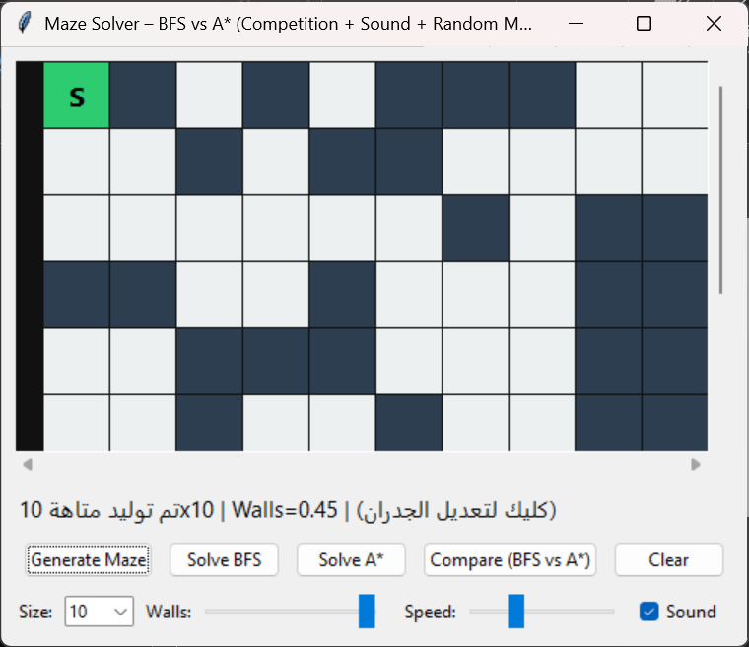
Figure 1: Graphical user interface

The system also includes additional features such as random maze generation, algorithm comparison, adjustable speed, and optional sound effects.

6. System Architecture
This figure demonstrates how the maze is processed and solved using BFS and A* algorithms. The grid represents the maze structure, including walls, open paths, the starting point (S), and the goal point (G).
The BFS algorithm explores the maze in all directions, resulting in visiting a large number of nodes. In contrast, the A* algorithm uses a heuristic function to guide the search toward the goal, reducing the number of explored nodes.

After the search process is completed, the shortest path from the start to the goal is highlighted. The system also displays statistics such as time taken, number of visited nodes, and path length.

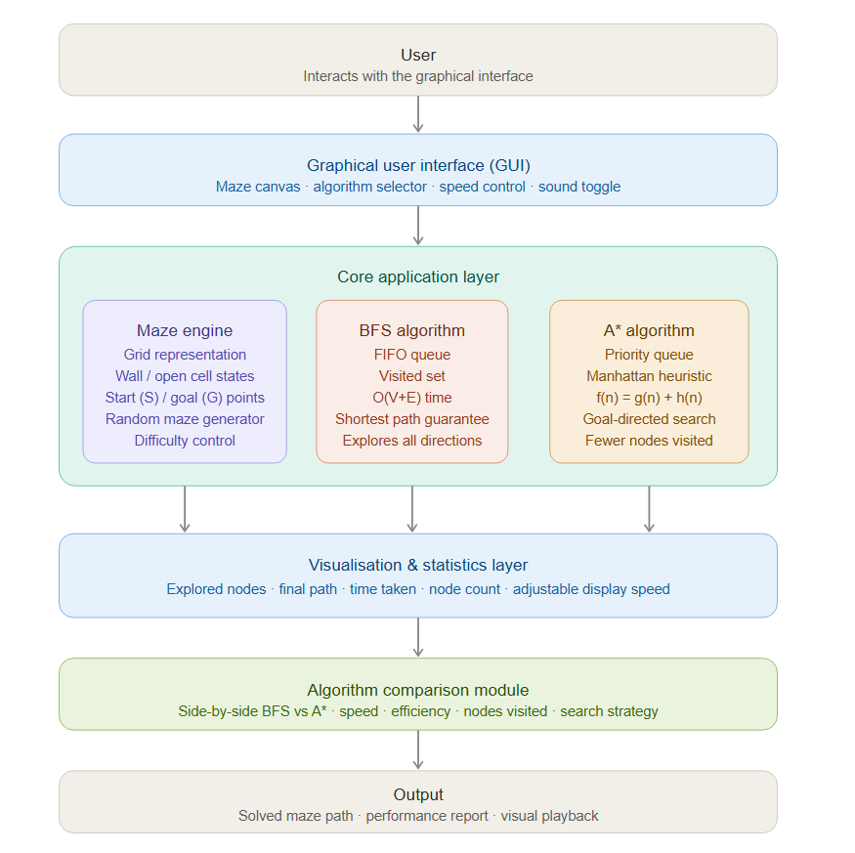
Figure 2:System Architecture of the Maze Solver

7. Visualization Process of BFS and A* Algorithms
This figure demonstrates how the maze is processed and solved using BFS and A* algorithms. The grid represents the maze structure, including walls, open paths, the starting point (S), and the goal point (G).
The BFS algorithm explores the maze in all directions, resulting in visiting a large number of nodes. In contrast, the A* algorithm uses a heuristic function to guide the search toward the goal, reducing the number of explored nodes.
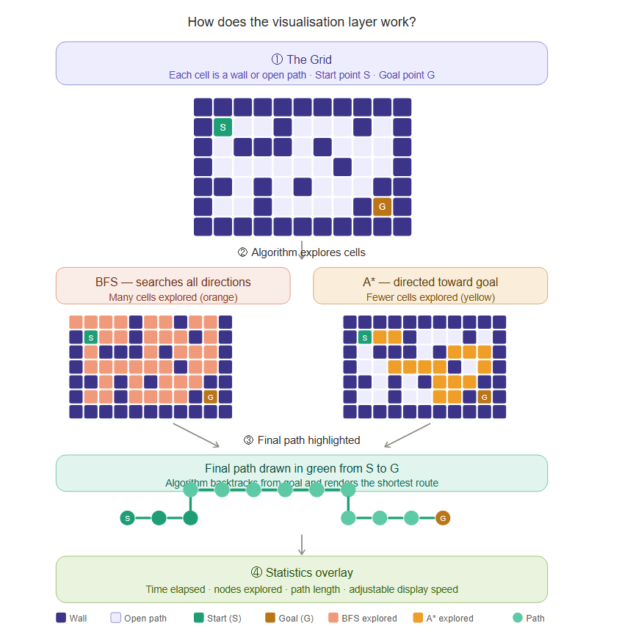
After the search process is completed, the shortest path from the start to the goal is highlighted. The system also displays statistics such as time taken, number of visited nodes, and path length.
Figure 3: Visualization of BFS and A* Search Process

8. ALGORITHMS USED

8.1 Breadth-first search (BFS) algorithm
A basic algorithm used to traverse or search structures such as graphs and trees, using a queue (FIFO) to manage nodes. It can be effectively applied to solve mazes.
The algorithm systematically explores the graph to ensure that all nodes at the present depth are visited before moving to the next depth level.
A queue and a visited set (or array) are used to prevent revisiting nodes and avoid infinite loops in graphs with cycles.

8.1.1 Optimality:
BFS guarantees finding the shortest path in an unweighted graph (where every edge has the same weight) because it explores nodes in increasing order of their distance (number of edges) from the source.

8.1.2 Time Complexity:
The time complexity is typically O(V + E), where V is the number of vertices (nodes) and E is the number of edges, as every vertex and edge is processed once.

8.1.3 Space Complexity:
The space complexity is O(V) due to the need for a queue and a visited set that can potentially store all vertices.

8.1.4 Disadvantage
Its disadvantage, especially in large mazes, is that it may visit a large number of nodes before reaching the destination.

8.2 ( A* ) algorithm (priority-based):
The A* algorithm is one of the most widely used search algorithms in artificial intelligence applications, including games and navigation systems.
This algorithm uses an estimation function to estimate the remaining distance to the target and combines it with the cost of the current path.
In this project, the distance between the current node and the target was estimated using the Manhattan distance.

8.2.1 Advantages of this algorithm:
- It is “complete” (finds a solution if one exists) and “optimal” (finds the best solution).
- Reduces the number of nodes that must be examined.
- Often faster than traditional search algorithms.
- Focuses the search process on the goal in a more intelligent way.

9. How the program works
The program represents the maze as a grid of squares, where each cell represents an impassable wall or an empty space that can be crossed.
The size of the cell can be controlled, as well as the location and number of obstacles within it, to select the level of difficulty.
This grid defines the starting point and the end point.
The program begins searching for possible paths to the destination when one of the algorithms is executed
Neighboring nodes are examined during the search process, and the algorithm's mechanism is used to determine the best path.
When the search is complete, statistics are displayed, including the time taken, with the possibility of also controlling the display time and the number of nodes visited, in addition to the final path connecting the starting point to the end point.

10. COMPARISON OF ALGORITHMS:
Since the breadth-first search (BFS) algorithm searches broadly without a specific goal, it explores a larger number of nodes when comparing the performance of the algorithms used.
On the other hand, the A* algorithm uses a heuristic function that helps direct the search toward the goal, reducing the number of nodes visited and often leading to a faster solution.
Ultimately, this project demonstrates the importance of search algorithms in solving pathfinding problems in artificial intelligence.
It also shows how algorithms based on heuristics differ from traditional search algorithms.
The visual representation of the process helps to understand and comprehend the mechanism of each algorithm and how it works in a simple and easy to use way.
Feature | BFS | A*
Search type | Broad search without goal direction | Heuristic-based search
Nodes visited | Large number of nodes | Fewer nodes
Speed | Slower | Faster
Efficiency | Lower | Higher
Strategy | Explores all direction | Directed toward goale

The comparison clearly shows that A* is more efficient due to its ability to guide the search toward the goal.

11. Results
The experimental results show that the A* algorithm generally performs more efficiently than BFS when solving the maze.
BFS explores a larger number of nodes because it searches the maze level by level without any knowledge of the goal direction.
In contrast, A* uses a heuristic function (Manhattan distance) to guide the search toward the goal, which reduces the number of explored nodes and often results in faster performance.

12. Conclusion
This project demonstrates how artificial intelligence search algorithms can be used to solve pathfinding problems such as maze navigation.
By implementing and comparing BFS and A* algorithms, we observed the differences in efficiency and search behavior.
The visual interface of the program helps illustrate how each algorithm explores the maze and finds a solution.
Overall, the project highlights the importance of heuristic based search methods like A* in improving performance in complex environments.

13. How to run the program
Before running the program, make sure that all project files are saved correctly.
1. Open the project folder using Visual Studio Code.
2. Open the terminal inside VS Code (Terminal → New Terminal).
3. Navigate to the project folder by typing:
cd "C:\Users\h6881\OneDrive\Desktop\maze_ai_project"
4. Run the program using:
python maze_gui.py
5. The graphical interface will appear, and you can start using the program.
Make sure Python is installed on your system before running the program.

