Ubuntu Example Content
Ubuntu is a Linux-based operating system of Free and Open Source software. In addition to the core operating system, the Ubuntu software distribution also contains a wide range of user-oriented applications such as an office suite, image display and manipulation programs and multimedia tools for playing music and video. To illustrate these features and to help you explore your new system we have bundled a few documents and media files. Simply click on a file's icon or thumbnail to open it for viewing or editing in its default application.

Productivity

The productivity suite OpenOffice.org 3.0 contains word processor, spreadsheet, presentation, drawing and database applications and is installed on Ubuntu by default. To help you get started exploring the suite we have included some files in the Open Document Format, used by OpenOffice.org (and several other office suites).
OpenOffice.org also has the ability to read and write documents in other formats such as those used by MS Word and Excel.

Graphics
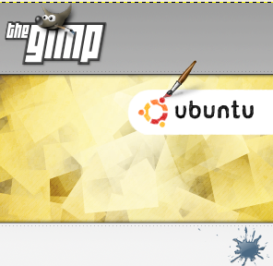
The default Ubuntu installation includes the powerful image manipulation program Gimp. Click on gimp-ubuntu-splash.xcf to start Gimp with a small sample file. Open Dialogues ► Layers to see how the image is constructed from 16 separate layers.

Multimedia

Ubuntu 9.04 includes the latest gstreamer infrastructure, providing smooth video and audio playback in applications like Totem and Rhythmbox.
Music & Video & Art: The Ubuntu_Free_Culture_Showcase directory contains the short ogg/Vorbis file Invocation.ogg featuring a track by MoShang. The Ogg Video SpiritOfUbuntu.ogv was contributed by Robbie Ferguson. The picture CanadianClouds.jpg was contributed by m0deth. All three files were released under a Creative Commons license.
Speech: The LibriVox project prepares recordings of books and poetry for public domain release, from short items such as the fable included here to a range of full-length books. Please visit the LibriVox website to download other works.

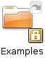
Managing example content files
The arrow emblem in the top right corner signifies that this folder is not actually a directory in itself, but simply a link to another directory somewhere on the system. In this case the link points to the location /usr/share/example-content. You can remove the desktop link if you wish to keep your desktop tidy without removing the actual content.

Creating a bookmark
There are several ways you can bookmark the location of these files so that it will be easier to find them in the future. You can either just move the desktop icon over to another convenient location such as your Home directory or you can create a bookmark in the Nautilus file browser.
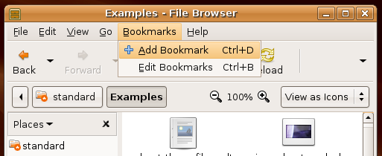

Making a copy in your home directory
If you wish to modify any of the files, you should first copy them to a location in your home directory, either individually or the whole example-content directory. You can then experiment with the files to familiarise yourself with the different applications. You will always have a clean copy available in the original location and any new user accounts that are created will also have a new link to the fresh content.

Logos and templates
We have included the 2 basic logos for Ubuntu and Kubuntu that you can use for designing materials and websites as well as templates for CD/DVD covers and presentation templates. Please see the trademark policy on the Ubuntu website.

http://www.jonobacon.org/2009/03/24/ubuntu-904-free-culture-showcase-winners/
http://creativecommons.org/licenses/by-sa/2.0/
http://www.librivox.org
http://www.ubuntu.com/ubuntu/TrademarkPolicy

