WEEK 2 TASK REPORT
Exploratory Data Analysis and Visualization

Titanic Exploratory Data Analysis

Submitted By: Hanee Patel
Internship Program: Virtual Data Science with Python Trainee
Submission Date: 07 September 2026

1. Introduction
Exploratory Data Analysis (EDA) is an important process used to understand a dataset before performing further analysis. It helps in identifying patterns, relationships, trends, and useful insights from the data.
In this project, I performed Exploratory Data Analysis and Visualization on the cleaned Titanic dataset. The dataset contains information about Titanic passengers, including their survival status, passenger class, gender, age, family information, ticket details, fare, and embarkation port.
The main objective of this task was to explore the dataset, perform statistical analysis, identify important patterns, and create meaningful visualizations. Python was used for the analysis along with Pandas, Matplotlib, and Seaborn libraries.
Different graphs were created to understand survival patterns, gender-based survival, passenger class relationships, age distribution, fare distribution, and correlations between numerical variables.
2. Dataset Overview
The dataset used in this project is the cleaned Titanic dataset obtained after completing the data cleaning and preprocessing process.
The original dataset contains information about Titanic passengers. Important columns in the dataset include PassengerId, Survived, Pclass, Name, Sex, Age, SibSp, Parch, Ticket, Fare, and Embarked.
The dataset was explored using Pandas functions such as head(), shape, info(), and describe(). These functions helped in understanding the structure of the dataset, the available columns, data types, and statistical information.
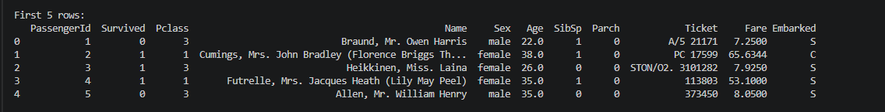
3. Statistical Analysis
Statistical analysis was performed to understand the numerical characteristics of the dataset. The describe() function was used to calculate values such as count, mean, standard deviation, minimum, maximum, and quartiles.
This analysis helped in understanding the distribution of numerical variables such as Age, Fare, SibSp, and Parch.
4. Survival Count Analysis
A visualization was created to analyze the number of passengers who survived and the number of passengers who did not survive.
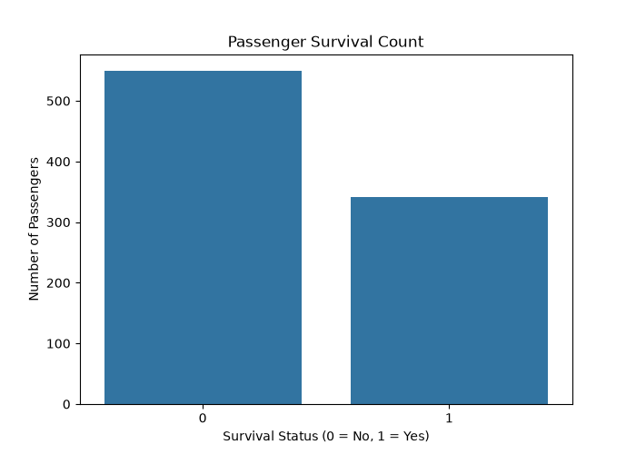
Interpretation
The visualization shows the overall distribution of passenger survival. The number of passengers who did not survive was higher than the number of passengers who survived. This graph provides a basic understanding of the survival distribution in the Titanic dataset and helps identify the overall outcome of the disaster.
5. Gender and Survival Analysis
A visualization was created to analyze the relationship between passenger gender and survival.

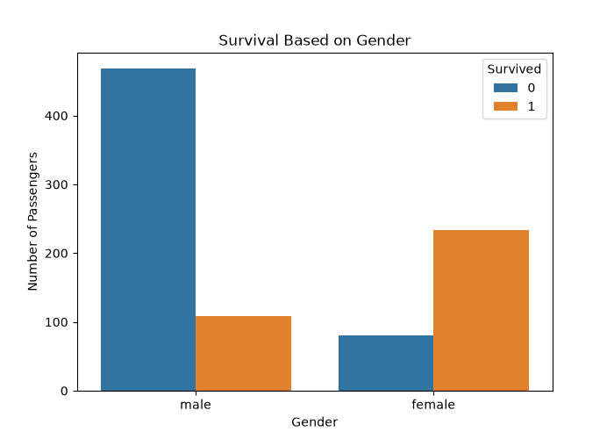
Interpretation
The visualization shows a clear difference in survival patterns between male and female passengers. Female passengers had a higher survival rate compared to male passengers. This indicates that gender was an important factor associated with survival in the Titanic dataset.
6. Passenger Class and Survival Analysis
A visualization was created to compare passenger class with survival status.

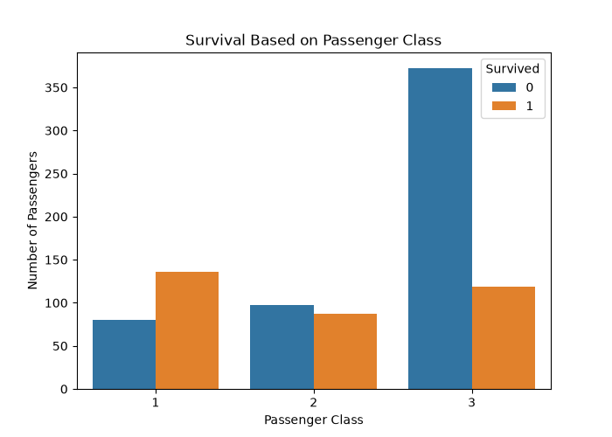
Interpretation
The analysis shows that survival patterns were different across passenger classes. Passenger class appears to have influenced the chances of survival. Passengers travelling in different classes had different survival outcomes, showing that Pclass is an important variable for understanding the dataset.
7. Age Distribution Analysis
A histogram was created to understand the distribution of passenger ages.
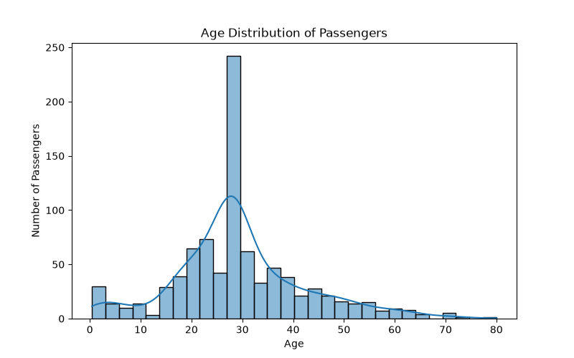
Interpretation
The age distribution graph shows that passengers belonged to different age groups. The majority of passengers were concentrated within younger and middle-age groups. The visualization helps in understanding how age values are distributed throughout the dataset.
8. Fare Distribution Analysis
A visualization was created to analyze the distribution of passenger fares.
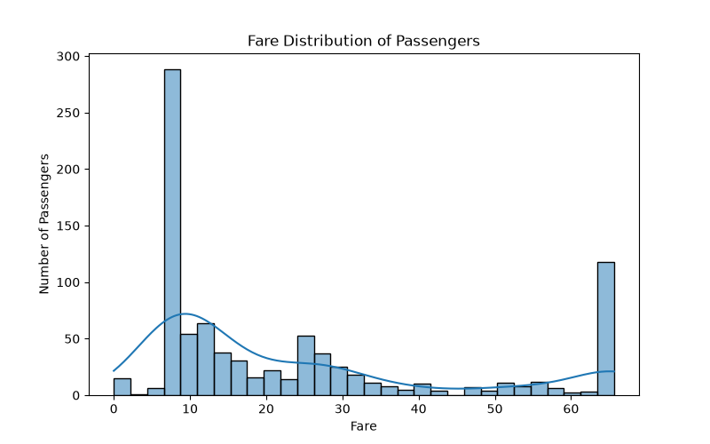
Interpretation
The fare distribution shows variation in ticket prices among passengers. Most passengers paid relatively lower fares, while a smaller number of passengers paid higher fares. This indicates that the Fare column has an uneven distribution and contains considerable variation in ticket prices.
9. Correlation Analysis
A correlation heatmap was created to understand the relationships between numerical variables in the dataset.
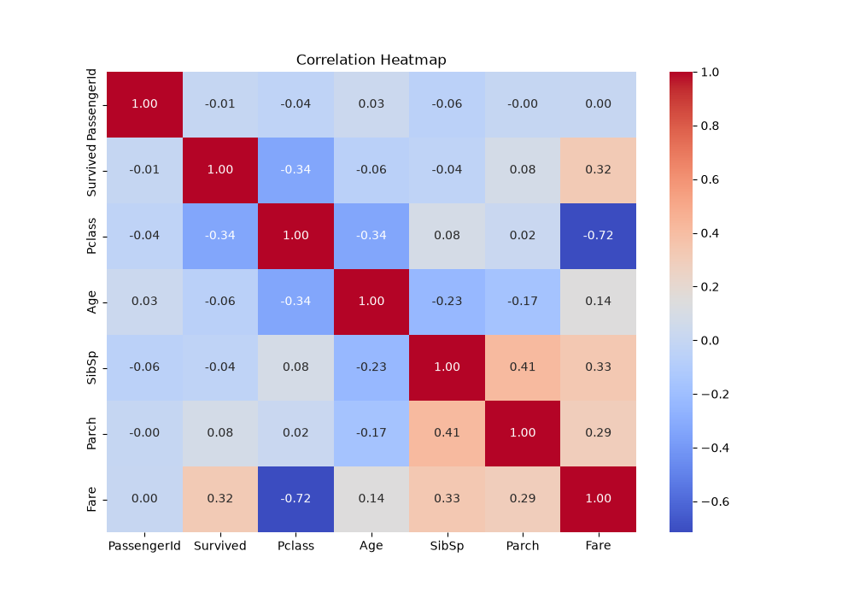
Interpretation
The correlation heatmap provides a visual representation of relationships between numerical variables. Positive and negative relationships can be observed between different variables. This analysis helps identify which numerical features may have relationships with each other and provides useful insights for future analysis.
10. Key Findings
The Exploratory Data Analysis provided several useful insights from the Titanic dataset.
- The number of passengers who did not survive was higher than the number of passengers who survived.
- Gender showed an important relationship with survival.
- Female passengers had a higher survival rate compared to male passengers.
- Passenger class showed differences in survival patterns.
- The Age column showed the distribution of passengers across different age groups.
- Fare values varied significantly among passengers.
- The correlation heatmap helped identify relationships between numerical variables.
11. Data Analysis Process
The cleaned Titanic dataset from Week 1 was used for this analysis. The following steps were performed:
- Loaded the cleaned Titanic dataset.
- Examined the first few rows of the dataset.
- Checked the dataset shape and structure.
- Used statistical functions to understand numerical data.
- Analyzed passenger survival distribution.
- Compared survival based on gender.
- Compared survival based on passenger class.
- Analyzed the distribution of Age.
- Analyzed the distribution of Fare.
- Created a correlation heatmap for numerical variables.
- Interpreted the findings from each visualization.
Matplotlib and Seaborn were used to create visualizations with appropriate titles and labels.
12. Technologies and Libraries Used
- Python
- Pandas
- Matplotlib
- Seaborn
- Visual Studio Code
13. Conclusion
In this project, Exploratory Data Analysis and Visualization were performed on the cleaned Titanic dataset using Python.
The analysis helped in understanding the dataset and identifying important patterns related to passenger survival. Different visualizations were created to explore relationships between survival, gender, passenger class, age, and fare.
The analysis showed that gender and passenger class were important variables associated with survival patterns. Age and fare distributions also provided useful information about the characteristics of Titanic passengers.
The correlation analysis helped in understanding relationships between numerical variables. Overall, this project improved my understanding of Exploratory Data Analysis, statistical analysis, data visualization, and interpretation of results using Python.

