WEEK 3 TASK REPORT
Unsupervised Learning and Clustering Analysis
Titanic Passenger Segmentation using K-Means Clustering

Submitted By: Hanee Patel
Internship Program: Virtual Data Science with Python Trainee
Submission Date: 09 September 2026

1. Introduction
This report presents an unsupervised learning and clustering analysis performed on the cleaned Titanic dataset. The goal is to discover meaningful passenger groups based on their characteristics without using the survival outcome as a prediction target.

2. Objective
The objective is to preprocess the available Titanic data, apply a clustering algorithm, determine a suitable number of clusters, visualize the groups, and interpret the characteristics of each cluster.

3. Dataset and Features
The cleaned Titanic dataset from Week 2 is reused. The clustering features include Pclass, Age, SibSp, Parch, Fare, and Sex when available. The Survived column is excluded because it represents an outcome and should not be used to create the unsupervised groups.

4. Data Preprocessing
Numeric columns are converted to numeric form and missing numeric values are replaced using median values. The Sex column is encoded numerically. StandardScaler is then applied so that variables with larger numerical ranges do not dominate the clustering process.

5. Clustering Methodology
K-Means clustering is used because it is a simple and effective method for grouping observations according to feature similarity. Several values of K are tested. The Elbow Method is used to examine inertia, and Silhouette Score is used to measure the quality of cluster separation. The best tested K according to the silhouette score is selected automatically.

6. Visualizations
The following five visualizations are generated by the Python program. After running the code, paste the corresponding output screenshot below each heading.

6.1 Elbow Method
Shows the change in K-Means inertia for different values of K.
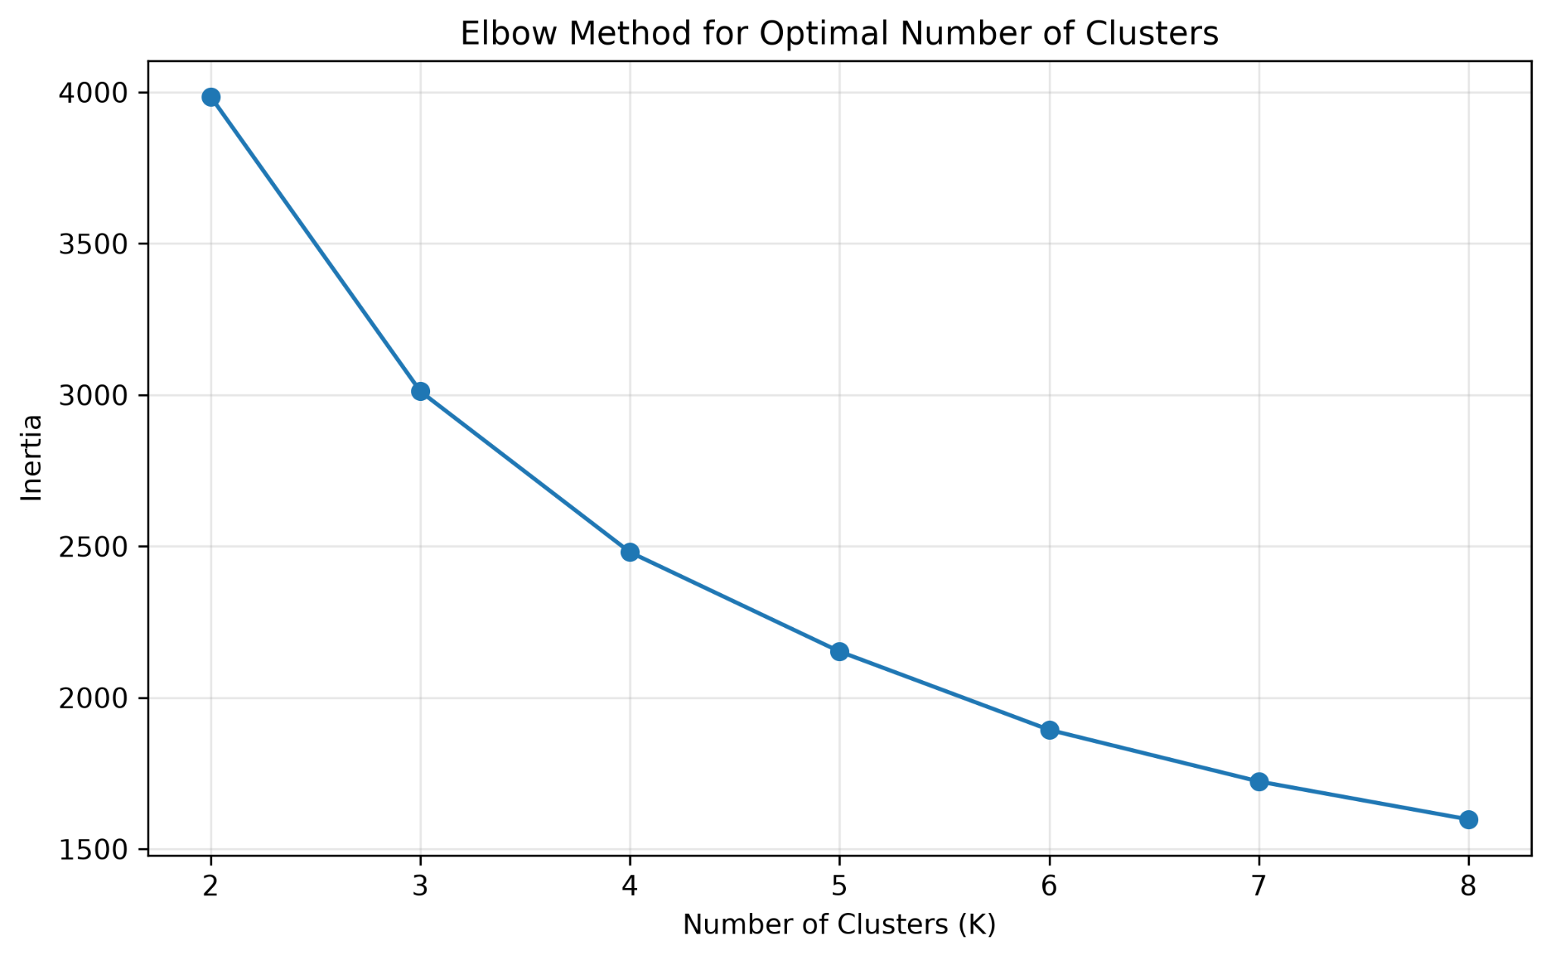

6.2 Silhouette Score
Compares silhouette scores for the tested cluster counts.
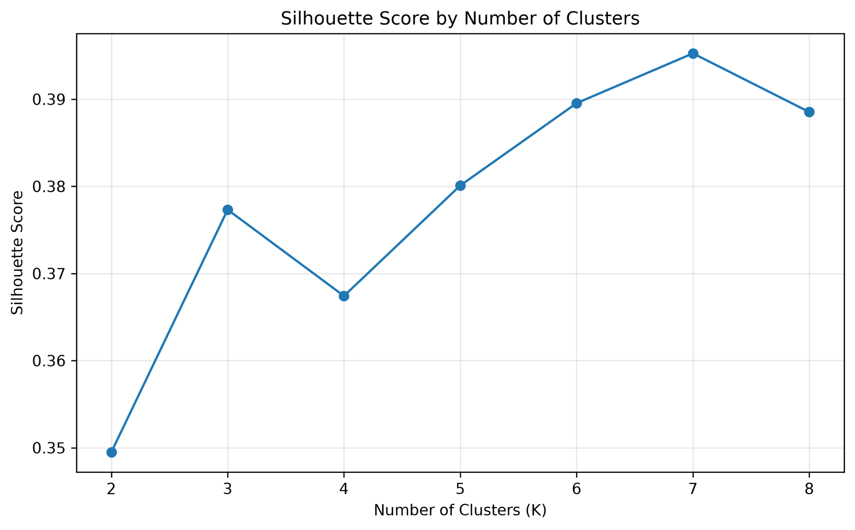

6.3 Cluster Visualization
Shows the clusters in two dimensions after PCA transformation.
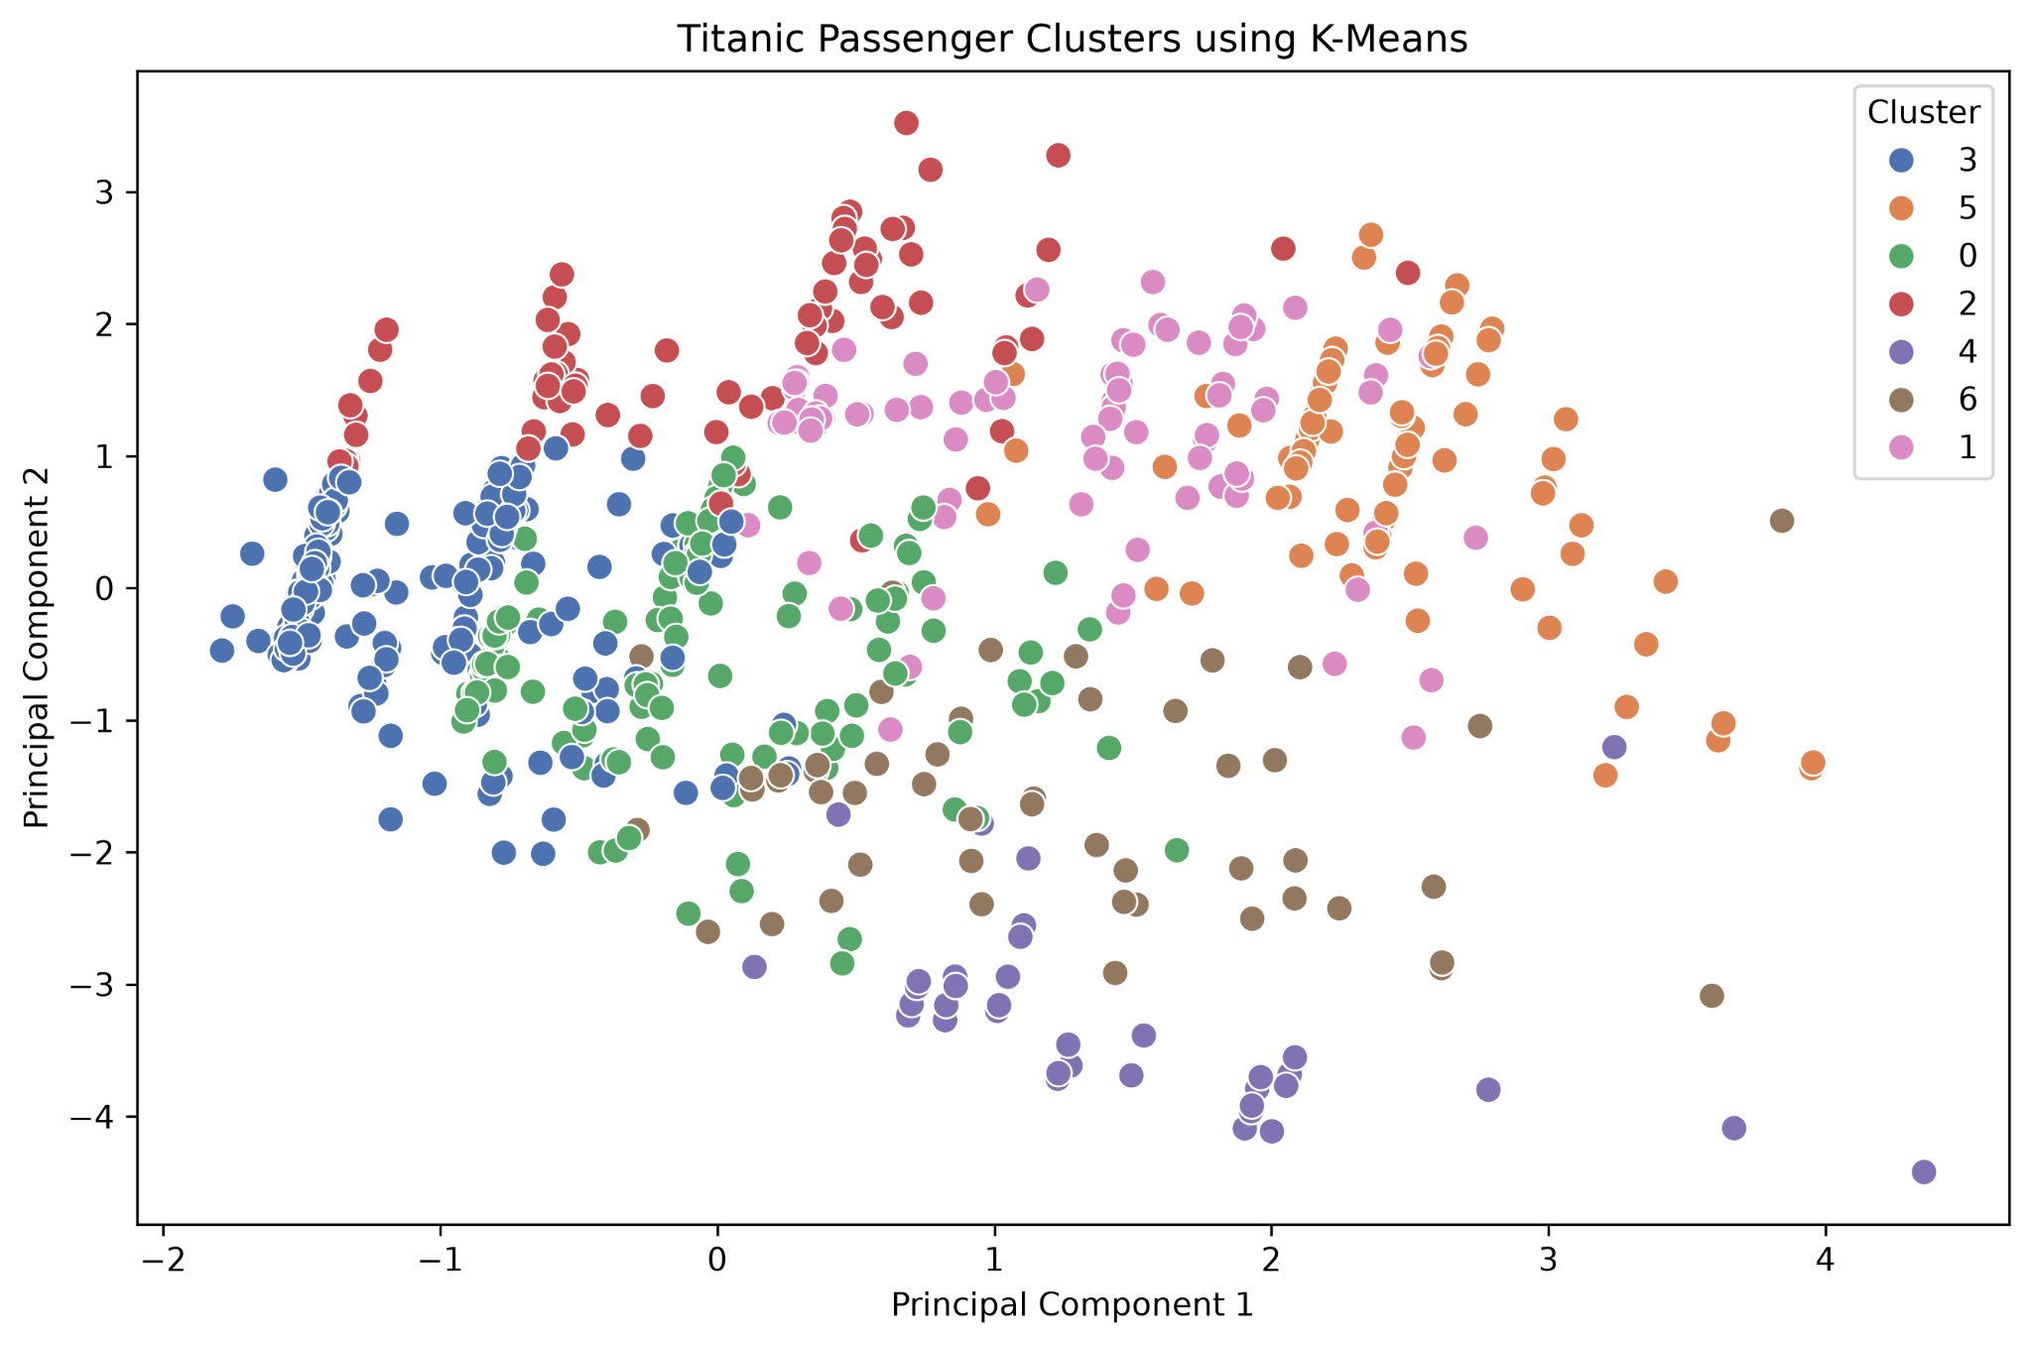

6.4 Cluster Profile Heatmap
Compares average feature values across clusters.
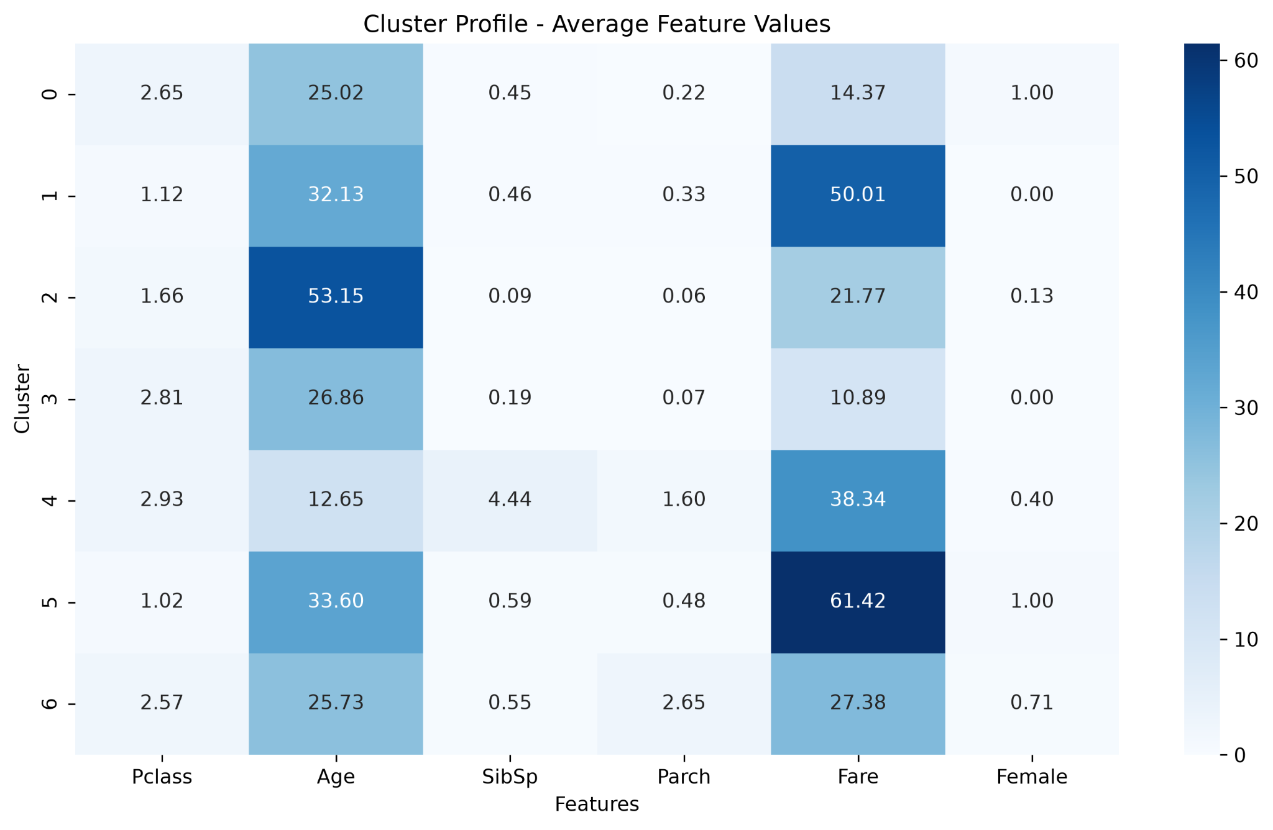

6.5 Cluster Sizes
Shows the number of passengers assigned to each cluster.
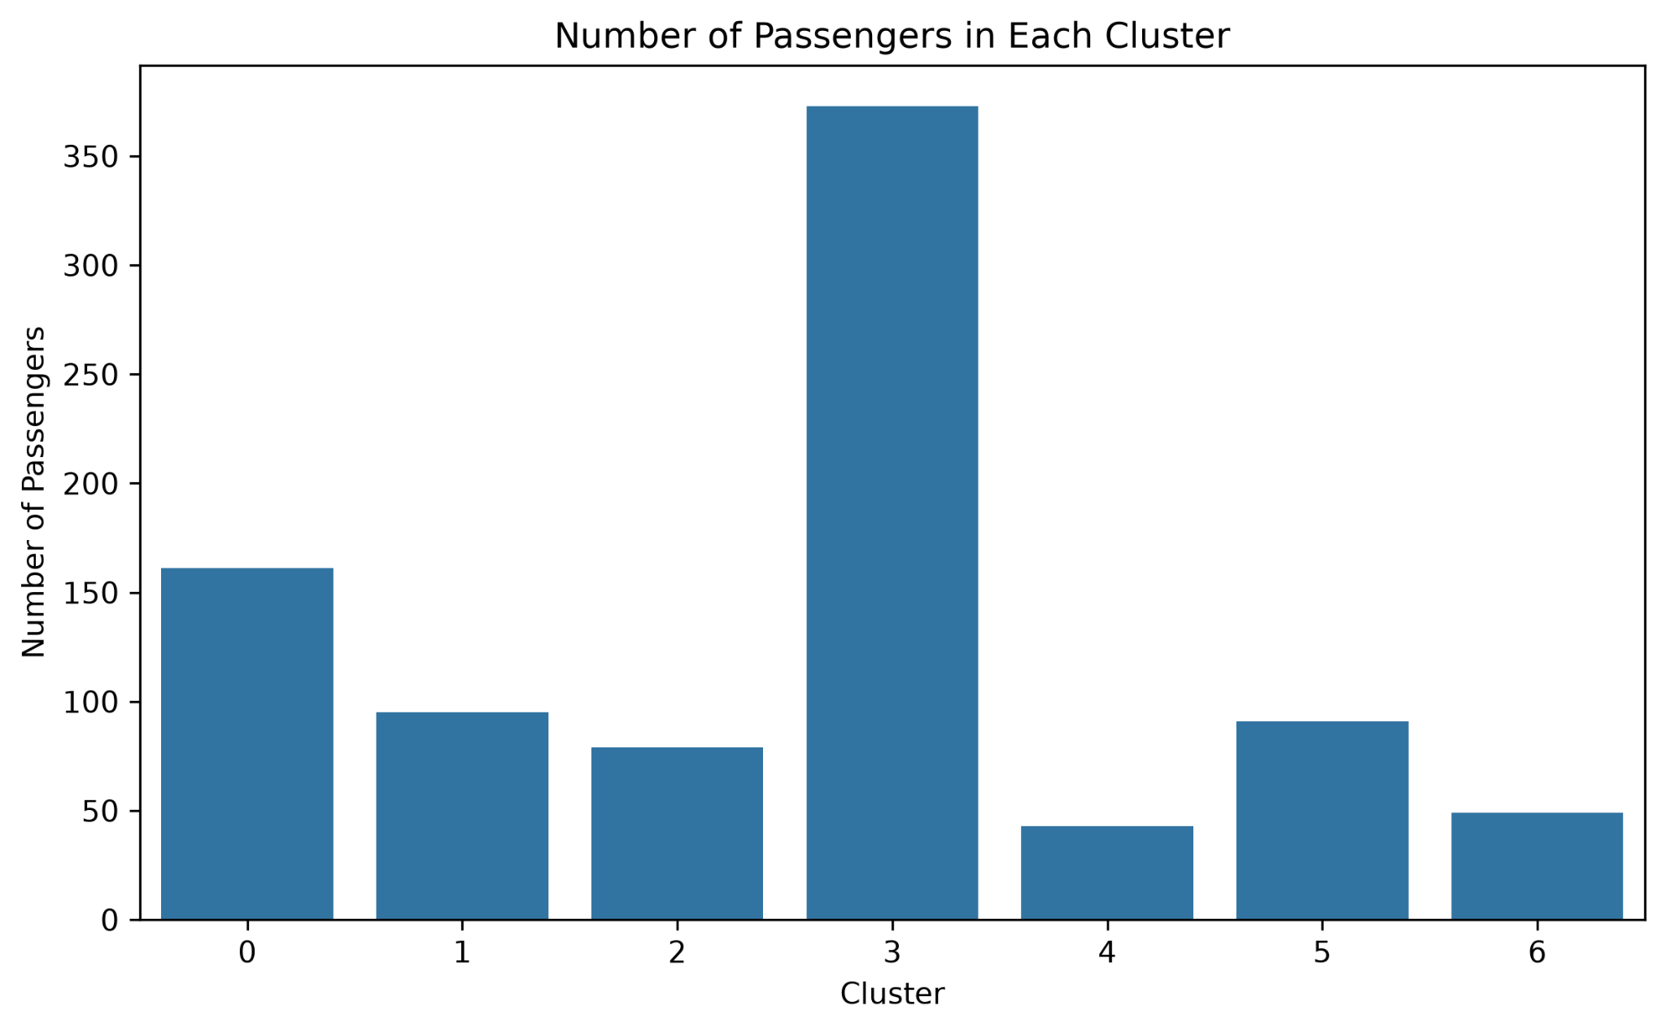

7. Cluster Analysis and Interpretation
The clusters should be interpreted by comparing their average feature values in the cluster profile heatmap. Differences in passenger class, age, fare, family-related variables, and gender can indicate distinct passenger segments. The cluster-size graph also shows whether the groups are relatively balanced or whether some passenger segments are much larger than others. These patterns can be useful for understanding passenger composition and segmentation.

8. Results and Findings
The final results are stored in the output folder. The clustered Titanic dataset contains the assigned cluster for every passenger. The silhouette score and cluster profile provide quantitative support for interpreting the segmentation. The PCA visualization provides a visual representation of the separation between groups.

9. Business / Research Implications
Clustering can be used to identify groups of customers, passengers, or records with similar characteristics. In a business context, such segments can support targeted services and customer profiling. In research, the same approach can reveal hidden structures in datasets when no predefined labels are available.

10. Conclusion
This project demonstrates the complete workflow of an unsupervised learning task: feature selection, preprocessing, scaling, cluster-count selection, K-Means clustering, dimensionality reduction, visualization, and cluster interpretation. The analysis shows how machine learning can discover meaningful patterns without a predefined target variable.

