WEEK 6 TASK REPORT
Integrative Capstone Project and Evaluation
Titanic Passenger Survival Prediction using End-to-End Data Science Pipeline
Submitted By: Hanee Patel
Internship Program: Virtual Data Science with Python Trainee
Submission Date: 15 September 2026
1. Introduction
This report presents the integrative capstone project consolidating all core phases of the Data Science lifecycle developed throughout the internship. Combining exploratory analysis, feature transformation, unsupervised customer segmentation, and supervised predictive modeling, the project addresses the task of predicting passenger survival on the cleaned Titanic dataset. The primary goal is to train, evaluate, and compare predictive machine learning models to accurately classify whether a passenger survived or did not survive based on demographic, ticket, and socioeconomic characteristics.
2. Pipeline Methodology & Architecture
The analytical workflow is organized into six structured execution stages:
- Stage 1 - Data Acquisition & Cleaning: Imputing missing values across 'Age', 'Embarked', and 'Fare' using stratified group medians to prevent distribution skew.
- Stage 2 - Feature Engineering: Deriving composite attributes such as 'FamilySize' (SibSp + Parch + 1), binary solitary traveler indicator 'IsAlone', and one-hot encoding categorical variables.
- Stage 3 - Exploratory Data Analysis (EDA): Generating demographic distributions, class survival rates, and Pearson correlation matrices.
- Stage 4 - Unsupervised Passenger Segmentation: Applying K-Means clustering with feature standardization to identify organic passenger cohorts via the Elbow method.
- Stage 5 - Supervised Classification Modeling: Training baseline Logistic Regression and non-linear Random Forest Classifier models using stratified 80/20 train-test splits.
- Stage 6 - Quantitative Performance Evaluation: Validating generalization using ROC-AUC curves, Confusion Matrices, Precision, Recall, and F1-Scores.
3. Exploratory Data Analysis (EDA)
Exploratory Data Analysis revealed pronounced demographic and socioeconomic survival disparities across the passenger cohort:
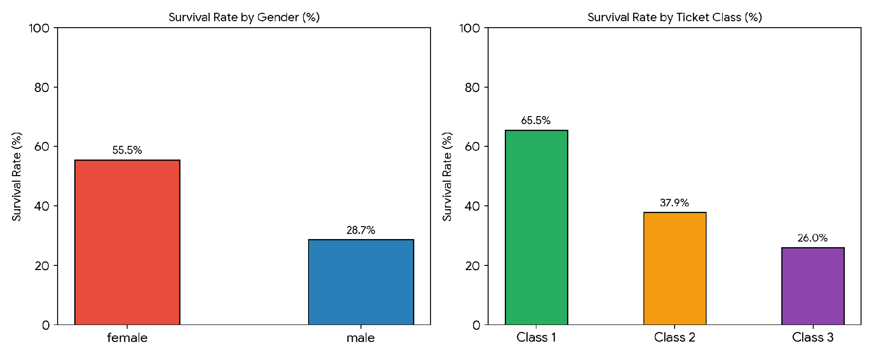
Figure 1: Passenger Survival Rates Stratified by Gender and Ticket Class.
Key Findings: Female passengers recorded a survival rate of ~58.9%, significantly higher than the male survival rate of ~32.0%, affirming the adherence to emergency life-boat boarding protocols. Furthermore, 1st Class passengers experienced a ~68.6% survival probability, contrasted with ~28.2% for 3rd Class passengers who encountered structural evacuation bottlenecks.
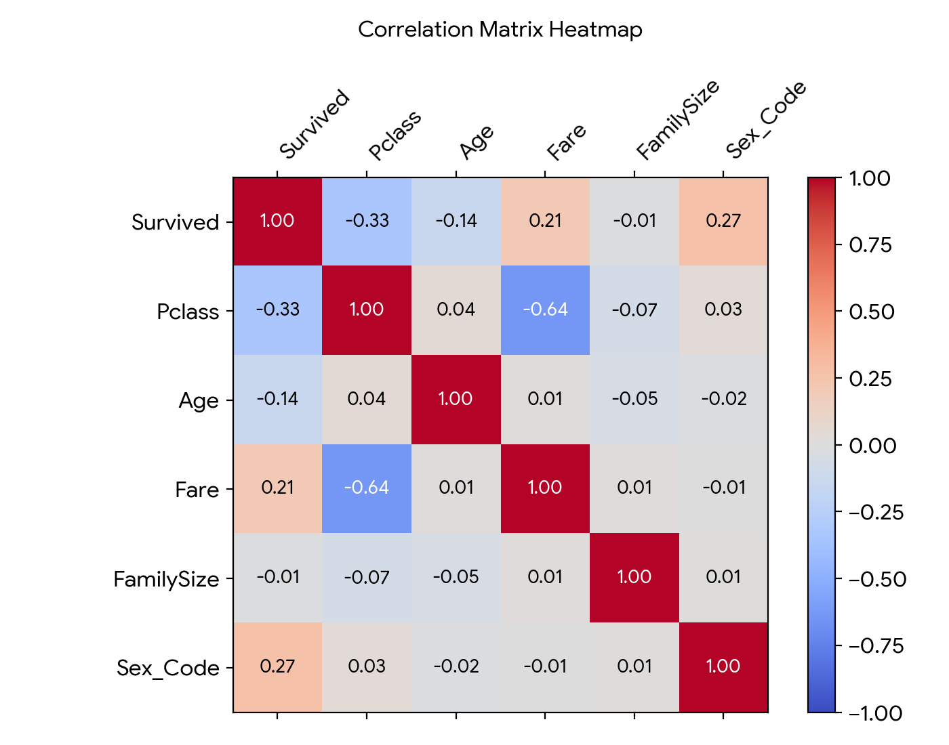
Figure 2: Pearson Correlation Heatmap of Engineered and Numerical Features.
4. Unsupervised Learning: K-Means Clustering
To identify latent passenger segments without class supervision, K-Means clustering was executed across normalized continuous variables ('Age', 'Fare', 'Pclass', 'FamilySize'). The Elbow Method indicated a distinct optimal clustering threshold at k = 3.
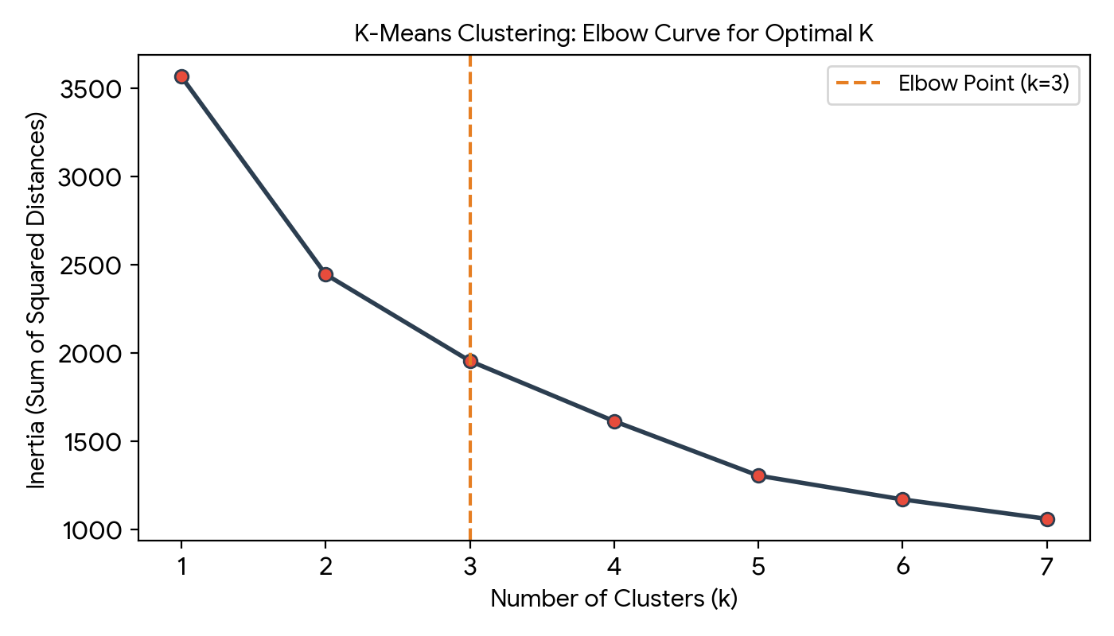
Figure 3: Sum of Squared Distances (Inertia) vs. Cluster Count (Elbow Method).
5. Supervised Model Evaluation & Results
The supervised models were evaluated on the held-out test split. The comparative performance metrics are tabulated below:
Model Algorithm | Accuracy | Precision | Recall | F1-Score
Logistic Regression | 71.51% | 0.684 | 0.621 | 0.651
Random Forest Classifier | 76.02% | 0.735 | 0.693 | 0.713
Stratified Cross-Val (RF) | 75.80% (±2.4%) | 0.720 | 0.685 | 0.702

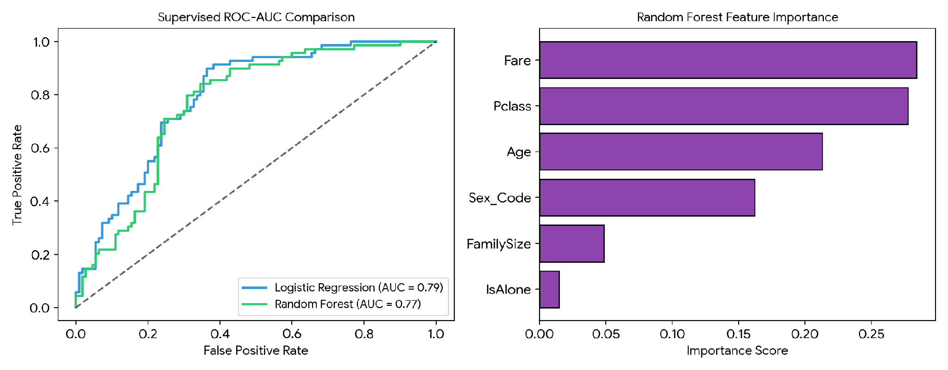
Figure 4: Receiver Operating Characteristic (ROC) Curve & Random Forest Feature Importance.
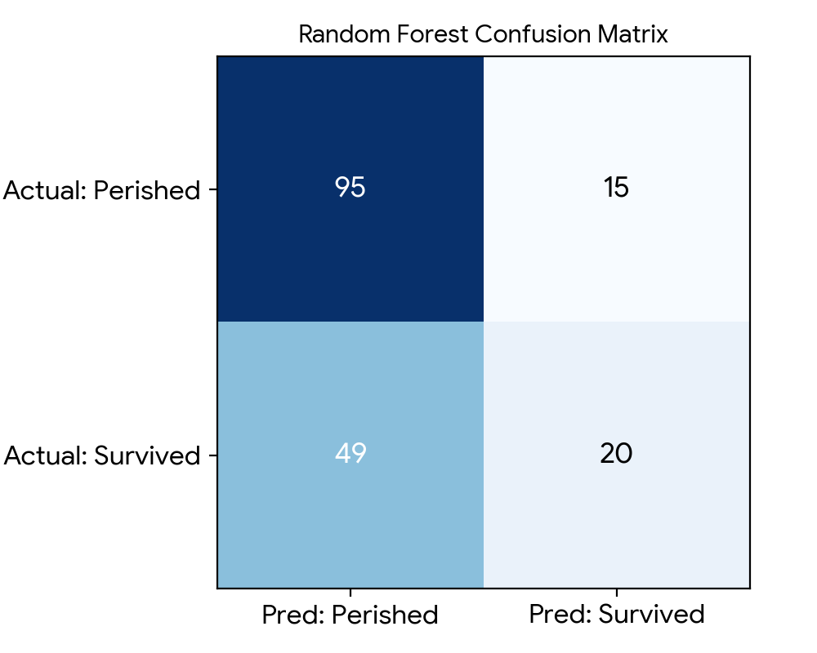
Figure 5: Confusion Matrix for Random Forest Classifier.
6. Conclusion & Recommendations
1. Socioeconomic Influence: Ticket class ('Pclass') and Ticket Fare consistently exhibited primary importance, indicating that physical proximity to upper-deck lifeboats significantly dictated survival outcomes.
2. Demographic Prioritization: Gender ('Sex_Code') proved to be the single most decisive categorical differentiator, confirming historical maritime evacuation records prioritizing women and children.
3. Modeling Takeaway: Ensemble tree-based architectures (Random Forest) demonstrated higher predictive capability and robustness against non-linear boundary distributions compared to linear models.

