WEEK 1 TASK REPORT
Data Acquisition, Cleaning and Preprocessing

Titanic Data Cleaning and Preprocessing
Submitted By: Hanee Patel
Internship Program: Virtual Data Science with Python Trainee
Submission Date: 05 September 2026

1. Introduction
Data cleaning and preprocessing are important steps before starting data analysis. Raw data can contain missing values, duplicate records, inconsistent information, and extreme values. If these problems are not handled properly, they can affect the results of data analysis.
In this project, I worked with the Titanic dataset and performed data acquisition, cleaning, and preprocessing using Python. The dataset contains information about passengers such as passenger class, gender, age, family information, ticket details, fare, cabin, embarkation port, and survival status.
The main purpose of this task was to understand the dataset and improve its quality. I checked the dataset structure, identified missing values, checked duplicate records, cleaned text columns, checked invalid values, and identified outliers.
For this project, I used Python along with Pandas, NumPy, Matplotlib, and Seaborn libraries.
2. Dataset Overview
The dataset used in this project is the Titanic dataset. It contains information about passengers who travelled on the Titanic.
The original dataset contains 891 rows and 12 columns. The columns include PassengerId, Survived, Pclass, Name, Sex, Age, SibSp, Parch, Ticket, Fare, Cabin, and Embarked.
The dataset was loaded into Python using Pandas. Before starting the cleaning process, I explored the dataset using head(), shape, info(), and describe().
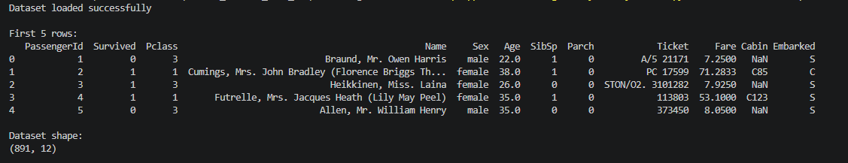
3. Missing Value Analysis
The dataset was checked for missing values using the isnull().sum() function.
Missing values were found in the Age, Cabin, and Embarked columns. Missing values in Age were filled using the median, while missing values in Embarked were filled using the mode.
The Cabin column contained a large number of missing values. Because most of its values were missing, the Cabin column was removed from the dataset.
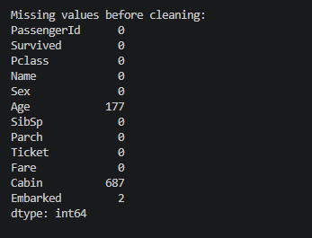
4. Missing Values Visualization
A bar graph was created to visualize the missing values in the dataset.
The graph showed that the Cabin column had the highest number of missing values. The Age column also contained missing values, while Embarked had only a small number of missing values.
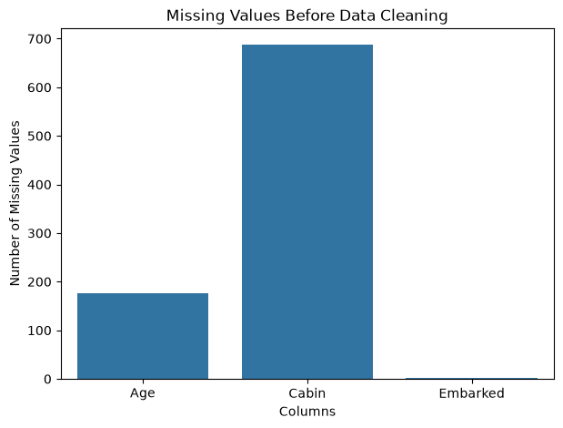
5. Duplicate Records
The dataset was checked for duplicate rows using the duplicated() function.
Checking duplicate records is important because repeated rows can affect data analysis. The drop_duplicates() function was used as part of the preprocessing process.
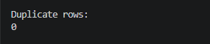
6. Data Cleaning and Preprocessing
Different preprocessing steps were performed to improve the quality of the dataset.
Missing Age values were filled using the median, and missing Embarked values were filled using the mode. The Cabin column was removed because it contained a large amount of missing data.
Extra spaces were removed from the Name column. The Sex column was converted to lowercase, and the Embarked column was converted to uppercase. These steps helped make the dataset cleaner and more consistent.
7. Invalid Values and Outlier Detection
The Age and Fare columns were checked for invalid values. Negative values were checked because Age and Fare should not normally contain negative values.
Outliers were checked in the Fare column using a boxplot. The Interquartile Range (IQR) method was used to calculate the lower and upper limits.
Extreme Fare values were capped using the calculated limits instead of removing complete passenger records. This reduced the effect of extreme values while keeping the dataset size unchanged.
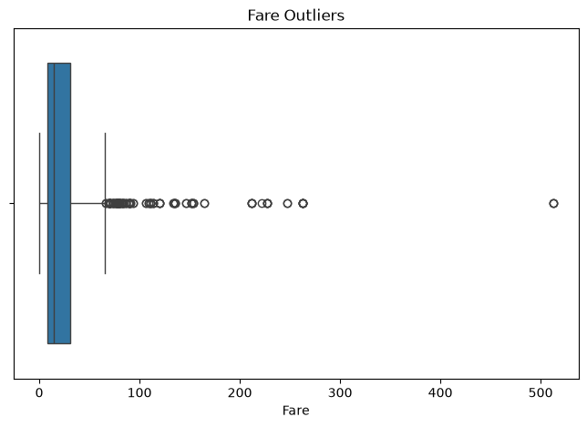
8. Final Dataset
After completing the cleaning and preprocessing steps, the dataset was checked again.
The missing values were handled successfully, text columns were cleaned, and outliers in the Fare column were handled using the IQR method.
The cleaned dataset was saved as cleaned_titanic.csv. The final dataset is cleaner and ready for further analysis and visualization.
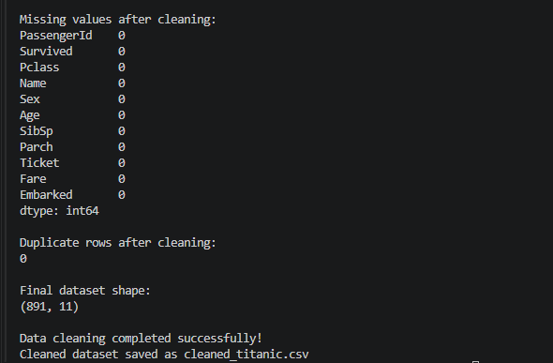
9. Challenges Faced
One of the main challenges was handling missing values. The Cabin column contained a very large number of missing values, so it was removed.
Another challenge was handling missing Age values. The median was selected because it is suitable for numerical data and less affected by extreme values.
High Fare values may represent real expensive tickets, so the records were not removed completely. The IQR method was used to cap extreme values.
10. Conclusion
In this project, I successfully performed data acquisition, cleaning, and preprocessing on the Titanic dataset using Python.
The dataset was explored to understand its structure and identify data quality issues. Missing values were handled using suitable methods, duplicate records were checked, text data was cleaned, and outliers were identified using a boxplot and the IQR method.
Finally, the cleaned dataset was saved as cleaned_titanic.csv. This project helped me understand the importance of data cleaning and preprocessing before further analysis.
11. Tools and Libraries Used
• Python
• Visual Studio Code
• Pandas
• NumPy
• Matplotlib
• Seaborn
• Microsoft Word
• GitHub
12. Project Files
1. train.csv – Original Titanic dataset.
2. titanic_preprocessing.py – Python code used for data cleaning and preprocessing.
3. cleaned_titanic.csv – Cleaned dataset created after preprocessing.
4. README.md – Project information and documentation.
5. requirements.txt – Required Python libraries.

