PetroMall Project
Database Design Document — Version 2.0 (Aligned with PRD)

1. Executive Summary
This document defines the enterprise-standard logical database schema design for the PetroMall Project. The architecture is designed to support dealer onboarding, comprehensive station management, brand requirement filtering, automated matching logic, granular admin review workflows, and full data auditability.

2. Domain & Boundary Models
- Auth Domain: users, dealer_profiles
- Dealer Domain: stations, station_spaces, station_files, dealer_brand_preferences
- Brand Domain: brands, brand_requirements, brand_categories
- Matching Domain: matches, match_history
- Administration Domain: upload_logs, audit_logs

3. Detailed Data Dictionary & Schema Fields
Table: Dealers
Field Name | Data Type | Index Key / Constraints | Description / Constraints Mapping
id | SERIAL | PK | Primary key identifier
full_name | VARCHAR(120) | None | User display or corporate name
email | VARCHAR(255) | UNIQUE | Account email address
phone | VARCHAR(20) | None | System security access role (Dealer/Admin/Brand)
Table: stations
Field Name | Data Type | Index Key / Constraints | Description / Constraints Mapping
id | SERIAL | PK | Primary key identifier
dealer_id | INT | FK / Index | References users.id
name | VARCHAR(200) | None | Physical gas station station name
address | VARCHAR(500) | None
city | VARCHAR(100) | None | City location tag
state | VARCHAR(100) | None
pincode | VARCHAR(20) | None
latitude | DECIMAL(9,6) | Composite Index | Geo-coordinates latitude value
longitude | DECIMAL(9,6) | Composite Index | Geo-coordinates longitude value
Contact number | VARCHAR(20)
description | TEXT | None
status | VARCHAR(50) | Index | Current station validation state (Green/Pending/etc.)
Table: spaces
Field Name | Data Type | Index Key / Constraints | Description / Constraints Mapping
id | SERIAL | PK | Primary key identifier
station_id | INT | FK | References stations.id
name | VARCHAR[200] | none
Space_type | VARCHAR[500 | none
area_sqft | DOUBLE PRECISION | None | Total usable square feet area
power_kw | DOUBLE PRECISION | None | Available electrical power infrastructure capacity
Rent | Double precision | None
Availability_status | VARCHAR[30] | None
water_available | BOOLEAN | None | Flag denoting fluid line plumbing setup
drainage_avail | BOOLEAN | None | Flag denoting functional dynamic utility runoff outflow
Table: station_images
Field Name | Data Type | Index Key / Constraints | Description / Constraints Mapping
id | SERIAL | PK | Primary key identifier
station_id | INT | FK | References stations.id
file_name | VARCHAR[255] | None
file_type | VARCHAR(100) | None | Document classification metadata tag
file_path | VARCHAR(500) | None | Absolute pointer to remote private AWS S3 object store bucket
File_size | INT | None
Mime_pipe | VARCHAR[100] | none
Table: station_utilities
Field Name | Data Type | Index Key / Constraints | Description / Constraints Mapping
id | INT | PK | Primary key identifier
Station_id | INT | FK | References users.id
electricity | BOOLEAN | NONE
Water | BOOLEAN | None
iNTERNET | BOOLEAN | None
PARKING | BOOLEAN | None
WASHROOM | BOOLEAN | Index
CCTV | BOOLEAN

Table: brand_categories
Field Name | Data Type | Index Key / Constraints | Description / Constraints Mapping
id | SERIAL | PK | Primary key identifier
name | VARCHAR(255) | UNIQUE | Unified category designation label
Table: preferred_brand
Field Name | Data Type | Index Key / Constraints | Description / Constraints Mapping
station_id | INT | FK / Unique Composite | References stations.id (Part of unique tracking layout)
category_id | INT | FK / Unique Composite | References brand_categories.id
Brand_name | VARCHAR[200] | None
Brand_category | VARCHAR[100] | None

Table: brand_requirements
Field Name | Data Type | Index Key / Constraints | Description / Constraints Mapping
id | SERIAL | PK | Primary key identifier
brand_user_id | INT | FK | References users.id
category_id | INT | FK / Index | References brand_categories.id
radius_km | NUMERIC(10,2) | None | Maximum radial service boundary coverage calculation distance
min_area_sqft | NUMERIC(12,2) | None | Minimum asset boundary dimension requirements filter threshold
max_area_sqft | NUMERIC(12,2) | None | Maximum asset boundary dimension requirements filter threshold
status | VARCHAR(50) | Index | Validation requirement pipeline status metadata
Table: matches
Field Name | Data Type | Index Key / Constraints | Description / Constraints Mapping
id | SERIAL | PK | Primary key identifier
space_id | INT | FK | References station_spaces.id
requirement_id | INT | FK | References brand_requirements.id
status | VARCHAR(50) | Index | System automated matching lifecycle state
reviewed_by | INT | FK | References users.id (Points to internal administrative operator accounts)

4. Tables Summary

Database Relationships Summary
Parent | Child | Relationship
User (Dealer) | Stations | 1 : Many
Station | Station Spaces | 1 : Many
Station | Station Files | 1 : Many
Station | Dealer Preferences | 1 : Many
Brand Category | Dealer Preferences | 1 : Many
Brand User | Brand Requirements | 1 : Many
Brand Category | Brand Requirements | 1 : Many
Station Space | Matches | 1 : Many
Brand Requirement | Matches | 1 : Many
Admin User | Matches Reviewed | 1 : Many

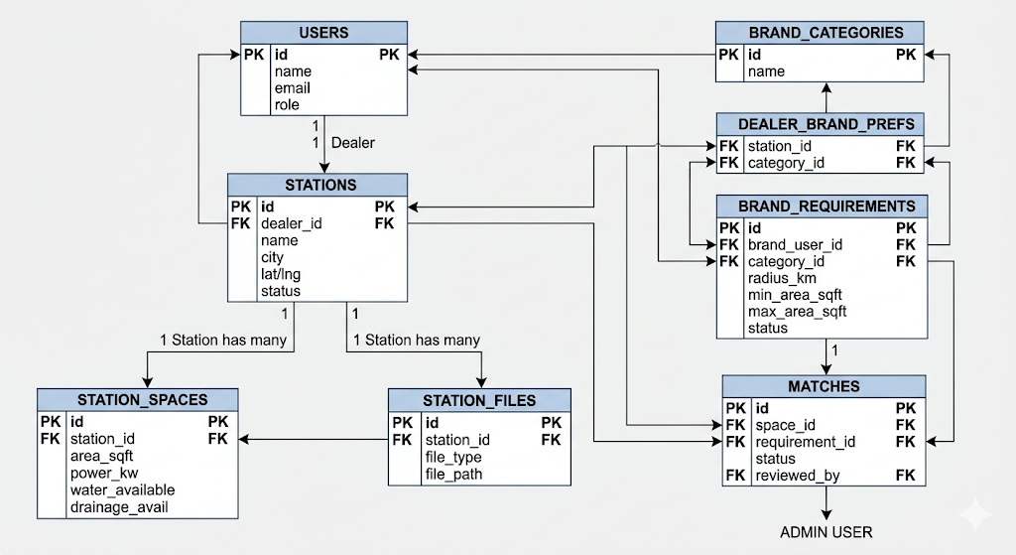

Algorithmic Matching Logic
A match record is created when all functional attributes reconcile cleanly across active category fields, space area minimums, power values, status logs, and spatial search radiuses.

Matching Logic
A match is generated when:
- Dealer selected the brand category
- Area is within requested range
- Utility requirements are satisfied
- Power requirements are satisfied
- Station is Green
- Space is Available
- Location falls within search radius

Indexing Strategy
Indexes recommended:
- stations(latitude, longitude)
- brand_requirements(latitude, longitude)
- matches(status)
- stations(status)
- brand_requirements(status)
- dealer_brand_preferences(station_id, category_id)

