**Multiple Types of Cancer Classification Using CT/MRI Images Based on Learning Without Forgetting Powered Deep Learning Models**

**ABSTRACT: -**

Cancer is the second biggest cause of death worldwide, accounting for one of every six deaths. On the other hand, early detection of the disease significantly improves the chances of survival. The use of Artificial Intelligence (AI) to automate cancer detection might allow us to evaluate more cases in less time. In this research, AI-based deep learning models are proposed to classify the images of eight kinds of cancer, such as lung, brain, breast, and cervical cancer. This work evaluates the deep learning models, namely Convolutional Neural Networks (CNN), against classifying images with cancer traits. Pre-trained CNN variants such as MobileNet, VGGNet, and DenseNet are employed to transfer the knowledge they learned with the ImageNet dataset to detect different kinds of cancer cells. We use Bayesian Optimization to find the suitable values for the hyperparameters. However, transfer learning could make it so that models can no longer classify the datasets they were initially trained. So, we use Learning without Forgetting (LwF), which trains the network using only new task data while keeping the network’s original abilities. The results of the experiments show that the proposed models based on transfer learning are more accurate than the current state-of-the-art techniques.

|  |  |
| --- | --- |
| **EXSISTING SYSTEM** | **PROPOSED SYSTEM** |
| * Before the proliferation of deep learning concepts, traditional methods were extensively utilized for cancer detection in medical imaging. Image processing techniques such as edge detection, employing Sobel and Canny edge detectors, were employed to identify boundaries and contours indicative of potential tumors. Texture analysis, incorporating statistical measures and Gabor filters, characterized the texture patterns within images. * Feature extraction and selection methods, including histogram-based features and shape-based descriptors, quantified pixel intensity distributions and delineated geometric properties of potential tumors. Classical machine learning algorithms like Support Vector Machines, Decision Trees, and Random Forests were commonly applied for binary classification tasks, leveraging extracted features for cancer identification. | * The proposed system in the context of the given abstract involves the application of Artificial Intelligence (AI) through deep learning models for the automated classification of various types of cancer based on medical imaging. Specifically, Convolutional Neural Networks (CNN) variants, including MobileNet, VGGNet, and DenseNet, are utilized for their ability to learn intricate features from images. The focus is on eight distinct types of cancer, such as lung, brain, breast, and cervical cancer. * Transfer learning is employed, leveraging pre-trained CNN variants that have acquired knowledge from the ImageNet dataset to effectively detect different types of cancer cells. To optimize the models, Bayesian Optimization is applied to identify suitable hyperparameter values, enhancing the classification performance. |
| **EXISTING ALGORITHM**   * VGG16,CNN | **PROPOSED ALGORITHM: -**   * Vgg19( Visual Geometry Group),CNN |
| **ALGORITHM DEFINITION: -**  Deep learning is a subfield of machine learning and a collection of algorithms that are inspired by the structure of human brain and try to imitate the functions of human brain, which is the reason these algorithms are most of the times also termed as ‘‘neural networks”.These algorithms are called ‘‘deep” as the input passes through series of non-linear transformations before it becomes output. Convolution neural network (CNN) is one such deep learning algorithm in which the transformations are done using an operation called ‘‘convolution.  VGG16 was trained on very general images of Image Net dataset (natural images), it was still able to extract useful features for our classification task. We also computed various metrics to support the performance of our classification model and compared accuracy of our method with past methods. | **ALGORITHM DEFINITION: -**  Vgg19, VGG stands for Visual Geometry Group; it is a standard deep Convolutional Neural Network (CNN) architecture with multiple layers. The “deep” refers to the number of layers with VGG-19 consisting of 16 and 19 convolutional layers. The VGG architecture is the basis of ground breaking object recognition models.VGG19 is an advanced CNN with pre-trained layers and a great understanding of what defines an image in terms of shape, color, and structure. VGG19 is very deep and has been trained on millions of diverse images with complex classification tasks.  VGG-19 is an extension of the original VGGNet, and the "19" in its name refers to the total number of layers, including convolutional and fully connected layers. The architecture is known for its simplicity and uniformity, consisting of 19 layers with 16 convolutional layers followed by three fully connected layers and max-pooling layers for spatial down-sampling. |
| **DRAWBACKS: -**   * Limited Scalability * Inefficient Resource Management * Lack of Flexibility | **ADVANTAGES: -**   * High Scalability * Fault Tolerance and Reliability * Accuracy and Precision |

**SYSTEM ARCHITECTURE:**

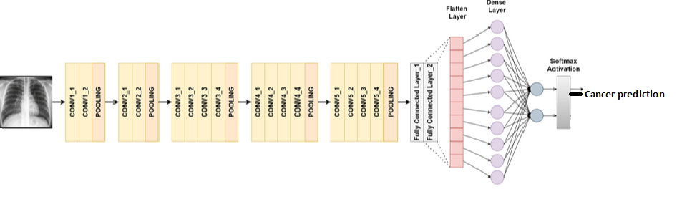

**VGG19 Architecture for Classification of multiple types of cancer prediction**

Fig: - proposed model

**MINIMUMSYSTEM REQUIREMENTS**

**HARDWARE REQUIREMENTS**

* PROCESSOR : Pentium i3 Processor
* RAM : 4GB DD RAM
* HARD DISK : 450 GB

**SOFTWARE REQUIREMENTS**

* BACK END : PYTHON
* OPERATING SYSTEM : WINDOWS 10
* IDE : Spyder3