Overview and System Architecture
This document provide guideline on how to set up the Hadoop environment and executing the Exploratory Data Analysis (EDA) for the online retail dataset extracted from (UCIML Repo). The analysis is conducted within a big data ecosystem using Apache Ambari for cluster management, Hadoop Distributed File (HDFS) for data storage, and Apache Zeppelin for running the data processing task and EDA via the Pyspark and Spark SQL.
Steps to launch Hadoop
- Launch Oracle VM VirtualBox and ensure the Hadoop cluster node is fully booted and running.
- Launch Ambari using http://127.0.0.1:1080/at any web browser to access Apache Ambari UI.
- In Ambari, navigate to the File View and create a new folder, name it as onlineretail2 to configure the HDFS Storage.
- Open the created folder and upload the cleaned parquet data into this HDFS directory.
- Access Apache Zeppelin UI using http://localhost:9995/ in any web browser.
- Create a new notebook at the Zeppelin UI and name it as onlineretail2_1 to begin development.
- After the analysis has been completed, we may download the file and it will be exported as JSON file.

Execution Note
Before feeding data into the Hadoop, we need to ensure the data scheme and structure are syntactically correct. Therefore, we would validate and clean the data that we have obtained in the parquet format using the Jupyter Notebook before load it to the Hadoop Distributed File System (HDFS).
The data cleaning method applied in this study include standardizing the column name for example removing the whitespace, filtering out the bad regex on the product name for example damage, gwp and etc. Besides that, the missing value on the product name is also imputed using the product name existed at the same SKU code. The comprehensive details of the cleaning process can be viewed on the attached cleancolumn_cleandescription.ipynb file.

Environment and Notebook Configuration
Upon completing the data cleaning, the subsequent analysis on the exploratory data analysis (EDA) was transitioned into an Apache Zeppelin. The zeppelin notebook used for this stage is exported and saved in a JSON format. The raw code can be viewed using standard text editor for example Notepad++. However, the Zeppelin notebook environment and its execution paths are strictly coupled with Hadoop ecosystem. Therefore, to access the code, we need to ensure that our computer has a compatible environment where the Hadoop Cluster, Apache Spark and Apache Zeppelin are fully installed and configured.
In short, the exported notebook can only be fully operated and executed within a Hadoop environment. With the environment are fully setup, the system is now ready for the EDA utilizing the SQL queries inside the Apache Zeppelin.
From figure 1 below, the onlineretail2 directory has been successfully integrated and verified within Apache Ambari.
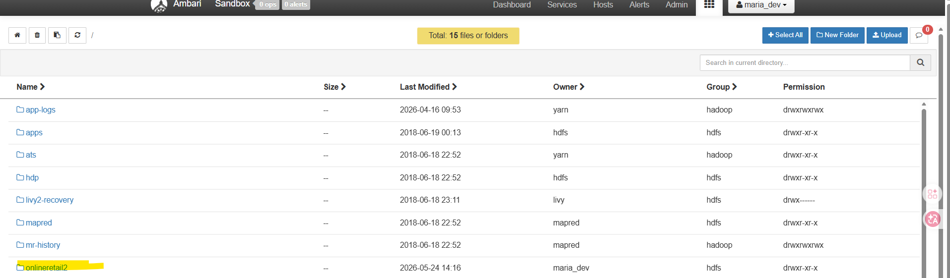
Figure 1: Setting up onlineretail2 directory

Data Loading and Environment Verification

Before proceeding with the EDA, the cleaned dataset was loaded into the Apache Zeppelin environment using the following pyspark command below.
df_zeppelin = spark.read.parquet("/onlineretail2/onlineretail_ii_v1.parquet")

To ensure the dataset was loaded successfully with its structural integrity intact, we perform a quick preview of the dataset as below.
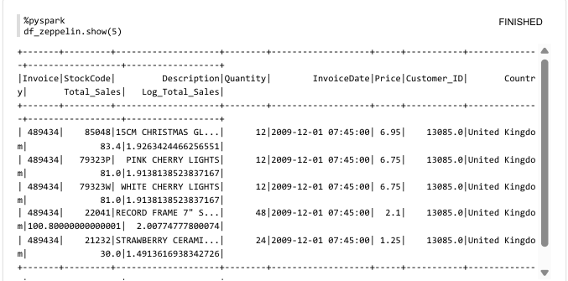
Figure 2: Data Preview

Subsequently, the data frame was registered as a Spark SQL Temporary Virtual View to enable a native SQL query executions.

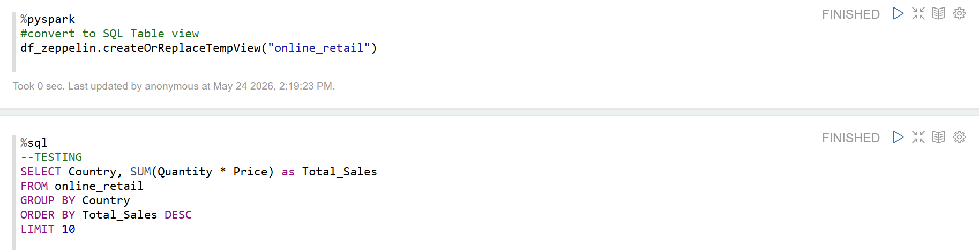
Figure 3: Spark SQL Creation
Finally, to verify a seamless integration between the HDFS and the Apache Zeppelin, a test aggregation query was executed. We apply data scaling using the log transformation (log 10) on the total sale to mitigate data skewness. The code and the corresponding result are captured in Figure 3 below.
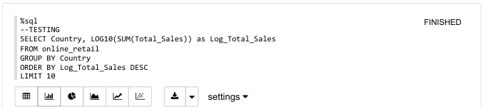
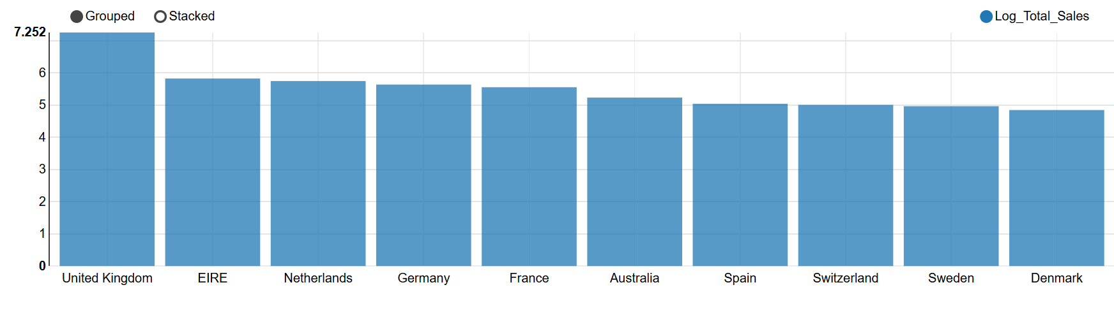
Figure 4: Result from Quick Verification for HDFS and Apache Zeppelin

Advanced Data Cleansing and Imputation

Before executing the EDA, a further granular data cleaning and structural validation is perform directly within the Apache Zeppelin environment to address the unresolved data quality issues.

Validating missing value

A comprehensive audit was executed to quantify the extent of the missing value across dataset as per Figure 5 below.
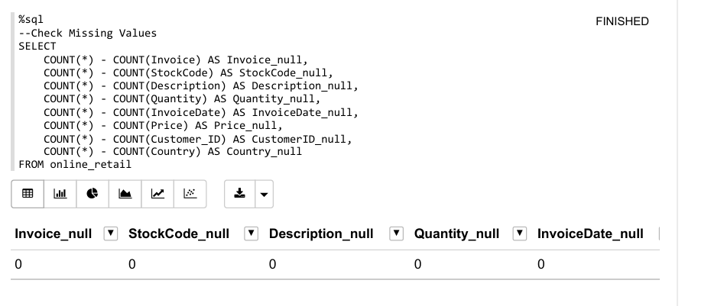
Figure 5: Validate missing value
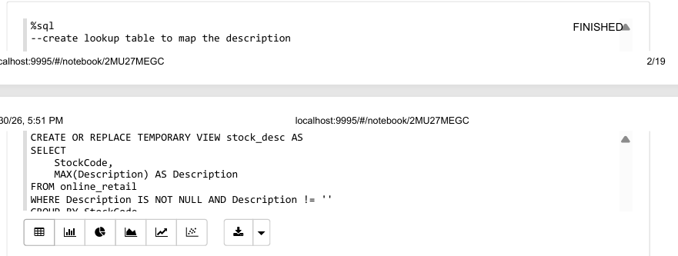
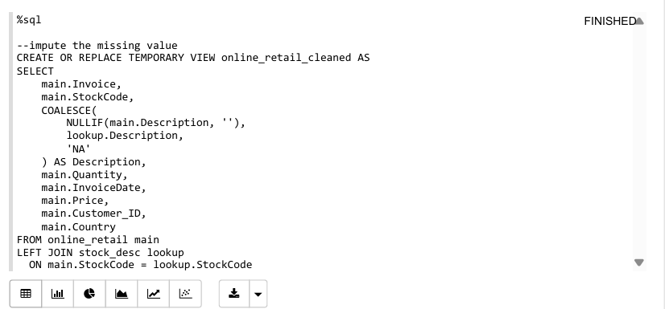
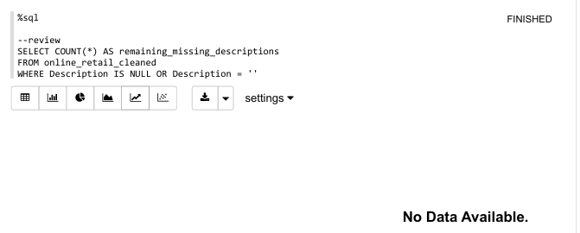
Figure 6: Missing Value Imputation using Apache Zeppelin
Nevertheless, the study would like to demonstrate the capabilities of Apache Zeppelin environment to perform the data engineering as per attached above. For example, missing product name information can be solved using a historical SKU lookup table, LEFT JOIN structure and COALESCE functions. From the command above there is no missing value on the product name as it has been cleaned earlier before feeding it in the HDFS.
However, the limitation of Apache Zeppelin is it is not ideal to process the heavily distorted data for example whitespace in column header or complex regular expression data corruptions. This is significantly easier to be computed within the Jupyter Notebook environment before feeding the data into the HDFS.

Product Name Unification
In a retail dataset, a common data integrity issue arises when a single unique identifier SKU is tied to a multiple product name. Hence, a validation query was executed using COUNT(DISTINCT Description) >1 associated with each SKU as shown in Figure 7 below. There are several SKU entries were found having more than one product name for a single SKU.

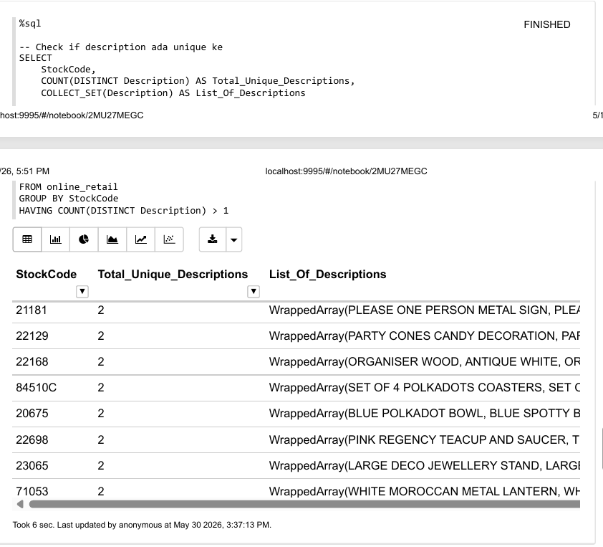
Figure 7: Check on Duplicate Data Entry

Hence, the study must standardize the product name convention to achieve correct analysis and finding. The data unification process is performed. The product name can be mapped to each unique SKU by extracting the maximum string value of the product name as shown in Figure 8 below.
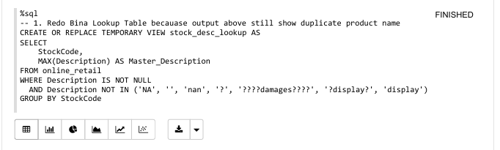
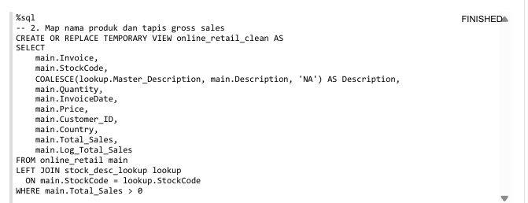
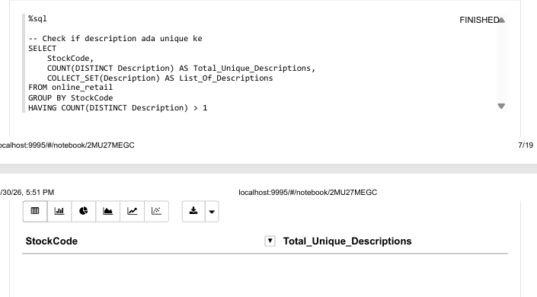
Figure 8: Product Mapping
From the executed result in Figure 8 above, there are no longer duplicate product name existed. This is because the query returned an empty result. This outcome confirms that the dataset maintain each unique SKU only contain one product name. This action is necessary to reduce risk of product name ambiguity or data fragmentation during the subsequent EDA and subsequent analysis.

Handling Duplicate Data

Apart from the inconsistent product name, the raw online retail data contains an identical column name where every single row matches as showed on Figure 9 below. The duplicate data entry could artificially inflate the sales figure and skew the final statistical metrics. Hence, a final data cleansing step was conducted using the command in Figure 10 below. 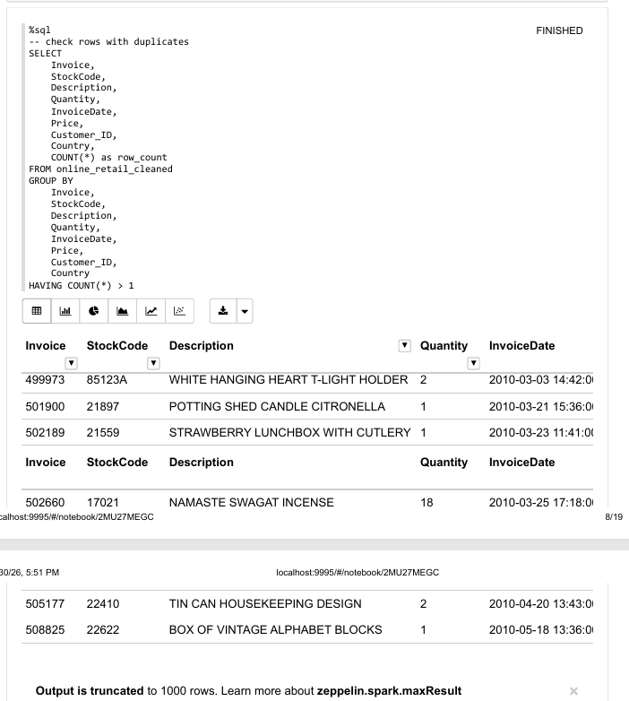
Figure 9: Checking on the duplicate rows
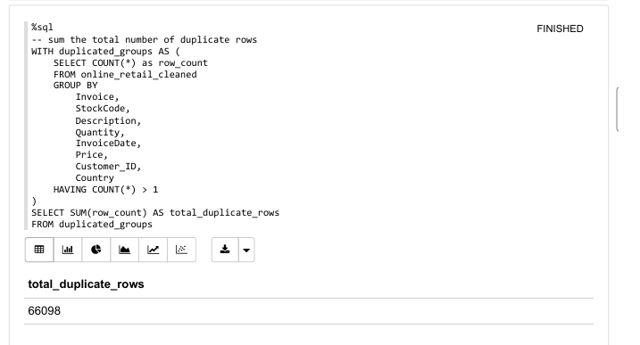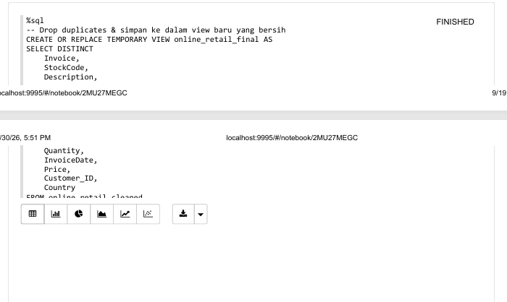
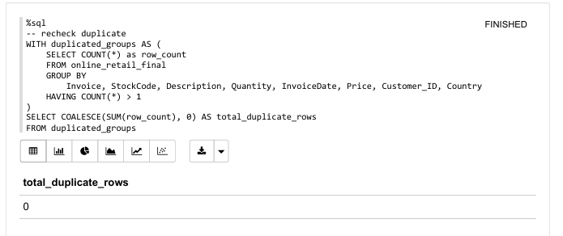
Figure 10: Remove Duplicate Data
Based on the Figure 10 above, the function. dropDuplicates() was applied to remove the duplicate. The process has effectively removed the duplicate ensuring that all remaining transactions in the dataset are unique and accurate.
With all the data inconsistencies, duplicate rows being resolved through Figure 4 until 9, the dataset has achieved a full correct structural data integrity and can be feed into the analysis.

Feature Engineering and Data Transformation

There are several new features added directly within the Apache Environment using the Spark SQL. to support a comprehensive analysis of the purchase trend. The purpose of the transformation is to convert a meaningful time-based metric that could be extracted based on existing features InvoiceDate.
As displayed by the query within Figure 11, the transaction timestamps were being divided into specific months and hour. Additionally, the study has also further classified the date into the two major categories which are weekend and weekday.
Additionally, the exact hour of the transactions was also mapped into four operational shifts to identify pattern of shipping among the online customer.
The time is categorized as Morning (6am – 11.59pm), Afternoon (12pm-3.59pm), Evening (4pm-859pm and Late Night (9pm – 5.59am).
The final transformed output was registered into a new unified view named as online_retail_final_metrics to ensure a clean structure for the subsequent analytical queries.

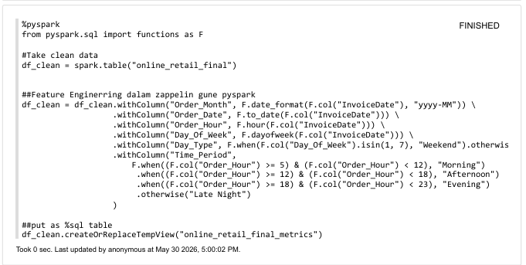
Figure 11: Time based Feature Engineering

Explanatory Data Analysis (EDA)

Once the dataset was fully enriched with all the temporal features, the EDA process was carried out accordingly. One of the primary reasons of selecting Apache Zeppelin in this study is because the environment has a built-in interactive visualization capability. It allows users to automatically generate the explanatory plots directly from a SQL query output without requiring an additional plotting library such as Matplotlib or Seaborn.
Additionally, the users may seamlessly toggle between different type of chart such as bar chart, pie chart, line graphs or scatter plot. The GUI has been directly embedded in the Apache Zeppelin system.
Hence, utilizing these capabilities the study can effortlessly executed multiple analytical queries to uncover customer behaviour pattern in the online retail data.

Temporal and Seasonal Sale Performance

To identify the temporal buying behaviors, the gross sale figures were aggregated across the multiple time dimensions extracted during the feature engineering stage earlier.

Monthly Gross Sales Performance

The first EDA performed in the study is to identify the seasonal trend exist in the dataset based on the trend of the cumulative gross sales over months as per Figure 12 below.
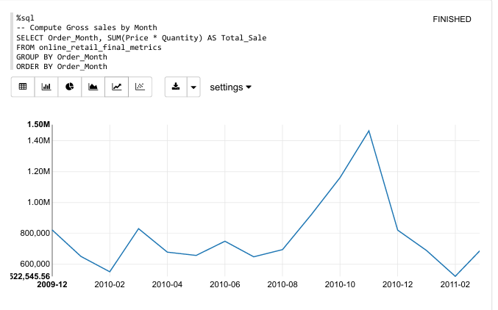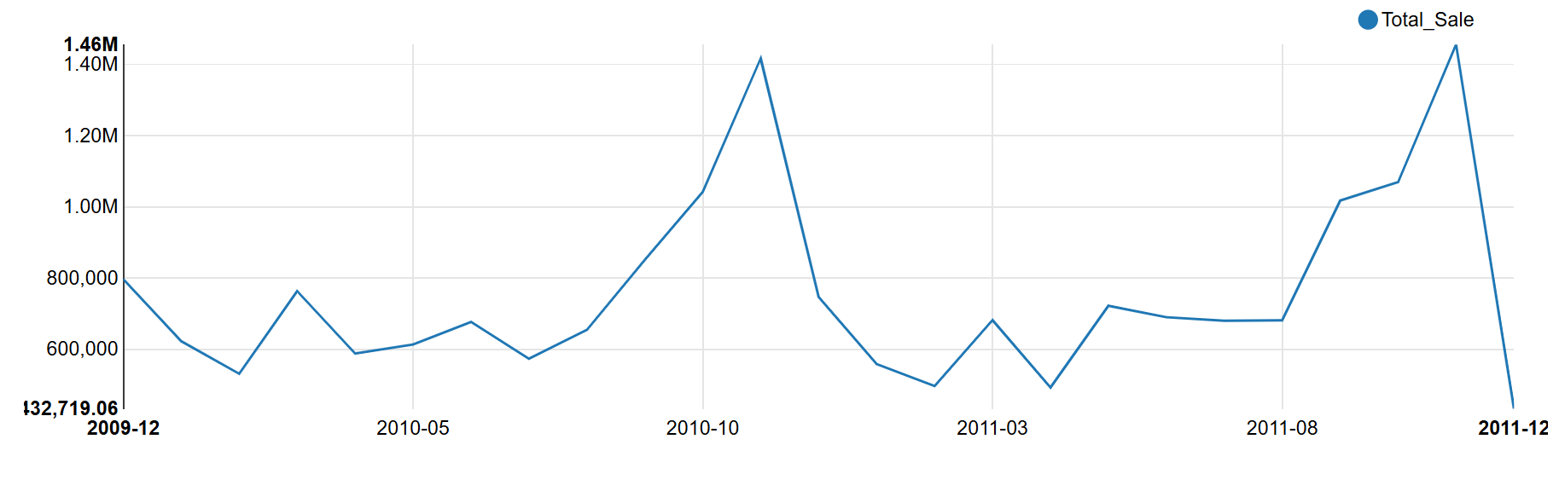
Figure 12: Analysis of Monthly Sales Performance
From the Figure 12 above, there is an obvious peak sale on the fourth quarter of the month specifically on the October 2010. The spike in sales during the final quarter is common seasonal pattern exist in retail industry which normally drive by the year-end holiday shopping, promotional campaigns and corporate inventory clears-out. Conversely, early months of the year shows a relatively stable or lower sales volume before picking up momentum in the next quarter.

Hourly Sales Performance
Following by the macro-level seasonal analysis, an hourly aggregation was computed to identify the specific operational periods of the day where buying behavior is heavily concentrated.

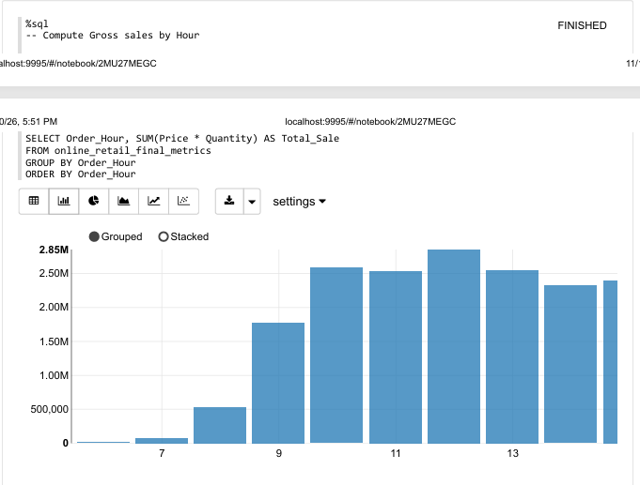
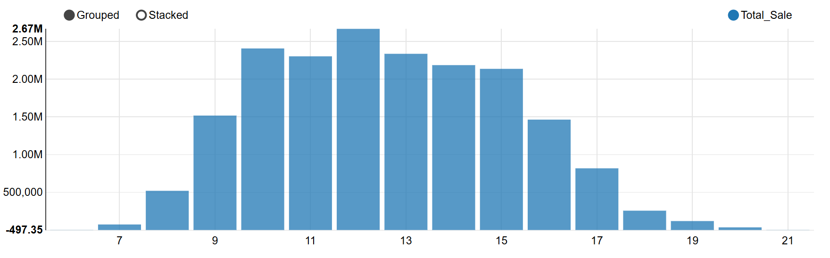
Figure 13: Purchase Trend Analysis by Hour
From Figure 13 above, the buying behavior begins as early as 7am and experience and aggressive upward momentum as the day progresses. The absolute peak sales volume occurs during the midday window, specifically between 12:00 and 13:00, indicating that customers highly prefer shopping online during lunchtime or midday breaks.

After 3pm, the total gross sales shows a steady and continuous decline throughout the late afternoon, eventually dropping to its lowest baseline by 8pm. This clear transactional curve provides critical operational insights for scheduling digital marketing campaigns, web server maintenance windows, and customer service shift planning.

Sales Breakdown Across Operational Time Shifts
To simplify the customer online purchase behavior the study segmented the time of the day into three main operational shifts which are Morning, Afternoon and Evening.
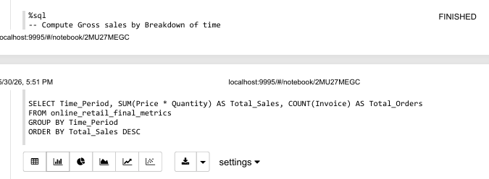
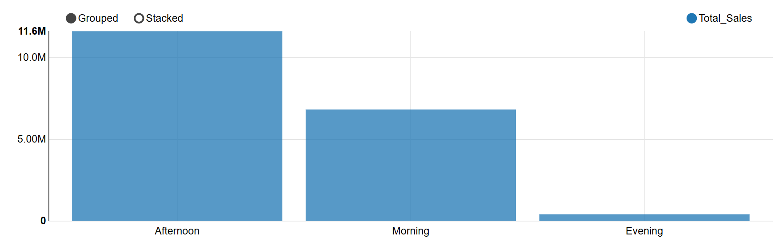
Figure 14: Sales Analysis by Time Shifts
From the Figure 14 above, the visualization reveals a highly concentrated buying preference during specific periods of the day. The Afternoon shift clearly dominates the chart, capturing the absolute highest volume of gross sales followed by the Morning shift.
In contrast, the transaction levels negligible minimum during the Evening shift. This distinct breakdown confirms that the platform's primary consumer traffic is highly active during daylight business hours which are from morning until late afternoon. Thus, these two shifts served as the most critical windows for launching time-sensitive promotions and maintaining high system availability.

Sales Performance by Week of Day
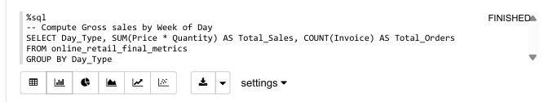
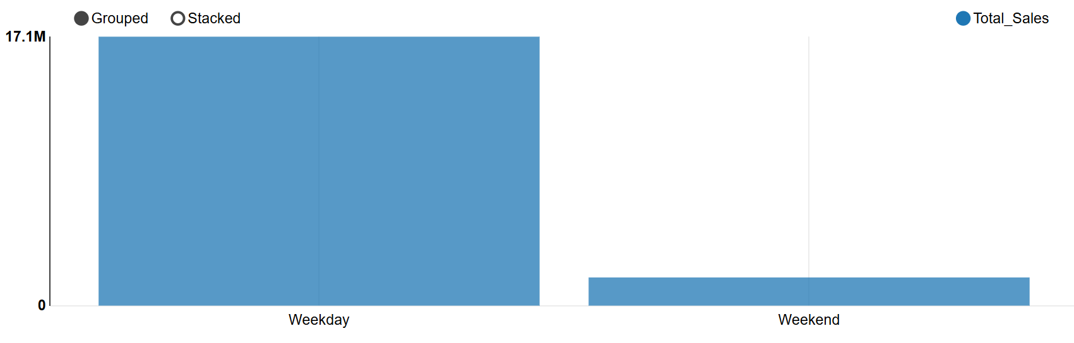
Figure 15: Week of Day Sales Performance
To further understand the customer purchase behaviour changes between workday and off day, the study was evaluated based on the categorized day tupe as Figure 15 above.

From the Figure 15, there is a substantial imbalance in the sales behaviour between the two day categories. Sales are heavily concentrated on the weekday while weekend shows a minimal revenue contribution. The drastic drop of sales during weekend suggest that the online retail platform is primarily utilized by commercial entities, wholesalers, or business-oriented buyers who operate strictly during standard working days. This insight complements the findings found in the subsequent EDA which suggest a strong presence of Business-to-Business (B2B) buying activities within the ecosystem.

Sales Performance by Country
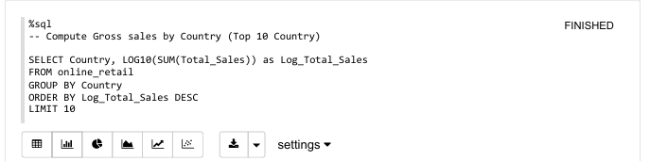


Figure 16: Sales Performance by Country
Next, the study explores the sales behaviour across each of the countries within the global retail ecosystem. A country level revenue aggregation query was executed to determine the top 10 countries based on the overall gross sales.
From the Figure 16 above there were a severe geographic data disparity observed. The United Kingdom (UK) stands out as the dominant primary market for this retail platform.
Countries such as EIRE (Ireland), Netherlands, Germany, and France lead the international revenue generation. It indicates that the international customer base is heavily concentrated within the European region.

Sales Trend Analysis between Countries
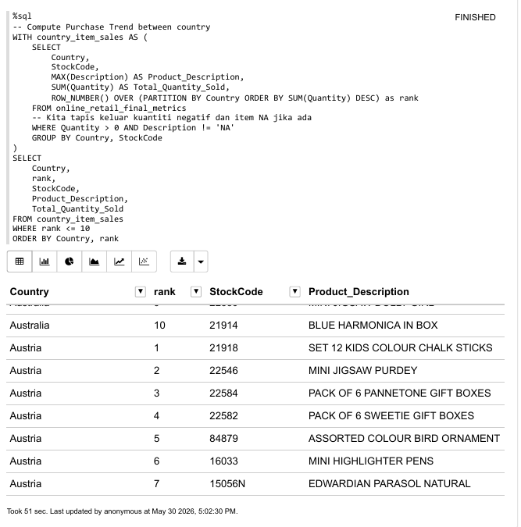

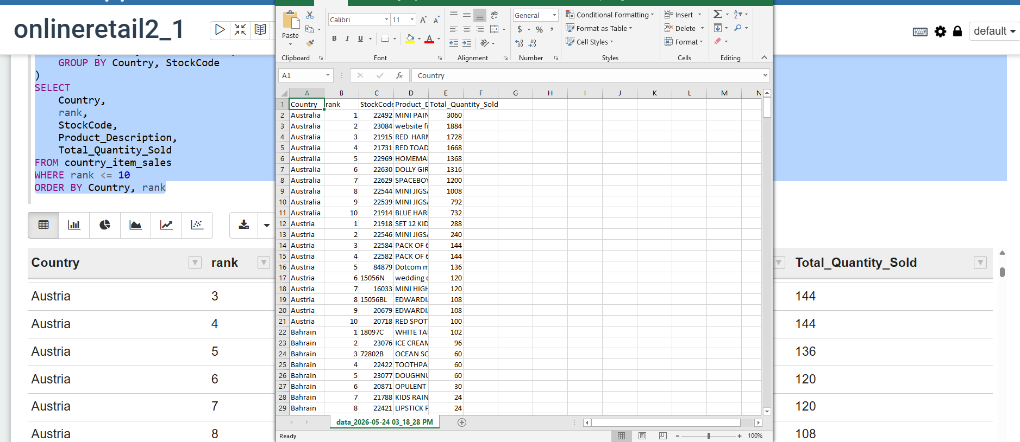
Figure 17: Sales Trend Analysis within Countries
Country | rank | StockCode | Product_Description | Total_Qty_Sold
United Kingdom | 1 | 84077 | WORLD WAR 2 GLIDERS ASSTD DESIGNS | 97,465
Denmark | 1 | 37410 | BLACK AND WHITE PAISLEY FLOWER MUG | 25,164
France | 1 | 21088 | SET/6 FRUIT SALAD PAPER CUPS | 7,176
Netherlands | 1 | 35961 | FOLKART ZINC HEART CHRISTMAS DEC | 6,697
EIRE | 1 | 21212 | PACK OF 72 RETROSPOT CAKE CASES | 6,000
Sweden | 1 | 16033 | MINI HIGHLIGHTER PENS | 5,760
Australia | 1 | 22492 | MINI PAINT SET VINTAGE BOY+ GIRL | 3,060
Germany | 1 | 22326 | ROUND SNACK BOXES SET OF4 WOODLAND | 2,698
Spain | 1 | 22670 | FRENCH WC SIGN BLUE METAL | 1,788
Bermuda | 1 | 84598 | BOYS ALPHABET IRON ON PATCHES | 1,152
Table 1: Identification of High-Volume Top Products with Over 1,000 Units in Total Quantity Sold
To identify localized product preferences, a window ranking function (ROW_NUMBER()) was used to isolate the top 10 products per country based on Total_Quantity_Sold. This query explicitly filters out negative quantities and invalid descriptions if still exist. Due to the high dimensionality of comparing products across global markets, the results are presented in a structured tabular format.

Based on the partitioned data in Table 1, there were several key operational insights and data profiling were discovered. First, a massive demand exists for novelty, stationery, and event items, highlighted by 97,465 gliders sold in the United Kingdom, 7,176 paper cups in France, and 5,760 mini highlighter pens in Sweden. Second, household, kitchen, and decorative goods drive the top spots in other European markets, such as 25,164 flower mugs in Denmark, 6,697 Christmas decorations in the Netherlands, and 6,000 cake cases in EIRE. The remaining international markets show a steady demand for varied consumer goods, ranging from over 3,000 paint sets in Australia to 1,152 clothing patches in Bermuda.

Cross-Border Product Popularity

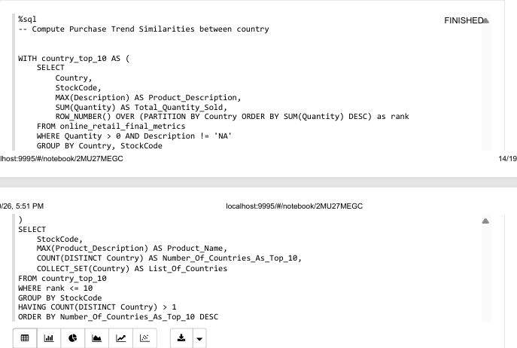

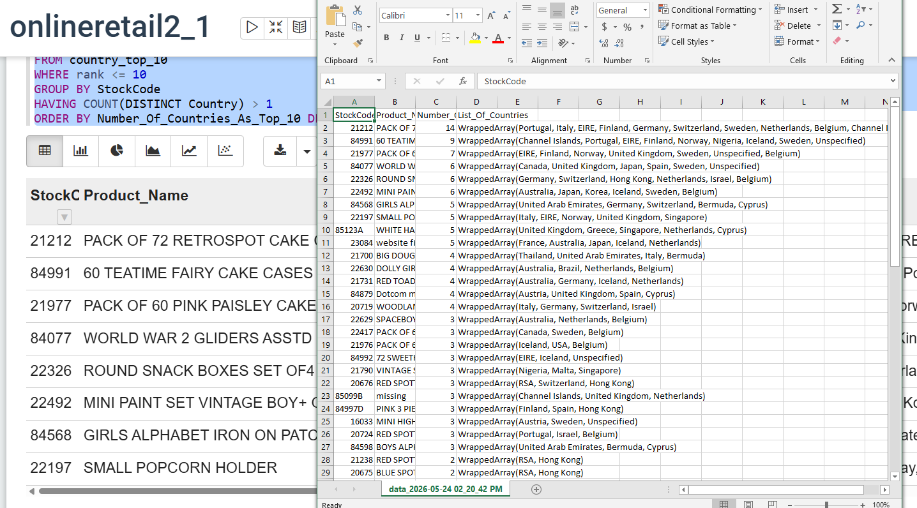
Figure 18: Cross-Border Product Popularity

StockCode | Product_Name | # countries | List_Of_Countries
21212 | PACK OF 72 RETROSPOT CAKE CASES | 14 | WrappedArray(Portugal, Italy, EIRE, Finland, Germany, Switzerland, Sweden, Netherlands, Belgium, Channel Islands, Norway, United Kingdom, Unspecified, USA)
84991 | 60 TEATIME FAIRY CAKE CASES | 9 | WrappedArray(Channel Islands, Portugal, EIRE, Finland, Norway, Nigeria, Iceland, Sweden, Unspecified)
21977 | PACK OF 60 PINK PAISLEY CAKE CASES | 7 | WrappedArray(EIRE, Finland, Norway, United Kingdom, Sweden, Unspecified, Belgium)
84077 | WORLD WAR 2 GLIDERS ASSTD DESIGNS | 6 | WrappedArray(Canada, United Kingdom, Japan, Spain, Sweden, Unspecified)
22326 | ROUND SNACK BOXES SET OF4 WOODLAND | 6 | WrappedArray(Germany, Switzerland, Hong Kong, Netherlands, Israel, Belgium)
22492 | MINI PAINT SET VINTAGE BOY+ GIRL | 6 | WrappedArray(Australia, Japan, Korea, Iceland, Sweden, Belgium)
84568 | GIRLS ALPHABET IRON ON PATCHES | 5 | WrappedArray(United Arab Emirates, Germany, Switzerland, Bermuda, Cyprus)
22197 | SMALL POPCORN HOLDER | 5 | WrappedArray(Italy, EIRE, Norway, United Kingdom, Singapore)
85123A | WHITE HANGING HEART T-LIGHT HOLDER | 5 | WrappedArray(United Kingdom, Grece, Singapore, Netherlands, Cyprus)
21700 | BIG DOUGHNUT FRIDGE MAGNETS | 4 | WrappedArray(Thailand, United Arab Emirates, Italy, Bermuda)
Table 2: Top 10 item Purchased Similarly within countries

To evaluate the breath of the product popularity across the retail ecosystem in the dataset, a nested Common Table Expression (CTE) was implemented. This query identifies items that frequently appear within the “Top 10” most demanded products across multiple distinct countries by filtering items with cross-border traction (HAVING COUNT(DISTINCT Country) > 1) as per Figure 16.

Based on Table 2 above, the cross-border market penetration can be summarized into two core strategic insights. First, cake case is a global bestseller by securing a top demand spot across fourteen distinct international markets spanning Western Europe, Scandinavia, and North America.

Second, low-cost and lightweight consumables, specifically cake cases and novelty items such as gliders, paint sets, and snack boxes, consistently drive the widest international footprint by appearing across five to nine different countries. Ultimately, these affordable baking accessories and everyday novelty goods served as the primary catalysts for the platform's recurring cross-border shipping logistics.

High Value Customer Identification
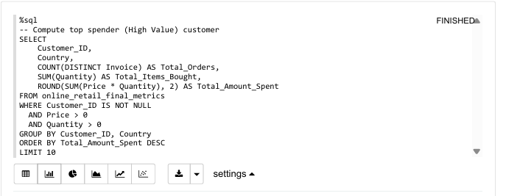
Figure 19: Computational Analysis of Basket Size

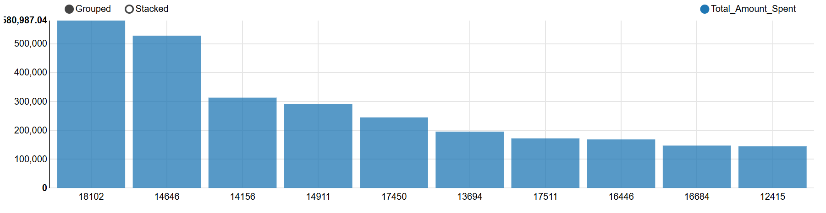
Figure 20: High Value Customer Identification
Next, the study identified the top customer in the dataset so the business can protect its core revenue and prevent these high-yield accounts from churning. By identifying these specific individuals allows the company to deploy targeted retention strategies, such as exclusive VIP loyalty programs, personalized pricing tier incentives, and dedicated account management to secure the customer long-term value.

Based on Figure 20 above, the elite tier is led by Customer ID 18102, who tops the platform with a total spend approaching nearly 600,000, followed closely by Customer ID 14646.

Basket Size Analysis by Country

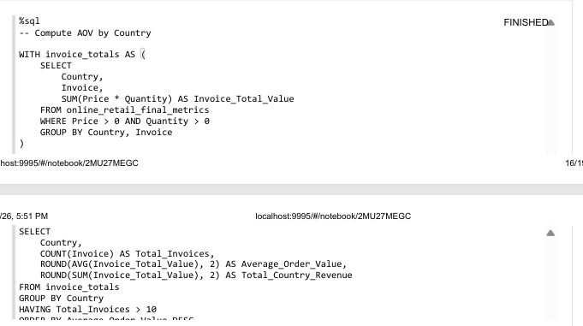
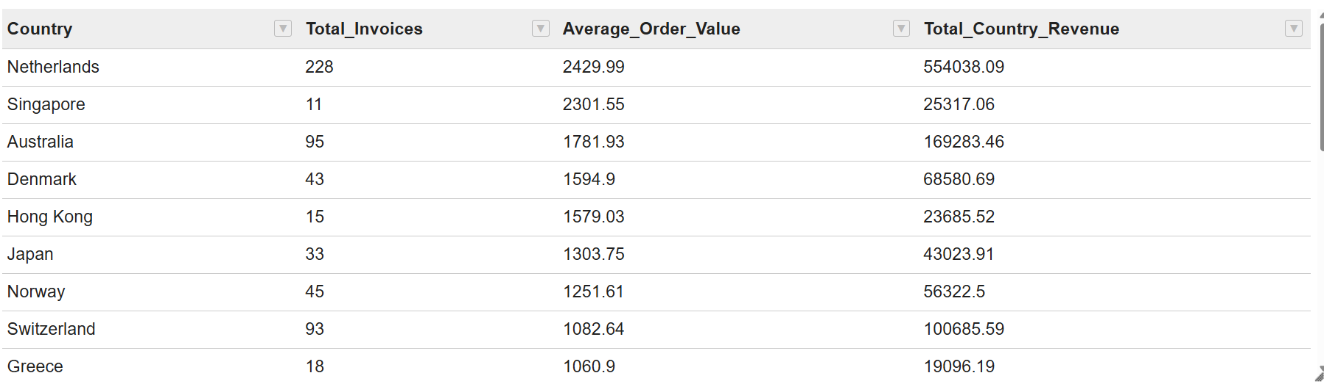
Table 3: Basket Size by Company

To evaluate cross-border purchasing power, the Average Order Value (AOV) by country was computed as presented in Table 3 above. The data reveals that the Netherlands leads overall performance with 228 invoices and an average spend of 2,430 whereas Singapore emerges as a highly lucrative, untapped premium market.

Despite recording a lower number of orders, Singapore served as the second-highest average spend globally at 2,301. Therefore, we may conclude that Singapore as an exclusive, high-purchasing-power customer base focused on large bulk wholesale orders rather than casual retail. To exploit this underutilized segment, the platform should transition toward targeted business-to-business corporate outreach with customized volume discounts to safely increase order frequency.

Concurrently, the company should implement bulk-purchase incentives for lower-performing regions like Switzerland and Grece to drive their average spend past the 1,200 thresholds. The company should also allocate dedicated supply chain distribution resources to high-frequency hubs like the Netherlands to sustain core cross-border revenue.

Customer Purchasing Behaviour Validation Analysis

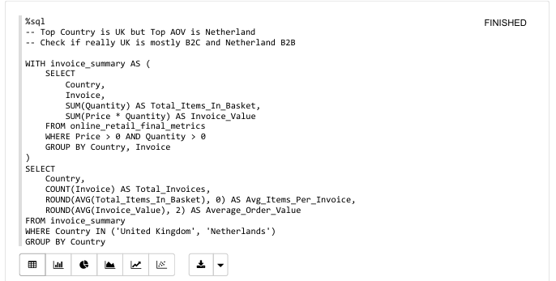
Figure 21: Comparative Analysis of Basket Size and Purchasing Behavior between the Overall Top Performing Country and the Highest Average Order Value Country.
To evaluate the structural behavioral differences between the platform's top revenue drivers, a comparative market segmentation analysis was conducted between the United Kingdom and the Netherlands. This is because from the analysis on Figure 16, United Kingdom is the top performing country while from result in Table 3, Netherland served as the best performing country in term of AOV.
From finding in the Figure 21 above, United Kingdom has a massive volume of 36,536 invoices while its average items per order stands at 251 units with a modest AOV of 476.
On the contrary, the Netherlands records only 228 invoices but reflects an extraordinary bulk-purchasing pattern, averaging 1,684 order and a high AOV of 2,429.
Therefore, the company should maintain a dual-focused strategy by deploying high-volume transactional ad campaigns for the retail-heavy United Kingdom market, while simultaneously offering specialized cargo shipping and personalized B2B contract terms for the high-yield corporate accounts in the Netherlands.

Top Purchase Item in Netherlands
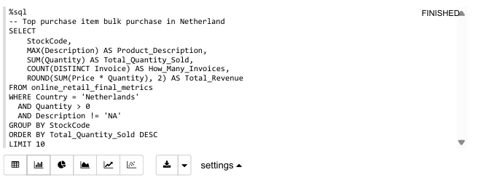
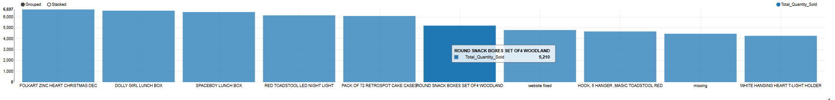
Figure 22: Top Purchase Product in Netherlands

To deep dive into the specific inventory requirements of the platform's highest-spending wholesale market, an analysis of the top purchased items in the Netherlands was conducted as shown in Figure 20 above.
The organizational and household novelty products have the highest demand, heavily driven by items such as Folkart Zinc Heart registered a massive volume of over 6,000 units sold.
To capitalize on this localized preference, the company should take action by establishing dedicated B2B stock allocation policies for these specific high demand items to ensure zero stockouts.
The company should also offer a tailored bundle discount to corporate buyers in the Netherlands to continuously secure a long-term wholesale contract.

